COMMON COURSE ASSIGNMENT

AMRITA ARUN(192372295)

Assignment Information

Particular | Details
Department: | Computer science engineering with artificial intelligence
Programme: | Bachelor of engineering
Course Code & Course Name | CSA1404-COMPILER DESIGN
Academic Year / Batch | 2023
Faculty Name | ANITHA G
Assignment Title
Date of Issue
Date of Submission
Maximum Marks | 100
Course Outcome(s) – CO
Bloom's Taxonomy Level
SDG Mapping (SDG 1-17)
Industry / Societal Relevance

Assignment Problem / Challenge
Problem / Challenge
The rapid growth of Federated Learning (FL), Edge AI, intelligent IoT systems, and AI-based orchestration has created a need for reliable mechanisms to process analytical expressions generated or modified dynamically. In a Federated Learning environment, analytical expressions may be used to calculate client contribution scores, aggregation weights, privacy costs, communication overhead, fairness measures, and other decision-making parameters.
The challenge is to design a Federated Learning Analytics Expression Compiler (FLAEC) capable of validating such expressions before they are executed within a distributed learning environment.
The proposed compiler should perform two important front-end tasks:
- Lexical analysis – identify identifiers, constants, operators, assignment symbols, parentheses, and invalid characters.
- Syntax analysis – determine whether the sequence of tokens follows the defined grammar while correctly maintaining operator precedence, associativity, and nested expressions.
The work requires the application of compiler-design concepts rather than merely describing them. A suitable lexical analyzer must be developed using LEX/FLEX, followed by the construction and transformation of a Context-Free Grammar (CFG). The resulting language must then be examined using LL(1), Recursive Descent, Operator-Precedence, and SLR(1) parsing techniques.
The assignment also requires validation through JFLAP and other suitable parsing tools. The four approaches must be compared based on their applicability, complexity, reliability, and extensibility so that an appropriate parsing strategy can be recommended for the proposed compiler.

Problem Statement

Problem / Case / Design Challenge:

A technology organization intends to develop a Federated Learning Analytics Expression Compiler (FLAEC) for privacy-preserving distributed analytics. Federated Learning allows multiple clients such as edge devices, smartphones, industrial systems, and intelligent sensors to participate in model training while retaining their local training information.

The proposed compiler acts as a trusted front-end between distributed FL clients, AI-based orchestration agents, edge applications, and the FL coordination layer. Its purpose is to verify analytical expressions before they are executed.

Consider the following expression:

aggregationScore = (accuracy * clientWeight)

+ (dataQuality * participationRate)

- privacyPenalty / communicationCost

+ fairnessBonus

Here, the variables represent different FL-related metrics. accuracy indicates local model performance, clientWeight represents the contribution assigned to a client, dataQuality represents the quality of locally available data, and participationRate represents how frequently a client participates. privacyPenalty represents the privacy-related cost, while communicationCost indicates the overhead associated with exchanging model updates. fairnessBonus represents an adjustment intended to encourage balanced participation.

The compiler must correctly process this type of expression without confusing the intended mathematical structure. In particular, multiplication and division must be evaluated with higher precedence than addition and subtraction, while parentheses must be respected.

The proposed system shall therefore:

Define regular expressions for valid tokens.

Develop a LEX/FLEX-based lexical analyzer.

Detect invalid identifiers, unsupported operators, malformed constants, and illegal symbols.

Construct a CFG for the expression language.

Analyze ambiguity, left recursion, left factoring, and predictive-parsing conflicts.

Transform the grammar wherever necessary.

Determine FIRST and FOLLOW sets.

Demonstrate LL(1) and Recursive Descent parsing.

Construct an Operator-Precedence parser.

Construct and evaluate an SLR(1) parser.

Validate the grammar using JFLAP and suitable parsing applications.

Test valid as well as invalid expressions.

Compare the four parsing techniques.

Recommend an appropriate parsing method for the future development of FLAEC.

The assignment also considers future language extensions, including unary operators, exponentiation, comparison operators, logical operators, nested expressions, and Federated Learning functions such as fedAvg(), fedProx(), weightedAggregate(), privacyBudget(), clientScore(), fairnessScore(), robustnessScore(), energyCost(), and communicationCost().

Requirements and Constraints
1. Functional Requirements
The proposed compiler should be capable of:
- Recognizing valid identifiers.
- Recognizing integer and decimal constants.
- Identifying arithmetic operators.
- Recognizing assignment operators.
- Recognizing opening and closing parentheses.
- Ignoring unnecessary whitespace.
- Detecting illegal symbols.
- Detecting malformed constants.
- Detecting invalid lexical patterns.
- Generating an appropriate token sequence.
- Validating the syntactic structure of expressions.
- Maintaining operator precedence and associativity.
- Supporting nested parenthesized expressions.
- Rejecting syntactically incorrect expressions.
- Providing parsing information for valid and invalid inputs.
2. Performance Requirements
The compiler front-end should:
- Process expressions efficiently.
- Avoid unnecessary repeated scanning.
- Produce token sequences in a consistent manner.
- Detect errors as early as practical.
- Provide deterministic parsing behaviour for the selected grammar.
- Remain suitable for extension as the expression language grows.
3. Technical Constraints
The implementation should consider:
- LEX/FLEX-based lexical analysis.
- CFG-based syntax specification.
- FIRST and FOLLOW computation.
- LL(1) grammar requirements.
- Recursive-descent implementation requirements.
- Operator-precedence relationships.
- SLR(1) item construction.
- Shift/reduce and reduce/reduce conflicts where applicable.
- Proper handling of parentheses and arithmetic precedence.
4. Tool Constraints
The work should use appropriate compiler-design tools such as:
- LEX/FLEX
- JFLAP
- Python, where required for implementation or testing
- Suitable web-based parsing applications
- AI-assisted tools for generating additional test cases or exploring grammar alternatives, followed by independent verification.
5. Security and Privacy Considerations
Since the proposed compiler is intended for a Federated Learning environment, the design should avoid requiring raw client training data merely to validate an analytical expression.
The compiler should operate primarily on the expression and its token/grammar structure. This provides a separation between expression validation and the sensitive datasets used by FL clients.
6. Reliability Requirements
An invalid expression should not silently pass through the compiler. Lexical and syntactic errors should be identified so that incorrect analytical rules do not proceed to later stages of the FL pipeline.

Student Work

Problem Understanding and Formulation
1.1 Understanding the Problem
The primary problem is to design a compiler front-end capable of validating analytical expressions used in Federated Learning.
The expression:
aggregationScore = (accuracy * clientWeight)
+ (dataQuality * participationRate)
- privacyPenalty / communicationCost
+ fairnessBonus
contains:
- Identifiers
- Assignment operator
- Parentheses
- Multiplication
- Addition
- Subtraction
- Division
The compiler must first identify these elements and then determine whether they appear in a syntactically valid arrangement.
1.2 Expected Outcomes
The expected outcomes are:
- A set of regular expressions for lexical categories.
- A working LEX/FLEX lexical analyzer.
- A formal CFG.
- A transformed grammar suitable for predictive parsing.
- FIRST and FOLLOW sets.
- An LL(1) parsing table.
- Recursive-descent parsing logic.
- Operator-precedence analysis.
- SLR(1) item sets and parsing table.
- Valid and invalid test cases.
- Parse trees and derivations.
- Stack-operation demonstrations.
- A comparison of parsing techniques.
- A justified recommendation for the compiler.
1.3 Available Information
The assignment provides a representative Federated Learning expression and describes the meaning of its variables. It also specifies the required lexical-analysis and parsing techniques and identifies possible future extensions.
1.4 Assumptions
The following assumptions are made:
- Identifiers begin with an alphabetic character or underscore.
- Identifiers may contain letters, digits, and underscores.
- Arithmetic operators are initially limited to +, -, *, and /.
- Parentheses are used for explicit grouping.
- Numerical values may be represented as integers or decimal constants.
- Whitespace does not affect the meaning of an expression.
- The initial grammar does not include logical or comparison operators.
- Future extensions can be incorporated by expanding the lexical rules and grammar.
1.5 Constraints
The solution must:
- Correctly distinguish tokens.
- Preserve mathematical precedence.
- Handle nested expressions.
- Detect invalid input.
- Support formal grammar analysis.
- Be testable using compiler-design tools.
- Remain extensible for future requirements.

Application of Course Knowledge

2.1 Lexical Analysis
Lexical analysis converts the character stream into tokens.
For example:
accuracy * clientWeight
can produce:
Lexeme | Token
accuracy | IDENTIFIER
* | MULTIPLY
clientWeight | IDENTIFIER
For the complete expression:
Lexeme | Token
aggregationScore | IDENTIFIER
= | ASSIGN
( | LEFT_PAREN
accuracy | IDENTIFIER
* | MULTIPLY
clientWeight | IDENTIFIER
) | RIGHT_PAREN
+ | PLUS
dataQuality | IDENTIFIER
* | MULTIPLY
participationRate | IDENTIFIER
- | MINUS
privacyPenalty | IDENTIFIER
/ | DIVIDE
communicationCost | IDENTIFIER
+ | PLUS
fairnessBonus | IDENTIFIER

2.2 Regular Expressions

Identifier
[A-Za-z_][A-Za-z0-9_]*

Integer
[0-9]+

Decimal
[0-9]+\.[0-9]+

Arithmetic Operators
[+\-*/]

Assignment
=

Opening Parenthesis
\(

Closing Parenthesis
\)

Whitespace
[ \t\n]+

2.3 Context-Free Grammar
An initial grammar can be defined as:
S → id = E

E → E + T
| E - T
| T

T → T * F
| T / F
| F

F → ( E )
| id
| num
This grammar separates addition/subtraction from multiplication/division and therefore captures the required precedence relationship.

2.4 Grammar Transformation
The initial grammar contains left recursion:
E → E + T
T → T * F
For predictive parsing, it can be transformed into:
S → id = E

E → T E'

E' → + T E'
| - T E'
| ε

T → F T'

T' → * F T'
| / F T'
| ε

F → ( E )
| id
| num

2.5 FIRST Sets
FIRST(S) = { id }

FIRST(E) = { (, id, num }

FIRST(E') = { +, -, ε }

FIRST(T) = { (, id, num }

FIRST(T') = { *, /, ε }

FIRST(F) = { (, id, num }

2.6 FOLLOW Sets
FOLLOW(S) = { $ }

FOLLOW(E) = { ), $ }

FOLLOW(E') = { ), $ }

FOLLOW(T) = { +, -, ), $ }

FOLLOW(T') = { +, -, ), $ }

FOLLOW(F) = { *, /, +, -, ), $ }
These sets form the basis for predictive parsing-table construction.

Solution / Design / Methodology

3.1 Proposed Architecture
The proposed compiler front-end follows the sequence:
Input Expression
↓
Lexical Analyzer
↓
Token Stream
↓
Grammar / Syntax Analyzer
↓
Parsing Technique
↓
Parse Tree / Acceptance
↓
Error Detection or Valid Expression
Four parsing approaches are investigated:
┌── LL(1)
Token Stream ────┼── Recursive Descent
├── Operator-Precedence
└── SLR(1)
3.2 LEX/FLEX Implementation
A simplified scanner can be implemented as:
%{
#include <stdio.h>
%}

%%

[ \t\n]+ ;

[A-Za-z_][A-Za-z0-9_]* {
printf("IDENTIFIER: %s\n", yytext);
}

[0-9]+ {
printf("INTEGER: %s\n", yytext);
}

[0-9]+\.[0-9]+ {
printf("DECIMAL: %s\n", yytext);
}

"=" { printf("ASSIGN\n"); }
"+" { printf("PLUS\n"); }
"-" { printf("MINUS\n"); }
"*" { printf("MULTIPLY\n"); }
"/" { printf("DIVIDE\n"); }
"(" { printf("LEFT_PAREN\n"); }
")" { printf("RIGHT_PAREN\n"); }

. {
printf("LEXICAL ERROR: %s\n", yytext);
}

%%
3.3 LL(1) Parser
The transformed grammar is used to construct the LL(1) parsing table.
The parser uses:
- Current non-terminal.
- One lookahead token.
- FIRST set.
- FOLLOW set.
The objective is to ensure that the parser can select one production without backtracking.
3.4 Recursive Descent Parser
The recursive-descent implementation can contain procedures corresponding to:
parseS()
parseE()
parseEPrime()
parseT()
parseTPrime()
parseF()
The procedure structure follows the transformed grammar, making the implementation relatively easy to understand.
3.5 Operator-Precedence Parser
The parser assigns precedence relationships to operators.
The intended hierarchy is:
Parentheses
↓
* and /
↓
+ and -
Thus:
a + b * c
is interpreted structurally as:
a + (b * c)
rather than:
(a + b) * c
3.6 SLR(1) Parser
SLR(1) parsing uses LR(0) items together with FOLLOW sets.
The major parser actions are:
- Shift
- Reduce
- Goto
- Accept
- Error
The construction involves generating LR(0) item sets and then creating the ACTION and GOTO tables.
3.7 Alternative Solutions
Two broad approaches can be considered:
Approach 1 – Predictive Parsing
Use transformed CFG + LL(1)/Recursive Descent.
Advantages:
- Simple implementation.
- Easy debugging.
- Clear grammar-to-code relationship.
- Suitable for a relatively small expression language.
Limitations:
- Grammar must satisfy predictive-parsing requirements.
- Grammar transformations may become more complicated as language features increase.
Approach 2 – Bottom-Up Parsing
Use Operator-Precedence or SLR(1).
Advantages:
- More suitable for grammars with richer structures.
- Naturally supports bottom-up recognition.
- SLR(1) provides greater grammar-handling capability than simple predictive parsing.
Limitations:
- More complicated construction.
- Parsing tables are harder to understand manually.
- Debugging can be more difficult.

Where appropriate, consider more than one possible solution.

Use of Modern Tools

4.1 LEX/FLEX
LEX/FLEX is used for constructing the lexical analyzer.
It is responsible for:
- Pattern matching.
- Token recognition.
- Lexical error detection.
- Token generation.
4.2 JFLAP
JFLAP can be used to:
- Enter the CFG.
- Generate derivations.
- Examine parse trees.
- Test accepted strings.
- Test rejected strings.
- Validate grammar behaviour.
4.3 Python
Python may be used to implement supporting programs for:
- Token testing.
- Parsing simulations.
- Automated test-case generation.
- Comparing parser outputs.
- Recording experimental results.
4.4 Web-Based Parsing Tools
Suitable online parsing applications can be used as an additional validation mechanism. Their outputs should be compared against the manually derived grammar and parsing results.
4.5 AI-Assisted Tools
AI tools may assist in:
- Generating additional test expressions.
- Suggesting grammar alternatives.
- Identifying possible grammar conflicts.
- Exploring grammar transformations.
However, AI-generated suggestions must be checked independently because the correctness of a compiler grammar cannot be assumed merely because an automated system generated it. The assignment specifically requires independent verification of AI-assisted results.
Evidence to Include
Add your actual screenshots in this section:
Lexer — successful tokenization
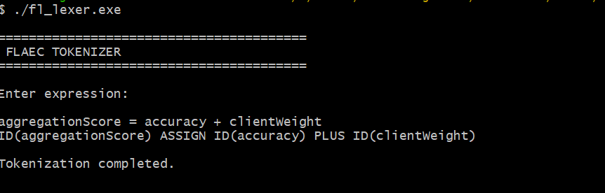

LL (1) — valid → ACCEPT

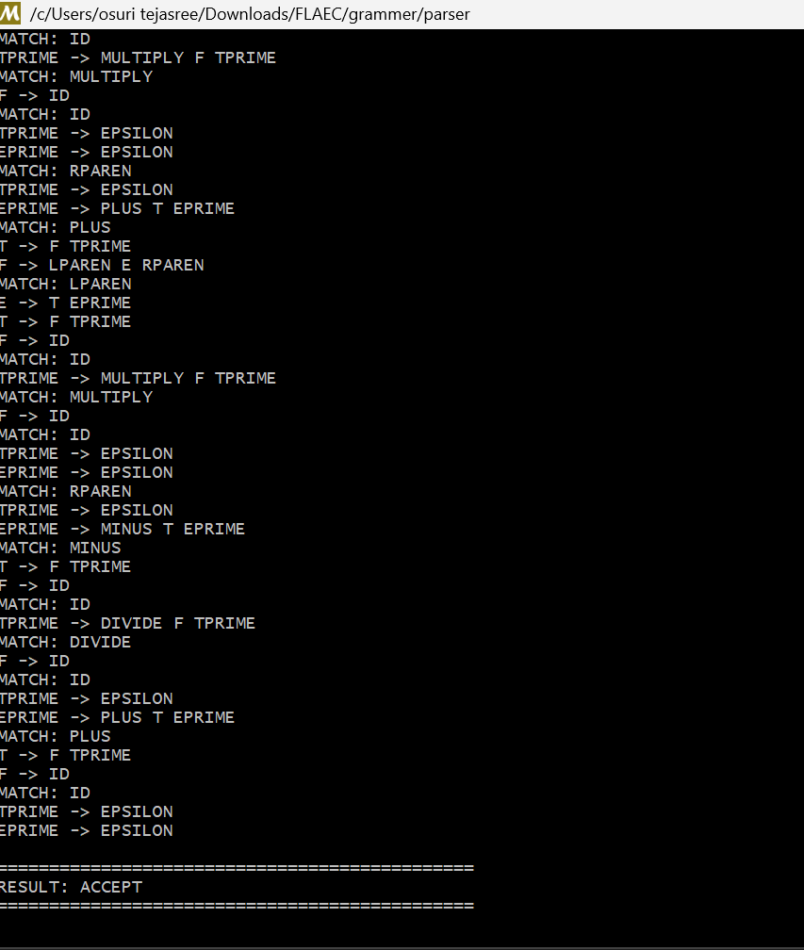

LL (1) — invalid → REJECT

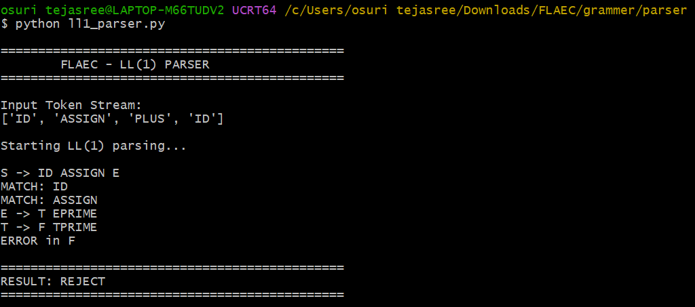

Recursive Descent — valid → ACCEPT

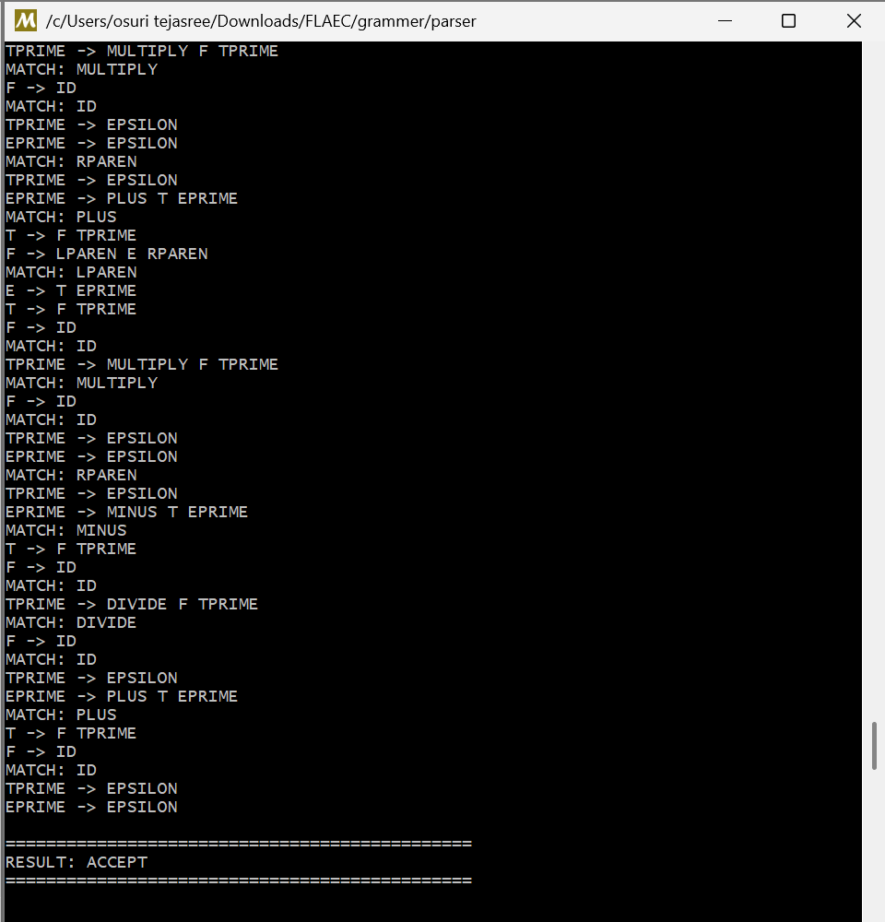

Recursive Descent — invalid → REJECT

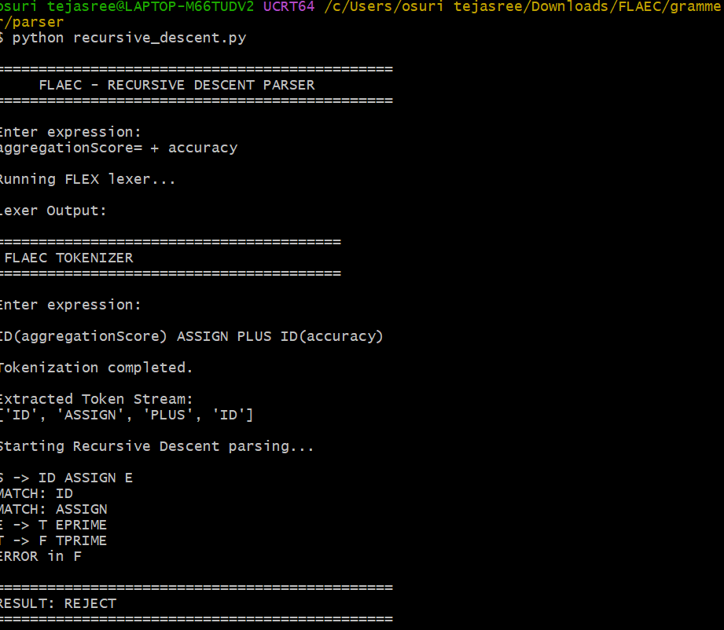

Operator Precedence — valid → ACCEPT

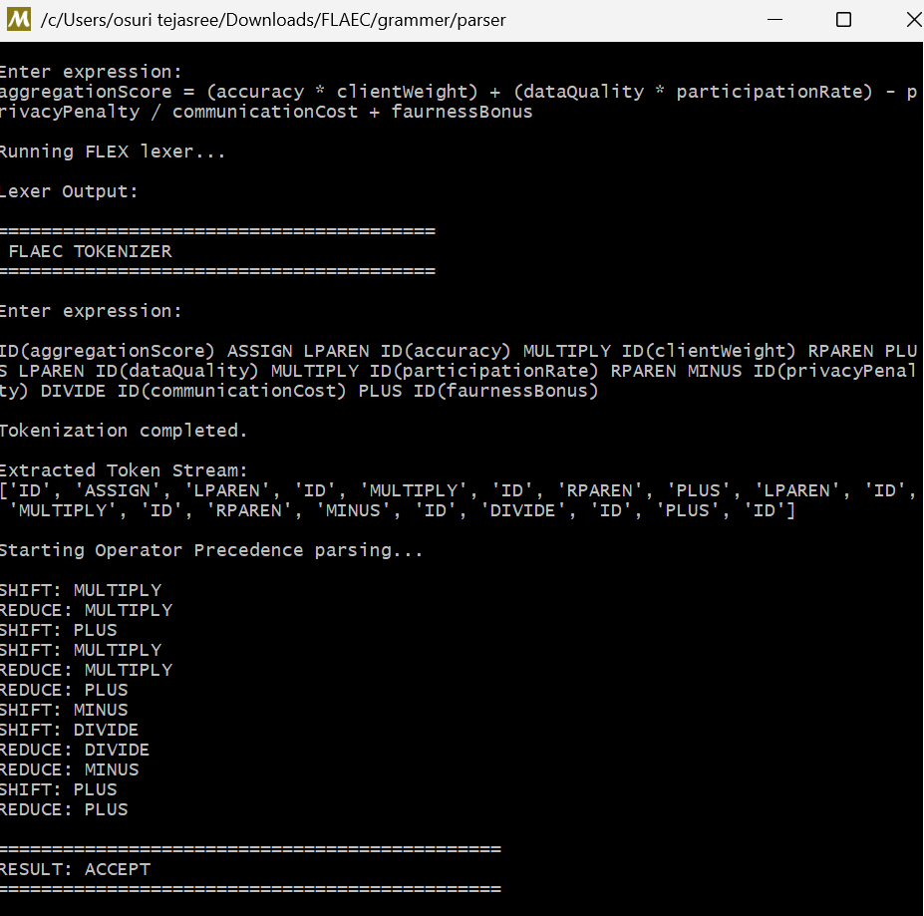

Operator Precedence — invalid → REJECT

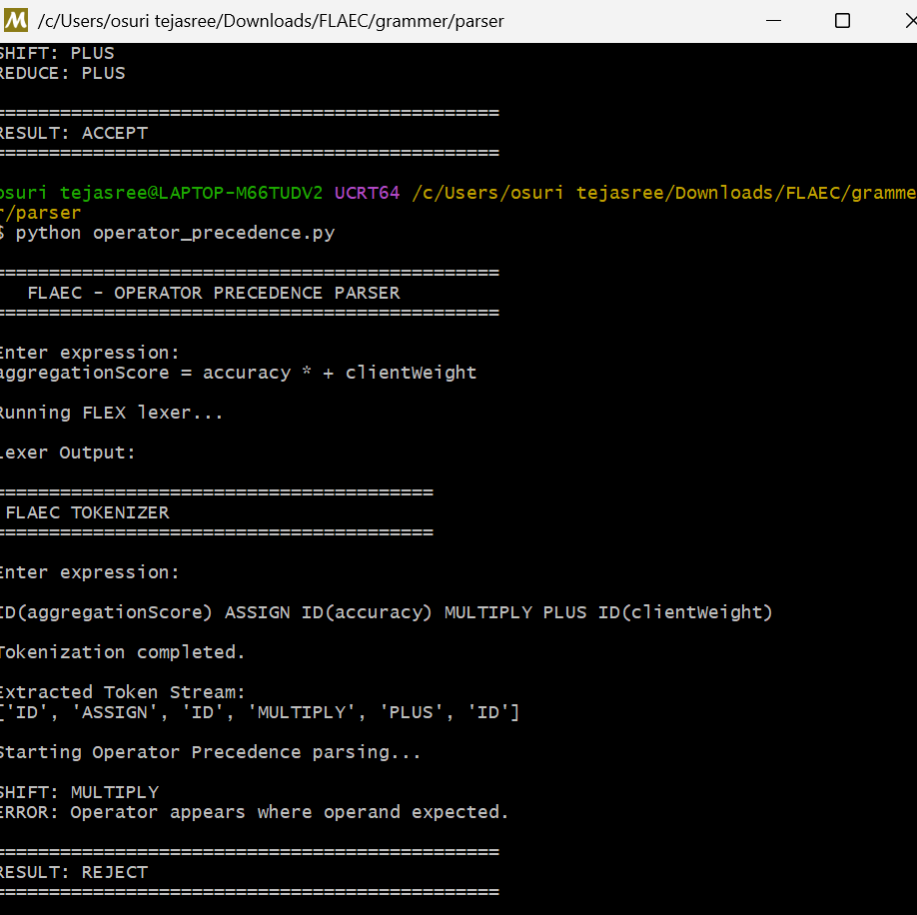

Results and Validation
5.1 Valid Test Cases
Test Case | Expression | Expected Result
TC01 | aggregationScore = accuracy | Accepted
TC02 | aggregationScore = accuracy + clientWeight | Accepted
TC03 | aggregationScore = accuracy * clientWeight | Accepted
TC04 | aggregationScore = (accuracy + clientWeight) * dataQuality | Accepted
TC05 | aggregationScore = accuracy + dataQuality * participationRate | Accepted
TC06 | aggregationScore = accuracy * clientWeight + fairnessBonus | Accepted
5.2 Invalid Test Cases
Test Case | Expression | Expected Result
TC07 | aggregationScore = (accuracy + clientWeight | Rejected – missing )
TC08 | aggregationScore = accuracy + | Rejected – incomplete expression
TC09 | aggregationScore = * accuracy | Rejected – invalid operator placement
TC10 | aggregationScore = accuracy / | Rejected – missing operand
TC11 | aggregationScore = accuracy @ clientWeight | Rejected – illegal symbol
5.3 Expected Lexical Output
For:
aggregationScore = accuracy * clientWeight
the lexical analyzer should produce a sequence similar to:
IDENTIFIER
ASSIGN
IDENTIFIER
MULTIPLY
IDENTIFIER
5.4 Validation Criteria
The solution can be considered successful when:
- Valid expressions are accepted.
- Invalid expressions are rejected.
- Operators follow the intended precedence.
- Parentheses alter grouping correctly.
- Lexical errors are detected.
- Syntax errors are detected.
- LL(1) conflicts are appropriately addressed.
- The parser outputs agree with the defined grammar.
- JFLAP results agree with the manually derived results.
Insert your actual execution screenshots and measured results here. Do not claim a screenshot/output unless you have actually obtained it.

Analysis and Engineering Decision

6.1 Comparison
Parameter | LL(1) | Recursive Descent | Operator-Precedence | SLR(1)
Parsing direction | Top-down | Top-down | Bottom-up | Bottom-up
Implementation complexity | Low | Low–Medium | Medium | High
Grammar transformation | Usually required | Usually required | Precedence-based | LR-based
Arithmetic expressions | Good | Good | Very good | Very good
Error handling | Relatively simple | Easy to customize | Moderate | More structured
Scalability | Moderate | Moderate | Moderate | High
Table construction | Required | Not necessarily | Required | Required
Ease of understanding | High | High | Medium | Lower

6.2 Advantages
LL(1)
- Simple parsing mechanism.
- Easy to trace.
- Works efficiently when grammar is appropriately transformed.
Recursive Descent
- Easy to implement.
- Parser functions correspond closely to grammar rules.
- Error messages can be customized.
Operator-Precedence
- Well suited to arithmetic expressions.
- Directly reflects operator hierarchy.
- Useful for precedence-sensitive expressions.
SLR(1)
- Handles a broader range of grammars.
- Provides a systematic bottom-up approach.
- More suitable when the language becomes structurally complex.
6.3 Limitations
The major limitation of LL(1) and recursive descent is their dependence on grammar suitability. If many new language constructs are introduced, repeated grammar transformation may become cumbersome.
Operator-precedence parsing is highly effective for expressions but is less convenient when the language expands beyond precedence-driven constructs.
SLR(1) offers greater flexibility but requires more complex table construction and implementation.
6.4 Final Engineering Decision
For the initial version of FLAEC, the recommended implementation is a transformed LL(1) grammar with a Recursive Descent parser, because the current expression language is relatively structured and arithmetic-oriented.
However, for a future version supporting a larger set of operators, function calls, logical expressions, and more complex Federated Learning constructs, SLR(1) provides a stronger foundation for handling grammar growth.
Therefore, the recommended development strategy is:
Initial FLAEC
↓
LEX/FLEX
↓
Transformed CFG
↓
LL(1) / Recursive Descent
↓
Future expansion
↓
SLR(1)-based syntax analysis
This provides a balance between simplicity for the initial implementation and scalability for future development.

Broader Considerations

7.1 Sustainability
The proposed compiler is designed around expressions rather than raw training datasets. In an FL environment, this supports the principle of keeping sensitive data at participating devices while validating the analytical logic separately.

7.2 Environment
The compiler itself has relatively small computational requirements compared with model-training workloads. Efficient expression validation can reduce unnecessary processing caused by invalid analytical instructions.

7.3 Society
Federated Learning can support distributed AI applications where central collection of raw data may be undesirable. A reliable expression-validation layer can contribute to safer deployment of such systems.

7.4 Safety
Incorrect analytical expressions could affect client selection, aggregation weights, fairness calculations, or communication-related decisions. Syntax validation provides an additional protection layer before expressions reach execution stages.

7.5 Ethics
A syntactically correct expression is not necessarily an ethically correct decision rule. For example, a fairness-related expression may be mathematically valid but still produce undesirable outcomes if its underlying assumptions are inappropriate.

7.6 Economics
A reusable compiler front-end can reduce development effort when analytical expressions are frequently created or modified. Early error detection can also reduce the cost associated with debugging invalid expressions later in the processing pipeline.

7.7 Accessibility
Clear lexical and syntax-error messages can make the compiler easier to use for developers who are not experts in formal language theory.

7.8 Professional Responsibility
AI-assisted development should not replace formal verification. Any grammar, parsing table, or test case generated using AI should be checked against established compiler-design principles and validated using appropriate tools.

Conclusion

The assignment presents a compiler-design solution for analytical expressions used in a Federated Learning environment. The proposed FLAEC front-end combines lexical analysis and syntax analysis to verify expressions before they are processed further.
Regular expressions provide the foundation for token recognition, while LEX/FLEX can automate lexical scanning and lexical-error detection. A Context-Free Grammar establishes the formal structure of the expression language, and grammar transformation makes the language suitable for predictive parsing.
LL(1), Recursive Descent, Operator-Precedence, and SLR(1) parsing provide different approaches to syntax analysis. The comparison shows that predictive approaches are attractive for the current expression language because of their simplicity, whereas SLR(1) becomes more attractive when the language develops more complex constructs.
The proposed design therefore provides a practical starting point for a Federated Learning Analytics Expression Compiler while leaving room for future enhancements such as unary operators, exponentiation, logical operators, comparison operations, and FL-specific functions.

Student Reflection
This assignment helped me understand how compiler-design principles can be applied to a modern computing problem instead of being restricted to conventional programming languages.
I learned that lexical analysis and syntax analysis are closely connected. A parser cannot work reliably if the lexical analyzer produces incorrect tokens. Similarly, a well-designed lexical analyzer alone cannot guarantee that an expression is structurally valid.
The grammar-transformation process also improved my understanding of left recursion, FIRST and FOLLOW sets, operator precedence, and predictive parsing. Comparing different parsing techniques helped me recognize that parser selection depends on the structure and future requirements of the language.
Another important learning outcome was understanding the limitations of AI-assisted development. AI can provide useful suggestions for grammar construction and test generation, but the results must be checked using formal compiler concepts and actual parsing tools.
If additional time and resources were available, I would extend the compiler to support function calls, unary operators, exponentiation, comparison operators, logical operators, and more advanced Federated Learning functions. I would also develop a graphical interface that displays tokens, grammar derivations, parse trees, and syntax errors in a single environment.

References
- A. V. Aho, M. S. Lam, R. Sethi and J. D. Ullman, Compilers: Principles, Techniques, and Tools, Pearson.
- C. N. Fischer, R. K. Cytron and R. K. LeBlanc, Crafting a Compiler, Pearson.
- JFLAP, Java Formal Languages and Automata Package, software documentation.
- Flex, Fast Lexical Analyzer Generator, documentation.
- Course materials and lecture notes for CSA14 – Compiler Design.
- Research literature related to Federated Learning, distributed machine learning, and privacy-preserving analytics.
- Documentation for any web-based parsing tools used during validation.
- AI-assisted tools used during grammar/test-case development, with outputs independently verified.

Common Assessment Rubric

Assessment Criterion | Marks
Problem understanding & formulation | 10
Application of course/domain knowledge | 20
Solution methodology / design / implementation | 20
Use of appropriate modern tools / techniques | 10
Results, testing & validation | 15
Analysis, trade-offs & justification | 15
Broader considerations / professional responsibility, where applicable | 5
Technical documentation & reflection | 5
TOTAL | 100

CO–PO–Assessment Mapping

Assessment Component | CO | PO(s) | Bloom's Level | Marks
Problem formulation |  |  | L3/L4 | 10
Application of knowledge |  |  | L3/L4 | 20
Solution / Design / Implementation |  |  | L4/L5/L6 | 20
Modern tool usage |  |  | L3/L4 | 10
Validation |  |  | L4/L5 | 15
Analysis & justification |  |  | L4/L5 | 15
Broader considerations |  |  | L4/L5 | 5
Documentation & reflection |  |  | L3/L4 | 5
Note: Faculty shall map only the POs and Bloom's levels genuinely assessed by the particular assignment. Every assignment is not required to map to every PO.

Faculty Evaluation & Continuous Improvement CO Attainment

Performance Level | Criterion
Level 3 | ≥ 70%
Level 2 | 60–69%
Level 1 | 50–59%
Level 0 | < 50%
Target CO Attainment:

Actual CO Attainment:

Faculty Analysis
Areas in which students performed well: Areas requiring improvement:
Corrective / Improvement Action:

Action to be implemented in the next offering:

Documents to be Maintained

The department/course faculty shall maintain:

- Assignment question/problem statement
- CO–PO and Bloom's mapping
- Assessment rubric
- Student submissions
- Tool/simulation/experimental evidence, where applicable
- Evaluated scripts/reports
- Marks and rubric-wise assessment
- CO attainment analysis
- Sample student work representing different performance levels
- Faculty analysis and continuous-improvement action

