1: Write a LEX specification file to take input C program from a .c file and count tthe number of characters, number of lines & number of words.
Input Source Program: (sample.c)
#include <stdio.h>
int main()
{
int number1, number2, sum;
printf("Enter two integers: ");
scanf("%d %d", &number1, &number2);
sum = number1 + number2;
printf("%d + %d = %d", number1, number2, sum);
return 0;
}

Program: (count_lines.l)
%{
int nchar, nword, nline;
%}
%%
\n { nline++; nchar++; }
[^ \t\n]+ { nword++, nchar += yyleng; }
. { nchar++; }
%%
int yywrap(void) {
return 1;
}
int main(int argc, char *argv[]) {
yyin = fopen(argv[1], "r");
yylex();
printf("Number of characters = %d\n", nchar);
printf("Number of words = %d\n", nword);
printf("Number of lines = %d\n", nline);
fclose(yyin);
}

Output:
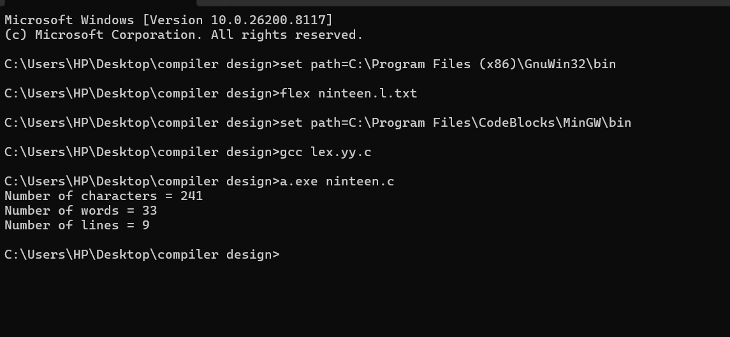

2: Write a LEX program to print all the constants in the given C source program file.

Input Source Program: (sample.c)
#define P 314
#include<stdio.h> #include<conio.h>
void main()
{
int a,b,c = 30;
printf("hello");
}
Program: (countconstants.l)
digit [0-9]
%{
int cons=0;
%}
%%
{digit}+ { cons++; printf("%s is a constant\n", yytext); }
.|\n { }
%%
int yywrap(void) {
return 1; }
int main(void)
{
FILE *f;
char file[10];
printf("Enter File Name : ");
scanf("%s",file);
f = fopen(file,"r");
yyin = f;
yylex();
printf("Number of Constants : %d\n", cons);
fclose(yyin);
}

Output:

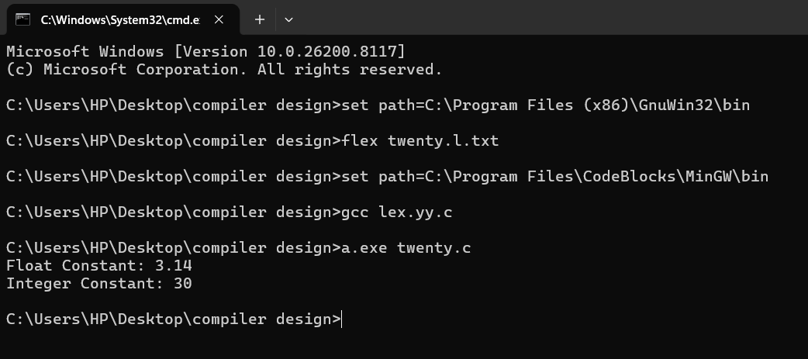

3: Write a LEX program to count the number of Macros defined and header files included in the C program.

Input Source Program: (sample.c)
#define PI 3.14
#include<stdio.h>
#include<conio.h>
void main()
{
int a,b,c = 30;
printf("hello");
}
Program: (count_macro.l)
%{
int nmacro, nheader;
%}
%%
^#define { nmacro++; }
^#include { nheader++; }
.|\n { }
%%
int yywrap(void) {
return 1;
}
int main(int argc, char *argv[]) {
yyin = fopen(argv[1], "r");
yylex();
printf("Number of macros defined = %d\n", nmacro);
printf("Number of header files included = %d\n", nheader);
fclose(yyin);
}

Output:
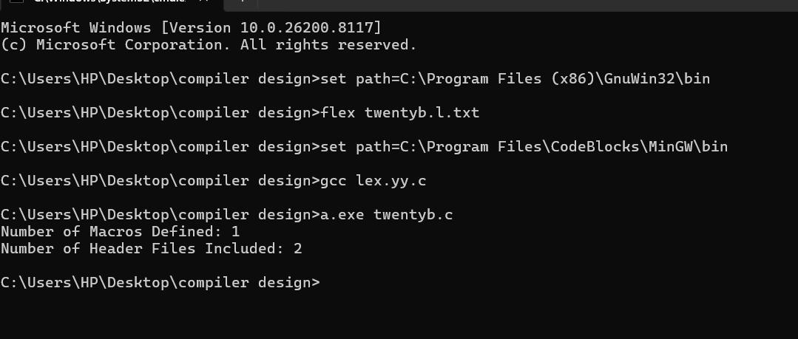

4: Write a LEX program to print all HTML tags in the input file.
Input Source Program: (sample.html)
<html>
<body>
<h1>My First Heading</h1>
<p>My first paragraph.</p>
</body>
</html>
Program: (html.l)
%{
int tags;
%}
%%
"<"[^>]*> { tags++; printf("%s \n", yytext); }
.|\n { }
%%
int yywrap(void) {
return 1; }
int main(void)
{
FILE *f;
char file[10];
printf("Enter File Name : ");
scanf("%s",file);
f = fopen(file,"r");
yyin = f;
yylex();
printf("\n Number of html tags: %d",tags);
fclose(yyin);
}

Output:

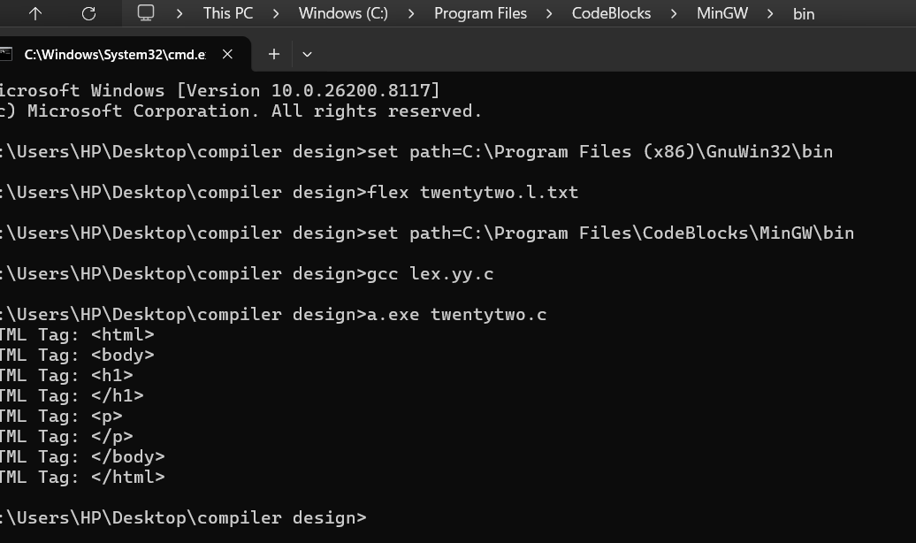
5 : Write a LEX program which adds line numbers to the given C program file and display the same in the standard output.

Input Source Program: (sample.c)
#define PI 3.14
#include<stdio.h>
#include<conio.h>
void main()
{
int a,b,c = 30;
printf("hello");
}
Program: (addlinenos.l)
%{
int yylineno;
%}
%%
^(.*)\n printf("%4d\t%s", ++yylineno, yytext);
%%
int yywrap(void) {
return 1;
}
int main(int argc, char *argv[]) {
yyin = fopen(argv[1], "r");
yylex();
fclose(yyin);
}
Output:
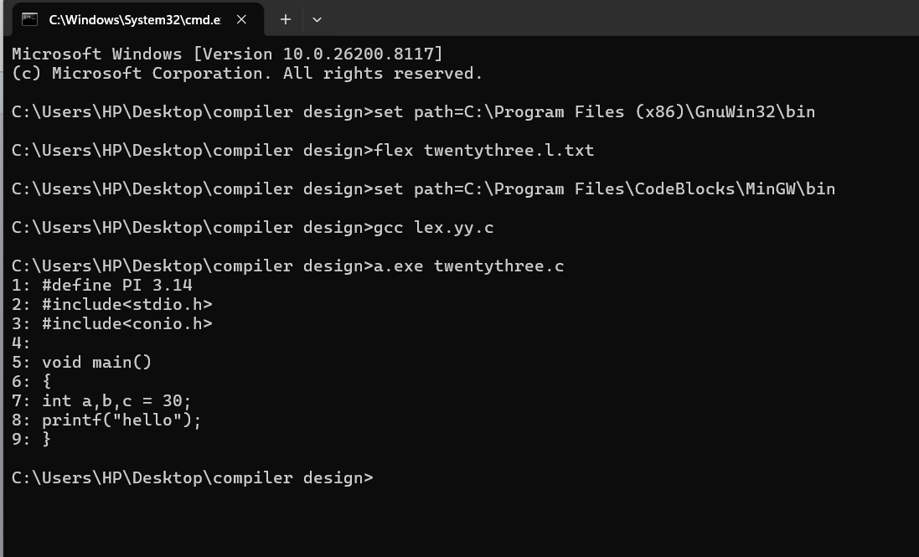

6: Write a LEX program to count the number of comment lines in a given C program and eliminate them and write into another file.

Input Source File: (input.c)
#include<stdio.h>
int main()
{
int a,b,c; /*varible declaration*/ printf(“enter two numbers”); scanf(“%d %d”,&a,&b); c=a+b;//adding two numbers printf(“sum is %d”,c);
return 0;
}
Program: (comment.l)
%{
int com=0;
%}
%s COMMENT
%%
"/*" {BEGIN COMMENT;}
<COMMENT>"*/" {BEGIN 0; com++;}
<COMMENT>\n {com++;}
<COMMENT>. {;}
\/\/.* {; com++;}
.|\n {fprintf(yyout,"%s",yytext);}
%%
void main(int argc, char *argv[])
{
if(argc!=3)
{
printf("usage : a.exe input.c output.c\n");
exit(0);
}
yyin=fopen(argv[1],"r");
yyout=fopen(argv[2],"w");
yylex();
printf("\n number of comments are = %d\n",com);
}
int yywrap()
{
return 1;
}

Output:

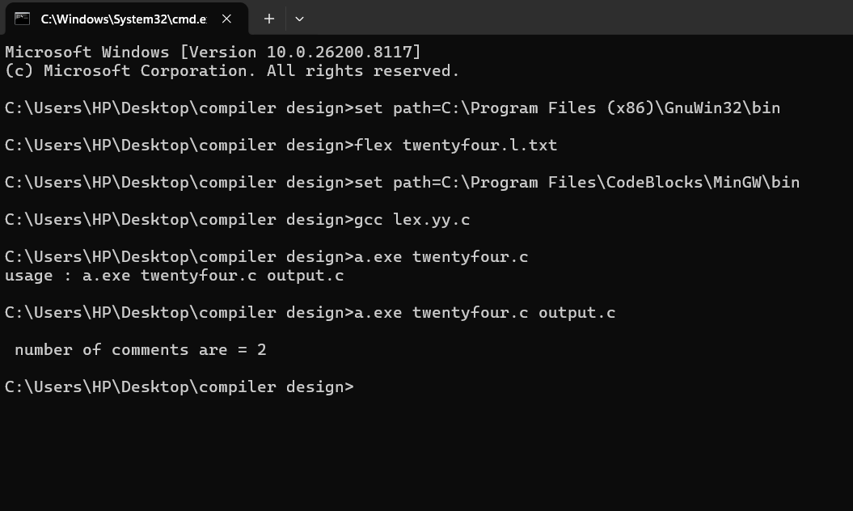

Output File: (output.c)
include<stdio.h>
int main()
{
int a,b,c;
printf(“enter two numbers”);
scanf(“%d %d”,&a,&b);
c=a+b;
printf(“sum is %d”,c);
return 0;
}

7 : Write a LEX program to identify the capital words from the given input.

Program: (capital.l)
%%
[A-Z]+[\t\n ] { printf("%s is a capital word\n",yytext); }
. ;
%%

int main( )
{
printf("Enter String :\n");
yylex();
}
int yywrap( )
{
return 1;
}

Output:

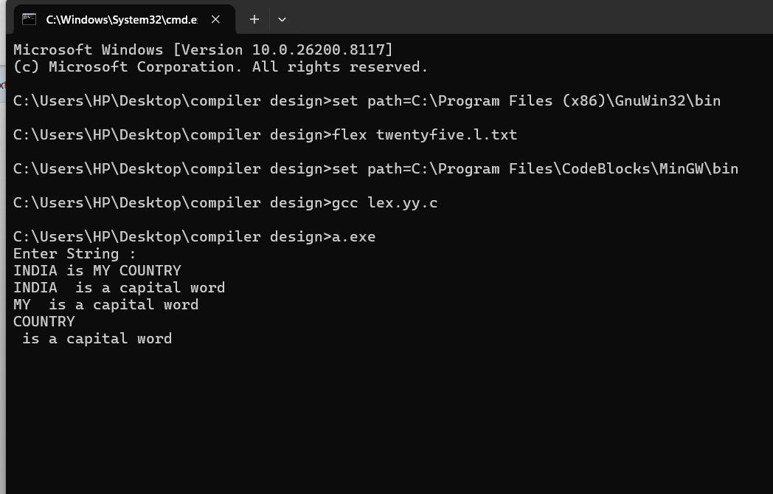

8:Write a LEX Program to check the email address is valid or not.
Program: (email_valid.l)
%{
int flag=0;
%}
%%
[a-z . 0-9]+@[a-z]+".com"|".in" { flag=1; }
%%
int main()
{
yylex();
if(flag==1)
printf("Accepted");
else
printf("Not Accepted");
}
int yywrap()
{ return 1;
}

Output:

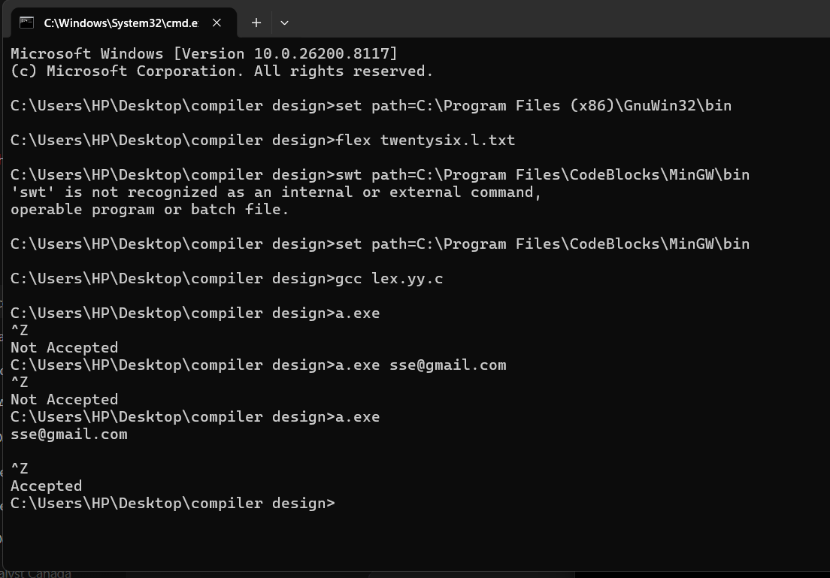

9: Write a LEX Program to convert the substring abc to ABC from the given input string

Program: (substring.l)
%{
int i;
%}
%%
[a-z A-Z]* { for(i=0;i<=yyleng;i++)
{ if((yytext[i]=='a')&&(yytext[i+1]=='b')&&(yytext[i+2]=='c'))
{ yytext[i]='A';
yytext[i+1]='B';
yytext[i+2]='C';
}
}
printf("%s",yytext);
}

[\t]* return 1;
.* {ECHO;}
\n {printf("%s",yytext);}
%%
int main()
{
yylex();
}
int yywrap()
{
return 1;
}

Output:
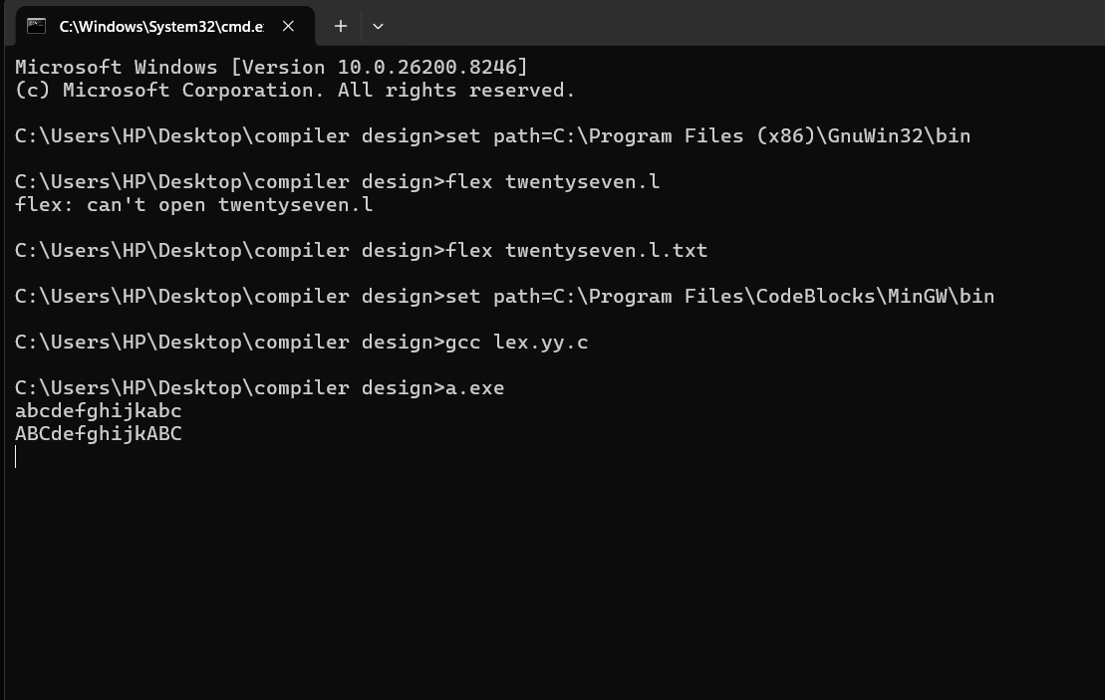

10:Implement a LEX program to check whether the mobile number is valid or not.
Program: (mobile.l)
%%
[1-9][0-9]{9} {printf("\nMobile Number Valid\n");}
.+ {printf("\nMobile Number Invalid\n");}
%%
int main()
{
printf("\nEnter Mobile Number : ");
yylex();
printf("\n");
return 0;
}
int yywrap()
{ }

Output:

