11: Implement Lexical Analyzer using LEX or FLEX (Fast Lexical Analyzer). The program should separate the tokens in the given C program and display them with the appropriate caption.
Input Source Program: (sample.c)
#include<stdio.h>
void main()
{ int a,b,c = 30;
printf("hello");
}
Aim
To implement a lexical analyzer using LEx that identifies tokens in a C program.
Algorithm
- Read C source program.
- Identify keywords.
- Identify identifiers.
- Identify operators.
- Identify special symbols.
- Display corresponding token type.
PROGRAM:
%{
#include<stdio.h>
%}

%%
"#include<stdio.h>" { printf("Header File\n"); }
"int"|"void" { printf("Keyword: %s\n", yytext); }
"main" { printf("Function: %s\n", yytext); }
[a-zA-Z_][a-zA-Z0-9_]* { printf("Identifier: %s\n", yytext); }
[0-9]+ { printf("Number: %s\n", yytext); }
"=" { printf("Operator: %s\n", yytext); }
";" { printf("Delimiter: %s\n", yytext); }
\".*\" { printf("String: %s\n", yytext); }
. ;
%%

int main(){ yylex(); return 0; }
int yywrap(){ return 1; }
RESULT: Tokens are identified and printed with categories like Keyword, Identifier, Operator, etc.

OUTPUT: 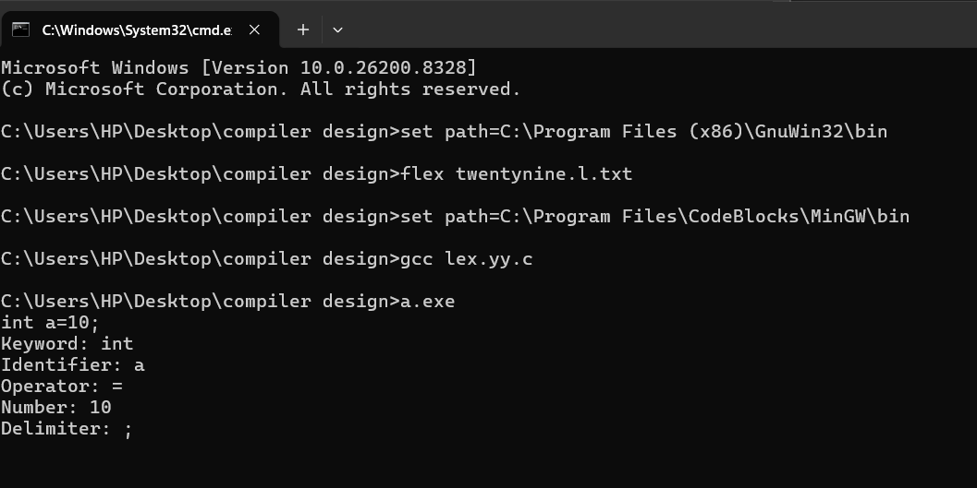
12: Keywords are predefined, reserved words used in programming that have special meanings to the compiler. Keywords are part of the syntax and they cannot be used as an identifier. In general, there are 32 keywords. The prime function of Lexical Analyser is token Generation. Among the 6 types of tokens, differentiating Keywords and identifiers is a challenging issue. Thus write a LEX program to separate keywords and identifiers.
Aim
To distinguish keywords and identifiers using LEX.
Algorithm
- Define keyword patterns
- Define identifier pattern
- Compare input
- Print type
- Stop
PROGRAM:
%{
#include<stdio.h>
%}

%%
"int"|"float"|"if"|"else" { printf("Keyword\n"); }
[a-zA-Z_][a-zA-Z0-9_]* { printf("Identifier\n"); }
%%

int main(){ yylex(); }
int yywrap(){ return 1; }
OUTPUT: 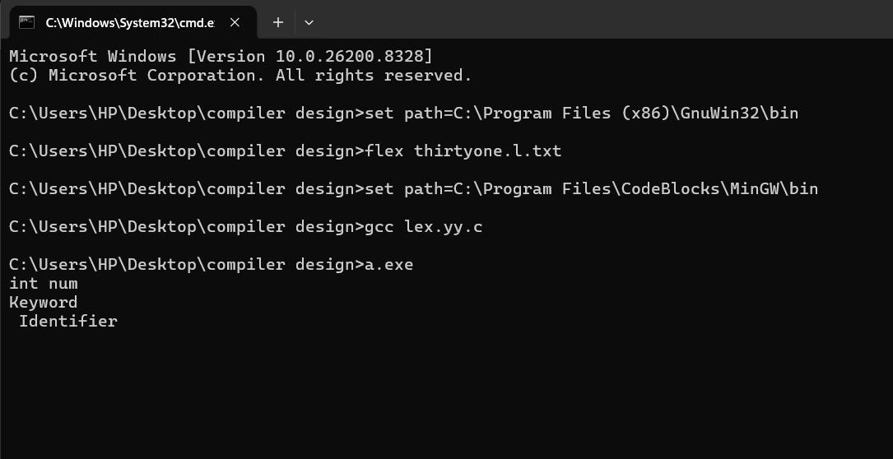
Result
Keywords and identifiers are correctly classified.
13: Write a LEX program to identify and count positive and negative numbers.
Aim
To identify and count positive and negative numbers.
Algorithm
- Initialize counters
- Match positive numbers
- Match negative numbers
- Increment counters
- Display result
Program:

%{
#include<stdio.h>
int p=0,n=0;
%}

%%
-[0-9]+ { n++; }
[0-9]+ { p++; }
%%

int main()
{
yylex();
printf("Positive=%d\nNegative=%d\n",p,n);
}

int yywrap(){ return 1; }
Output
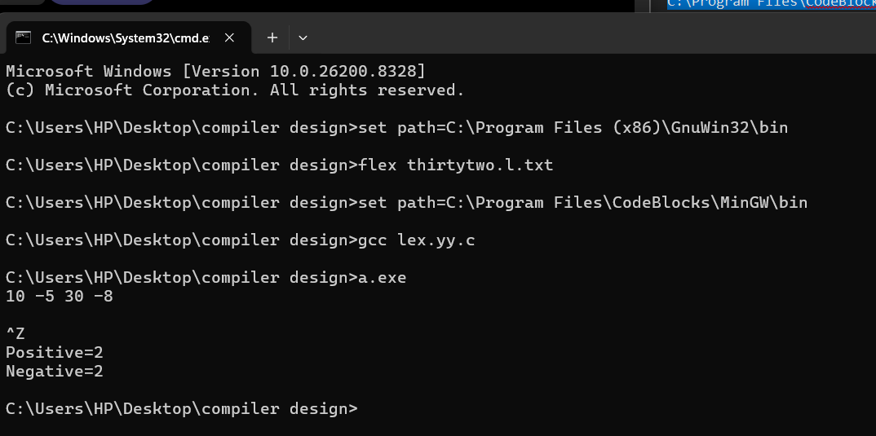
Result
Displays count of positive and negative numbers.

14: A networking company wants to validate the URL for its clients. Write a LEX program to implement the same.
Aim
To validate URL format.
Algorithm
- Define URL pattern
- Match input
- Print valid/invalid
Program
%{
#include<stdio.h>
%}

%%

http:\/\/[a-zA-Z0-9./]+ { printf("Valid URL\n"); }
https:\/\/[a-zA-Z0-9./]+ { printf("Valid URL\n"); }
ftp:\/\/[a-zA-Z0-9./]+ { printf("Valid URL\n"); }

.+ { printf("Invalid URL\n"); }

%%

int main()
{
yylex();
return 0;
}

int yywrap()
{
return 1;
}

Output
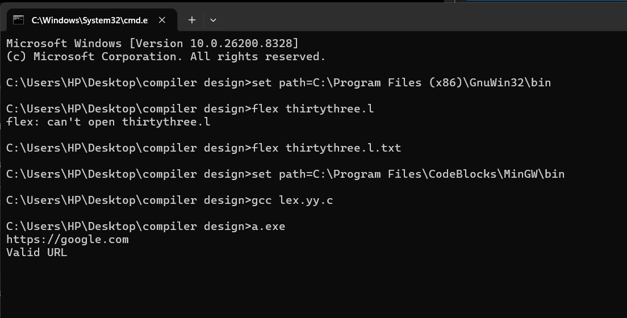
Result
Valid URLs are accepted; others rejected.
15: School management wants to validate the DOB of all students. Write a LEX program to implement it.
Aim
To validate date of birth format (DD/MM/YYYY).
Algorithm
- Define date pattern
- Match input
- Print validity
Code
%{
#include<stdio.h>
%}
%%
[0-3][0-9]/[0-1][0-9]/[0-9]{4}
{ printf("Valid DOB\n"); }
.+
{ printf("Invalid DOB\n"); }
%%
int main(){ yylex(); }
int yywrap(){ return 1; }
Output

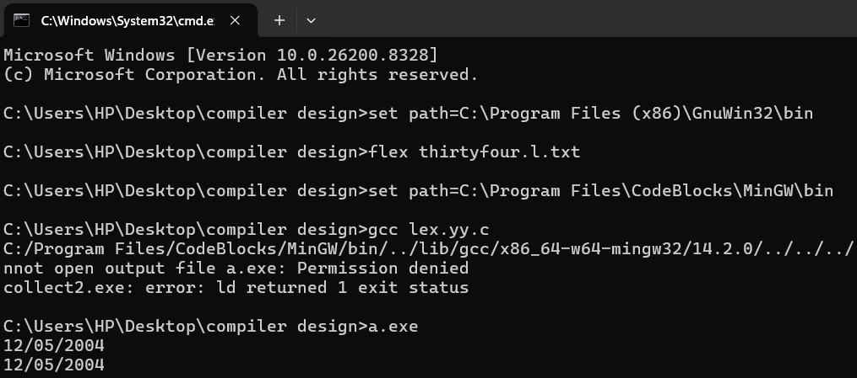

Result
DOB is validated based on format.

16: Write a LEX program to check whether the given input is a digit or not.
Aim
To check whether input is a digit.
Algorithm
- Read input
- Match digit
- Print result
Code
%{
#include<stdio.h>
%}
%%
[0-9] { printf("Digit\n"); }
. { printf("Not a Digit\n"); }
%%
int main(){ yylex(); }
int yywrap(){ return 1; }
Output
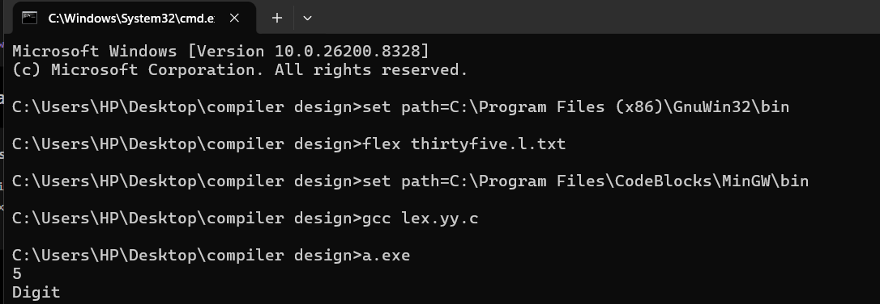
Result
Identifies whether input is a digit.
17: A School student was asked to do basic mathematical operations. Implement a LEX program to implement the same.
Aim
To perform basic arithmetic operations.
Algorithm
- Read expression
- Identify operator
- Perform operation
- Print result
Code
%{
#include<stdio.h>
int a,b;
%}
%%
[0-9]+ { a = atoi(yytext); }
"+" { scanf("%d",&b); printf("Sum=%d\n", a+b); }
"-" { scanf("%d",&b); printf("Diff=%d\n", a-b); }
"*" { scanf("%d",&b); printf("Mul=%d\n", a*b); }
"/" { scanf("%d",&b); printf("Div=%d\n", a/b); }
%%
int main(){ yylex(); }
int yywrap(){ return 1; }
Output
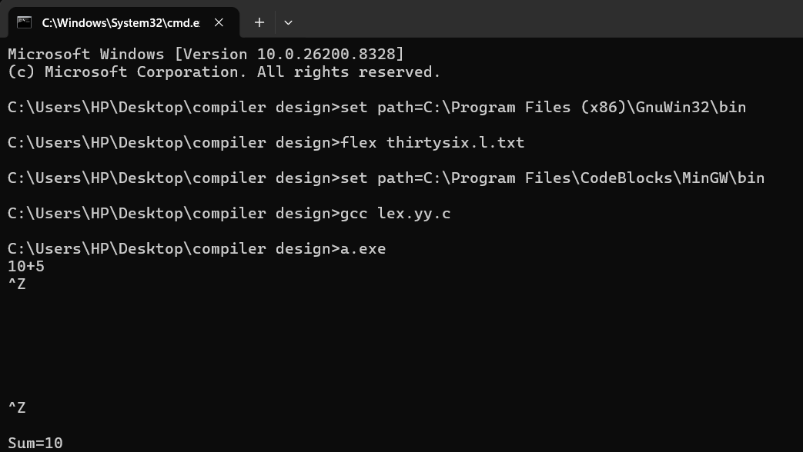
Result
Performs arithmetic operations.

18: Write a Lex program to count the frequency of the given word in a given sentence.
Aim
To count occurrences of a word.
Algorithm
- Read word
- Match occurrences
- Count
- Display
Code
%{
#include<stdio.h>
int count=0;
%}
%%
"hello" { count++; }
%%
int main(){
yylex();
printf("Count=%d\n", count);
}
int yywrap(){ return 1; }
Output
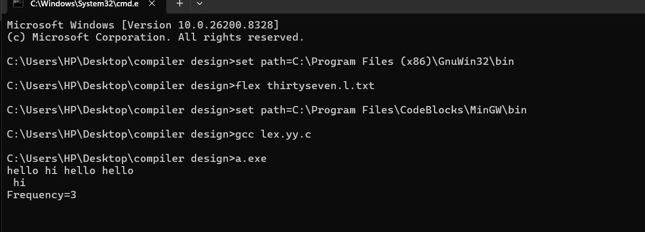
Result
Displays frequency of the word.

19:Write a Lex program to find the length of the longest word
.Aim
To find longest word in input.
Algorithm
- Read words
- Compare lengths
- Store max
- Print result
Code
%{
#include<stdio.h>
int max=0;
%}
%%
[a-zA-Z]+ {
if(yyleng > max)
max = yyleng;
}
%%
int main(){
yylex();
printf("Longest length=%d\n", max);
}
int yywrap(){ return 1; }
Output
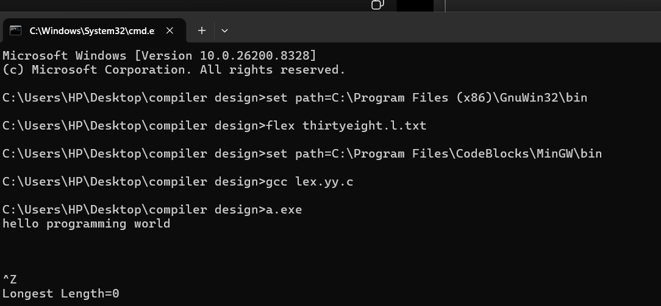
Result
Displays longest word length.

20:Write a Lex code to replace a word with another word in a file
Aim
To replace a word with another word.
Algorithm
- Read input
- Match target word
- Replace
- Print output
Code
%{
#include<stdio.h>
%}
%%
"hello" { printf("hi"); }
. { ECHO; }
%%
int main(){ yylex(); }
int yywrap(){ return 1; }
Output
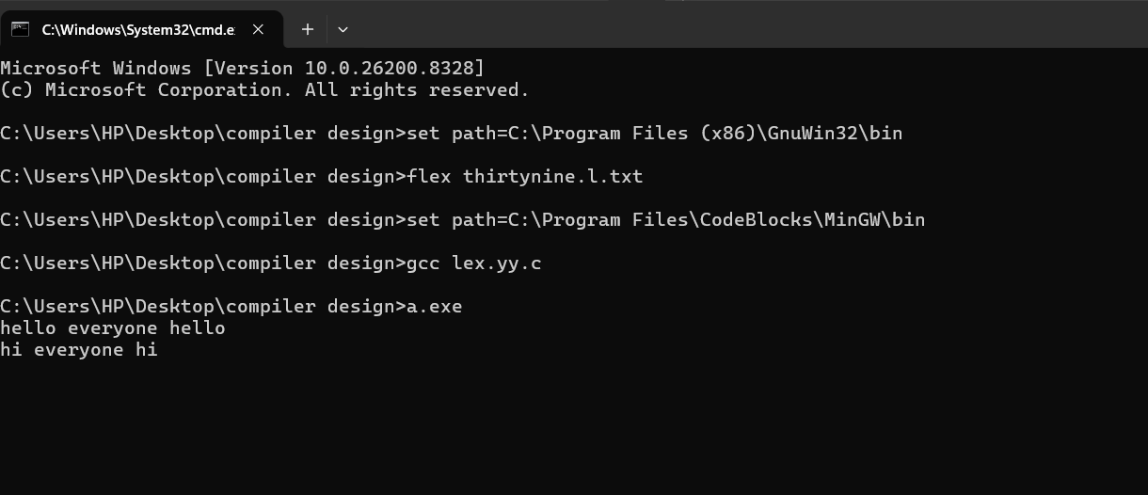
Result
All occurrences of "hello" are replaced with "hi".

