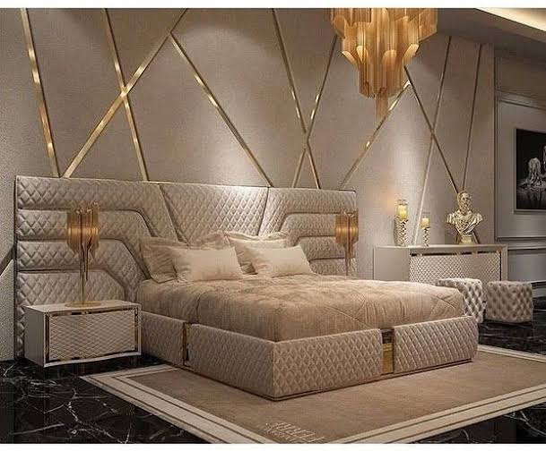

For wall attached to bed, same design as in photo. Chandler and light design can be similar to this photo.

Right side of bed, l shaped small sitting place must be added

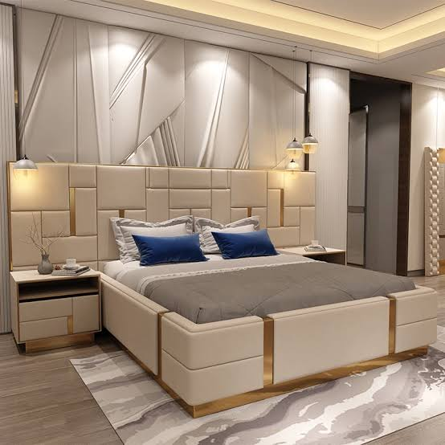

Bed design and back padding will be something like this.

**Left side wall of bedroom**:

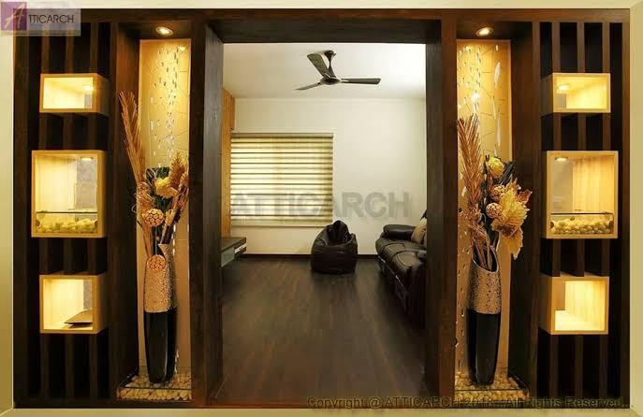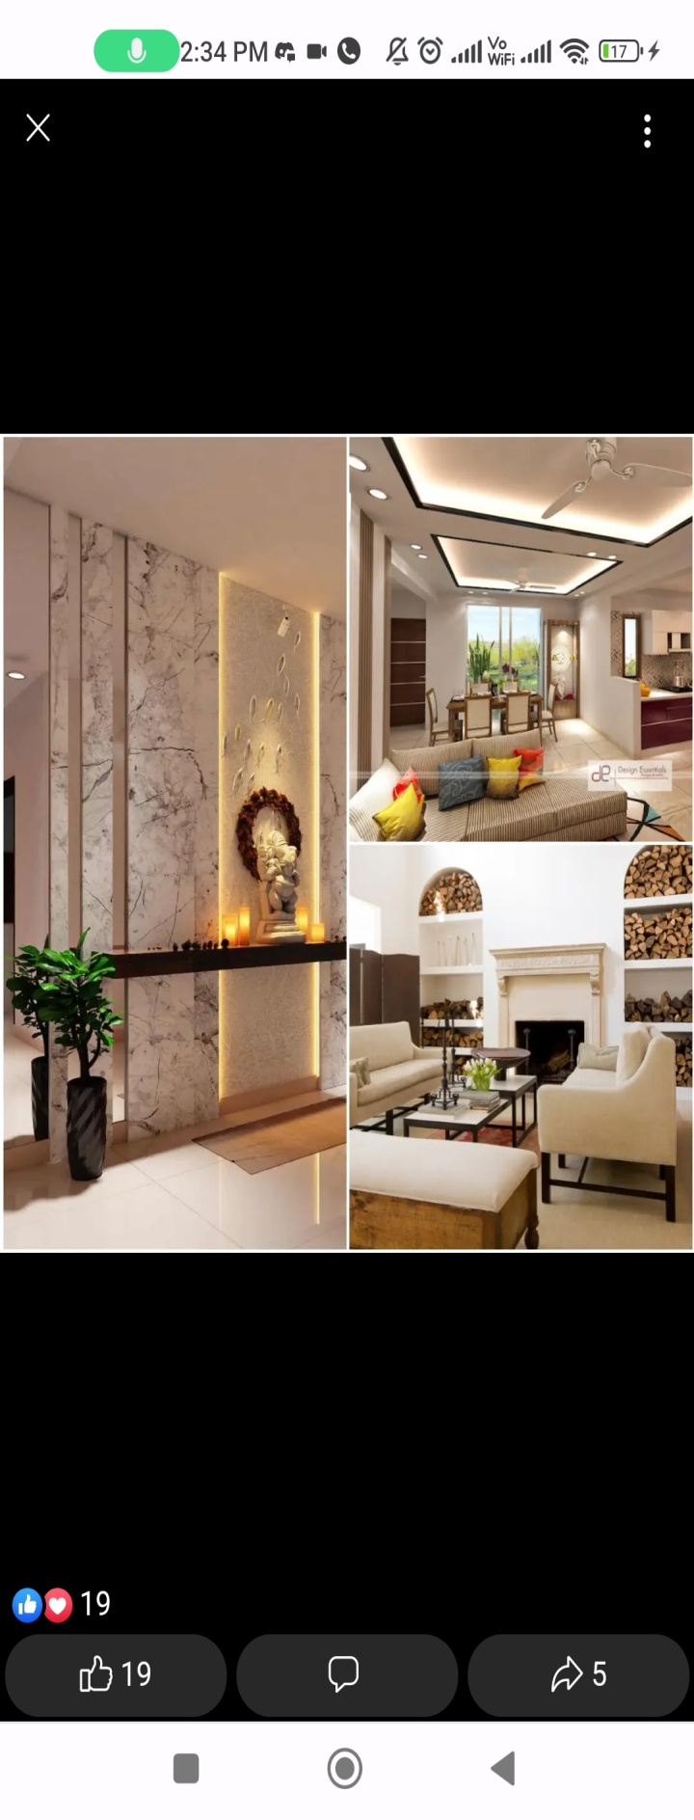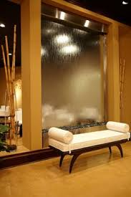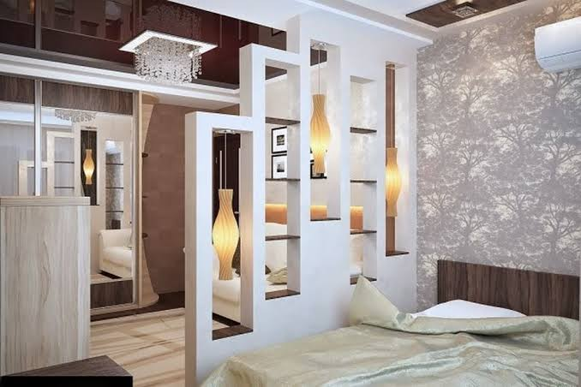

Left side wall can be a mix of all this. It can have a glass waterfall (not see through from other side), Marble slab wall, show piece or plant holder of different shapes.

**Tv unit**

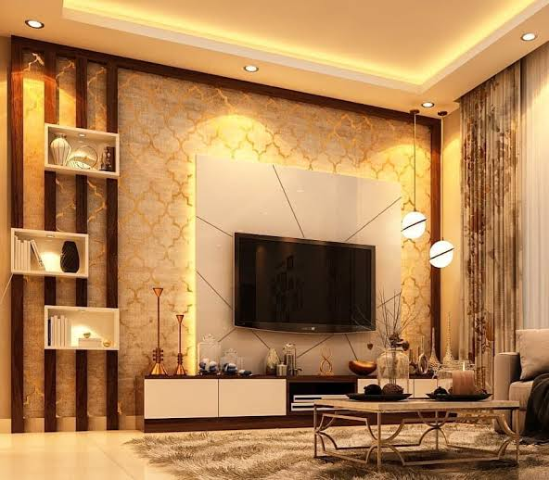

Tv unit wall, balcony side , there should be a study table. Design mentioned with arrow will be shifted to balcony side and it will be shifted upwards so that there can be a work desk.

**In walk in closet:**

* One wall can be of this rough stone pattern with some plant holder, below that Small sitting area like sopha

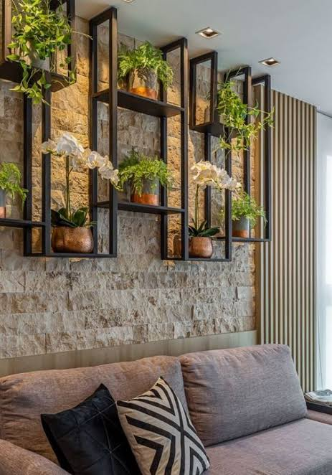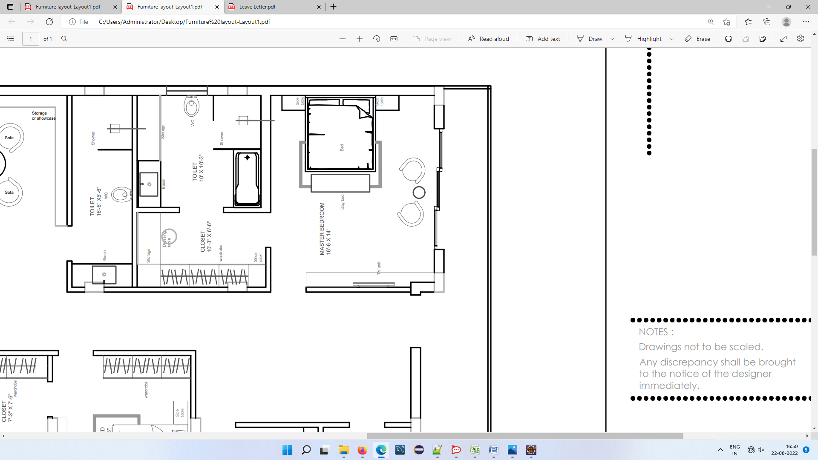

* **Walk in closet door(one or two) can have a full length mirror**
* **Inside wardrobe light**

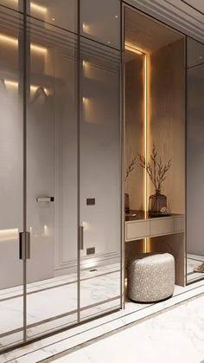

**Balcony:**

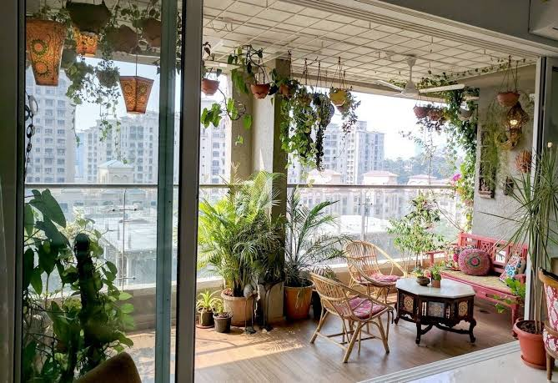

**In balcony side Transparent wall**

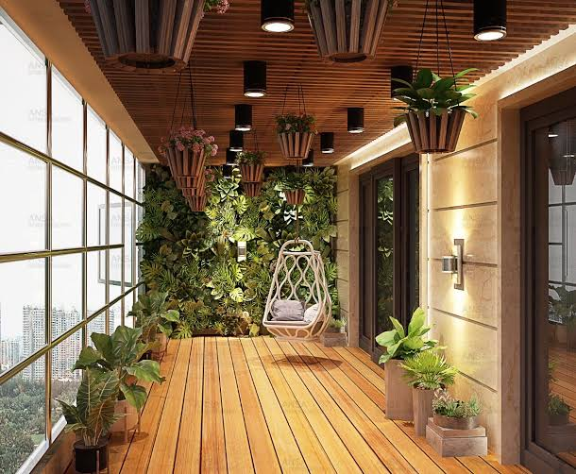

**Balcony wall, light and plant holding probation on top**

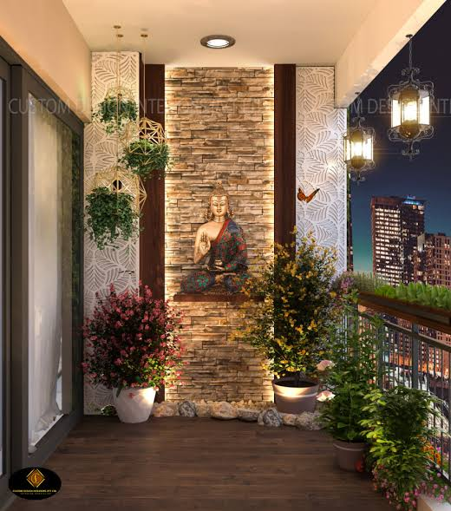

**Balcony left side wall design.**

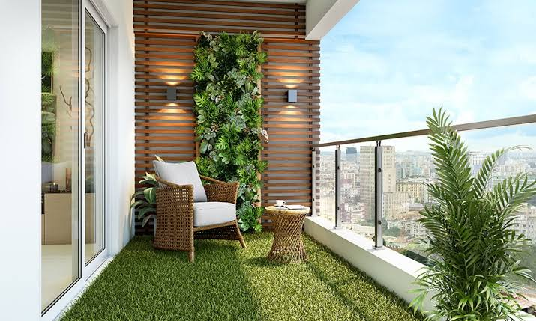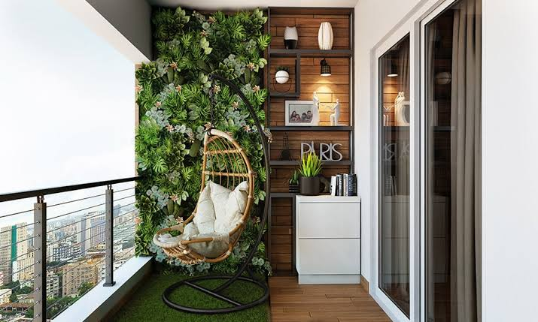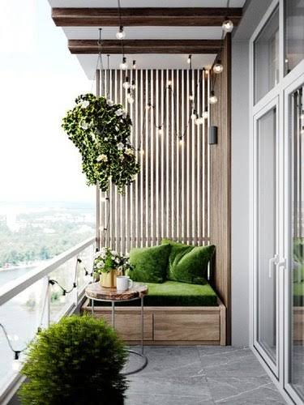

**Right side wall of balcony, can have any of ds 3 design with a sofa attached.**