Cost-Aware Credit Card Fraud Detection
A Dollar-Weighted, Cross-Validation-Rigorous Approach to Fraud Model Selection
Amrita Behura
Master of Data Science, UNSW
Project Report
Final model: XGBoost | Threshold: 0.82 | Test-set expected cost: $3,983.45

Table of Contents
1. Executive Summary
2. Business Problem & Approach
3. Dataset Overview
4. Exploratory Findings
5. Modeling Approach
6. Cost-Sensitive Threshold Selection
7. Capacity Analysis
8. Interpretability & Error Analysis
9. Putting the Result in Perspective: Annual Scale
10. Limitations & Future Work
11. Conclusion

1. Executive Summary
This project builds and evaluates a fraud detection system for credit card transactions, with a specific focus on translating model output into real business cost rather than optimizing an abstract accuracy metric. The analysis covers 284,807 transactions, of which 492 (0.17%) are fraudulent — a level of class imbalance that shapes every methodological decision in this project, from evaluation metric choice to threshold selection.

Headline Results
- Final model: XGBoost, selected over Random Forest and Logistic Regression baselines, deployed at a decision threshold of 0.82.
- Selection criterion: a dollar-weighted cost function — missed fraud (false negatives) costed at the transaction's actual amount, false positives costed at a flat $15 investigation charge — rather than a generic accuracy metric or an arbitrary cost ratio.
- Test-set result: an expected cost of $3,983.45, correctly identifying 80 of 98 fraud cases (18 missed) with only 10 false positives across 56,864 legitimate transactions.
- Capacity finding: reviewing just the highest-risk 0.5% of transactions captures 89.8% of all fraud, offering a directly actionable resourcing recommendation for a fraud review team.
- Annual-scale illustration: extrapolated to this dataset's approximate implied annual volume (~52 million transactions), the model's residual expected cost is on the order of $3.6 million per year (an order-of-magnitude illustration, not a forecast — see Section 10).

What Makes This Analysis Different
Most public analyses of this dataset stop at reporting the best PR-AUC or F1-score. This project instead treats model selection as a business decision: every threshold and model choice is grounded in a defensible cost framework, and the final result is validated through a disciplined train/validation/test methodology designed specifically to prevent decision-influenced, overly optimistic metrics.
During development, cross-validation scores during hyperparameter tuning came back suspiciously close to perfect (PR-AUC > 0.999). Rather than reporting this figure, the anomaly was investigated and traced to a well-documented but frequently overlooked pitfall: SMOTE oversampling applied before cross-validation splitting, which allows synthetic minority-class points to leak across folds. The fix — moving SMOTE inside the cross-validation pipeline — is standard best practice, and correcting it here (rather than reporting the inflated figure) reflects the validation discipline this project is built around. Full detail is provided in Section 6.

2. Business Problem & Approach
Fraud detection is fundamentally a cost-asymmetric decision problem. A missed fraudulent transaction (false negative) directly costs the business the transaction amount, while a false alarm (false positive) costs analyst investigation time and, potentially, customer friction. Standard classification metrics — accuracy, even F1-score — do not naturally reflect this asymmetry, and can lead to model and threshold choices that look strong on paper but are financially suboptimal in deployment.
This project's approach is structured around four questions a fraud operations team would actually ask, rather than a single technical question:
- Which model best distinguishes fraud from legitimate transactions under severe class imbalance?
- At what decision threshold does the model minimize real financial cost, not just a generic metric?
- If a review team has limited capacity, how should that capacity be allocated for maximum fraud capture?
- Can the model's decisions be explained and trusted well enough for audit and stakeholder communication?
Each of these questions is addressed in a dedicated stage of the analysis, summarized in Section 5 onward.

3. Dataset Overview
The dataset consists of 284,807 credit card transactions made by European cardholders over a two-day period, sourced from a widely used public fraud detection benchmark (Kaggle / ULB Machine Learning Group).

Structure
Attribute | Detail
Total transactions | 284,807
Fraudulent transactions | 492 (0.17%)
Features | 30 numerical features: Time, Amount, and 28 PCA-transformed components (V1–V28)
Missing values | None
Target variable | Binary (1 = fraud, 0 = legitimate)
Table 1. Dataset structure summary.

A Note on Feature Anonymization
For confidentiality, 28 of the 30 features (V1–V28) are the output of a PCA transformation and cannot be interpreted in business terms — only their statistical importance can be assessed, not their real-world meaning. Time and Amount remain in their original, interpretable form, and both proved analytically valuable throughout this project (Sections 4, 8, and 9).

4. Exploratory Findings

4.1 Class Imbalance
Fraudulent transactions represent approximately 0.17% of the dataset. This extreme imbalance has direct methodological consequences: accuracy is not a meaningful evaluation metric (a model predicting “legitimate” for every transaction would be 99.83% accurate while catching zero fraud), so Precision-Recall AUC (PR-AUC) is used as the primary ranking metric throughout this project, with ROC-AUC retained only as a secondary signal.

4.2 Fraud Rate by Transaction Amount — A U-Shaped Pattern
Examining fraud rate across transaction amount reveals a distinct U-shaped pattern: fraud rate is highest among very low-value transactions, drops sharply through the mid-range, and rises again at high transaction values.
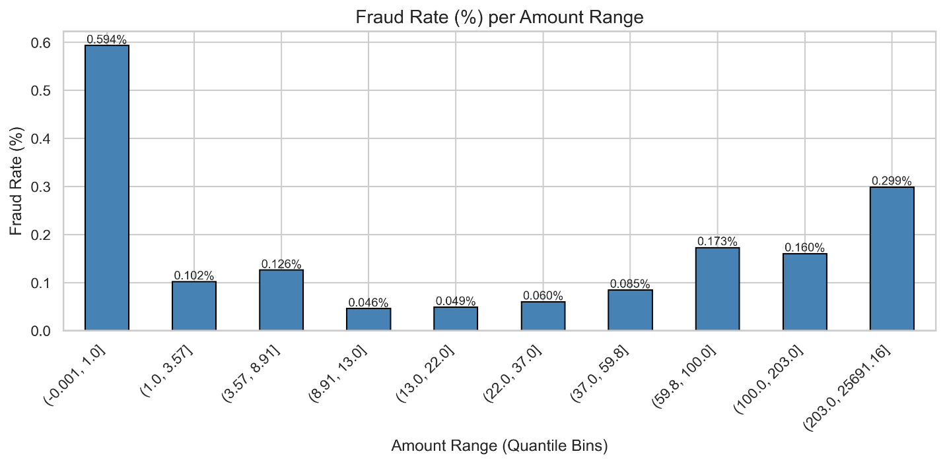
Figure 1. Fraud rate (%) by transaction amount, quantile-binned.
- Very low amounts (≤$1) show the highest fraud rate of any bin — consistent with “card-testing” behavior, where a stolen card is validated with a trivial purchase before larger fraudulent activity is attempted.
- Fraud rate drops through the $1–$60 range, dominated by ordinary legitimate spending.
- Fraud rate rises again above roughly $60–$200, consistent with “cash-out” behavior following a successful card validation.
This pattern directly informed the project's cost modeling (Section 7) and is referenced again in the error analysis (Section 9).

4.3 Fraud Rate by Hour of Day
Fraud rate also varies meaningfully by hour of day, with the highest-risk window falling between approximately 1am and 4am — several times the overall baseline fraud rate. This finding is used in Section 8's capacity analysis to propose a time-aware review prioritization alongside the primary transaction-volume-based recommendation.
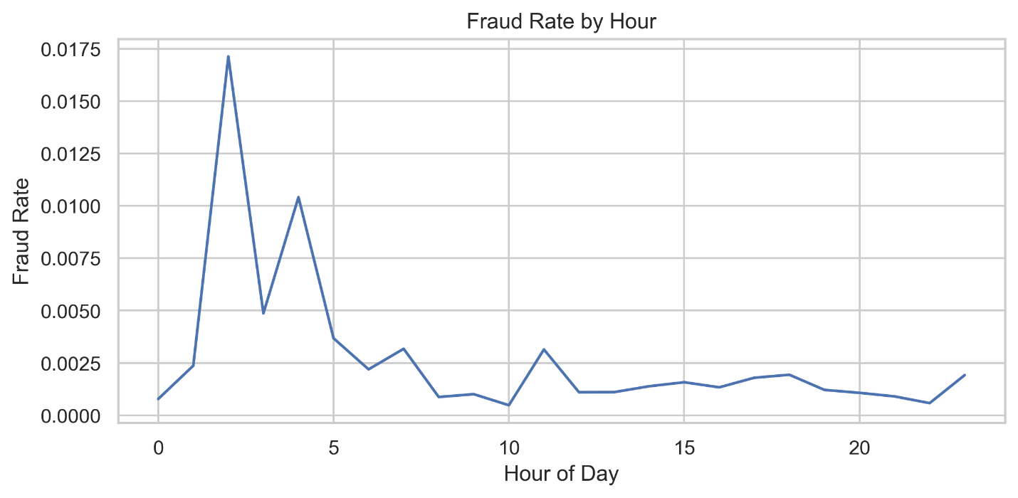
Figure 2. Fraud rate (%) by hour of day.

5. Modelling Approach

5.1 Train / Validation / Test Methodology
A stratified three-way split (60% train, 20% validation, 20% test) is used, rather than a simple train/test split. This is a deliberate methodological choice: the training set is used only to fit model parameters, the validation set is used for every model comparison, tuning decision, and threshold selection, and the test set is touched exactly once — at the very end — to report final, official performance. This discipline exists specifically to prevent an inflated, decision-influenced final metric, a risk that materialized and was corrected during this project (Section 6.3).
Split | Transactions | Fraud Cases | Role
Train | 170,883 | 295 | Fit model parameters
Validation | 56,962 | 99 | All model, tuning, and threshold decisions
Test | 56,962 | 98 | Final result, reported once
Table 2. Train / validation / test split.

5.2 Baseline Model Comparison
Three baseline model families were compared on the validation set: Logistic Regression (with class weighting), Random Forest, and XGBoost.
Model | ROC-AUC | PR-AUC
XGBoost | 0.9672 | 0.8012
Random Forest | 0.9597 | 0.7957
Logistic Regression | 0.9718 | 0.6750
Table 3. Baseline model comparison, validation set.
Tree-based ensemble models (Random Forest and XGBoost) show clearly superior minority-class ranking performance (PR-AUC) and were shortlisted for hyperparameter tuning. Logistic Regression shows the highest ROC-AUC but the lowest PR-AUC by a wide margin — an expected pattern under severe imbalance, since ROC-AUC evaluates ranking broadly while PR-AUC focuses specifically on minority-class precision and recall.

5.3 Hyperparameter Tuning
Random Forest and XGBoost were tuned using RandomizedSearchCV with 3-fold stratified cross-validation, optimizing for PR-AUC.

5.4 Diagnosing and Correcting a Cross-Validation Leakage Issue
An earlier iteration of this tuning step applied SMOTE oversampling to the training data once, upfront, before cross-validation splitting. This produced cross-validated PR-AUC scores in excess of 0.999 — an implausibly strong result for a genuinely difficult, real-world fraud detection problem.
Investigation traced this to a specific and well-documented pitfall: because SMOTE generates synthetic minority-class points by interpolating between real fraud cases that are close together in feature space, applying it before cross-validation splitting means a synthetic point and its real “parent” fraud case can land in different cross-validation folds. The model then effectively validates against near-duplicates of what it just trained on, inflating the cross-validated score without reflecting genuine ability to generalize to unseen fraud patterns.
The correction was to restructure SMOTE as a step inside an imbalanced-learn pipeline object, ensuring resampling is fit fresh within each fold's training portion only, with no synthetic point able to influence the corresponding held-out fold. This is the standard, correct approach for combining SMOTE with cross-validation. Following the fix, cross-validated PR-AUC scores fell to a realistic 0.840 (Random Forest) and 0.848 (XGBoost) — figures now closely tracking the models' actual validation-set performance, which is itself a strong indicator that the cross-validation process is trustworthy.
Critically, this correction changed the trustworthiness of the validation process, but not the final model ranking: XGBoost was, and remained, the top-performing model both before and after the fix.
Model | Tuned Validation PR-AUC | Tuned Validation ROC-AUC
XGBoost | 0.8150 | 0.9673
Random Forest | 0.8030 | 0.9734
Table 4. Tuned model performance, validation set, post-correction.
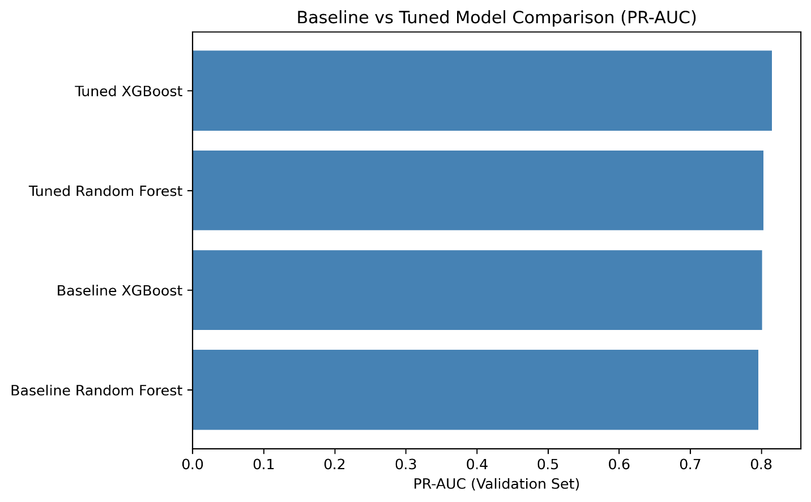
Figure 3. Baseline vs. tuned model comparison (PR-AUC).

6. Cost-Sensitive Threshold Selection

6.1 A Dollar-Weighted Cost Framework
Rather than using a generic classification threshold (e.g., the default 0.5) or an arbitrary unit-cost ratio (e.g., “false negative = 10, false positive = 1”), this project defines an explicit, financially grounded cost function:
- False Negative (missed fraud): costed at the transaction's actual dollar amount — missing a $50 fraud and missing a $5,000 fraud are not treated as equally costly.
- False Positive (legitimate transaction flagged): costed at a flat $15 investigation charge, reflecting an estimated ~15 minutes of analyst time at a loaded cost of approximately $50–$60/hour.
The $15 false-positive figure is an illustrative assumption, stated explicitly rather than presented as a verified industry benchmark — a limitation acknowledged directly here rather than glossed over.

6.2 Threshold Optimization
Each model's decision threshold was swept from 0.00 to 1.00 on the validation set, computing total expected dollar cost at every threshold. Each model was evaluated at its own optimal threshold, since Random Forest and XGBoost produce differently calibrated probability outputs — forcing both to a single shared threshold would not represent a fair comparison.
Model | Optimal Threshold | Minimum Expected Cost (Validation)
XGBoost | 0.82 | $2,987.91
Random Forest | 0.48 | $3,122.15
Table 5. Cost-optimal threshold per model, validation set.
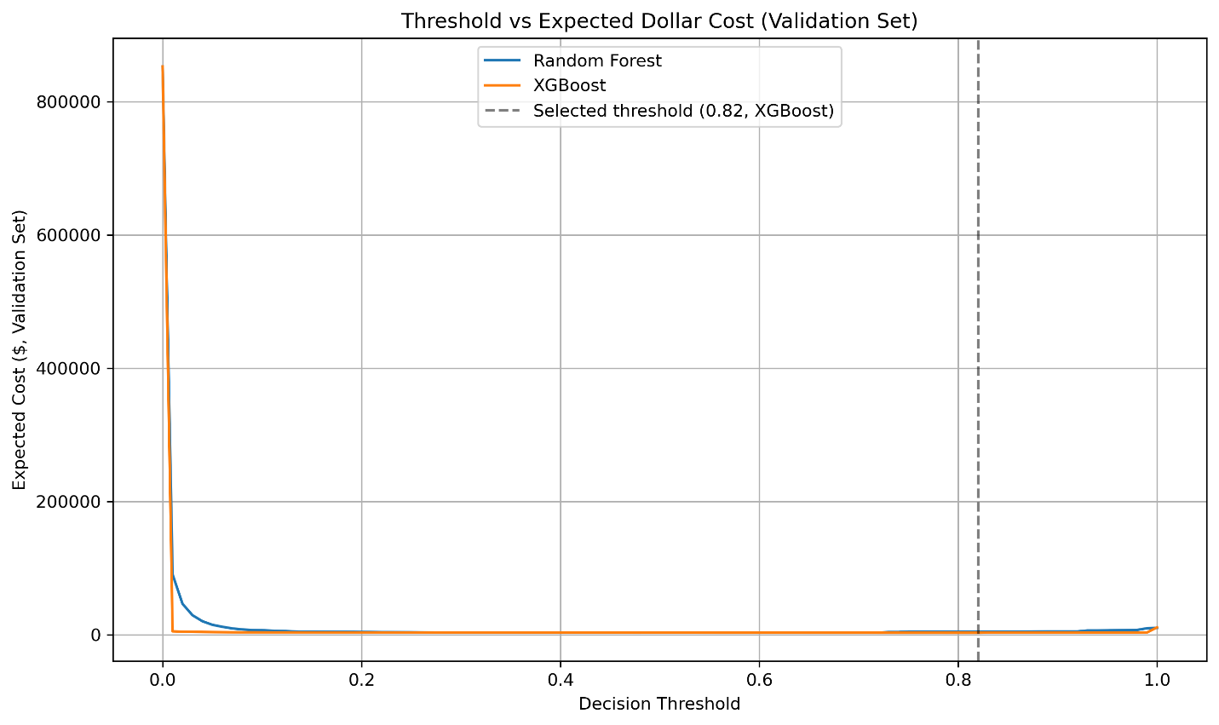
Figure 4. Expected cost vs. decision threshold, validation set.
XGBoost achieves the lower minimum cost and was selected as the final model, at a threshold of 0.82.

6.3 Final, One-Time Test Set Evaluation
With the model and threshold fixed using validation data alone, a single evaluation was performed on the previously untouched test set — the one honest, decision-uninfluenced measurement of real-world performance for this project.
Metric | Result
Model | XGBoost
Threshold | 0.82
Expected Cost | $3,983.45
True Positives (fraud caught) | 80 of 98
False Negatives (fraud missed) | 18
False Positives | 10 of 56,864
Table 6. Final test-set result — the official, one-time reported outcome of this project.
The validation cost ($2,987.91) and test cost ($3,983.45) are consistent in magnitude — a meaningful contrast to an earlier, uncorrected iteration of this analysis, in which the SMOTE cross-validation leakage produced an artificially perfect validation result ($0 expected cost) that did not hold on the test set. This consistency, achieved through disciplined validation/test separation, corrected cross-validation, and a realistic cost function, gives confidence that the reported result reflects genuine model performance rather than a methodological artifact.
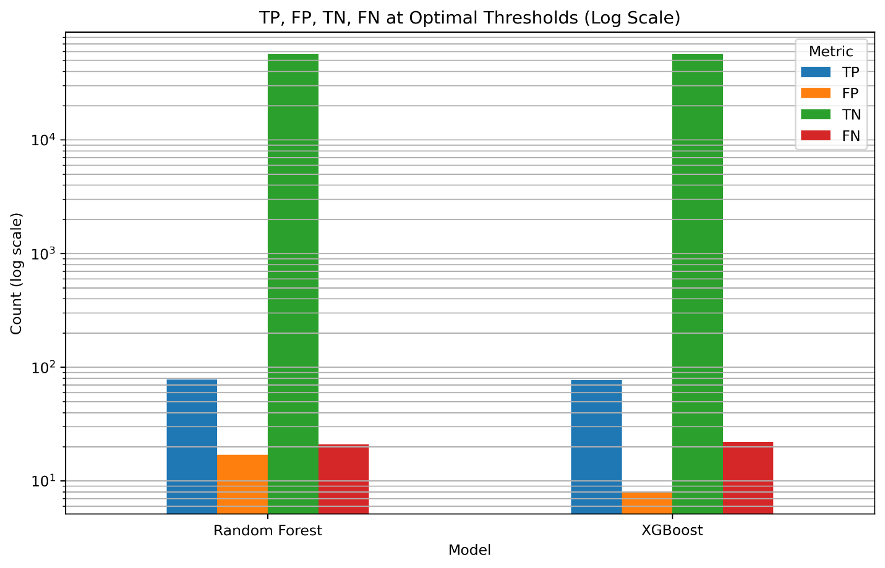
Figure 5. Confusion matrix comparison (validation set), Random Forest vs. XGBoost, log scale.

7. Capacity Analysis
A decision threshold answers “which transactions should be flagged,” but a fraud review team typically operates under a separate, practical constraint: a limited number of alerts that can be manually investigated per day. Capacity analysis reframes the question accordingly: if a team can review only the top X% of transactions by predicted risk, how much fraud would actually be caught?
Review Budget | Transactions Reviewed | Fraud Caught | Fraud Capture Rate
0.5% | 285 | 88 of 98 | 89.8%
1.0% | 570 | 89 of 98 | 90.8%
2.0% | 1,140 | 90 of 98 | 91.8%
5.0% | 2,849 | 91 of 98 | 92.9%
Table 7. Fraud capture rate by review-capacity budget, test set.
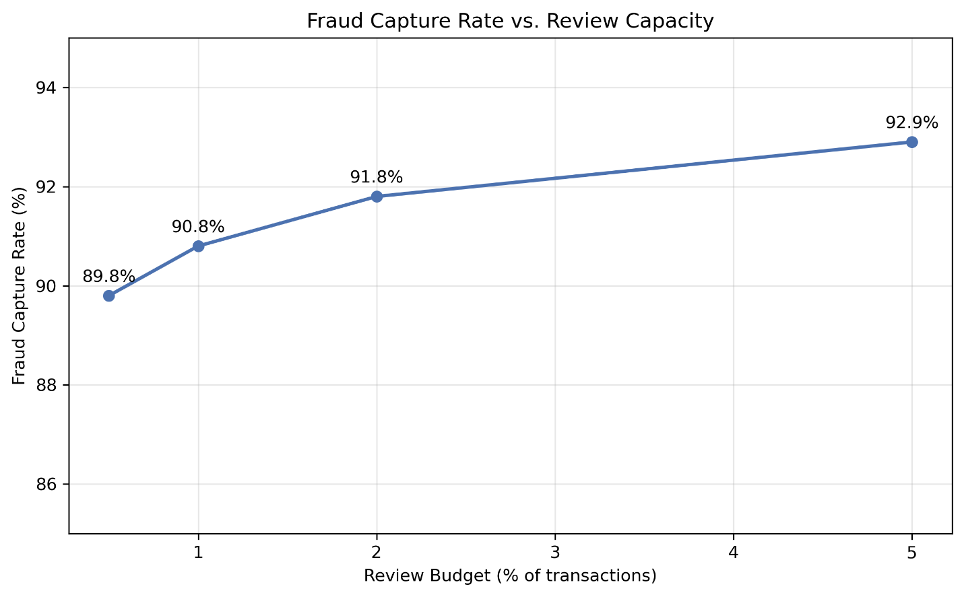
Figure 6. Fraud capture rate vs. review capacity.
Fraud risk is highly concentrated at the top of the model's ranked probability scores: reviewing just 0.5% of transactions already captures 89.8% of all fraud. Expanding the review budget tenfold, to 5%, only increases capture to 92.9% — a clear diminishing-returns pattern with direct staffing implications: a fraud team does not need to review a large share of transactions to catch the large majority of fraud.

Time-Aware Prioritization
Combining the hourly fraud-rate pattern from Section 4.3 with the capacity analysis above: if review capacity is limited, prioritizing alerts during the historically higher-risk overnight window (approximately 1am–4am) would concentrate review effort where it is statistically most likely to catch fraud, complementing the volume-based recommendation with a time-based dimension.

8. Interpretability & Error Analysis

8.1 Global Feature Importance (SHAP)
SHAP (SHapley Additive exPlanations) was used to interpret the final XGBoost model's predictions, both to understand key risk drivers and to support the kind of transparent, explainable analysis auditors and stakeholders expect from a deployed fraud model.
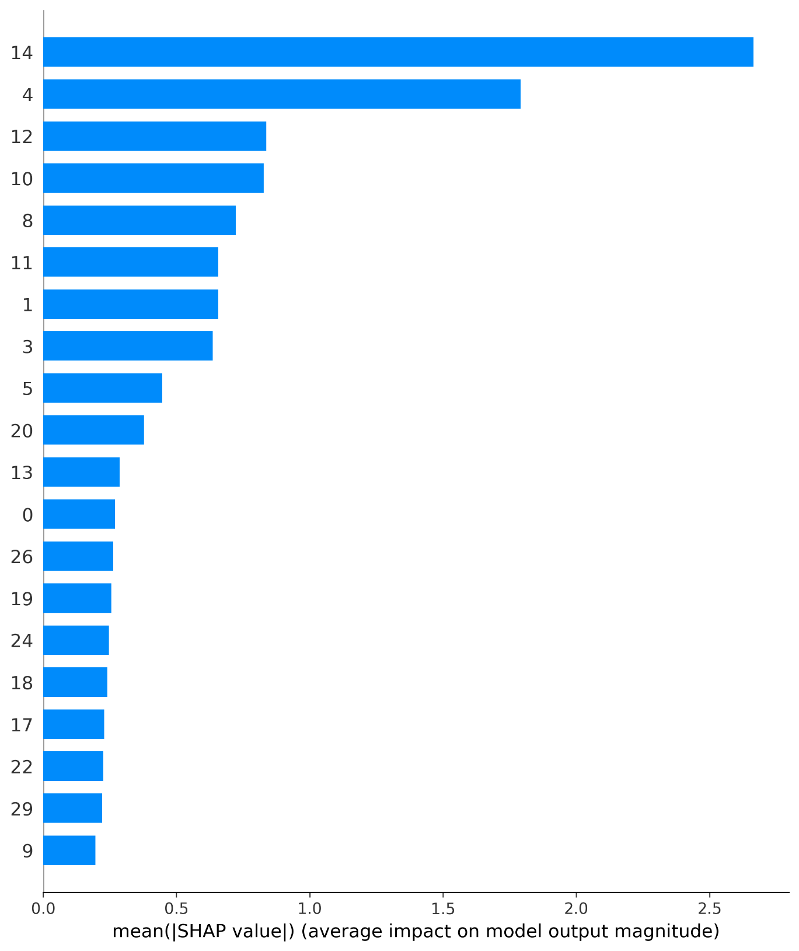
Figure 7. Global feature importance (mean absolute SHAP value), XGBoost.
Feature importance is concentrated rather than diffuse: V14 is the dominant predictor (mean |SHAP| ≈ 2.66), contributing roughly 1.5x more than the next-ranked feature, V4 (≈ 1.79). A secondary cluster of moderate contributors follows (V12, V10, V8, V11, V1, V3, each roughly 0.64–0.84), with the remaining features contributing comparatively little.
This concentration was cross-checked against Random Forest's independently computed SHAP values: six of the same features appear in both models' top groups, despite the two models using structurally different algorithms (sequential boosting vs. independent tree ensembles). This consistency increases confidence that the identified risk drivers reflect genuine underlying fraud patterns in the data, rather than an artifact of one algorithm's inductive bias.
Because V1–V28 are anonymized PCA components, their real-world business meaning cannot be stated — only their statistical importance. V14 and V4 are recommended as priority features for future drift monitoring: a meaningful shift in their distribution in production data would be an early warning that the model's core decision logic may no longer reflect current fraud patterns.

8.2 Error Analysis
A confusion matrix reports how many errors a model makes, but not what kind. Missed frauds (false negatives) and false alarms (false positives) at the deployed threshold were examined directly.
 | Missed Fraud (FN) | Caught Fraud (TP)
Count | 18 | 80
Median Amount | $4.14 | $11.51
Maximum Amount | $1,809.68 | $802.52
Table 8. Transaction amount comparison, missed vs. caught fraud.
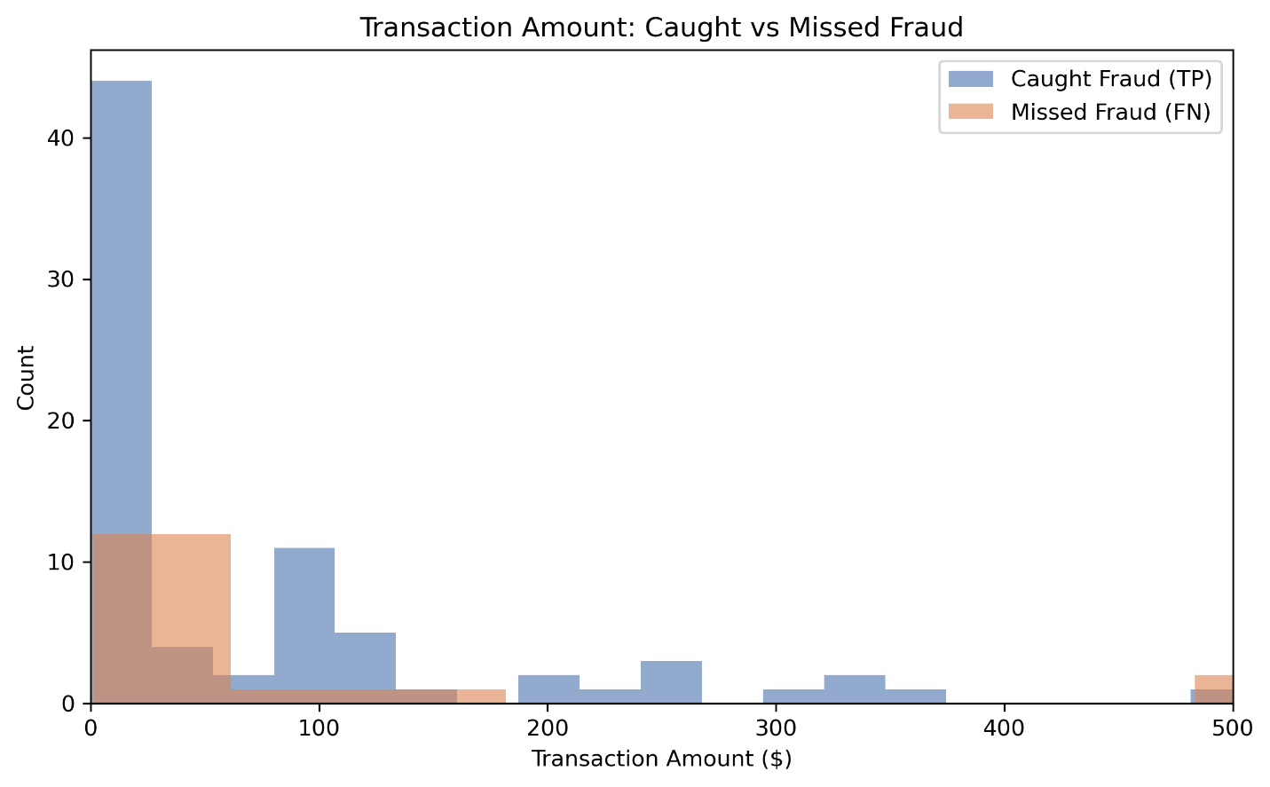
Figure 8. Transaction amount distribution, caught vs. missed fraud.
Missed fraud skews toward low transaction amounts (median $4.14 vs. $11.51 for caught fraud) — consistent with the U-shaped EDA finding (Section 4.2): very small, card-testing-style transactions are inherently harder to distinguish from ordinary small purchases. However, the missed-fraud distribution has a meaningful high-value tail, with a maximum single miss of $1,809.68 — exactly the kind of case the dollar-weighted cost function is designed to penalize most heavily.

Case Study: The Highest-Value Missed Fraud ($1,809.68)
SHAP analysis of this specific transaction reveals a genuinely close call rather than a clear model failure. Several features pushed toward a fraud prediction — most notably V14, the model's single most important feature overall, alongside V4, V10, and V12 — but these were counteracted by an even stronger pull toward “legitimate” from V7, reinforced by smaller contributions from V13, V5, and V27. The net effect was a narrow tip toward “legitimate,” resulting in a missed detection.
This illustrates that the model did not fail to recognize fraud-like signals in this transaction — it recognized several, but they were outweighed by competing signals resembling normal behavior. A practical implication: monitoring cases where a strong fraud-indicating feature like V14 is present but does not trigger a flag could serve as a useful secondary review trigger, routing high-value transactions with elevated V14 values to manual review even when the overall model score falls just under the deployed threshold.

8.3 Benchmarking Against an Unsupervised Approach
As a supplementary investigation, an Isolation Forest model — trained with no fraud labels at all — was evaluated as a proxy for a “cold-start” scenario where labeled fraud data is not yet available (e.g., a new product line or market). This analysis does not affect the model selection made in Sections 5–6; it quantifies what would be lost without labels.
Method | True Positives | False Positives
XGBoost (supervised) | 80 | 10
Isolation Forest (unsupervised) | 32 | 92
Table 9. Supervised vs. unsupervised detection, test set.
The supervised model catches 2.5x more fraud while generating 9x fewer false alarms. Isolation Forest has no notion of “fraud” specifically — it flags any statistically unusual transaction, which inevitably includes legitimate but atypical spending alongside genuine fraud. Unsupervised anomaly detection remains a reasonable fallback in a genuine cold-start scenario, but this comparison quantifies a real, substantial cost to operating without labeled data.

9. Putting the Result in Perspective: Annual Scale
The test-set result ($3,983.45) reflects a small transaction sample over a short window (the source data spans approximately 48 hours). To make this figure meaningful at a realistic operational scale, it is extrapolated using the observed per-transaction cost rate, applied to this dataset's implied annual transaction volume (~52 million transactions/year).
Metric | Value
Cost per transaction (test set) | $0.0699
Estimated annual transaction volume | 51,977,278
Estimated annual expected cost | $3,634,859.84
Table 10. Annual cost extrapolation.
Assumed Annual Transactions | Estimated Annual Expected Cost
1,000,000 | $69,932
10,000,000 | $699,317
50,000,000 | $3,496,585
100,000,000 | $6,993,171
Table 11. Sensitivity of annual cost estimate to assumed transaction volume.
This figure represents the residual expected cost under the deployed model (missed fraud plus false-positive investigation cost) — not the cost of fraud in the absence of any detection system. It is an order-of-magnitude illustration, not a precise forecast: it assumes constant fraud rate and model performance at scale, and does not account for seasonality, fraud-pattern drift over time, or a direct “no-detection-system” cost baseline. Its purpose is to translate a small-sample technical result into a scale relevant to real business decision-making.

10. Limitations & Future Work

Limitations
- Anonymized features: 28 of 30 features are PCA-transformed and cannot be interpreted in business terms — only Time and Amount are directly explainable.
- Small fraud sample: validation and test sets each contain fewer than 100 fraud cases. Granular findings (e.g., hourly miss rates) can be sensitive to small-sample noise and are reported directionally, not as statistically confirmed patterns.
- Untested temporal generalization: the dataset spans only ~48 hours. Whether the model's performance holds as fraud patterns evolve over longer periods is not evaluated here.
- Illustrative cost assumptions: the $15 false-positive investigation cost is a stated, transparent assumption, not a verified industry figure. The annual extrapolation (Section 9) is similarly an order-of-magnitude illustration, not a calibrated forecast for any specific institution.
- No comparison to a “no-model” baseline: the annual cost figure represents residual cost under the deployed model; a full cost-benefit case would compare this against the cost of having no fraud detection system at all.
- Ambiguous real-world hour labels: hour-of-day labels (e.g., "2am") are relative to the dataset's first recorded transaction, whose actual real-world clock time is not disclosed by the data source. The cyclical 24-hour fraud-rate pattern itself is genuine and reproducible, but the specific hour labels should be interpreted as positions within a recurring cycle rather than confirmed real-world clock times.

Future Work
- Segment-specific models: the U-shaped fraud-by-amount pattern (Section 4.2) suggests low-value (card-testing) and high-value (cash-out) fraud may represent distinct behavioral patterns. Whether separate models per value segment, or value-aware thresholds, would outperform a single unified model is a candidate for further investigation, though the limited number of fraud cases (492 total) constrains how robustly this could be tested with the current dataset.
- Probability calibration: this project's cost analysis depends on model probability outputs being meaningfully comparable across thresholds. A formal calibration check (e.g., reliability diagrams) was not performed and would add further rigor.
- Temporal generalization: testing model performance on chronologically later data, rather than a random split, would give a stronger signal on whether performance holds as fraud patterns evolve — though the ~48-hour window of this dataset limits how meaningful this test could be.
- Time-tiered review prioritization: the time-aware capacity recommendation (Section 7) is directional; a fuller implementation could integrate hour-of-day risk directly into a staffing-optimization model.

11. Conclusion
This project selected XGBoost, at a decision threshold of 0.82, as the final fraud detection model — not on the basis of a generic accuracy metric, but through a dollar-weighted cost framework grounded in the actual financial consequences of missed fraud and false alarms. The result, an expected cost of $3,983.45 on a held-out test set, is corroborated by three independent lines of evidence: superior validation PR-AUC, minimum expected cost, and superior F1-score at the deployed threshold — all pointing to the same model.
Equally important to the result itself is the process behind it: a disciplined train/validation/test methodology, a diagnosed and corrected cross-validation leakage issue, and transparent, stated assumptions throughout. Capacity analysis and interpretability findings extend the result into directly actionable operational recommendations, and honestly stated limitations mark a clear path for further work.
Full technical implementation, including all code, is available in the accompanying notebooks (01–08) and project repository.

