**NetPyNE Parameter Overview for Izhikevich Neuron Model and**

**Network Simulation**

***Tabel :1 Izhikevich Neuron Model Parameters***

|  |  |  |  |
| --- | --- | --- | --- |
| **Parameter** | **Symbol** | **Typical Values** | **Description** |
| Membrane capacitance | C | 1 µF/cm² | Determines how fast the neuron responds to input. |
| Resting potential | vr | -60 mV | The neuron’s stable voltage when no input is given. |
| Threshold potential | vt | -40 mV | The voltage at which the neuron generates a spike. |
| Peak voltage | vpeak | 35 mV | The highest voltage before reset occurs. |
| Reset potential | c | -50 mV | Voltage after a spike is completed. |
| Recovery increment | d | 100 pA | The amount by which recovery variable u is increased after a spike. |
| Adaptation time scale | a | 0.03 | Controls the speed of recovery variable u. |
| Sensitivity of u to v | b | -2 | Determines how strongly u is coupled to v. |
| Scaling factor for v | k | 0.7 ± 0.05 | Modifies the influence of voltage. |
| Cell type identifier | celltype | 1 | Defines neuron behavior (e.g., regular spiking, bursting, etc.). |

***single_izhikevich.py***

***Table: 2 NetPyNE Components***

|  |  |  |
| --- | --- | --- |
| **Component** | **Usage in Code** | **Purpose** |
| specs | from netpyne import specs | Defines network structure and parameters. |
| sim | from netpyne import sim | Runs the simulation and analyzes results. |
| NetParams() | netParams = specs.NetParams() | Creates a network parameter object to store neuron and synapse properties. |
| cellParams | netParams.cellParams['IZH'] = IZH_Neuron | Stores the definition of neuron models (geometry, dynamics, etc.). |
| popParams | netParams.popParams['SingleIZH'] = {'cellType': 'IZH', 'numCells': 1} | Defines neuron populations (how many neurons and which type). |
| stimSourceParams | netParams.stimSourceParams['IClamp'] = {'type': 'IClamp', 'amp': 10} | Defines external current (e.g., IClamp) or other inputs to neurons. |
| stimTargetParams | netParams.stimTargetParams['IClamp->SingleIZH'] = {'source': 'IClamp', 'conds': {'pop': 'SingleIZH'}} | Applies external stimuli to a specific neuron population. |
| connParams | netParams.connParams['IZH->IZH'] = {'preConds': {'pop': 'IZHpop'}, 'postConds': {'pop': 'IZHpop'}, 'probability': 0.1} | Defines connectivity between neurons, probability of connection, and synaptic mechanisms. |
| synMechParams | netParams.synMechParams['exc'] = {'mod': 'Exp2Syn', 'tau1': 1.0, 'tau2': 5.0, 'e': 0} | Defines synaptic properties (excitation and inhibition). |
| SimConfig() | simConfig = specs.SimConfig() | Stores all simulation settings (duration, time step, recording options). |
| recordTraces | simConfig.recordTraces = {'V_soma': {'sec': 'soma', 'loc': 0.5, 'var': 'v'}} | Records membrane potential from specific neuron sections. |
| plotTraces | simConfig.analysis['plotTraces'] = {'include': [0], 'saveFig': True} | Plots voltage traces of neurons. |
| plotRaster | simConfig.analysis['plotRaster'] = {'saveFig': True} | Generates a raster plot showing neuron firing times. |
| plot2Dnet | simConfig.analysis['plot2Dnet'] = {'saveFig': True} | Plots the neuron network layout. |
| createSimulateAnalyze() | sim.createSimulateAnalyze(netParams=netParams, simConfig=simConfig) | Runs the entire simulation, records data, and generates results. |

***Table: 3 Common Modifications & Their Effect***

|  |  |  |
| --- | --- | --- |
| **Modification** | **How to Change It?** | **Effect on Simulation** |
| Increase Excitation | 'e': 10 in 'synMechParams' | More neuron firing, more activity. |
| Increase Inhibition | 'e': -80 in 'synMechParams' | Stronger suppression, fewer spikes. |
| Increase Network Size | numCells: 50 instead of 20 | More complex network, longer runtime. |
| Increase Input Current | 'amp': 20 instead of 10 | Neuron fires more frequently. |
| Increase Connection Probability | 'probability': 0.5 instead of 0.1 | More synaptic connections, more interaction. |

Results: single_izhikevich.py

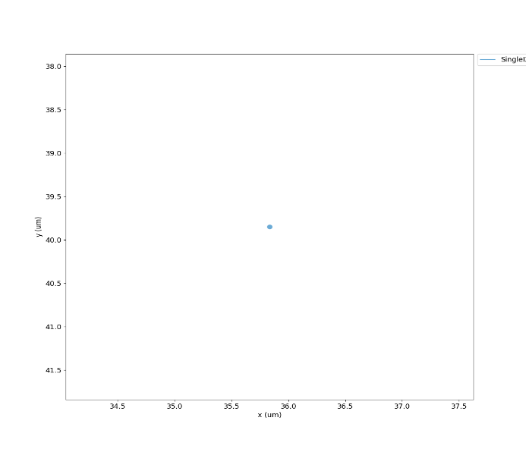

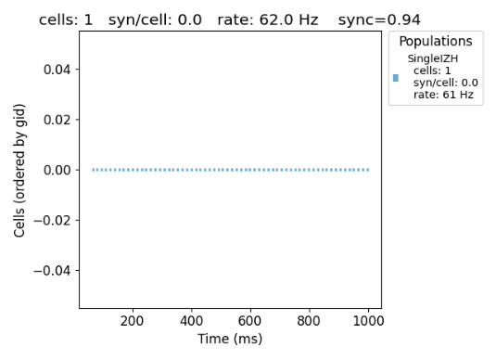

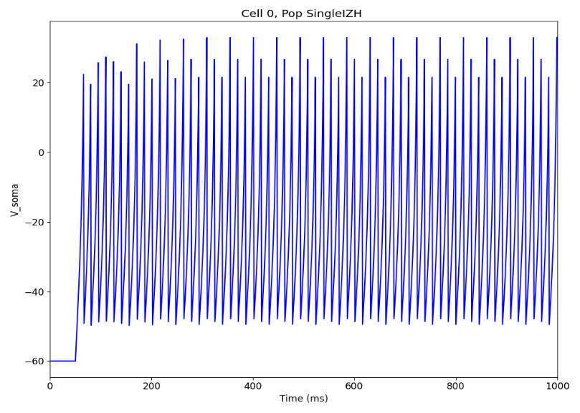

***izhikevich_network.py***

***Table 4: Exercise 2***

|  |  |  |  |
| --- | --- | --- | --- |
| **Parameter** | **Symbol** | **Typical Value** | **Description** |
| Number of Neurons | numCells | 20 | Defines the number of neurons in the network. |
| Synaptic Mechanism | synMechParams | Exp2Syn | Defines the type of synapse used in the network. |
| Excitatory Reversal Potential | e | 0 mV | Determines if the synapse is excitatory (0 mV) or inhibitory (-70 mV). |
| Synaptic Weight | weight | 0.005 | Defines the strength of the synapse. |
| Connection Probability | probability | 0.1 | Determines how likely two neurons will be connected. |
| Synaptic Delay | delay | 5 ms | Defines the transmission delay of synapses. |
| Neuron Stimulation | stimSourceParams | NetStim | Defines external stimulation using a Poisson spike generator. |
| Stimulation Rate | rate | 100 Hz | Frequency of external input stimulation. |
| Noise in Stimulation | noise | 0.5 | Adds variability to the external input pattern. |
| Simulation Duration | duration | 1000 ms | Defines how long the network will be simulated. |
| Integration Time Step | dt | 0.025 ms | Defines the resolution of the simulation steps. |
| Recorded Variable | recordTraces | V_soma | Records the membrane potential of the neurons. |
| Raster Plot | plotRaster | True | Generates a raster plot to visualize spikes. |
| Voltage Traces | plotTraces | True | Plots the voltage traces of neurons. |
| 2D Network Visualization | plot2Dnet | True | Plots the network connectivity in 2D. |

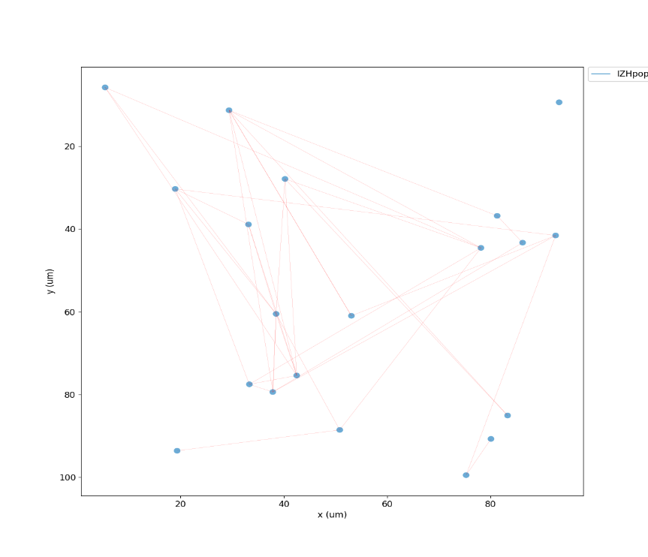Results: izhikevich_network.py

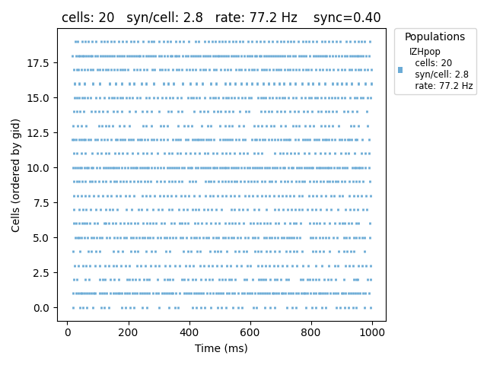

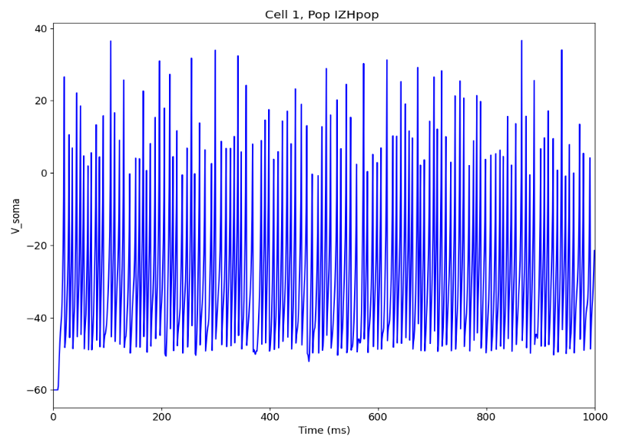

***izhikevich_inhibitory_network.py***

***Table 5: Exercise 3***

|  |  |  |  |
| --- | --- | --- | --- |
| **Parameter** | **Symbol** | **Value** | **Description** |
| **Number of Excitatory Neurons** | numCells (exc) | 20 | Number of excitatory neurons in the network |
| **Number of Inhibitory Neurons** | numCells (inh) | 10 | Number of inhibitory neurons in the network |
| **Excitatory Synapse Type** | mod (exc) | Exp2Syn | Synaptic mechanism for excitation |
| **Excitatory Reversal Potential** | e (exc) | 10 | Reversal potential for excitatory synapses |
| **Inhibitory Synapse Type** | mod (inh) | Exp2Syn | Synaptic mechanism for inhibition |
| **Inhibitory Reversal Potential** | e (inh) | -70 | Reversal potential for inhibitory synapses |
| **Excitatory Synaptic Weight** | weight (exc) | 0.005 | Synaptic weight for excitatory connections |
| **Inhibitory Synaptic Weight** | weight (inh) | 0.007 | Synaptic weight for inhibitory connections |
| **Excitatory Synaptic Delay** | delay (exc) | 5 | Synaptic delay for excitatory connections |
| **Inhibitory Synaptic Delay** | delay (inh) | 3 | Synaptic delay for inhibitory connections |
| **Excitatory Connection Probability** | probability (exc) | 0.1 | Probability of connection for excitatory neurons |
| **Inhibitory Connection Probability** | probability (inh) | 0.3 | Probability of connection for inhibitory neurons |
| **Stimulation Type (Poisson Input)** | type | NetStim | Type of external stimulation (Poisson) |
| **Poisson Input Rate** | rate | 100 Hz | Poisson input firing rate |
| **Poisson Input Noise** | noise | 0.5 | Degree of randomness (0: regular, 1: fully random) |
| **Poisson Input Synaptic Weight** | weight | 0.01 | Synaptic weight for Poisson input |
| **Poisson Input Synaptic Delay** | delay | 5 ms | Synaptic delay for Poisson input |
| **Simulation Duration** | duration | 1000 ms | Duration of the simulation |
| **Time Step** | dt | 0.025 ms | Integration time step |
| **Recorded Variable** | recordTraces | V_soma | Variable recorded from neurons (membrane potential) |
| **Raster Plot** | plotRaster | True | Whether to generate a raster plot |
| **Voltage Traces** | plotTraces | True | Whether to plot voltage traces |
| **2D Network Visualization** | plot2Dnet | True | Whether to visualize the network in 2D |

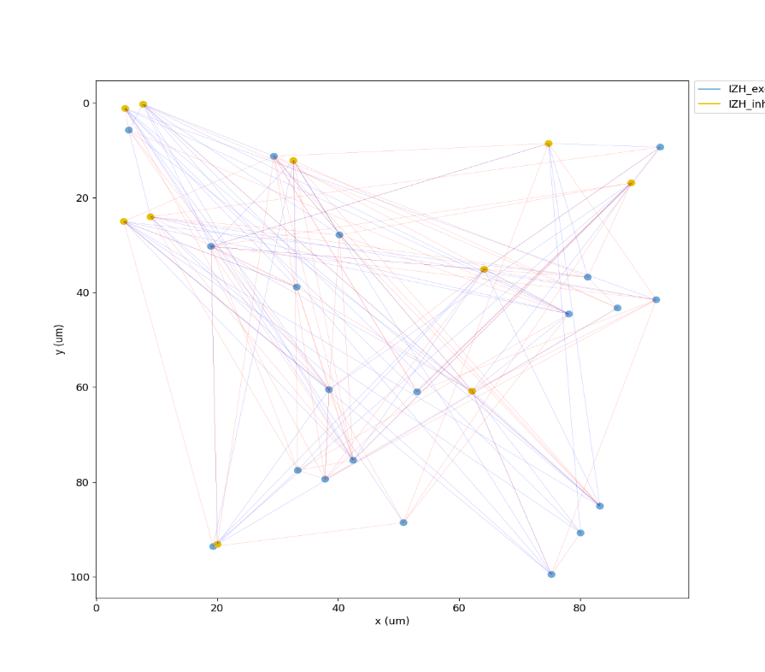Results: izhikevich_inhibitory_network.py

