Input-Output:

getchar() &putchar():

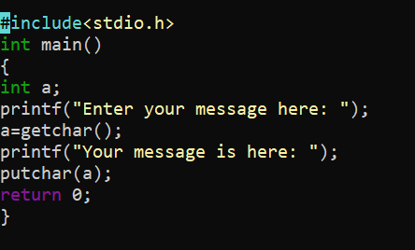

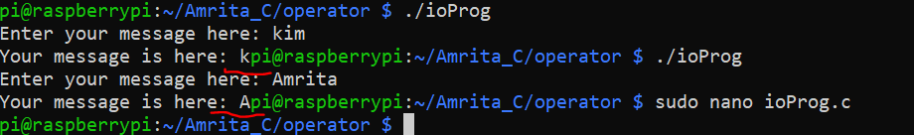

Use of scanf and printf:

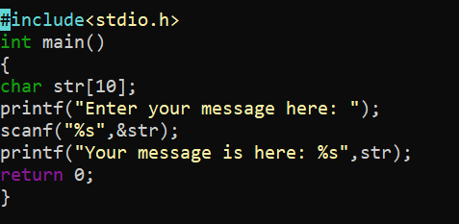



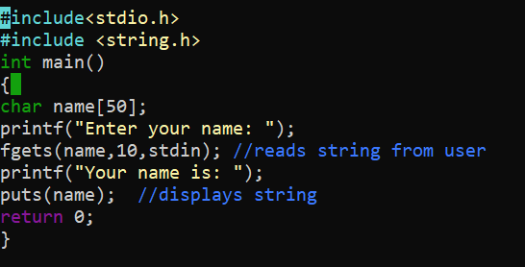Use of fgets() and puts():

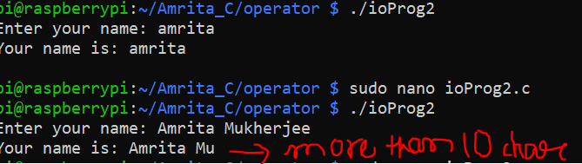

File input output: Created a text file in E drive and store a number in it that is 100.

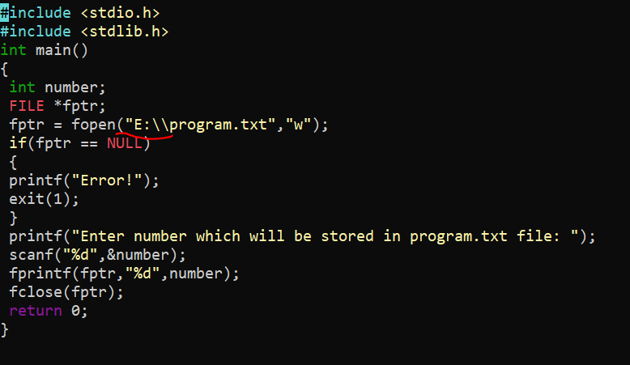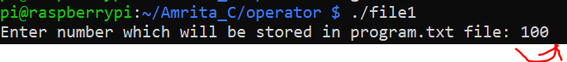

Read the number already stored in it that is 100.

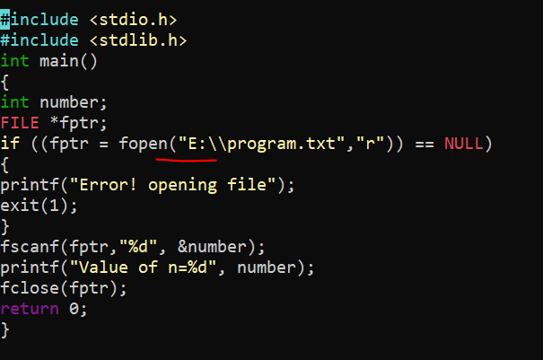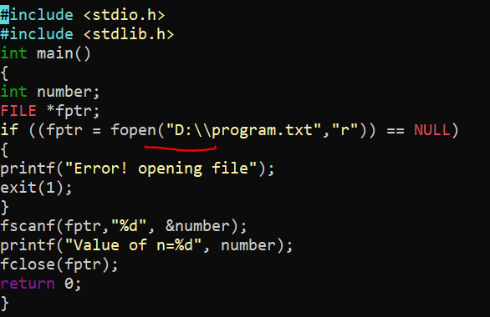

If we change the location from E drive to D drive then it produce error.

Preprocessor:

Predefined macros:

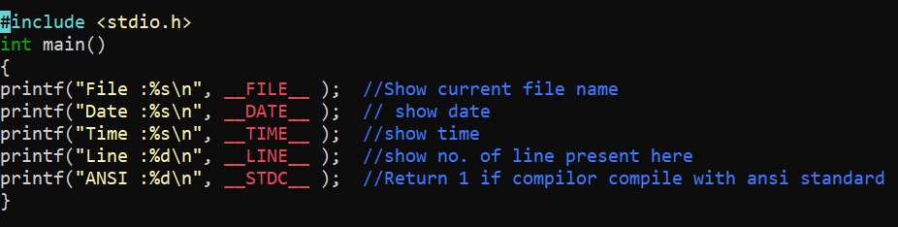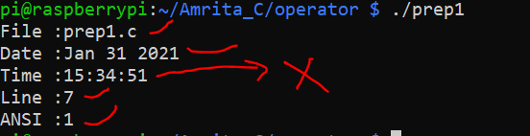

Preprocessor Operators:

Continuation and stringize(#) operator:

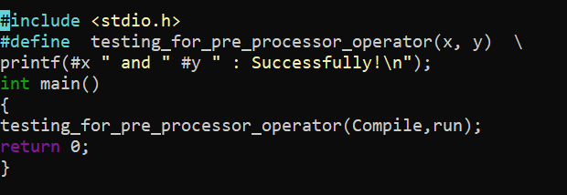

Token paster operator:

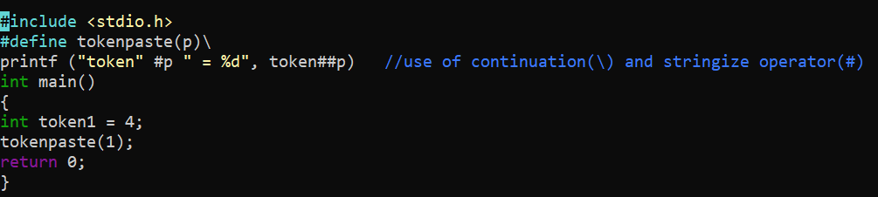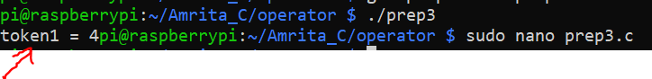

Defined operator:

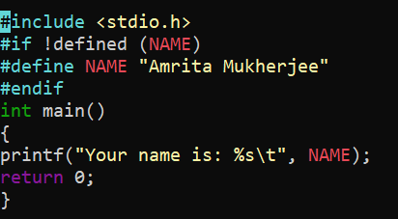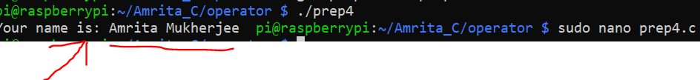

## Parameterized Macros:

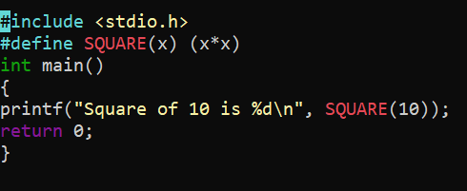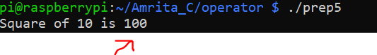

**Type casting**: Here int first converted into float and then complete the operation and give float type data.

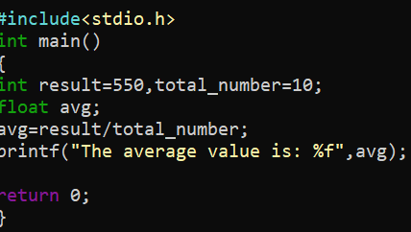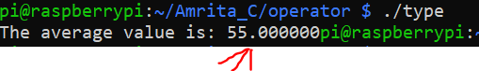

Integer promotion:

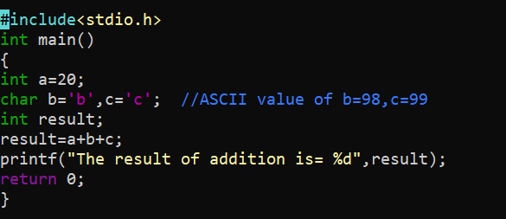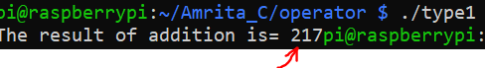

Arithmetic conversion: Here conversion will be like this:

Char🡪int-->float🡪double..and represent result as double. Cause double has highest place in hierarchy among all of them.

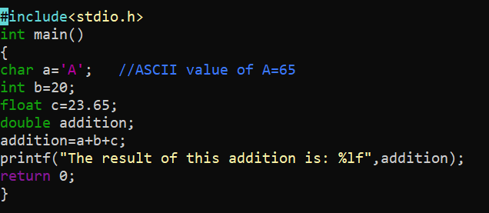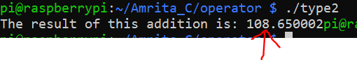

Error handling:

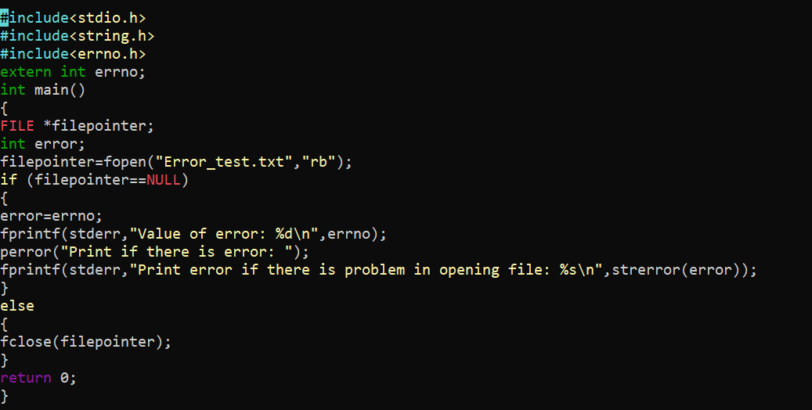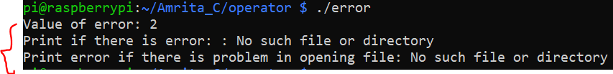

Divide by zero error:

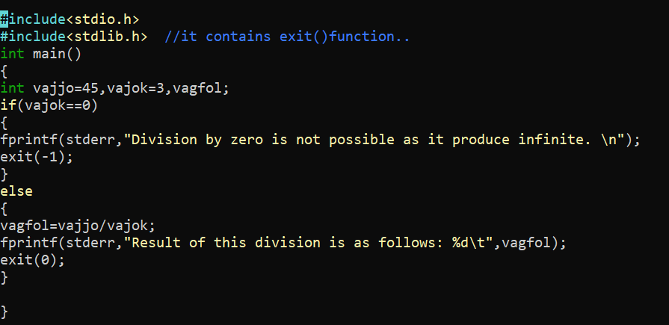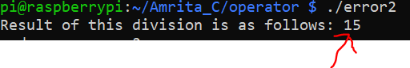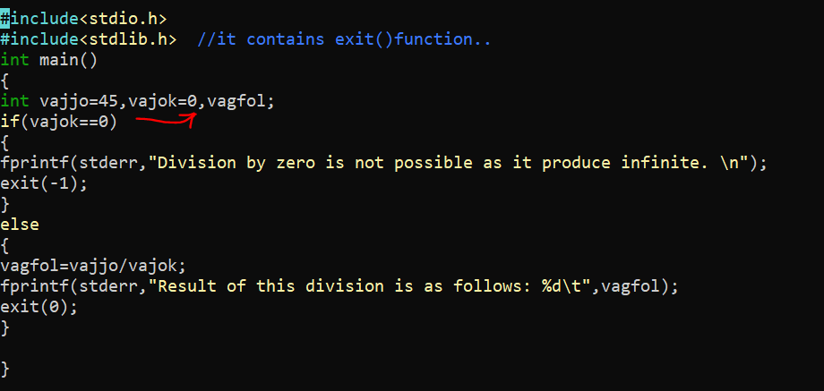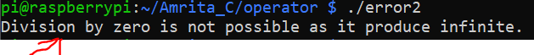

Program exit() status:

