LAUNCH AND CONGURE a WORDPRESS instance with AMAZON lightsail

STEPS

1. Crete instance with wordpress in linux OS

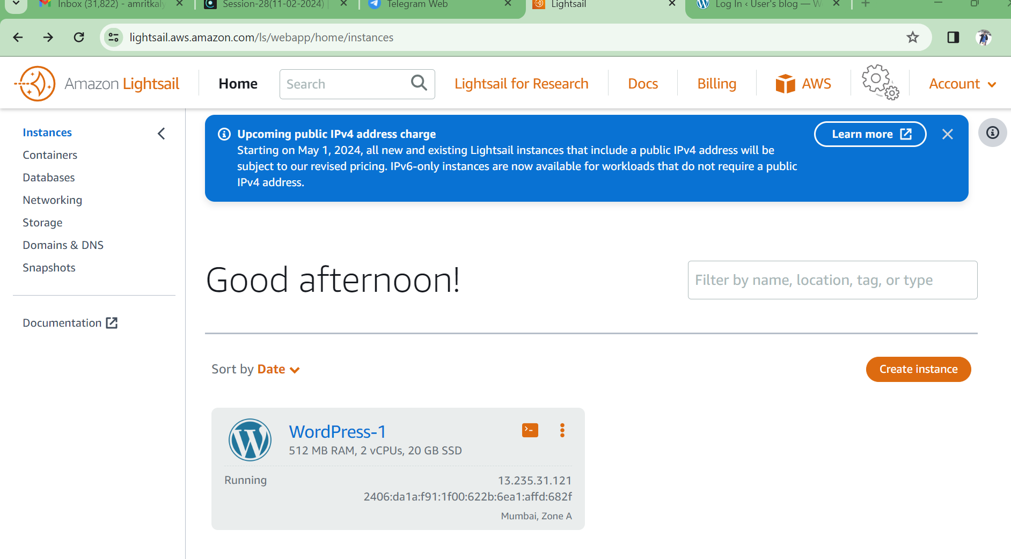

1. Need to login an find password go CMD

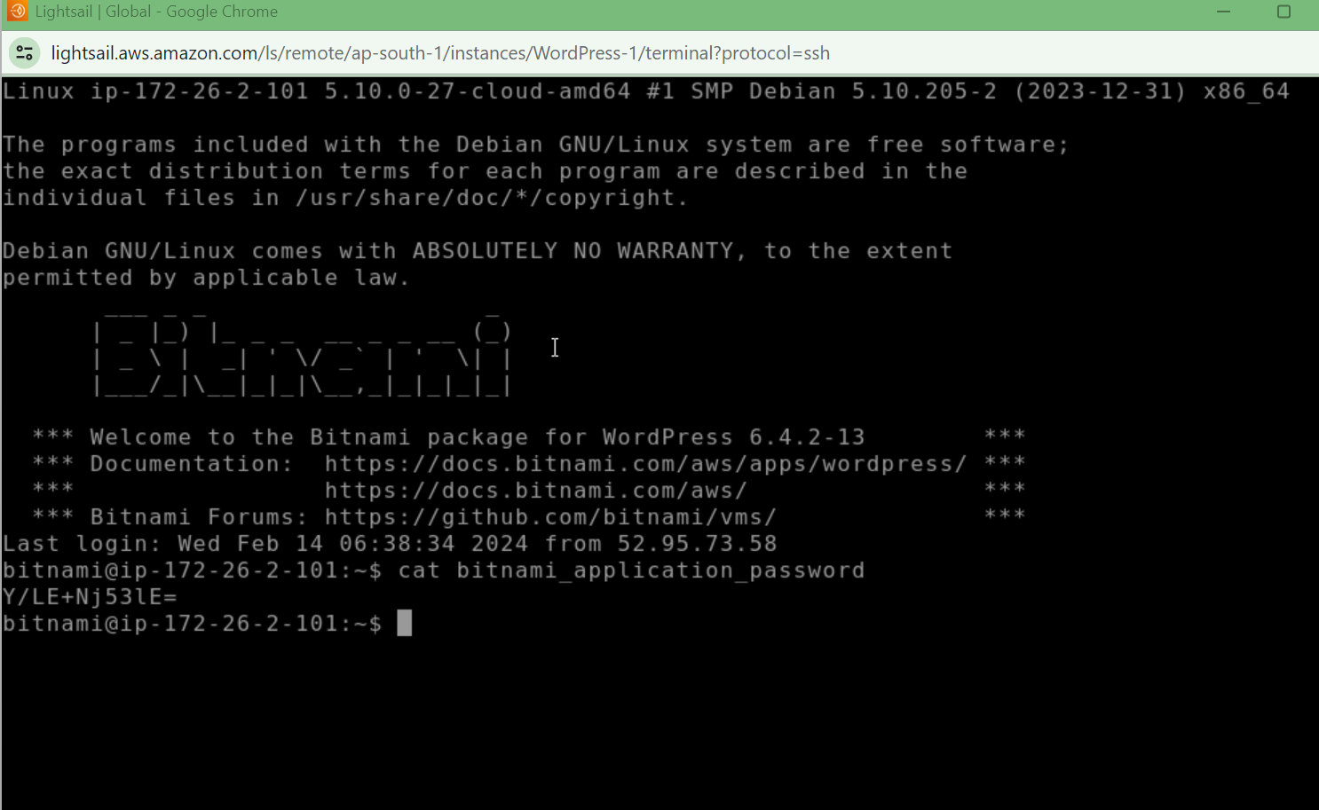

1. tRy to login IP 13.232.31.121

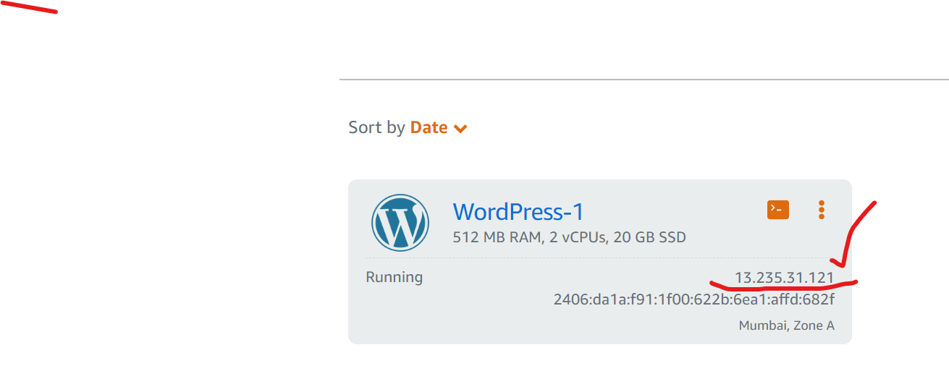

4 .login with <http://ip/wp-login.php>

