Name: AMRITANSH ANAND Reg. No.: 20BCE1650 Date: 08/10/22

**IWP DA1**

*#animation has been used in Swacch Bharat text same can be seen in the drive link I have shared at the end of document*



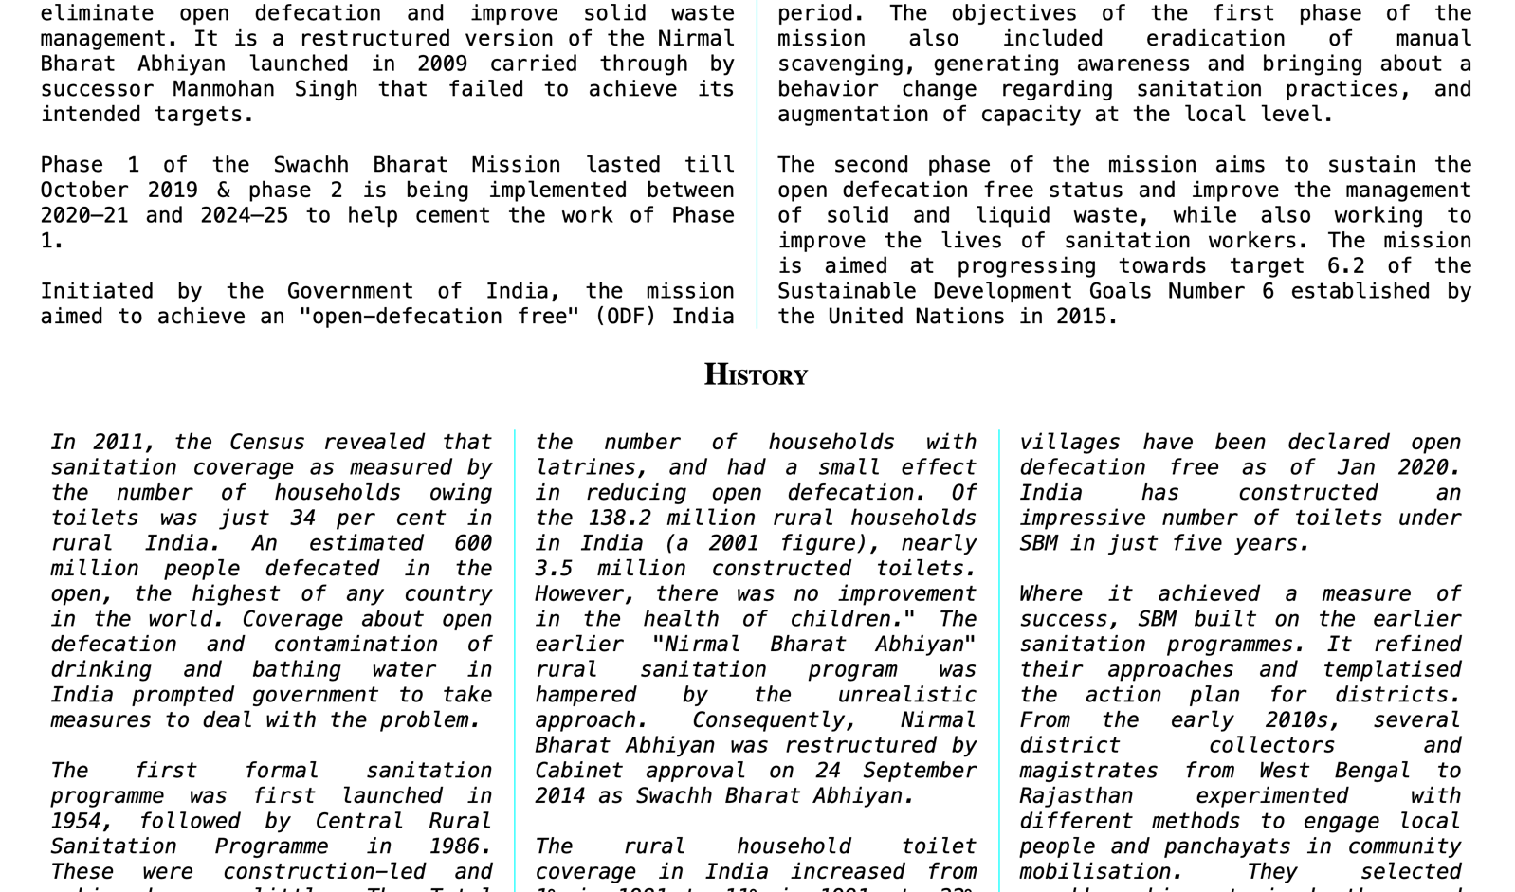

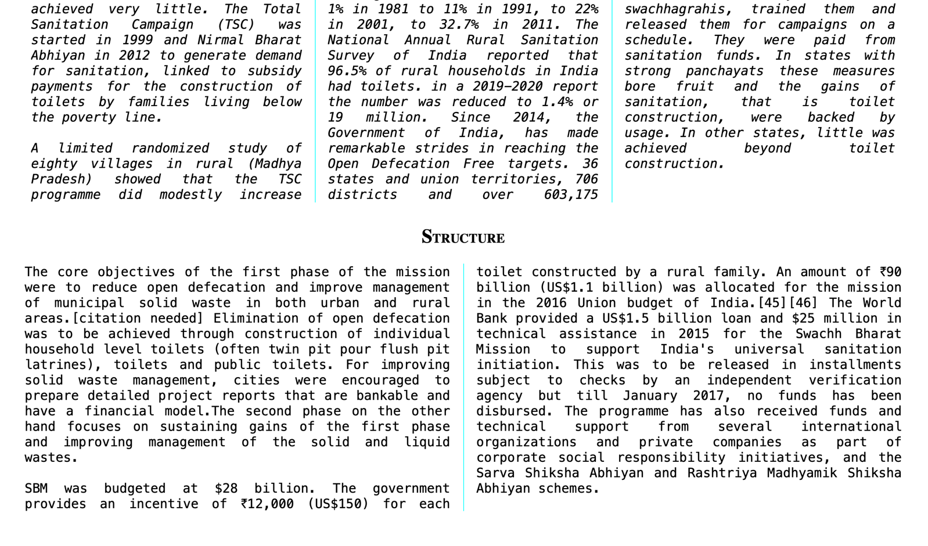

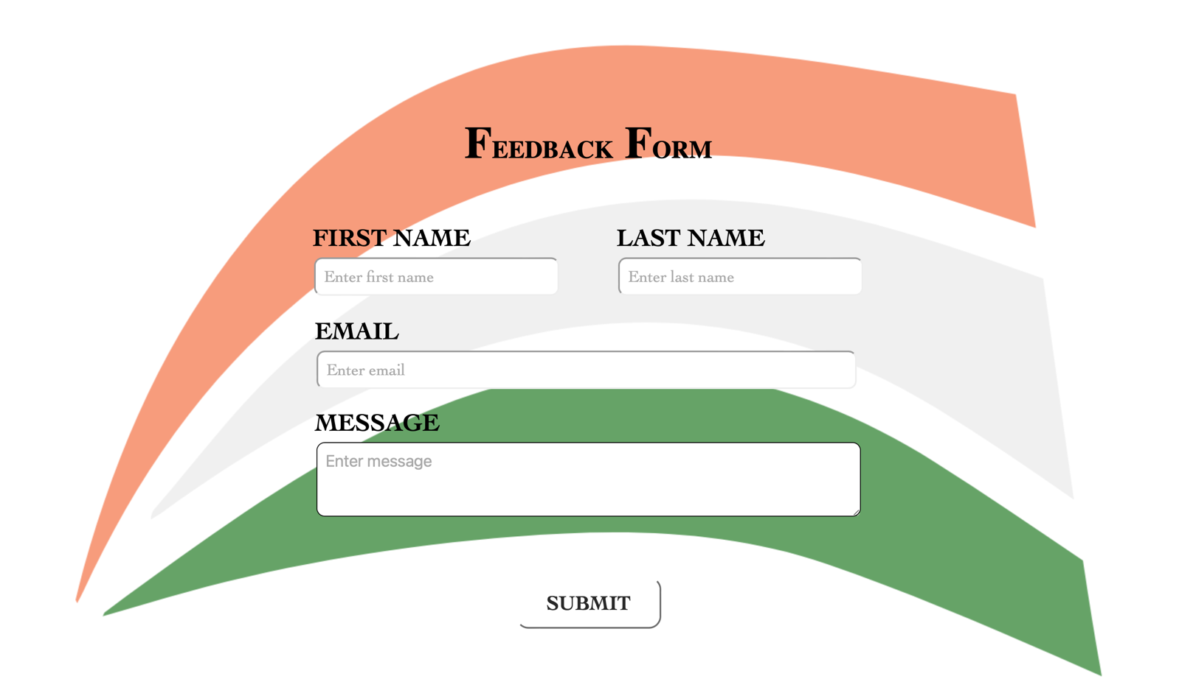

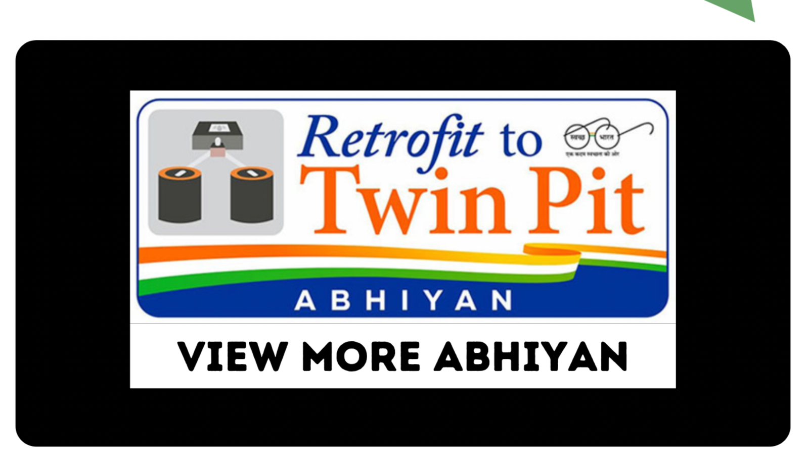

**index.html**

<!DOCTYPE html>

<html lang="en">

<head>

<meta charset="UTF-8">

<meta http-equiv="X-UA-Compatible" content="IE=edge">

<meta name="viewport" content="width=device-width, initial-scale=1.0">

<title>Document</title>

<link rel="stylesheet" href="style.css">

<style>

li{

list-style: none;

display: inline-block;

}

a{

text-decoration: none;

color: white;

margin: 10px;

line-height: 50px;

font-size: 15px;

}

nav{

background-color: black;

color: white;

display: inline-block;

width: 100%;

}

ul{

margin: 0% auto;

display: inline;

}

</style>

</head>

<body>

<nav style="text-align: right;">

SWACHH BHARAT&emsp;&emsp;&emsp;&emsp;&emsp;&emsp;&emsp;&emsp;&emsp;&emsp;&emsp;&emsp;&emsp;&emsp;&emsp;&emsp;&emsp;&emsp;&emsp;&emsp;&emsp;&emsp;&emsp;&emsp;&emsp;&emsp;&emsp;&emsp;&emsp;&emsp;&emsp;&emsp;&emsp;&emsp;&emsp;&emsp;&emsp;&emsp;&emsp;&emsp;&emsp;&emsp;&emsp;&emsp;&emsp;&emsp;&emsp;&emsp;&emsp;&emsp;&emsp;&emsp;&emsp;&emsp;&emsp;&emsp;&emsp;&emsp;&emsp;&emsp;

<ul>

<li><a href="#home">HOME</a></li>|

<li><a href="#about">ABOUT</a></li>|

<li><a href="#contact">CONTACT</a></li>

</ul>

</nav>

<section style="background-image: url(flag.png); background-size: 100% 100%;" class="s1" id="home">

<span class="s13"><br></span>

<span class="s12"><br></span>

<span class="s14">&ensp;<span class="t1">S</span><span class="t2">W</span><span class="t3">A</span><span class="t4">C</span><span class="t5">C</span><span class="t6">H</span> &nbsp;&nbsp;&nbsp;&nbsp;&nbsp;<span class="t7">B</span><span class="t8">H</span><span class="t9">A</span><span class="t10">R</span><span class="t11">A</span><span class="t12">T</span> &nbsp;<span class="t13"></span><span class="t14"></span></span><br>

<span class="s12"><br></span>

<span class="s13"><br></span>

</section>

<section style="background-image: url(images/about.png); background-size: 100% 100%; margin: 0%;">

<section class="about" id="about">

<h1>A<span class="specialh1">BOUT</span> U<span class="specialh1">S</span></h1>

<div id="ab">

<h2>A<span class="special">BOUT</span></h2>

<p class="footer2" style="color: black; font-family: monospace; text-align: justify;">Swachh Bharat Mission (SBM), Swachh Bharat Abhiyan, or Clean India Mission is a country-wide campaign initiated by the Government of India in 2014 to eliminate open defecation and improve solid waste management. It is a restructured version of the Nirmal Bharat Abhiyan launched in 2009 carried through by successor Manmohan Singh that failed to achieve its intended targets.<br><br>Phase 1 of the Swachh Bharat Mission lasted till October 2019 & phase 2 is being implemented between 2020–21 and 2024–25 to help cement the work of Phase 1.<br><br>Initiated by the Government of India, the mission aimed to achieve an "open-defecation free" (ODF) India by 2 October 2019, the 150th anniversary of the birth of Mahatma Gandhi through construction of toilets. An estimated 89.9 million toilets were built in the period. The objectives of the first phase of the mission also included eradication of manual scavenging, generating awareness and bringing about a behavior change regarding sanitation practices, and augmentation of capacity at the local level.<br><br>The second phase of the mission aims to sustain the open defecation free status and improve the management of solid and liquid waste, while also working to improve the lives of sanitation workers. The mission is aimed at progressing towards target 6.2 of the Sustainable Development Goals Number 6 established by the United Nations in 2015.</p>

</div>

<div id="hi">

<h2>H<span class="special">ISTORY</span></h2>

<p class="footer" style="color: black; font-family: monospace; text-align: justify;">In 2011, the Census revealed that sanitation coverage as measured by the number of households owing toilets was just 34 per cent in rural India. An estimated 600 million people defecated in the open, the highest of any country in the world. Coverage about open defecation and contamination of drinking and bathing water in India prompted government to take measures to deal with the problem.<br><br>The first formal sanitation programme was first launched in 1954, followed by Central Rural Sanitation Programme in 1986. These were construction-led and achieved very little. The Total Sanitation Campaign (TSC) was started in 1999 and Nirmal Bharat Abhiyan in 2012 to generate demand for sanitation, linked to subsidy payments for the construction of toilets by families living below the poverty line.<br><br>A limited randomized study of eighty villages in rural (Madhya Pradesh) showed that the TSC programme did modestly increase the number of households with latrines, and had a small effect in reducing open defecation. Of the 138.2 million rural households in India (a 2001 figure), nearly 3.5 million constructed toilets. However, there was no improvement in the health of children." The earlier "Nirmal Bharat Abhiyan" rural sanitation program was hampered by the unrealistic approach. Consequently, Nirmal Bharat Abhiyan was restructured by Cabinet approval on 24 September 2014 as Swachh Bharat Abhiyan.<br><br>The rural household toilet coverage in India increased from 1% in 1981 to 11% in 1991, to 22% in 2001, to 32.7% in 2011. The National Annual Rural Sanitation Survey of India reported that 96.5% of rural households in India had toilets. in a 2019-2020 report the number was reduced to 1.4% or 19 million. Since 2014, the Government of India, has made remarkable strides in reaching the Open Defecation Free targets. 36 states and union territories, 706 districts and over 603,175 villages have been declared open defecation free as of Jan 2020. India has constructed an impressive number of toilets under SBM in just five years.<br><br>Where it achieved a measure of success, SBM built on the earlier sanitation programmes. It refined their approaches and templatised the action plan for districts. From the early 2010s, several district collectors and magistrates from West Bengal to Rajasthan experimented with different methods to engage local people and panchayats in community mobilisation. They selected swachhagrahis, trained them and released them for campaigns on a schedule. They were paid from sanitation funds. In states with strong panchayats these measures bore fruit and the gains of sanitation, that is toilet construction, were backed by usage. In other states, little was achieved beyond toilet construction.</p>

</div>

<div id="fr">

<h2>S<span class="special">TRUCTURE</span></h2>

<p class="footer2" style="color: black; font-family: monospace; text-align: justify;">The core objectives of the first phase of the mission were to reduce open defecation and improve management of municipal solid waste in both urban and rural areas.[citation needed] Elimination of open defecation was to be achieved through construction of individual household level toilets (often twin pit pour flush pit latrines), toilets and public toilets. For improving solid waste management, cities were encouraged to prepare detailed project reports that are bankable and have a financial model.The second phase on the other hand focuses on sustaining gains of the first phase and improving management of the solid and liquid wastes.<br><br>SBM was budgeted at $28 billion. The government provides an incentive of ₹12,000 (US$150) for each toilet constructed by a rural family. An amount of ₹90 billion (US$1.1 billion) was allocated for the mission in the 2016 Union budget of India.[45][46] The World Bank provided a US$1.5 billion loan and $25 million in technical assistance in 2015 for the Swachh Bharat Mission to support India's universal sanitation initiation. This was to be released in installments subject to checks by an independent verification agency but till January 2017, no funds has been disbursed. The programme has also received funds and technical support from several international organizations and private companies as part of corporate social responsibility initiatives, and the Sarva Shiksha Abhiyan and Rashtriya Madhyamik Shiksha Abhiyan schemes.</p>

</div>

<br>

<br>

</section>

</section>

<section id="contact" style="background-image: url(flag2.png); background-size: 100% 100%; margin-top: -40px;">

<br><br><br>

<center>

<h1>F<span class="specialh1">EEDBACK</span> F<span class="specialh1">ORM</span></h1><br>

<table>

<tr><td><label for="fn">FIRST NAME</label></td><td class="space"></td><td><label for="ln">LAST NAME</label></td></tr>

<tr><td><input type="text" id="fn" placeholder="Enter first name"></td><td class="space"></td><td><input type="text" id="ln" placeholder="Enter last name"></td></tr>

</table>

<table>

<tr><td><label for="eid">EMAIL</label></td></tr>

<tr><td><input type="email" id="eid" placeholder="Enter email" size="50"></td></tr>

<tr><td><label for="msg">MESSAGE</label></td></tr>

<tr><td><textarea id="msg" placeholder="Enter message" rows="3" cols="52"></textarea></td></tr>

<tr><td style="height: 40px;">&nbsp;</td></tr>

<tr><td align="center"><input type="submit" value="SUBMIT"></td></tr>

</table>

</center>

<br><br><br>

</section>

<section>

<img src="abhiyan.png" height="100%" width="100%" usemap="#mapname">

<map name="mapname">

<area shape="circle" coords="734 325 210" href="https://swachhbharatmission.gov.in/SBMCMS/retrofit.htm">

<area shape="circle" coords="734 593 60" href="https://swachhbharatmission.gov.in/sbmcms/index.htm">

</map>

</section>

<br>

</body>

</html>

**style.css**

body{

margin: 0;

padding: 0;

}

.footer{

column-count: 3;

column-gap: 40px;

column-rule-style: solid;

column-rule-width: 1px;

column-rule-color: aqua;

column-width: 100px;

}

.footer2{

column-count: 2;

column-gap: 40px;

column-rule-style: solid;

column-rule-width: 1px;

column-rule-color: aqua;

column-width: 100px;

}

a:hover{

font-weight: bold;

color: aquamarine;

background-color: gray;

padding: 16px;

}

html{

scroll-behavior: smooth;

}

.s1{

align-items: center;

text-align: center;

font-size: 30px;

}

.s11{

border-radius: 50%;

display: inline-block;

font-weight: bold;

line-height: 0px;

margin-right: 5px;

width: 40px;

border-style: solid;

border-width: 0px;

border-color: black;

color: black;

font-size: 40px;

}

.s1 a:hover{

background-color: black;

color: white;

}

.s1 a:link{

text-decoration: none;

}

.s12{

font-size: 110px;

}

.s13{

font-size: 60px;

}

.s14{

font-size: 80px;

font-family: 'Amarnath';

font-weight: 900;

position: relative;

letter-spacing: 5px;

}

.about{

text-align: justify;

margin: 40px;

font-size: 20px;

}

h1{

font-weight: 1000;

text-align: center;

font-size: 55px;

}

h2{

font-weight: 700;

text-align: center;

}

.special{

font-size: 20px;

}

.specialh1{

font-size: 30px;

}

p{

font-family: monospace;

}

input[type="text"]{

font-size: 20px;

margin-bottom: 20px;

padding: 10px;

border-radius: 10px;

font-family: Cambria, Cochin, Georgia, Times, 'Times New Roman', serif;

}

input[type="email"]{

font-size: 20px;

margin-bottom: 20px;

padding: 10px;

border-radius: 10px;

font-family: Cambria, Cochin, Georgia, Times, 'Times New Roman', serif;

}

input[type="submit"]{

font-size: 25px;

font-family: Cambria, Cochin, Georgia, Times, 'Times New Roman', serif;

background-color: white;

font-weight: bold;

border-radius: 15px;

padding-top: 15px;

padding-bottom: 15px;

padding-left: 35px;

padding-right: 35px;

}

input[type="submit"]:hover{

background-color: black;

color: white;

}

textarea{

font-size: 20px;

margin-bottom: 20px;

padding: 10px;

border-radius: 10px;

}

.footer{

color: white;

text-align: center;

font-family: Cambria, Cochin, Georgia, Times, 'Times New Roman', serif;

font-style: italic;

padding: 10px;

font-size: 20px;

}

.space{

width: 60px;

}

section{

margin: 0px;

padding: 0px;

}

label{

font-size: 30px;

font-family: Cambria, Cochin, Georgia, Times, 'Times New Roman', serif;

font-weight: bold;

}

.t1{

animation-name: animation1;

animation-duration: 10s;

animation-iteration-count: infinite;

}

@keyframes animation1{

0% {opacity: 0;}

3.5% {opacity: 1;}

7% {opacity: 1;}

10.5% {opacity: 1;}

14% {opacity: 1;}

17.5% {opacity: 1;}

21% {opacity: 1;}

24.5% {opacity: 1;}

28% {opacity: 1;}

31.5% {opacity: 1;}

35% {opacity: 1;}

38.5% {opacity: 1;}

42% {opacity: 1;}

45.5% {opacity: 1;}

49% {opacity: 1;}

52.5% {opacity: 1;}

56% {opacity: 1;}

59.5% {opacity: 1;}

63% {opacity: 1;}

66.5% {opacity: 1;}

70% {opacity: 1;}

73.5% {opacity: 1;}

77% {opacity: 1;}

80.5% {opacity: 1;}

84% {opacity: 1;}

87.5% {opacity: 1;}

91% {opacity: 1;}

94.5% {opacity: 1;}

98% {opacity: 1;}

100% {opacity: 0;}

}

.t2{

animation-name: animation2;

animation-duration: 10s;

animation-iteration-count: infinite;

}

@keyframes animation2{

0% {opacity: 0;}

3.5% {opacity: 0;}

7% {opacity: 1;}

10.5% {opacity: 1;}

14% {opacity: 1;}

17.5% {opacity: 1;}

21% {opacity: 1;}

24.5% {opacity: 1;}

28% {opacity: 1;}

31.5% {opacity: 1;}

35% {opacity: 1;}

38.5% {opacity: 1;}

42% {opacity: 1;}

45.5% {opacity: 1;}

49% {opacity: 1;}

52.5% {opacity: 1;}

56% {opacity: 1;}

59.5% {opacity: 1;}

63% {opacity: 1;}

66.5% {opacity: 1;}

70% {opacity: 1;}

73.5% {opacity: 1;}

77% {opacity: 1;}

80.5% {opacity: 1;}

84% {opacity: 1;}

87.5% {opacity: 1;}

91% {opacity: 1;}

94.5% {opacity: 1;}

98% {opacity: 0;}

100% {opacity: 0;}

}

.t3{

animation-name: animation3;

animation-duration: 10s;

animation-iteration-count: infinite;

}

@keyframes animation3{

0% {opacity: 0;}

3.5% {opacity: 0;}

7% {opacity: 0;}

10.5% {opacity: 1;}

14% {opacity: 1;}

17.5% {opacity: 1;}

21% {opacity: 1;}

24.5% {opacity: 1;}

28% {opacity: 1;}

31.5% {opacity: 1;}

35% {opacity: 1;}

38.5% {opacity: 1;}

42% {opacity: 1;}

45.5% {opacity: 1;}

49% {opacity: 1;}

52.5% {opacity: 1;}

56% {opacity: 1;}

59.5% {opacity: 1;}

63% {opacity: 1;}

66.5% {opacity: 1;}

70% {opacity: 1;}

73.5% {opacity: 1;}

77% {opacity: 1;}

80.5% {opacity: 1;}

84% {opacity: 1;}

87.5% {opacity: 1;}

91% {opacity: 1;}

94.5% {opacity: 0;}

98% {opacity: 0;}

100% {opacity: 0;}

}

.t4{

animation-name: animation4;

animation-duration: 10s;

animation-iteration-count: infinite;

}

@keyframes animation4{

0% {opacity: 0;}

3.5% {opacity: 0;}

7% {opacity: 0;}

10.5% {opacity: 0;}

14% {opacity: 1;}

17.5% {opacity: 1;}

21% {opacity: 1;}

24.5% {opacity: 1;}

28% {opacity: 1;}

31.5% {opacity: 1;}

35% {opacity: 1;}

38.5% {opacity: 1;}

42% {opacity: 1;}

45.5% {opacity: 1;}

49% {opacity: 1;}

52.5% {opacity: 1;}

56% {opacity: 1;}

59.5% {opacity: 1;}

63% {opacity: 1;}

66.5% {opacity: 1;}

70% {opacity: 1;}

73.5% {opacity: 1;}

77% {opacity: 1;}

80.5% {opacity: 1;}

84% {opacity: 1;}

87.5% {opacity: 1;}

91% {opacity: 0;}

94.5% {opacity: 0;}

98% {opacity: 0;}

100% {opacity: 0;}

}

.t5{

animation-name: animation5;

animation-duration: 10s;

animation-iteration-count: infinite;

}

@keyframes animation5{

0% {opacity: 0;}

3.5% {opacity: 0;}

7% {opacity: 0;}

10.5% {opacity: 0;}

14% {opacity: 0;}

17.5% {opacity: 1;}

21% {opacity: 1;}

24.5% {opacity: 1;}

28% {opacity: 1;}

31.5% {opacity: 1;}

35% {opacity: 1;}

38.5% {opacity: 1;}

42% {opacity: 1;}

45.5% {opacity: 1;}

49% {opacity: 1;}

52.5% {opacity: 1;}

56% {opacity: 1;}

59.5% {opacity: 1;}

63% {opacity: 1;}

66.5% {opacity: 1;}

70% {opacity: 1;}

73.5% {opacity: 1;}

77% {opacity: 1;}

80.5% {opacity: 1;}

84% {opacity: 1;}

87.5% {opacity: 0;}

91% {opacity: 0;}

94.5% {opacity: 0;}

98% {opacity: 0;}

100% {opacity: 0;}

}

.t6{

animation-name: animation6;

animation-duration: 10s;

animation-iteration-count: infinite;

}

@keyframes animation6{

0% {opacity: 0;}

3.5% {opacity: 0;}

7% {opacity: 0;}

10.5% {opacity: 0;}

14% {opacity: 0;}

17.5% {opacity: 0;}

21% {opacity: 1;}

24.5% {opacity: 1;}

28% {opacity: 1;}

31.5% {opacity: 1;}

35% {opacity: 1;}

38.5% {opacity: 1;}

42% {opacity: 1;}

45.5% {opacity: 1;}

49% {opacity: 1;}

52.5% {opacity: 1;}

56% {opacity: 1;}

59.5% {opacity: 1;}

63% {opacity: 1;}

66.5% {opacity: 1;}

70% {opacity: 1;}

73.5% {opacity: 1;}

77% {opacity: 1;}

80.5% {opacity: 1;}

84% {opacity: 0;}

87.5% {opacity: 0;}

91% {opacity: 0;}

94.5% {opacity: 0;}

98% {opacity: 0;}

100% {opacity: 0;}

}

.t7{

animation-name: animation7;

animation-duration: 10s;

animation-iteration-count: infinite;

}

@keyframes animation7{

0% {opacity: 0;}

3.5% {opacity: 0;}

7% {opacity: 0;}

10.5% {opacity: 0;}

14% {opacity: 0;}

17.5% {opacity: 0;}

21% {opacity: 0;}

24.5% {opacity: 1;}

28% {opacity: 1;}

31.5% {opacity: 1;}

35% {opacity: 1;}

38.5% {opacity: 1;}

42% {opacity: 1;}

45.5% {opacity: 1;}

49% {opacity: 1;}

52.5% {opacity: 1;}

56% {opacity: 1;}

59.5% {opacity: 1;}

63% {opacity: 1;}

66.5% {opacity: 1;}

70% {opacity: 1;}

73.5% {opacity: 1;}

77% {opacity: 1;}

80.5% {opacity: 0;}

84% {opacity: 0;}

87.5% {opacity: 0;}

91% {opacity: 0;}

94.5% {opacity: 0;}

98% {opacity: 0;}

100% {opacity: 0;}

}

.t8{

animation-name: animation8;

animation-duration: 10s;

animation-iteration-count: infinite;

}

@keyframes animation8{

0% {opacity: 0;}

3.5% {opacity: 0;}

7% {opacity: 0;}

10.5% {opacity: 0;}

14% {opacity: 0;}

17.5% {opacity: 0;}

21% {opacity: 0;}

24.5% {opacity: 0;}

28% {opacity: 1;}

31.5% {opacity: 1;}

35% {opacity: 1;}

38.5% {opacity: 1;}

42% {opacity: 1;}

45.5% {opacity: 1;}

49% {opacity: 1;}

52.5% {opacity: 1;}

56% {opacity: 1;}

59.5% {opacity: 1;}

63% {opacity: 1;}

66.5% {opacity: 1;}

70% {opacity: 1;}

73.5% {opacity: 1;}

77% {opacity: 0;}

80.5% {opacity: 0;}

84% {opacity: 0;}

87.5% {opacity: 0;}

91% {opacity: 0;}

94.5% {opacity: 0;}

98% {opacity: 0;}

100% {opacity: 0;}

}

.t9{

animation-name: animation9;

animation-duration: 10s;

animation-iteration-count: infinite;

}

@keyframes animation9{

0% {opacity: 0;}

3.5% {opacity: 0;}

7% {opacity: 0;}

10.5% {opacity: 0;}

14% {opacity: 0;}

17.5% {opacity: 0;}

21% {opacity: 0;}

24.5% {opacity: 0;}

28% {opacity: 0;}

31.5% {opacity: 1;}

35% {opacity: 1;}

38.5% {opacity: 1;}

42% {opacity: 1;}

45.5% {opacity: 1;}

49% {opacity: 1;}

52.5% {opacity: 1;}

56% {opacity: 1;}

59.5% {opacity: 1;}

63% {opacity: 1;}

66.5% {opacity: 1;}

70% {opacity: 1;}

73.5% {opacity: 0;}

77% {opacity: 0;}

80.5% {opacity: 0;}

84% {opacity: 0;}

87.5% {opacity: 0;}

91% {opacity: 0;}

94.5% {opacity: 0;}

98% {opacity: 0;}

100% {opacity: 0;}

}

.t10{

animation-name: animation10;

animation-duration: 10s;

animation-iteration-count: infinite;

}

@keyframes animation10{

0% {opacity: 0;}

3.5% {opacity: 0;}

7% {opacity: 0;}

10.5% {opacity: 0;}

14% {opacity: 0;}

17.5% {opacity: 0;}

21% {opacity: 0;}

24.5% {opacity: 0;}

28% {opacity: 0;}

31.5% {opacity: 0;}

35% {opacity: 1;}

38.5% {opacity: 1;}

42% {opacity: 1;}

45.5% {opacity: 1;}

49% {opacity: 1;}

52.5% {opacity: 1;}

56% {opacity: 1;}

59.5% {opacity: 1;}

63% {opacity: 1;}

66.5% {opacity: 1;}

70% {opacity: 0;}

73.5% {opacity: 0;}

77% {opacity: 0;}

80.5% {opacity: 0;}

84% {opacity: 0;}

87.5% {opacity: 0;}

91% {opacity: 0;}

94.5% {opacity: 0;}

98% {opacity: 0;}

100% {opacity: 0;}

}

.t11{

animation-name: animation11;

animation-duration: 10s;

animation-iteration-count: infinite;

}

@keyframes animation11{

0% {opacity: 0;}

3.5% {opacity: 0;}

7% {opacity: 0;}

10.5% {opacity: 0;}

14% {opacity: 0;}

17.5% {opacity: 0;}

21% {opacity: 0;}

24.5% {opacity: 0;}

28% {opacity: 0;}

31.5% {opacity: 0;}

35% {opacity: 0;}

38.5% {opacity: 1;}

42% {opacity: 1;}

45.5% {opacity: 1;}

49% {opacity: 1;}

52.5% {opacity: 1;}

56% {opacity: 1;}

59.5% {opacity: 1;}

63% {opacity: 1;}

66.5% {opacity: 0;}

70% {opacity: 0;}

73.5% {opacity: 0;}

77% {opacity: 0;}

80.5% {opacity: 0;}

84% {opacity: 0;}

87.5% {opacity: 0;}

91% {opacity: 0;}

94.5% {opacity: 0;}

98% {opacity: 0;}

100% {opacity: 0;}

}

.t12{

animation-name: animation12;

animation-duration: 10s;

animation-iteration-count: infinite;

}

@keyframes animation12{

0% {opacity: 0;}

3.5% {opacity: 0;}

7% {opacity: 0;}

10.5% {opacity: 0;}

14% {opacity: 0;}

17.5% {opacity: 0;}

21% {opacity: 0;}

24.5% {opacity: 0;}

28% {opacity: 0;}

31.5% {opacity: 0;}

35% {opacity: 0;}

38.5% {opacity: 0;}

42% {opacity: 1;}

45.5% {opacity: 1;}

49% {opacity: 1;}

52.5% {opacity: 1;}

56% {opacity: 1;}

59.5% {opacity: 1;}

63% {opacity: 0;}

66.5% {opacity: 0;}

70% {opacity: 0;}

73.5% {opacity: 0;}

77% {opacity: 0;}

80.5% {opacity: 0;}

84% {opacity: 0;}

87.5% {opacity: 0;}

91% {opacity: 0;}

94.5% {opacity: 0;}

98% {opacity: 0;}

100% {opacity: 0;}

}

.t13{

animation-name: animation13;

animation-duration: 10s;

animation-iteration-count: infinite;

}

@keyframes animation13{

0% {opacity: 0;}

3.5% {opacity: 0;}

7% {opacity: 0;}

10.5% {opacity: 0;}

14% {opacity: 0;}

17.5% {opacity: 0;}

21% {opacity: 0;}

24.5% {opacity: 0;}

28% {opacity: 0;}

31.5% {opacity: 0;}

35% {opacity: 0;}

38.5% {opacity: 0;}

42% {opacity: 0;}

45.5% {opacity: 1;}

49% {opacity: 1;}

52.5% {opacity: 1;}

56% {opacity: 1;}

59.5% {opacity: 0;}

63% {opacity: 0;}

66.5% {opacity: 0;}

70% {opacity: 0;}

73.5% {opacity: 0;}

77% {opacity: 0;}

80.5% {opacity: 0;}

84% {opacity: 0;}

87.5% {opacity: 0;}

91% {opacity: 0;}

94.5% {opacity: 0;}

98% {opacity: 0;}

100% {opacity: 0;}

}

.t14{

animation-name: animation14;

animation-duration: 10s;

animation-iteration-count: infinite;

}

@keyframes animation14{

0% {opacity: 0;}

3.5% {opacity: 0;}

7% {opacity: 0;}

10.5% {opacity: 0;}

14% {opacity: 0;}

17.5% {opacity: 0;}

21% {opacity: 0;}

24.5% {opacity: 0;}

28% {opacity: 0;}

31.5% {opacity: 0;}

35% {opacity: 0;}

38.5% {opacity: 0;}

42% {opacity: 0;}

45.5% {opacity: 0;}

49% {opacity: 1;}

52.5% {opacity: 1;}

56% {opacity: 0;}

59.5% {opacity: 0;}

63% {opacity: 0;}

66.5% {opacity: 0;}

70% {opacity: 0;}

73.5% {opacity: 0;}

77% {opacity: 0;}

80.5% {opacity: 0;}

84% {opacity: 0;}

87.5% {opacity: 0;}

91% {opacity: 0;}

94.5% {opacity: 0;}

98% {opacity: 0;}

100% {opacity: 0;}

}

DRIVE LINK:

<https://drive.google.com/drive/folders/1be2nEN2bjYW3H85B-lNcP-aiE5APGz11?usp=share_link>

-----------------------------------------------------------------------------------------------------------------------------