Name: AMRITANSH ANAND Reg. No.: 20BCE1650 Date: 25/08/22

**IWP LAB – 5**

Faculty: Sandhya P

*Calculator*

<!DOCTYPE html>

<html lang="en">

<head>

<meta charset="UTF-8">

<meta http-equiv="X-UA-Compatible" content="IE=edge">

<meta name="viewport" content="width=device-width, initial-scale=1.0">

<title>Calculator-20BCE1650</title>

<style>

table td{

border: 5px solid #000000;

text-align: center;

height: 114px;

width: 114px;

background-color: rgb(87, 72, 72);

}

table{

border: 15px solid black;

border-radius: 30px;

}

button{

height: 100px;

width: 100px;

padding: 10px;

font-size: 50px;

background-color: gray;

color: white;

border-radius: 20px;

}

button:hover{

color: black;

background-color: white;

font-weight: bold;

}

input[type=text]{

font-size: 50px;

padding-left: 30px;

padding-right: 30px;

height: 90%;

width: 85%;

border-radius: 20px;

}

</style>

<script>

function clearScreen(){

document.getElementById("result").value = "";

}

function display(value){

document.getElementById("result").value += value;

}

function calculate(){

var amrit = document.getElementById("result").value;

var ansh = eval(amrit);

document.getElementById("result").value = ansh;

}

</script>

</head>

<body>

<center>

<table>

<thead>

<tr>

<td colspan="4" style="font-size: 70px;"><input class="display-box" type="text" id="result" disabled/></td>

</tr>

</thead>

<tbody>

<tr>

<td><button onclick="display('(')">(</button></td><td><button onclick="display(')')">)</button></td><td><button onclick="display('%')">%</button></td><td><button onclick="display('/')">/</button></td>

</tr>

<tr>

<td><button onclick="display('7')">7</button></td><td><button onclick="display('8')">8</button></td><td><button onclick="display('9')">9</button></td><td><button onclick="display('*')">*</button></td>

</tr>

<tr>

<td><button onclick="display('4')">4</button></td><td><button onclick="display('5')">5</button></td><td><button onclick="display('6')">6</button></td><td><button onclick="display('-')">-</button></td>

</tr>

<tr>

<td><button onclick="display('1')">1</button></td><td><button onclick="display('2')">2</button></td><td><button onclick="display('3')">3</button></td><td><button onclick="display('+')">+</button></td>

</tr>

</tbody>

<tr>

<td><button onclick="clearScreen()">C</button></td><td><button onclick="display('0')">0</button></td><td><button onclick="display('.')">.</button></td><td><button onclick="calculate()">=</button></td>

</tr>

</table>

</center>

</body>

</html>

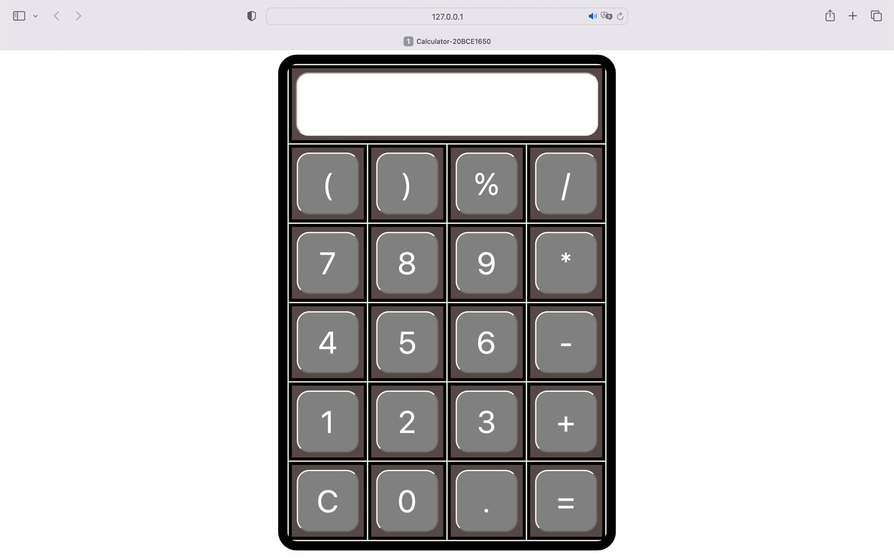

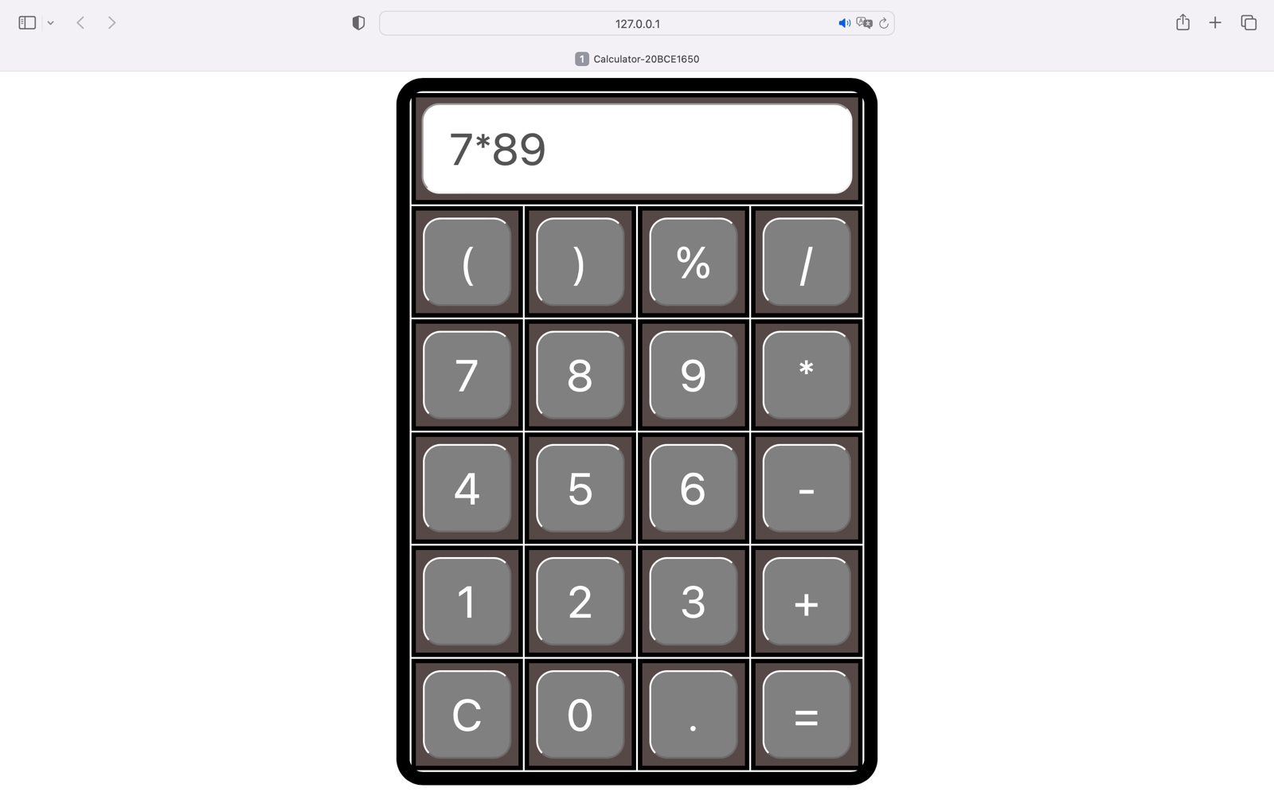

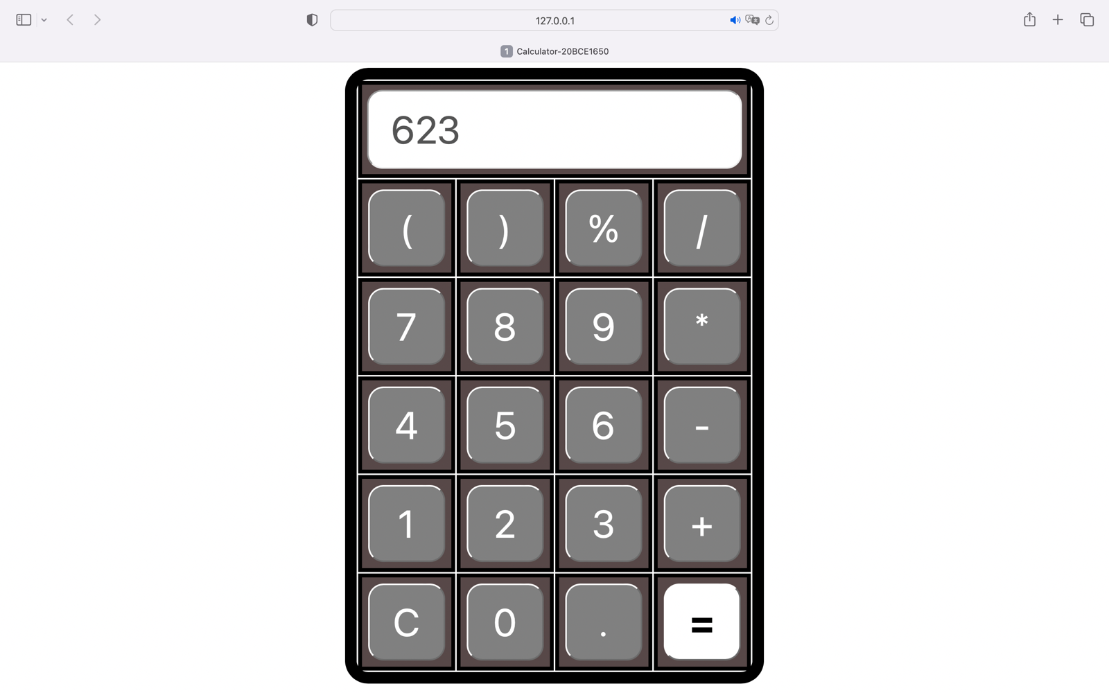

*SVG*

<!DOCTYPE html>

<html lang="en">

<head>

<meta charset="UTF-8">

<meta http-equiv="X-UA-Compatible" content="IE=edge">

<meta name="viewport" content="width=device-width, initial-scale=1.0">

<title>Document</title>

</head>

<body style="margin: 0% auto;">

<svg width="1440px" height="810px">

<rect x="0" y="0" width="1440" height="810"

style="fill: green ;stroke:none;stroke-width:6;fill-opacity:1;stroke-opacity:0.9" />

<svg height="810px" width="1440px">

<polygon points="720,0 450,810 980,810" style="fill:darkgray;stroke:black;stroke-width:2"/>

<svg width="1440px" height="810px">

<rect x="717" y="30" width="5" height="30"

style="fill: white ;stroke:none;stroke-width:6;fill-opacity:1;stroke-opacity:0.9" />

</svg>

<svg width="1440px" height="810px">

<rect x="716" y="70" width="7" height="34"

style="fill: white ;stroke:none;stroke-width:6;fill-opacity:1;stroke-opacity:0.9" />

</svg>

<svg width="1440px" height="810px">

<rect x="715" y="120" width="9" height="38"

style="fill: white ;stroke:none;stroke-width:6;fill-opacity:1;stroke-opacity:0.9" />

</svg>

<svg width="1440px" height="810px">

<rect x="714" y="180" width="11" height="42"

style="fill: white ;stroke:none;stroke-width:6;fill-opacity:1;stroke-opacity:0.9" />

</svg>

<svg width="1440px" height="810px">

<rect x="713" y="250" width="13" height="46"

style="fill: white ;stroke:none;stroke-width:6;fill-opacity:1;stroke-opacity:0.9" />

</svg>

<svg width="1440px" height="810px">

<rect x="712" y="330" width="15" height="50"

style="fill: white ;stroke:none;stroke-width:6;fill-opacity:1;stroke-opacity:0.9" />

</svg>

<svg width="1440px" height="810px">

<rect x="711" y="420" width="17" height="54"

style="fill: white ;stroke:none;stroke-width:6;fill-opacity:1;stroke-opacity:0.9" />

</svg>

<svg width="1440px" height="810px">

<rect x="710" y="520" width="19" height="58"

style="fill: white ;stroke:none;stroke-width:6;fill-opacity:1;stroke-opacity:0.9" />

</svg>

<svg width="1440px" height="810px">

<rect x="709" y="630" width="21" height="62"

style="fill: white ;stroke:none;stroke-width:6;fill-opacity:1;stroke-opacity:0.9" />

</svg>

<svg width="1440px" height="810px">

<rect x="708" y="750" width="23" height="66"

style="fill: white ;stroke:none;stroke-width:6;fill-opacity:1;stroke-opacity:0.9" />

</svg>

<svg width="1440" height="810">

<circle cx="70" cy="70" r="50" stroke=" " stroke-width="4" fill="orange" />

</svg>

<svg width="1440px" height="810px">

<rect x="850" y="250" width="80" height="80"

style="fill: red; stroke:black; stroke-width:6; fill-opacity:1;stroke-opacity:0.9" />

</svg>

<svg width="1440px" height="810px">

<rect x="882" y="330" width="15" height="80"

style="fill:black; stroke:none; stroke-width:6; fill-opacity:1;stroke-opacity:0.9" />

</svg>

<svg height="810px" width="1440px">

<line x1="720" y1="0" x2="470" y2="810" style="stroke:black;stroke-width:2" />

</svg>

<svg height="810px" width="1440px">

<line x1="720" y1="0" x2="960" y2="810" style="stroke:black;stroke-width:2" />

</svg>

</svg>

</svg>

</body>

</html>



