Name: AMRITANSH ANAND Reg. No.: 20BCE1650 Date: 08/09/22

**IWP LAB – 7**

Faculty: Sandhya P

QUES1

<!DOCTYPE html>

<html lang="en">

<head>

<meta charset="UTF-8">

<meta http-equiv="X-UA-Compatible" content="IE=edge">

<meta name="viewport" content="width=device-width, initial-scale=1.0">

<title>Binary Search 20BCE1650</title>

<script>

function binarySearch(amritansh,x,low,high){

if(high>=low){

var mid=low+(high-low)/2;

if(amritansh[mid]==x)

return mid;

if(amritansh[mid]>x)

return binarySearch(amritansh,x,low,mid-1);

return binarySearch(amritansh,x,mid+1,high);

}

return -1;

}

var amritansh = [3, 4, 5, 6, 7, 8, 9];

var n = 7;

var x = prompt("Enter element to search for: ");

var result = binarySearch(amritansh,x,0,n-1);

if (result == -1)

document.write("Not found");

else

document.write("Element is found at index "+result);

</script>

</head>

<body>

</body>

</html>

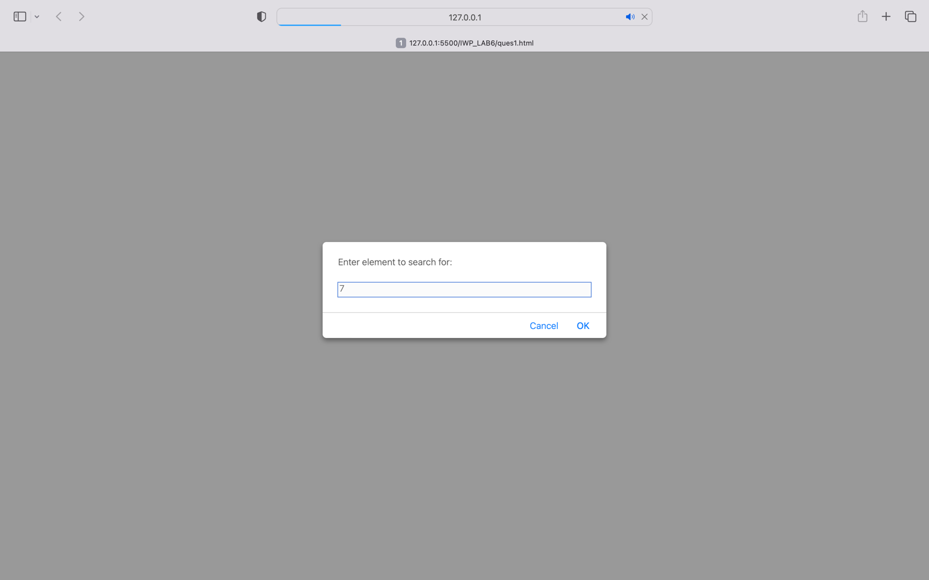

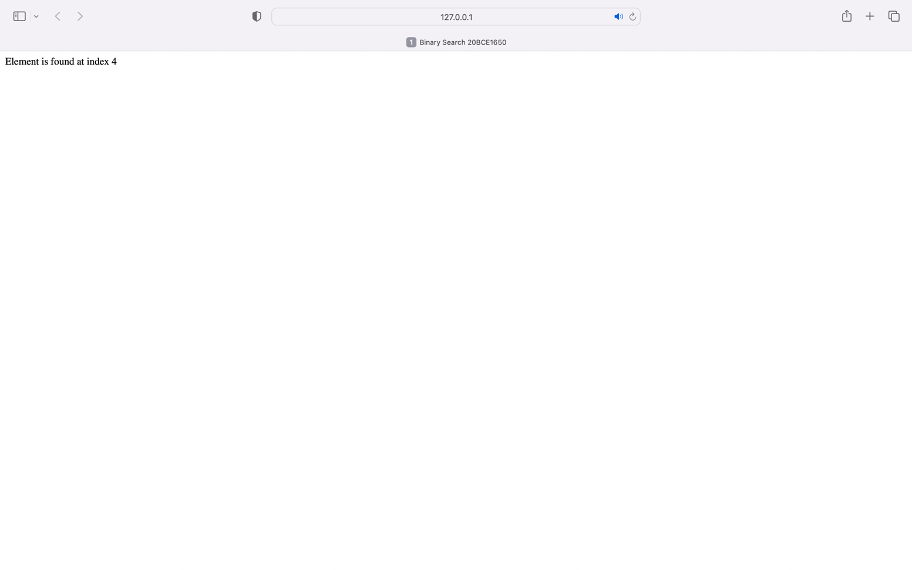

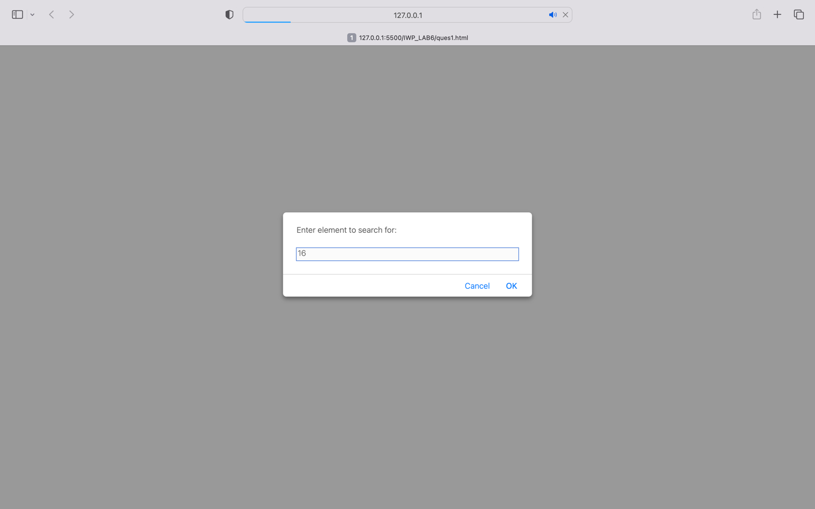

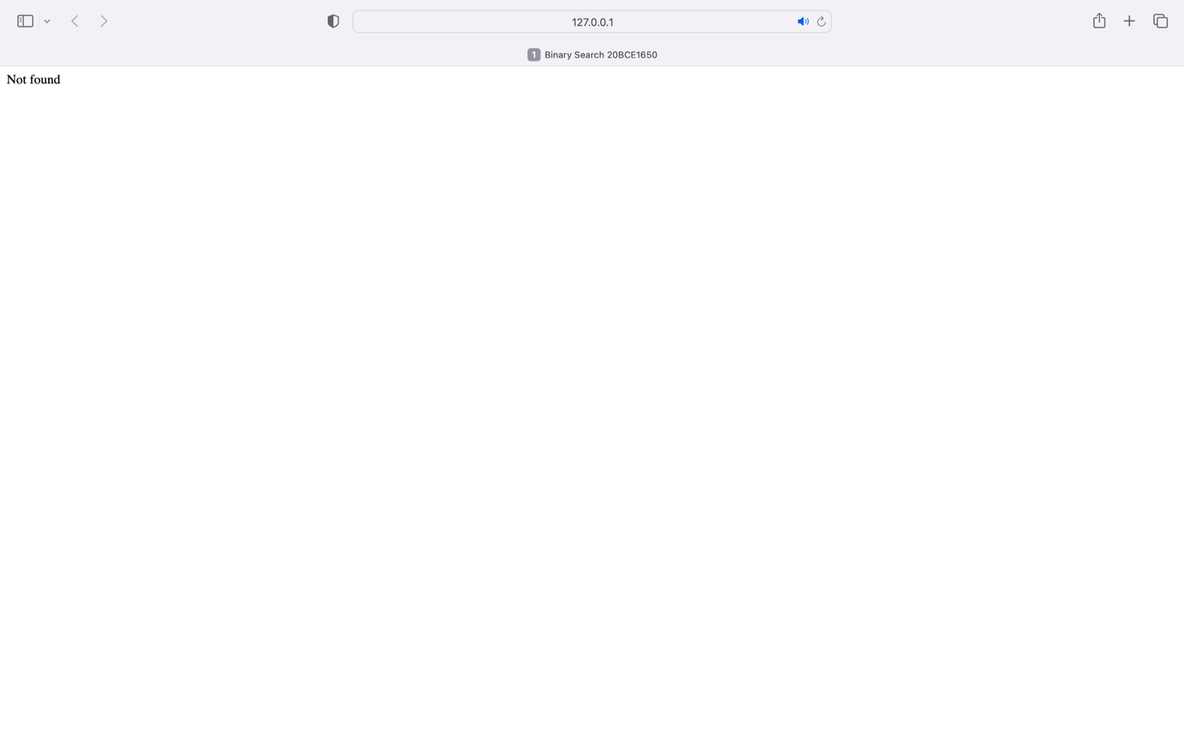

QUES2

<!DOCTBE html>

<html lang="en">

<head>

<meta charset="UTF-8">

<meta http-equiv="X-UA-Compatible" content="IE=edge">

<meta name="viewport" content="width=device-width, initial-scale=1.0">

<title>Marks Sort 20BCE1650</title>

<script>

function swap(amritansh,A,B){

var temp = amritansh[A];

amritansh[A] = amritansh[B];

amritansh[B] = temp;

}

function Sort(amritansh,n){

var i,j;

for(i=0;i<n-1;i++){

for(j=0;j<n-i-1;j++){

if(amritansh[j]<amritansh[j+1]){

swap(amritansh,j,j+1);

}

}

}

}

var amritansh=[55,59,37,60,12,23];

var n=7;

Sort(amritansh,n);

document.write("Marks in descending order: "+amritansh);

</script>

</head>

<body>

</body>

</html>

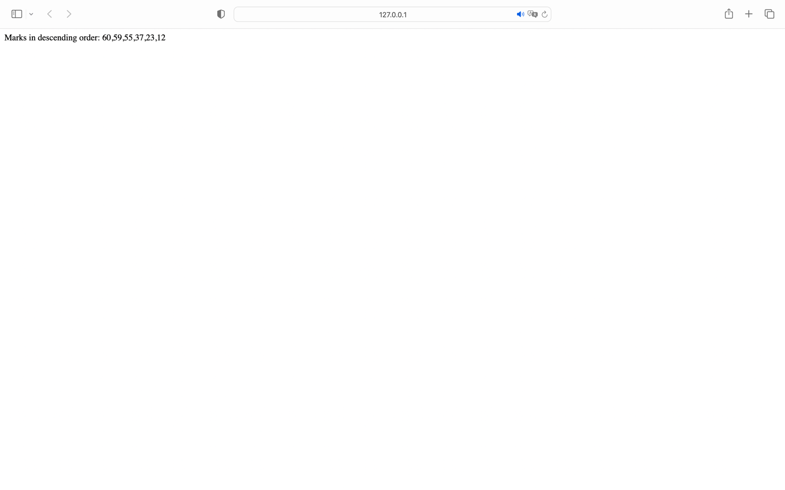

QUES3

<!DOCTYPE html>

<html lang="en">

<head>

<meta charset="UTF-8">

<meta http-equiv="X-UA-Compatible" content="IE=edge">

<meta name="viewport" content="width=device-width, initial-scale=1.0">

<title>Diagonal Sum 20BCE1650</title>

<script>

function max(i,j){

if(i>j){

return i;

}

else if(i<j){

return j;

}

}

function sumnmax(amrit,n){

var sumup=0,sumlow=0;

for(var i=0;i<n;i++){

for(var j=0;j<n;j++){

if(i<j){

sumup=parseInt(sumup)+parseInt(amrit[i][j]);

}

else if(i>j){

sumlow=parseInt(sumlow)+parseInt(amrit[i][j]);

}

}

}

return max(sumup,sumlow);

}

var n=prompt("Enter the dimension of matrix: ");

var amrit=new Array(n);

for(var i=0;i<n;i++){

amrit[i]=new Array();

}

for(var i=0;i<n;i++){

for(var j=0;j<n;j++){

var x=prompt("Enter element at ("+i+","+j+"): ");

amrit[i][j]=x;

}

}

document.write("Entered Matrix:<br/>");

for(var i=0;i<n;i++){

for(var j=0;j<n;j++){

document.write(amrit[i][j]+" ");

}

document.write("<br/>");

}

document.write("<br/>Bigger of upper and lower sum is: "+sumnmax(amrit,n));

</script>

</head>

<body>

</body>

</html>

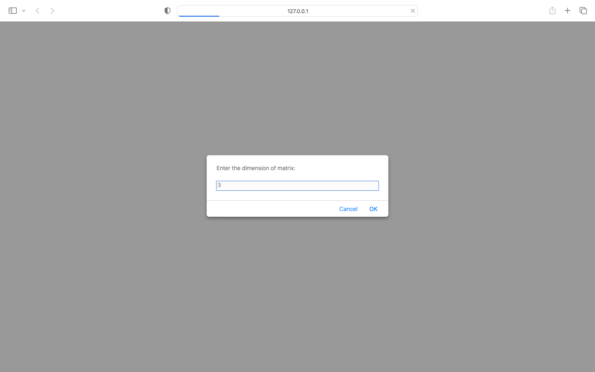

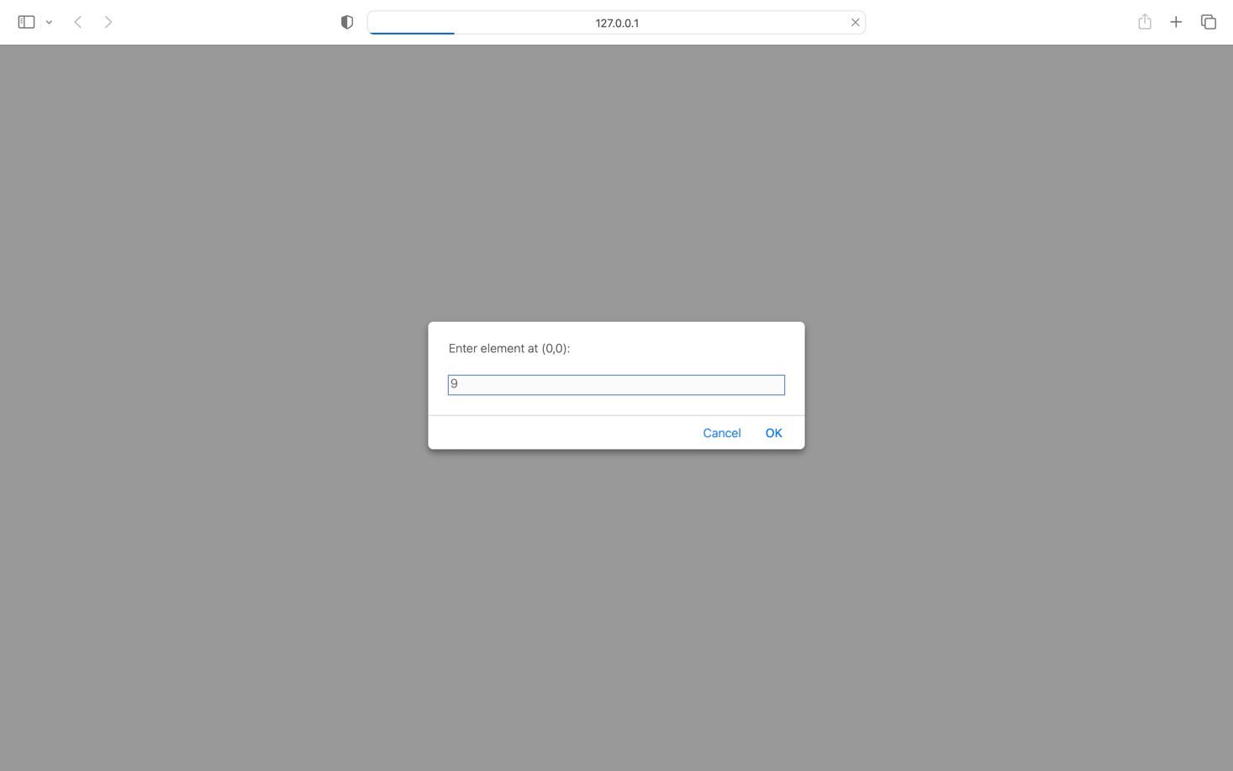

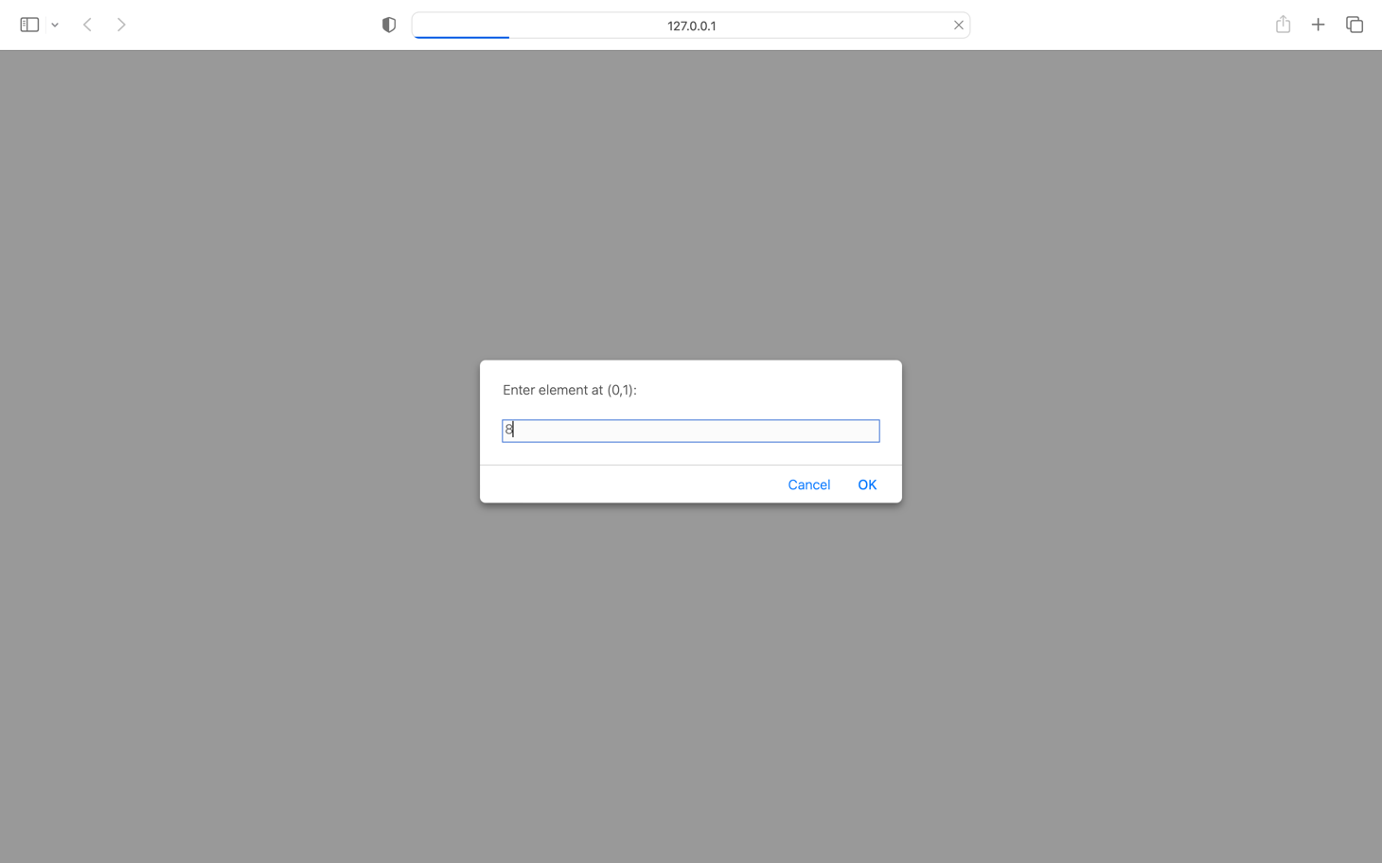

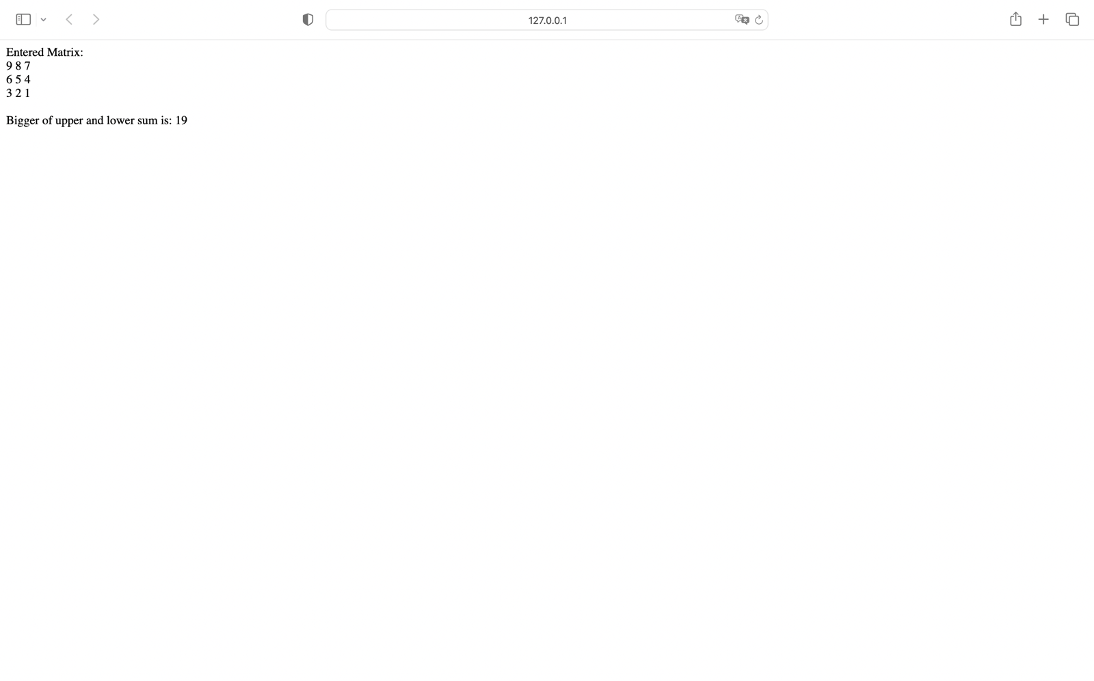

QUES4

<!DOCTYPE html>

<html lang="en">

<head>

<meta charset="UTF-8">

<meta http-equiv="X-UA-Compatible" content="IE=edge">

<meta name="viewport" content="width=device-width, initial-scale=1.0">

<title>Document</title>

<script>

var flag=0;

var n=prompt("Enter dimension of board:");

var size = 2; //max possible size of battleship

//generating x & y coordinate of ship

do{

var battleship = new Array();

var guess=new Array();

for(var i=0;i<2*size;i++){

var xy = Math.floor(Math.random()*n);

battleship.push(xy);

}

var j=1;

for(var i=0;i<2*size;i++){

if(i%2==0)

var ab=prompt("Enter x"+j+" coordinate:");

else{

var ab=prompt("Enter y"+j+" coordinate:");

j++;

}

guess.push(ab);

}

if(battleship.join()==guess.join()){

alert("You guessed it!!!");

break;

}

else{

alert("Wrong guess!! Chances left "+(3-(flag+1)));

flag++;

}

}while(flag<3);

if(flag==3){

document.write("Better luck next time!!<br/>");

}

document.write("Correct coordinates are: ");

document.write(battleship);

</script>

</head>

<body>

</body>

</html>

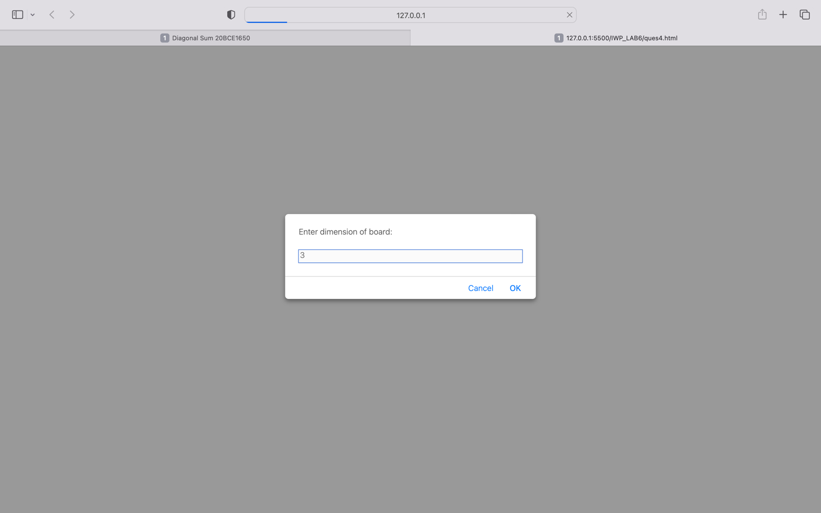

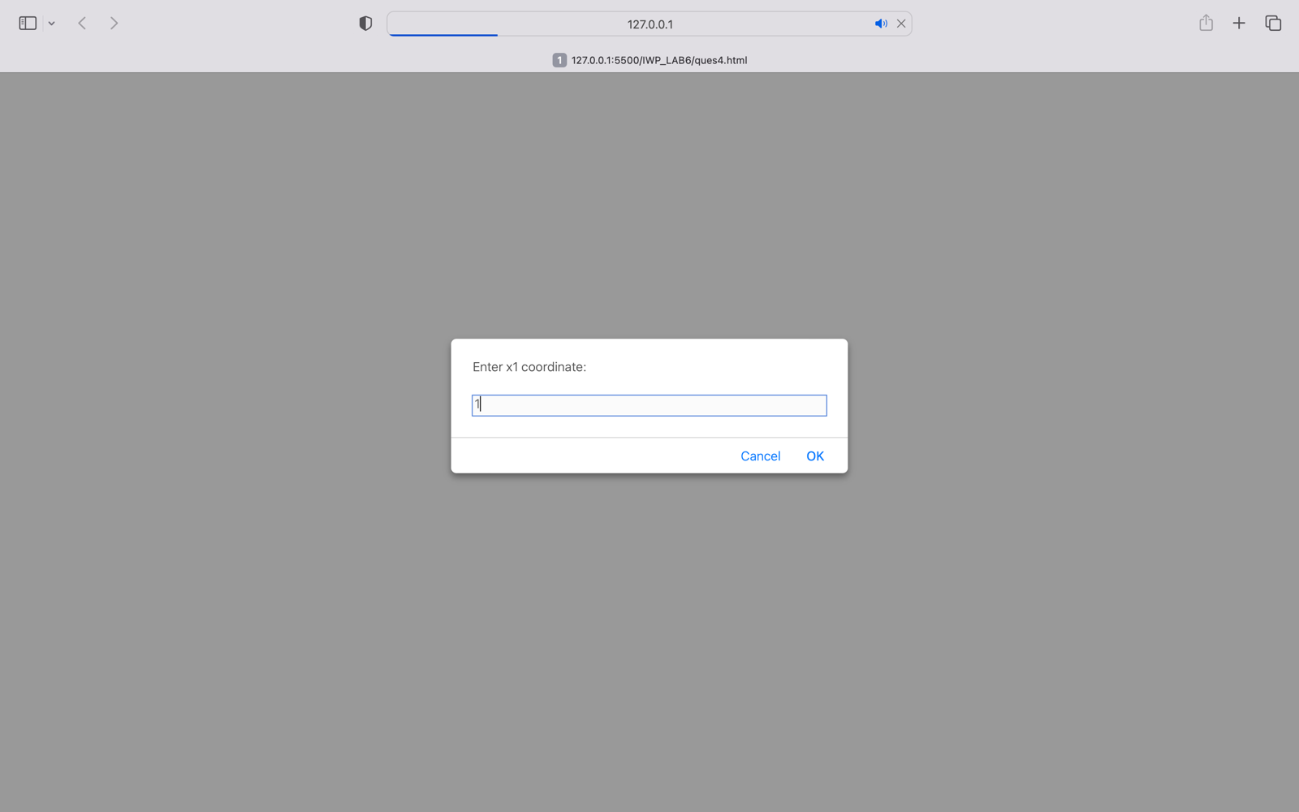

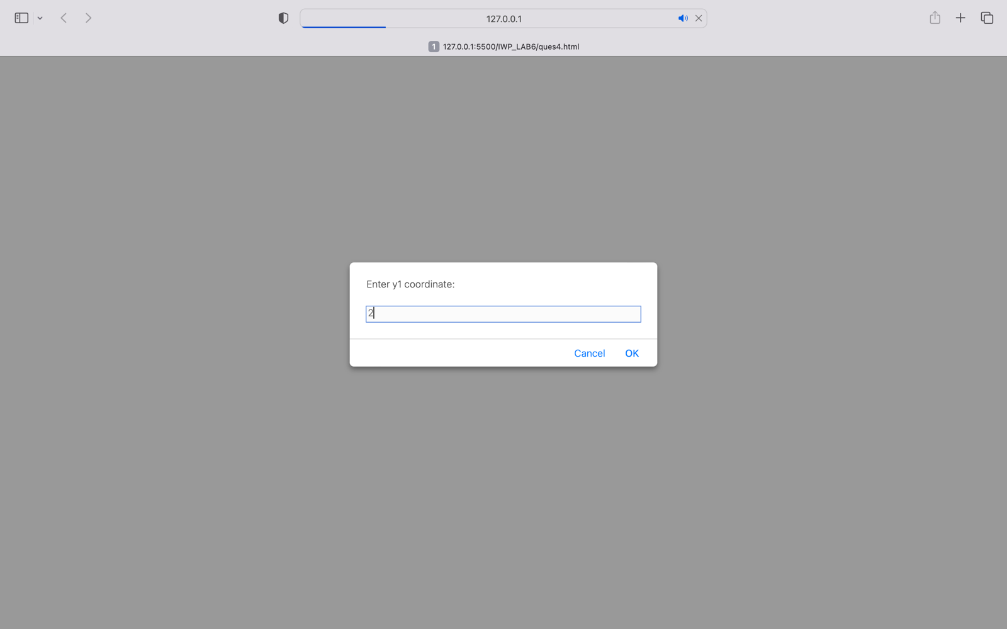

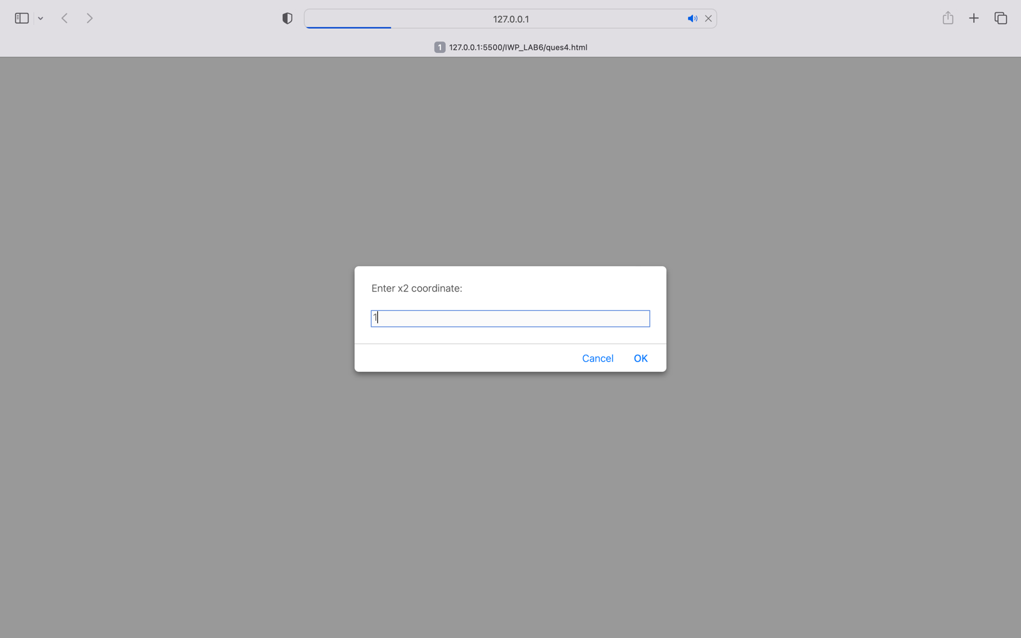

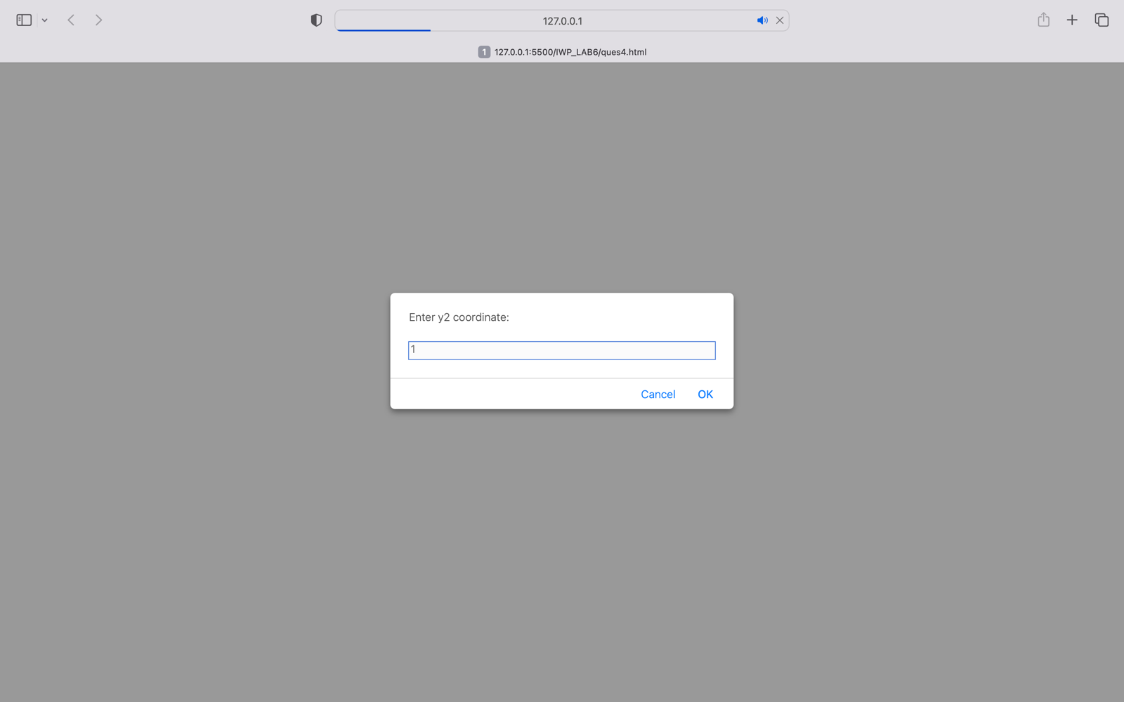

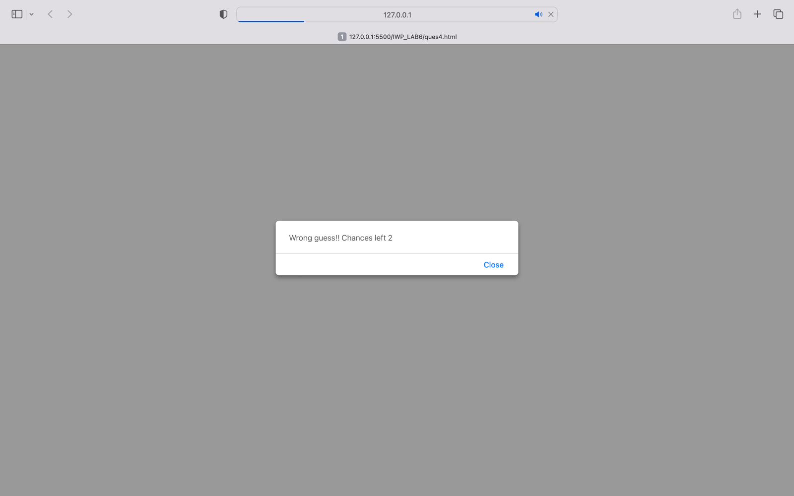

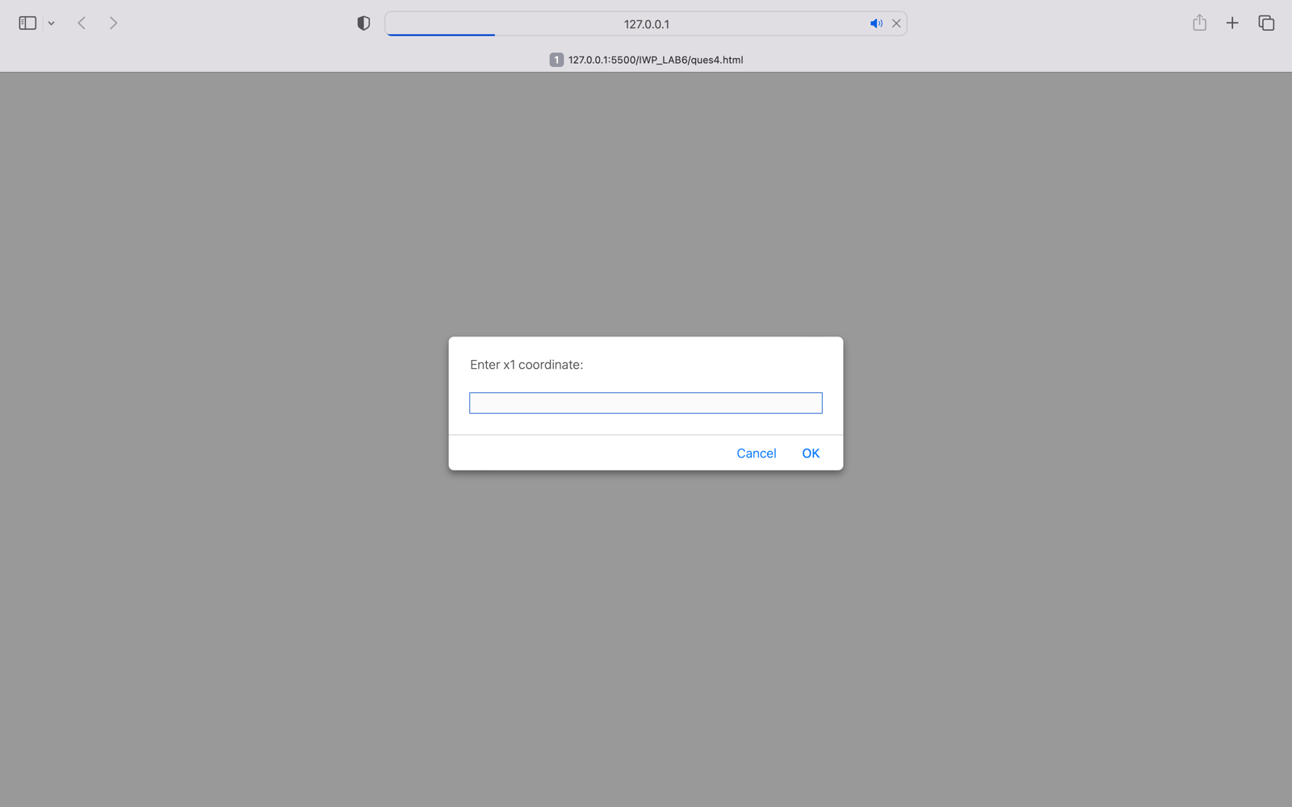

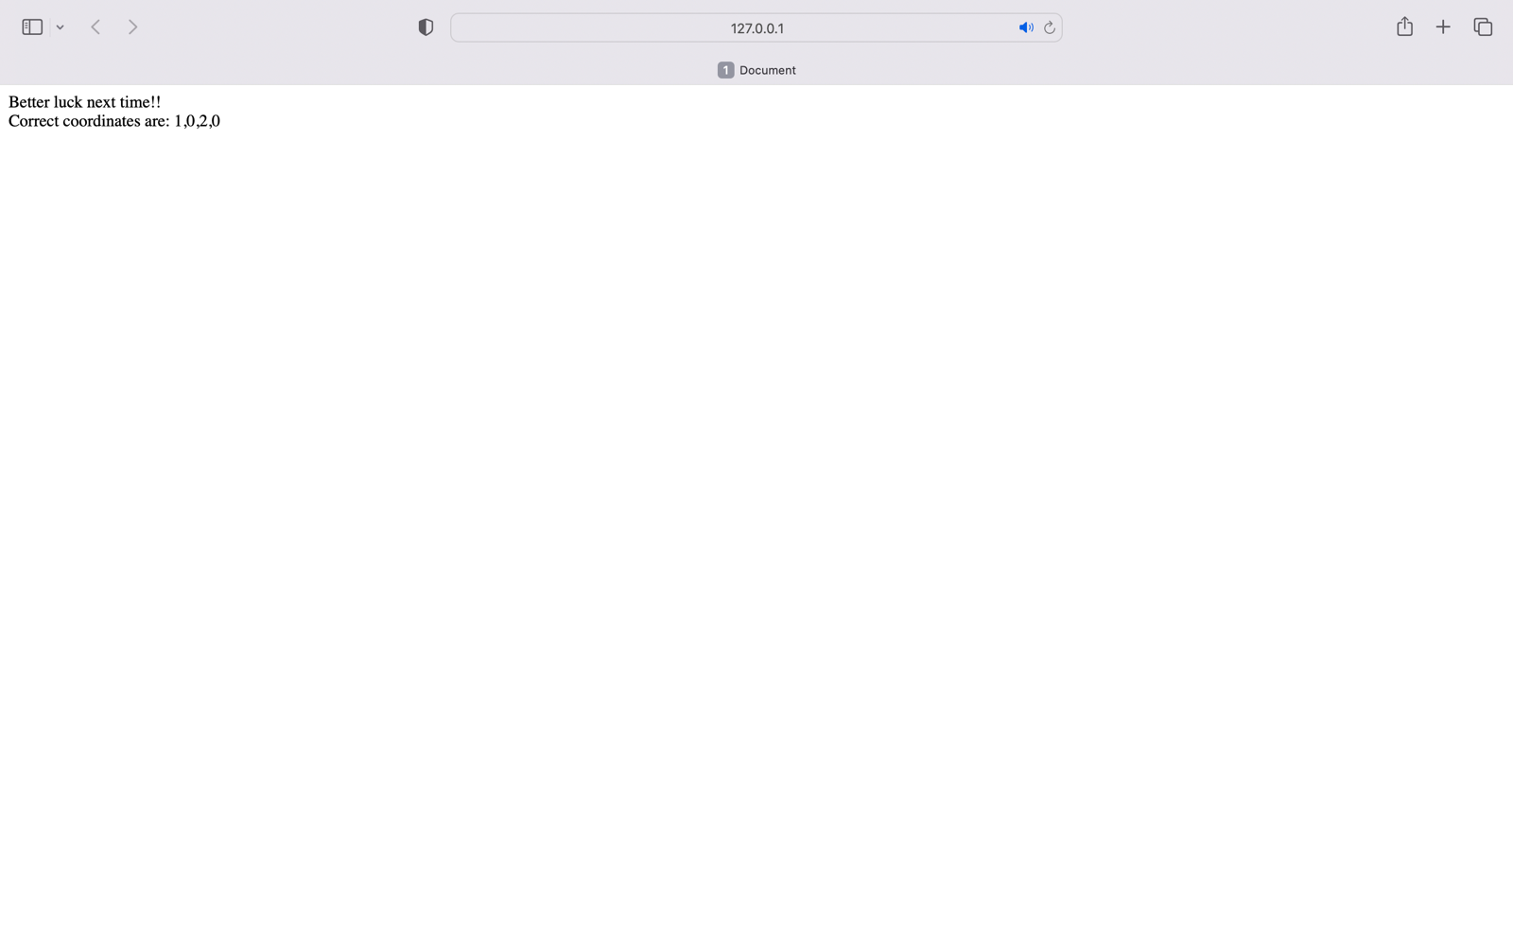

QUES5

<!DOCTYPE html>

<html lang="en">

<head>

<meta charset="UTF-8">

<meta http-equiv="X-UA-Compatible" content="IE=edge">

<meta name="viewport" content="width=device-width, initial-scale=1.0">

<title>Document</title>

<script>

var pp={"A":"Dear Maam , this is the participant certificate for the conference held in 2021.",

"B":"Dear Sir , this is the participant certificate for the conference held in 2021.",

"C":"Dear Maam , this is the participant certificate for the conference held in 2021.",

"D":"Dear Maam , this is the participant certificate for the conference held in 2021.",

"E":"Dear Sir , this is the participant certificate for the conference held in 2021.",

"F":"Dear Maam , this is the participant certificate for the conference held in 2021.",

"G":"Dear Sir , this is the participant certificate for the conference held in 2021.",

"H":"Dear Sir , this is the participant certificate for the conference held in 2021."}

var male = new Array();

var female = new Array();

for(key in pp){

var arr = pp[key].split(" ");

if(arr[1]==="Maam"){

female.push(" Mrs."+key);

}

else if(arr[1]==="Sir"){

male.push(" Mr."+key);

}

}

document.write("Male participants: "+male+"<br/>Female participants: "+female);

</script>

</head>

<body>

</body>

</html>



