EXPLANATION OF ASSIGNMENT 1

the dataset consists of transactional data with customers in different countries who make purchases from an online retail that sells unique all-occasion gifts

The following are the Results of my analysis

1-AVERAGE VALUE OF THE TOATAL_TARANSACTION AT USER LEVEL=21800

2-AVERAGE COST PER TRANSACTION ID= 6854.530297297297 WHICH GIVES US THE CRITERIA FOR THE SEGMENTATION/BINING

3- LABELING THE BINS - [0, 2000)=Low, [2000, 4000)=below_avg, [4000, 7000)=avg, [7000, 22000)=above_avg, [22000, 100000000)=High as per Total_cost_bins

4- MEAN VALUE OF THE NO. of TRANSACTION PER USER IS ROUGHLY 6

5- CREATING THE INTERVALS/BINS FOR THE NO.OF TRANSACTIONS OF A USER AS PER THE MEAN VALUE OF NO. OF TRANSACTIONS

6- LABELING THE BINS- [1, 2)=Low, [2, 4)= below_avg, [4, 8)= avg, [8, 100)= above_avg, [100, 4000)=High

7-BY LOOKING THE GRAPH BELOW WE CAN CATAGORISE THE HOURS IN [1,7),[7,10),[10,13),[13,20) AND WE FOUND THAT MAXIMUM BUYERS ARE IN THE RANGE [7,10]

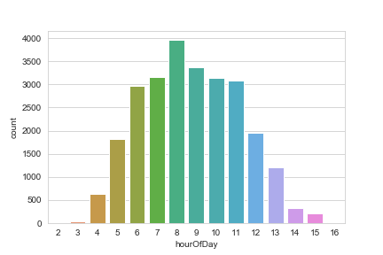

8- ANALYSIS ON WHEATHER A BUYER IS WEEKEND -SHOPPER OR WEEKDAY -SHOPPER USING DAY OF THE WEEK IN TRANSACTION TIME COLUMN AND BY LOOKING THE GRAPH BELOW WE CAN FIND THAT THERE ARE MOSTLY WEEKDAY BUYERS

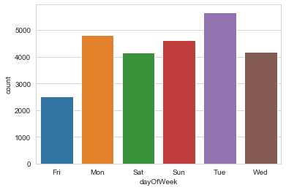

9- BY LOOKING THE GRAPH BELOW WE CAN INTERPRET THAT NUMBER OF BUYERS ARE MORE IN THE MONTH OF DEC,JAN,FEB AS IT IS A FESTIVE SEASON IN MANY COUNTRIES

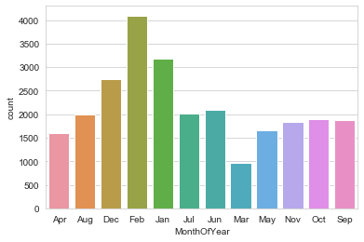

10-MOSTLY PEOPLE ARE IN BELOW AVERAGE TRANSACTION CATEGORY BY INTERPRETING “output_feature_engineer.csv” FILE

11-IN THE WORD CLOUD FOR ITEM BOUGHT BY USER WE CAN SEE THAT MORE PREFERENCE IS GIVEN TO WORDS LIKE“SET”,”PINK”,”VINTAGE”,”RED”,”GLASS”,”BLUE”,”BOX”

