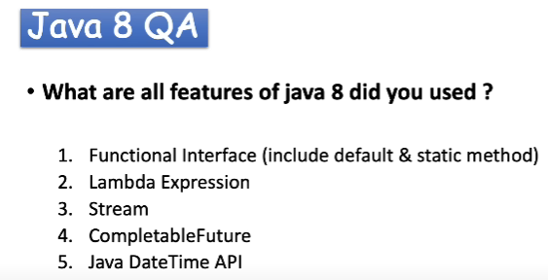

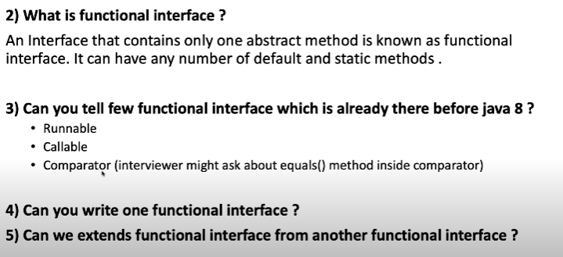

Ans 4.

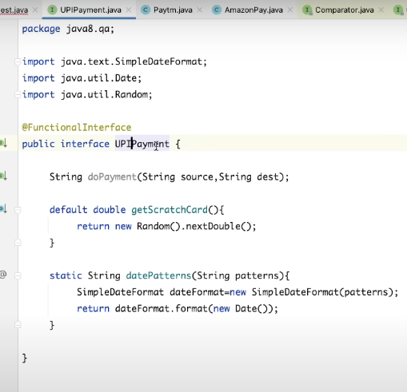

Ans 5. Yes we can but the one functional interface in which we are extending another functional interface that will act as traditional interface since now it will be having 2 abstract methods.

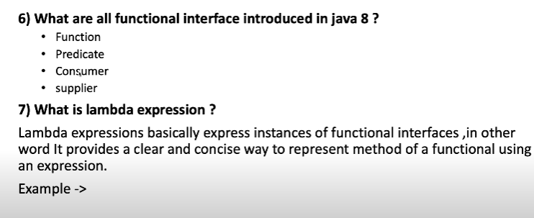

Ans 6. Function : having 1 abstract method which will accept single value/object as parameter and return Single value/object.

Predicate : having 1 abstract method which will accept single value/object as parameter and return boolean value/object.

Consumer : having 1 abstract method which will accept single value/object as parameter and return void/nothing.

Supplier : having 1 abstract method which will accept nothing as parameter and return a value/object.

Ans 7. Below is how we define a lambda inside our code.

