# Uber Supply Demand Gap

## Business Objectives

The aim of analysis is to identify the root cause of the problem (i.e. cancellation and non-availability of cars) and recommend ways to improve the situation. As a result of your analysis, you should be able to present to the client the root cause(s) and possible hypotheses of the problem(s) and recommend ways to improve them.

## Data Cleaning and Manipulation

Following are the data available for analysis:

* Request id: A unique identifier of the request
* Time of request: The date and time at which the customer made the trip request
* Drop-off time: The drop-off date and time, in case the trip was completed
* Pick-up point: The point from which the request was made
* Driver id: The unique identification number of the driver
* Status of the request: The final status of the trip, that can be either completed, cancelled by the driver or no cars available

As part of Data Cleaning, each Data field was checking if any missing or NA values are present. If present, it was analysed is data missing is valid and replaced with appropriate values for analysis.

Date and times were converted to single format for data extraction and analysis.

## Definitions

* Demand of Uber cars = Total no of Requests made
* Supply of Uber cars = Total no of Trips Completed

## Data Analysis

Data obtained post cleaning and manipulation was used for plotting demand-supply patterns to understand the issues.

### Uber Demand Pattern day wise across 24 hours

Demand Pattern was plotted for each of 5 days spread across 24hours. Here count of requests received for each hour was considered and plotted.

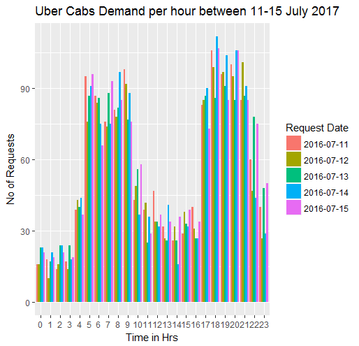

As seen from the above plot, Demand Pattern is similar for all days. Hence we can aggregate the requests for all 5 days and analyse the pattern.

### Uber Demand Pattern across 24 hours

Demand Pattern was plotted across 24 hours with separate bars for Airport and City pickup points.

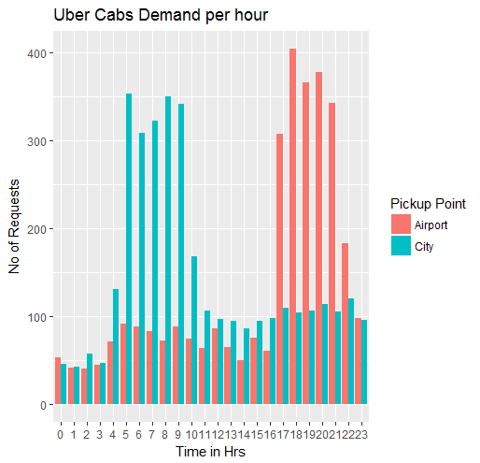

Analysing the above plot, 5 timeslots were identified in which demand is varying. Following time slots were identified for analysis:

* Early Morning - 12 AM – 04 AM
* Morning - 04 AM – 10 AM
* Day - 10 AM – 05 PM
* Evening - 05 PM – 09 PM
* Night - 09 PM – 12 AM

### Demand Supply Patterns based on Time Slots

Based on time slots identified, demand and supply patterns were plotted to understand the time slots where the gap was high and needs to be addressed.

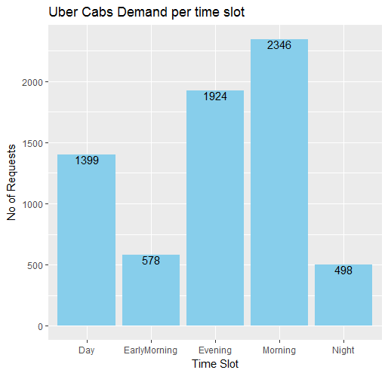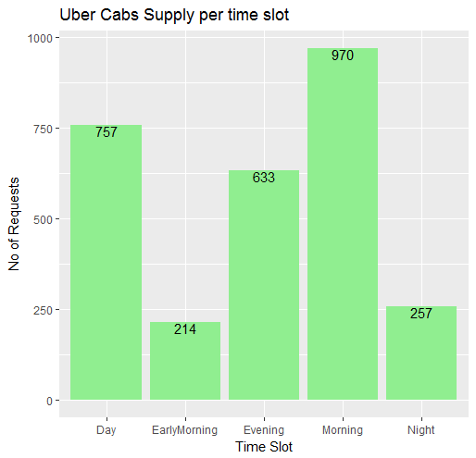

Based on the Demand Supply plots, following demand and supply counts emerged:

|  |  |  |  |
| --- | --- | --- | --- |
| **TIME SLOT** | **DEMAND COUNT** | **SUPPLY COUNT** | **DEMAND FULFILLED** |
| Early Morning | 578 | 214 | **37.02%** |
| Morning | 2346 | 970 | 41.35% |
| Day | 1399 | 757 | 54.11% |
| Evening | 1924 | 633 | **32.90%** |
| Night | 498 | 257 | 51.61% |

From the above table, Time Slots Morning and Evening were found to have a considerable Demand-Supply Gap than other time slots.

### Demand Supply Patterns based on Time Slots grouped by Status

To analyse Demand-Supply Gaps in depth, Demand patterns with Trip Status included were plotted.

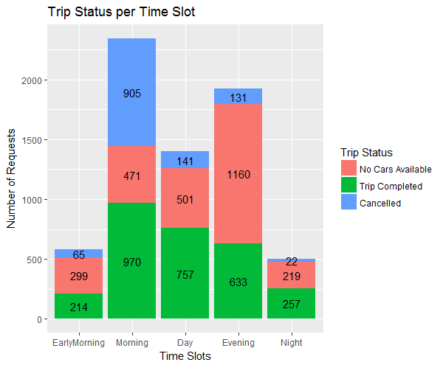

Based on above Demand Plot, problems were identified:

* Problem 1 - High % of requests are cancelled during the Morning Time slot
* Problem 2 - High % of requests are not accepted in Evening Time Slot due to unavailability of cars

## Demand-Supply Problem Analysis

Following problems were identified in Data Analysis Stage:

* Problem 1 – Cancellation Issue in Morning Time Slot
* Problem 2 – Unavailability of cars Issue in Evening Time Slot

### Problem 1 – Cancellation Issue in Morning Time Slot

### Analysis

To analyse the issue of high cancellation rate in morning time slot, plots were created with additional detail of pickup point to understand where the issue was more.

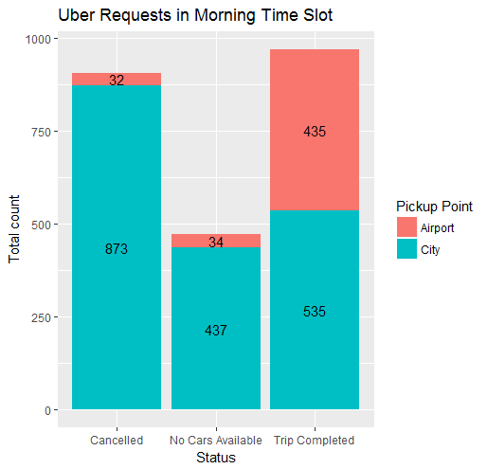

Based on above plot, following stats were identified:

* Percentage of Cancelled Requests in Morning Time Slot = 38.60%
* Percentage of Airport pickup point cancellations = 03.54%
* Percentage of City pickup point cancellations = **96.50%**

### Problem identification

Based on the cancellation rates, high cancellations rate was identified when pickup point was City and trip was to Airport.

### Demand-Supply Gap Issue Analysis

Demand-Supply rate was calculated for Morning Time Slots for City to Airport trips since high cancellation rate is seen for these trips.

* Demand of Uber cars in Morning Time Slot at City = 1845
* Supply of Uber cars in Morning Time Slot at City = 0535
* Percentage of Demand fulfilled = **29%**

### Reasons for Demand-Supply Gap

Based on flight patterns, high no of flights depart in Morning time slot of 4AM - 10AM. But the flight arrivals are less compared to departures.

Driver who successfully completes a trip from City to Airport in Morning would have to wait in Airport to pick customer back to City. Return to City would be loss to driver in terms of toll, fuel charges etc. So driver will wait in Airport thus having idle time in a day when additional trips could have been made if driver was in City.

Hence a large number of cancellations can be seen for City to Airport trips in Morning Time Slots.

### Recommendations

* Drivers can be provided incentives for City to Airport trip
* Customers can be charged toll charges, parking fee charges etc.
* Co-ordinate with Airport authority to understand flight patterns and increase the supply
* Airport Car Pool to combine multiple requests to meet the demands
* Penalty to driver for cancellations
* Provide base amount to drivers who return to City with no customer

### Problem 2 – Unavailability of cars Issue in Evening Time Slot

### Analysis

To analyse the issue of unavailable cars in evening time slot, plots were created with additional detail of pickup point to understand where the issue was more.

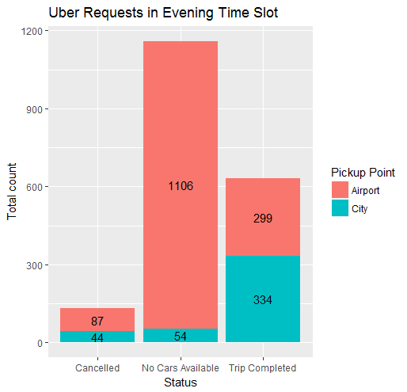

Based on above plot, following stats were identified:

* Percentage of unavailable cars in Evening Time Slot = 60.30%
* Percentage of unavailable cars at Airport pickup point = **95.30%**
* Percentage of unavailable cars at City pickup point = 04.66%

### Problem identification

Based on the unavailability car stats, high unavailability was identified when pickup point was Airport and trip was to City.

### Demand-Supply Gap Issue Analysis

Demand-Supply rate was calculated for Evening Time Slots for Airport to City trips since high unavailability of cars is seen for these trips.

* Demand of Uber cars in Evening Time Slot at Airport = 1492
* Supply of Uber cars in Evening Time Slot at Airport = 0299
* Percentage of Demand fulfilled = **20%**

### Reasons for Demand-Supply Gap

Based on flight patterns, high no of flights arrive in Evening time slot of 5PM - 9PM. But the flight departures are less when compared to arrivals.

As departures are less, less no of requests to Airport will be made from City to Airport. So less no of cars will be available in Airport to fulfil the demand from flight arrivals.

Hence high unavailability of cars will be seen for Airport to City trips in Evening Time Slots.

### Recommendations

* Drivers can be provided incentives for Airport to City trips
* Customers can be charged toll charges, parking fee charges etc.
* Co-ordinate with Airport authority to understand flight patterns and increase the supply
* Airport Car Pool to combine multiple requests to same drop locations to meet the demands
* Penalty to driver for cancellations