**Q 1.1**

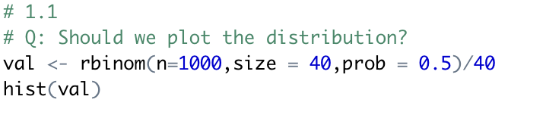

The distribution of the number of heads in the set of coin flips is

**Q 1.2**



**Q 1.3**

The Z-statistic for conducting a test of the null hypothesis that the coin is fair is defined as below

**Q 1.4**



**Q 1.5**

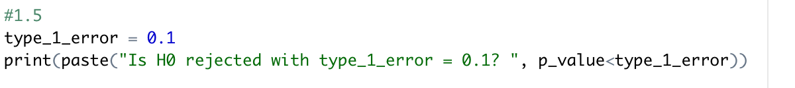



**Q 1.6**

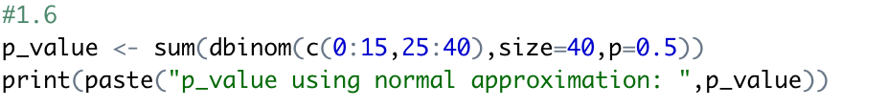



**Q 1.7**



**Q 1.8**

Final comment:

The 90% confidence interval range is narrower compared to 95% confidence interval, therefore there's more chance for the null hypothesis to be rejected

**Q 2.1**



**Q 2.2**



Final comment:

Based on above range of 95% confidence interval, the p-value would be less than 0.05, therefore the researcher can reject the null hypothesis that the proportion of drivers wearing their seatbelt after the intervention is equal to 0.7 (or unchanged from before)

**Q 2.3**

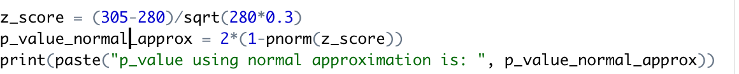



Final comment:

As p_value is lower than type 1 error probability 0.05, the researcher can reject the null hypothesis that proportion of drivers wearing seatbelt after intervention is same as before intervention. This conclusion is same as the conclusion from the confidence interval found earlier.

**Q 2.4**



As p-value is lower than type 1 error probability 0.05, the researcher can reject the null hypothesis that proportion of drivers wearing seatbelt after intervention is same as before intervention.





Final comment: The above p-values are not very different.

**Q 2.5**



**Q 3.1**

Final comment:

As seen above, the distribution of the IQ variable approximately resembles a normal distribution as their graphic representations along with their mean and standard deviation is similar.

**Q 3.2**

Final comment:

The mean is very well inside the lower bound of the 95% confidence interval.

**Q 3.3**



**Q 3.4**



Final comment: As the p-value is less than 0.05, the probability of the population mean being as or more extreme is higher therefore null hypothesis that the population mean is 100 is rejected

**Q 3.5**



Final comment:

As the bounds of confidence interval ( 88.5453639031405 , 93.6159264194401 ) don't include population mean of 100, the null hypothesis that the population mean is 100 is rejected. This conclusion is the same as hypothesis test method.

**Q 3.6**



Final comment:

As the bounds of confidence interval ( 87.7498547328537 , 94.4114355897269 ) don't include population mean of 100, the null hypothesis that the population mean is 100 is rejected. This conclusion is the same as hypothesis test method with 0.01 significance level.