**Reconcilation**

**Documentation of Reconcilation**



# Revision History

* 1. Saroj Ghorasaini: Initial Draft Prepared. (15th Feb, 2017)
  2. Saroj Ghorasaini: Contacts of Bank added(21st May 2017)

**Confidentiality Statement**

Copyright © 2000-2017 Elite Solutions. All Rights Reserved. No part of this publication may be reproduced or transmitted in any form or by any means, mechanical, electronic, photocopying, recording, or otherwise, without prior written permission 2017 Elite Solutions. The Elite logo is a trademark of 2017 Elite Solutions.

**Disclaimer**

The information included in this document has been prepared and included for the purpose of this document only and shall not be construed as a precedent in any other situation outside this proposal and context.

**Document Details**

Document ID: Reconcilation_Technical_Document_v1.0.docx  
Document Revision: 1.0

Author: Saroj Ghorasaini

Reviewed by:

Release Date:

**Elite Solutions**

**72Ga Nag Pokhari Colony**

**P. O.  Box 5134**

**Nag Pokhari, Kathmandu**

**Nepal**

**Telephone: +977-1-4429026**

**Fax: +977-1-4419891**

# 

# Objective

A bank reconciliation is the process of matching the balances in an entity's

accounting record from different sources like ATM,Switches(NPN/NEPS),Visa

and CBS(Core Banking System)

# Abbreviations

|  |  |
| --- | --- |
| Abbreviations | Description |
| Elite | Elite Solutions Pvt. Ltd. |
| MBL | Machhapuchchhre Bank Limited |
| NB | Nepal Bank |
| Mega Bank |  |

Table of Contents

Revision History 2

Objective 4

Abbreviations 4

1. Introduction 7

1.1 Purpose 7

1.2 Intended Audience 7

1.3 Scope of the Document 8

1.4 Document Conventions 8

2. Problem Statement 8

3. Product Details 8

3.1 Chapter Overview 8

3.2 Overview of Product Features 9

3.2.1 Reconcilation Client 9

3.2.2 Reconcilation Server 9

3.2.3 Reconcilation Administration 9

3.2.4 Reconcilation Reports 10

3.3 User Documentation 10

3.4 Assumptions and Dependencies 10

4. Product Description-Reconcilation Functions 10

4.1 Chapter Overview 10

4.2 Welcome Screen 10

4.3 Reconcilation Option 12

4.3.1 Information 13

4.3.2 Account Information 16

4.3.3 Date Conversion 19

4.3.4 Cheque Requisition 19

4.3.5 Cheque Deposit 21

4.3.6 Cheque Stop 23

5. Limited Liability 27

6. Codebase Repo 28

7. Deployment Steps 28

Appendix 29

Bank Contacts 29

NCHL Contacts 30

# 1. Introduction

A bank reconciliation is the process of matching the balances in an entity's

accounting record from different sources like ATM,Switches(NPN/NEPS),Visa

and CBS(Core Banking System).

## 1.1 Purpose

The document will serve as the basis for gathering the necessary requirements for the requested system and as the basis for defining the functional specification for the development team of Elite.

## 1.2 Intended Audience

The document is intended for the requirement gathering project teams of the Bank and Elite.

## 1.3 Scope of the Document

The document consists of the requirements identified during the discussions held with the Bank and discussion held internally within Elite.

## 1.4 Document Conventions

The document is compiled according to Elite standards in developing Software Requirement Specifications for projects. Each requirement is discussed under four separate sections:

* Description: a brief description of the requirement.
* Stimulus and Response: the activities which trigger the need and the response from the system.
* Functional Requirement: the detailed functional requirement.
* Exclusions: any of the functional exclusions are documented here.

# 2. Product Details

## 2.1 Chapter Overview

This chapter attempts to provide an understanding of the scope of the product delivered, in the following areas.

1. The functional aspects of the RECONCILATION in terms of a user who will be carrying out day-to-day banking activities (end users).
2. The functional aspects of the RECONCILATION in terms of a user who will be managing the Reconcilation, in order to provide smooth service to the end users.

## 2.2 Overview of Product Features

The features available from each application and admin module are explained below:

1. Transaction Reconcilation
2. Reconcilation Reports

### Transaction Reconcilation

Transaction Reconcilation is the process of reconcile (check,verify) whether the transaction is done in different sources like ATM,SWITCH,CBS and VISA.

### 1.2.2 Reconcilation Reports

Reconcilation report are those report which helps to the bank user to identify whether the transaction is Matched,Unmatched,DateDiff ,Invalid,Exception and Suspected.

## 3.3 User Documentation

A copy of the SRS for future references

## 3.4 Assumptions and Dependencies

For proper working of Reconcilation with all the functionalities defined above, it is assumed that the bank provides all the necessary data in views related to Account but that should not be limited to Account Number and Card Number mapping etc.

# 4. Product Description-Reconcilation Functions

## 4.1 Chapter Overview

This chapter provides an overview of the Reconcilation operations and describes each of these operations in detail, showing the screen flows of operations:

Following are the list of operations that will be supported:

1. Dashboard
2. Report
3. Settlement Maker
4. Settlement Checker
5. File Upload
6. User
7. Branch
8. Terminal
9. Member Bank
10. Bin No
11. Member Bank Bin No

## 4.2 Dashboard

Given below is the screenshot of dashboard of Reconcilation:

## 

## 4.3 Reports

We can have multiple individual reports for Matched,Failed,Invalid,DateDiff,Exception and Suspected below shown is Matched report and we can further export in Excel document .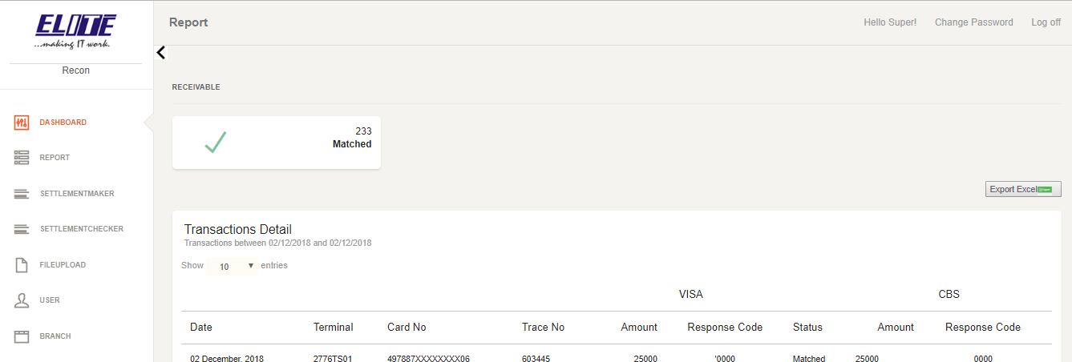

### 4.4 Settlement Maker

We have here Settlement maker concept to make sure whether the following transaction is Unsettled Transaction and Maker try to it settled manually and send these transaction to Settlement Checker to finalize it.

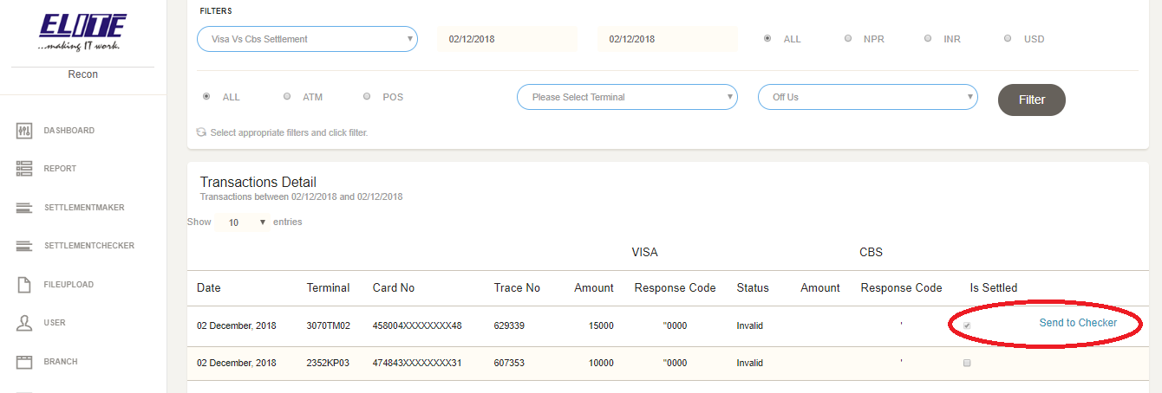

### 4.5 Settlement Checker

Settlement Checker verifies whether the transaction raised by maker are actually unsettled transactions or not

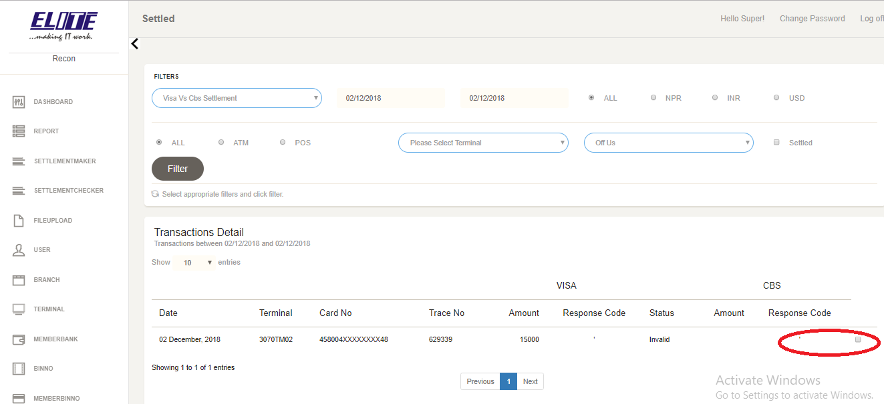

### 4.6 File Upload

This section handled the file upload entry for different sources like

SWITCH,CBS,ATM and VISA etc..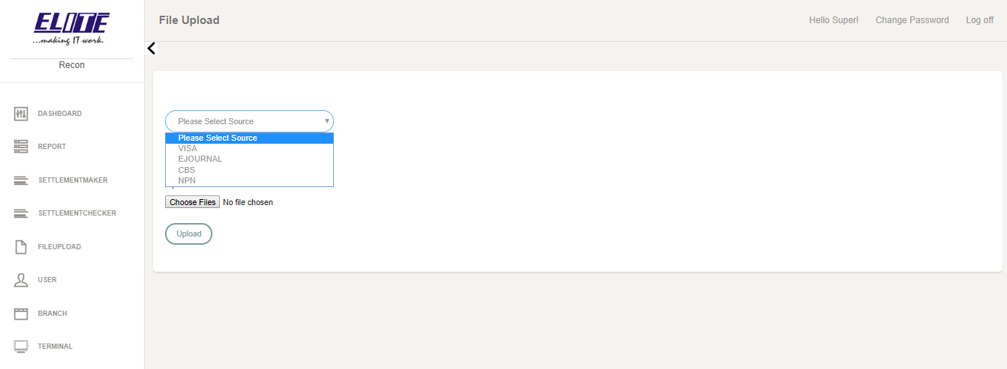

### 4.6 User

User section is entry to Create new user ,Create new Roles and assign Roles to the User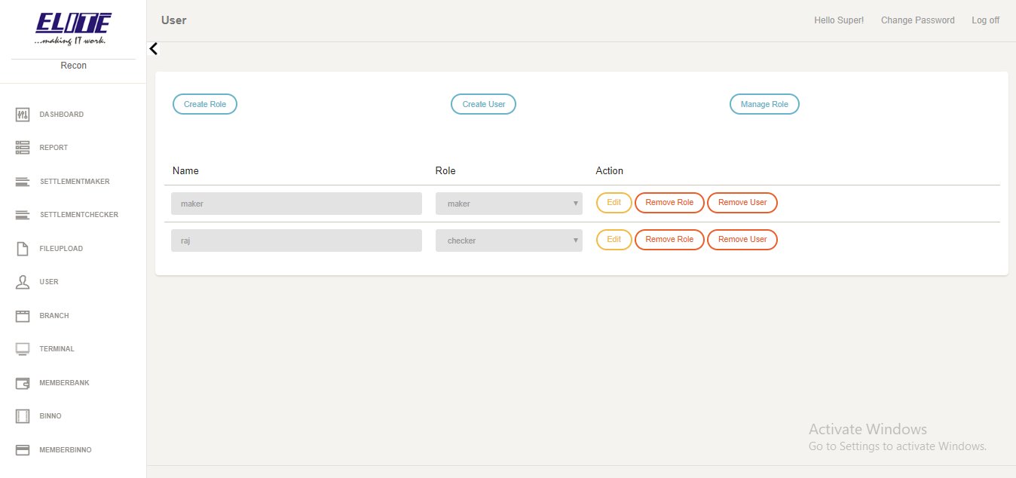

### 4.6 Branch

Branch section is the entry to Create ,Update ,Delete and Display the branch of the associate Bank.

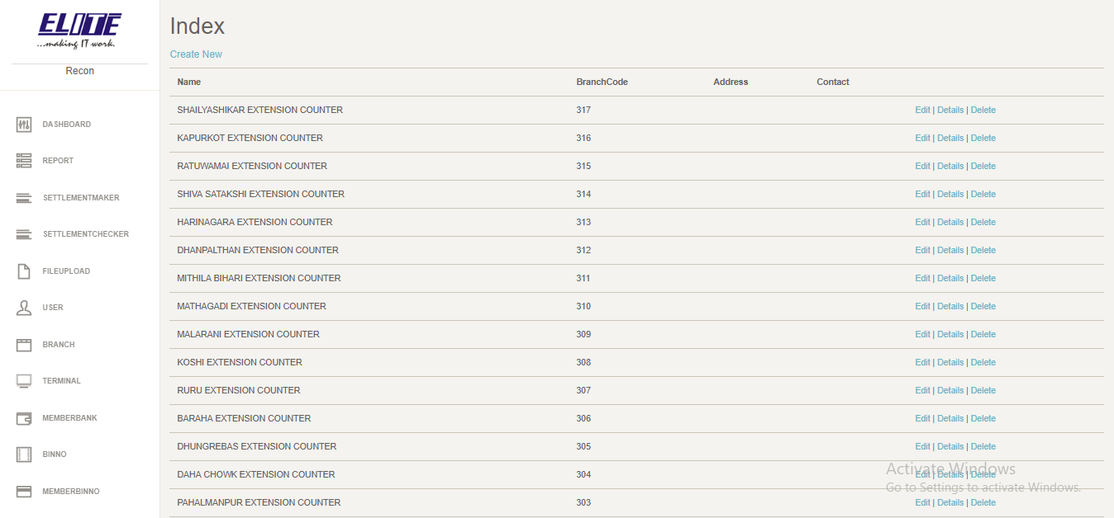

### 4.6 Terminal

Branch section is the entry to Create ,Update ,Delete and Display the Terminal(ATM/POS) of the associate Bank.

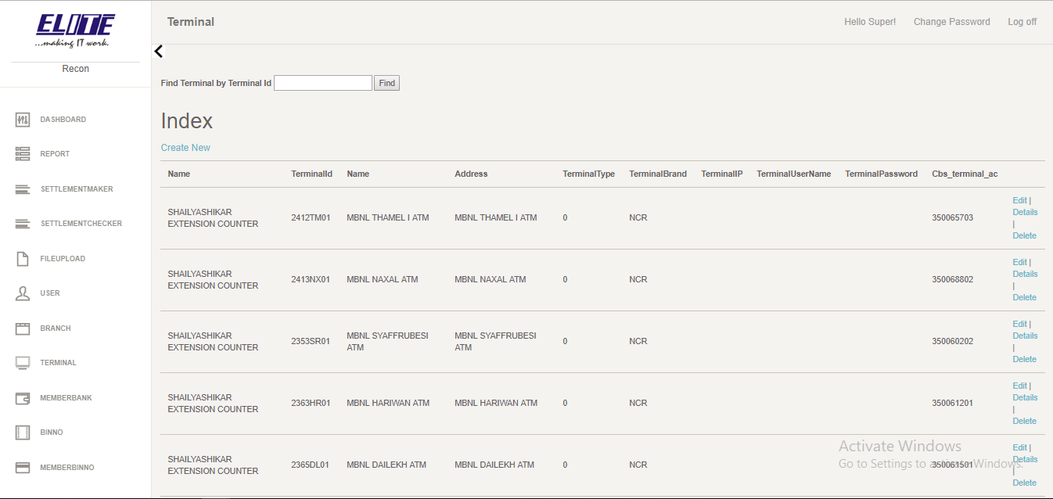

### 4.7 Member Bank

Member bank section is the entry to Create ,Update ,Delete and Display the Member of the associate Bank.

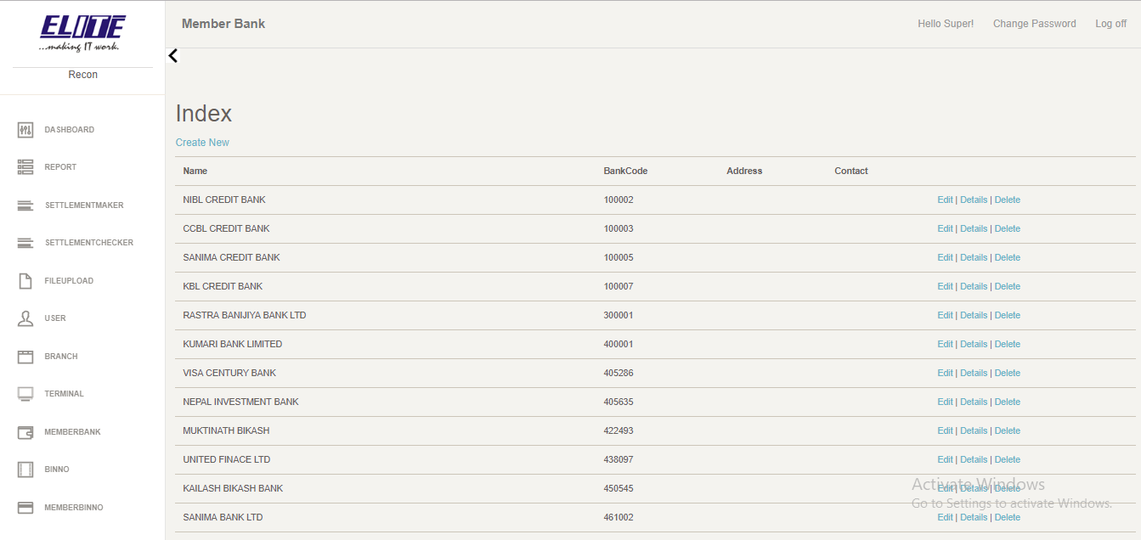

### 4.8 Bin No

Bin No section is the entry to Create ,Update ,Delete and Display the Bank card Bin number of the associate Bank.

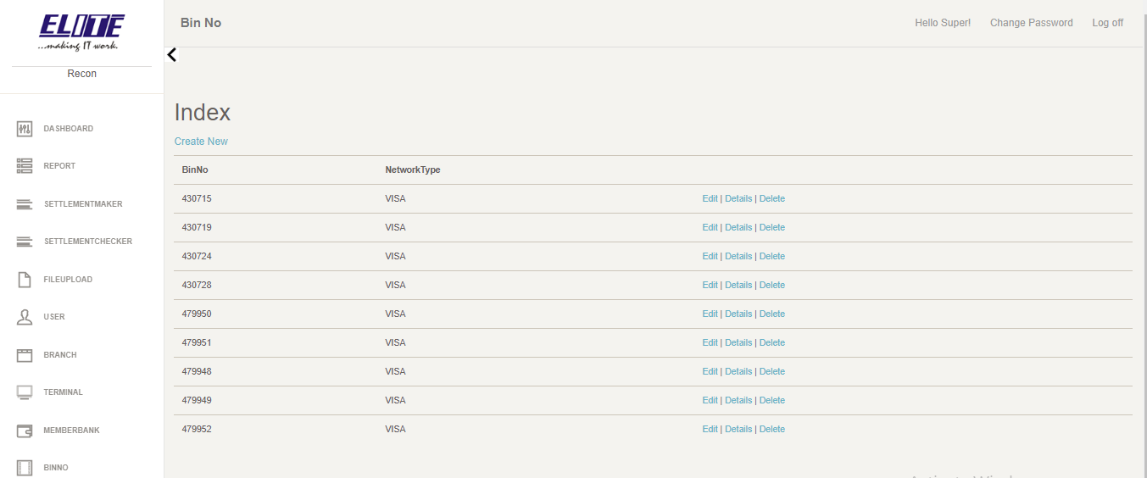

### 4.9 Member Bank Bin No

Member Bank Bin No section is the entry to Create ,Update ,Delete and Display the Member Bank card Bin number of the associate Bank.

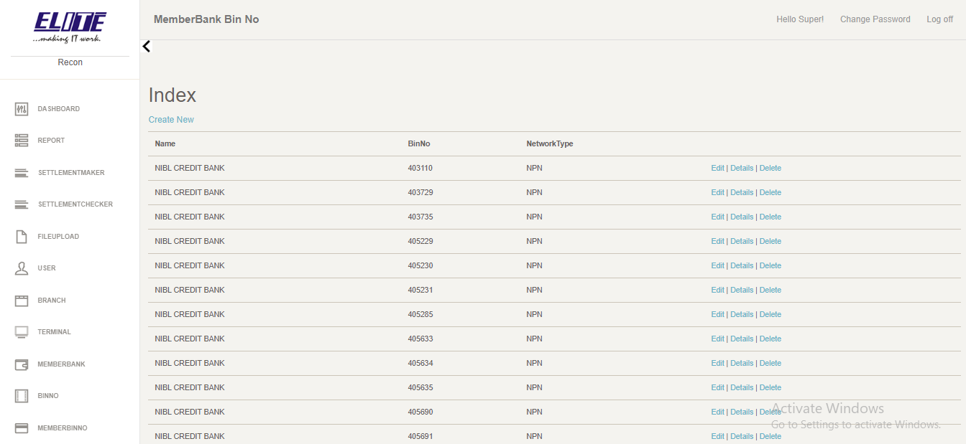

Simple flow diagram

Filter Recon Type

Export Report

Result

Repeat

# 5. Limited Liability

In no events shall Elite be liable for any special, incidental, indirect or consequential damages whatsoever (including, without limitation, damages for loss of business profits, business interruption, loss of business information, or any other pecuniary loss) whether in an action of contract, negligence or other tortuous action, rising out for in connection with the use or inability to use this information or the products, protocols or standards described here in, even if Elite has been advised of the possibilities of such damages.

# 6. Codebase Repo

The code for the project is maintained in bit bucket where a single administrator manages the code accessibility to all the users.

The code repo is located at:

**SSH**: git clone git@bitbucket.org:eliterecon/recon.git

**HTTPS**: git clone <https://sarojgrs@bitbucket.org/eliterecon/recon.git>

# 7. Deployment Steps

The deployment for all the projects in this application are defined in separate document titled:

**Reconcilation Manual**

## Bank Contacts

Below is the complete list of every contact person in banks where the system is being deployed or tested:

|  |  |  |  |  |  |
| --- | --- | --- | --- | --- | --- |
| S.N. | Bank | Contact Person | Address | Email Address | Contact Number |
| 1 | MBL | Divakar Thapa | Naxal |  | 9851136029 |
| 2 | Nepal Bank | Rabindra Maharjan | New Road |  | 9851102392 |
| 3 | Mega Bank | Bandana Rana Magar | Gyaneshor |  | 9808655318 |
|  | Rojee Shrestha | Gyaneshor |  | 9849499200 |