Lab 1 and 2

Q. Create Database “Bank” and display the list of database
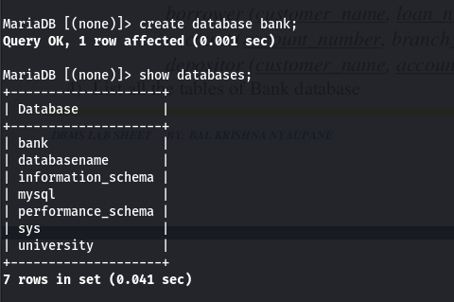

Q. Drop the database “Bank” and display the list of databases
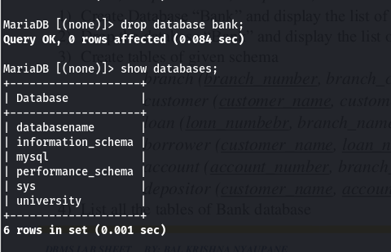

Q. Create tables of given schema
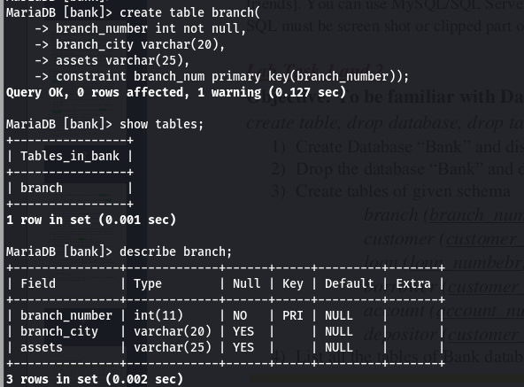

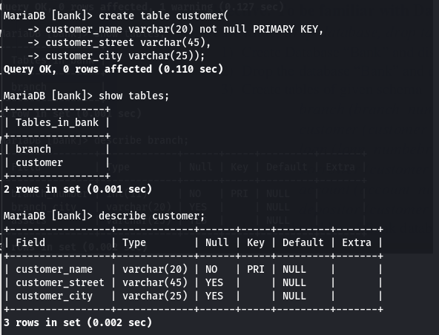
branch(branch_number, branch_city, assets)

customer (customer_name, customer_street, customer_city)

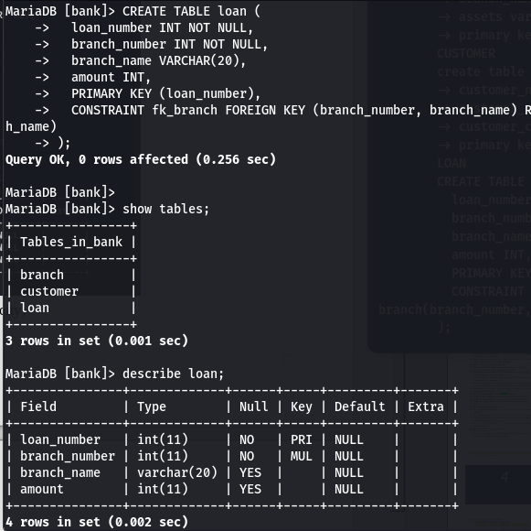

loan (lonn_numbebr, branch_name, amount)
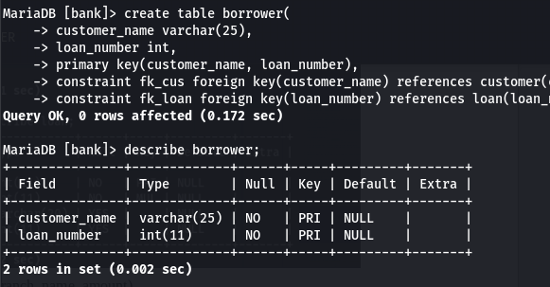
borrower (customer_name, loan_number)

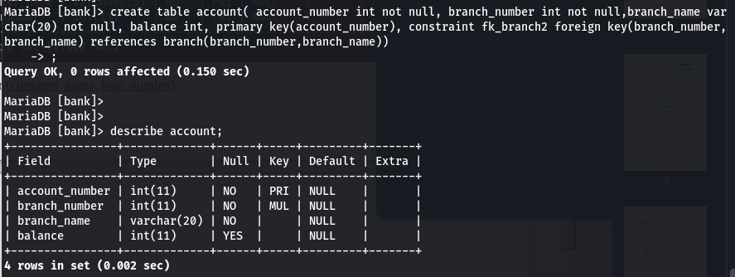
account (account_number, branch_name, balance)

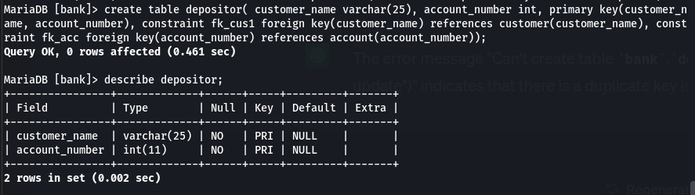
depositor (customer_name, account_number)

Q. List all the tables of Bank database
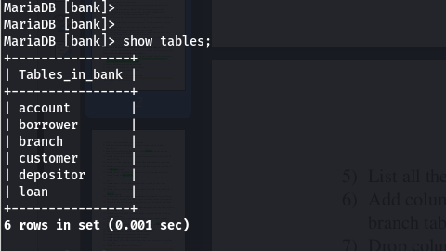

Q. List all the columns of “branch” and “customer” tables
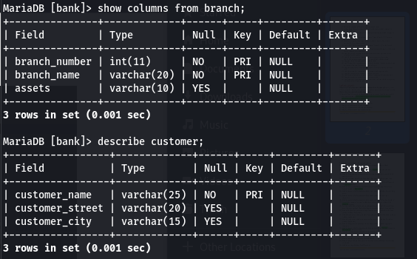
Q. Add column “Branch_manger” in branch table and list all the columns of
branch table
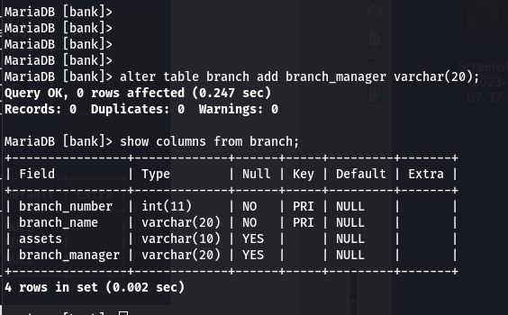

Q. Drop column “Branch_manger” from branch table and list all the columns of
branch table

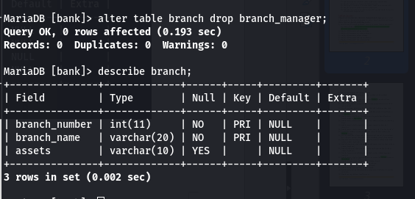

Q. Change the data type of a column “balance” from decimal (12,2) to int in
account table.
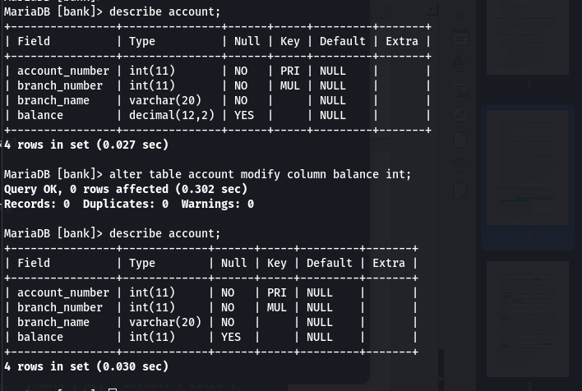

Q. Modify the length of data type “customer_name” from varchar (30) to
varchar (50) in a customer table.

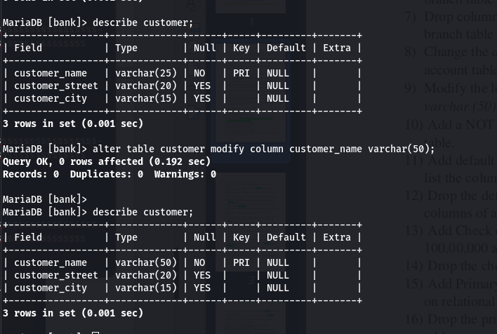

Q. Add a NOT NULL constraint in the column “branch_city” of the branch
table.

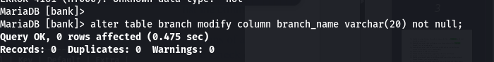

Q. Add default constraint in “account” table and set default balance is 1000. And
list the columns of account table.

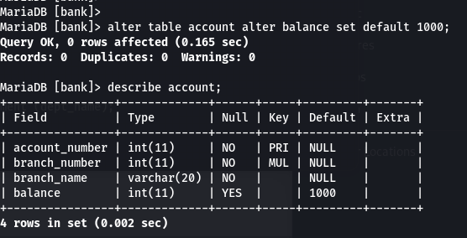

Q. Drop the default constraint of balance from the account table and list the
columns of account table.

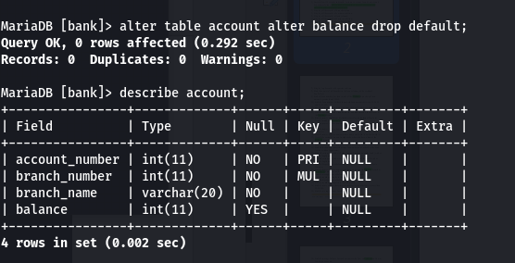

Q. Add Check constraint in “branch” Table assets must be greater than
100,00,000 and department city must be either KTM or PKR or BRT.

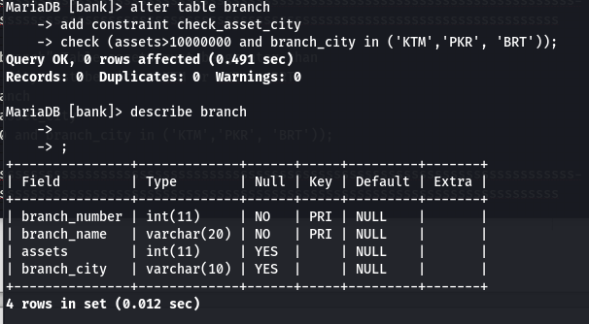
Q. Drop the check constraints from the branch table.

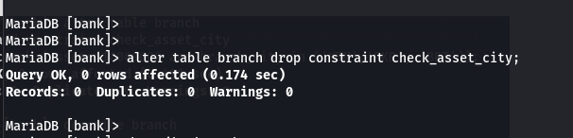

Q. Add Primary Key constraint in table branch, customer, loan and account based
on relational schema. List the columns of all tables.
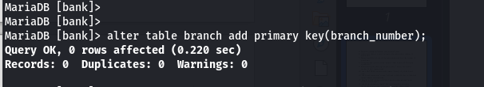
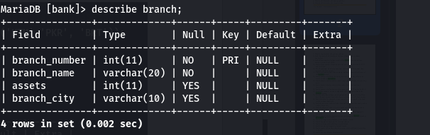
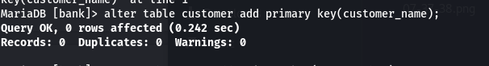
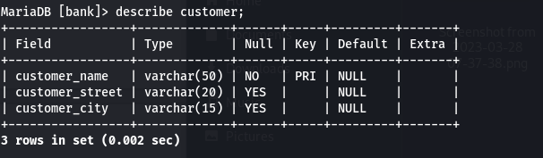
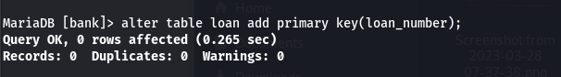
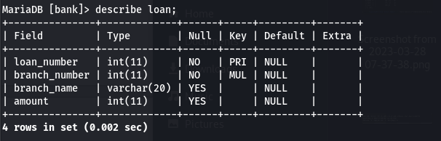

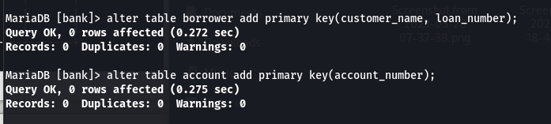
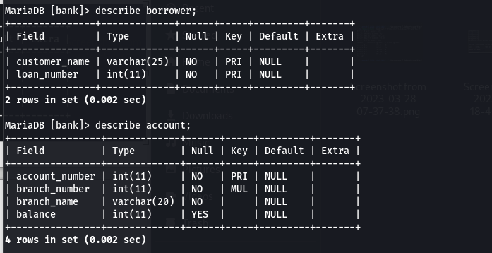
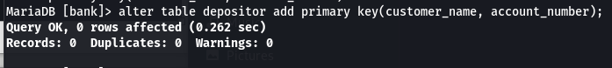

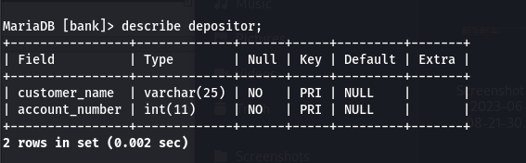

Q. Drop the primary key from the account table. List the columns of account
table.

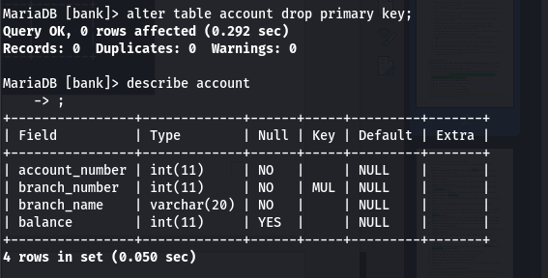

Q. Add the foreign key constraints on the borrower and depositor table
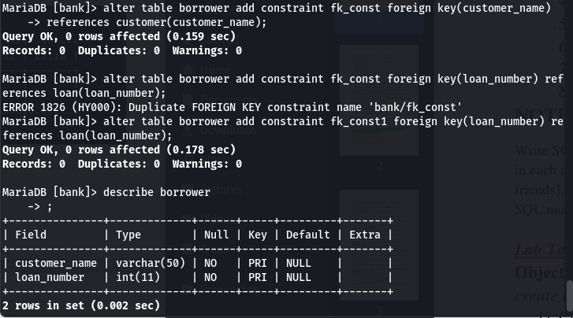

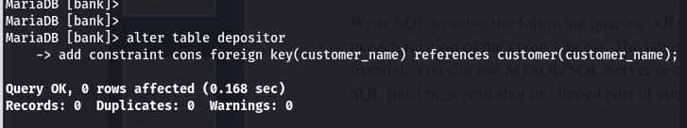

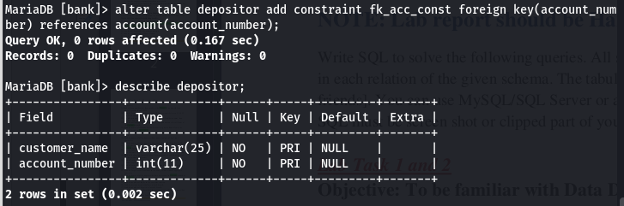

Q. Drop the foreign key constraints form depositor table.
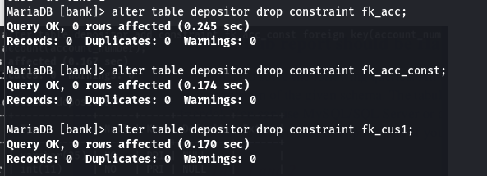

Q. Add unique constraints on “customer_name” column in the customer table.
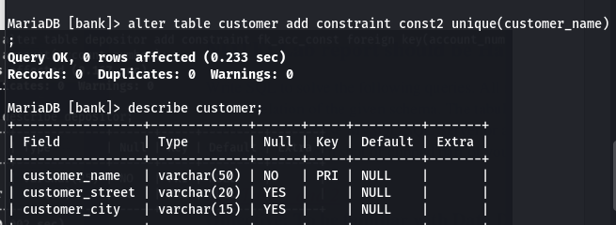
Q. Drop the unique constraints from the customer table.

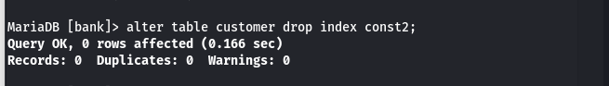
Q. Add primary key constraint in the account table. And also add the foreign key
constraints on the depositor table
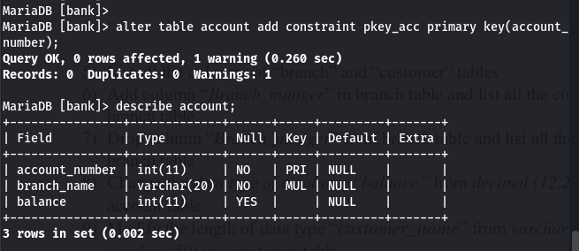
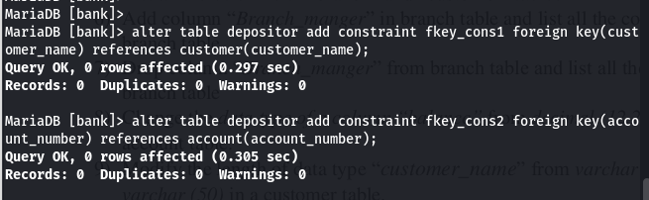

lab 3,4,5

UPDATED DATABASE
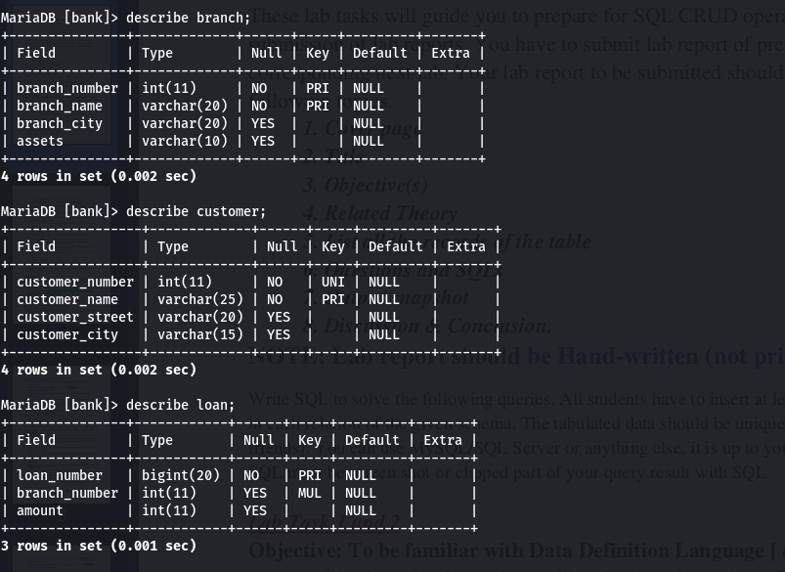
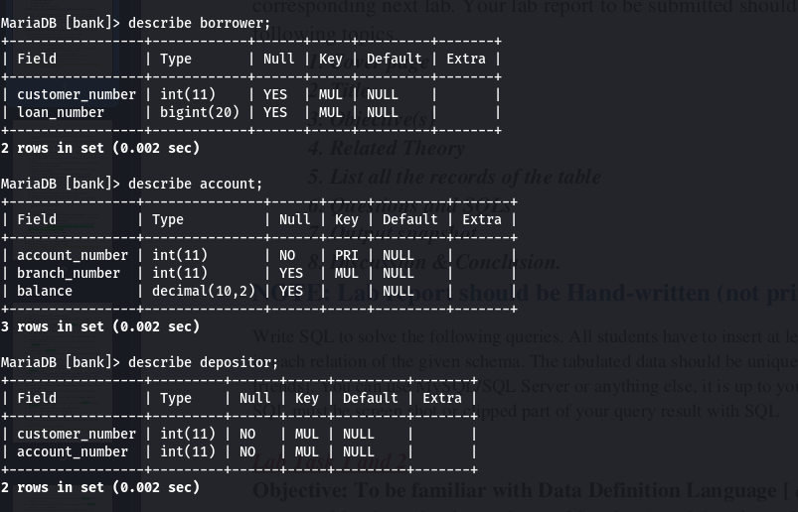

Q. Insert at least 10 records in branch, customer, account, loan, borrower and
depositor relations.

BRANCH:
insert into branch values(345,’Maharshi Chowk’,’Dhamauli’,2000000);

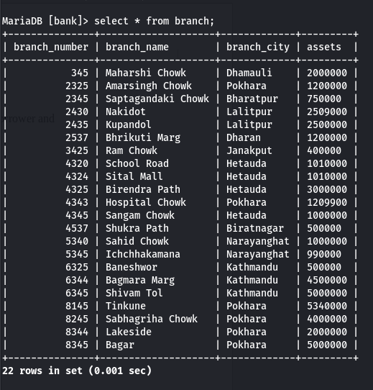

CUSTOMER:
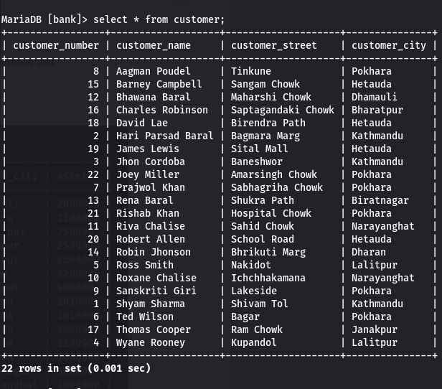

LOAN:
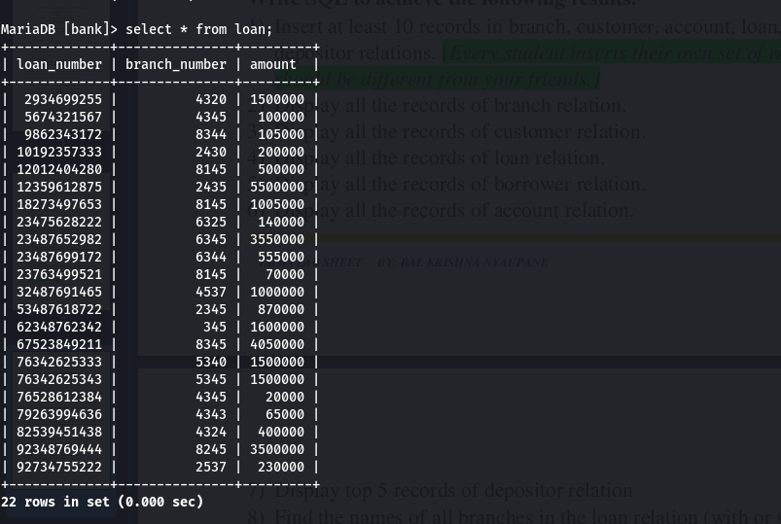

BORROWER:
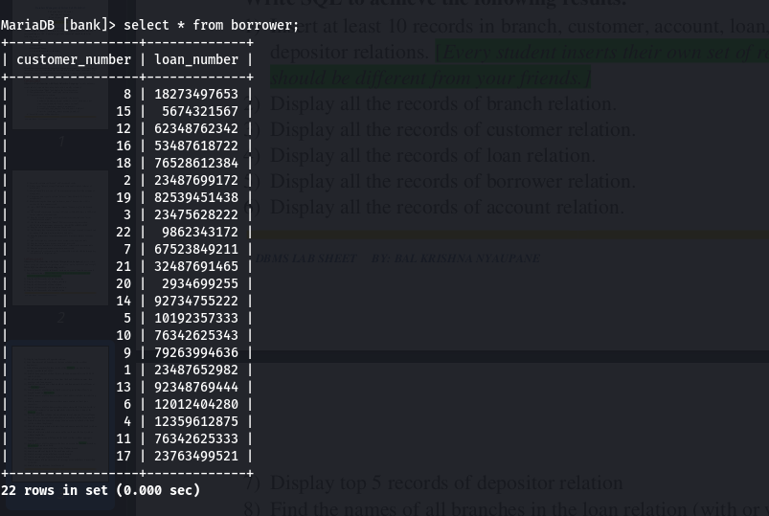

ACCOUNT:

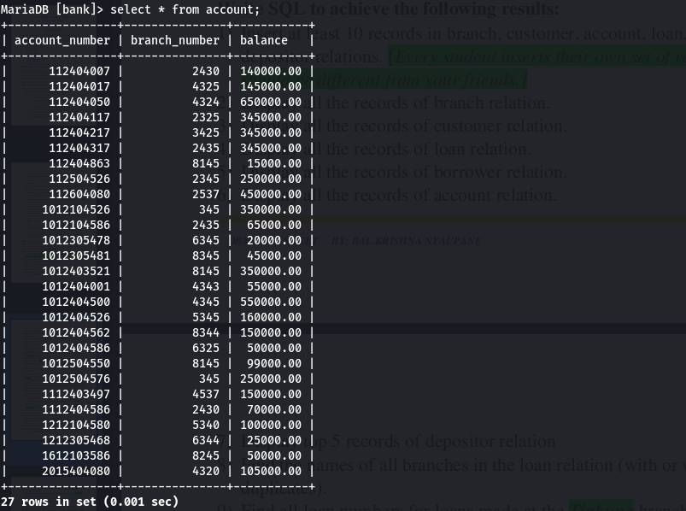

DEPOSITOR:

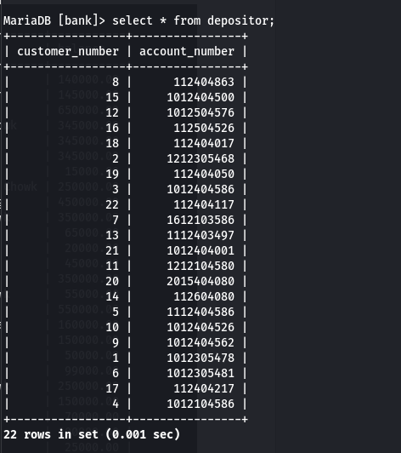

Q. Display top 5 records of depositor relation
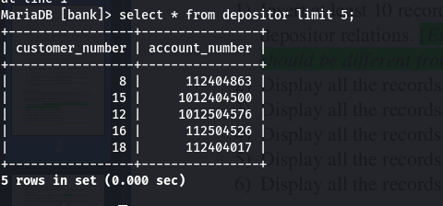

Q. Find the name of all branches in the loan relation (with or without duplicates)

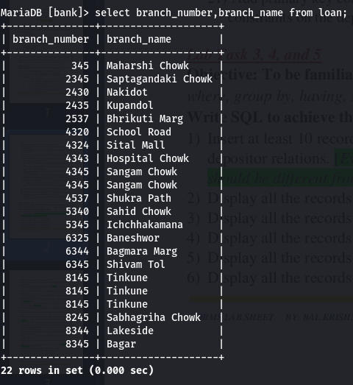

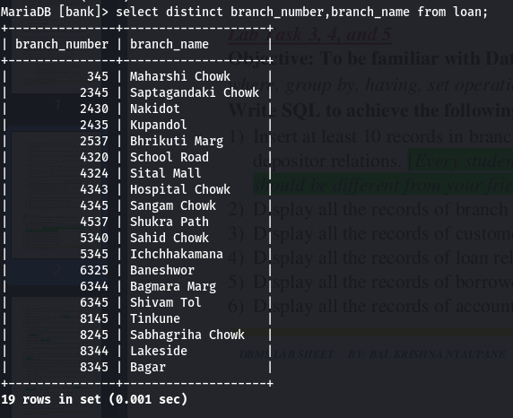

Q. Find all loan numbers for loans made at the Tinkune branch with loan
amounts greater than 200000

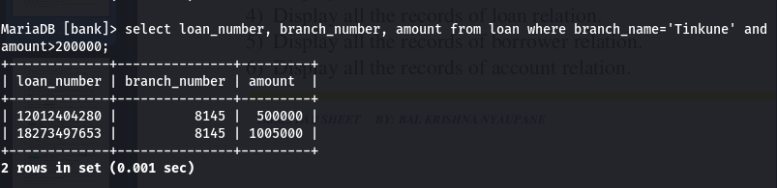

Q. Find the loan number of those loans with loan amounts between 9,00,000
and 10,00,000.

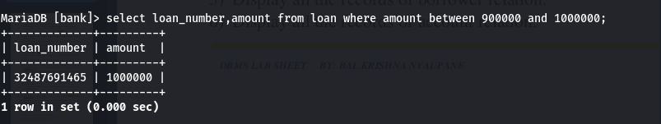
Q. For all customers who have a loan from the bank, find their names, loan
numbers, and loan amount.

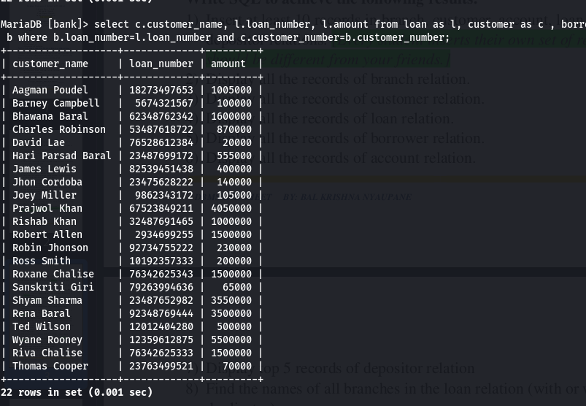

Q. Find the customer names, loan numbers, and loan amounts for all loans at
the Tinkune branch.

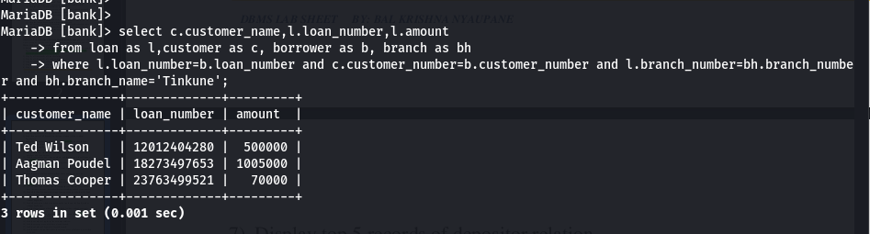

Q. Find the names of all branches that have assets greater than at least one
branch located in Baneshwor.

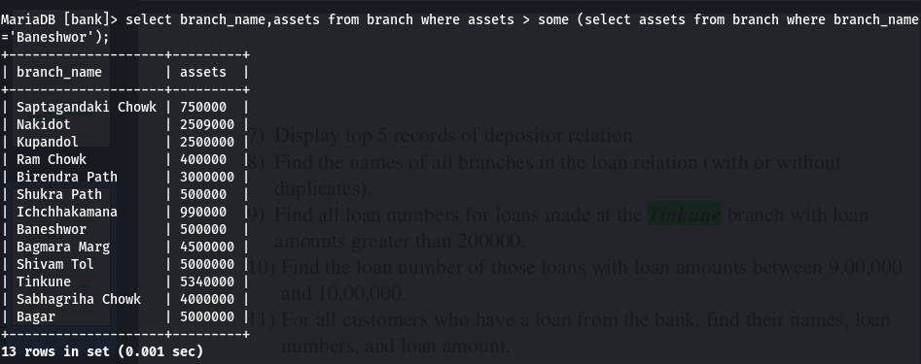

Q. Find the names of all customers whose street address includes the substring
'main'.

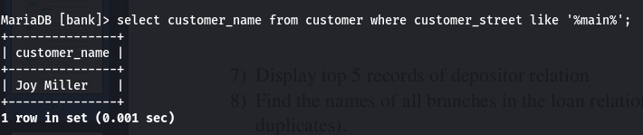

Q. Find the names of all customers whose name contains at least four
characters.

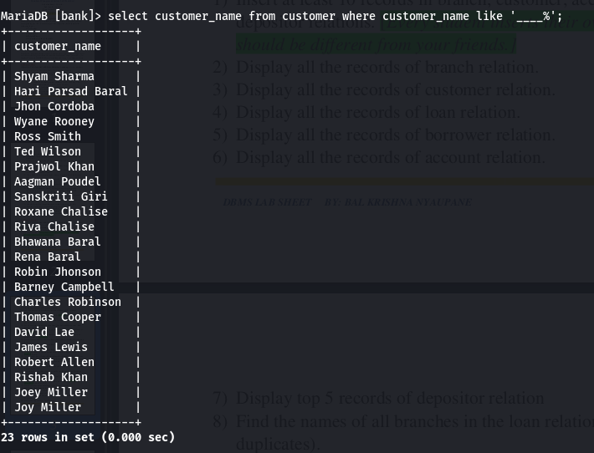
Q. Find the names of all customers whose name start with ‘b’ and end with ‘a’.

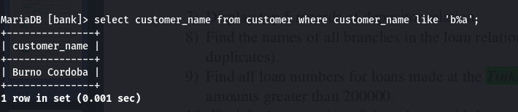

Q. List all the customer’s name in alphabetic order who have a loan at the
Tinkune branch.

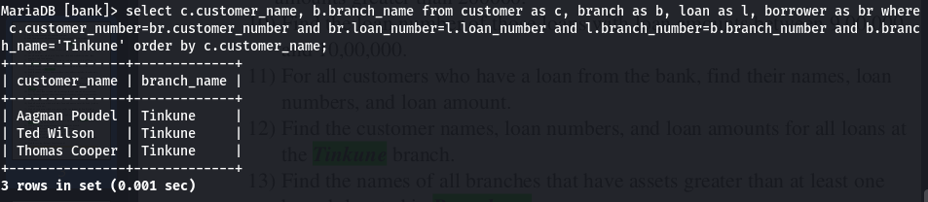
Q. List the entire loan relation in descending order of amount. If several loans
have the same amount, then order them in ascending order by loan number.

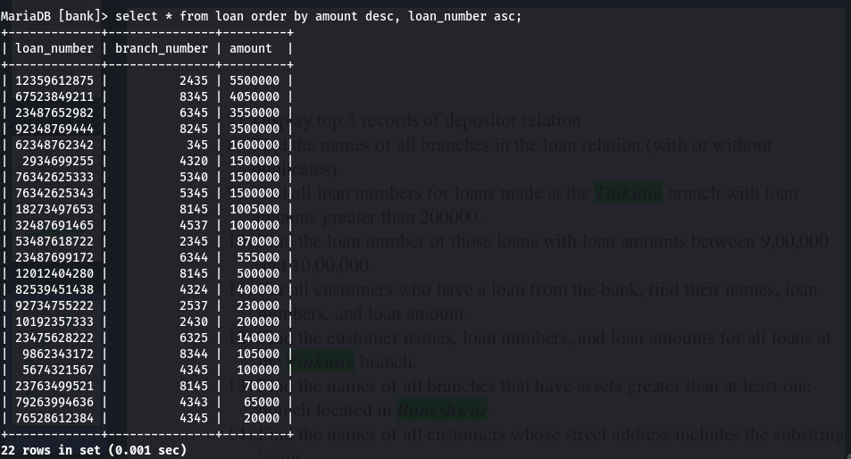

Q. Find all the bank customers having a loan, an account, or both at the bank
(with or without duplicates).

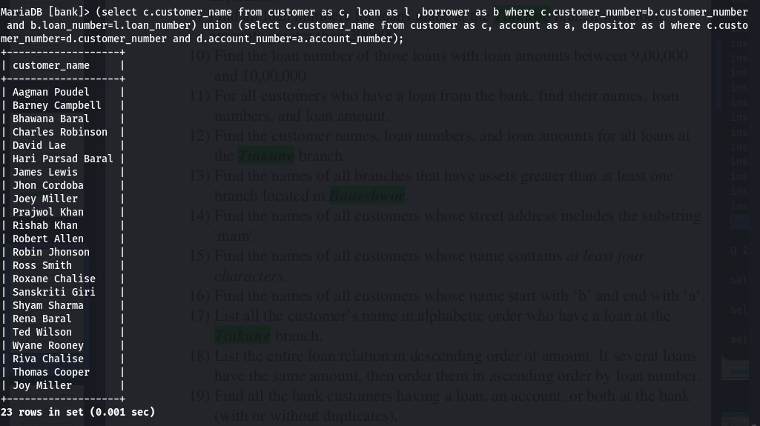


Q. Find all customers who have both a loan and an account at the bank (with or
without duplicates).
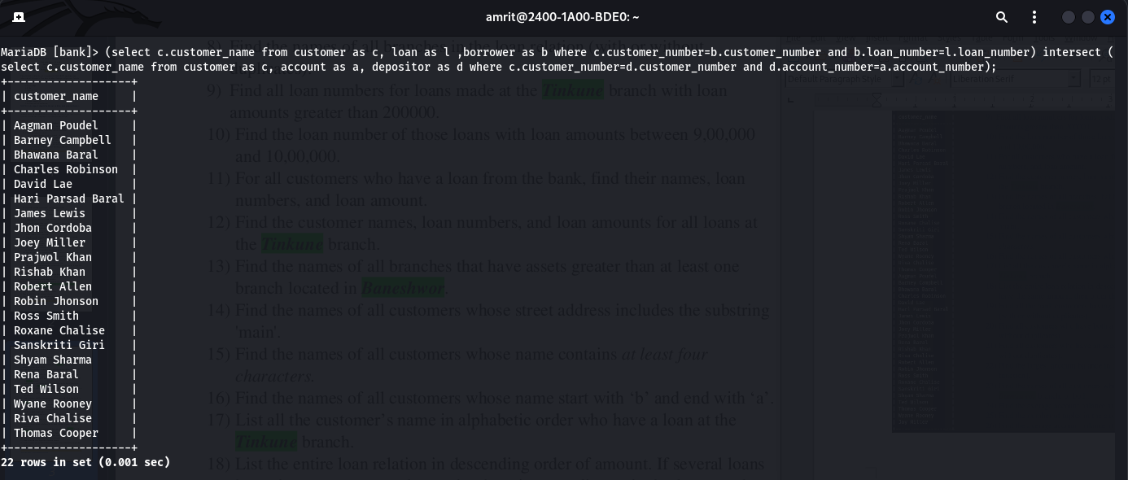
Q. Find all customers who have an account but no loan at the bank (with or
without duplicates).
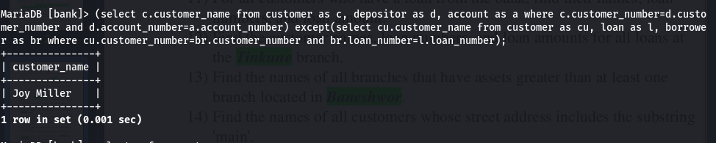
Q. Find the largest account balance in the bank [with or without aggregate
function].
With aggregate

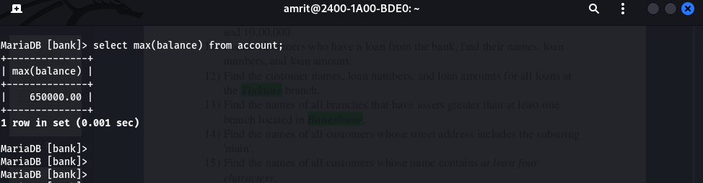

Without aggregate

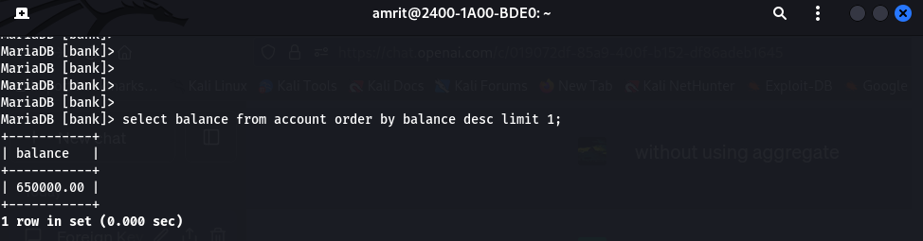

Q. Find the names of all customers who have an account in Tinkune branch or Baneshwor branch, or both.

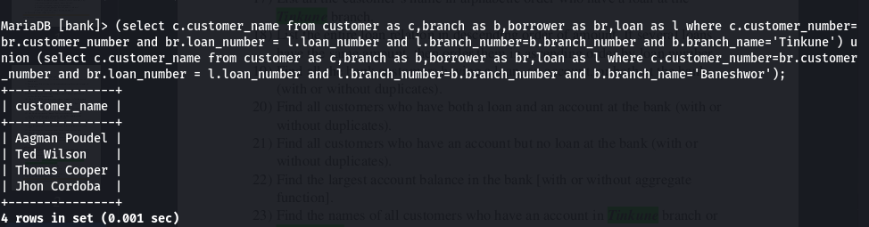
Q. Find the average account balance at the Tinkune branch.
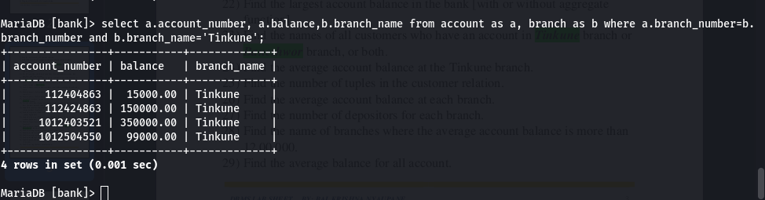
Q. Find the number of tuples in the customer relation.
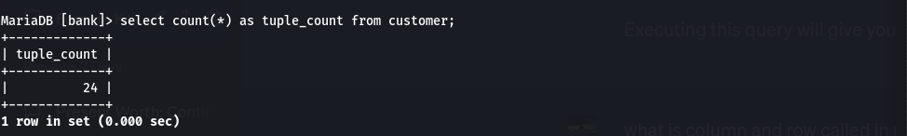

Q. Find the average account balance at each branch.
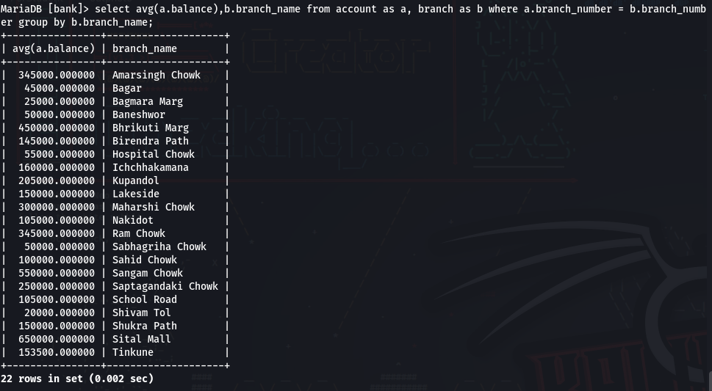
Q. 27 Find the number of depositors for each branch.
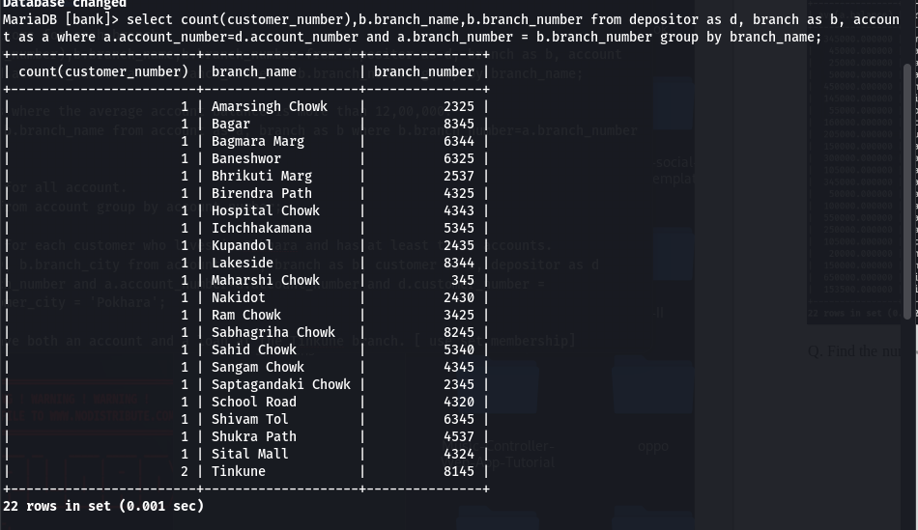

Q 28) Find the name of branches where the average account balance is more than 12,00,000.
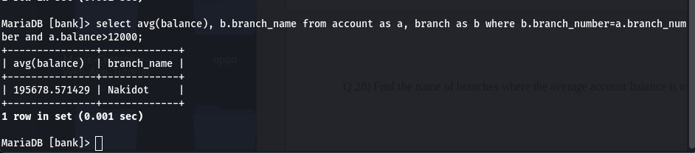
Q 29) Find the average balance for all account.
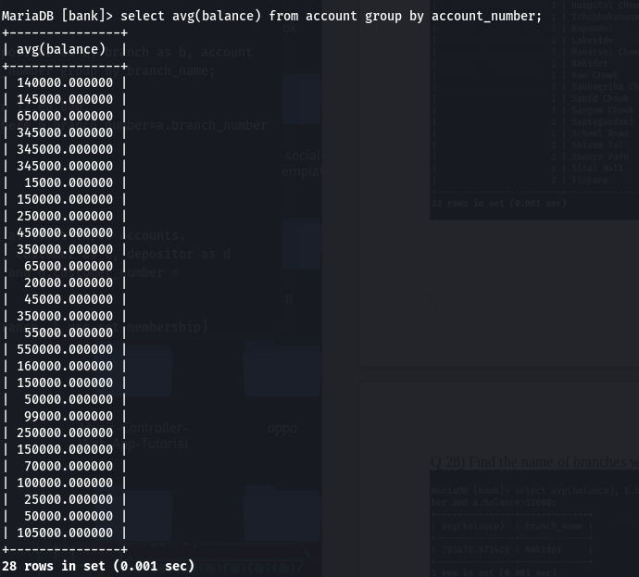

Q 30) Find the average balance for each customer who lives in Pokhara and has at least three accounts.

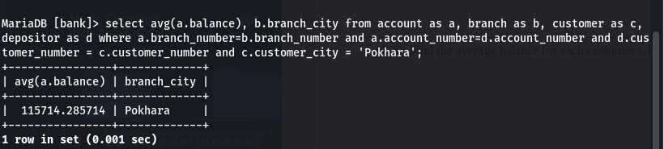
Q31) Find all customers who have both an account and a loan at the Tinkune branch. [ use set membership]
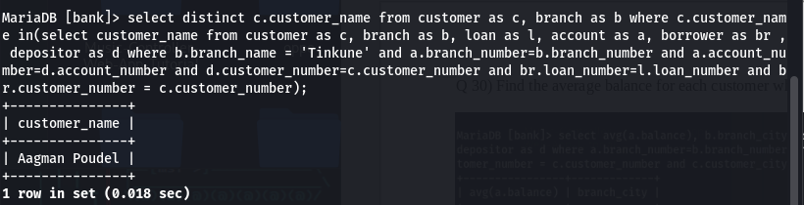
Q 32) Find all customers who do have a loan at the bank, but do not have an
account at the bank. [ use set membership]

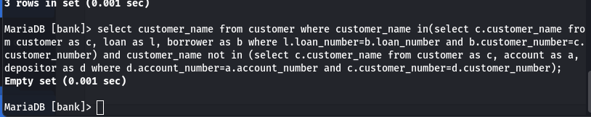

Q 33) Find out the total balance of the bank.
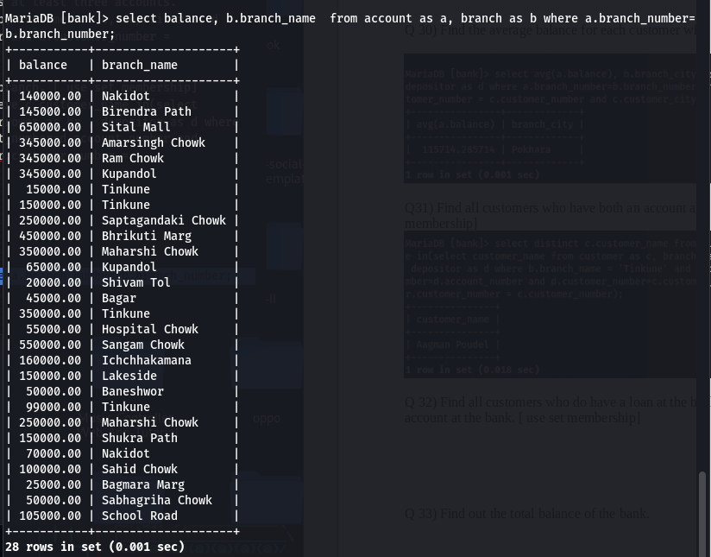
Q 34) Find the number of branches appearing in the account relation.
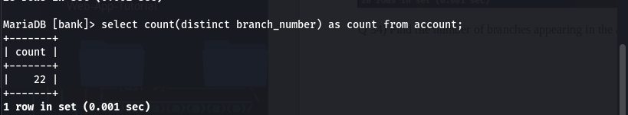

Q 35) Find the total balance of each branch of the bank.
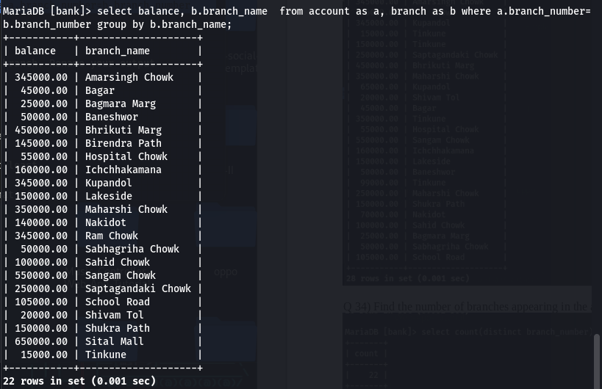
Q 36) Find the maximum balance at each branch and sum of the balance of each branch. Rename your output attributes.
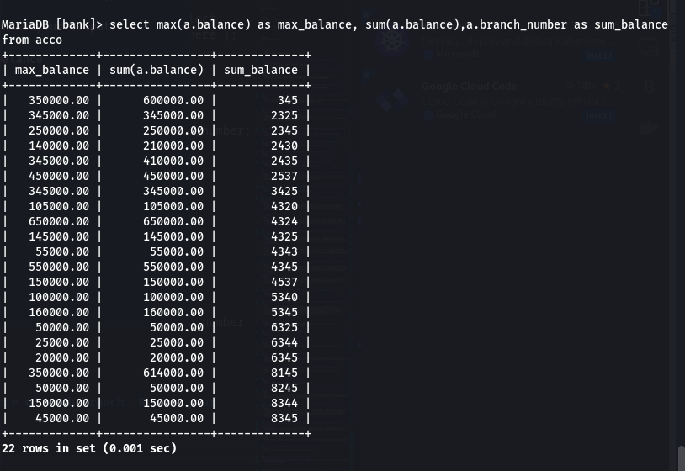

Q 37) List the names of customers who have a loan at the bank, and whose names
are neither Shyam nor Hari.

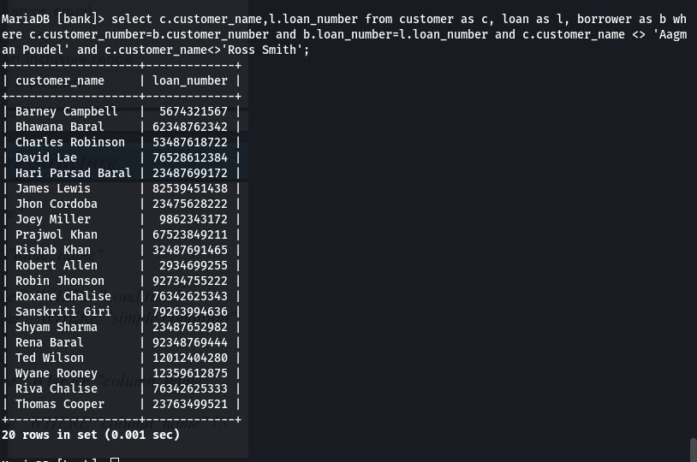
Q 38) Find the name of all branches that have assets greater than those of at least
one branch located in Baneshwor. [with or without using Set Comparison]
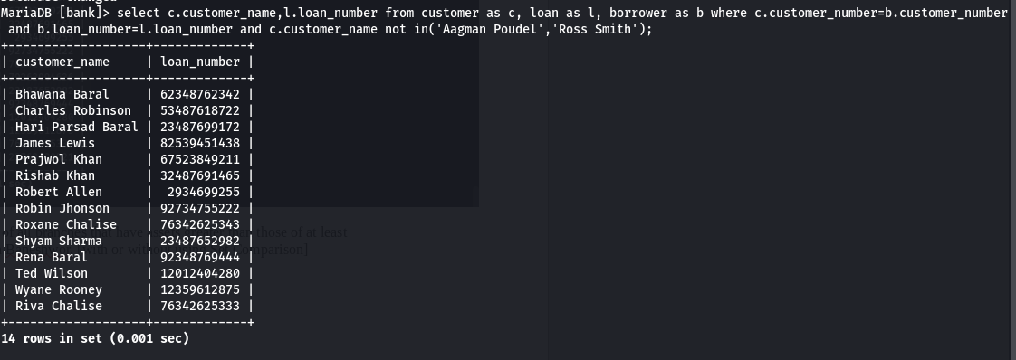

Q 39) Find the names of all branches that have an asset value greater than that of each branch in Baneshwor.
select branch_name,assets from branch where assets >all (select assets from branch where branch_name = 'Baneshwor');
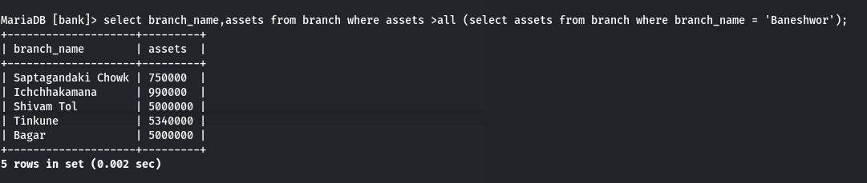

40) Delete all account tuples in the Tinkune branch.
delete from account where branch_number in(select branch_number from branch where branch_name='Tinkune');

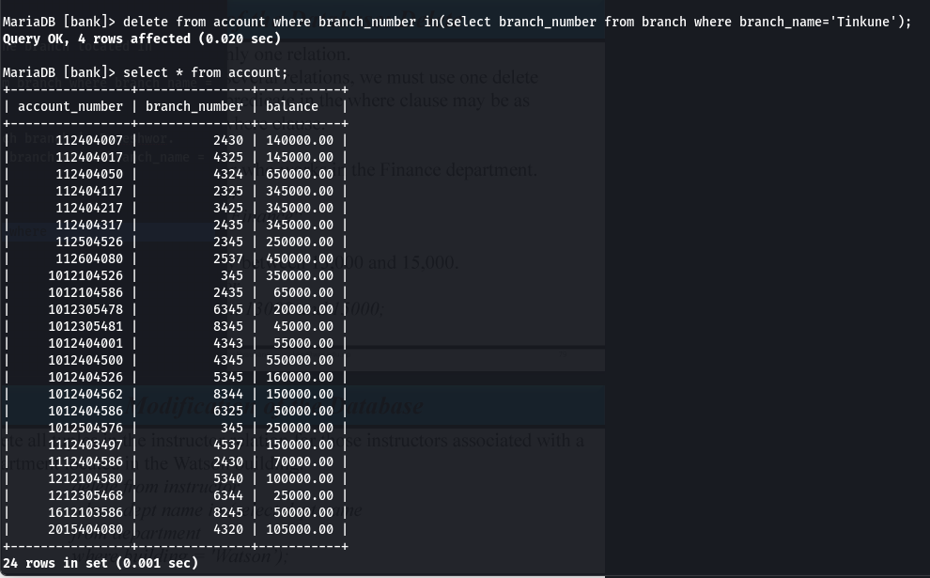

41) Delete all loans with loan amounts between 13000 and 150000.
delete from loan where amount between 13000 and 150000;
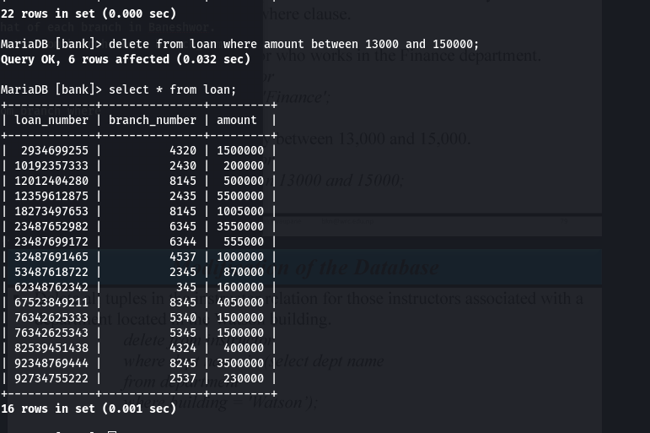
42) Delete all account tuples at every branch located in Baneshwor.
delete from account where branch_number in(select branch_number from branch where branch_name = 'Baneshwor');
43) Delete the records of all accounts with balances below the average at the bank.
delete from account where balance < (select avg(balance) from account);
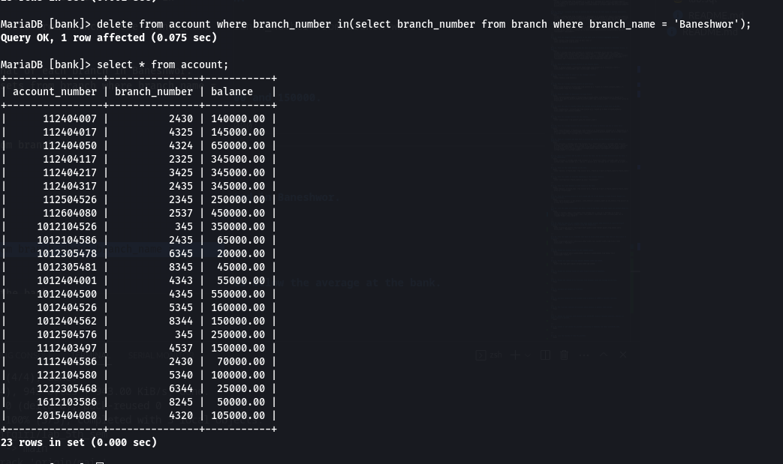
44) Increase all balance by 5 percent.
update account set balance = balance * 1.05;
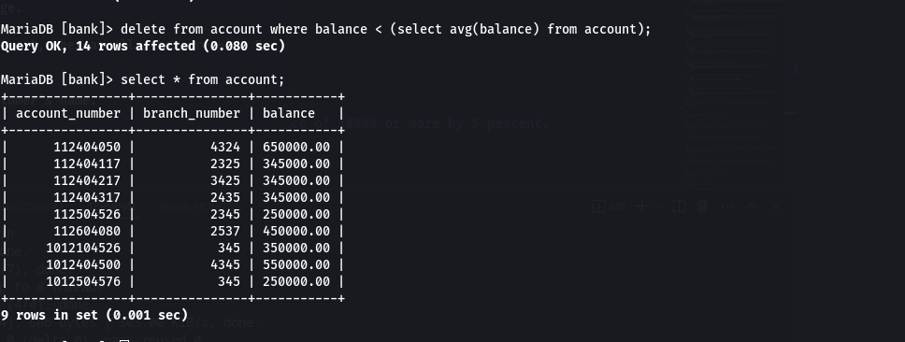
45) Increase balance only to accounts with a balance of 10000 or more by 5 percent.
update account set balance = balance*1.05 where balance>=300000;
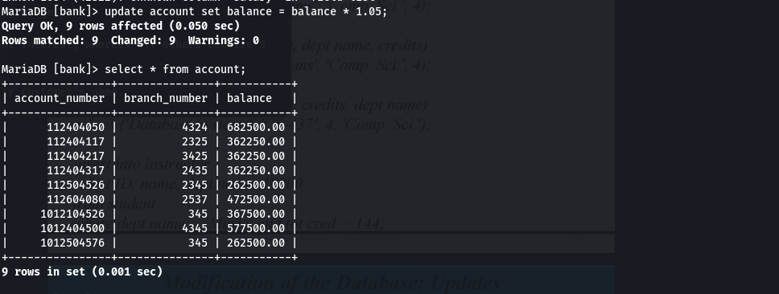
46) Pay 5 percent interest on accounts whose balance is greater than average.
update account set balance = balance*1.05 where balance > (select avg(balance) from account);
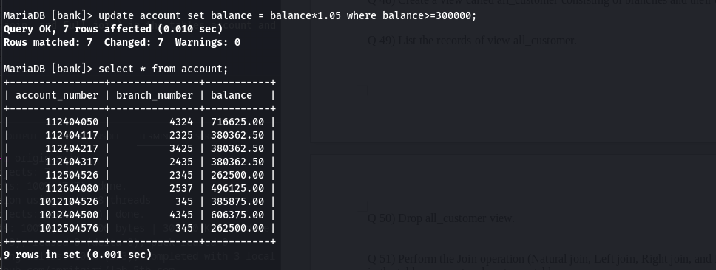
47) Update all accounts with balances over 10,00,000 receive 6 percent interest, whereas all others receive 5 percent.
update account set balance=case when balance>650000 then balance*1.06 else balance*1.05 end;
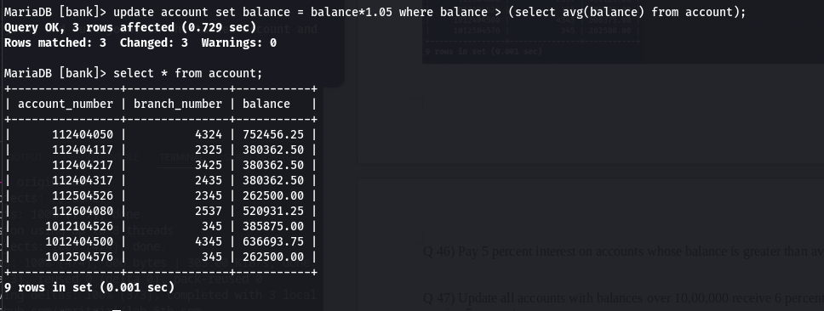
48) Create a view called all_customer consisting of branches and their customer’s name.
create view all_customer as select c.customer_number,c.customer_name,b.branch_name from customer as c, branch as b, account as a, depositor as d where c.customer_number=d.customer_number and d.account_number=a.account_number and a.branch_number=b.branch_number;
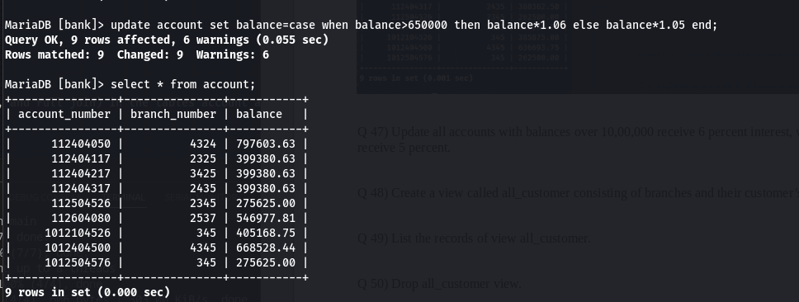
49) List the records of view all_customer.
select * from all_customer;

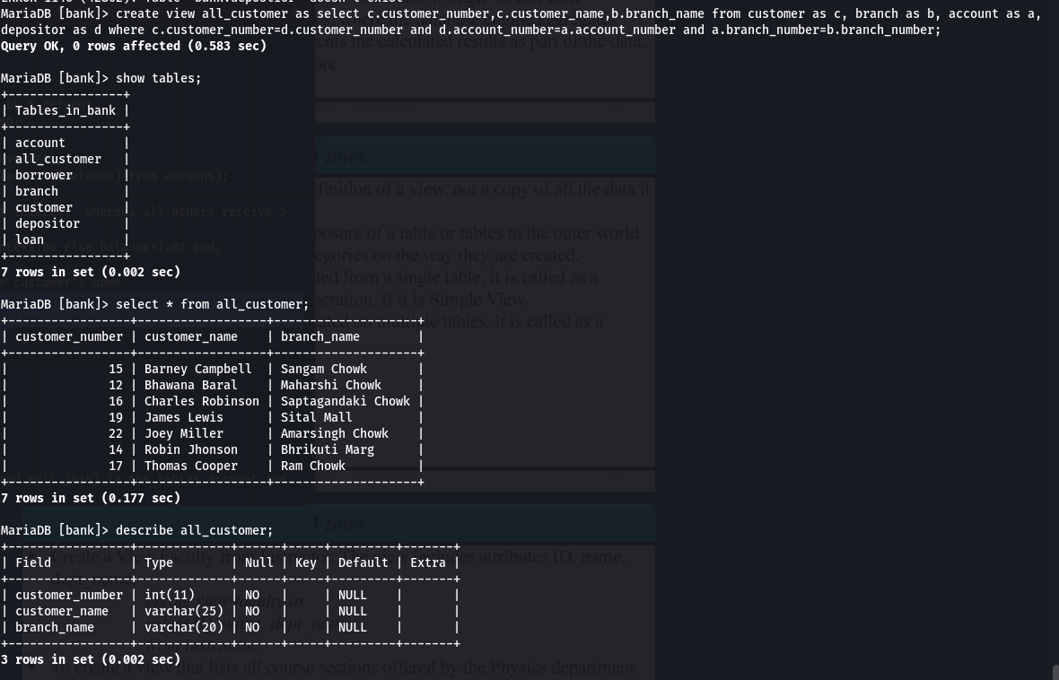

50) Drop all_customer view.
drop view all_customer;
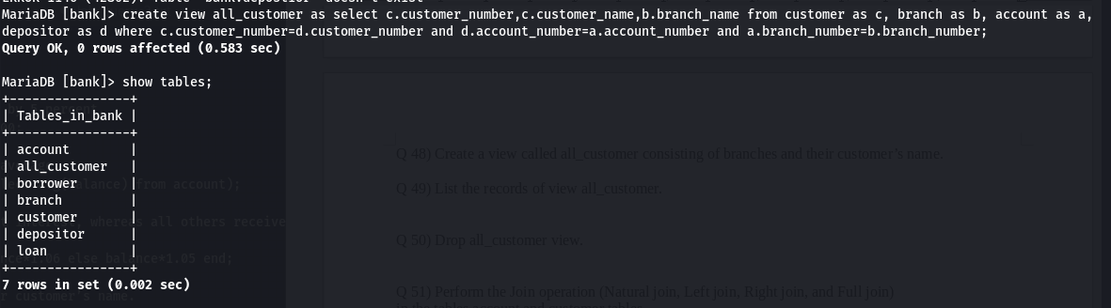
51) Perform the Join operation (Natural join, Left join, Right join, and Full join) in the tables account and customer tables.
select * from account natural join depositor natural join customer;
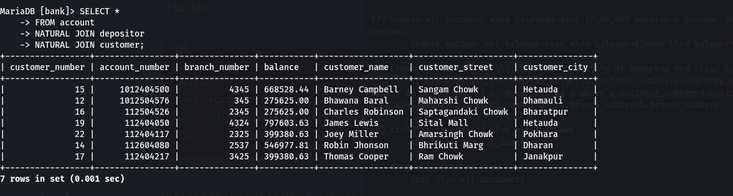
select * from account left join depositor on account.account_number=depositor.account_number left join customer on depositor.customer_number=customer.customer_number;

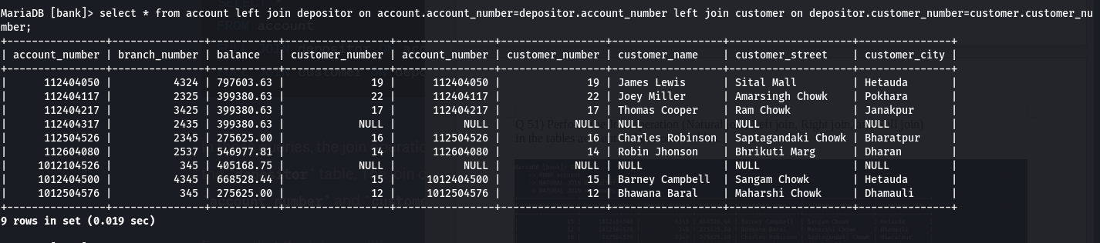
select * from account right join depositor on account.account_number=depositor.account_number right join customer on depositor.customer_number=customer.customer_number;

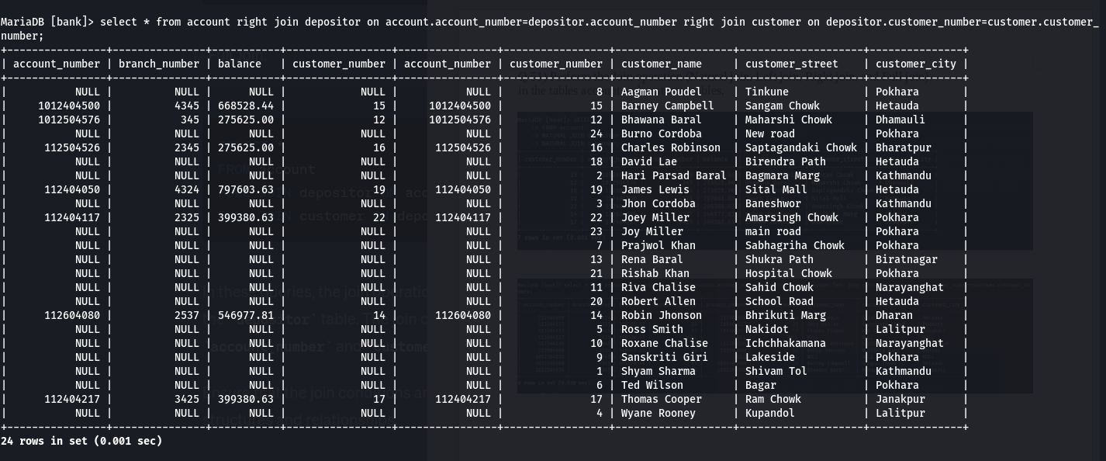
select * from account full join depositor on account.account_number=depositor.account_number full join customer on depositor.customer_number=customer.customer_number;
or
(select * from account left join depositor on account.account_number=depositor.account_number left join customer on depositor.customer_number=customer.customer_number) union (select * from account right join depositor on account.account_number=depositor.account_number right join customer on depositor.customer_number=customer.customer_number);



