

THE YENEPOYA INSTITUTE OF ARTS SCIENCE
COMMERCE AND MANAGEMENT

Project – High Level Design

ON
Design and Development of Identity Security
Framework for Finance

Student Name: Amritha Jayakumar Guided by:Thanziha
REG NO: 23BSCED003

Table of Contents
1. Introduction—----------------------------------------------------------------- 3
1.1 Scope of the Document—---------------------------- 3
1.2 Intended Audience—---------------------------------- 3
1.3 System Overview—----------------------------------- 4
2. System Design—---------------------------------------------------------------- 5
2.1 Application Design—--------------------------------- 5
2.2 Process Flow—-----------------------------------------6
2.3 Information Flow—------------------------------------7
2.4 Components Design—---------------------------------8
2.5 Key Design Considerations—------------------------ 8
2.6 API Catalogue—----------------------------------------9
3. Data Design—------------------------------------------------------------------- 10
3.1 Data Model—------------------------------------------- 10
3.2 Data Access Mechanism—----------------------------11
3.3 Data Retention Policies —-----------------------------11
3.4 Data Migration —---------------------------------------11
4. Interfaces—---------------------------------------------------------------------- 12
5. State and Session Management—-------------------------------------------- 14
6. Caching—------------------------------------------------------------------------ 14
7. Non-Functional Requirements—--------------------------------------------- 15
7.1 Security Aspects—--------------------------------------15
7.2 Performance Aspects—---------------------------------16
8. References—-------------------------------------------------------------------- 16

1. Introduction
NexaBank is a web-based NetBanking application designed to demonstrate industry-standard identity security practices. Built using Python, Flask, and SQLite, the system highlights the critical distinction between Authentication—verifying a user’s identity—and Authorization—defining the actions an authenticated user is permitted to perform—within a secure financial environment.
1.1 Scope of the Document
This document provides the high-level architecture and design overview for the NexaBank portal. It covers:
  - User Authentication and Authorization using Flask-Login and hashed credentials
  - Banking features — Fund Transfer (NEFT/IMPS/UPI), Fixed Deposits, Beneficiary management
  - Security controls — account lockout, session timeout, HTTP security headers, audit logging
  - Database design — seven SQLite tables managed through SQLAlchemy ORM
  - Frontend interface — professional banking UI with responsive design
This document does not cover production deployment, live SMS/email delivery, RBI regulatory compliance, or real financial transaction processing.
1.2 Intended Audience
Audience | Role | Purpose
Project Mentor | Technical Reviewer | Evaluate architecture decisions and security design
Student Developer | Implementer | Reference for design choices during development
Examiner/Evaluator | Assessment | Verify scope, depth, and technical correctness
Future Maintainers | Developer | Understand system structure for extensions

1.3 System Overview
NexaBank follows the Model-View-Controller (MVC) pattern. Users interact via a browser; Flask handles routing and business logic; SQLAlchemy persists data to SQLite; Jinja2 templates render the HTML views
Component | Technology | Role
Web Browser | Chrome / Safari / Firefox | Client — renders HTML, submits forms, holds session cookie
Web Framework | Python Flask 3.0.3 | HTTP routing, session management, business logic
Authentication | Flask-Login 0.6.3 | Login state, @login_required access control
ORM | Flask-SQLAlchemy 3.1.1 | Object–relational mapping, parameterized queries
Database | SQLite 3.x | Serverless, file-based relational database
Template Engine | Jinja2 | Dynamic HTML rendering with template inheritance
Form Validation | Flask-WTF / WTForms | Server-side validation with CSRF protection
Password Hashing | Werkzeug Security | pbkdf2:sha256 hashing — plain password never stored
Frontend | HTML5, CSS3, JavaScript | Responsive UI, client-side interactions

2. System Design
2.1 Application Design
The system is structured on three MVC layers with a dedicated form-validation layer:
Layer | File | Technology | Responsibility
Model | models.py | SQLAlchemy + SQLite | Schema definition, password hashing, data relationships
View | templates/ | Jinja2, HTML5, CSS3 | HTML rendering; all presentation logic isolated here
Controller | app.py | Flask routes | HTTP handling, session enforcement, business logic
Forms | forms.py | WTForms | Server-side field validation for all user input
Technology stack:
Category | Technology | Version | Purpose
Language | Python | 3.11+ | Backend programming language
Web Framework | Flask | 3.0.3 | Routing, request handling, middleware
Authentication | Flask-Login | 0.6.3 | Session management, route protection
Database ORM | Flask-SQLAlchemy | 3.1.1 | ORM — eliminates raw SQL, prevents injection
Database | SQLite | Built-in | Serverless embedded database
Validation | Flask-WTF / WTForms | 1.2.1 | CSRF protection, input validation
Password Security | Werkzeug Security | 3.0.3 | pbkdf2:sha256 with 16-byte salt
Templates | Jinja2 | Built-in | Dynamic HTML, template inheritance (DRY)
Styling | Custom CSS3 | — | Banking-grade responsive design system
Scripting | Vanilla JavaScript | ES6+ | Password strength, FD calculator, preview

2.2 Process Flow
Request Initiation:
The user interacts with the web interface by performing actions such as submitting login credentials or initiating a financial transaction.
Routing & Validation:
The Flask application receives the request and routes it to the appropriate endpoint. Incoming data is validated using WTForms to ensure integrity and to mitigate injection-based attacks.
Business Logic Execution:
The application processes the request through defined controllers. For sensitive operations, additional security measures are enforced, such as monitoring failed login attempts and generating One-Time Passwords (OTPs) delivered via email.
Database Interaction:
The system securely interacts with the SQLite database through SQLAlchemy to perform required data retrieval or updates.
Response Generation:
Based on the outcome, the system generates appropriate feedback messages and renders dynamic Jinja2 templates, which are then return

2.2.1 User Registration
The registration flow proceeds as follows:
- User submits the /signup form with name, email, phone, and password.
- WTForms validates all fields server-side: name (letters only), phone (10-digit Indian), password (minimum 8 characters, must contain a letter and a digit).
- The database is queried — if the email already exists, an error is returned.
- A User object is created; set_password() generates a pbkdf2:sha256 hash of the password.
- The record is committed to SQLite atomically via db.session.commit().
- Demo transactions, a sample beneficiary, and welcome notifications are seeded.
- The user is redirected to /login with a success message.

2.2.2 Login and Account Lockout
- User submits email and password at /login.
- If is_locked is True and the current time is before locked_until, login is rejected immediately without password checking.
- If the lockout period has expired, the account is automatically unlocked (is_locked=False, failed_attempts=0).
- check_password_hash() compares the submitted password against the stored hash.
- On success: failed_attempts reset to 0, login_user() called, session cookie created, event logged.
- On failure: failed_attempts incremented. At five failures: is_locked=True, locked_until=now+15 minutes.
2.2.3 Fund Transfer
- Route protected by @login_required — unauthenticated requests redirected to /login.
- Server validates: amount > 0, amount ≤ current balance, all required fields present.
- current_user.balance is decremented; a Transaction record (direction='debit') is created.
- Both the balance update and Transaction insert are committed atomically in one db.session.commit().
- A notification is created and the user is redirected to /transactions.
2.3 Information Flow
Every request follows a consistent pipeline through system layers:
From | To | Data | Channel
Browser | Flask (app.py) | Form fields (email, password, amount etc.) | HTTP POST
Flask | SQLAlchemy | Python model objects | ORM method calls
SQLAlchemy | SQLite | Parameterized SQL queries | DB driver
SQLite | SQLAlchemy | Result sets | DB driver
Flask | Jinja2 | Context dict (user, txns, fds…) | render_template()
Jinja2 | Browser | Rendered HTML | HTTP response
Flask-Login | Browser | Signed session cookie | Set-Cookie header
Browser | Flask-Login | Session cookie on each request | Cookie header

2.4 Components Design
Component | File(s) | Responsibility
Application Controller | app.py | All 20 route handlers, middleware (sec_headers, check_timeout), helper functions
Data Models | models.py | Seven SQLAlchemy classes: User, Transaction, Beneficiary, FixedDeposit, Notification, SupportTicket, LoginAttempt
Form Validators | forms.py | SignupForm and LoginForm with WTForms validators
Master Layout | base.html | Shared topbar, flash messages, session-aware navigation, footer
CSS System | static/style.css | Design variables, component library, responsive breakpoints
JavaScript | static/main.js | Password strength meter, FD calculator, transfer preview, balance toggle

2.5 Key Design Considerations
2.5.1 Security-First Architecture
All 15 authenticated routes carry @login_required — there are no accidentally public banking pages. Passwords are stored as pbkdf2:sha256 hashes; the original is mathematically irrecoverable. Account lockout and session timeout protect against both brute-force and abandoned-session attacks. SQLAlchemy ORM eliminates raw SQL throughout the codebase. Security headers (X-Frame-Options, X-XSS-Protection, Cache-Control) are applied to every HTTP response.

2.5.2 MVC Separation of Concerns
Models contain only data logic. Controllers handle only HTTP and orchestration. Views contain only presentation. This structure ensures each layer can be modified, tested, or replaced independently.

2.5.3 Atomicity of Financial Operations
Fund transfers and Fixed Deposit openings commit both the balance change and the corresponding Transaction record in a single db.session.commit(). This guarantees consistency — there is no state in which money is debited without a corresponding transaction record, or vice versa.

2.6 API Catalogue
NexaBank is server-rendered; all interactions use standard HTML form submissions (POST) and redirects (302). The full route catalogue is:
Method | Endpoint | Auth | Description
GET | / | No | Root redirect — dashboard if logged in, home otherwise
GET | /home | No | Public landing page
GET+POST | /signup | No | Account registration
GET+POST | /login | No | NetBanking login with lockout
GET | /logout | Yes | Secure session termination
GET | /dashboard | Yes | Main banking dashboard
GET | /transactions | Yes | Transaction history — filter + pagination
GET | /download-statement | Yes | Download statement as plain-text file
GET+POST | /transfer | Yes | Fund transfer (NEFT/IMPS/UPI)
GET | /beneficiaries | Yes | View saved payees
GET+POST | /beneficiaries/add | Yes | Add new beneficiary
GET | /beneficiaries/delete/<id> | Yes | Remove beneficiary
GET | /fixed-deposits | Yes | View FDs with interest rate table
GET+POST | /fixed-deposits/open | Yes | Open new Fixed Deposit
GET | /notifications | Yes | Notification centre
GET | /support | Yes | Support ticket list
GET+POST | /support/new | Yes | Raise support ticket
GET+POST | /change-password | Yes | Update account password
GET | /security-log | Yes | Login audit trail
GET | /profile | Yes | Account profile and details

3. Data Design
3.1 Data Model
The database contains seven SQLite tables. User is the central entity; all other tables reference it via a user_id foreign key. LoginAttempt is standalone, recording events regardless of whether the user exists.
Table | PK | FK | Key Columns | Purpose
users | id | — | email (UNIQUE), password_hash, balance, failed_attempts, is_locked | Account holders with security fields
transactions | id | user_id → users | txn_type, amount, direction, balance_after, reference | Immutable financial audit trail
beneficiaries | id | user_id → users | name, account_no, ifsc, bank_name | Saved payee bank details
fixed_deposits | id | user_id → users | principal, interest_rate, tenure_months, maturity_amt, maturity_date | FD investment records
notifications | id | user_id → users | title, message, notif_type, is_read | In-app alert system
support_tickets | id | user_id → users | subject, message, category, ticket_no, status | Customer support requests
login_attempts | id | — | email, ip_address, success, reason, created_at | Full login audit log
Security-critical columns on the users table:
Column | Type | Description
password_hash | String(256) | pbkdf2:sha256 hash — original password is irrecoverable from this value
failed_attempts | Integer(0) | Count of consecutive wrong passwords; resets to 0 on any successful login
is_locked | Boolean | Becomes True after five consecutive failures; gates the login check
locked_until | DateTime | Absolute timestamp at which the lockout expires (set to now + 15 minutes)
last_login | DateTime | Timestamp of most recent authenticated session — shown in security log

3.2 Data Access Mechanism
All database interaction is performed through SQLAlchemy ORM. No raw SQL appears anywhere in the codebase. SQLAlchemy generates parameterized queries automatically, making SQL injection structurally impossible. Representative patterns:
  - User.query.filter_by(email=email).first() — find user by normalised email at login
  - Transaction.query.filter_by(user_id=id).order_by(desc).paginate(page, per_page=10) — paginated statement
  - db.session.add(obj); db.session.commit() — all writes are transactional
  - func.sum() grouped by txn_type — spending breakdown aggregation, single query
3.3 Data Retention Policies
All data is retained indefinitely in the development build. For a production deployment the following policies would apply: login_attempts records older than 90 days purged; notifications archived after 30 days; support tickets retained for one year; transaction records retained for seven years per Indian financial regulation.

3.4 Data Migration
db.create_all() at startup creates all tables if they do not yet exist. It does not alter existing tables. Schema changes in development require dropping and recreating the database. A production system would use Flask-Migrate (Alembic) for incremental, non-destructive migrations.

4. Interfaces
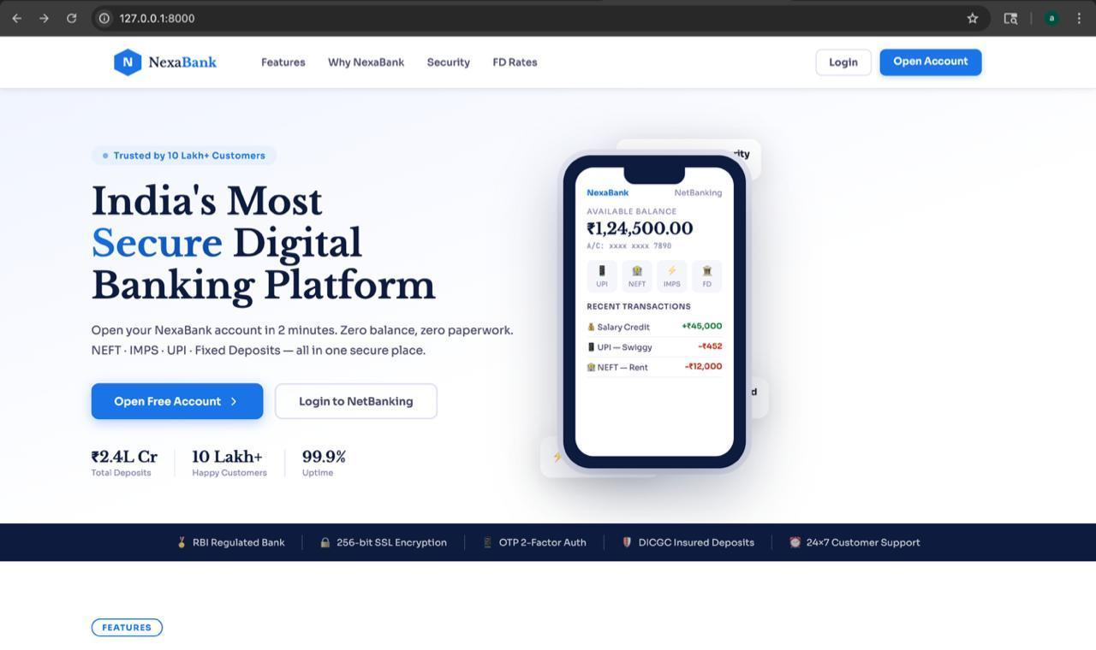
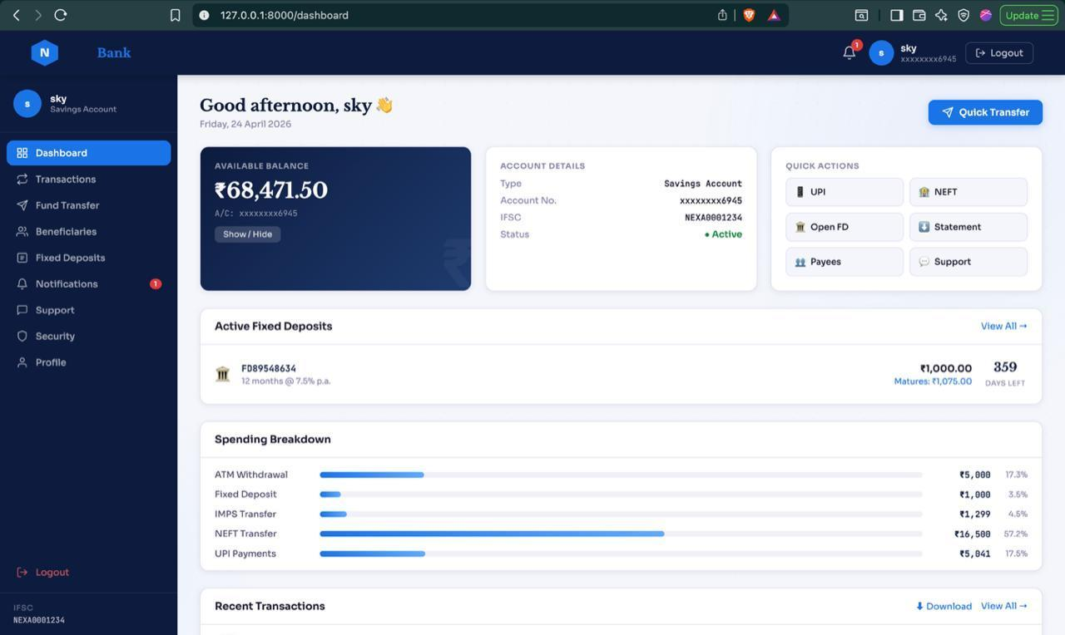

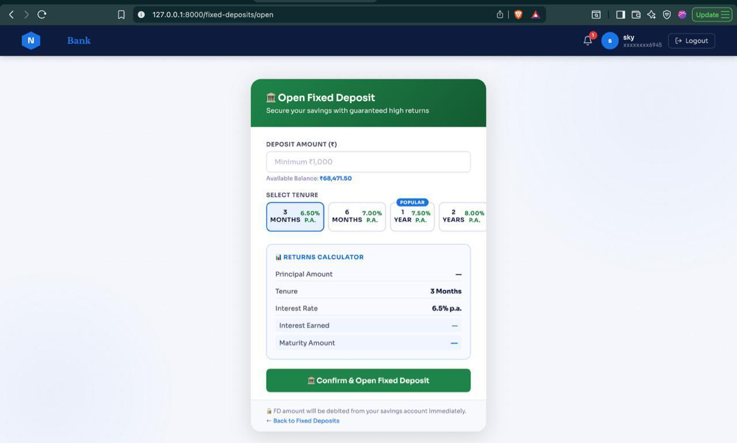

4.1 User Interface
The portal provides a professional browser-based interface modelled on HDFC/Kotak NetBanking. Design characteristics:
  - Responsive layout using CSS Grid and Flexbox — adapts to desktop, tablet, and mobile
  - Fixed sidebar navigation with active-state indicators
  - Monochrome colour palette: dark navy for structure, green for credits, red for debits
  - Monospaced font (JetBrains Mono) for account numbers, references, and financial values
  - Real-time client feedback: password strength meter, live transfer preview, FD returns calculator
  - Flash message system: auto-dismissing notifications positioned in the top-right corner

4.2 System Interfaces

Interface | Direction | Technology | Description
Browser ↔ Flask | Bidirectional | HTTP | Form submissions; server-rendered HTML responses
Flask ↔ SQLite | Bidirectional | SQLAlchemy ORM | Object persistence and parameterized queries
Flask ↔ Templates | Outbound | Jinja2 | Context dictionary rendered into HTML
Flask-Login ↔ Browser | Bidirectional | HMAC-signed Cookie | Session state maintained via HttpOnly cookie
Werkzeug ↔ models.py | Internal | Python calls | Password hashing and verification

5. State and Session Management
Session Storage:
Application state is managed on the server side using secure, cryptographically signed cookies through Flask’s built-in session management.
Session Security:
- Cookies are configured as HttpOnly to prevent access via client-side scripts, reducing XSS risks.
- Cookies are marked as Secure, ensuring they are transmitted only over HTTPS.
- The SameSite = 'Lax' attribute is enforced to mitigate Cross-Site Request Forgery (CSRF) attacks.
Timeout Policy:
An absolute inactivity timeout is enforced. If a user is idle for more than 15 minutes (SESSION_TIMEOUT), the session is automatically invalidated, and the user is forcefully logged out to prevent unauthorized access to unattended terminals.

6. Caching
6.1 Browser Cache Policy
Every response carries Cache-Control: no-store, no-cache, must-revalidate. This prevents browsers and intermediate proxies from caching any banking pages. Without this header, a user on a shared device could access another user's banking data from browser history without authentication.

6.2 Application-Level Optimisation
No external caching layer is used. Performance is managed through query discipline:
  - Transaction history is paginated — ten records per page; the full table is never fetched
  - Dashboard loads only the five most recent transactions
  - Spending breakdown is computed with a single grouped aggregation query
  - Fixed Deposit interest rates are stored as an in-memory Python constant — no database round trip
  - SQLAlchemy lazy-loading fetches related records only when accessed in code

7. Non-Functional Requirements
7.1 Security Aspects
Threat | Control | Implementation
Brute-force login | Account locked after five failures for 15 minutes | failed_attempts counter + is_locked flag in User model
Credential exposure | pbkdf2:sha256 hashing — hash is mathematically irrecoverable | Werkzeug generate_password_hash() in models.py
Session hijacking | HttpOnly cookie + 15-minute idle timeout + signed key | SESSION_COOKIE_HTTPONLY + before_request middleware
SQL injection | SQLAlchemy ORM parameterized queries only | No raw SQL anywhere in app.py or models.py
Clickjacking | X-Frame-Options: DENY on every response | @app.after_request sec_headers() decorator
XSS | X-XSS-Protection header; Jinja2 auto-escapes all output | Security headers + template engine defaults
CSRF | Flask-WTF tokens (disabled in demo, enabled in production) | WTF_CSRF_ENABLED configuration
Cached sensitive pages | Cache-Control: no-store on all responses | @app.after_request sec_headers()
MIME sniffing | X-Content-Type-Options: nosniff | @app.after_request sec_headers()
Unauthorised access | @login_required on all 15 protected routes | Flask-Login decorator

7.2 Performance Aspects
Requirement | Target | Approach
Page Response | < 2 s per route | SQLite + ORM, paginated queries, minimal DB round trips
Statement Page | 10 records per page | Query.paginate(page, per_page=10)
Dashboard Queries | ≤ 5 queries per load | 5 txns, count(), active FDs, spending aggregate, user object
Password Hashing | ~50 ms (intentional) | 600,000 pbkdf2 iterations — slow by design against brute force
Mobile Rendering | No JS framework overhead | Pure CSS Grid/Flexbox; no React/Vue

8. References
  - Flask Documentation v3.0 — https://flask.palletsprojects.com/en/3.0.x/
  - Flask-Login Documentation — https://flask-login.readthedocs.io/en/latest/
  - Flask-SQLAlchemy Documentation — https://flask-sqlalchemy.palletsprojects.com/
  - Werkzeug Security Utilities — https://werkzeug.palletsprojects.com/en/3.0.x/utils/
  - WTForms Documentation — https://wtforms.readthedocs.io/en/3.1.x/
  - OWASP Top 10 (2021) — https://owasp.org/www-project-top-ten/
  - NIST SP 800-63B: Digital Identity Guidelines — https://pages.nist.gov/800-63-3/sp800-63b.html
  - SQLite Documentation — https://www.sqlite.org/docs.html
  - Jinja2 Template Designer Docs — https://jinja.palletsprojects.com/en/3.1.x/templates/

