Rental Management

Rental Contract

**Tenancy**

|  |  |
| --- | --- |
| **Contact Number** | Auto Generated |
| **Date** |  |
| **Description** | A physical description of the rental space e.g, House, Flat, Room, Bedroom, etc. |
| **Lease Status** | Status of the contract. Active, Terminated, Tenant Signed |
| **Type of Building** | House, Flat, Room, Studio, Apartment, Bangalow |
| **Number of Bedrooms** | 1, 2, 3, 4, 5, 6, 7,8,9,10, 11 or more |
| **Furnished** | Unfurnished, Furnished |
| **Rent Start** | Tenancy start date |
| **Terms** | Text field to enter value, selection field to enter terms such as Months, Days, Years |
| **Rent End** | This is ending date. It should take automatically based on Terms but user can change. |
| **Estimated Amount** | The estimated amount of the payment due. For normalized terms, you cannot enter an amount in this field. |
| **Actual Amount** | The amount of the payment received. |
| **Frequency** | Weekly, 4 Weekly, Monthly, Quarterly, 6 Monthly, annually |
| **Informal Payment Date** | Alternative payment date informally agreed with tenant.  Note: Due date generated from tenancy start date |
| **Deposit** |  |
| **Address** |  |
| **Contact** |  |
| **Type of Lease** | The lease type describes how the rental amount is calculated. Three common types of leases are the gross lease, the net lease, and the percentage lease. The lease type is for informational purposes only and does not affect functionality.  **Gross lease**: The lessee (tenant) pays a fixed rent. The lessor (landlord) pays other expenses, including taxes, insurance, and operating expenses. Most residential and commercial office leases are gross leases.  **Net lease**: The lessee pays the rent as well as some or all of the operating costs, including maintenance, taxes, insurance, and utilities. Most residential ground leases and commercial building leases are net leases. |
| **Due Date** | Select the due date  1st, 2nd ,3rd, 4th, 5th ,6th up to 28th, End of the Month |
| **Payment Method** | Select the payment method from the list of values. This field is required.  Cash, Cheque, Bank Transfer, Credit Card |
| **Salesperson** | Enter the salesperson from the list of values. |
| **Comments** |  |
| **Notes** |  |
| **Attachment** |  |

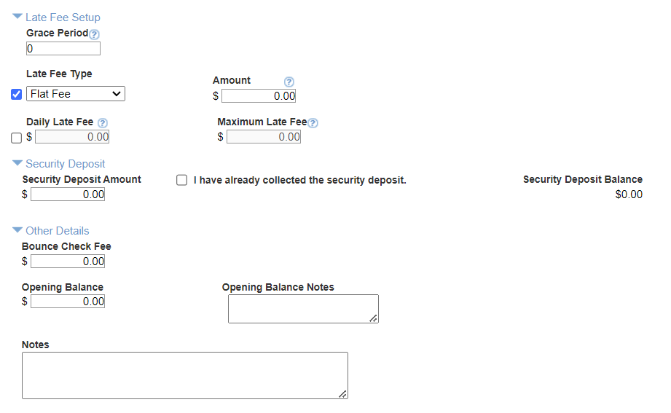

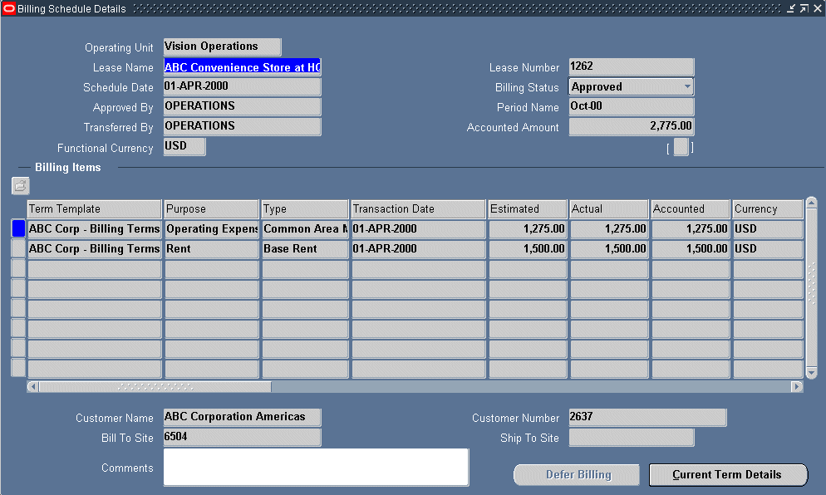

https://www.youtube.com/watch?v=dtMliR0Fi1I