logocover

**Smoke test DOCUMENT**

MySQL Smoke Test Cases

Date Prepared: August 2019

**Document Information**

|  |  |  |  |
| --- | --- | --- | --- |
| **Project Name** | **MySQL Smoke Test Document** | | |
| **Project Owner** |  | **Document Version No** | 1.0 |
| **Quality Review Method** | By email/HP SharePoint |  |  |
| **Prepared By** |  | **Preparation Date** | August 2019 |
| **Reviewed By** | Refer to version history | **Review Date** |  |

**Table of Contents**

1 Testing basic Functionality OF HBASE 4

1.1 Connecting to MySQL server 4

1.2 Show database 4

1.3 Create database 5

1.4 Use database 5

1.5 Create table 5

1.6 Show tables 6

1.7 Describe tables 6

1.8 Insert data 7

1.9 Select data 7

1.10 Delete data 8

1.11 Alter table 8

# Testing basic Functionality OF HBASE

## Connecting to MySQL server

Run below command in bin path of mysql to get connect to MySQL server

./mysql

Once you are connected to the MySQL server, a welcome message is displayed and the mysql> prompt appears, at which SQL statements are to be sent to the server for execution

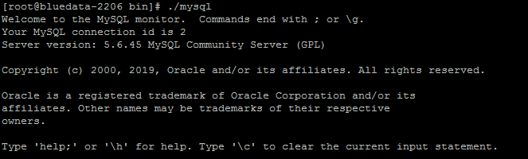

## Show database

Execute the below command to show the existing databases

SHOW DATABASES;

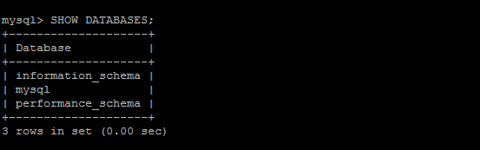

## Create database

Execute the below command to create a database

CREATE DATABASE pets;



## Use database

Execute the below command to use the created database

USE pets



## Create table

Execute the below command to create table

CREATE TABLE cats

(

id INT unsigned NOT NULL AUTO_INCREMENT, # Unique ID for the record

name VARCHAR(150) NOT NULL, # Name of the cat

owner VARCHAR(150) NOT NULL, # Owner of the cat

birth DATE NOT NULL, # Birthday of the cat

PRIMARY KEY (id) # Make the id the primary key

);

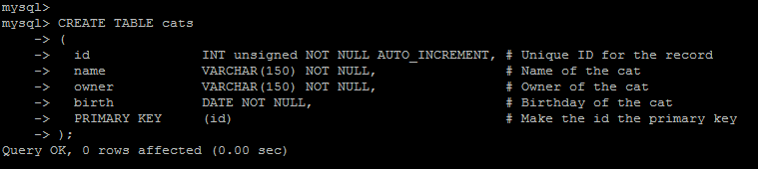

## Show tables

Execute the below command to view the tables

SHOW TABLES;

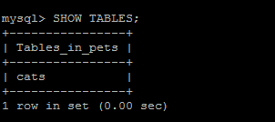

## Describe tables

Execute the below command to show the information on all the columns of a table

DESCRIBE cats;

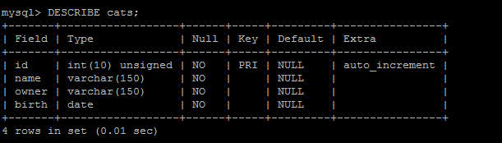

## Insert data

Execute the below command to insert the data in to tables

INSERT INTO cats ( name, owner, birth) VALUES

( 'Sandy', 'Lennon', '2015-01-03' ),

( 'Cookie', 'Casey', '2013-11-13' ),

( 'Charlie', 'River', '2016-05-21' );

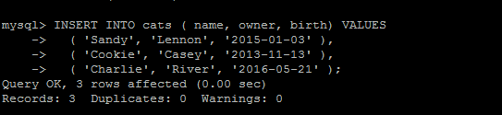

## Select data

* Execute the below command to retrieve records from a table

SELECT * FROM cats;

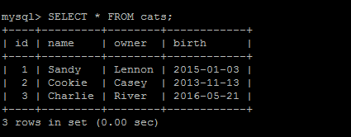

* Execute the below command to retrieve specific columns and rows by a certain condition using the WHERE clause

SELECT name FROM cats WHERE owner = 'Casey';

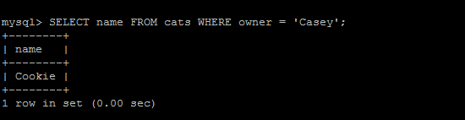

## Delete data

Execute the below command to delete a record from a table

DELETE FROM cats WHERE name='Cookie';

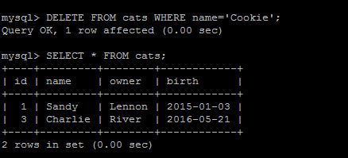

## Alter table

Execute the below command to add or delete a column from a table

ALTER TABLE cats ADD gender CHAR(1) AFTER name;

