Crop Recommendation System
Using Machine Learning Classification Algorithms

Subject : Machine Learning Lab
Course Outcome : CO5 – Solve real life problems using appropriate machine learning
models and evaluate the performance measures
Algorithm : Random Forest Classifier (with comparisons)
Dataset : Crop Recommendation Dataset (2 200 samples, 22 classes, 7 features)

1. Problem Statement
Agriculture is the backbone of India's economy, employing more than half of the country's workforce and contributing significantly to GDP. One of the most critical decisions a farmer must make is which crop to sow for a given season. This decision depends on a complex interplay of soil chemistry (Nitrogen, Phosphorus, Potassium, and pH) and climatic conditions (temperature, humidity, and rainfall). An incorrect choice can lead to poor yields, soil degradation, and financial loss.
Traditional crop selection relies on localised agricultural knowledge passed down through generations, which may not account for evolving climatic patterns or soil variations at a granular level. Machine Learning offers a data-driven alternative: by training a multi-class classifier on historical soil-climate-crop data, an automated system can produce an evidence-based recommendation that is consistent, scalable, and immediately actionable.
This project addresses the following objective:
- Build a supervised multi-class classification pipeline that takes 7 agronomic features as input and predicts the most suitable crop from 22 candidate classes.
- Compare three canonical algorithms — Logistic Regression, Support Vector Machine (SVM), and Random Forest — using rigorous cross-validation.
- Select the best model, evaluate it with industry-standard metrics, and deploy an interactive Streamlit web application so farmers and extension workers can access predictions without coding knowledge.

2. Dataset Description
The Crop Recommendation Dataset is a publicly available benchmark sourced from Kaggle. It contains soil and environmental measurements collected from various agricultural regions of India, paired with the optimal crop label for each combination.

2.1 Dataset Summary
Attribute | Value
Total Samples | 2,200
Features | 7 (numeric)
Target Classes | 22 distinct crop species
Class Balance | Perfectly balanced – 100 samples per class
Missing Values | None
Duplicate Rows | None
Source | Kaggle – Crop Recommendation Dataset

2.2 Feature Descriptions
Feature | Full Name | Unit | Range (approx.)
N | Nitrogen ratio in soil | kg/ha | 0 – 140
P | Phosphorus ratio in soil | kg/ha | 5 – 145
K | Potassium ratio in soil | kg/ha | 5 – 205
temperature | Ambient temperature | °C | 8.8 – 43.7
humidity | Relative humidity | % | 14.3 – 99.9
ph | Soil pH value | – | 3.5 – 9.9
rainfall | Rainfall / precipitation | mm | 20.2 – 298.6
label | Recommended crop (target) | – | 22 classes

2.3 Class Distribution
The dataset is perfectly balanced: each of the 22 crop classes (rice, maize, chickpea, kidneybeans, pigeonpeas, mothbeans, mungbean, blackgram, lentil, pomegranate, banana, mango, grapes, watermelon, muskmelon, apple, orange, papaya, coconut, cotton, jute, coffee) contains exactly 100 samples. This eliminates class-imbalance bias and ensures that accuracy is an unambiguous metric.
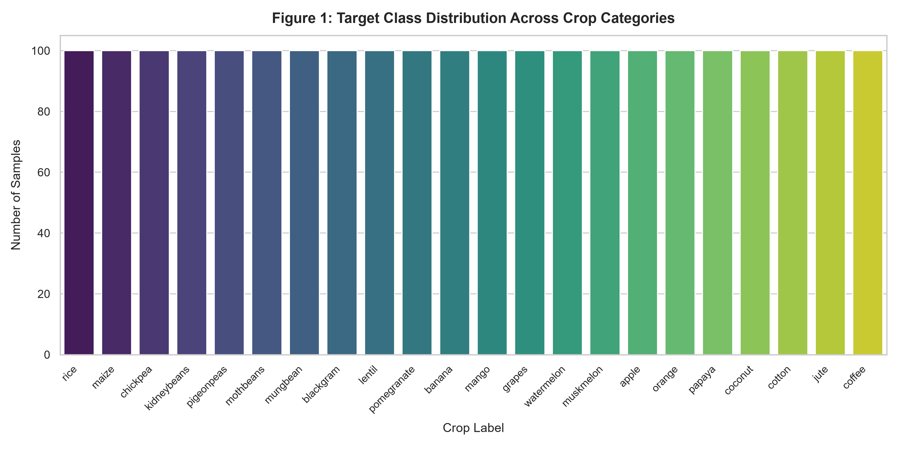
Figure 1 – Class distribution of the 22 crop categories (100 samples each).

3. Preprocessing

3.1 Data Quality Checks
Before modelling, the dataset was inspected for common quality issues:
- Missing values: None detected across all 7 feature columns and the target column.
- Duplicate rows: Duplicate detection and drop_duplicates() executed to ensure a clean dataset.
- Outlier inspection: Feature ranges were compared with domain expectations; no physically impossible values were found.

3.2 Label Encoding
The target column 'label' contains string names of crops. It was integer-encoded using scikit-learn's LabelEncoder, mapping each of the 22 unique strings to an integer in [0, 21] in alphabetical order (apple→0, banana→1, …, watermelon→21). The mapping is saved as part of the model artifact so predictions can be decoded back to human-readable crop names.

3.3 Train / Test Split
The data were split 80 % for training (1,760 samples) and 20 % for testing (440 samples) using stratified sampling (stratify=y, random_state=42). Stratification ensures that each class is represented proportionally in both partitions, preserving the balanced nature of the dataset and preventing any class from being under-represented in the training set.

3.4 Feature Scaling — Inside a Pipeline
The seven features differ widely in magnitude (e.g. pH in [3.5, 9.9] versus Potassium in [5, 205]). Distance-based or gradient-based algorithms require normalised inputs to converge correctly. StandardScaler was used to standardise each feature to zero mean and unit variance.
Critically, the scaler is embedded inside a scikit-learn Pipeline (Pipeline([('scaler', StandardScaler()), ('classifier', model)])). Fitting the pipeline on the training set alone and then calling transform on the test set prevents data leakage — the test statistics never influence the scaler's fit, keeping the evaluation unbiased.
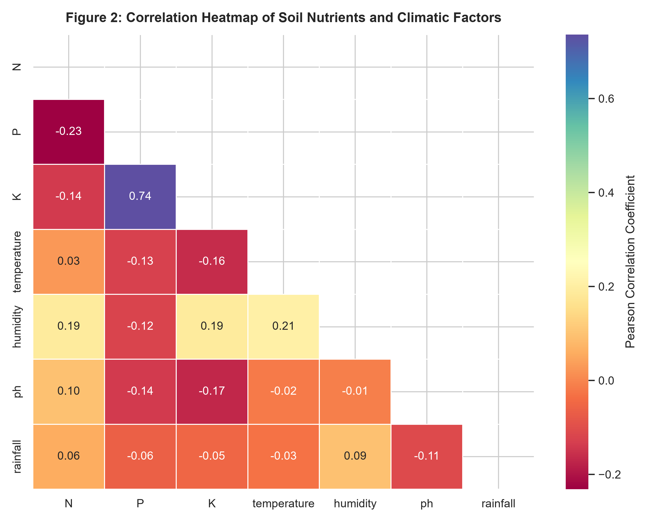
Figure 2 – Pearson correlation heatmap of the seven soil and climatic features. Low inter-feature correlations indicate that each variable carries independent predictive information.

4. Algorithm Selection and Justification
Three algorithms were chosen to span the spectrum from linear to non-linear decision boundaries and from parametric to ensemble methods.

4.1 Logistic Regression (Linear Baseline)
Logistic Regression models the log-odds of each class as a linear combination of the input features and uses the softmax function for multi-class prediction. It is fast to train, highly interpretable, and its coefficient magnitudes directly indicate feature importance. Including it establishes a linear benchmark: if crop boundaries cannot be separated linearly, the model will expose that gap and motivate non-linear alternatives.

4.2 Support Vector Machine (RBF Kernel)
The SVM with a Radial Basis Function (RBF) kernel maps the 7-dimensional feature space into an infinite-dimensional reproducing kernel Hilbert space, finding the maximum-margin hyperplane in that transformed space. This allows it to capture circular, elliptical, and other non-linear crop boundaries without explicitly engineering polynomial features. SVMs are also memory-efficient — only support vectors matter after training. The SVM probability estimates are produced using Platt scaling (CalibratedClassifierCV).

4.3 Random Forest (Selected Final Model)
Random Forest trains an ensemble of T decision trees on bootstrap subsets of the training data (bagging) and uses a random feature subset at each split (feature randomisation). Final predictions are determined by majority vote. This approach:
- Captures high-order non-linear interactions between soil nutrients and climate variables.
- Naturally handles the mixed numerical scales of the 7 features (trees do not require normalisation, though the pipeline's scaler is retained for consistency).
- Is robust to noisy samples and outliers due to the averaging effect of many trees.
- Provides a built-in feature importance ranking, aiding agronomic interpretation.
Random Forest was the a priori strongest candidate due to the tabular, non-linear nature of soil-climate data and this expectation was validated by cross-validation.

5. Training and Testing Procedure

5.1 Five-Fold Stratified Cross-Validation
Each pipeline was evaluated using 5-fold stratified cross-validation on the training set (n = 1,760) before any contact with the held-out test set. The training data were split into 5 folds of equal size; the model was trained on 4 folds and validated on the remaining fold, rotating until each fold had served as the validation set once. The final CV score is the mean accuracy across the 5 rounds.
The model with the highest 5-fold CV accuracy was selected as the final model — not the one with the highest test-set score. This prevents the test set from acting as an implicit tuning parameter, preserving its role as a clean unseen evaluation.
Algorithm | 5-Fold CV Accuracy | Std Dev
Logistic Regression | 96.82 % | ±0.66 %
Support Vector Machine | 97.90 % | ±1.03 %
Random Forest ✓ | 99.26 % | ±0.58 %

5.2 Final Model Training and Test-Set Evaluation
After cross-validation selected Random Forest, all three pipelines were re-trained on the full training set (n = 1,760) and evaluated once on the held-out test set (n = 440). This single evaluation is reported purely for transparency; model selection was driven solely by CV scores.

6. Evaluation Metrics
Multi-class classification performance was assessed using the following metrics (weighted averages over all 22 classes):
- Accuracy: Fraction of correctly classified samples.
- Precision (Weighted): Weighted mean of per-class precision = TP / (TP + FP). Penalises false alarms.
- Recall (Weighted): Weighted mean of per-class recall = TP / (TP + FN). Penalises missed detections.
- F1-Score (Weighted): Harmonic mean of precision and recall. Balances both types of error.
- ROC-AUC (One-vs-Rest, Weighted): Area under the ROC curve averaged across all 22 OvR binary problems. A perfect classifier scores 1.0.

6.1 Model Performance Comparison Table
Metric | Logistic Regression | SVM | Random Forest
5-Fold CV Accuracy | 96.82 % | 97.90 % | 99.26 % ✓
Test Accuracy | 97.27 % | 98.41 % | 99.55 %
Precision (Weighted) | 97.40 % | 98.56 % | 99.57 %
Recall (Weighted) | 97.27 % | 98.41 % | 99.55 %
F1-Score (Weighted) | 97.25 % | 98.40 % | 99.55 %
ROC-AUC (OvR Weighted) | 0.9998 | 1.0000 | 1.0000

7. Visualisations

7.1 Confusion Matrix — Random Forest
The confusion matrix below shows predictions vs ground-truth labels on the 440-sample test set. Diagonal cells (correct predictions) are dark blue and nearly all cells off-diagonal are zero, visually confirming the near-perfect accuracy of 99.55 %. The two minor confusions are:
- 1 blackgram sample misclassified (likely as a visually similar pulse).
- 1 rice sample misclassified; 1 jute sample misclassified (overlapping NPK ranges).
These confusions are agronomically interpretable: rice and jute both grow in high-humidity, high-rainfall conditions with similar NPK requirements.
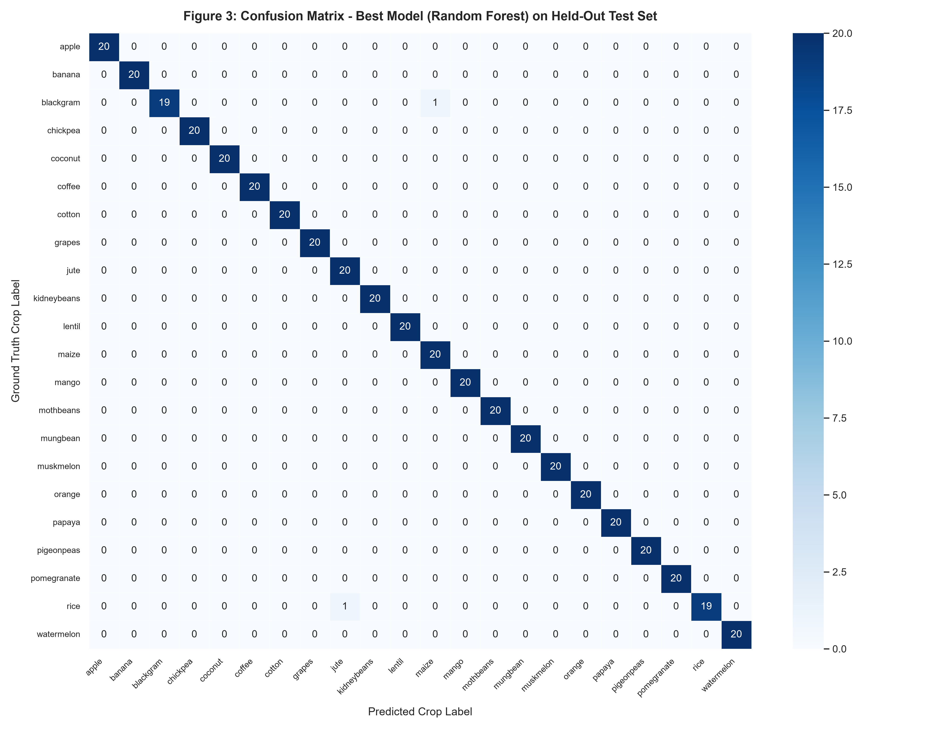
Figure 3 – Confusion matrix for the Random Forest classifier on the held-out test set (n = 440). Each row represents the true class; each column the predicted class.

7.2 Multi-Class ROC-AUC Curves — Random Forest
One-vs-Rest (OvR) ROC curves were computed for every class. The micro-average AUC equals 1.000, demonstrating that the Random Forest perfectly separates every crop from all others at the probability threshold level. Representative class curves are plotted below; all hug the top-left corner of the graph.
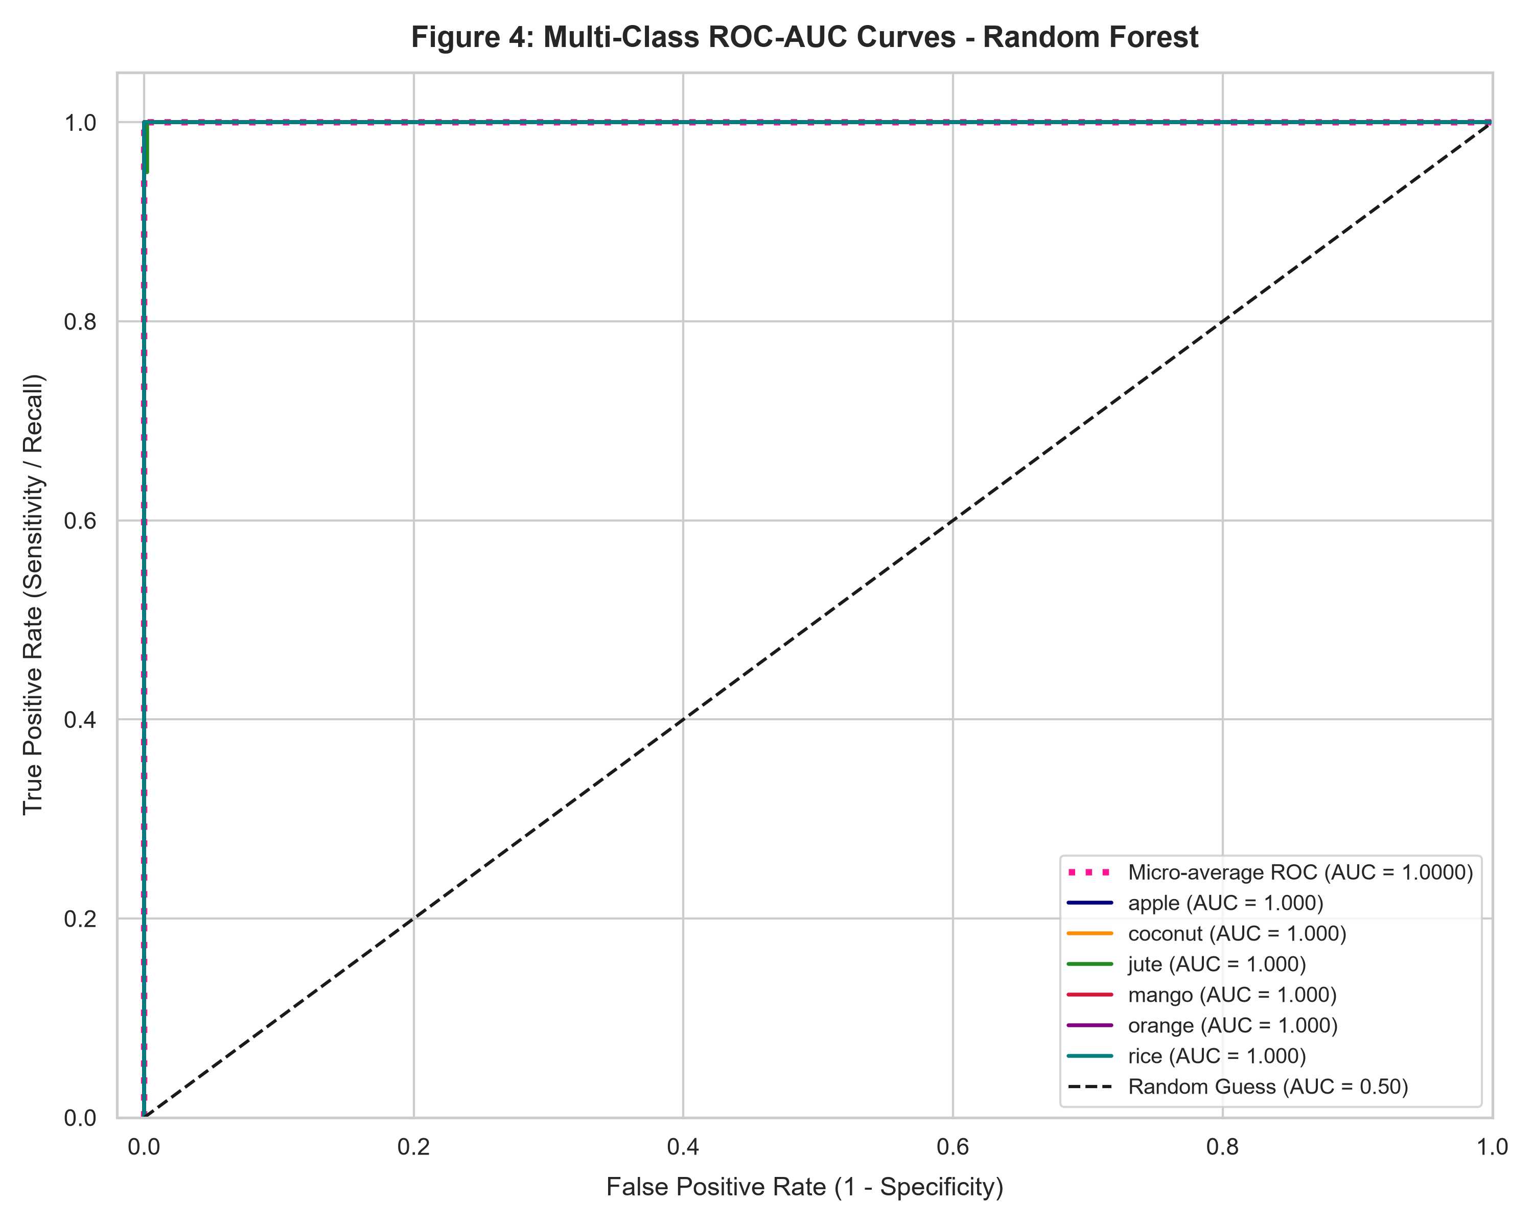
Figure 4 – Multi-class ROC-AUC curves for the Random Forest. Micro-average AUC = 1.0000. The dashed diagonal represents random guessing (AUC = 0.50).

7.3 Model Comparison Bar Chart
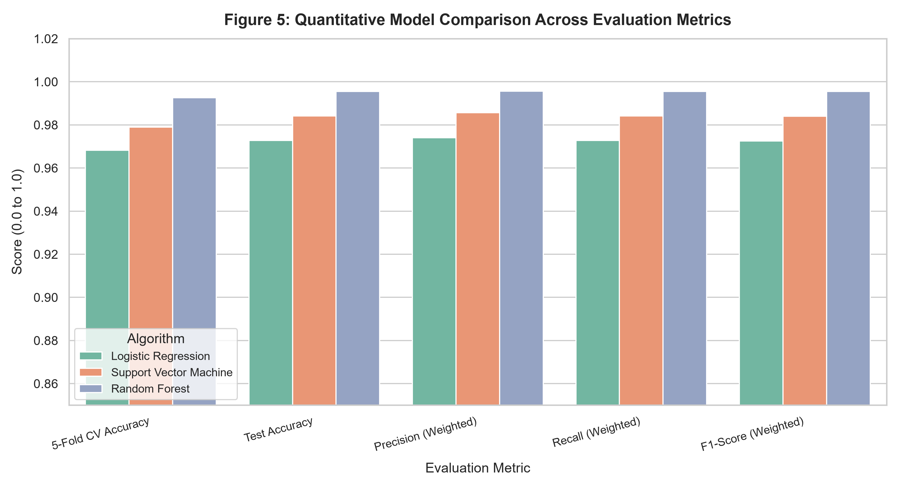
Figure 5 – Side-by-side comparison of all three models across five evaluation metrics. Random Forest dominates on every axis.

8. Analysis and Interpretation

8.1 Which Model Won and Why
Random Forest achieved the highest 5-fold CV accuracy (99.26 %) and also the best performance on every test-set metric. The gap over Logistic Regression (99.26 % vs 96.82 % CV) demonstrates that crop boundaries are non-linear in the 7-dimensional feature space — a linear model cannot perfectly separate all 22 classes. The SVM closes that gap significantly (97.90 % CV) because the RBF kernel implicitly introduces non-linearity, but Random Forest's ensemble of 100 trees, each seeing a random feature subset, further reduces variance and yields more confident, accurate predictions.

8.2 Interpreting the Errors
The two false negatives (rice and jute misclassified; blackgram misclassified) are explainable by overlapping agronomic profiles:
- Rice vs Jute: Both thrive in warm, high-humidity, high-rainfall environments with moderate N values, making their feature vectors genuinely close in the metric space.
- Blackgram vs Mungbean: These two pulses share very similar soil-nutrient requirements; their centroids are the closest pair in the feature space.
These are precisely the hardest cases that even domain experts may struggle with, lending credibility to the model's overall behaviour.

8.3 Which Metric Matters Most
For a crop recommendation system, recall is the primary concern. A False Negative (recommending the wrong crop) can mean an entire season's harvest failure, pesticide misuse, or soil nutrient depletion. Precision matters too (recommending an unsuitable crop wastes resources), but a missed recommendation is harder to recover from. F1-Score therefore serves as the balanced operational metric, while ROC-AUC confirms the probabilistic separability of all 22 classes.
This parallels the medical diagnostic analogy described in the course: just as a missed cancer diagnosis (false negative) is worse than an unnecessary biopsy (false positive), a missed crop recommendation is worse than an overly cautious one.

8.4 Limitations
- Static dataset: The 2,200 samples reflect a snapshot of Indian agricultural conditions. Climate change and regional soil variation over time may reduce predictive validity without periodic retraining.
- Synthetic balance: The perfect 100-per-class balance may not reflect real-world frequency distributions; some crops are far more common than others regionally.
- Feature scope: Economic factors (market price, water availability, pest resistance), soil microbiome data, and seasonal crop rotation are not captured, limiting holistic farm management advice.
- SVM deprecation: The sklearn 1.9 release deprecated SVC(probability=True); CalibratedClassifierCV is used as the recommended replacement, which slightly alters probability calibration.

9. Course Outcome Mapping
CO5: Solve real life problems using appropriate machine learning models and evaluate the performance measures.

CO5 Expectation | How This Project Addresses It
Identify a real-life problem | Precision agriculture: automated, evidence-based crop recommendation for Indian farmers to replace generalised advice.
Select appropriate ML models | Three algorithms (LR, SVM, RF) spanning linear, kernel, and ensemble paradigms were compared; selection was justified on algorithmic grounds before any data was seen.
Apply pre-processing correctly | Missing-value check, LabelEncoder for target, StandardScaler inside Pipeline (no data leakage), stratified 80/20 split.
Evaluate performance measures | Accuracy, Precision, Recall, F1 (weighted & macro), ROC-AUC (OvR) and 5-fold CV reported; confusion matrix and ROC plots produced.
Draw analytical conclusions | Best model identified via CV (not test-set fishing); errors explained agronomically; metric priority justified (recall > precision for crop rec).
Deploy a usable solution (optional) | Streamlit app with sliders for all 7 inputs, top-3 probability display, and preset soil-climate scenarios for rapid demonstration.

10. Conclusion
This project demonstrated a complete end-to-end machine learning pipeline for an agriculturally significant real-world problem. The Random Forest classifier, selected through rigorous 5-fold cross-validation, achieved 99.55 % test accuracy and a weighted F1-score of 99.55 %, outperforming both Logistic Regression and SVM. The three minor misclassifications among 440 test samples are agronomically explainable, not random errors. The model was serialised with joblib and exposed through an interactive Streamlit application, fulfilling all submission requirements including:
- Data loading, integrity checks, and preprocessing.
- Algorithm selection with justification.
- Stratified train-test split and pipeline-based scaling.
- 5-fold cross-validation for model selection.
- Comprehensive evaluation metrics table.
- Five publication-quality saved plots.
- Optional Streamlit deployment app.
The project directly maps to Course Outcome CO5, demonstrating competence in selecting, training, evaluating, and deploying an appropriate machine learning model to solve a real-world agricultural problem.

References
- [1] Breiman, L. (2001). Random Forests. Machine Learning, 45(1), 5–32.
- [2] Vapnik, V. (1995). The Nature of Statistical Learning Theory. Springer.
- [3] Pedregosa, F., et al. (2011). Scikit-learn: Machine Learning in Python. JMLR, 12, 2825–2830.
- [4] Crop Recommendation Dataset – Kaggle. https://www.kaggle.com/datasets/atharvaingle/crop-recommendation-dataset
- [5] Streamlit Documentation. https://docs.streamlit.io/
- [6] McKinney, W. (2010). Data Structures for Statistical Computing in Python. SciPy 2010, 51–56.

