VYUHAM
Benchmark Report
Task allocation, workload balance, budget, planning time and document retrieval
Agent Forge '26 · Problem AF-07: AI-Powered Team Coordination and Task Allocation Agent
Team CodeSilk
31 October 2026
How to read these results. All workforce scenarios and project documents here are simulated. They were measured using VYUHAM's real software, but they are not measurements from a real company, and they do not show real-world delivery outcomes.

Executive summary
We compared VYUHAM's two allocation methods with two simple alternatives on 160 simulated scenarios, then tested planning time, document search and written answers through the running application. The optimizer placed work correctly and handled budgets far better than the alternatives. The results also show clear weaknesses, including workload balance and search on reworded questions.
Table 1. Headline results, averaged across scenario sizes
Measure (simulated scenarios) | VYUHAM optimizer | VYUHAM engine | Skill-first | Basic
Tasks placed validly | 100.0% | 77.5% | 82.5% | 24.9%
Workload Gini (lower is more even) | 0.396 | 0.127 | 0.459 | 0.182
Busiest person's peak week | 77.1% | 72.0% | 105.3% | 80.1%
Valid and within budget, budget = hidden plan's cost | 100% | 3% | 10% | 0%

Main findings
- Accuracy. The optimizer placed 100% of tasks validly, 17.5 points above skill-first and 75.1 points above round robin. It enforces the same rules this measure checks, so see the caveat in section 3.2.
- Workload balance. The engine was the most even, with a Gini of 0.127, 30.4% lower than round robin. The optimizer was noticeably less even (0.396) because it favours cheaper qualified people. Nobody passed the 95% capacity ceiling under the optimizer or the engine.
- Budget. With the budget set to the cost of the hidden valid plan, the optimizer produced a valid, in-budget plan in 100% of scenarios; the best alternative managed 10%. Where both plans were fully valid, its labor cost was 21.5% lower than skill-first (n = 48).
- Computing time. Plans took from under a millisecond to about two seconds. The optimizer reached its 2-second limit from 25 tasks up, so those plans are good but not proven best.
- Document search. With the document's own wording, the right passage was in the top three results 100% of the time. With reworded questions that fell to 17%, because search matches keywords and does not understand meaning. The assistant makes up for much of this by rewriting questions before searching.
- Written answers through Claude. 24 of 24 direct document questions and 6 of 6 meeting-minutes questions were answered correctly, and 6 of 6 unanswerable questions were correctly declined. This was a small test on one short invented project, so these figures will not carry over directly to real documents.
We make no claim about time saved compared with people. No human planning time was measured, so no percentage saving is given anywhere in this report.

1. What was compared
Table 2. The four methods
Method | How it chooses | What it ignores
VYUHAM optimizer | Application code. Exact search across possible teams: rules first, then the lowest cost plus penalties for risk, overload and imbalance. | Nothing here, but it stops at a time limit on large problems.
VYUHAM engine | Application code. Goes task by task and picks the highest weighted score across skill, availability, workload, priority, record and growth. | Cost. It also allows partial skill matches on non-critical tasks, by design.
Skill-first | Baseline. Picks the person with the strongest skill match for each task. | Capacity and cost.
Basic (round robin) | Baseline. Gives each task to the next available person in turn. | Skills, capacity and cost.

Both baselines were written for this benchmark. They represent simple approaches and are not any specific competing product.

2. How the tests were run

2.1 Simulated scenarios
Simulated data · real VYUHAM code
We generated 40 scenarios at each of 8, 15, 25, 40 tasks (160 in total), with about three employees for every four tasks. Skills, levels, hourly rates, workloads, deadlines and dependencies were drawn at random from a fixed seed, so the same data can be recreated exactly. One person in each scenario is on leave.
A hidden valid plan. Each scenario contains a plan that is known to meet every skill and capacity rule. This means 100% valid allocation is always possible, which gives the accuracy measure a fair target. No method could see this plan.
A separate budget test. 30 scenarios of 15 tasks were run at eight budget levels, from 0.6 to 1.5 times the cost of the hidden plan.
Optimizer settings. Default company policy, with a 2-second time limit per plan.

2.2 Through the running application
Simulated documents · real application, database and Claude
Planning time, search and written answers went through the application's real routes, on a temporary database that was deleted afterwards. The live database was not touched. The test documents describe an invented project, with 14 searchable passages and 24 labelled facts, each asked in two ways: using the document's words and reworded.

2.3 Measures and formulas
Valid allocation rate = (tasks assigned to an available person with every required skill at the required level, whose scheduled weeks stay within the capacity ceiling) ÷ (all tasks) × 100
This is our meaning of accuracy. The ceiling is 95% of weekly capacity. Unassigned tasks count as not valid.
Weekly load = existing commitments + meetings + leave + Σ (task hours ÷ weeks available for the task)
Each task is spread across the weeks between its dependencies finishing and its deadline.
Utilisation = hours ÷ weekly capacity × 100
Peak utilisation is the highest weekly value for any person in the plan.
Gini = Σᵢ (2i − n − 1) xᵢ ÷ (n Σᵢ xᵢ), with xᵢ sorted from low to high
Computed on each available person's total hours as a share of weekly capacity. 0 is perfectly even. A low value says hours are evenly shared; it does not say the right people got them.
Labor cost = Σ (estimated hours × approved hourly rate)
Kept in whole minor currency units, so totals are exact.
Optimizer objective = labor cost + a × Σ(100 − suitability) + b × (overloaded assignments) + c × (peak utilisation) + d × (reassignments)
The rules are applied before this is minimized. The default a, b, c and d are a starting policy, not proven best values.
Suitability = 0.60 × skill fit + 0.25 × delivery record + 0.15 × deadline reliability
A 0 to 100 ranking score, not a probability of success. People without enough history get a neutral 50 for the record parts.
Hit@k = (questions with the right passage in the top k) ÷ (all questions) × 100
MRR is the average of 1 ÷ (rank of the right passage), counted as 0 when it isn't found.

2.4 Statistics
Methods were compared on the same scenarios, so each comparison is paired. We report:
- Mean difference with a 95% bootstrap confidence interval (10,000 resamples).
- Wilcoxon signed-rank test for whether the difference is likely to be real, with Holm correction across all comparisons.
- Rank-biserial effect size, from −1 to +1, showing how consistently one method beat the other.
- Percentage change = (A − B) ÷ B × 100, and percentage points where the measure is already a percentage.
- Wilson 95% intervals for pass rates based on counts.

3. Results

3.1 Task allocation accuracy
Simulated data · real VYUHAM code
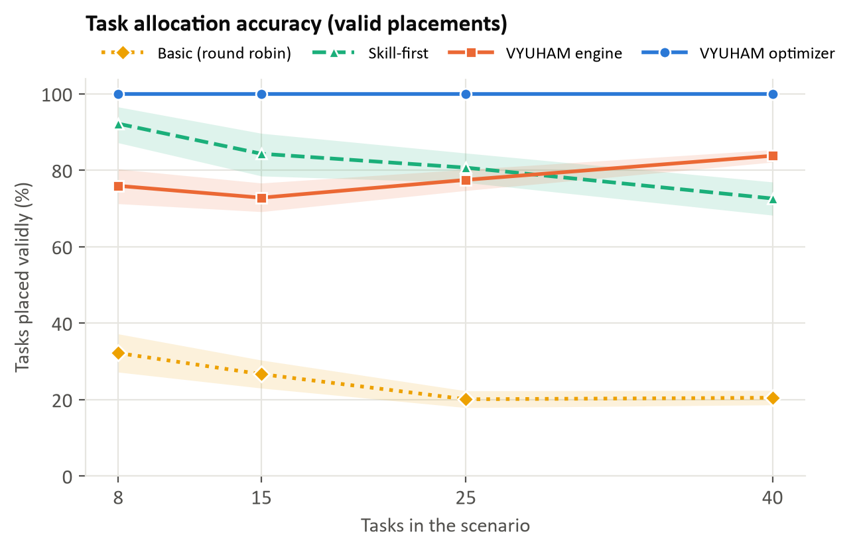
Figure 1. Share of tasks placed validly, with 95% confidence bands
Table 3. Valid allocation rate by size, with overall qualified and assigned rates
Method | 8 tasks | 15 tasks | 25 tasks | 40 tasks | Fully qualified | Assigned
VYUHAM optimizer | 100.0% | 100.0% | 100.0% | 100.0% | 100.0% | 100.0%
VYUHAM engine | 75.9% | 72.8% | 77.5% | 83.8% | 77.5% | 90.2%
Skill-first | 92.2% | 84.3% | 80.7% | 72.6% | 97.1% | 100.0%
Basic (round robin) | 32.2% | 26.7% | 20.1% | 20.5% | 25.0% | 100.0%

The optimizer was valid every time. Skill-first starts strong but declines as projects grow, from 92.2% to 72.6%, because it keeps choosing the same strong people until they run out of capacity. Round robin stays low, near 20%, because it ignores skills.
Where VYUHAM's engine falls short. Its valid rate of 77.5% was 4.9 points below skill-first overall (95% CI -8.2 to -1.8). Two design choices explain most of this: it accepts partial skill matches on non-critical tasks, and it leaves tasks unassigned when no one has enough flat weekly capacity. It assigned 90.2% of tasks, and fewer on small projects. The gap closes with size, and it passed skill-first at 40 tasks.

3.2 An important caveat on accuracy
The optimizer's 100% is partly by design: it refuses to assign anyone who breaks these same rules, and every scenario guarantees that a valid plan exists. The result shows that it applies its rules correctly at scale and always finds a plan. It does not show that people chosen this way would do better work. The scoring was written separately from the optimizer, and it was checked against the hidden plans.

3.3 Employee workload balance
Simulated data · real VYUHAM code
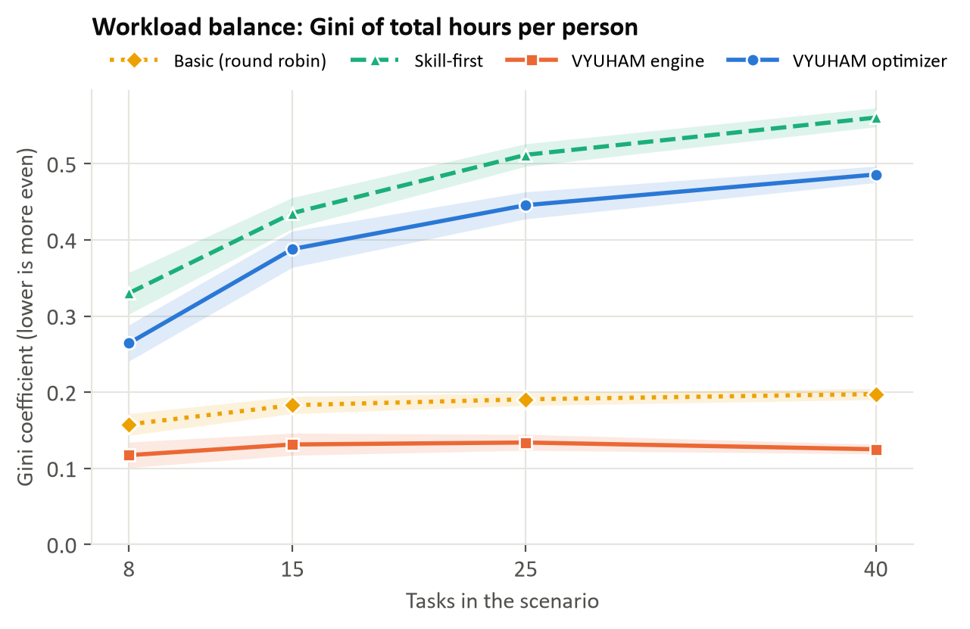
Figure 2. Evenness of total hours across people. Lower is more even
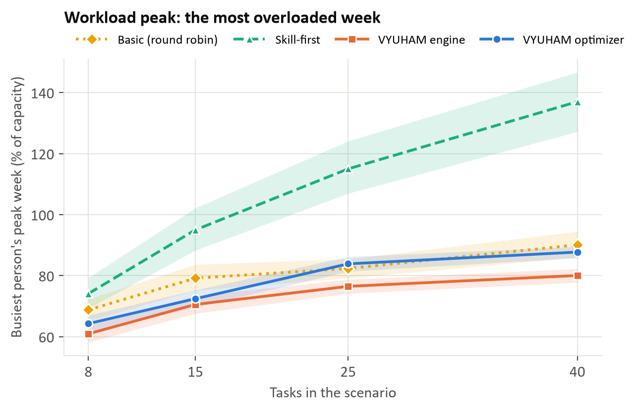
Figure 3. The busiest person's heaviest week. The ceiling is 95%
Table 4. Workload results
Method | Mean Gini | Mean peak week | Peak week at 40 tasks | People over ceiling
VYUHAM optimizer | 0.396 | 77.1% | 87.8% | 0.00%
VYUHAM engine | 0.127 | 72.0% | 80.1% | 0.00%
Skill-first | 0.459 | 105.3% | 137.0% | 5.03%
Basic (round robin) | 0.182 | 80.1% | 90.1% | 0.50%

The engine is the most balanced, with a Gini 30.4% below round robin and 72.4% below skill-first, and it kept every person under the ceiling. Skill-first overloads people badly on large projects, with its busiest week averaging 137% of capacity at 40 tasks.
The cost of optimizing for money. The optimizer's Gini of 0.396 is 212% higher than the engine's and 117% higher than round robin's, though 13.8% lower than skill-first's. It concentrates work on cheaper qualified people while staying within capacity. A company that values even workloads should raise the imbalance penalty. We did not test how far that closes the gap.

3.4 Project budget optimization
Simulated data · real VYUHAM code
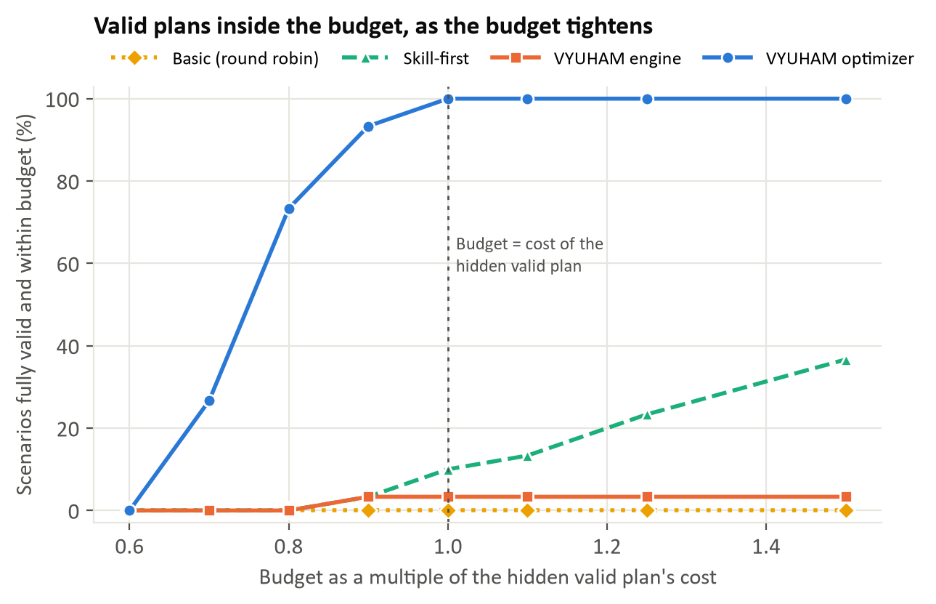
Figure 4. Scenarios with a fully valid plan inside the budget, at each budget level
Table 5. Fully valid and within budget, 30 scenarios at each level
Method | 0.7 × | 0.8 × | 0.9 × | 1.0 × | 1.25 × | 1.5 ×
VYUHAM optimizer | 27% | 73% | 93% | 100% | 100% | 100%
VYUHAM engine | 0% | 0% | 3% | 3% | 3% | 3%
Skill-first | 0% | 0% | 3% | 10% | 23% | 37%
Basic (round robin) | 0% | 0% | 0% | 0% | 0% | 0%

From a budget equal to the hidden plan's cost upward, the optimizer always delivered a valid plan inside the budget. Below that it degrades in stages: 93% at 0.9 ×, 73% at 0.8 ×, 27% at 0.7 × and 0% at 0.6 ×. When it cannot fit, it keeps the plan valid and reports the overrun, which averaged 27.0% at 0.6 ×. It never gave up required skills to save money.
The engine often stays within budget (87% at 1.0 ×), but only 3% of its plans were fully valid, because it ignores cost and often leaves tasks unassigned or partly matched.
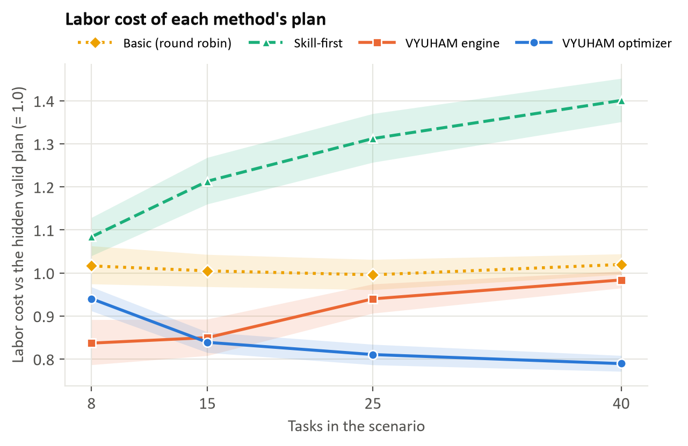
Figure 5. Labor cost of each method's plan, relative to the hidden plan. Counts assigned tasks only
Read Figure 5 with care. A low line does not always mean a better plan. The engine's and round robin's costs include invalid placements, and the engine's leave some tasks uncosted. The fair comparison uses only scenarios where both plans are fully valid: there the optimizer cost 21.5% less than skill-first (n = 48, Holm p < 0.001). Against the engine the difference was 16.1%, but with only 6 comparable scenarios it was not significant (Holm p 0.094). Round robin had no fully valid plans, so a fair cost comparison with it was not possible.

3.5 Project planning time
Simulated scenarios and sample documents · real application
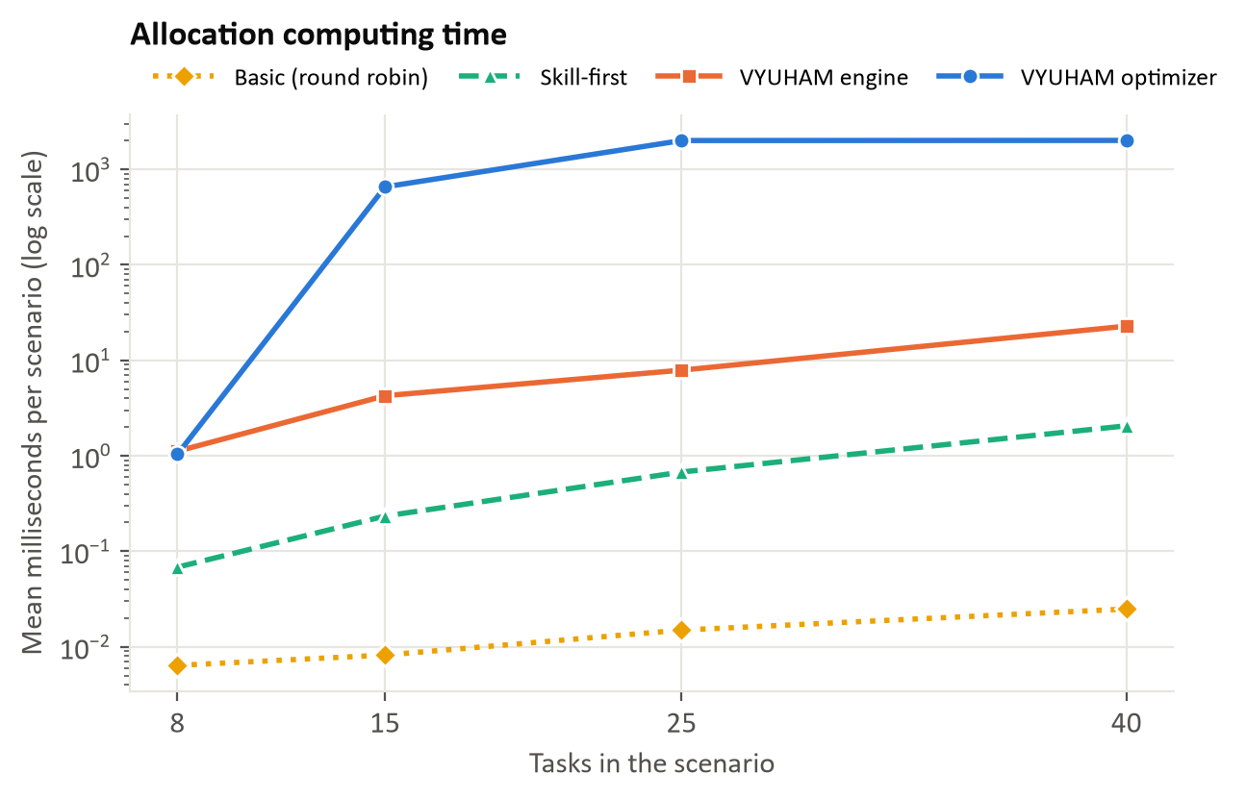
Figure 6. Computing time per plan. Note the logarithmic scale
Table 6. Allocation computing time
Median milliseconds | 8 tasks | 15 tasks | 25 tasks | 40 tasks
VYUHAM optimizer | 0.9 | 442.0 | 2004.0 | 2007.9
VYUHAM engine | 1.1 | 2.9 | 7.6 | 18.4
Skill-first | 0.1 | 0.2 | 0.7 | 1.7
Basic (round robin) | 0.0 | 0.0 | 0.0 | 0.0

Table 7. How often the optimizer finished its search
Optimizer at each size | 8 tasks | 15 tasks | 25 tasks | 40 tasks
Proved best within the limit | 100% | 88% | 0% | 0%
Median gap to the lower bound | 0.0% | 0.0% | 9.8% | 10.3%
Stopped with no plan | 0% | 0% | 0% | 0%

The time limit matters. Up to 15 tasks the optimizer usually proves its plan is the best one. At 25 tasks and above it always hits the 2-second limit and returns the best plan found, with a gap of roughly 10%. The true gap may be smaller, because the bound it is measured against is cautious.
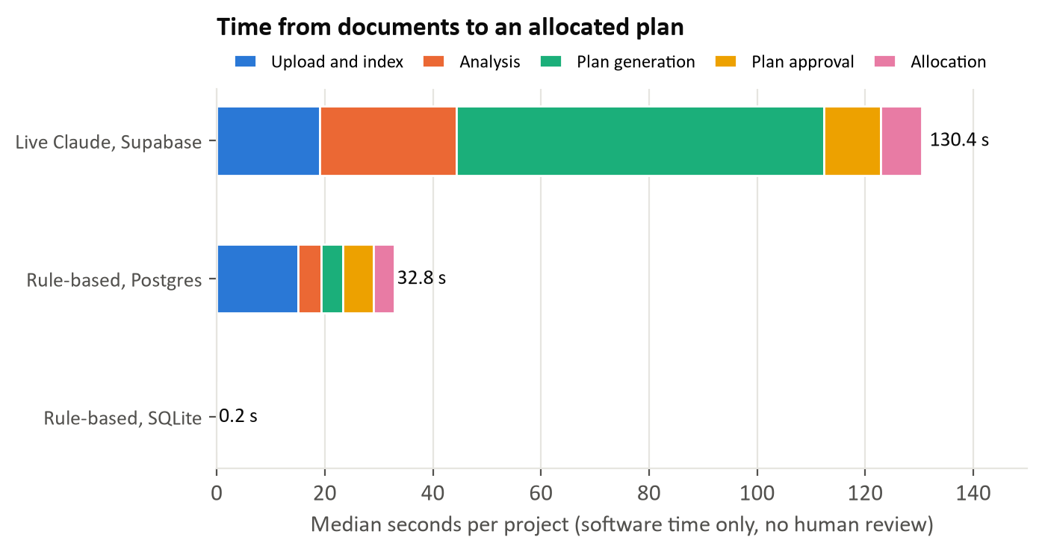
Figure 7. Median software time from uploaded documents to an allocated plan
Table 8. Time for each stage. Human review time is not included
Median seconds | Rule-based, SQLite | Rule-based, Postgres | Live Claude, Supabase
Upload and index | 0.08 | 15.04 | 19.03
Analysis | 0.03 | 4.33 | 25.33
Plan generation | 0.03 | 3.93 | 68.04
Plan approval | 0.03 | 5.69 | 10.42
Allocation | 0.02 | 3.86 | 7.59
Total | 0.19 | 31.96 | 133.76
Successful runs | 10 of 10 | 3 of 3 | 3 of 3
Tasks in plan (median) | 7 | 7 | 16

Without Claude, the flow took 0.19 seconds on a local database and 32 seconds on Supabase. That difference is mostly database round trips from a laptop in India to a server in London, so hosting the backend near the database should reduce it. We have not measured that. Rule-based plans are simple, with a median of 7 tasks. With Claude, the flow took a median of 134 seconds across 3 runs and produced a median of 16 tasks, with most of the time in analysis and plan generation. Three runs is a small sample, so treat this as indicative.
Not measured: how long a person takes to plan the same project. So we can show how long the software takes, but not how much time it saves.

3.6 Document retrieval
Simulated documents · real search
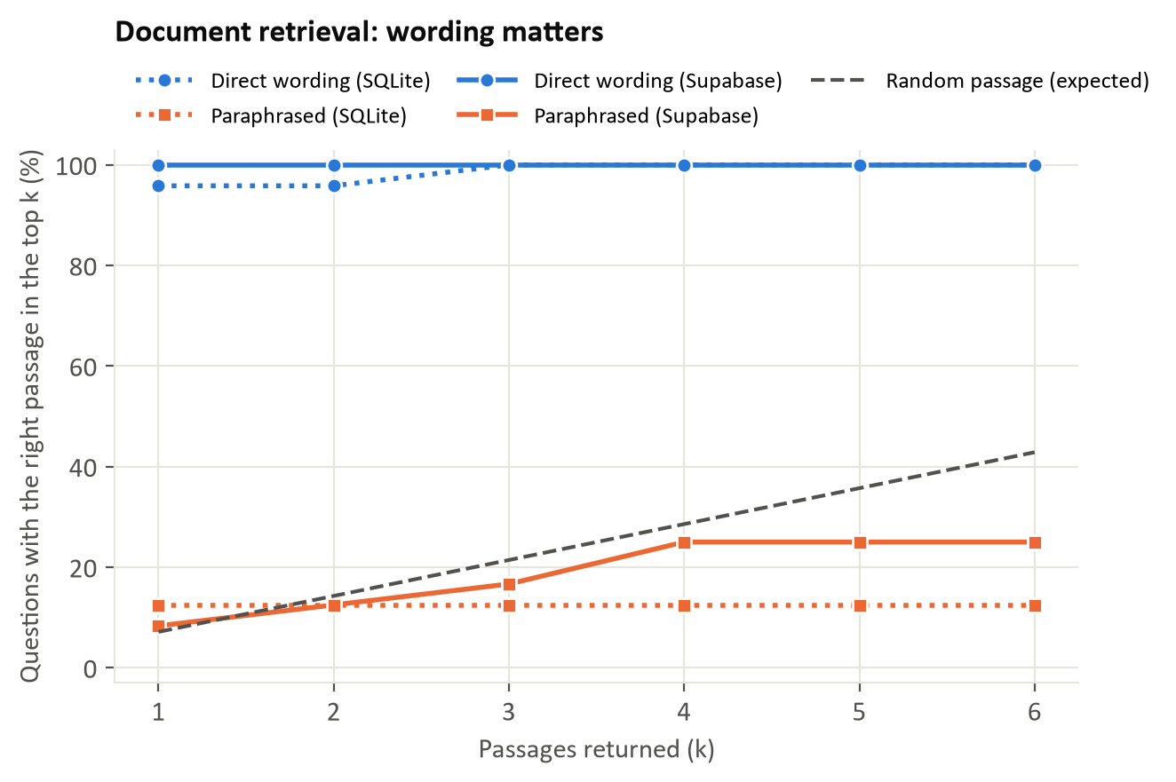
Figure 8. Share of questions with the right passage in the top k results
Table 9. Search results, against a simple word-overlap baseline and random chance
Database | Question | n | Hit@1 | Hit@3 | Hit@6 | MRR | Word overlap Hit@3 | Random Hit@3 | No results
SQLite | Direct | 24 | 96% | 100% | 100% | 0.97 | 100% | 21% | 0%
SQLite | Paraphrase | 24 | 12% | 12% | 12% | 0.12 | 33% | 21% | 62%
Supabase | Direct | 24 | 100% | 100% | 100% | 1.00 | 100% | 21% | 0%
Supabase | Paraphrase | 24 | 8% | 17% | 25% | 0.14 | 33% | 21% | 50%

Clear strength, clear weakness. When a question uses the document's words, search works well: top-three hit rate 100%. When it is reworded, the rate drops to 17%, and 50% of those questions returned nothing. That is below the 21% expected from picking passages at random, and below the word-overlap baseline's 33%. The cause is known: search uses keywords, with no embeddings. Adding semantic search is the most valuable improvement this benchmark points to.
Meeting minutes. Of 8 questions about minutes, the right record was found for 8, with the right kind of record (approved decision, action item or unapproved note) among the results for 8. The test corpus is small, so this is a basic check rather than a precise rate.

3.7 Written answers through Claude
Simulated documents · real assistant · live Claude API
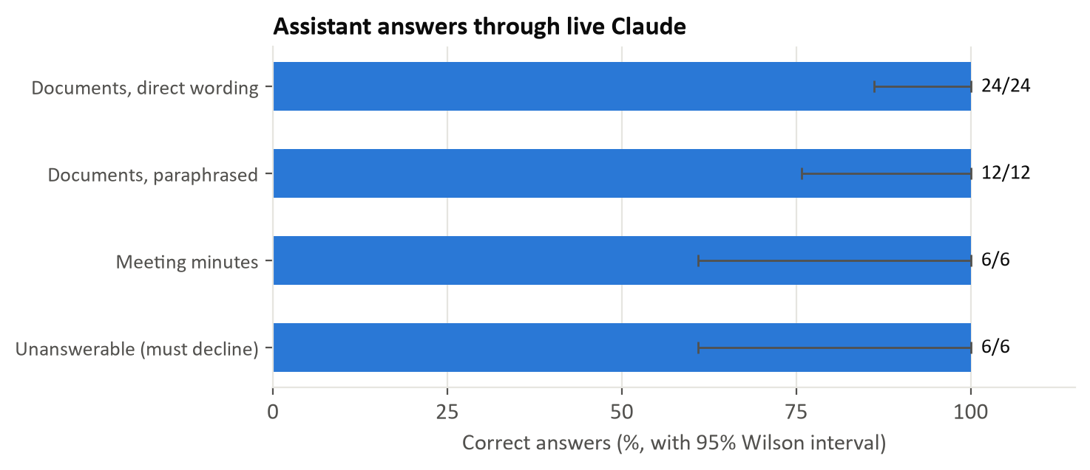
Figure 9. Correct answers by question type, with 95% Wilson intervals
Table 10. Answer accuracy
Question type | n | Correct | Accuracy | 95% interval | Median seconds
Documents, direct wording | 24 | 24 | 100% | 86% to 100% | 11.4
Documents, paraphrased | 12 | 12 | 100% | 76% to 100% | 13.0
Meeting minutes | 6 | 6 | 100% | 61% to 100% | 12.1
Unanswerable (must decline) | 6 | 6 | 100% | 61% to 100% | 12.5

The assistant answered 48 of 48 questions correctly. An answer counted as correct only if it contained the expected fact, and an unanswerable question counted only if the answer clearly declined. Because a keyword check can be fooled, we also read every reworded, unanswerable and meeting-minutes answer, plus a sample of the direct ones, and found no errors.
Do not read this as near-perfect real-world accuracy. Each group is small: 6 of 6 still has a 95% interval that reaches down to 61%. The test also uses one short invented project with only 14 passages, where every fact is stated plainly. Long or messy real documents will be harder.
Why answers beat raw search. Reworded questions reached 12 of 12, even though search on the same wording found so little. Claude rewrites the question into better search terms and tries again, averaging nearly two searches per question. This helps most in a small collection, so it does not replace semantic search.
Malicious documents. We planted a false instruction in one document and asked 3 questions about it. The assistant followed the instruction 0 times. This is a small test, and it does not prove the assistant is immune to such attacks.
API use. 114 Claude calls, 64,392 input tokens and 45,596 output tokens, with 0 failed calls.

3.8 Percentage comparisons
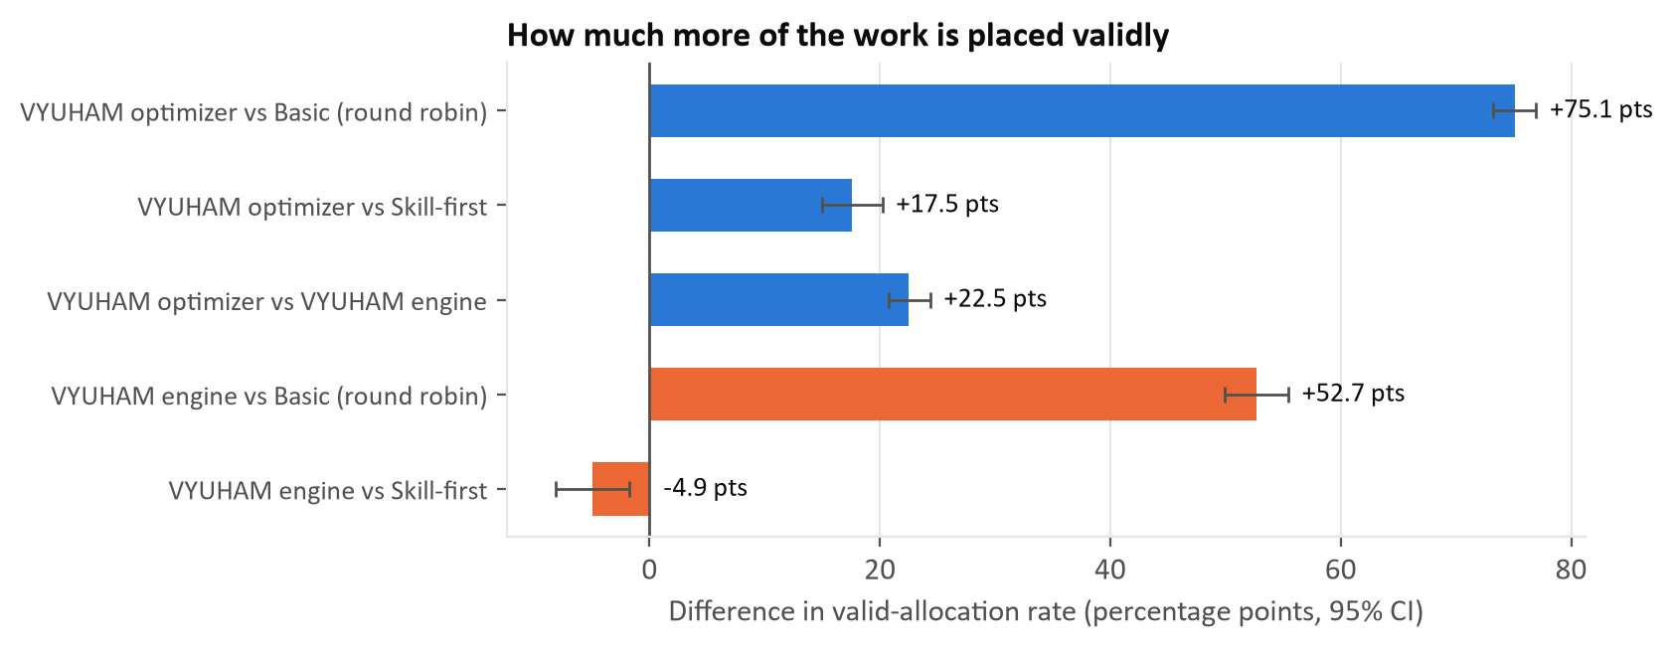
Figure 10. Paired differences in valid allocation rate, across all scenario sizes
Table 11. Paired comparisons. For Gini, peak week and cost, lower is better
Comparison (A vs B) | Measure | n | A | B | Change | 95% CI of difference | Holm p
VYUHAM optimizer vs Basic (round robin) | Valid allocation | 160 | 100.0 | 24.9 | +75.1 pts | 73.2 to 77.0 | < 0.001
VYUHAM optimizer vs Basic (round robin) | Gini | 160 | 0.396 | 0.182 | +117.3% | 0.198 to 0.229 | < 0.001
VYUHAM optimizer vs Basic (round robin) | Peak week | 160 | 77.1 | 80.1 | -3.0 pts | -5.1 to -1.0 | 0.051
VYUHAM optimizer vs Basic (round robin) | Cost, both valid | 0 | — | — | — | Not enough comparable scenarios | —
VYUHAM optimizer vs Skill-first | Valid allocation | 160 | 100.0 | 82.5 | +17.5 pts | 14.9 to 20.2 | < 0.001
VYUHAM optimizer vs Skill-first | Gini | 160 | 0.396 | 0.459 | -13.8% | -0.077 to -0.050 | < 0.001
VYUHAM optimizer vs Skill-first | Peak week | 160 | 77.1 | 105.3 | -28.2 pts | -32.6 to -23.9 | < 0.001
VYUHAM optimizer vs Skill-first | Cost, both valid | 48 | 0.901 | 1.148 | -21.5% | -0.308 to -0.188 | < 0.001
VYUHAM optimizer vs VYUHAM engine | Valid allocation | 160 | 100.0 | 77.5 | +22.5 pts | 20.7 to 24.4 | < 0.001
VYUHAM optimizer vs VYUHAM engine | Gini | 160 | 0.396 | 0.127 | +212.0% | 0.253 to 0.285 | < 0.001
VYUHAM optimizer vs VYUHAM engine | Peak week | 160 | 77.1 | 72.0 | +5.1 pts | 3.6 to 6.5 | < 0.001
VYUHAM optimizer vs VYUHAM engine | Cost, both valid | 6 | 0.915 | 1.091 | -16.1% | -0.388 to -0.056 | 0.094
VYUHAM engine vs Basic (round robin) | Valid allocation | 160 | 77.5 | 24.9 | +52.7 pts | 49.9 to 55.4 | < 0.001
VYUHAM engine vs Basic (round robin) | Gini | 160 | 0.127 | 0.182 | -30.4% | -0.063 to -0.047 | < 0.001
VYUHAM engine vs Basic (round robin) | Peak week | 160 | 72.0 | 80.1 | -8.1 pts | -9.9 to -6.4 | < 0.001
VYUHAM engine vs Skill-first | Valid allocation | 160 | 77.5 | 82.5 | -4.9 pts | -8.2 to -1.8 | 0.011
VYUHAM engine vs Skill-first | Gini | 160 | 0.127 | 0.459 | -72.4% | -0.349 to -0.315 | < 0.001
VYUHAM engine vs Skill-first | Peak week | 160 | 72.0 | 105.3 | -33.3 pts | -38.1 to -28.7 | < 0.001
VYUHAM engine vs Skill-first | Cost, both valid | 5 | 1.113 | 1.142 | -2.6% | -0.136 to 0.148 | 1.000

A small p-value says a difference is unlikely to be chance within these simulated scenarios. It says nothing about real-world performance.

4. How the results were checked
Table 12. Validation: 7 of 7 calculation checks passed, plus the demo scenario
Check | Detail | Result
The optimizer's best plan matched an independent check of every possible plan on small scenarios | 50/50 small instances | Pass
Every hidden plan scored 100% valid, across all scenarios | 0 invalid of 160 | Pass
The same seed produces identical data | — | Pass
The benchmark's Gini formula matches the application's own | 0.3654 vs 0.3654 | Pass
Gini gives the known answers on hand-worked cases | — | Pass
Unassigned tasks are scored correctly | — | Pass
The optimizer gives the same plan on the same input | — | Pass
The seeded demo scenario, through the application's real route, still gives the known result | Gini 0.1584 to 0.1369, 8 of 8 tasks assigned | Pass

5. Limitations
- Simulated data. Scenario settings such as skill mix and pay ranges were our choices. Real companies could give different results.
- Accuracy means following the rules. It does not measure quality of work, on-time delivery or team satisfaction. None of those outcomes were observed.
- The measure suits the optimizer. The rules being scored are the ones it enforces. The engine, which accepts partial matches by design, is judged by a stricter standard than it was built for.
- Scoring model. Capacity is scored with weekly loads spread over each task's window, which is how the optimizer plans. The engine plans with flat weekly hours, so it is more cautious and leaves more tasks unassigned.
- Baselines are simple. A more advanced competitor would likely perform better than these two.
- Default policy only. Optimizer penalties were not tuned. The 2-second limit also affects results at larger sizes.
- Timing. Measured on one development laptop in India with other work running, including tests over the internet to a database in London. Hosted performance will differ. Treat times as a rough guide.
- Small document test. One invented project with few passages. Search gets harder as collections grow, so real performance could be lower. Keyword grading of answers is also imperfect.
- Scale. Up to 40 tasks. Larger projects were not tested.

What could not be measured
Table 13. Benchmarks not completed
Not measured | Why
Time saved compared with human planners | No human baseline was collected, so no saving is claimed.
Real-world delivery outcomes | VYUHAM has no history of completed real projects.
Budget forecast accuracy | It needs actual costs from finished projects.
Performance against real competing products | None were available to test.
Prediction of task success | VYUHAM has no calibrated model for this. Its scores are rankings, not probabilities.

6. Conclusion
Within these simulated tests, VYUHAM's optimizer did what it was built to do. It placed every task validly across 160 scenarios, always found a valid plan, respected the budget whenever that was possible, and said so when it was not. Against skill-first it was 17.5 points more accurate and, where both were valid, 21.5% cheaper, while its busiest week was 28.2 points lower.
The tests also show that VYUHAM's two methods trade off against each other. The engine shares work more evenly and runs faster, but ignores cost and leaves more tasks unmatched. The optimizer saves money and meets every rule, but concentrates work on fewer people.

Recommended next steps
- Add semantic search, because reworded questions are the weakest search result in this report.
- Test higher imbalance penalties, to see how much evenness the optimizer can regain and at what cost.
- Collect real project data, so that delivery and budget accuracy can be measured.
- Time real planners, so that any time-saving claim rests on evidence.

