Amrith_Ravindra_HW2.R

Chanti

Wed Mar 1 23:37:54 2017

x = getwd()  
setwd(x)  
clopidogrel = readxl::read_excel("clopidogrel.xlsx")  
inputvar <- clopidogrel[c(1:8)]  
outputvar <- clopidogrel[c(9, 10)]  
  
summary(clopidogrel)

## clopidogrel Mortality_Score Diabetes Aspirin_Use   
## Min. :0.0000 Min. : 1.000 Min. :0.0000 Min. :0.0000   
## 1st Qu.:0.0000 1st Qu.: 2.000 1st Qu.:0.0000 1st Qu.:0.0000   
## Median :0.0000 Median : 3.000 Median :0.0000 Median :1.0000   
## Mean :0.3333 Mean : 4.602 Mean :0.4839 Mean :0.6559   
## 3rd Qu.:1.0000 3rd Qu.: 6.000 3rd Qu.:1.0000 3rd Qu.:1.0000   
## Max. :1.0000 Max. :15.000 Max. :1.0000 Max. :1.0000   
##   
## Age Height Weight BSA   
## Min. :47.00 Min. :139.0 Min. : 57.00 Min. :1.560   
## 1st Qu.:58.00 1st Qu.:171.0 1st Qu.: 80.00 1st Qu.:1.980   
## Median :64.00 Median :178.0 Median : 89.00 Median :2.110   
## Mean :64.83 Mean :176.7 Mean : 91.44 Mean :2.112   
## 3rd Qu.:72.00 3rd Qu.:183.0 3rd Qu.:104.00 3rd Qu.:2.260   
## Max. :85.00 Max. :196.0 Max. :150.00 Max. :2.720   
##   
## EBL24 logEBL24 NA NA   
## Min. :1025 Min. :3.011 Min. : NA Min. : NA   
## 1st Qu.:1800 1st Qu.:3.255 1st Qu.: NA 1st Qu.: NA   
## Median :2210 Median :3.344 Median : NA Median : NA   
## Mean :2368 Mean :3.346 Mean :NaN Mean :NaN   
## 3rd Qu.:2590 3rd Qu.:3.413 3rd Qu.: NA 3rd Qu.: NA   
## Max. :6610 Max. :3.820 Max. : NA Max. : NA   
## NA's :93 NA's :93

hist(clopidogrel$clopidogrel)

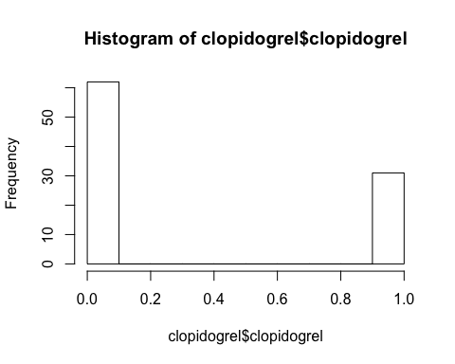

hist(clopidogrel$Mortality_Score)

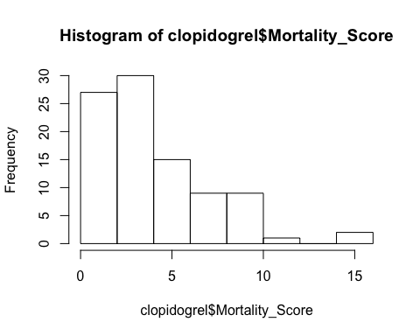

hist(clopidogrel$Diabetes)

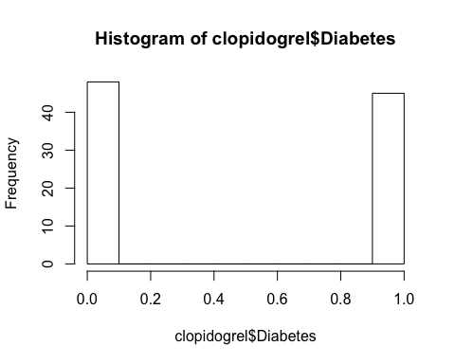

hist(clopidogrel$Aspirin_Use)

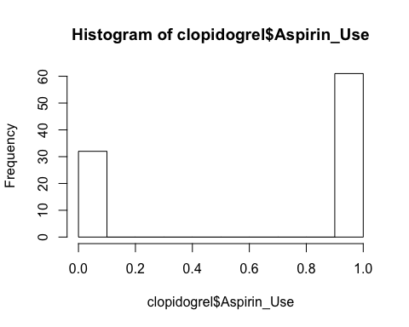

hist(clopidogrel$Age)

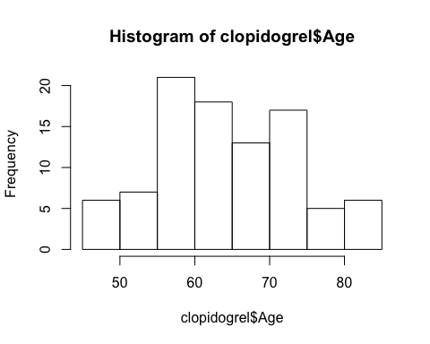

hist(clopidogrel$Height)

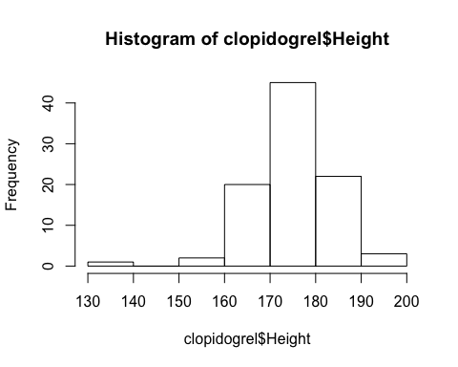

hist(clopidogrel$Weight)

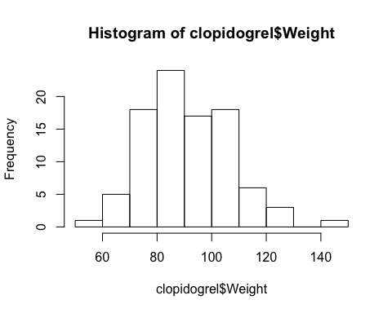

hist(clopidogrel$BSA)

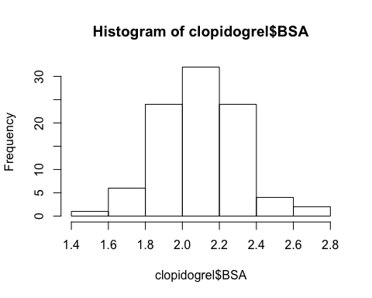

hist(clopidogrel$EBL24)

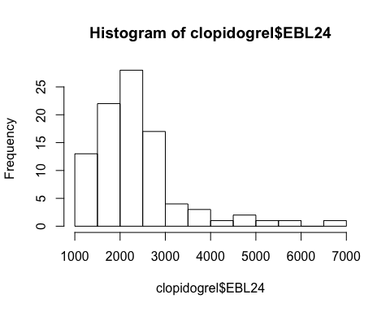

hist(clopidogrel$logEBL24)

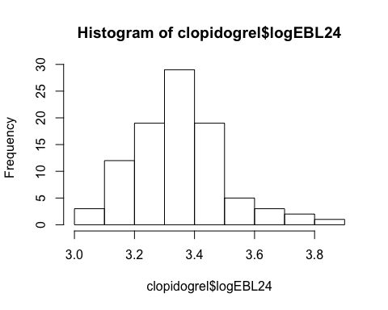

# We find Mortality Score, Age, Height, Weight and BSA to be continuous variables  
# Both the output variables are continuous as well  
# Clopidogrel use, Asipirin use and Diabetes are the discontinuous variables  
#####################################  
  
#Code for Covariance matrices of input and output variables  
cov(inputvar)

## clopidogrel Mortality_Score Diabetes Aspirin_Use  
## clopidogrel 0.22463768 -0.02898551 -0.03260870 0.039855072  
## Mortality_Score -0.02898551 9.65521272 0.09677419 0.046400187  
## Diabetes -0.03260870 0.09677419 0.25245442 0.026998597  
## Aspirin_Use 0.03985507 0.04640019 0.02699860 0.228143993  
## Age -0.12681159 12.05037401 -0.47019635 -0.483754091  
## Height 0.17028986 -1.10577373 -0.42952314 -0.239247312  
## Weight 1.39347826 -4.57791024 2.28323983 0.869985975  
## BSA 0.01753623 -0.05448223 0.02356241 0.008679289  
## Age Height Weight BSA  
## clopidogrel -0.1268116 0.1702899 1.393478 0.017536232  
## Mortality_Score 12.0503740 -1.1057737 -4.577910 -0.054482235  
## Diabetes -0.4701964 -0.4295231 2.283240 0.023562412  
## Aspirin_Use -0.4837541 -0.2392473 0.869986 0.008679289  
## Age 80.2961664 -10.4946237 -35.312833 -0.454899486  
## Height -10.4946237 65.7933614 63.276508 1.133353202  
## Weight -35.3128331 63.2765077 271.803703 3.481145863  
## BSA -0.4548995 1.1333532 3.481146 0.046743361

cov(outputvar)

## EBL24 logEBL24  
## EBL24 939487.8558 141.43374423  
## logEBL24 141.4337 0.02303678

#####################################  
  
# Code for computing mean, median and standard deviations of each variables  
names(clopidogrel)

## [1] "clopidogrel" "Mortality_Score" "Diabetes"   
## [4] "Aspirin_Use" "Age" "Height"   
## [7] "Weight" "BSA" "EBL24"   
## [10] "logEBL24" NA NA

str(clopidogrel)

## Classes 'tbl_df', 'tbl' and 'data.frame': 93 obs. of 12 variables:  
## $ clopidogrel : num 0 0 0 0 0 0 0 0 0 0 ...  
## $ Mortality_Score: num 1 1 2 2 2 2 2 2 2 2 ...  
## $ Diabetes : num 0 0 1 0 1 1 0 1 0 1 ...  
## $ Aspirin_Use : num 1 0 1 0 1 1 1 1 1 0 ...  
## $ Age : num 58 63 61 69 56 60 63 65 68 73 ...  
## $ Height : num 193 175 183 178 170 176 182 185 183 183 ...  
## $ Weight : num 91 80 81 107 101 95 79 108 91 89 ...  
## $ BSA : num 2.2 1.97 2.03 2.3 2.18 2.16 2 2.36 2.15 2.13 ...  
## $ EBL24 : num 2314 3057 1642 2590 1890 ...  
## $ logEBL24 : num 3.36 3.49 3.22 3.41 3.28 ...  
## $ NA : num NA NA NA NA NA NA NA NA NA NA ...  
## $ NA : num NA NA NA NA NA NA NA NA NA NA ...

apply(clopidogrel, 2, mean, na.rm = TRUE)

## clopidogrel Mortality_Score Diabetes Aspirin_Use   
## 0.3333333 4.6021505 0.4838710 0.6559140   
## Age Height Weight BSA   
## 64.8279570 176.6559140 91.4387097 2.1118280   
## EBL24 logEBL24 <NA> <NA>   
## 2367.7795699 3.3459726 NaN NaN

apply(clopidogrel, 2, median, na.rm = TRUE)

## clopidogrel Mortality_Score Diabetes Aspirin_Use   
## 0.000000 3.000000 0.000000 1.000000   
## Age Height Weight BSA   
## 64.000000 178.000000 89.000000 2.110000   
## EBL24 logEBL24 <NA> <NA>   
## 2210.000000 3.344392 NA NA

apply(clopidogrel, 2, sd, na.rm = TRUE)

## clopidogrel Mortality_Score Diabetes Aspirin_Use   
## 0.4739596 3.1072838 0.5024484 0.4776442   
## Age Height Weight BSA   
## 8.9608128 8.1113107 16.4864703 0.2162021   
## EBL24 logEBL24 <NA> <NA>   
## 969.2718173 0.1517787 NA NA

pca1 = prcomp(inputvar, scale = TRUE)  
  
names(pca1)

## [1] "sdev" "rotation" "center" "scale" "x"

pca1$rotation

## PC1 PC2 PC3 PC4  
## clopidogrel 0.14043726 -0.02773373 0.03646672 -0.76198315  
## Mortality_Score -0.13614023 -0.72419942 -0.11837215 -0.03728022  
## Diabetes 0.15557800 -0.10132632 -0.67921888 0.40343127  
## Aspirin_Use 0.09523122 0.03119196 -0.56037048 -0.49583872  
## Age -0.26255809 -0.62608169 0.12004966 -0.04816151  
## Height 0.41993418 -0.14635423 0.43436692 0.06010088  
## Weight 0.57326465 -0.14702076 -0.06663142 0.03936011  
## BSA 0.59544596 -0.16885831 0.04217295 0.04356805  
## PC5 PC6 PC7 PC8  
## clopidogrel 0.56569104 -0.15587382 -0.2307124 0.005373996  
## Mortality_Score -0.13846835 -0.62177596 0.1892399 0.002947769  
## Diabetes 0.34233785 -0.03095659 -0.4725083 0.003967406  
## Aspirin_Use -0.62184013 0.20042839 -0.0568140 0.001565867  
## Age 0.09778441 0.70206531 -0.1409962 0.004012458  
## Height -0.36256389 -0.12595715 -0.6563565 0.178402199  
## Weight 0.12378085 0.16362535 0.4340262 0.642876265  
## BSA 0.02457152 0.11150787 0.2130859 -0.744856296

pca1$sdev

## [1] 1.62129307 1.15533731 1.10018026 1.07782984 0.86100552 0.72703331  
## [7] 0.62711987 0.03610285

pca1$x

## PC1 PC2 PC3 PC4 PC5  
## [1,] 1.25163233 1.096300088 1.16473744 0.007928932 -1.81330896  
## [2,] -1.04207084 1.284159196 1.44059896 0.813166280 0.23898917  
## [3,] 0.09592425 0.854345710 -0.71323669 0.650510953 -0.79121014  
## [4,] 0.74132386 0.079237673 1.59878726 0.922109436 0.36602713  
## [5,] 0.67795316 1.142745628 -1.52795484 0.659036336 -0.09748301  
## [6,] 0.60766567 0.824137233 -1.13271326 0.663639887 -0.36934573  
## [7,] -0.47625548 0.975582290 0.61405631 -0.181398930 -1.42445154  
## [8,] 1.92996217 0.040270219 -0.59729847 0.774791643 -0.59673602  
## [9,] 0.25939189 0.384029793 0.71535341 -0.141986485 -1.30744393  
## [10,] 0.09852524 -0.198827591 0.60789955 1.663357847 0.71305833  
## [11,] -1.31488936 1.528482449 -1.50591761 0.507529661 -0.27868902  
## [12,] -1.77993327 -0.094201340 -0.11552620 1.453774616 1.35006447  
## [13,] -0.02476009 1.586070994 1.68702129 0.942849687 -0.25158260  
## [14,] 1.45003863 1.325133169 -0.01470166 1.819326035 0.80318383  
## [15,] 0.82083764 0.904265566 1.57301614 0.971649670 0.10586238  
## [16,] 0.53241479 0.490911170 -1.52479618 0.611440318 0.12356777  
## [17,] -0.98060542 0.696790744 -0.24269235 1.557098148 1.20899976  
## [18,] 3.99588818 -0.135226995 0.02113558 1.966082414 1.30882033  
## [19,] -1.04529419 -0.617537820 1.75951660 0.747116097 0.26746929  
## [20,] 0.25738159 1.150709285 0.51159912 -0.108141344 -1.53822745  
## [21,] -1.67846145 1.707714501 0.10550583 -0.275620455 -1.36489472  
## [22,] -4.02895707 2.222255622 -3.18008524 0.196307542 0.89875378  
## [23,] -0.54099619 0.824036053 -1.29868351 0.558744914 -0.38582507  
## [24,] -2.58057463 1.728951405 -1.86727737 0.389512614 -0.17766257  
## [25,] 1.03596782 0.573751710 0.27110303 -0.088413446 -1.09592629  
## [26,] 1.30459898 -0.247488737 -0.86657641 0.692756576 -0.40690349  
## [27,] 1.00474189 0.385857078 -1.05686312 0.687129719 -0.44689722  
## [28,] 1.94510045 -0.255671112 -1.02347283 0.737115204 -0.24424141  
## [29,] 0.83210661 0.324616017 -0.64589070 0.698028802 -0.82440246  
## [30,] 0.37718539 0.377011386 1.77914662 0.926204272 -0.07760878  
## [31,] 2.02832582 0.412891213 -1.02454054 0.780308650 -0.47393672  
## [32,] 1.07970026 0.598440618 2.41708204 1.044854116 -0.76056834  
## [33,] -1.59538154 1.177078886 1.33704369 0.766044057 0.04569754  
## [34,] 0.84148186 -0.222459742 -0.55643266 0.675628910 -0.72094521  
## [35,] 1.76137922 0.750503603 -1.70263554 0.734370676 -0.10172123  
## [36,] 0.74857488 1.179692888 0.16945488 -0.080893120 -1.37324914  
## [37,] -1.65460563 1.713477875 1.33831517 0.797188559 -0.30373337  
## [38,] -0.44094614 0.489699496 0.09467577 1.631291963 0.63937000  
## [39,] -2.96157491 0.003868678 -0.90022124 1.321585726 1.57298261  
## [40,] -1.25235258 -0.141748268 0.22219978 -0.315914089 -1.15385105  
## [41,] -3.88536821 -0.321278791 -0.12785723 -0.579946422 -0.78837843  
## [42,] -1.87317168 0.751476852 -0.21479593 -0.352892834 -1.05006601  
## [43,] 1.33777182 -0.256266254 0.29198791 1.767304523 0.56944999  
## [44,] -1.22157308 0.299795769 0.10038339 1.560488881 0.52791405  
## [45,] -1.39323433 0.237276751 -0.21836908 -0.339119720 -0.86208687  
## [46,] 0.16595483 -0.159961279 0.21596835 -0.186571431 -1.28445829  
## [47,] -1.60951212 -0.739688882 0.04220159 -0.385023085 -0.93912858  
## [48,] -4.02492923 -0.662966713 -0.41722621 -0.624145913 -0.55418163  
## [49,] -0.73219112 -1.145878879 1.62017697 0.764402590 -0.05700290  
## [50,] 0.68545062 -1.438905194 -1.30386304 0.578925734 -0.38780784  
## [51,] 0.59609642 -1.179900543 0.25737473 1.671604894 0.42867648  
## [52,] -0.08702924 -2.199461621 1.83276305 0.786109764 -0.04986210  
## [53,] -2.07486502 -0.985479253 1.04978783 0.622565365 0.25852732  
## [54,] -1.59700857 -1.701854725 1.69077955 0.671128679 -0.10525207  
## [55,] -0.66037809 -0.689381408 -1.76520098 0.483279618 -0.54340567  
## [56,] -0.46168933 -1.308837987 -1.39990593 0.493152466 -0.67845726  
## [57,] -1.26706645 -2.317140552 0.46177418 -0.382082787 -1.43872734  
## [58,] 0.59507765 -2.051060038 -1.46858381 0.540554529 -0.34091375  
## [59,] 0.86303742 -2.463218834 0.56895179 1.661955876 0.25339489  
## [60,] 2.49407661 -1.638617956 -0.55055561 0.793617828 -1.34468307  
## [61,] -1.80037981 -2.730462978 1.20788453 0.613308119 -0.41622858  
## [62,] -2.42612748 -2.603852992 -1.72906572 0.264169194 -0.74539001  
## [63,] -1.25134142 1.469784374 1.12357541 -0.853485331 1.72131886  
## [64,] 0.58475592 0.663481818 0.28785989 -1.764702990 0.25600323  
## [65,] 0.72113169 0.060753105 0.65524590 -1.759232715 0.11230710  
## [66,] 3.63287130 0.792149575 -1.03883146 -0.702923661 0.83473849  
## [67,] -0.36140312 1.659127266 1.28564899 -0.746982897 1.34947713  
## [68,] 0.65276300 1.789684555 0.38155774 -1.691433196 -0.22399315  
## [69,] 3.81845953 0.436535509 0.81799153 -1.456958152 -0.13416342  
## [70,] 2.32409220 1.015559641 0.55536897 -1.574965862 -0.10128769  
## [71,] 3.57413242 -0.946613126 -0.19074944 -0.741770545 0.61849328  
## [72,] -1.83713556 0.164200323 0.12380436 -2.007436907 0.39402060  
## [73,] 0.59432971 0.820541606 -0.90103763 -0.949915346 0.49030218  
## [74,] -1.25139585 -0.073940601 1.77308237 -0.876388348 1.30681905  
## [75,] -1.21165120 1.464539686 -0.01959901 -1.892886366 0.08977893  
## [76,] 2.17929000 1.276429313 0.44330401 -1.574340911 -0.24703953  
## [77,] 0.73770620 -0.307065645 -0.72630345 -0.985909985 0.71450575  
## [78,] -0.98757198 -0.318251738 -0.09251988 -0.109209545 2.33646160  
## [79,] -0.98369469 -0.434370581 1.28889467 -0.899833706 1.74086337  
## [80,] -0.95133132 0.298061379 0.01911588 -1.923359023 0.29867027  
## [81,] 1.62994165 0.168524887 0.58355426 -1.665014591 -0.16702926  
## [82,] 2.33019956 -0.460979452 -0.80564780 -0.846623091 0.54230820  
## [83,] 0.83099689 0.169671731 -0.10091820 0.082352160 2.03780219  
## [84,] 0.33247914 -0.467168185 -0.66321420 -1.011175927 0.38074692  
## [85,] -0.39874827 -0.506172140 0.31101736 -1.890706486 0.14159045  
## [86,] -0.27354919 0.479475312 0.03198372 -1.846474970 0.07070016  
## [87,] -0.21536465 -1.219855558 -1.38489524 -1.136688342 1.00765801  
## [88,] 0.48839039 -0.653325210 -1.24816064 -1.034968442 0.68859639  
## [89,] 0.68217190 -1.128318683 1.52647288 -0.746627827 1.12797428  
## [90,] 1.20259890 -1.990600402 -1.04081310 -1.008700992 0.47696969  
## [91,] 0.90842053 -2.514673835 0.70727635 -1.821313358 -0.33488534  
## [92,] 0.10372218 -1.231881138 -2.03752801 -1.134358616 1.16113681  
## [93,] -1.50865127 -2.089494909 0.25912139 -2.026862288 -0.40477782  
## PC6 PC7 PC8  
## [1,] 0.256983612 -0.78276327 0.0256529771  
## [2,] 0.280824169 0.19777227 -0.0078263431  
## [3,] 0.198673390 -1.33110212 0.0116383110  
## [4,] 0.942396344 0.95756073 -0.0222765895  
## [5,] 0.284663121 0.47387645 -0.0134201099  
## [6,] 0.435021105 -0.25224356 -0.0447248321  
## [7,] 0.397187854 -0.42346131 0.0080106705  
## [8,] 0.919180081 -0.51982750 -0.0266504067  
## [9,] 0.969862785 -0.11930137 -0.0166038399  
## [10,] 0.850209907 -1.09180464 -0.0188317637  
## [11,] 0.008793394 -0.53905158 0.0105553557  
## [12,] 1.345671674 -0.44266823 -0.0125117653  
## [13,] -0.834304483 -0.05776727 0.0055184963  
## [14,] -0.731430234 0.22329801 -0.0369629824  
## [15,] -0.035829999 0.76156916 -0.0449194438  
## [16,] 1.076027871 0.62897341 -0.0007574608  
## [17,] 0.397341107 -0.11841302 -0.0425307073  
## [18,] 0.740686587 1.72046968 0.2109135673  
## [19,] 1.350271219 0.04025470 -0.0079878520  
## [20,] -0.329338660 -0.04461372 -0.0097360670  
## [21,] -0.558333772 -0.21946430 0.0679819236  
## [22,] -0.052618203 1.41606337 -0.0396094022  
## [23,] 0.143151009 -0.47411059 -0.0305539647  
## [24,] -0.393578071 -0.48007859 0.0657457836  
## [25,] 0.426611843 0.96876515 -0.0311642658  
## [26,] 0.980970350 -0.21332395 -0.0056069162  
## [27,] 0.367936766 -0.16829158 -0.0455319631  
## [28,] 1.021237133 0.37798565 -0.0005254062  
## [29,] 0.212158630 -1.05638393 -0.0009090465  
## [30,] 0.008804276 0.25762278 -0.0419972549  
## [31,] 0.214789981 0.18670663 -0.0177303796  
## [32,] -0.707624216 -0.82168661 0.0118186214  
## [33,] -0.485400824 0.05761233 0.0252927522  
## [34,] 0.811002175 -1.04812515 -0.0185994735  
## [35,] -0.260808317 1.26312323 0.0244636683  
## [36,] -0.713402600 0.77060160 -0.0191282048  
## [37,] -1.626307630 -0.23002444 0.0904019628  
## [38,] -0.622246455 -0.66340917 0.0077361649  
## [39,] 0.299250120 0.39243044 -0.0104706829  
## [40,] 0.526819015 0.19655607 0.0028288532  
## [41,] 1.213499458 -0.13353216 0.0972084057  
## [42,] -0.216509733 0.52112713 0.0072963158  
## [43,] -0.532076246 -0.14210400 -0.0225757200  
## [44,] -0.826791549 -1.01550905 0.0330608388  
## [45,] 0.351899985 0.90490442 -0.0359394961  
## [46,] -0.094632731 0.73259044 -0.0379463330  
## [47,] 0.878770641 0.53937667 -0.0035244698  
## [48,] 1.302908462 0.43536614 0.0417025196  
## [49,] 0.010844338 0.32424462 -0.0231581894  
## [50,] 0.199323698 0.43474248 -0.0065837461  
## [51,] -0.851376826 -0.30120202 -0.0148352576  
## [52,] 0.572322165 0.44408291 -0.0060345240  
## [53,] -0.210974776 0.78984788 -0.0074181640  
## [54,] 0.213123622 -0.07034697 0.0089477003  
## [55,] -1.297424684 0.39748363 -0.0336281528  
## [56,] -0.796073700 -0.05150338 -0.0193356722  
## [57,] 0.454720725 0.05562544 -0.0012636526  
## [58,] 0.026961830 0.78560471 0.0002994592  
## [59,] -0.543129725 -0.54145241 -0.0185747670  
## [60,] -1.204925672 -0.42772660 -0.0044260256  
## [61,] -1.788483029 0.63382677 0.0024694714  
## [62,] -1.384661095 -0.15236408 0.0429620466  
## [63,] -0.053412631 0.21755579 -0.0176302953  
## [64,] 0.536768587 0.31806163 -0.0134067829  
## [65,] 1.023037170 -0.16710744 -0.0036566267  
## [66,] -0.206021023 0.36426659 0.0667445328  
## [67,] -0.970862503 0.11871029 -0.0083842279  
## [68,] -0.871691513 -0.22880143 -0.0290214687  
## [69,] 0.169131617 0.67397230 0.0348725179  
## [70,] -0.217118181 0.38315246 -0.0244910608  
## [71,] 1.368296078 -0.79445786 0.0462905749  
## [72,] 0.966779876 -0.27155788 0.0275487191  
## [73,] -0.526858520 -1.28022701 0.0133150918  
## [74,] 0.390165911 -0.73364560 0.0241444426  
## [75,] -0.562821625 -0.16076108 0.0240352600  
## [76,] -0.952798457 0.38387889 -0.0099465155  
## [77,] 0.700993372 -1.19134532 -0.0129811136  
## [78,] 0.186087663 -0.71062942 -0.0087084929  
## [79,] 0.578396297 0.40952621 -0.0224592063  
## [80,] 0.275575739 0.18950971 -0.0155652178  
## [81,] -0.164536845 0.16786496 -0.0122613819  
## [82,] -0.237168262 -0.46424906 -0.0056243711  
## [83,] -1.078126009 -0.17437229 -0.0045350803  
## [84,] -0.116584618 -1.59073162 0.0126747127  
## [85,] 0.500696786 0.02366045 -0.0129598560  
## [86,] -0.522097567 0.30782962 -0.0374022754  
## [87,] 0.257983061 -0.25015514 -0.0288733721  
## [88,] -0.570603711 -0.42638606 -0.0143942882  
## [89,] -0.923452565 0.55050893 -0.0197643957  
## [90,] -0.685358511 -0.32570299 0.0082776995  
## [91,] 0.004135930 0.06188799 0.0064849420  
## [92,] -0.884930321 0.98399169 0.0065645545  
## [93,] -1.006222434 -0.34065567 0.0314184099

pca1$scale

## clopidogrel Mortality_Score Diabetes Aspirin_Use   
## 0.4739596 3.1072838 0.5024484 0.4776442   
## Age Height Weight BSA   
## 8.9608128 8.1113107 16.4864703 0.2162021

biplot(pca1, scale = 0)

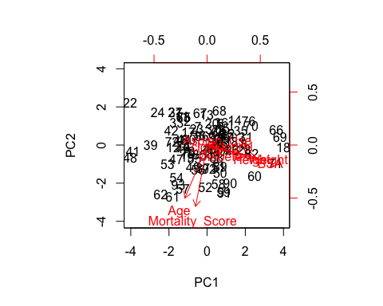

pca1_var = pca1$sdev^2  
pca1_var

## [1] 2.628591224 1.334804309 1.210396600 1.161717171 0.741330504 0.528577440  
## [7] 0.393279336 0.001303416

pca1_explained = pca1_var/sum(pca1_var)  
pca1_explained

## [1] 0.328573903 0.166850539 0.151299575 0.145214646 0.092666313 0.066072180  
## [7] 0.049159917 0.000162927

plot(pca1_explained, xlab = "Principal Component", ylab = "Proportion of Variance Explained", ylim = c(0,1), type = 'b')

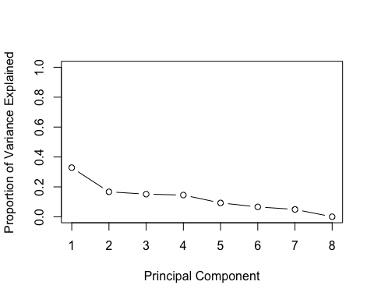

plot(cumsum(pca1_explained), xlab = "Principal Component", ylab = "Cumulative Proportion of Variance Explained", ylim = c(0,1), type = 'b')

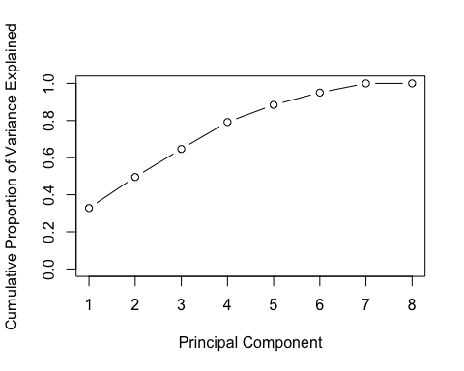

# We find that the mean, median and standard deviations of the variables are varying widely  
# Therefore we must normalize the means  
# If we perform PCA without standardizing then Height would've been the most critical factor  
# Therefore we standardize to make mean 0 and standard deviation 1  
   
  
########################################  
  
# Principal Component Analysis of Age, Weight and Mortality Score  
pcadata <- clopidogrel[c(2, 5, 7)]  
pca2 = prcomp(x = pcadata, scale = TRUE)  
names(pca2)

## [1] "sdev" "rotation" "center" "scale" "x"

pca2$rotation

## PC1 PC2 PC3  
## Mortality_Score 0.6145897 -0.4676600 -0.6352745  
## Age 0.6771320 -0.1003839 0.7289824  
## Weight -0.4046872 -0.8781897 0.2549726

pca2$sdev

## [1] 1.2392212 0.9618151 0.7343313

pca2$x

## PC1 PC2 PC3  
## [1,] -1.21766135 0.64199899 0.174193821  
## [2,] -0.56981890 1.17192654 0.410833889  
## [3,] -0.54770734 0.99055991 0.059148054  
## [4,] -0.58139230 -0.48401025 1.112070858  
## [5,] -1.41646944 -0.01877333 -0.038301917  
## [6,] -0.96692602 0.25602027 0.194313724  
## [7,] -0.34748226 1.07468941 0.190921441  
## [8,] -0.90820259 -0.49246736 0.802127386  
## [9,] -0.26421220 0.37946908 0.783269537  
## [10,] 0.16271062 0.42999094 1.159099703  
## [11,] -0.57803208 1.45030595 -0.308633256  
## [12,] 0.86157237 0.89544865 1.492557598  
## [13,] -1.27689383 0.98484824 -0.642091151  
## [14,] -2.01907072 -0.10015740 -0.561371036  
## [15,] -1.26533761 -0.04117843 0.124402603  
## [16,] -0.83456271 -0.33266546 0.755730686  
## [17,] -0.24351765 0.77474527 0.512306052  
## [18,] -2.39255637 -2.66247863 0.963567614  
## [19,] 1.03866782 0.34966803 1.559074200  
## [20,] -0.92604595 0.64093428 -0.556084554  
## [21,] -0.43511343 1.70628026 -0.865395881  
## [22,] -0.21034173 1.84367706 -0.749088061  
## [23,] -0.37446396 0.78678819 -0.129833261  
## [24,] -0.16124847 1.95021166 -0.780019194  
## [25,] -1.01460227 -0.42715715 0.144522506  
## [26,] -0.43462158 -0.57004483 0.810806150  
## [27,] -0.81630323 -0.17202320 0.148546934  
## [28,] -0.85576630 -1.13358002 0.818222861  
## [29,] -0.51981768 0.29617995 0.090709096  
## [30,] -0.51789164 0.12517550 0.218458055  
## [31,] -1.41312640 -0.76642060 0.008724691  
## [32,] -0.84855400 0.45872728 -0.346983335  
## [33,] -0.20456362 1.33066373 -0.365841184  
## [34,] -0.06449616 0.05796021 0.706571614  
## [35,] -1.79146501 -1.11604623 -0.606507917  
## [36,] -1.35155178 0.01376960 -1.012637071  
## [37,] -0.59060637 1.66505587 -1.492069628  
## [38,] -0.25223987 0.64748631 -0.415632402  
## [39,] 1.17337329 0.88402176 0.282844429  
## [40,] 0.82586845 0.48028846 0.243864441  
## [41,] 2.29723182 1.57100576 0.864383531  
## [42,] 0.31760160 0.95398248 -0.596564862  
## [43,] -0.59447563 -0.67489869 -0.279836824  
## [44,] 0.34214823 1.00724978 -0.612030428  
## [45,] 0.44996491 0.36529675 -0.035147899  
## [46,] 0.05093175 -0.37960507 -0.379417024  
## [47,] 1.42796069 0.15603415 0.558462250  
## [48,] 2.54796716 1.18502705 0.884503435  
## [49,] 1.25177320 -0.28046643 0.202751988  
## [50,] 0.70546028 -1.34497204 -0.048723739  
## [51,] 0.54855035 -0.80955361 -0.594675135  
## [52,] 1.78407764 -1.10653152 0.819244414  
## [53,] 1.67048284 0.04843484 -0.140884992  
## [54,] 2.19944425 -0.02998299 0.428580827  
## [55,] 0.73620113 -0.51067418 -1.646338121  
## [56,] 1.24061591 -0.64235931 -1.061406736  
## [57,] 2.64796959 -0.56646613 0.244253848  
## [58,] 1.17853225 -1.82818788 -0.248516283  
## [59,] 1.52603709 -1.42445459 -0.209536295  
## [60,] 0.14708211 -1.78908936 -1.275164528  
## [61,] 2.97944698 -0.99389358 -1.653365423  
## [62,] 3.25138591 -0.57895773 -1.695737694  
## [63,] -0.62083818 1.23639638 0.314016063  
## [64,] -0.73830224 0.05140818 0.566119462  
## [65,] -0.20934084 -0.02700965 1.135585280  
## [66,] -2.55717045 -1.44304242 -0.093379617  
## [67,] -1.20132791 0.97364569 -0.560738891  
## [68,] -1.60177807 0.80538669 -0.824285665  
## [69,] -2.20388750 -1.55232246 0.328847248  
## [70,] -1.88863344 -0.51783868 -0.127703033  
## [71,] -0.84562708 -1.58296388 1.665438965  
## [72,] 0.95539776 1.04488836 0.966726105  
## [73,] -0.77491412 0.61852918 -0.393380035  
## [74,] 0.83073860 0.94955631 0.916304978  
## [75,] -0.45580799 1.31100407 -0.594432397  
## [76,] -2.04605241 -0.38805862 -0.882125738  
## [77,] 0.08663567 0.03555512 0.869276133  
## [78,] 0.70557039 0.44858589 0.657412541  
## [79,] 0.78498838 0.09537445 0.994262719  
## [80,] 0.32774082 0.50459863 0.250651242  
## [81,] -0.81681227 -0.57766157 -0.059924376  
## [82,] -0.71528273 -1.11223963 -0.074760033  
## [83,] -0.69844025 -0.37495455 -0.601221435  
## [84,] 0.47643758 0.24755961 0.077135493  
## [85,] 0.75608065 -0.02152233 0.545759058  
## [86,] -0.17718299 0.23064539 -0.542751452  
## [87,] 1.10940277 -0.58941676 0.292452272  
## [88,] 0.32428768 -0.54131204 -0.502511646  
## [89,] 0.50138313 -1.08709265 -0.435995043  
## [90,] 1.05002101 -1.58151104 -0.554435328  
## [91,] 1.75466087 -1.62906667 0.162269443  
## [92,] 0.69673806 -1.47223100 -0.976662193  
## [93,] 2.63539529 -0.35171620 -0.939182524

pca2$scale

## Mortality_Score Age Weight   
## 3.107284 8.960813 16.486470

biplot(pca2, scale = 0)

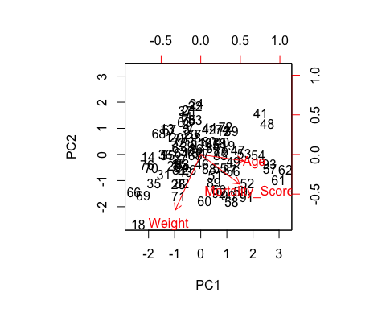

pca2_var = pca2$sdev^2  
pca2_var

## [1] 1.5356691 0.9250884 0.5392425

pca2_explained = pca2_var/sum(pca2_var)  
pca2_explained

## [1] 0.5118897 0.3083628 0.1797475

plot(pca2_explained, xlab = "Principal Component", ylab = "Proportion of Variance Explained", ylim = c(0,1), type = 'b')

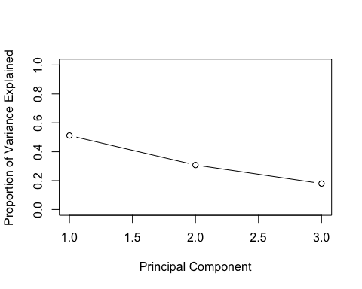

plot(cumsum(pca2_explained), xlab = "Principal Component", ylab = "Cumulative Proportion of Variance Explained", ylim = c(0,1), type = 'b')

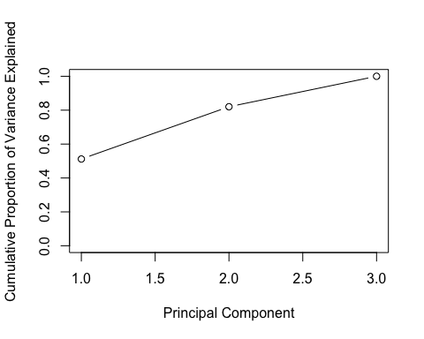

# As you can see there are 3 distinct principal components of the data  
# The rotation matrix gives the coordinates of the data in the rotated system  
# The coordinates are the principal component scores  
#########################################  
  
# SVD Analysis of Age, Weight and Mortality  
#install.packages("ripa")  
#install.packages("rafalib")  
#install.packages("rARPACK")  
#library(ripa)  
#library(rARPACK)  
#library(rafalib)  
  
svddata <- clopidogrel[c(2,5,7)]  
svddata.svd <- svd(svddata)  
u <- svddata.svd$u  
v <- svddata.svd$v  
s <- diag(svddata.svd$d)  
dim(u)

## [1] 93 3

dim(v)

## [1] 3 3

dim(s)

## [1] 3 3

########################################