**Entity Relationship Diagram of the datasets**

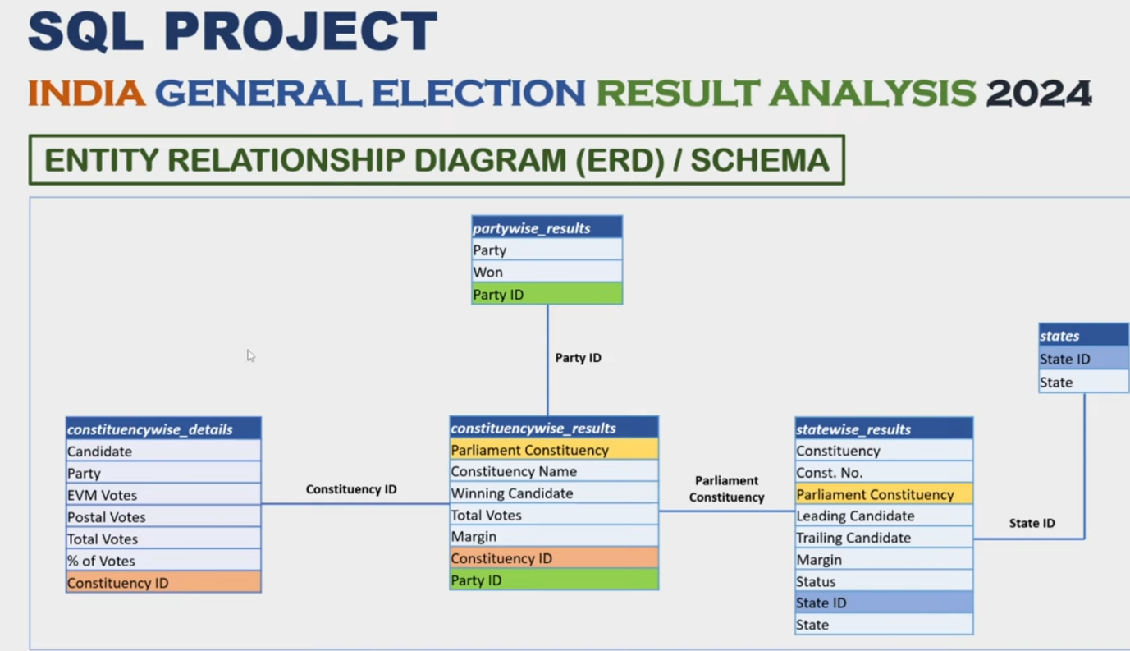

**1)Total seats**

Learning :

Backtick:

When our data set contains spaces

Reserv words

Special charecteristics

What not to do

It will give wrong result when I was using “” and use distinct inside the bracket

1. **Total number of seats available in each sates.**

**3)** **Total seats won by the NDA alliance**

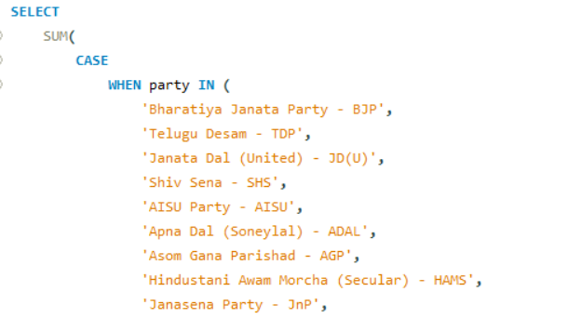

**Note: if there is any chanfe in the spaces in the query ,it will false result**

**4)** **Total seats won by NDA Alliencs parties**

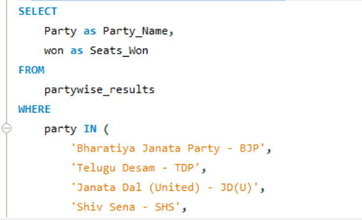

**Learning:**

**Case Statements**

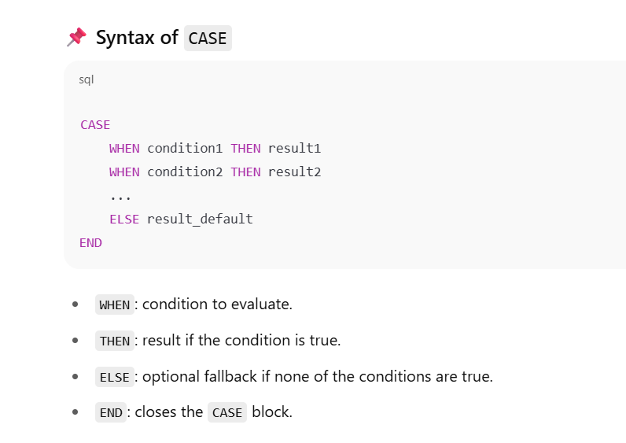

5) **Total seats won by the I.N.D.I.A alliance (Indian National Developmental Inclusive Alliance).**

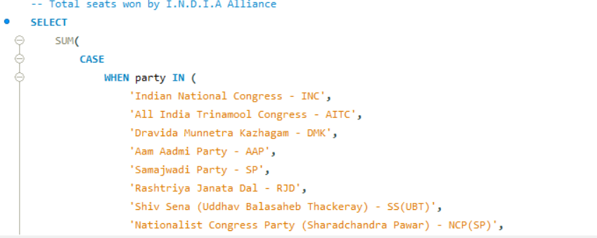

**6)** **seat won bt I.N.D.I.A Allience Parties**

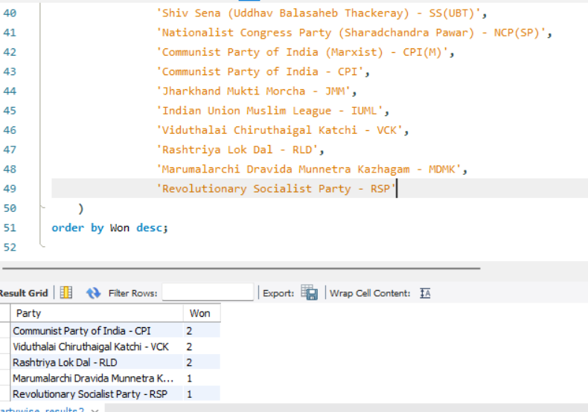

8) Add new column field in table partwise_results to get the party Allience as

as NDA,I.N.D.I. and OTHER

Learning : safe update mode

When your system is not allowed to chafe or update any table

in **MySQL Workbench** when you're in **Safe Update Mode**, which prevents UPDATE queries that **don’t use a key column in the WHERE clause**—to avoid accidental mass updates.

SET SQL_SAFE_UPDATES = 0;

CODE:

alter table partywise_results

add party_alliance varchar(50);

select* from partywise_results;

SET SQL_SAFE_UPDATES = 0;

UPDATE partywise_results

SET party_alliance = 'I.N.D.I.A'

WHERE party IN (

'Indian National Congress - INC',

'Aam Aadmi Party - AAAP',

'All India Trinamool Congress - AITC',

'Bharat Adivasi Party - BHRTADVSIP',

'Communist Party of India (Marxist) - CPI(M)',

'Communist Party of India (Marxist–Leninist) (Liberation) - CPI(ML)(L)',

'Communist Party of India - CPI',

'Dravida Munnetra Kazhagam - DMK',

'Indian Union Muslim League - IUML',

'Jammu & Kashmir National Conference - JKN',

'Jharkhand Mukti Morcha - JMM',

'Kerala Congress - KEC',

'Marumalarchi Dravida Munnetra Kazhagam - MDMK',

'Nationalist Congress Party Sharadchandra Pawar - NCPSP',

'Rashtriya Janata Dal - RJD',

'Rashtriya Loktantrik Party - RLTP',

'Revolutionary Socialist Party - RSP',

'Samajwadi Party - SP',

'Shiv Sena (Uddhav Balasaheb Thackeray) - SHSUBT',

'Viduthalai Chiruthaigal Katchi - VCK'

);

UPDATE partywise_results

SET party_alliance = 'I.N.D.I.A'

WHERE party IN ('Bharatiya Janata Party - BJP',

'Telugu Desam - TDP',

'Janata Dal (United) - JD(U)',

'Shiv Sena - SHS',

'AISU Party - AISU',

'Apna Dal (Soneylal) - ADAL',

'Asom Gana Parishad - AGP',

'Hindustani Awam Morcha (Secular) - HAMS',

'Janasena Party - JnP',

'Janata Dal (Secular) - JD(S)',

'Lok Janshakti Party(Ram Vilas) - LJPRV',

'Nationalist Congress Party - NCP',

'Rashtriya Lok Dal - RLD',

'Sikkim Krantikari Morcha - SKM');

UPDATE partywise_results

SET party_alliance ='OTHER'

WHERE party_alliance IS NULL;

OUTPUT:

9) winning candidate name,their party name ,totl votes and margin of victory for a specific state and constituency?

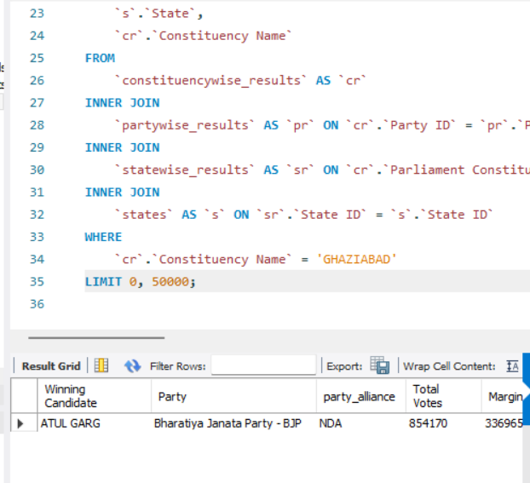

10)what is the distribution of EVM votes versus postal votes for candidates in a specific constituency?

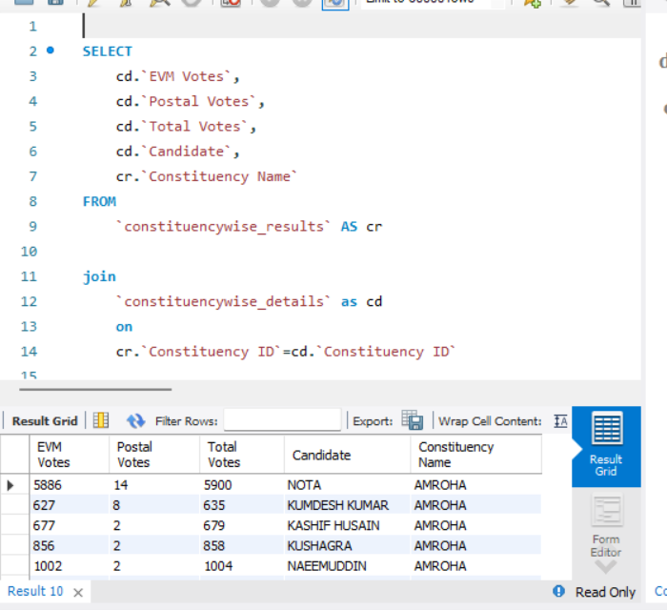

11) -- which party won the most seats in a state ,and how many seats did each party win

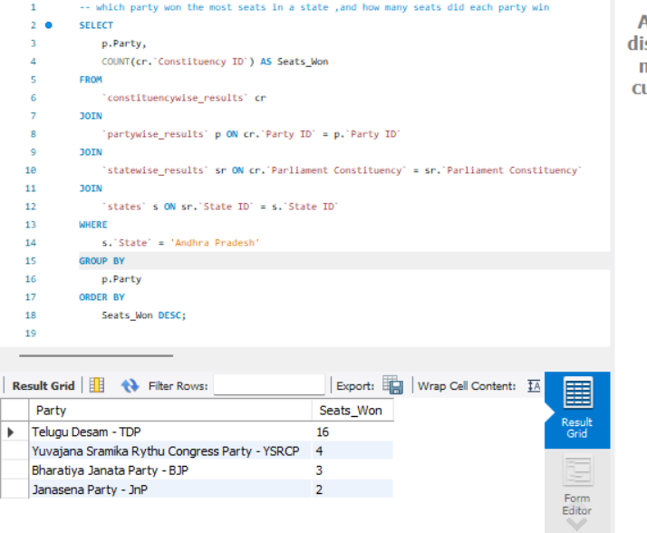

12) /*what is the total number of seats won by each party alliance (NDA,I.N.D.Aand OTHSER)in each stage for the india election 2024 */

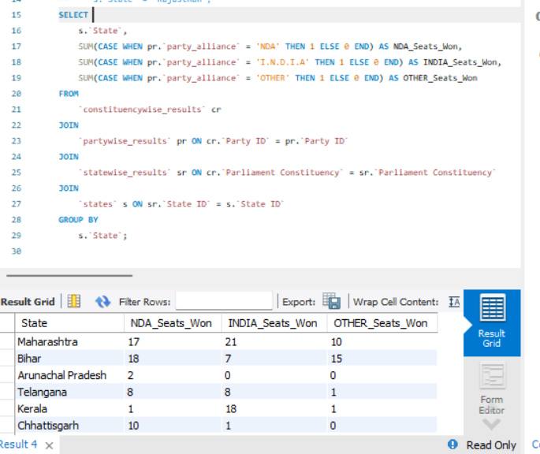

13)which candidate received the highest number of evm votes in each constituency

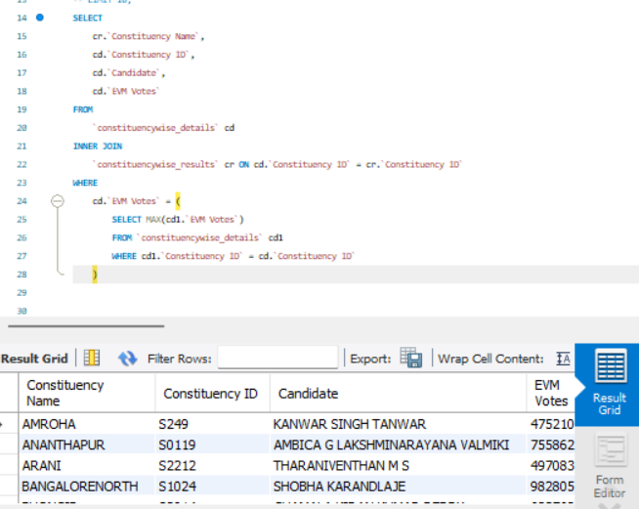

DASHBOARD

ERD:

Data Modeling process is also essential during dashboard preparation

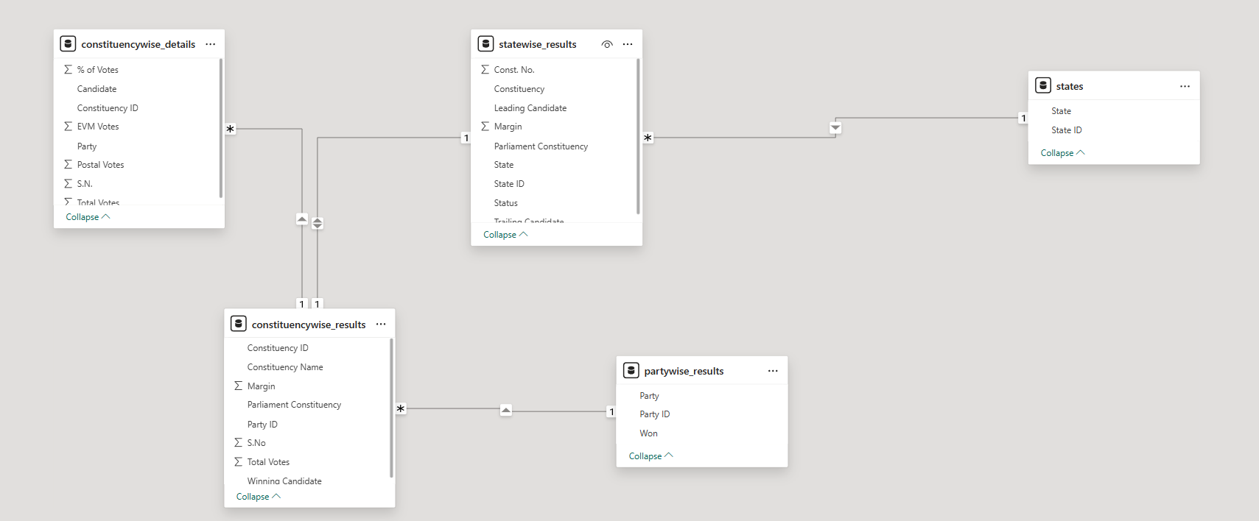

**DASHBOARD 1: OVERVIEW ANALYSIS**

The India General Election Results – 2024 dashboard aims to provide a comprehensive

overview of the election outcomes with a focus on seat distribution among key alliances and

independent candidates. The dashboard will help political analysts, researchers, and the

general public gain insights into the election performance of major political groups.

KPI’s

1. NDA Performance

o Total seats won by the NDA alliance.

o Percentage of total seats secured by NDA.

o Bookmark: A grid matrix details table showing all seats won by the NDA

Alliance.

2. I.N.D.I.A. Performance

o Total seats won by the I.N.D.I.A. alliance.

o Percentage of total seats secured by I.N.D.I.A.

o Bookmark: A grid matrix details table showing all seats won by the I.N.D.I.A.

Alliance.

3. Independent & Other Parties Performance

o Total seats won by independent candidates and smaller parties.

o Percentage of total seats won by this group.

o Bookmark: A grid matrix details table showing all seats won by Independent

and Other Parties.

NDA Alliance Analysis

• Identify all parties within NDA that won seats.

• Display each party's seat count along with their party logos.

I.N.D.I.A. Alliance Analysis

• Identify all parties within I.N.D.I.A. that won seats.

• Display each party's seat count along with their party logos.

**DASHBOARD 2: STATE DEMOGRAPHIC ANALYSIS**

The India General Election Results – 2024 dashboard provides an in-depth state-wise and

constituency-wise analysis of the election outcomes. It offers a geographical breakdown of

seat distributions, winning parties, and candidates, helping analysts, policymakers, and

citizens understand the political landscape at different levels.

1. Total Seats, Alliance with Majority Seats, NDA Seats and I.N.D.I.A. Seats by

State

• Displays Total Seats, Alliance with Majority Seats, NDA Seats, and I.N.D.I.A. Seats at

the state level.

• Visual Representation:

o Map Chart by State

o Tooltip includes Total Seats, Majority Alliance, NDA Seats, and I.N.D.I.A.

Seats per state.

o Drill-through to a grid details table showing all underlying data per state.

2. Winning Candidate & Party by Constituency

• Displays Winning Candidate, Winning Party, Total Votes, and Total Margin per

constituency.

• Visual Representation:

o Bubble Map Chart

o Each Bubbles represent a constituency.

o Color-coded bubbles to distinguish NDA, I.N.D.I.A., and OTHER seats.

o Drill-through to a grid details table showing all underlying constituency data.

3. State with the Maximum Seats won by either the NDA Alliance or the

I.N.D.I.A. Alliance

• Identifies the state where either NDA or I.N.D.I.A. won the most seats.

• Visual Representation:

o State-wise Map Chart

o Color-coded states based on the majority alliance in each state.

o Drill-through to a grid details table showing all underlying seat data for that

state.

**DASHBOARD 3: POLITICAL LANDSCAPE BY STATE**

The State Analysis dashboard provides a state-wise breakdown of the India General Election

2024 results. It enables users to analyze the performance of different political alliances and

parties within a selected state, helping with comparative analysis, decision-making, and

trend identification.

KPI’s

Dynamic Selection: Users can select a specific state from a filter.

• Key Metrics Display:

o Seats won by I.N.D.I.A. Alliance

o Seats won by NDA Alliance

o Seats won by Independent & Other Parties

Charts & Visualizations

1. State Map Chart:

o Displays the selected state with its constituency boundaries.

o Highlights the distribution of seats across constituencies.

2. Party-wise Result (Grid View):

o Displays all parties that won seats in the selected state.

o Includes the alliance affiliation of each party (NDA, I.N.D.I.A., or

Independent).

3. Party-wise Seat Share (Donut Chart):

o Represents the percentage share of total seats won by each party in the

selected state.

o Provides a visual comparison of party dominance within the state.

**DASHBOARD 4: CONSTITUENCY ANALYSIS**

The Constituency Analysis dashboard provides an in-depth analysis of election results for a

selected constituency, allowing users to examine voter turnout, candidate performance, and

seat outcomes. This dashboard helps political analysts, researchers, and citizens gain insights

into the competitive landscape at the constituency level.

KPI’s - Primary (Overall Election Metrics for the Selected Constituency)

• Total Votes cast in the constituency.

• Total EVM Votes recorded.

• Total Postal Votes counted.

• Total Candidates participating in the elections for that constituency.

KPI’s - Secondary (Candidate Performance Overview)

1. Winning Candidate:

o State

o Winning Candidate Name

o Party Name

o Total Votes Secured

o Vote Share (%)

2. Runner-up Candidate:

o State

o Candidate Name

o Party Name

o Total Votes Secured

o Vote Share (%)

3. 2nd Runner-up Candidate:

o State

o Candidate Name

o Party Name

o Total Votes Secured

o Vote Share (%)

**DASHBOARD 5: DETAILS GRID**

The Details Grid dashboard provides a comprehensive tabular view of the election results at

the constituency level. It serves as a data exploration tool, allowing users to drill through

from other dashboards and export election data for further analysis.

Grid View Fields

The grid will display the following fields:

• Constituency Name

• Winning Candidate

• Runner-Up Candidate

• Party Name (Winning Party)

• Party Alliance (NDA, I.N.D.I.A., or Independent)

• EVM Votes (Electronic Voting Machine Votes)

• Postal Votes (Postal Ballots Counted)

• Total Votes (Sum of EVM + Postal Votes)

• Margin (Vote difference between Winner & Runner-Up)

Functionalities

1. Drill-Through Capability

o Users can drill through from other dashboards (State Analysis, Constituency

Analysis, etc.) to view the detailed underlying data for a specific state or

constituency.

2. Data Export Option

o The grid should allow users to export the data as an Excel file for further

external analysis.

3. Show All Data Button (Using Bookmark)

o A button will be provided to refresh the grid and display all relevant data

after filters are applied and drill-through actions are performed.

**DASHBOARD 6: LANDING PAGE**

The Landing Page serves as the central navigation hub for the India General Election Results

2024 dashboard. It allows users to seamlessly navigate between different analytical

dashboards and ensures a user-friendly experience with easy access to all key insights.

1. Dashboard Navigation Menu

The landing page will provide clickable buttons/cards to navigate to the following

dashboards:

• Overview Analysis

• State Demographics

• Political Landscape by State

• Constituency Analysis

Each button will be designed to provide quick access to the respective dashboard with a

clear label and relevant icon.

2. Home Button on Each Dashboard

• Each dashboard will include a Home Button that allows users to quickly return to the

Landing Page with a single click.

3. Interactive UI Elements

• Minimalist & Clean Design for easy readability.

• Icons & Color Coding for better visualization and quick recognition.

• Hover Effects to highlight active selections.

4. Responsive Layout

• The landing page will be optimized for different screen sizes, ensuring a smooth

experience on desktops, tablets, and large screens.

DAX PERDORMED

In partywise result columns

1) Party Alliance =

IF(

partywise_results[Party] = "Bharatiya Janata Party - BJP" ||

partywise_results[Party] = "Telugu Desam - TDP" ||

partywise_results[Party] = "Janata Dal (United) - JD(U)" ||

partywise_results[Party] = "Shiv Sena - SHS" ||

partywise_results[Party] = "AJSU Party - AJSUP" ||

partywise_results[Party] = "Apna Dal (Soneylal) - ADAL" ||

partywise_results[Party] = "Asom Gana Parishad - AGP" ||

partywise_results[Party] = "Hindustani Awam Morcha (Secular) - HAMS" ||

partywise_results[Party] = "Janasena Party - JnP" ||

partywise_results[Party] = "Janata Dal (Secular) - JD(S)" ||

partywise_results[Party] = "Lok Janshakti Party(Ram Vilas) - LJPRV" ||

partywise_results[Party] = "Nationalist Congress Party - NCP" ||

partywise_results[Party]= "Rashtriya Lok Dal - RLD" ||

partywise_results[Party] = "Sikkim Krantikari Morcha - SKM",

"NDA",

IF(

partywise_results[Party] = "Indian National Congress - INC" ||

partywise_results[Party] = "Aam Aadmi Party - AAAP" ||

partywise_results[Party] = "All India Trinamool Congress - AITC" ||

partywise_results[Party] = "Bharat Adivasi Party - BHRTADVSIP" ||

partywise_results[Party]= "Communist Party of India (Marxist) - CPI(M)" ||

partywise_results[Party] = "Communist Party of India (Marxist-Leninist) (Liberation) - CPI(ML)(L)" ||

partywise_results[Party] = "Communist Party of India - CPI" ||

partywise_results[Party] = "Dravida Munnetra Kazhagam - DMK" ||

partywise_results[Party] = "Indian Union Muslim League - IUML" ||

partywise_results[Party] = "Jammu & Kashmir National Conference - JKN" ||

partywise_results[Party] = "Jharkhand Mukti Morcha - JMM" ||

partywise_results[Party] = "Kerala Congress - KEC" ||

partywise_results[Party] = "Marumalarchi Dravida Munnetra Kazhagam - MDMK" ||

partywise_results[Party] = "Nationalist Congress Party Sharadchandra Pawar - NCPSP" ||

partywise_results[Party] = "Rashtriya Janata Dal - RJD" ||

partywise_results[Party] = "Rashtriya Loktantrik Party - RLTP" ||

partywise_results[Party] = "Revolutionary Socialist Party - RSP" ||

partywise_results[Party] = "Samajwadi Party - SP" ||

partywise_results[Party] = "Shiv Sena (Uddhav Balasaheb Thackrey) - SHSUBT" ||

partywise_results[Party] = "Viduthalai Chiruthaigal Katchi - VCK",

"I.N.D.I.A.",

"OTHER"

)

)

1. Sum of won
2. NDA Seats = CALCULATE([Total Seats],partywise_results[Party Alliance]="NDA" )
3. % OF NDA SEATS