

**UNIVERSITY OF PETROLEUM & ENERGY STUDIES**

**SCHOOL OF COMPUTER SCIENCE**

***Department of Cybernetics***

**GRAPHICS AND ANIMATIONS TOOLS**

LAB FILE

SESSION (2020-21)

Course: B.Tech with specialization in Open Source & Open Standards

Submitted to: Submitted by:

Dr. Durgansh Sharma Amrit Kumar

Associate Professor SAP: 500062268

Department of Cybernetics Roll no: R100217007

**Project**

**AIM-** Design of Mountain using Blender

1. Open up Blender and delete everything if you want.
2. We need to use a plugin that will generate mountains and trees for us. So go to File -> User Preferences -> Add-ons.
3. Look for (or type in) the addon ‘ANT Landscape’. Enable by checking the box on the right (near the scared-looking human figure).
4. Close the User Preferences window.
5. Make a house by some cubes add some textures on it
6. For the road asphalt add road image texture on plane
7. Make a sun by using the sphere and emission and give it toIt to red color
8. Turn on bloom and reflection
9. And the tree using tree spline curve in the blender add-ons
10. Render image

**Steps Previews:**

**Shading:**

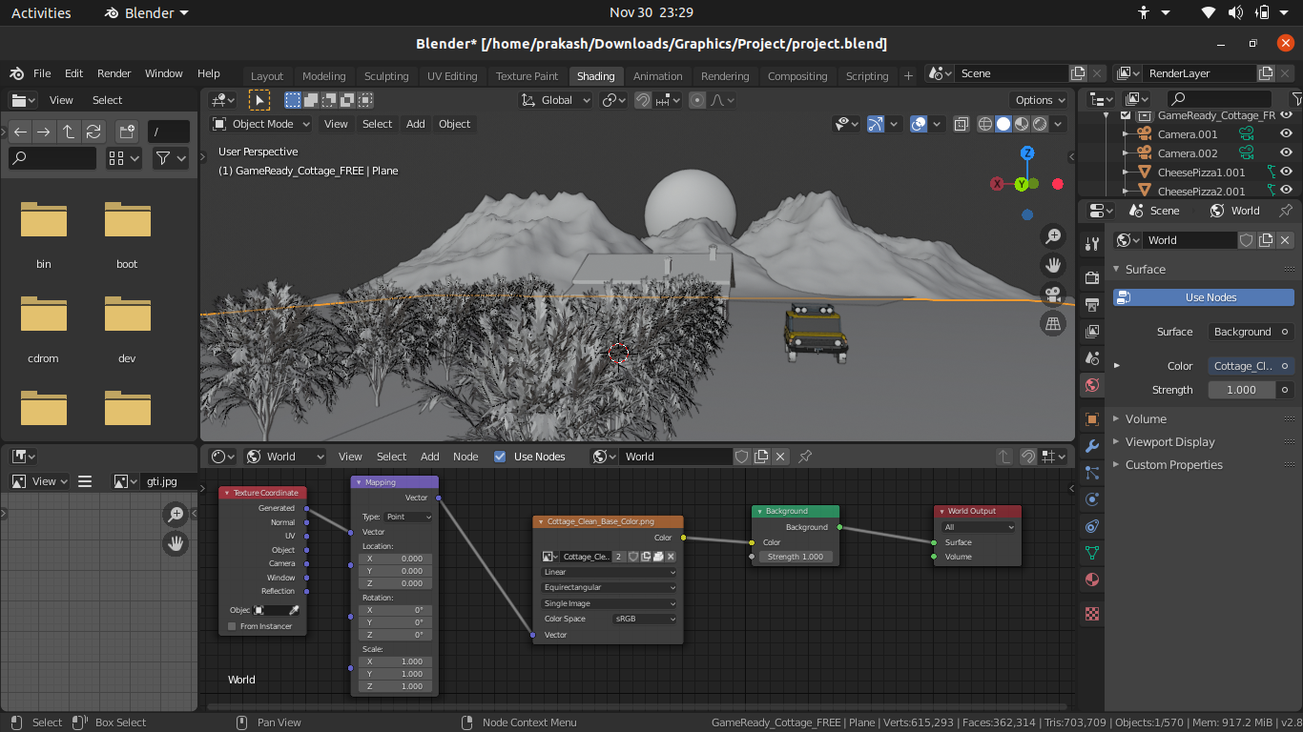

**Sculpting:**

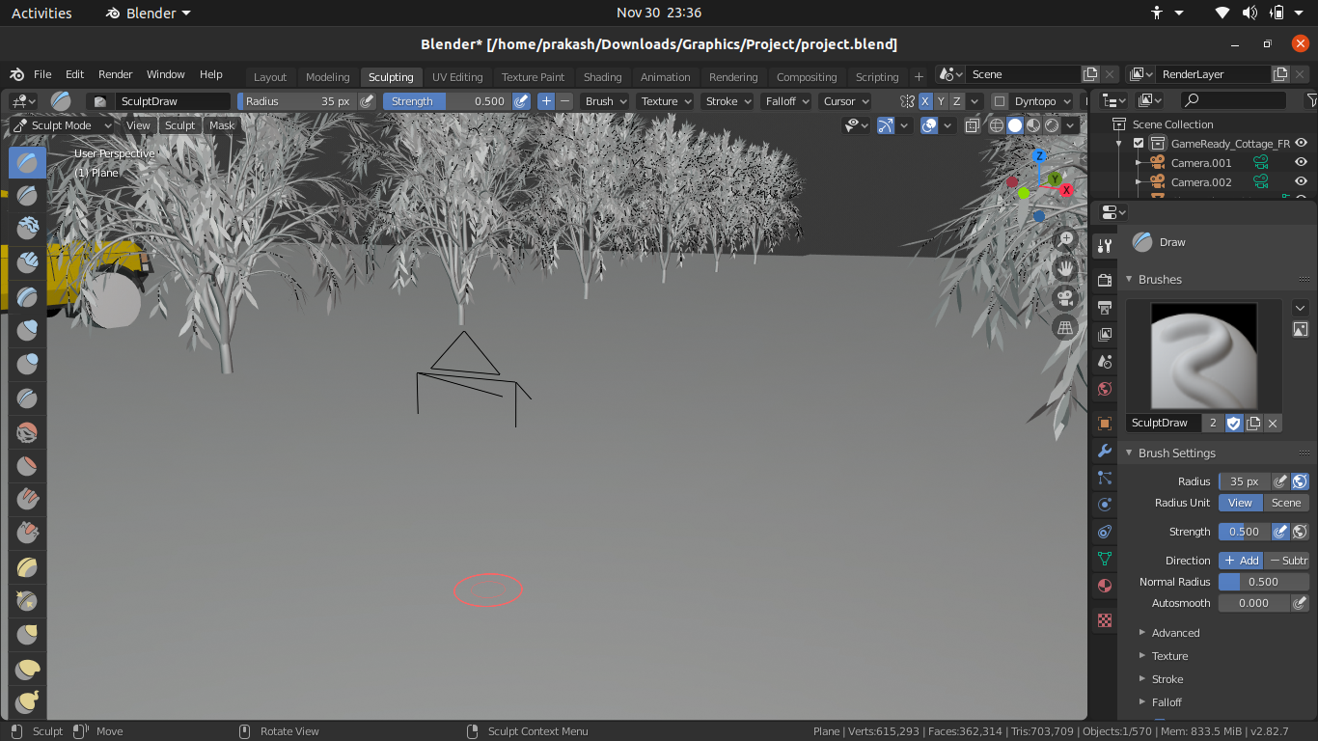

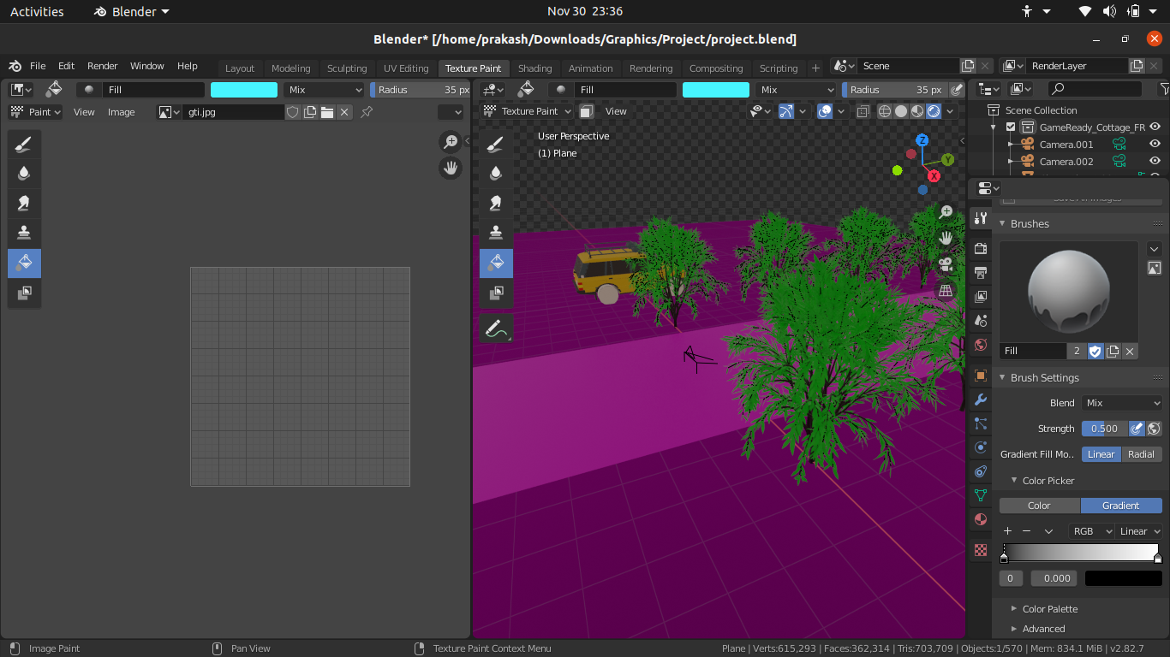**Final Output:**



