**GIT/Github    
Documentation :** [**https://www.atlassian.com/git/tutorials**](https://www.atlassian.com/git/tutorials)

Step 1 : **Install git for mac and windows**

Follow the link below to download git for mac and windows

Mac : <https://git-scm.com/download/mac>

Windows : <https://git-scm.com/download/win>

Once installed please test the following command in the terminal(mac) and git bash(windows)

* git  – version (two dashes - - )

Step 2 : **Create an account on github**

 To create an account on github use your email address and choose a unique username to create an account.

Step 3: **Create Repository on github**

  Create repositories

At the bottom of the page click on Create repository and it you will see the following page here.

echo "# pragra" >> README.md

git init

git add README.md

git commit -m "first commit"

git branch -M main

git remote add origin https://github.com/Surinderpragra/pragra.git

git push -u origin main

Step 4: Once you have create a repository, go to mac terminal or windows git bash or open intellij terminal for connecting local git to github

Commands :

* If you are connecting the github to local git for the first time, add the username and email with the following commands
* **NOTE** : Use your own username and email
* **git config --global user.name "pragra"**
* **git config --global user.email pragra**[**@gmail.com**](mailto:bugs@gmail.com)
* **git init** →  to initialize the git repository on local machine
* **git add .** → to add the git files to the staging area
* **git add file_name**  → to just add one file
* **git commit -m “add you message inside these quotes”**
* **git remote add origin** [**https://github.com/Surinderpragra/pragra.git**](https://github.com/Surinderpragra/pragra.git)
* git push -u origin main   → this will push your local code/files to the remote(github account)

Now you will get a prompt to either login to github via username or password. If it asks for any login please add.   
Otherwise create a token from the link below

<https://github.com/settings/tokens>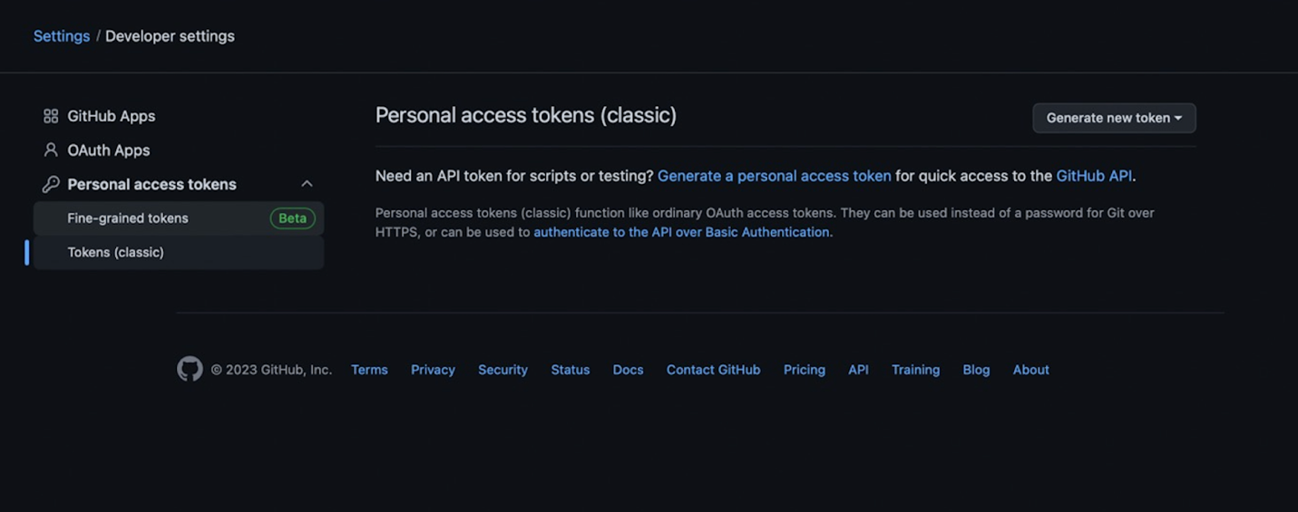  
  
**Git Branching**

**Git stages**

========================================================================**Git commands:**

Git –help

Configure git :

Git config  - -global user.name “surinder”

Git config  - -global user.email [surinder032@gmail.com](mailto:surinder032@gmail.com)

Git config - -global color.ui auto

* git config -l   → to check the configuration
* git rm --cached index.html  → to untrack a file from git
* git rm --cached . -r   → for all files
* Git add -A → to add all the files even outside of current directory
* Git commit -m “added javascript code”
* Git log → to check the commit hash
* Git show 43a847a096ccc636a0289bd84d32780821f9aa40
* Git diff → to see the difference
* git commit --amend -m "added console log in index.js" → to make changes to current log message
* Git pull

Branch

* Git branch -r → to check the branch on remote
* Git branch -a → to check all the branches local and remote
* Git branch feature-a
* Git checkout -b feature-b → to create and checkout at the same time

**Merge branches**

If you want to merge branch A into Branch B

* Git checkout branch B
* Git merge A

===============

Branches

main/ master    – restricted (no one can directly push to this branch )

1. Develop
2. Staging

— > feature branch —>

Task 123 :

Create a branch called feature-task123

Feature1

Feature2

Feature3

  → master