Measure type: Female Doctor: self
Sample ID: 16492 Date: 2024-10-14
P.arameter: Result: Limit:
WBC: + 13.39 10"9 /1 r4.oo - 11.001 "'8C -
LYM: + 5.89 10"9 /1 J0.80 - 4 .001
MIO: |  | 0.45 | 10"911 | ro.10 - o.901
GRA: | + | 7.05 | 10"9 /I | (2.00 - 7.001
LYM%:+ |  | 44.00 | % | (20.0 - 40.01
MIO%: |  | 3.40 | % | (3.0 - 9.01
GRA%: |  | 52.60 | % | (40.0 - 70.01

RSC: | 4.97 | 10"12 II | (3.50 - 5.501
HGB: | 12.00 | All | r10 - 131
HCT: 44.44 % (37.00 - 54.0C:
MCV: 89.00 fl rao - 1001
MCH: - 25.70 PA (27 - 34]
MCHC: - 28.80 All (32 - 361
RDWs: 40.80 fl f35.0 - 56.01
14.40 %
'
.
' WUI | 'IIJQ | - mo
21 | 1<I llll | I'-3 1 t

,me lmfrlllT1tm

4!YJ t

RDWcv:
(11.0 - 16.01 ^{AM1}
31.llf

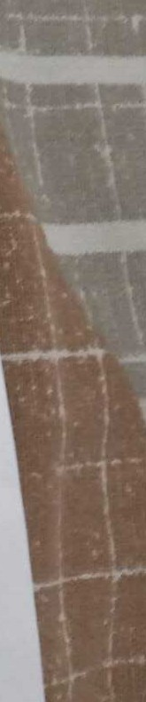
P,LT: 382.00 10A011 r1so - 4so1 PLT hll tJt,IWII
PCT: + 0.31 % ro.1a - o.2a1
MPV: 8.00 fl rB.s - 12.01
P,DWs: - 10.40 fl rJs.o - sa.01
P,DWcv:+ .. .. .
39.40 o/o r11.0-16.0l • -.--r ..-
PM2

SO I

