**Amrit Pandey**

**207907**

**MCA, SEM II, YEAR II**

**Knowledge Engineering Lab**

**Solution 1**

**Star Schema for the Data Warehouse:**

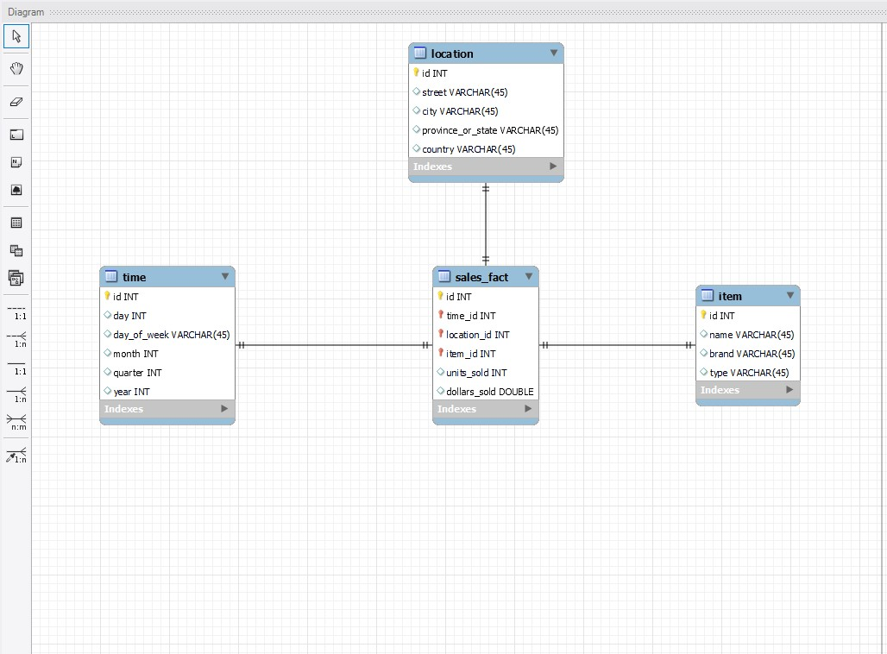

1. **“Compute the sum of sales, grouping by city and item.**

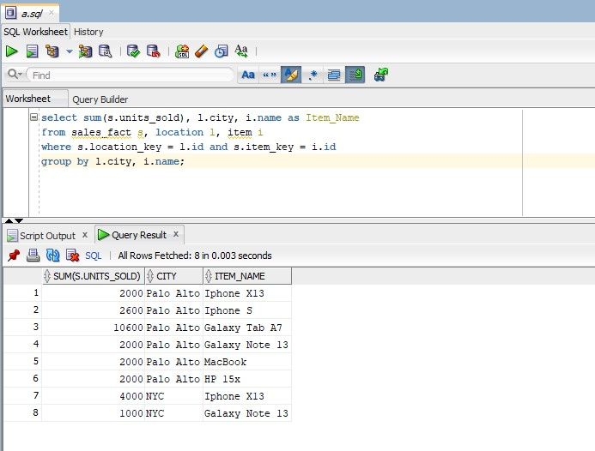

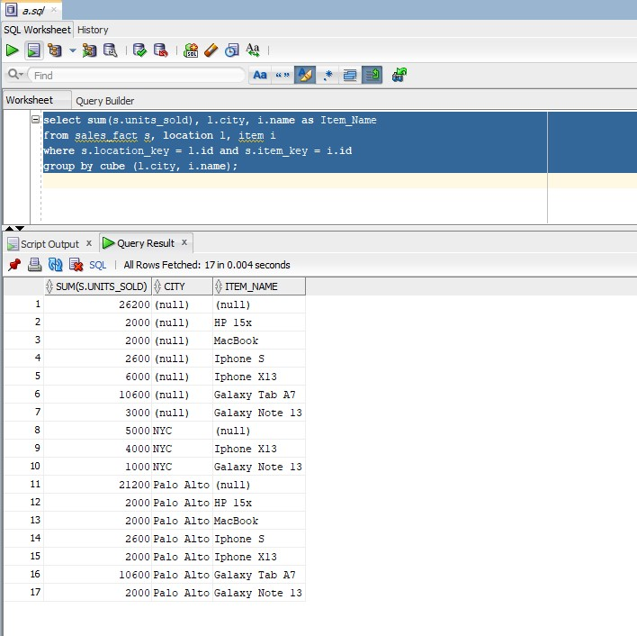

1. **“Compute the sum of sales, grouping by city.**

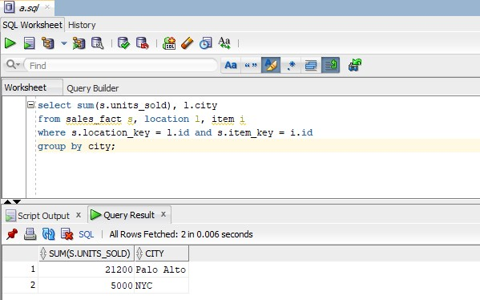

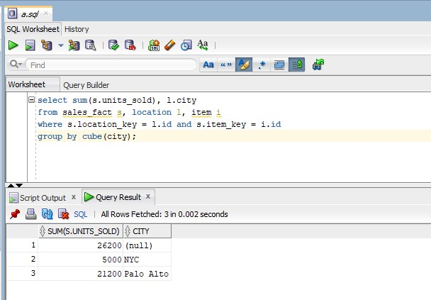

1. **“Compute the sum of sales, grouping by item.**

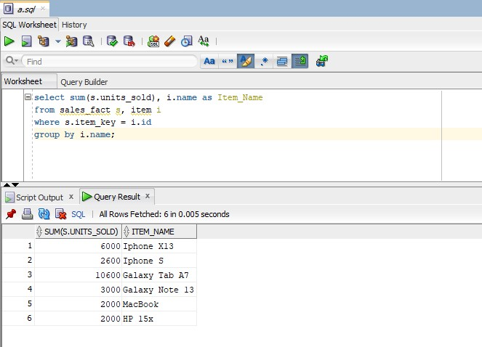

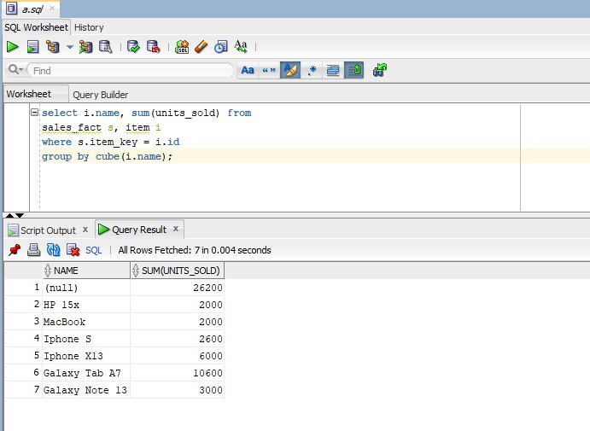

1. **What is the maximum number of cells in base cuboid?**

**Ans:** Maximum number of cells in base cuboid =

Values of Date * Values of Game * Values of Spectator * Values of Location

= (30 * 12 * 10) * (1) * (3) * (2) [assuming on 10 years in date]

= 21,600

1. **What is the minimum number of cells in base cuboid?**

**Ans:** Minimum number of cells in base cuboid =

= Maximum(Values of Date, Values of Game, Values of Spectator, Values of Location)

= Maximum((30 * 12 * 10), 1, 3, 2))

= 3600

i.e. atleast 3600 tuples are needed to store all distinct values of date.

**Solution 2**

1. **And implement that operation using OLAP query language.**

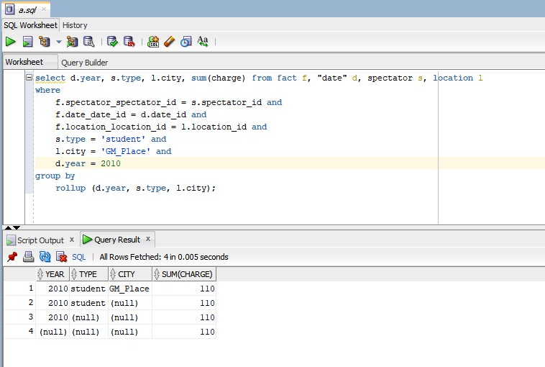

1. **Perform rollup operation from date to year**

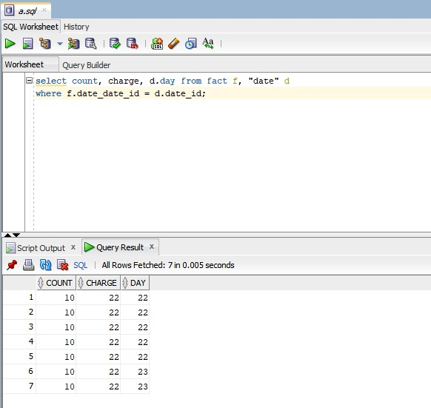

**After rollup:** 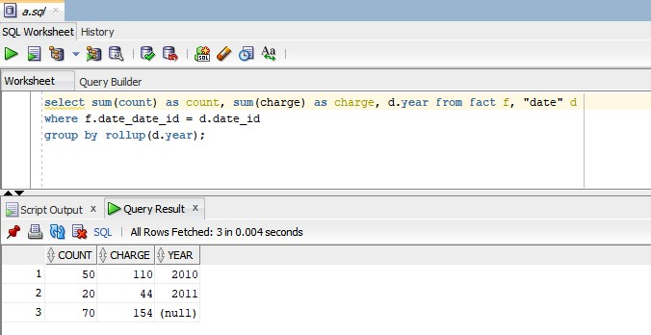

1. **What is the average charge paid by students, adults and seniors in each category you need to compute average?**

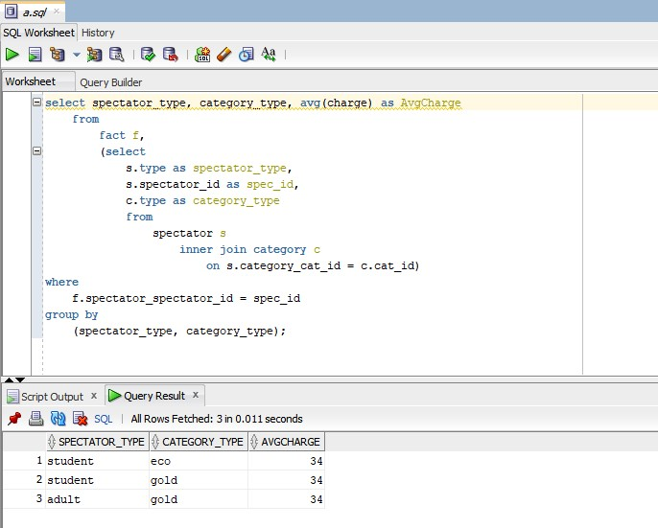

1. **Draw the snowflake schema diagram for the data warehouse.**

