Name:-Amrit Ranjan

Reg No:-21BCE1847

Cryptography And Network Security

Assignment 6

Faculty Name:-Dr Tapabarta Roy

RSA Digital Signature Algorithm and RSA Encryption algorithm



Ques:-Construct a RSA Digital Signature Algorithm as well as RSA Encryption algorithm between two entities choosing separate sets of parameters for each of them to ensure confidentiality and authenticity .

Code:-

pip install pycryptodome

pip install pycryptodomex

import random

def gcd(a, b):

    while b:

        a, b = b, a % b

    return a

def mod_inverse(a, m):

    m0, x0, x1 = m, 0, 1

    while a > 1:

        q = a // m

        m, a = a % m, m

        x0, x1 = x1 - q * x0, x0

    return x1 + m0 if x1 < 0 else x1

def mod_exp(base, exp, mod):

    result = 1

    while exp > 0:

        if exp % 2 == 1:

            result = (result * base) % mod

        base = (base * base) % mod

        exp //= 2

    return result

def generate_keypair(bits):

    # Step 1: Choose two large prime numbers, p and q

    p = generate_prime(bits)

    q = generate_prime(bits)

    # Step 2: Compute n = pq and Euler's totient function phi(n)

    n = p * q

    phi_n = (p - 1) * (q - 1)

    # Step 3: Choose e such that 1 < e < phi_n and gcd(e, phi_n) = 1

    e = random.randrange(2, phi_n)

    while gcd(e, phi_n) != 1:

        e = random.randrange(2, phi_n)

    # Step 4: Compute d, the modular multiplicative inverse of e (mod phi_n)

    d = mod_inverse(e, phi_n)

    return ((n, e), (n, d))

def generate_prime(bits):

    candidate = random.getrandbits(bits)

    while not is_prime(candidate):

        candidate = random.getrandbits(bits)

    return candidate

def is_prime(n, k=5):

    if n <= 1:

        return False

    if n <= 3:

        return True

    if n % 2 == 0:

        return False

    # Write n-1 as 2^r * d

    r, d = 0, n - 1

    while d % 2 == 0:

        r += 1

        d //= 2

    # Witness loop

    for _ in range(k):

        a = random.randint(2, n - 2)

        x = mod_exp(a, d, n)

        if x == 1 or x == n - 1:

            continue

        for _ in range(r - 1):

            x = mod_exp(x, 2, n)

            if x == n - 1:

                break

        else:

            return False  # n is composite

    return True  # n is probably prime

def sign_message(message, private_key):

    n, d = private_key

    signature = [mod_exp(ord(char), d, n) for char in message]

    return signature

def verify_signature(message, signature, public_key):

    n, e = public_key

    expected_message = ''.join([chr(mod_exp(char, e, n)) for char in signature])

    return message == expected_message

def encrypt_message(message, public_key):

    n, e = public_key

    cipher_text = [mod_exp(ord(char), e, n) for char in message]

    return cipher_text

def decrypt_message(cipher_text, private_key):

    n, d = private_key

    plain_text = ''.join([chr(mod_exp(char, d, n)) for char in cipher_text])

    return plain_text

# Example usage

message = "Hello, Entity B!"

public_key_A, private_key_A = generate_keypair(256)

public_key_B, private_key_B = generate_keypair(256)

# Entity A signs and encrypts the message

signature_A = sign_message(message, private_key_A)

encrypted_message = encrypt_message(message, public_key_B)

# Entity B verifies the signature and decrypts the message

is_signature_valid = verify_signature(message, signature_A, public_key_A)

decrypted_message = decrypt_message(encrypted_message, private_key_B)

# Display results

print(f"Original message: {message}")

print(f"Signature verification: {is_signature_valid}")

print(f"Encrypted message: {encrypted_message}")

print(f"Decrypted message: {decrypted_message}")

Using Python Library

from Crypto.PublicKey import RSA

from Crypto.Signature import pkcs1_15

from Crypto.Hash import SHA256

from Crypto.Cipher import PKCS1_OAEP

import base64

# Generate keys for Entity A (sender)

key_A = RSA.generate(2048)

private_key_A = key_A.export_key()

public_key_A = key_A.publickey().export_key()

# Generate keys for Entity B (receiver)

key_B = RSA.generate(2048)

private_key_B = key_B.export_key()

public_key_B = key_B.publickey().export_key()

# Entity A signs a message

def sign_message(message, private_key):

    hash_value = SHA256.new(message.encode())

    signer = pkcs1_15.new(RSA.import_key(private_key))

    signature = signer.sign(hash_value)

    return signature

# Entity B verifies the signature

def verify_signature(message, signature, public_key):

    hash_value = SHA256.new(message.encode())

    verifier = pkcs1_15.new(RSA.import_key(public_key))

    try:

        pkcs1_15.new(RSA.import_key(public_key)).verify(hash_value, signature)

        return True

    except (ValueError, TypeError):

        return False

# Entity A encrypts a message for Entity B

def encrypt_message(message, public_key):

    cipher = PKCS1_OAEP.new(RSA.import_key(public_key))

    ciphertext = cipher.encrypt(message.encode())

    return base64.b64encode(ciphertext).decode()

# Entity B decrypts the message from Entity A

def decrypt_message(ciphertext, private_key):

    cipher = PKCS1_OAEP.new(RSA.import_key(private_key))

    ciphertext = base64.b64decode(ciphertext)

    decrypted_message = cipher.decrypt(ciphertext).decode()

    return decrypted_message

# Example usage

message = "Hello, Entity B!"

# Entity A signs and encrypts the message

signature = sign_message(message, private_key_A)

encrypted_message = encrypt_message(message, public_key_B)

# Entity B verifies the signature and decrypts the message

is_signature_valid = verify_signature(message, signature, public_key_A)

decrypted_message = decrypt_message(encrypted_message, private_key_B)

# Display results

print(f"Signature verification: {is_signature_valid}")

print(f"Encrypted message: {encrypted_message}")

print(f"Decrypted message: {decrypted_message}")

Output ScreenShots:-

ScreenShots Without Using Python Library

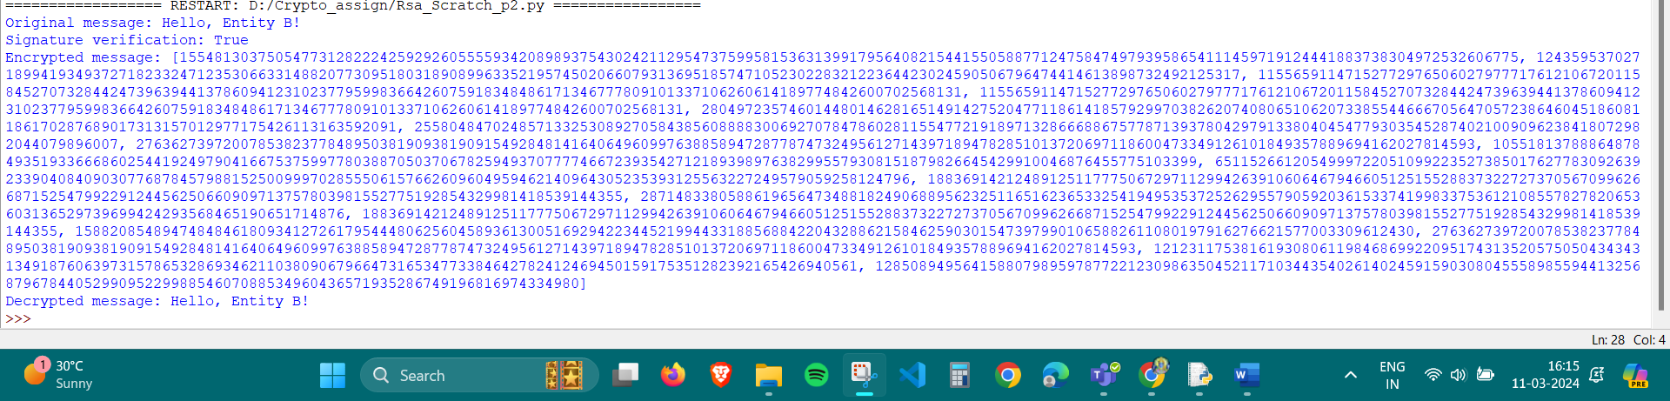

Using Python Library

