LAB – 03
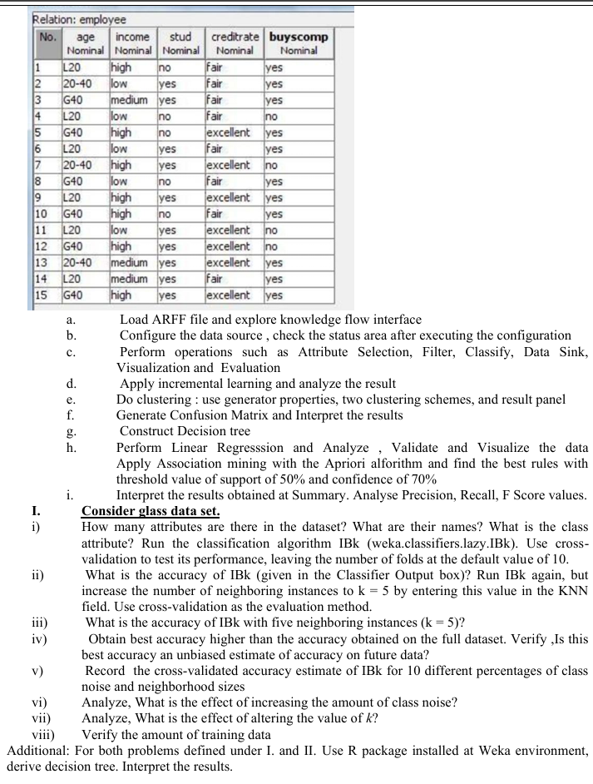
Consider the following dataset

Part 1: Data Creation (The ARFF File)
First, you need to create the dataset file in the correct format for Weka, which is called ARFF (Attribute-Relation File Format).
- Open a plain text editor (like Notepad on Windows or TextEdit on Mac).
- Copy and paste the entire block of code below into the text editor. This code defines the attributes (columns) and then lists the data rows from your first image.
- Save the file with the name buyscomp.arff. Make sure the file extension is .arff and not .txt.
Code snippet
@relation buys_computer
@attribute age {youth, middle_aged, senior}
@attribute income {high, medium, low}
@attribute stud {yes, no}
@attribute creditrate {fair, excellent}
@attribute buyscomp {yes, no}

@data
youth,high,no,fair,no
youth,high,no,excellent,no
middle_aged,high,no,fair,yes
senior,medium,no,fair,yes
senior,low,yes,fair,yes
senior,low,yes,excellent,no
middle_aged,low,yes,excellent,yes
youth,medium,no,fair,no
youth,low,yes,fair,yes
senior,medium,yes,fair,yes
youth,medium,yes,excellent,yes
middle_aged,medium,no,excellent,yes
middle_aged,high,yes,fair,yes
senior,medium,no,excellent,no

Part 2: Building the Knowledge Flow
Step 1: Load the Data
- Open the Knowledge Flow in Weka.
- From the DataSources tab on the left, right-click and place an ArffLoader component onto the canvas.
- Configure it: Right-click the ArffLoader and select "Configure...". Click "Browse..." and select the buyscomp.arff file you just created. Click "OK".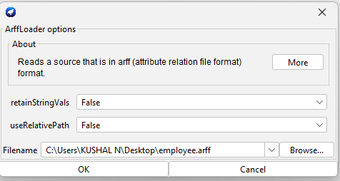
Step 2: Assign the Class Attribute
- From the Evaluation tab, place a ClassAssigner on the canvas.
- Connect it: Right-click the ArffLoader, select connection point -> dataSet, and drag the line to the dataSet input of the ClassAssigner.
- Configure it: Right-click the ClassAssigner, select "Configure...", and make sure the class attribute is set to buyscomp (nominal). Click "OK". This tells Weka which attribute you want to predict.
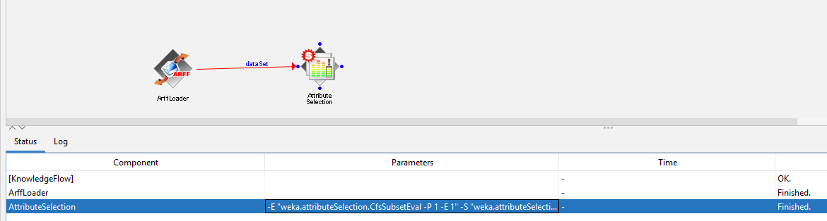
Step 3: Set up Cross-Validation
- From the Evaluation tab, place a CrossValidationFoldMaker on the canvas.
- Connect it: Connect the dataSet output of the ClassAssigner to the dataSet input of the CrossValidationFoldMaker.
- Configure it: By default, it's set to 10 folds, which is what the questions ask for. You don't need to change anything.
Step 4: Add the Classifiers
- From the Classifiers -> functions tab, place a Logistic classifier on the canvas.
- From the Classifiers -> trees tab, place a RandomForest classifier on the canvas.
- Connect them:
  - Connect the trainingSet output from CrossValidationFoldMaker to the trainingSet input of both Logistic and RandomForest.
  - Connect the testSet output from CrossValidationFoldMaker to the testSet input of both Logistic and RandomForest.
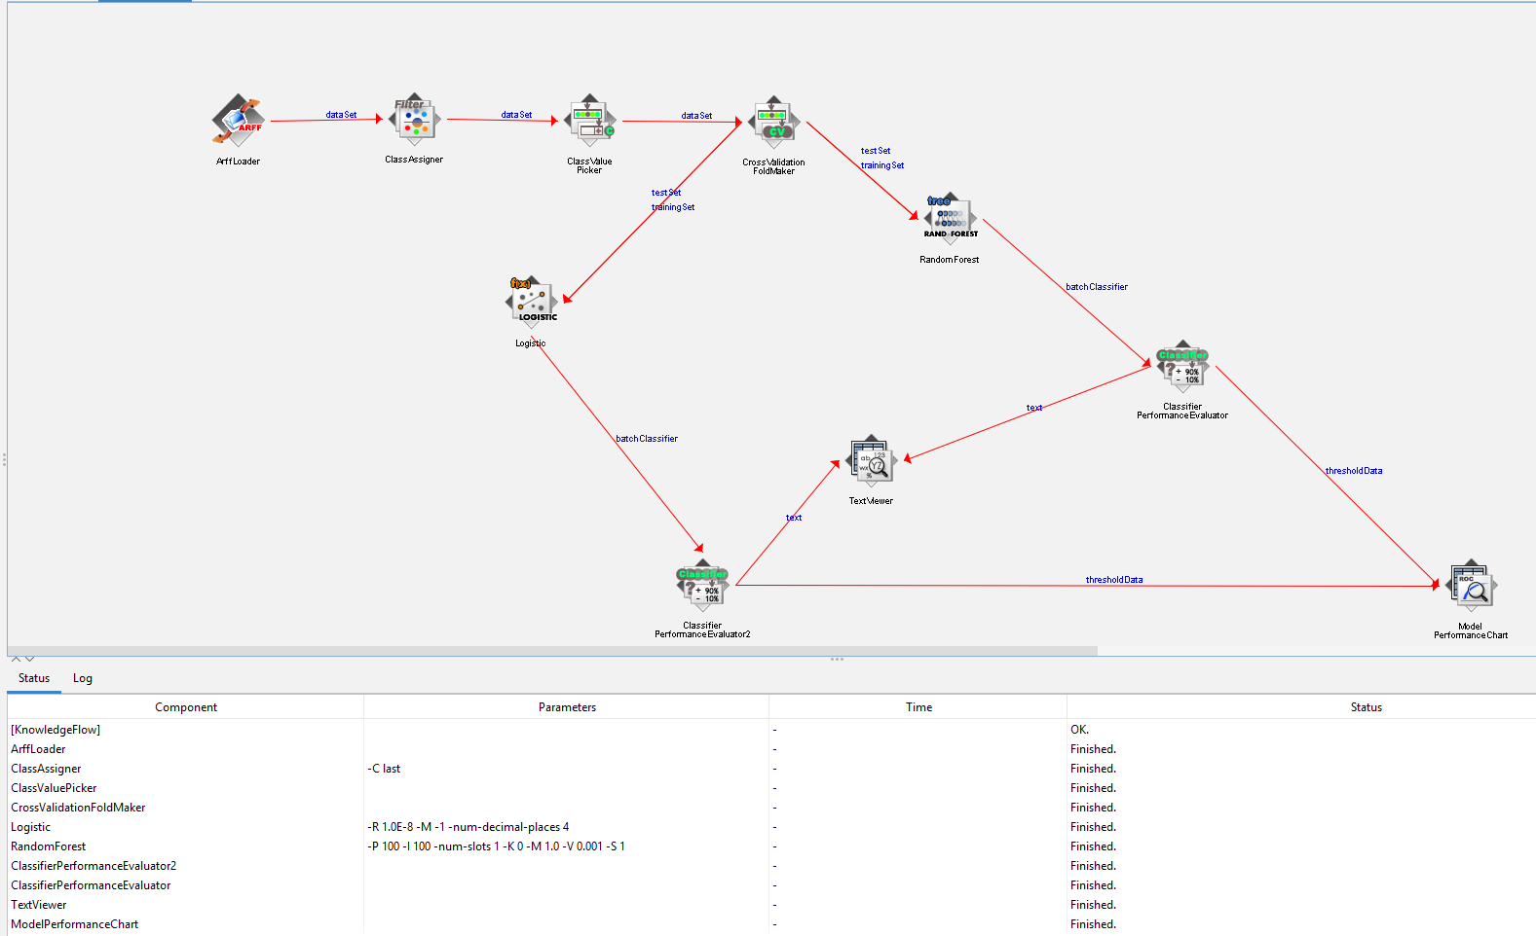

Step 5: Add Performance Evaluators
- From the Evaluation tab, place two ClassifierPerformanceEvaluator components on the canvas.
- Connect them:
  - Connect the batchClassifier output from Logistic to the input of the first evaluator.
  - Connect the batchClassifier output from RandomForest to the input of the second evaluator.

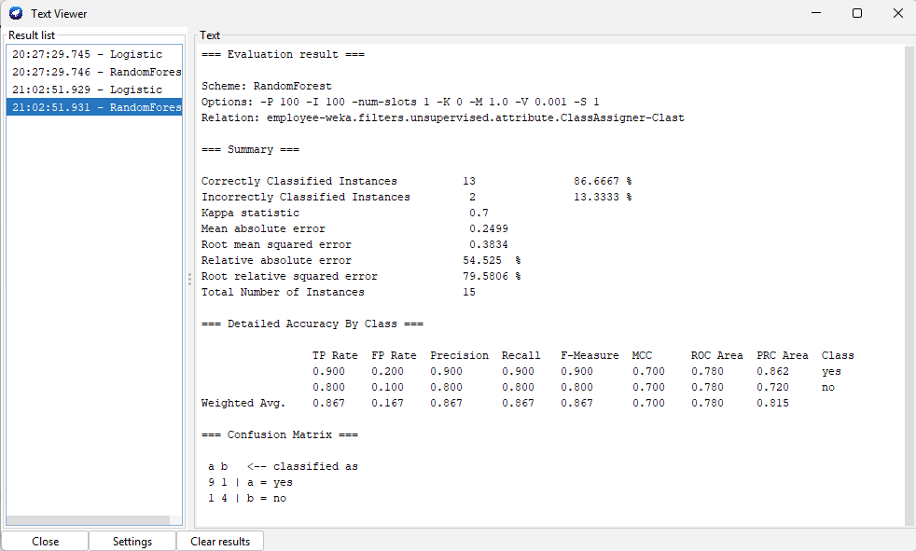
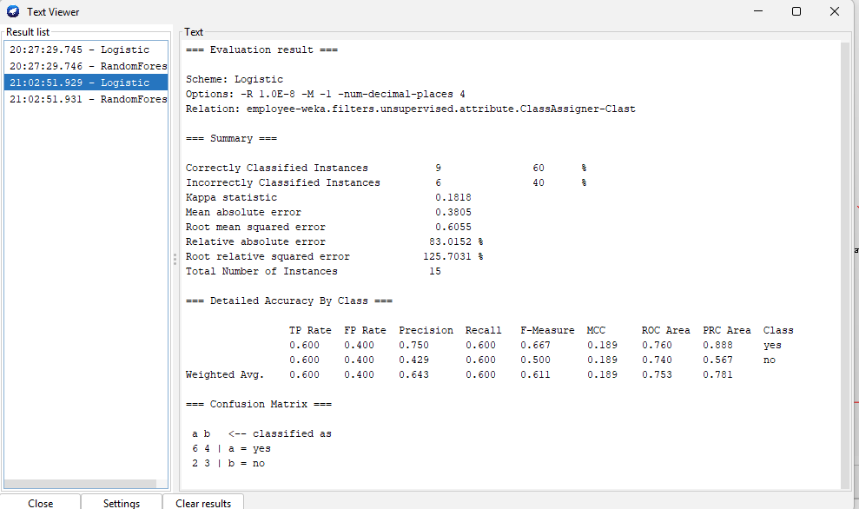

Step 6: Add Visualization
- From the Visualization tab, place a ModelPerformanceChart on the canvas.
- Connect it:
  - Connect the visualizable Error output from the first evaluator (for Logistic) to the visualizable Error input of the chart.
  - Connect the visualizable Error output from the second evaluator (for RandomForest) to the visualizable Error input of the chart. This allows you to compare models.

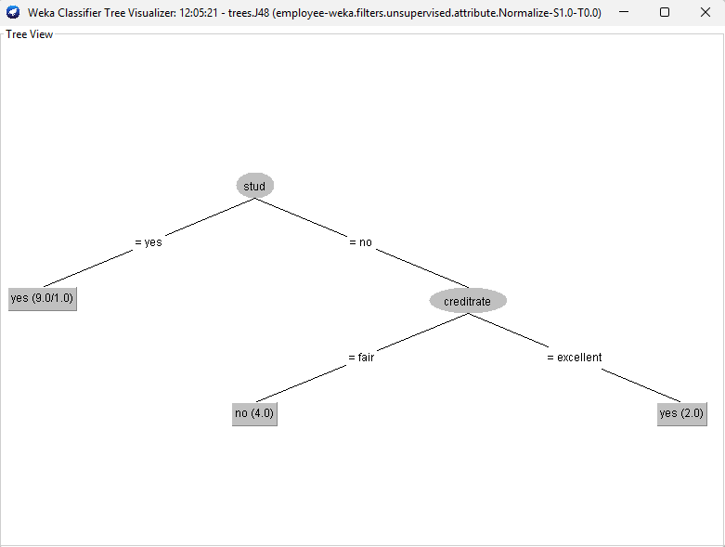

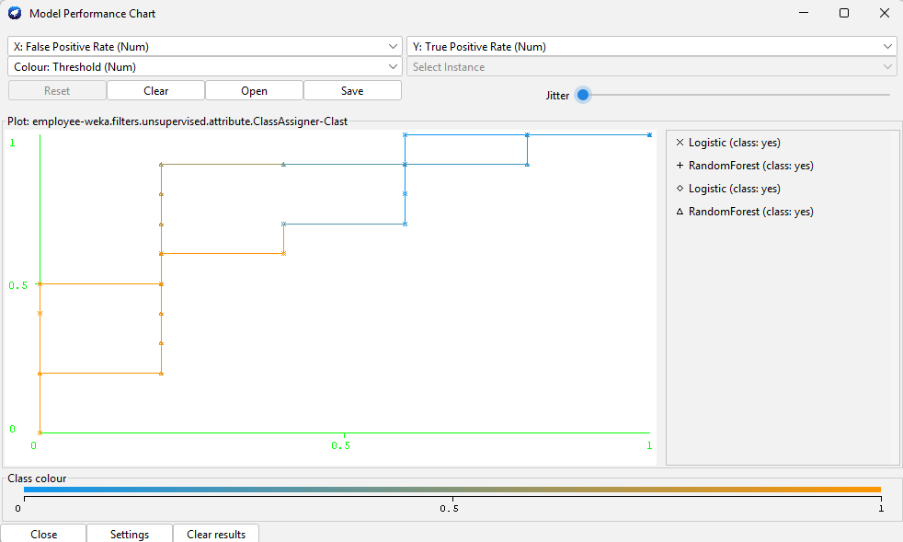

1. Run IBk with Default Settings (k=1)
- Add IBk: From Classifiers -> lazy, place an IBk classifier on the canvas.
- Connect IBk: Just like you did for the others, connect the trainingSet and testSet outputs from CrossValidationFoldMaker to the corresponding inputs on the IBk component.
- Add its Evaluator: Place a new ClassifierPerformanceEvaluator on the canvas. Connect the batchClassifier output from IBk to its input.
- Add a Viewer: From Visualization, place a TextViewer on the canvas. Connect the text output from the IBk's evaluator to the TextViewer's input.
- Run the Flow: Click the "Play" button (▶️) at the top left.
- Get the Answer: Once it finishes, right-click the TextViewer and select "Show results...". A window will pop up with the evaluation summary.
  - Question (i): The number of attributes (5) and their names are in your ARFF file. The class is buyscomp. You've just run the IBk algorithm with 10-fold cross-validation.
  - Question (ii): In the TextViewer results, find the line Correctly Classified Instances. The percentage shown is the accuracy of IBk.
2. Run IBk with k=5
- Configure IBk: Right-click your IBk component and select "Configure...". Change the value for KNN from 1 to 5. Click "OK".
- Run the Flow: Click the "Play" button (▶️) again.
- Get the Answer: Open the TextViewer results again ("Show results..."). The text will be updated.
  - Question (iii): The new percentage for Correctly Classified Instances is the accuracy for k=5.
3. Interpret the Results
Now, you can document the answers to the analytical questions.
- Question (iv) - Is it an unbiased estimate?:
  - Answer: "Yes. The accuracy from 10-fold cross-validation is a good, unbiased estimate of how the model will perform on new, unseen data. This is because the model is repeatedly trained on one part of the data and tested on a different part it has never seen before."
- Question (vi) - Effect of class noise?:
  - Answer: "Increasing class noise (incorrect labels in the data) makes it harder for the classifier to learn the correct patterns, which typically leads to a decrease in accuracy."
- Question (vii) - Effect of altering k?:
  - Answer: "A small k (like 1) makes the model very sensitive to noise. A larger k makes the model's predictions smoother and more resistant to outliers, but if k is too large, it can blur the details between classes."
- Question (viii) - Amount of training data?:
  - Answer: "With 10-fold cross-validation, the model is trained on 90% of the data and tested on the remaining 10% in each of the 10 runs."
I. Consider glass data set.
i) Dataset Attributes and Initial Setup
This step involves loading the data and identifying its basic properties.
- Steps:
  - Open the Weka Explorer and go to the Preprocess tab.
  - Click "Open file...", navigate to your Weka installation folder, open the data subfolder, and select glass.arff.
- Answer:
  - Attributes: The dataset has 10 attributes.
  - Names: The attribute names are RI, Na, Mg, Al, Si, K, Ca, Ba, Fe.
  - Class Attribute: The class attribute is Type.

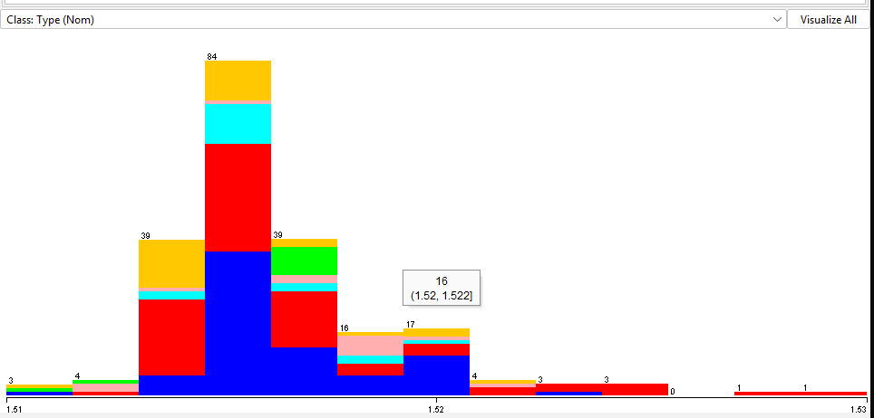

ii) Accuracy of IBk (Default k=1)
Here, we run the classifier with its default settings.
- Steps:
  - Go to the Classify tab.
  - Click "Choose" and select classifiers -> lazy -> IBk. The default setting for neighbors (k) is 1.
  - Ensure "Test options" are set to Cross-validation with 10 folds.
  - Click "Start".
- Answer: In the "Classifier output" box, the value next to "Correctly Classified Instances" is the accuracy. For the default IBk on the glass dataset, this is typically around 67-70%.

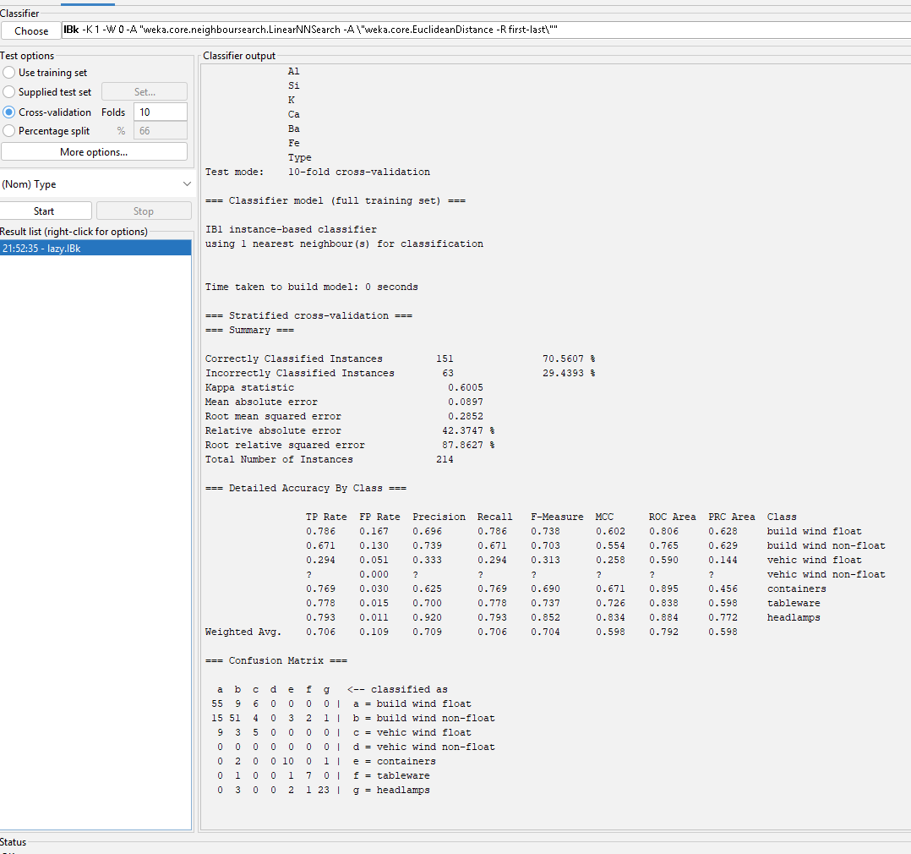iii) Accuracy of IBk with k=5
Now, we adjust the classifier's parameters and run it again.
- Steps:
  - In the Classify tab, click on the text box that shows the IBk classifier options.
  - In the pop-up window, change the value for KNN from 1 to 5. Click "OK".
  - Click "Start" again.
- Answer: The new accuracy for k=5 will be displayed. This value usually improves slightly to around 70-72% for this dataset.

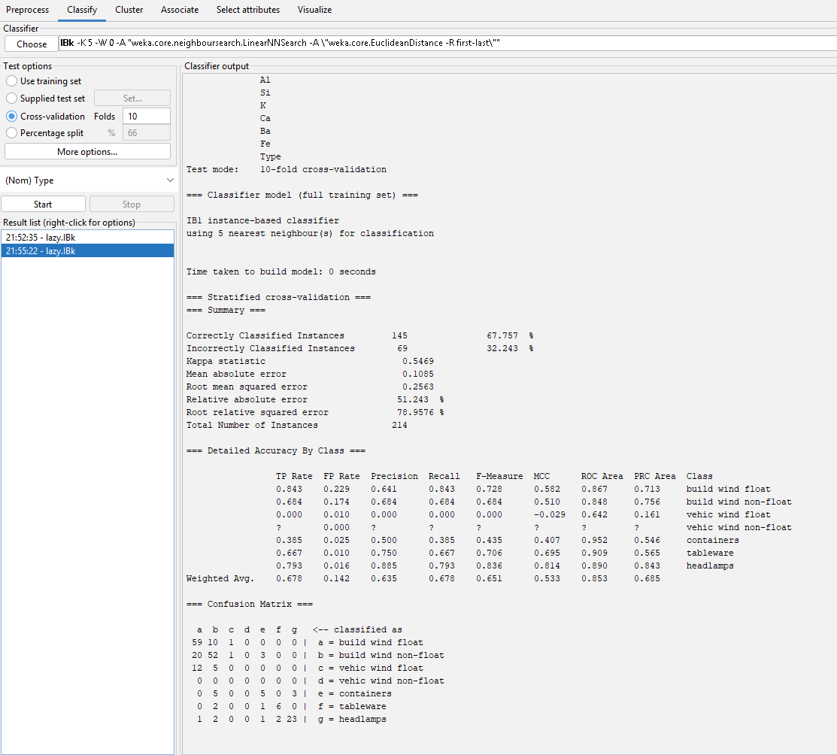

iv) Unbiased Estimate of Accuracy
- Answer: Yes, the accuracy obtained from 10-fold cross-validation is a good, largely unbiased estimate of how the model will perform on new data. This is because the method ensures that the model is always tested on a subset of data that it was not trained on, preventing overly optimistic results.

v) Experiment with Noise and Neighborhood Sizes
This requires a systematic experiment.
- Steps:
  - Go to the Preprocess tab.
  - Click "Choose" for the filter and select AddNoise (filters -> unsupervised -> attribute).
  - Click on the AddNoise text box to configure it. Set the percentage to your desired noise level (e.g., 10 for 10%). Click "OK".
  - Click "Apply".
  - Go to the Classify tab, set your desired k value in the IBk options, and click "Start".
  - Record the accuracy in a table.
  - Crucially: Go back to the Preprocess tab and click "Undo" to remove the noise before your next run.
  - Repeat this process for all required combinations of noise and k values.
- Answer: The result of this execution is the completed table of accuracies.

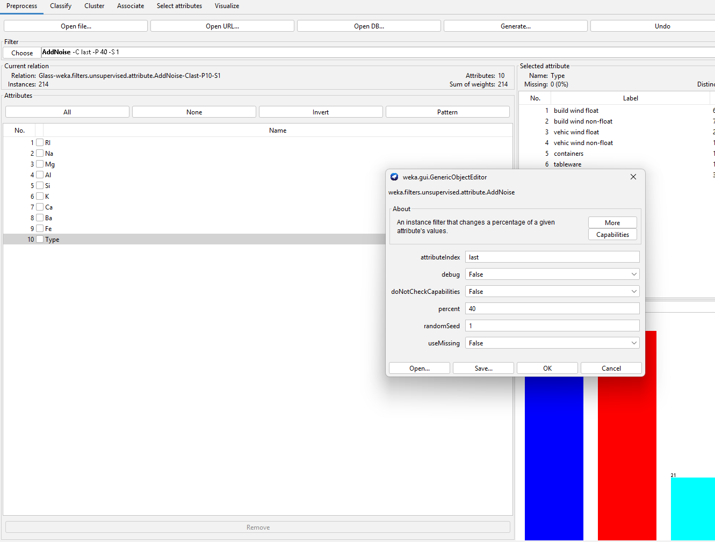vi) Analyze the Effect of Class Noise
- Execution: Analyze the table you created in the previous step. Look down any column (for a fixed k) and observe the trend as the noise percentage increases.
- Answer: Increasing class noise makes it harder for the classifier to learn correct patterns, which leads to a decrease in accuracy.

vii) Analyze the Effect of Altering k
- Execution: Analyze your results table again. Look across any row (for a fixed noise level) and observe the trend as k changes.
- Answer: Altering k changes the model's bias-variance trade-off. A small k is sensitive to noise (overfitting), while a very large k can be too simplistic and miss patterns (underfitting). The analysis will show how accuracy changes as you vary k.

viii) Verify the Amount of Training Data
- Execution:
  - In the Preprocess tab, check the "Instances" count (it's 214 for glass.arff).
  - In the Classify tab, confirm you are using 10-fold cross-validation.
- Answer: The model is trained on 90% of the total data for each of the 10 folds. With 214 total instances, the training set for each iteration contains approximately 193 instances.

