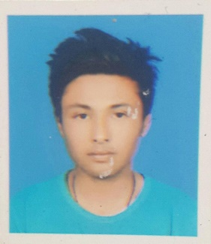

*Susan Marikhu*

Kamal-Binayak, Bhaktapur | 9863662999 | [susan.marikhu123@gmail.com](mailto:susan.marikhu123@gmail.com)

OBJECTIVE

* To obtain internship in web page designing and Database Management preferable at IT Company of British Embassy utilize problem solving, communication, and technical skills.

**EDUCATION**

BCS-IT (Hons) with GPA 3.50(expected to be graduated in 2019)

Sunway International Business School in affiliation with Infrastructure University of Kuala Lumpur.

Maitidevi, Kathmandu.

Higher Secondary Education

Khwopa Higher Secondary School

Dekocha, Bhaktapur.

**Computer Skill**

**Language**: Java, C, HTML, JavaScript

**Operating System**: Windows, Linux

**Software**: MS Office

**Hardware:** Assembling and Disassembling, VHD

**Relevant courses and Trainings**

* Web designing and developing
* Hybrid application Development
* Mobile programming (Android)
* PHP and JavaScript training

**Activation and Participation**

* Participation in Taekwondo Competition.
* Class Representative in Grade 07.