AOP 2027 Modeler Detailed Requirements
Version 2.0 | 17 September 2026 | Companion to the Product Requirements
Build one modeler with four coordinated tabs and a reproducible rule engine. This document defines what each control does, how funding changes propagate, what the source workbook must provide and how the delivery will be accepted. Requirement identifiers provide a direct link from implementation and test cases to the approved product scope.

Authority and requirement language
The current user request and latest Detailed Prioritisation Approach take precedence over older HTML logic, screenshots, the previous PRD and older skills. Requirements labelled Proposed are explicit choices submitted for approval with the PRD. All other requirements implement the current request and established approach. No legacy script is accepted as correct solely because it already exists.

Confirmed source snapshot
Measure | Current position
Demand | 279.6 M€ requested; 509 demand-evidence rows; 506 Item No. references.
Reporting groups | 167.9 M€ BU Led and 111.7 M€ Enterprise Wide.
Decision Band | 215 Healthy; 14 Contain; 280 blank.
Overall AOP decision | 183 Healthy rank; 30 P1; 3 P2; 12 Contain; 1 priority TBD; 280 blank.
Evidence gaps | 11 rows have a missing requested amount; 196 rows contain numeric benefits. Blank benefits are not zero.
Approved envelope | Not supplied in the source. 100.0 M€ is an illustrative scenario input.

The source SHA-256 begins 4ca3c6d42959. Full source locations and fingerprints appear in the reference section. Snapshot counts are verification fixtures, not engine constants. Numeric results are displayed upward to one decimal; counts remain whole numbers.

Requirement groups
NAV navigation; SC scenario experience; MET metrics; RULE funding; SCORE merit; CONF conference edits; FIL filters; DATA source and refresh; SAVE persistence; EXP exports; UX design; AT acceptance tests. All are release requirements unless expressly labelled Proposed.
Build approval is pending. The approval register in the PRD resolves the product choices described here.

Navigation and scenario page structure

NAV 01 Four tabs
Render exactly AOP Scenarios, BU Led, Enterprise Wide, AOP2027 : Overview in that order. AOP Scenarios opens first. Preserve active scenario and per-tab filters on navigation. Tabs must support keyboard focus and a clear selected state. Switching tabs must not alter allocations or produce decision events.

SC 01 Executive position
Section 1 follows Image 1: five KPI cards and a funding-stage bar, all driven by final scenario results. Put source version, scenario name/status and Total AOP nearby. Show a visible over-budget amount whenever final allocation exceeds the envelope, including after manual changes.

SC 02 Controls and custom scenarios
Section 2 contains the scenario selector, Total AOP and five funding lever cards in a horizontal desktop section. Show preset descriptions and Save Custom Scenario, Open, Compare and Export inclusions. Each percentage lever uses a slider, numeric input, visible basis tabs, derived target and actual selected amount. Image 2 guides the control anatomy, not its old tranche rules.
Additional configuration sits immediately below, collapsed initially. It contains the advanced merit floor, four score weights, tolerance and rule/evidence review settings. Applying a valid change updates the scenario once. Invalid values produce an inline error and leave the prior valid result intact.

SC 03 Explanations
Section 3 shows six gate cards using Image 3, followed by the merit framework. Each card explains the bucket in business terms and why it appears in that order. Gate 0 has no money; Gates 1 to 5 show requested demand, target where applicable and current allocation.

SC 04 Unfunded table
Section 4 follows Image 4 with BURF details, Program Name, Demand Type, Requested Demand, Merit Score, Benefit Details and Reason for Not Funded. Add Prioritised Amount and Unfunded Amount to explain manual partial funding. Show all rows with positive residual demand and separately flagged missing/zero-amount evidence rows. Counts and totals must disclose these two populations.

SC 05 Log and source controls
Section 5 contains the chronological decision log, then Demand data and decision rules. Expose source file, hash/version, last refresh, row counts, evidence coverage, rule version, refresh/import/export controls and plain-language rules. Older saved versions remain accessible. Program-name links in these sections open the same read-only detail popup.

Metric definitions and financial identities
MET 01 Calculate metrics from unrounded amounts for the active source and scenario revision. The scenario tab is portfolio-wide. BU and EW headline cards remain stream-wide while filter results are reported beside the chart and table, so a filtered view cannot be confused with the entire conference budget.
Metric | Formula and meaning
Allocated / Prioritised | Sum of final program amounts. Show automatic total and manual net change as supporting detail.
Initiatives funded | Count distinct source demand records whose final amount is positive; group rows are excluded. Show partial-scope count separately.
BU Led share | BU final amount divided by portfolio final amount × 100.0. At zero allocation display Not applicable.
Available AOP / Over budget | max(envelope minus allocation, 0) / max(allocation minus envelope, 0). Label these distinctly.
Demand left unfunded | Sum of requested amount minus final amount for valid numeric requests. Missing requests have a separate count and no imputed value.
Programme demand | Sum of source requested demand in the selected reporting stream.
Programme envelope | Proposed: stream automatic allocation before manual overrides. Read-only indicative allocation; not a second ceiling.
Demand gap | Stream requested minus stream final allocation. Separately show variance to indicative programme envelope.
Merit line | The configured advanced Value Based Portfolio floor. It is not the score of the last funded program.
Submitted benefits | Sum numeric submitted lifetime claims for selected rows, with evidence coverage count. Partial-scope claims shown separately, not scaled in proportion to funding.

MET 02 Funding-bar segments equal final funding in Legal and Compliance, Sustain Engineering, Hygiene, Carryover and Value Based Portfolio. Divide segments by final allocation, not the envelope. Show an envelope comparison separately. Exclude Gate 0 and reporting categories from the stacked total.
MET 03 Reconcile: numeric requested = final prioritised + unfunded residual; BU final + EW final = portfolio final; stage final totals = portfolio final; envelope = final + available - over budget. Display rounding does not change any identity.
MET 04 Use upward rounding only for display: positive value → ceiling(value × 10) / 10. Show variance direction in words and round its magnitude upward, so a small overspend cannot disappear. Keep original precision in calculations and machine-readable exports. All financial UI labels use M€; raw source fields keep K€ labels.

Funding classification and six gates
RULE 01 Proposed six-card interpretation: Gate 0 checks identity, amount and recorded decision evidence for all rows; Gates 1 to 5 are mutually exclusive funding stages. A held row retains its classified stage, stays visible and receives an explicit eligibility reason.
Gate | Classification and precedence
0 Evidence and decision check | Inspect the source Decision Band and Overall AOP decision. Do not recompute the nine waste dimensions. Separate unknown evidence from a negative assessment.
1 Legal and Compliance (Must Do) | Source P1 Immediate or P2 Scheduled Overall AOP decision, plus approved exceptions EW-11 Group Functions, EW-65 Supply Chain and EW-71 Finance. This precedes all other categories.
2 Sustain Engineering | Source New initiative or Carry-over equals Change & Sustain after normalising whitespace/case; exclude Gate 1. No request-size rule and no name-based CCB inference.
3 Hygiene | Category is Continuous Improvement, its documented spelling variants, or Upgrades & Enhancements, excluding earlier gates.
4 Carryover | Remaining explicit Carry Over rows, excluding decommissioning/replatforming designated for Gate 5. Eligibility is tested after classification.
5 Value Based Portfolio | All remaining demand, including AI unless in an earlier gate, and Decommissioning/Decomm/Replatforming after Gate 1 and Gate 2 precedence.

RULE 02 The three Legal and Compliance exceptions use the current requested amount for their stable source IDs. Historic amounts display as Group Functions 7.7 M€, Supply Chain 4.2 M€ and Finance 6.3 M€. Never hardcode these amounts into refresh logic. Flag any changed identity or missing designated ID.
RULE 03 Accepted Hygiene category aliases are Continuous Improvement, Continous Improvement, Continuous Improvement (CI), and Upgrades & Enhancements. A versioned alias dictionary may normalise spacing/case. Unknown categories remain visible; do not infer Hygiene from a narrative description.
RULE 04 Proposed Carryover boundary: an ineligible Carryover stays in Carryover and is not rerouted into Value Based Portfolio. Decommissioning follows the explicit user direction to Value Based Portfolio. Source type remains unchanged for filtering and audit.
Baseline from the latest approach: Legal and Compliance 34.6 M€, Sustain Engineering 12.4 M€, Hygiene 35.0 M€, Carryover 102.0 M€, Value Based Portfolio 95.9 M€. These are source-version reference amounts; independently rounded stages need not sum to the rounded 279.6 M€ total.

Eligibility ordering and funding controls

RULE 05 Evidence eligibility
Missing program name, missing/invalid/nonpositive request, or priority TBD prevents automatic funding. A blank Decision Band earns 0.0 points and remains Unassessed. Proposed default: blank Overall AOP decision alone does not block competition or create Must Do status; all stage, benefit and merit checks still apply. Surface the blank as an evidence exception.
Contain requires a source or reviewed condition retained in the rationale. An unresolved condition is held. A source decision value outside the approved dictionary is held for review. Carryover and Value Based Portfolio need a finite numeric Quantified Benefits value. Text, a number embedded in prose, blank and error cells are not numeric benefits. Numeric zero is valid evidence but earns 0.0 benefit points.
Carryover needs benefit / source requested amount ≥ selected threshold and is not subject to the merit floor. Value Based Portfolio must meet the advanced merit floor. Claims above 5.0x require evidence acknowledgement before benefit-led allocation. Manual inclusion can record a conference exception inline but must retain the source warning; it cannot invent evidence.

RULE 06 Deterministic priority
Legal and Compliance: P1, then P2, then designated exceptions. Within a tier use merit descending, benefit/request descending, submitted priority descending, then stable ID. Sustain and Hygiene use the same merit-first tie-break sequence. Carryover uses benefit/request descending, then merit, submitted priority and stable ID. Value Based Portfolio uses merit descending, then benefit/request, submitted priority and stable ID. Null ratios sort after numeric ratios. Every row records its stage rank.

RULE 07 Lever definitions
Control | Input and behaviour
Total AOP | Finite amount ≥ 0.0 M€. A zero envelope permits no automatic funding.
First three stages | Percentage 0.0–100.0, step 0.1, plus basis selector: bucket demand or Total AOP. target = min(bucket demand, selected basis amount × percentage / 100.0).
Basis change | Preserve the entered percentage, recompute the amount and log both bases and targets. Display the denominator beside the percentage.
Carryover | 1.0x through 5.0x in 0.5x steps. Display last tick 5.0x+. The rule is ≥ 5.0x, with separate above-5.0x evidence review.
Value Based Portfolio | Read-only remaining capacity after prior stages. No separate percentage slider or independent envelope.

Targets are reservations in order, not promises of full coverage. If requested reservations exceed Total AOP, preserve the settings, show the conflict and apply the stage order. Never silently rescale all lever percentages.

Merit framework and allocation arithmetic
Component | Default scoring
Benefit / request | Maximum 50.0. Missing or <1.0x: 0.0; ≥1.0x and <2.0x: 20.0; ≥2.0x and <3.0x: 30.0; ≥3.0x and <5.0x: 40.0; ≥5.0x: 50.0.
Submitted priority | Maximum 25.0. Must Do 25.0; Must Have 18.0; Deprioritised 5.0; blank/unrecognised 0.0. This label alone never creates mandatory status.
Captured Consequence | Maximum 15.0. No usable evidence 0.0; general consequence 5.0; named affected activity/stakeholder and explicit harm 10.0; level 10.0 plus quantified impact or enterprise reach 15.0.
Decision Band | Maximum 10.0. Healthy 10.0; Contain 6.0; blank/other 0.0. Preserve recorded Overall AOP decision separately.

SCORE 01 Keep exact source passages and the originating field for Captured Consequence. Only Impact and Cost of Not Doing, Problem Statement and Scope contribute. A number without context, a keyword, or the count of populated fields is not sufficient evidence for a higher tier. Dependencies add no points. Any interpretation rule or reviewed tier is versioned and visible.
SCORE 02 Advanced weights are nonnegative and must sum to 100.0. Score = sum(component base points / component default maximum × configured weight). The initial weights are 50.0, 25.0, 15.0 and 10.0. Initial Value Based Portfolio floor is 45.0. Compare unrounded score with the floor. Keep tier definitions fixed to the approved rule version.
RULE 08 For each stage, scan eligible rows in priority order. Automatic amount is either the full requested amount or 0.0. Select a row only if both cumulative stage spending and cumulative portfolio spending remain within their applicable limits. Otherwise record why it does not fit and continue to the next eligible row; do not split or proportionally reduce it.
For the first three stages, stage limit = target × (1 + tolerance/100.0), capped by bucket demand. For every stage, portfolio limit = Total AOP × (1 + tolerance/100.0). Carryover uses the remaining automatic capacity; Value Based Portfolio follows Carryover. Tolerance is applied once to the portfolio, not compounded at every stage.
RULE 09 Default tolerance 5.0%, proposed configurable range 0.0–5.0% in Advanced. It is a maximum overshoot allowance, not a minimum spend requirement. Show signed stage and portfolio delta; unused room is allowed. If earlier stages consume the portfolio limit, later automatic stages stop. Unused room caused by unaffordable programs may be used by later eligible rows; show any remaining mandatory coverage gap.
RULE 10 Record automatic results first, then apply manual overrides by stable ID. Manual changes can take the final portfolio above the automatic limit and do not silently displace other programs. Show over-budget variance prominently and permit finalisation.

Conference table edits and shared recalculation
CONF 01 BU Led and Enterprise Wide display a grouped table with inclusion checkbox, BURF and program name, source ID, demand type, stage, Decision Band, Overall AOP decision, merit, requested amount, editable prioritised amount, unfunded amount, benefit details and outcome reason. Groups have an indeterminate checkbox when only some child programs are selected. Proposed: group toggles affect only currently filtered child rows and show the count in the inline action.
Action | Committed state change
Select unchecked program | Set override Include with full source requested amount. Do not remove any existing automatic selections.
Deselect program | Set override Exclude and final amount 0.0. Preserve previous amount in the event log.
Edit prioritised amount | Proposed: accept finite 0.0 ≤ amount ≤ source request. Positive value becomes Include with explicit scope amount; zero becomes Exclude. Never overwrite source request.
Return to automatic | Remove the active override for that program and restore its current automatic result; log the transition.
Change top-down settings | Recompute the automatic baseline from current source/rules; reapply retained manual overrides and recalculate totals.
Change only filters | Change the visible row set and chart. No funding change or decision event.

CONF 02 Commit numeric editing on Enter or blur after validation. Escape cancels an uncommitted value. Do not commit on every keystroke. A rejected negative, excessive, nonnumeric or missing amount leaves prior valid state and shows an inline message. Merely focusing and leaving a rounded amount does not replace its underlying exact value.
CONF 03 Emit one immutable event per committed edit and one transaction containing child events for a group action. Update the scenario revision, final results, executive cards, both stream totals, chart status, unfunded table, Overview and export snapshot atomically. There must be no render containing totals from mixed revisions.
CONF 04 Table edits preserve the automatic baseline: an exclusion or scope reduction leaves available AOP; no automatic refill occurs as a side effect. A subsequent top-down setting change deliberately creates a new automatic baseline and reapplies exclusions. Excluded rows remain excluded even when selected automatically in that new baseline.
CONF 05 Checkboxes and amount changes open no dialog. Log an operational explanation such as “Prioritised amount changed from 0.4 M€ to 0.3 M€ in BU Led”. A business rationale is a separate optional inline note. Missing evidence or above-5.0x exceptions need an inline review acknowledgement before they can be described as reviewed; retain the warning on an unacknowledged manual inclusion.
CONF 06 Undo creates a new inverse event; it never erases history. Finalised scenarios are read-only; edit by creating a new working version. The modeler does not claim that a manual amount reduction preserves the original scope or submitted benefits.

Cascading filters chart and program details
FIL 01 Use one horizontal desktop row with the advanced merit readout, Decision Band/Funding colour toggle, Organisation, Platform, Demand Type, Investment Area, Funding Status, search and Download Excel. Organisation through Investment Area are cascading checkbox multi-selects ordered left to right. Search and funding status apply to their result. Use the same filter schema in BU Led, Enterprise Wide and Overview.
FIL 02 Values within a filter combine with OR; separate filters combine with AND. No selection means All, including blank. Provide an explicit Not supplied option for missing source values. Downstream options and counts depend on selected upstream values. Disable impossible unselected options; retain selected zero-count values visibly. Never clear a downstream selection silently.
FIL 03 A search matches source ID, program name and organisation without altering funding. Clear all resets filter state only. Tab filters are retained separately and saved with the scenario as viewing preferences. Empty results show a clear message and reset action; metrics labelled as stream-wide remain unchanged.
UX 01 Follow Image 6 using the controlling HTML font and palette. The SVG/chart container and plot expand with the available panel width; avoid the existing empty right-hand area. Proposed plot height is between 320 and 520 pixels based on viewport, retaining readable axes, legend and labels. All filters remain in one row at the approved desktop width; smaller screens wrap the controls.
UX 02 X-axis is merit 0.0–100.0. Y-axis is positive requested investment in M€ with a labelled log scale and source amounts in tooltips. Bubble area is proportional to requested investment with a practical minimum clickable radius. Zero or missing requests appear in the table and an excluded-from-plot count, not at a fabricated log value.
UX 03 Colour mode uses source Decision Band or final Funding status, with explicit legend labels for Healthy, Contain, Unassessed and funded, excluded, not funded, or partial scope. The dashed merit line denotes the Value Based Portfolio eligibility threshold only. Programs funded by an earlier gate can appear below it.
UX 04 Clicking Program Name opens a small read-only popup; Image 7 is the field reference. Proposed width is at most 560 pixels or viewport minus margins, height at most 70% of viewport, with internal scrolling. Show all nonblank original fields and derived evidence in labelled groups, preserving zero/false values and exact source wording. Include source sheet/row, ID, request, benefit claim, ratio, merit components, decision fields, condition, problem, scope and dependency when present.
Keep blank/unknown placeholder fields hidden; scenario warnings remain visible outside the source-field list. Source waste fields may be shown if populated, but do not drive rules. Remove all funding inputs/buttons from the popup. Support Close, Escape, focus containment and return focus to the invoking program link. Chart hover is informational and does not open a funding form.

Source workbook and normalized record contract
DATA 01 Import .xlsx workbooks equivalent to 15926_IT AOP2027 Demand.xlsx. The current sheets are EW and Bu, with headings/prompts across rows 1 to 3 and demand from row 4. Resolve composite headings, aliases and subheadings rather than fixed column offsets. Unknown equivalent sheet names require an explicit mapping preview. Include every demand-evidence row; do not turn formatted empty rows into initiatives.
Normalized field | Authoritative source and handling
Identity and lineage | Item No., Planisware ID, source workbook/hash, sheet, row and an internal stable record ID. Duplicate IDs require resolution; temporary row IDs cannot safely survive a changed workbook by position alone.
Organisation and name | Organization setting demand [BU, Region, CoE]; Initiative name. Keep the sheet-derived stream separate from BURF ownership.
Classification | Type; New initiative or Carry-over (allow extra whitespace); Category; Leading IT Platform; Investment Area. Keep source and normalised text.
Requested amount | IT Investment Requested 2027 [k€] or reviewed kEUR alias. Divide by 1,000 exactly once for M€. Preserve missing separately from zero.
Benefit | Quantified Benefits (in K€) and Quantified Benefits (Details). Numeric cell or unambiguous whole-cell numeric value only, with locale and unit validation; preserve original text.
Priority | Submitted Priority column, not the later mandatory-risk Priority column. Resolve by surrounding headings and header mapping preview.
Decision Band | Current workbook has duplicated Waste headings; select the column with subheading band. EW AY and Bu AW are snapshot checks, not mapping constants.
Overall decision | Overall AOP decision, with source text and a versioned match dictionary. Current EW BM and Bu BK are validation references.
Consequence evidence | Impact and Cost of Not Doing; Problem Statement; Scope. Preserve exact passages for score explanation.
Other evidence | Dependency or Dependency (Item No & Explaination), Remarks / evidence, LFR fields and every other nonblank source column for program details.

DATA 02 Requested Budget Updated, Handshaked and source IT Investment Prioritised remain distinct evidence fields. They must not silently replace requested demand or current modeler allocation. Source requested remains the ratio denominator after a manual amount edit.
DATA 03 Currency source is K€; normalized currency is M€. Do not infer corrections from value magnitude. Preserve original formula, cached result and unit if applicable. An unresolved formula/cell error is a validation issue, never zero. Sanitize displayed source content and neutralise spreadsheet-formula injection in exported text cells.

Refresh validation and decision migration

DATA 04 Refresh transaction
- Read the selected workbook into a candidate snapshot without modifying the active scenario. Show sheet/header mapping and any missing required headings.
- Validate IDs, types, monetary units, dates where used, source decision values, requested amounts and row coverage. Reconcile stream and total demand. Missing business evidence is a visible warning; structural ambiguity and invalid currency mappings block apply.
- Compare candidate and current source by stable ID and material evidence fingerprint. Display added, changed, removed and unchanged rows, totals and source exceptions.
- Prepare an override migration preview. Unchanged matched records retain decisions. Changed requests, benefits, decisions, classifications or supporting evidence require review; removed records remain in history and lose their active allocation.
- Apply as a single transaction only after the preview is accepted. Create a new source version and working scenario, re-run the approved rules and preserve the previous scenario for recovery. Cancel leaves all active data intact.

DATA 05 Identity and review rules
Item No. is primary within the dataset. Use a unique Planisware ID with consistent ownership only when an explicit mapping is confirmed. Name or row number alone never automatically transfers a monetary override. Temporary IDs on the current source include Bu rows 516, 517 and 528; sorting or inserting rows requires rematching, not reuse of row positions.
A material source change marks an override Needs review and excludes that override from active financial totals until accepted inline. Its program may have a new automatic result under the refreshed evidence; show this separately. Changes to row position only, for a stable ID with identical business evidence, preserve the decision and update provenance.
A removed record remains attached to the old source and decision history. A new or renamed record does not inherit an override without a confirmed match. Never carry a partial amount above a revised request; hold it for review.

DATA 06 Reconciliation report
The refresh report states file/hash, source version, mapping version, count of source evidence rows, numeric-demand total, missing-demand count, benefits coverage, Decision Band coverage, Overall AOP decision coverage and unresolved identities. Baseline: 509 rows, 279.6 M€, 280 blank bands and 280 blank overall decisions. Changed values are reported as changes, not rejected solely because they differ from this snapshot.
A refresh must fully replace the active source snapshot after validation. It must not append duplicate copies of old demand or silently discard unfamiliar nonblank evidence columns. The adapter is built for equivalent workbook layouts, not arbitrary unstructured spreadsheets.

Scenario state persistence and decision history
Entity | Minimum fields and behaviour
Demand version | Version ID, full file hash, source name, import time, mapping version, original rows, normalized records and validation report. Immutable after apply.
Scenario revision | Scenario ID/name, parent revision, status Draft/Finalised, source version, rule version, budget, lever bases/percentages, threshold, tolerance, merit configuration and view filters.
Program override | Stable record ID, Include/Exclude/Automatic, optional scope amount, business note, evidence acknowledgement, material-source fingerprint and review state.
Allocation result | Revision ID, stage, eligibility reasons, four merit components, score, rank, automatic amount, final amount, unfunded residual and all reconciled totals.
Decision event | Unique event ID, transaction ID, scenario/source/rule revision, timestamp with timezone, originating tab, action, program/setting key, old/new values, operational description and optional business note.
Saved snapshot | Source snapshot, settings, active overrides, automatic and final results, unresolved exceptions, full decision log and accepted over-budget variance.

SAVE 01 A preset applies its named settings to the current source. Existing manual overrides are retained and the visible state says Custom based on that preset. Provide a separate explicit Reset manual decisions action with an inline affected-count preview. Never hide or delete its history.
SAVE 02 Mark unsaved changes after any committed setting, evidence-review or program edit. Save Custom Scenario requires a name and creates a revision; duplicate names must be disambiguated by revision/date. Autosave the draft locally after each valid transaction and show success or failure. Do not imply that autosave equals finalisation.
SAVE 03 Open restores exactly the saved source and rule versions, settings and overrides. Recompute and compare against the stored result fingerprint. Incompatible source or rule versions require a visible migration workflow. Comparing presets uses the same source and envelope without manual overrides; comparing named saved scenarios shows their actual overrides and any differing source versions.
SAVE 04 Finalise freezes the chosen revision including variance and outstanding exceptions. Over-budget status does not block it. Proposed: inline acknowledgements identify material evidence exceptions; log finalisation and accepted variance. Further editing creates a new draft. Refresh creates a new source version without modifying a finalised snapshot.
SAVE 05 Local persistence needs portable session export/import and an explicit storage-failure message. Exported sessions include schema version and content checksums. Import rejects malformed or incompatible data atomically. No server or multi-user approval identity is assumed; if actor identity is unavailable record Local session, not an invented user.

Excel downloads and traceability
EXP 01 Provide actual .xlsx files. Download Excel from BU Led, Enterprise Wide and Overview exports the exact filtered row set plus settings and filter context. Export inclusions from AOP Scenarios exports all final positive allocations across the portfolio regardless of another tab’s filters. Include partial-scope programs and their residual demand.
Workbook sheet | Contents
Scenario Summary | Scenario/source/rule IDs, Total AOP, automatic/final allocation, variance, requested demand, missing-data counts, BU/EW totals, stage totals and exported filter context.
Portfolio | One demand record per row: IDs, source location, BURF, name, type, stage, decision fields, requested amount, automatic amount, final prioritised amount, unfunded balance, eligibility, rank and rationale.
Score Evidence | Four raw and weighted score components; exact Captured Consequence passages and fields; numeric/raw benefits; source request and ratio; review flags.
Settings | Preset/custom name, bases, percentages, targets, carry threshold, merit floor, weights, tolerance and configuration/rule versions.
Decisions | Chronological settings and program events, active overrides, inline notes, review acknowledgements and migration states.
Source Reference | Original relevant source fields, workbook hash, sheet/row, units and mappings; preserve blank versus zero.

EXP 02 Portfolio rows, score evidence and source reference use identical stable IDs. Totals derive from the same calculation result used by the dashboard. Save exact numeric amounts in Excel and provide explicitly labelled upward-rounded display columns or a matching summary view; do not reduce stored precision to one decimal.
EXP 03 Filtered exports state their row count and scope. Summary amounts identify full-scenario versus exported-subset totals. Inclusion exports contain final allocations, including amounts above the envelope; the variance and rule/evidence exceptions must remain visible. Overview exports retain exclusions and automatic unfunded rows.
EXP 04 A complete portable scenario file is separate from a demand refresh. It restores source, settings, decisions and versions. An Excel demand refresh uses the source schema; importing an exported model workbook requires an explicit supported mapping and must not interpret derived model amounts as source requests.
EXP 05 All row edits, settings, exports and scenarios use one canonical calculation engine. If a separate model workbook is generated for the modeler, it must record identical input and rule versions and reproduce row-level allocations. Excel formulas cannot be maintained as an untested second financial model.
Modeler data files belong in AOP2027/AOP 2027 Modeler/Data file. Browser downloads use the user-selected save location; a standalone HTML cannot silently write to that directory.

Visual requirements and reference register
UX 05 Preserve the AOP2027-IT-Portfolio-Scenario-Modelling.html design. Reuse its component anatomy and CSS variables. Do not replace its header, logo treatment, typography or palette with the other HTML’s theme. The appended screenshots are layout references; this document defines the new content and behaviour.
Design element | Controlling value
Font | Neue Frutiger World, Frutiger, Calibri, Segoe UI, Arial, sans-serif. Local font fallback only.
Primary colours | Blue #0B5ED7; dark #00126E; light #BDF0FF.
Surface and text | Background #FAFBFC; card #FFFFFF; border #D5DAE0; text #1A1F2B, #4A5568, #8895A7.
Status colours | Green #008800 / #ADFFB5; amber #FCA708 / #FCFCC2; coral #D43F44 / #FFDEDB. Retain supporting dot colours from the reference.
Structure | Header padding 12×24 pixels; tab active underline 3 pixels; pane padding 16×20 pixels; card gap 12 pixels; compact table style and sticky headers.
Fill available width | Replace restrictive KPI maximum widths with equal flexible columns; stretch chart and tables to panel width while retaining margins and consistent gaps.

UX 06 Test at 1440×900 and 1920×1080 desktop viewports, plus 1024-wide and narrow screens. At desktop, all six stream cards fill the row, the filter row remains horizontal and the chart has no unexplained empty right panel. Tables may scroll within their container with sticky headers and identifier columns; the page must not overflow horizontally.
UX 07 Provide labelled controls, clear keyboard focus, checkbox labels, numeric input validation, screen-readable status changes and colour-independent statuses. Preserve scroll position and row identity after edits. Use explicit empty, loading, error, unsaved, refreshed and storage-failure states.
Image | Application and required change
1 | Scenario KPIs and stage bar; recompute numbers and replace legacy labels.
2 | Control hierarchy; replace old tranches with approved levers and horizontal arrangement.
3 | Six cards; replace waste screen with Gate 0 and apply the approved five-stage order.
4 | Unfunded table; use required BURF and benefit/rationale columns.
5 | Six stream cards; make values derived, fill width and distinguish demand gap from budget variance.
6 | Checkbox filter row and chart; cascade filters, fill width, export matching rows.
7 | Evidence details only; suppress blank fields and remove the entire funding form.

Acceptance tests and build handoff
AT 01 Each test records input source/rule/scenario versions and checks the dashboard against its Excel output. Pass/fail evidence is required before release; the following are specification tests, not tests already executed.
Test | Acceptance condition
AT 02 Source baseline | Current workbook yields 509 rows and 279.6 M€ display demand; 506 IDs, 11 missing requests and all decision-coverage counts reconcile.
AT 03 Stage precedence | P1/P2 and designated exceptions occur once; small initiatives do not enter Sustain by size; CI/upgrades enter Hygiene; decommissioning enters Value after mandatory/Sustain precedence.
AT 04 Eligibility edges | Missing benefits differ from zero; threshold equality passes; below Carryover threshold does not reroute; above 5.0x review is visible; TBD and unresolved conditions are held.
AT 05 Whole allocation | At target 10.0 M€, prior spend 9.8 plus a 0.6 request may reach 10.4 with 5.0% tolerance, subject to portfolio room. A 0.8 request is skipped; it is not cut.
AT 06 Manual addition | Include a previously unfunded whole request. Existing automatic rows stay selected, all tabs increase identically and over-budget finalisation remains available.
AT 07 Amount edit | Change requested 0.4 / prioritised 0.4 to prioritised 0.3. All views show 0.1 residual, source request and ratio stay unchanged; no funding popup or silent refill.
AT 08 Top-down after edit | Change a lever after manual include/exclude/amount edits. New automatic baseline plus retained overrides yields one reconciled revision.
AT 09 Filters | Two organisations OR together, then platform AND type AND area. Downstream zero-match selections stay visible; export/chart/table match; funding does not change.
AT 10 Details and overview | Only program-name click opens read-only details with nonblank fields. Overview shows every outcome and offers no amount or selection editing.
AT 11 Persistence | Save/reopen, session export/import and finalise/new-version preserve exact allocations, source/rules, overrides and event order. Undo leaves history.
AT 12 Refresh | Moved stable IDs retain valid choices; changed requests/benefits hold overrides; removed rows archive; temporary-ID ambiguity and invalid mappings never transfer decisions silently.
AT 13 Cross-view integrity | Every edit, preset and refresh satisfies financial identities and row-level Excel parity, including partial amounts, empty filters and zero envelope.
AT 14 Visual and resilience | All reference components pass desktop/mobile checks; keyboard flows work; large datasets meet agreed targets; corrupt imports/storage failures preserve the prior valid state.

Delivery order: approve PRD and requirements; resolve product interpretations; implement source and rules; build the four tabs; add conference events and saved versions; verify exports/refresh; complete acceptance testing. Product, Finance and IT Portfolio owners are to be named before release. No implementation change is authorised by approval of the document format alone.

Image references for scenario controls
Reference images are embedded at their original resolution for zooming. They specify component layout; the approved labels, source data and rules in this document replace the older content visible in them.
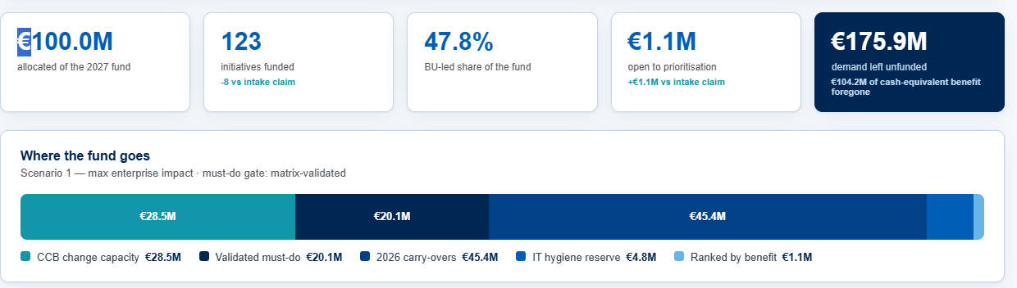
Image 1. Scenario KPI cards and the allocation bar. Replace legacy stages and values with the five approved stages and current final scenario results.
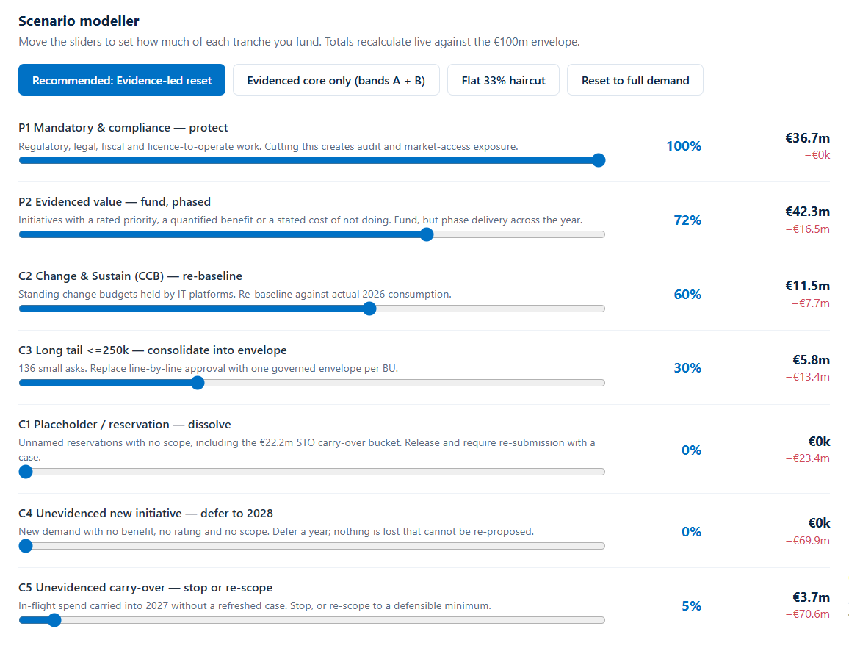
Image 2. Slider and input hierarchy. Rebuild with the five approved levers in a horizontal desktop section; retain numeric entry, visible basis and target amounts. Old tranche percentages are not defaults.

Image references for gates and demand
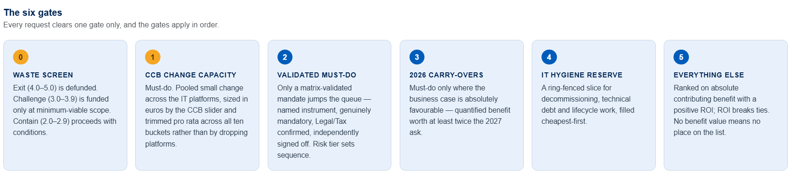
Image 3. Six gate cards. Gate 0 becomes Evidence and decision check; the next five cards follow the approved funding sequence. Remove legacy waste and CCB rules.
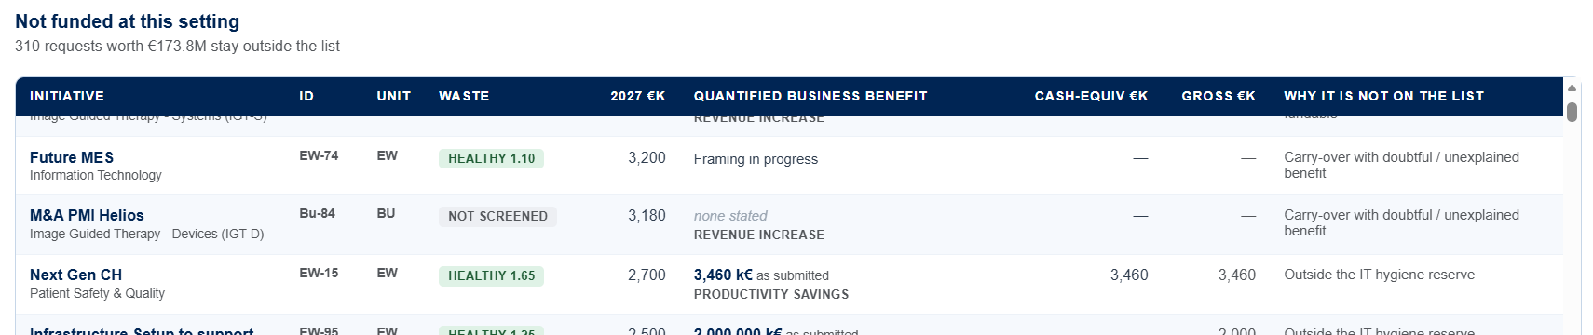
Image 4. Unfunded demand table. Use BURF, program, demand type, requested amount, merit, benefit details and outcome reason, plus residual demand for partial scopes.
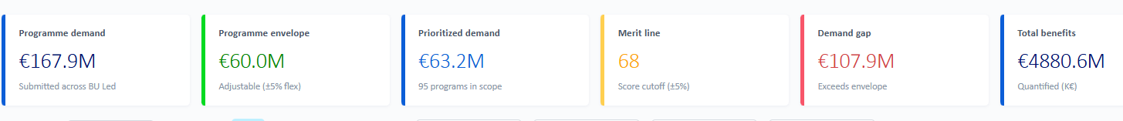
Image 5. Stream KPI cards. Populate from the active scenario, make cards fill the row and distinguish the demand gap from budget variance.

Reference file locations
Controlling design: C:\Users\320126040\Documents\Codex\2026-09-15\create-an-image-of-2\outputs\AOP2027-IT-Portfolio-Scenario-Modelling.html
Supporting component example: C:\Users\320126040\OneDrive - Philips\Download\IT Portfolio Prioritisation 2027 — Philips.html
Latest approach: C:\Users\320126040\Documents\Codex\AOP2027\Approach\AOP2027-Detailed-Prioritisation-Approach.docx
Calculation source: C:\Users\320126040\Documents\Codex\AOP2027\AOP 2027 Demand\15926_IT AOP2027 Demand.xlsx
Source workbook SHA-256: 4ca3c6d4295996c1ff3062d22679ef272ee88a38a6050e112014e5ce25e2ba89
Design HTML SHA-256: efabddd204187f62ccb077b94639344452ff9b38e0d3b3282b887553930a68c2

Image references for filters and details
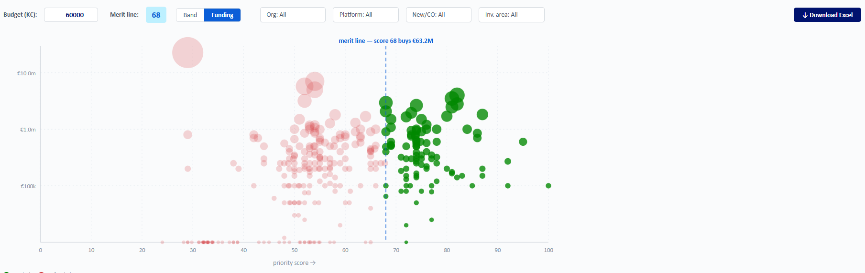
Image 6. Filter row and bubble chart. Filters combine left to right and use checkboxes. Expand the plot to fill its panel and export matching rows as Excel.
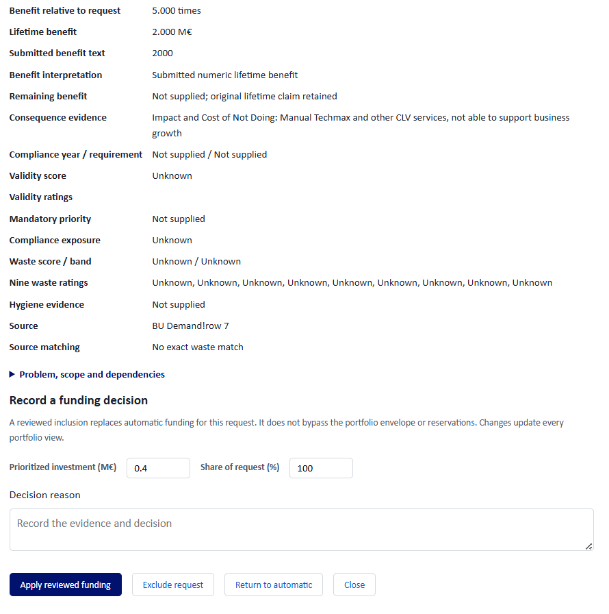
Image 7. Program evidence reference. Show nonblank fields in a compact read-only popup opened from Program Name. Remove Record a funding decision and every funding input or action shown here.

