AOP 2027 Modeler End to End Test Scenarios and Outcomes
  - Version 3.1 | 17 September 2026 | Release verification
The modeler passed the complete test set for the current rule engine, CIO conference sequence, coordinated views and changed Excel workbook refresh. The release evidence contains 60 automated checks and 13 calculated scenario cases with no failed result. The approved AOP envelope and individual funding choices remain leadership decisions.

Test conclusion
Evidence set | Executed | Failed | Conclusion
Rule engine | 22 | 0 | Funding, evidence, arithmetic and lifecycle rules passed.
Core browser flow | 10 | 0 | Four-tab editing, persistence, export and baseline refresh passed.
Interaction regression | 18 | 0 | New tab order, chart details, median lines and collapsed BURF tables passed.
Changed workbook refresh | 10 | 0 | Added, changed, removed and unchanged records migrated as defined.
Scenario outcomes | 13 | 0 | Preset, envelope, threshold, merit and tolerance cases reconciled.

Test basis
Source file 15926_IT AOP2027 Demand.xlsx. Source SHA-256 4ca3c6d4295996c1ff3062d22679ef272ee88a38a6050e112014e5ce25e2ba89. Baseline 509 demand rows and 279.6 M€ requested. Calculations retain full precision. Financial values in this report use the required upward one-decimal display rule.

Rule coverage
Rule area | Coverage | Outcome
Source and lineage | Row count, demand, blanks, IDs, original cells, formulas and source hash. | Passed
Funding classification | Mandatory precedence, exceptions, Sustain source value, Hygiene aliases, decommissioning in Value. | Passed
Eligibility | Missing, zero and numeric benefits; Contain conditions; priority TBD; high-ratio review. | Passed
Automatic allocation | Whole programs, merit order, no forced minimum, stage and portfolio tolerance. | Passed
Manual decisions | Include, exclude, partial scope, no silent refill and visible over-budget variance. | Passed
Conference sequence | Function/EW before BU, checkpoint locks, reopen behaviour and finalisation. | Passed
Persistence | Undo, saved revisions, portable restore and tamper rejection. | Passed
Filtering and export | OR within one filter, AND across filters, row parity and genuine Excel output. | Passed
Refresh | Candidate validation, preview, source replacement, decision hold and recovery. | Passed
Presentation | New tab order, responsive layout, chart labels, hover details and collapsed BURF summaries. | Passed

Financial controls
Every automatic case confirmed that the final automatic allocation stayed within Total AOP plus the selected whole-program tolerance. Automatic selections remained whole requests. Financial identities reconciled at row, stream, stage and portfolio level. Manual changes remained additive and could retain an over-budget result without silently removing another program.

Scenario outcomes
These cases use the same source snapshot and deterministic rule engine as the modeler. They test the proposed presets and the main configuration boundaries. A lower allocation than the envelope is valid when remaining demand is ineligible or no whole program fits the remaining capacity.
Scenario | Allocated M€ | Unfunded M€ | Programs | Over M€ | Result
Protect commitments | 100.0 | 179.6 | 147 | 0.0 | PASS
Tighten carryover evidence | 94.6 | 185.1 | 143 | 0.0 | PASS
Release sustain capacity | 96.4 | 183.2 | 145 | 0.0 | PASS
Zero envelope | 0.0 | 279.6 | 0 | 0.0 | PASS
50 M envelope | 52.5 | 227.2 | 76 | 2.5 | PASS
200 M envelope | 110.5 | 169.2 | 175 | 0.0 | PASS
AOP basis reservations | 82.3 | 197.4 | 131 | 0.0 | PASS
Carryover threshold 1.0x | 103.1 | 176.6 | 151 | 3.1 | PASS
Carryover threshold 5.0x plus | 91.7 | 188.0 | 138 | 0.0 | PASS
Merit floor 0 | 104.8 | 174.8 | 155 | 4.8 | PASS
Merit floor 90 | 68.3 | 211.4 | 98 | 0.0 | PASS
No whole-program tolerance | 99.5 | 180.2 | 147 | 0.0 | PASS
Maximum whole-program tolerance | 100.0 | 179.6 | 147 | 0.0 | PASS

Scenario interpretation
Protect commitments reaches 100.0 M€ on the current source. Tightening Carryover evidence to 3.0x reduces the automatic allocation to 94.6 M€. A 50.0 M€ envelope reaches 52.5 M€ because whole-program tolerance permits up to 5.0% above the envelope. A 200.0 M€ envelope allocates 110.5 M€ because eligibility and evidence rules remain in force. Merit floor 90.0 leaves 211.4 M€ unfunded. These values are scenario outputs, not recommendations or approved budgets.

CIO conference journey
Step | Action tested | Expected outcome | Result
1 Scenario | Open AOP Scenarios and set the portfolio position. | One recalculated portfolio with traceable source and rule versions. | Passed
2 Function | Open Enterprise Wide, filter by Function, change amounts inline and complete. | EW checkpoint records all EW amounts and unlocks BU editing. | Passed
3 BU Led | Open BU Led, filter by BU, change amounts inline and complete. | BU checkpoint records BU amounts without changing the completed EW decision. | Passed
4 Final review | Open Overview and inspect inclusions, exclusions, partial scope and variance. | Read-only combined portfolio matches both conference tables and exports. | Passed
5 Finalise | Finalise after both checkpoints, including an over-budget case. | Revision freezes; a later change requires reopen or a working version. | Passed
6 Recover | Save, reopen and import a portable scenario. | Source, settings, decisions, amounts and event order reproduce. | Passed

Controls that prevent incorrect sequencing
BU editing is blocked until the Function checkpoint is complete. A global lever or merit change clears both checkpoints. Reopening BU keeps the Function checkpoint; reopening Function clears both. A refreshed decision marked Needs review blocks Function completion until the CIO explicitly resolves it.

Excel refresh scenarios and outcomes
Refresh event | Expected treatment | Observed outcome
Changed stable record EW-01 | Recalculate from the new evidence and hold the earlier manual override. | Detected as changed; override state became Needs review.
Unchanged stable record EW-04 | Retain its active manual decision. | Decision remained active after source replacement.
New record EW-188 | Add to the active source and classify using current rules. | Added and classified in Value Based Portfolio.
Removed record EW-187 | Remove from the active portfolio but preserve the previous saved revision. | Absent from the refreshed scenario; previous revision remained reopenable.
Conference state | Do not carry approval checkpoints across a changed source. | Function and BU checkpoints both reset.
Atomic apply | Keep the current scenario until validation completes. | Preview appeared first; apply created a child scenario with a new source hash.

The preview reported 1 added, 135 changed, 1 removed and 373 unchanged records. The fixture deliberately changed EW-01, added EW-188 and removed EW-187. Its workbook rewrite also recalculated other material source evidence; the modeler listed those records as changed instead of treating them as unchanged. Requested demand changed from 279.6 M€ to 279.9 M€. The new source produced 509 active records and a different SHA-256 hash.

Refresh acceptance decision
The end-to-end refresh path is accepted for equivalent EW and Bu workbooks. The modeler reads the complete selected workbook, shows a mapping and migration preview, saves the current revision before apply, creates a new source version and reruns the conferences. A structurally different workbook still requires a valid mapping and must fail without replacing the active scenario.

Chart and table verification
Enterprise Wide, BU Led and Overview each show the actual median score for the plotted programs and the configured merit threshold as separate references. Bubble details appear on mouse hover and keyboard focus. Filters recalculate the median from the visible programs, and an empty result shows no fabricated value.
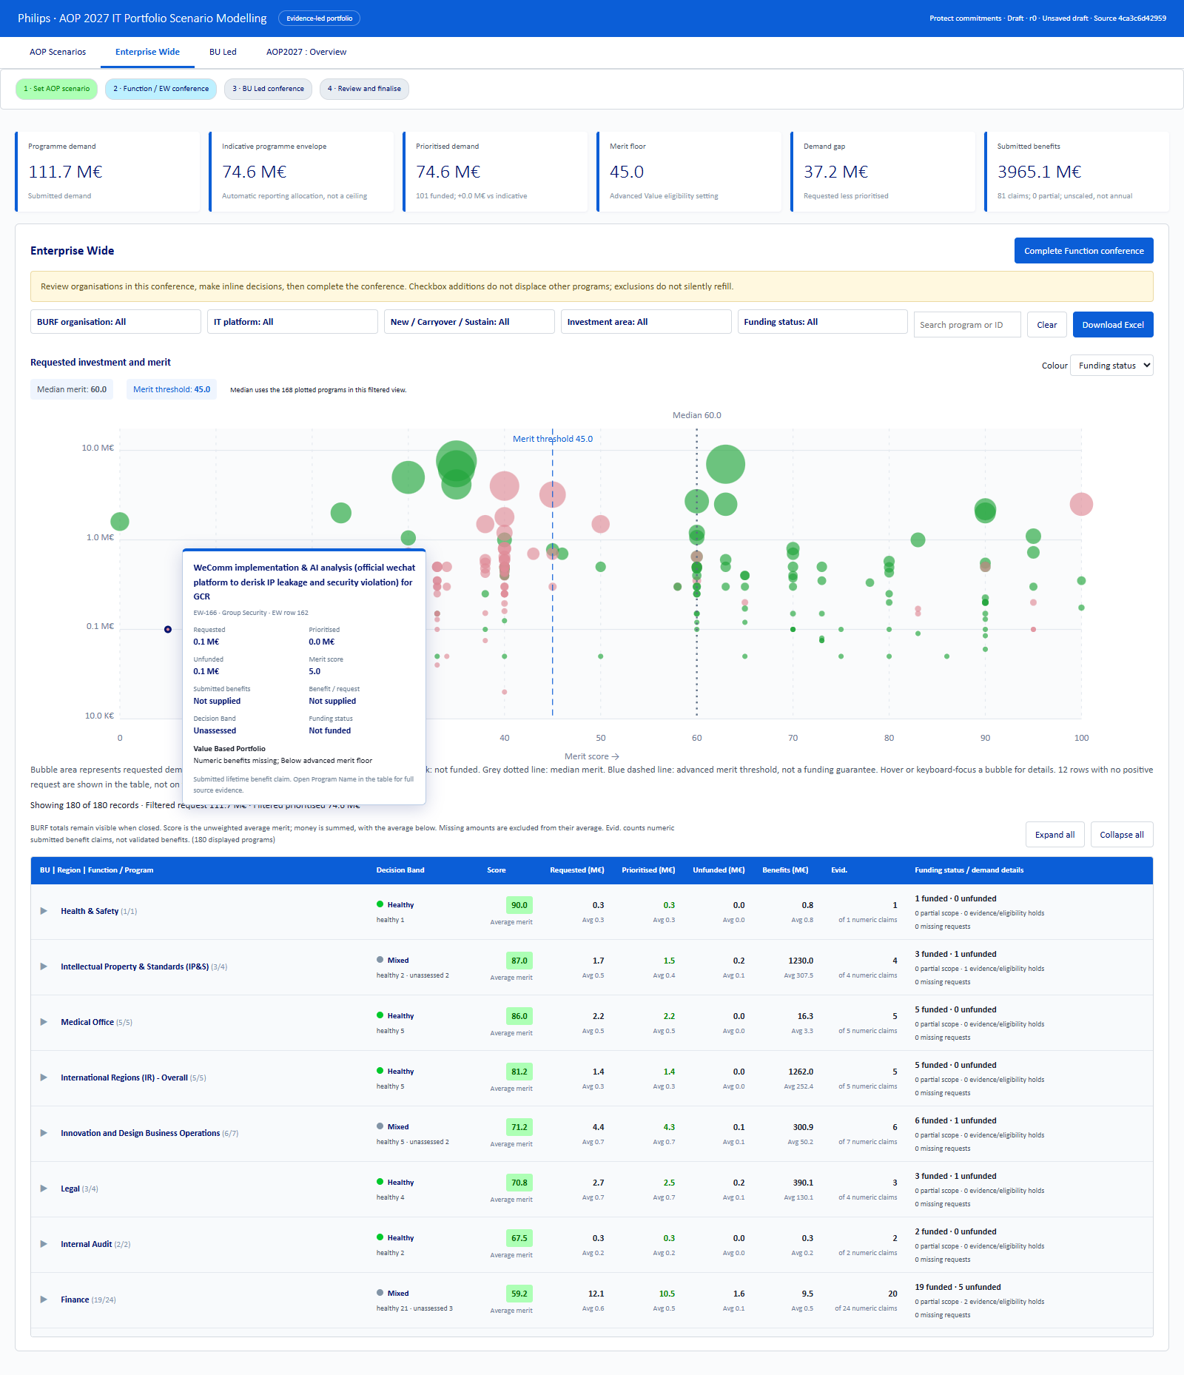
Enterprise Wide chart with median, configured threshold and program detail on hover.
Every demand table opens at BURF level. The summary is a view of its child rows, not an additional initiative. Requested, prioritised, unfunded and benefit values are sums. Merit is the arithmetic average of scored children. Evidence is a count. Opening or closing a group does not change allocations or create a decision event.
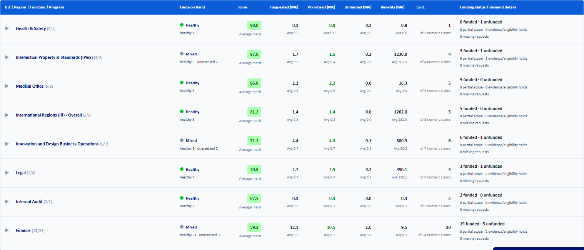
Collapsed BURF table with aggregate totals, average merit and evidence counts.

Executed test register
Executed check | Result
509 rows, exact demand, whitespace blanks and stage reconciliation | PASS
All source cells and formula metadata preserved | PASS
Decision coverage and numeric benefit counts reconcile | PASS
No decommissioning in Hygiene or Carryover after priority precedence | PASS
Whole-program funding and portfolio tolerance at all presets and envelope boundaries | PASS
LFR ringfence and approved exceptions receive correct stage | PASS
Manual exclusion does not silently refill or alter others | PASS
Manual additions are additive and retain over-budget variance | PASS
Manual partial scope retains source ratio and rejects invalid amount | PASS
Function conference must precede BU; locked Function cannot be edited | PASS
Global lever changes invalidate both conference checkpoints | PASS
Reopen BU preserves Function; reopen Function invalidates both | PASS
Finalisation requires both checkpoints and freezes edits; fork is editable | PASS
Undo preserves event history and clears stale checkpoints | PASS
Blank, zero, missing and high benefit eligibility are distinct | PASS
Contain hold, mandatory warning and unresolved priority handling | PASS
Refresh changed evidence holds decisions, resets conferences and retains original | PASS
Portable source validation rejects tampered source records | PASS
Incomplete session and stale conference snapshots are rejected atomically | PASS
Over-budget portfolio can complete both conferences and finalise | PASS
Filter OR within a field and AND across fields; no financial mutation | PASS
Settings reject invalid weights, coverage and thresholds | PASS
Initial source and four tabs render | PASS
BU editing gated behind Function conference | PASS
EW inline exclusion updates shared total without dialog | PASS
Program detail popup is read-only and closes | PASS
Function completion then BU inline edit then finalise | PASS
Excel export is real ZIP workbook and portable snapshot restores | PASS
Refresh reads complete original XLSX with parity and preview | PASS
Cascading multi-select filters and filtered Excel reconcile | PASS
Browser storage saves and restores exact working revision | PASS
Responsive layout retains tabs and no page-level overflow | PASS
Navigation follows Scenario, Enterprise Wide, BU Led, Overview | PASS
Scenario unfunded table is collapsed with BURF summaries visible | PASS
Median and average helper handle odd/even/zero/missing populations | PASS
ew: collapsed BURF financial totals and average merits reconcile | PASS
ew: actual median and configured merit labels visible and correct | PASS
ew: mouse hover and keyboard focus show program details | PASS
bu: collapsed BURF financial totals and average merits reconcile | PASS
bu: actual median and configured merit labels visible and correct | PASS
bu: mouse hover and keyboard focus show program details | PASS
overview: collapsed BURF financial totals and average merits reconcile | PASS
overview: actual median and configured merit labels visible and correct | PASS
overview: mouse hover and keyboard focus show program details | PASS
Opening one group shows children without changing funding or events | PASS
Inline edit updates group totals and retains its expanded state | PASS
Filtering recalculates median and group summary on matching programs | PASS
Empty filter result displays no fabricated median | PASS
Reload resets all demand groups to collapsed while restoring decisions | PASS
Desktop and narrow widths contain tables without page overflow | PASS
Baseline workbook is loaded with traceable source hash | PASS
Changed Function decision is captured before refresh | PASS
Changed workbook validates before source replacement | PASS
Unchanged Function decision is captured for migration control | PASS
Refresh creates a new scenario version and recalculates source totals | PASS
Changed override is held for review and unchanged override remains active | PASS
Both conference checkpoints reset and prior revision stays reopenable | PASS
Held decision blocks Function completion until explicitly resolved | PASS
After resolution, Function then BU conferences complete in order | PASS
Refreshed source can be exported with the added record | PASS

Release decision and remaining business inputs
The tested modeler, PRD, detailed requirements and AOP prioritisation skill can move together as version 3.1. The implementation gap count is zero for the defined rule engine, conference journey, changed-workbook refresh and requested presentation changes.

Inputs still owned by leadership
- Confirm the approved Total AOP envelope. The 100.0 M€ starting value is illustrative.
- Confirm the final scenario and program decisions during Function and BU Led conferences.
- Resolve source evidence gaps and any refreshed decisions placed on hold.
- Accept the displayed portfolio variance before finalisation.

Release evidence
The evidence package includes the engine, browser, interaction and refresh result files; the 13 scenario outcome cases; the controlled changed-workbook fixture; and the rendered chart and table captures. The fixture is for regression testing only and is not an AOP demand submission.

