AOP 2027 Modeler Product Requirements
Version 3.2 | 17 September 2026 | Tested build baseline
Approve an updated modeler that turns one demand baseline into a consistent AOP scenario across four tabs. Leadership sets the funding position in AOP Scenarios. Enterprise Wide and BU Led independently refine program selections and amounts in the same scenario. Every change updates the full portfolio, preserves its source evidence and is recorded for the final scenario.

Why the update is needed
The current experience combines useful executive visuals with older funding labels and separate editing interactions. Review users need to see the financial effect of a decision immediately, change funding in the table, compare scenarios and reproduce the agreed portfolio from the source workbook.
The confirmed source contains 279.6 M€ requested across 509 demand rows: 167.9 M€ BU Led and 111.7 M€ Enterprise Wide. It contains no approved Total AOP envelope. The 100.0 M€ scenario envelope in the approach is an illustration until leadership supplies the approved amount.

Product outcome
Outcome | Evidence of completion
One funding position | All four tabs, exports and saved scenarios reconcile to the same scenario revision.
Faster portfolio decisions | Select, deselect and change prioritised amounts inline; each committed change is logged without a funding dialog.
Explainable prioritisation | Show funding order, four merit components, missing evidence and the reason for each result.
Repeatable demand refresh | Import the next equivalent demand workbook, validate changes and create a new source version.

Build authority
This PRD defines the product scope, experience and choices for approval. The companion Detailed Requirements document defines calculations, state changes, data mappings, exports and acceptance criteria. Together they form the build baseline. The current user request authorises review closure, local implementation and skill updates.
Reading order: product scope; navigation; scenario experience; portfolio review experience; rules and scenarios; refresh and exports; design references; approval decisions. The appendix reproduces all eight reference images.

Product scope and source authority

Users and decisions
User | Decision supported
CIO and IT leadership | Set Total AOP, compare funding settings and accept the final portfolio variance.
BU and function leaders | Review their demand, include or exclude programs and record prioritised amounts in their respective views.
Finance | Reconcile requested demand, scenario funding, residual demand and the approved envelope.
IT Portfolio and PMO | Prepare source data, maintain rule versions, resolve evidence issues and publish scenario exports.

These are proposed product responsibilities. Named approvers and delivery dates must be assigned by the sponsor before release.

In scope
Four tabs; live executive metrics; funding controls and additional merit configuration; three presets and custom scenarios; Funding Prioritization Gate cards; live prioritised and unfunded demand tables; inline portfolio decisions; full decision history; read-only overview; a program evidence popup; Excel downloads; local scenario recovery; and complete refresh from an equivalent 15926 demand workbook.

Source precedence
Apply the 17 September request first, then the latest Detailed Prioritisation Approach dated 16 September and the prior explicit user decisions. Use AOP2027-IT-Portfolio-Scenario-Modelling.html as the controlling design reference. Use the other HTML and Images 1 to 7 as component references. Their embedded text, figures and scripts do not create new policy.
The older PRD, installed AOP policy and several project skill files retain superseded rules. They must not reintroduce a regional reservation, CCB labels, decommissioning in Hygiene, a main-panel merit slider, nine-dimension waste scoring, proportional automatic cuts or pending inclusions that cannot exceed the budget.

Scope limits
This release is a local browser modeler for one active editor per scenario. Shared concurrent approvals and enterprise authentication require a separate delivery scope. Demand refresh changes source evidence; table edits change the scenario amount. Neither action overwrites the original demand workbook.
The source workbook is the calculation authority. Numeric benefits remain submitted lifetime claims. No cash-equivalent, annualised or realised-benefit transformation is authorised.

Navigation and end to end flow
Tab in exact order | Purpose and sections
AOP Scenarios | 1 Executive metrics and funding bar. 2 Scenario controls and funding levers. 3 Funding Prioritization Gate. 4 Collapsed Merit Score Framework. 5 Open Demand Prioritized table with BUR, Platform and Priority filters. 6 Open Demand Not Funded table. 7 Collapsed decision log, source data and rules.
Enterprise Wide | 1 Stream metrics. 2 Cascading filters and full-width bubble chart. 3 Editable grouped demand table. It is independently editable in every draft.
BU Led | Same three sections as Enterprise Wide, scoped to the BU stream and independently editable in every draft.
AOP2027 : Overview | Combined metrics, matching filters and chart, and a read-only table of every inclusion, exclusion and unfunded request.

Portfolio review journey
- Open the modeler and confirm the active source version, Total AOP and scenario status. The initial tab is AOP Scenarios.
- Select a preset or set the funding controls. The model recalculates whole-program automatic selections, evidence holds and budget variance.
- Review the Funding Prioritization Gate. Open the Merit Score Framework only when needed. Use the live Demand Prioritized and Demand Not Funded tables to understand the result.
- Review Enterprise Wide and BU Led in the preferred meeting order. Filter from organisation to platform, demand type and investment area; review the chart and table together. Neither view requires completion to enable the other.
- Change a program checkbox or prioritised amount directly in the table. Commit once, update all tabs and create a decision event. An inline Undo action reverses the change.
- Review the combined AOP2027 : Overview and decision log. Save the choices as a named Custom Scenario and export inclusions or the full portfolio.
- Finalise an agreed revision. Refreshing demand starts a new source version and a new working scenario while preserving the finalised version.

Shared state is a product requirement
Navigation, filtering and opening program details never recalculate an independent portfolio. The same program has one final prioritised amount, one automatic baseline amount and one explicit override state across all views. Filters change what is shown; they do not change funding.

CIO review flow and closure
The CIO sets one portfolio envelope and one funding method. The visible order is AOP Scenarios, Enterprise Wide, BU Led and AOP2027 : Overview. Enterprise Wide and BU Led are independent editing views of the same scenario; neither tab must be completed to unlock or validate the other.
Step | CIO action | System response
Prepare | Confirm source, envelope, preset and evidence coverage. | Recalculate a whole-program baseline; show mandatory shortfalls and variance.
Enterprise Wide | Review Functions using organisation filters and decide inline. | Update the shared scenario, AOP Scenarios, BU Led and Overview immediately.
BU Led | Review BUs against the same portfolio and decide inline. | Update the same scenario without displacing other selected programs.
Final review | Open Overview and inspect inclusions, exclusions, partial scope, evidence holds and variance. | Keep the portfolio read-only and show unresolved changed-source decisions.
Finalise or change later | Resolve changed-source decisions, then Finalise. Fork a finalised scenario to continue. | Freeze the revision or create an editable child while retaining source, settings, decisions and history.

Closed overlaps
Corrected missing-demand evidence from 11 to 46 rows by counting whitespace-only cells. Removed carried-over decommissioning from Carryover and assigned it to Value Based Portfolio after mandatory/Sustain precedence. Preserved validated mandatory obligations where a Contain condition remains unresolved, with a visible warning.
Removed conference completion and checkpoint dependencies from prioritisation and validation. Retained refresh identity controls, manual-no-refill behaviour and immutable finalised revisions.
No source file contains an approved Total AOP envelope. The starting 100.0 M€ is illustrative. Confirm the intended envelope before leadership review.

AOP Scenarios experience

Section 1 Executive position
Follow Image 1: five metrics above a segmented funding bar. Show final allocated amount, funded program count, BU Led share of final allocation, available AOP or over-budget variance, and remaining unfunded demand. The bar contains the five funding stages and totals the final allocated amount. Show Total AOP and automatic versus manual changes beside it.

Section 2 Scenario and funding controls
Use Image 2 for the control hierarchy, within the approved modeler styling. At desktop width, place the scenario selector and funding controls in one horizontal section, with the five lever cards in a single row. Place additional configuration underneath. Controls show their percentage basis and amount together.
Legal and Compliance (Must Do), Sustain Engineering and Hygiene each have a slider and number input with switchable tabs for % of bucket demand and % of Total AOP. Carryover has a benefit/request threshold from 1.0x to 5.0x+ in 0.5x increments, default 2.0x. Value Based Portfolio displays the remaining AOP allocation automatically.
Changing a preset setting or program decision marks the scenario Custom. Save Custom Scenario, open, compare and export inclusions are available in this section. Additional configuration contains the merit floor, the four weights and automatic tolerance. Minimum merit is never a primary business lever.

Section 3 Explain the selection
Adapt Image 3 into six cards under Funding Prioritization Gate: Gate 0 Evidence and decision check; then Legal and Compliance (Must Do), Sustain Engineering, Hygiene, Carryover and Value Based Portfolio. Gate 0 evaluates every request and has no allocation. A request belongs to one of the five funding stages only. Put the Merit Score Framework in its own section and collapse it by default.

Sections 5 to 7 Explain funded demand gaps and changes
Insert Demand Prioritized before Demand Not Funded. Keep both sections open by default while their BURF groups remain collapsed. Demand Prioritized updates from EW and BU decisions and provides multi-select BUR, Platform and Priority filters, where Priority uses the five funding stages. Use Image 4 for unfunded demand. Required columns include BURF details, Program Name, Demand Type, Requested Demand, Merit Score, Benefit Details and Reason for Not Funded. Include residual demand from manually reduced programs and show both prioritised and unfunded amounts.
Follow the table with a complete decision log of settings and program changes, then demand metadata, refresh controls, decision rules and rule version. Every record must remain traceable to its source sheet and row.

Enterprise Wide BU Led and Overview

Stream metrics and chart
Use Image 5 for six stream metrics: programme demand, indicative programme envelope, prioritised demand, advanced merit threshold, demand gap and submitted numeric benefits associated with selected programs. Values are derived from the current scenario. BU and enterprise envelope amounts are reporting allocations from the automatic baseline, not independent funding ceilings.
Use Image 6 for the filter row and bubble chart. All filters support multi-select checkboxes. Within one filter selected values are alternatives; between filters all conditions must hold. Organisation constrains platform, platform constrains demand type, and demand type constrains investment area. A selected filter with no remaining matches stays visible with zero results until cleared.
The chart fills the available panel width, retains its proportions and uses requested investment against merit score. Bubble area represents requested demand; colour switches between Decision Band and Funding status. Show both the actual median merit for the plotted rows and the configured merit threshold. Hover or keyboard focus displays source ID, program, BURF, requested amount, final prioritised amount, benefit, score, stage and funding status. Download Excel exports the matching rows and their scenario context.

Editable portfolio table
Show one collapsed BURF summary row by default for each organisation. The summary displays child and funded counts, representative band, average merit score, requested total, prioritised total, unfunded total, submitted numeric-benefit total and evidence count. Totals sum underlying programs; the merit score is the arithmetic average of scored programs. Opening a BURF row reveals the program selection checkboxes and prioritised-amount inputs. Expand and Close all controls never change funding.
A checkbox includes the whole request or excludes it. A direct amount edit is a manual scope decision, can be smaller than requested demand and is reflected immediately across the modeler. The source request remains visible. Automatic selection continues to use whole initiatives.
No popup opens when selecting, deselecting or changing an amount. Log the old value, new value, affected program, source revision, scenario revision, time and originating tab. Offer an optional inline business note. Any required evidence acknowledgement is inline.

Program details and Overview
Image 7 supplies the evidence-field pattern only. Clicking Program Name opens a small read-only popup containing available nonblank details, grouped for readability. Remove its funding form and action buttons. Suppress absent fields; keep real zeros, source evidence and source references.
AOP2027 : Overview uses the combined portfolio layout from the controlling HTML. Its table includes final inclusions, exclusions, partial scope decisions and automatic unfunded requests. It supports the same filters and downloads; funding controls and editable cells are absent.

Funding method and proposed scenarios
Order | Stage and business definition
1 | Legal and Compliance (Must Do): work needed to meet a legal, fiscal, regulatory or compliance obligation. Source P1 precedes P2, followed by the three approved exceptions.
2 | Sustain Engineering: the explicitly classified capacity that keeps current IT services reliable and supportable while agreed changes are delivered.
3 | Hygiene: Continuous Improvement and Upgrades & Enhancements that improve the existing estate. Decommissioning and Replatforming belong to Value Based Portfolio after mandatory and Sustain precedence.
4 | Carryover: existing work that must show numeric benefit evidence meeting the selected continuation threshold. It receives no automatic preference from past spending alone.
5 | Value Based Portfolio: remaining discretionary work, including relevant AI and decommissioning, competing on merit for the remaining AOP.

Merit has four components: submitted benefit/request up to 50.0 points, submitted priority up to 25.0, Captured Consequence up to 15.0 and Decision Band up to 10.0. Captured Consequence uses only Impact and Cost of Not Doing, Problem Statement and Scope. The default advanced floor is 45.0 and does not gate Carryover.
Preset | Definition and management use
Protect commitments | 100.0% of Legal and Compliance and Sustain bucket demand; Hygiene 10.0% of Total AOP; Carryover 2.0x. Starting portfolio position.
Tighten carryover evidence | Same reservations; Carryover 3.0x. Tests the effect of stronger continuation evidence.
Release sustain capacity | Legal and Compliance 100.0%, Sustain 75.0% of bucket demand; Hygiene 10.0% of Total AOP; Carryover 2.0x. Tests reduced Sustain capacity.

The default automatic tolerance is 5.0% on the stage target and Total AOP. It permits whole programs to fit slightly above a target; it does not force a minimum level of spending. Manual inclusions remain additive and may exceed this tolerance, with the variance visible and finalisation available.
Preset outputs must be recalculated from the current workbook. Do not copy screenshot counts, benefit values or allocation amounts into the new product.

Refresh exports and acceptance outcomes

Complete refresh from the demand workbook
Accept a workbook with the same business structure as 15926_IT AOP2027 Demand.xlsx, including EW and Bu sheets. Discover columns by heading and supporting subheadings. Preserve source values and distinguish missing amounts from numeric zero. Show added, changed, removed and unmatched records before applying a refresh.
Keep manual choices on unchanged stable records. Place decisions on changed, removed or ambiguously matched records into a visible review queue. A row moving within a workbook must not inherit another program’s decision. Applying the refresh creates a new demand version; finalised scenarios remain reproducible.

Excel and scenario portability
Provide genuine .xlsx files for filtered views, inclusions and the full scenario. Include source provenance, requested amount, automatic allocation, final prioritised amount, unfunded balance, merit components, stage, evidence flags and decision rationale. Include scenario settings and source/rule versions. A portable scenario file preserves all decisions and the source snapshot for recovery.
The workbook and dashboard must use the same calculation result and revision. Exporting Excel does not create a second set of financial rules. A scenario import must reject unsupported versions or report any required migration before applying it.

Release acceptance
Area | Measurable release outcome
Financial consistency | Every visible total reconciles to full-precision row results and the Excel export.
Two-way decisions | A scenario setting and a BU or EW amount edit propagate to every affected tab, log and saved revision.
Interaction | No funding popup; program-name details remain read-only; filters combine predictably; bubble details work by mouse and keyboard.
Data refresh | The current 509-row source and controlled changed-workbook fixture import without silent row loss or reused changed decisions.
Visual fidelity | Match the controlling HTML palette and typography; show median and threshold on all three charts; keep table headers aligned while scrolling; open all demand tables as collapsed BURF summaries with reconciled totals and averages.
Recovery | Reopening a saved scenario reproduces source, settings, overrides, final allocation and variance.

Performance targets proposed for the build: committed edits refresh visible results within 500 milliseconds for 1,000 records; workbook preview within 10 seconds for 5,000 records on the agreed test laptop. Confirm the test environment during delivery planning.

Design standard and review closure

Design fidelity
Retain the controlling HTML header, tab treatment, local font stack, white cards, compact grouped tables and blue controls. Palette: Philips Blue #0B5ED7; Dark Blue #00126E; Light Blue #BDF0FF; background #FAFBFC; borders #D5DAE0. Preserve semantic green, amber and coral status colours and provide text labels alongside colour.
Use the screenshots for component layout. Their older typography, currency convention, CCB and waste wording, cash-equivalent claims and scenario values are not the new product specification. Appendix captions state what to retain and replace.

Resolved build interpretations
Decision | Recommended build interpretation
Funding Prioritization Gate | Gate 0 checks evidence; Gates 1 to 5 allocate demand. No sixth budget bucket.
Manual amount changes | Allow 0.0 up to the requested amount inline, as a manual scope override. A checkbox restores full request funding.
Logging and rationale | Automatically record operational reasons for every edit. Keep optional business notes; evidence exceptions require a visible inline acknowledgement.
Carryover boundary | Carryover remains in its stage when below threshold; it does not bypass the threshold through Value Based Portfolio. Decommissioning is routed to Value Based Portfolio after earlier mandatory/Sustain precedence.
Blank decisions | Preserve blanks as Unassessed and award no band points. Blank alone does not invent a mandatory status or a favourable assessment. The detailed eligibility rules govern funding.
Two-way behaviour | Recalculate automatic choices when settings change, then reapply existing manual overrides. Table-only changes do not silently refill or displace other programs.
5.0x plus | The last threshold position means at least 5.0x. Claims above 5.0x still require evidence review; the plus sign does not waive review.

Review and delivery sequence
Use the reviewed rule engine and source baseline. Review Enterprise Wide and BU Led without completion dependencies. Review the combined portfolio and accepted variance, resolve any changed-source decisions, finalise and export. Product, Finance and IT Portfolio operating owners and dates are not supplied; do not invent them.
Build status: authorised by the current request. This does not approve the illustrative AOP envelope or individual funding decisions. Leadership supplies the envelope and final portfolio choices.

Image references for scenario controls
Reference images are embedded at their original resolution for zooming. They specify component layout; the approved labels, source data and rules in this document replace the older content visible in them.
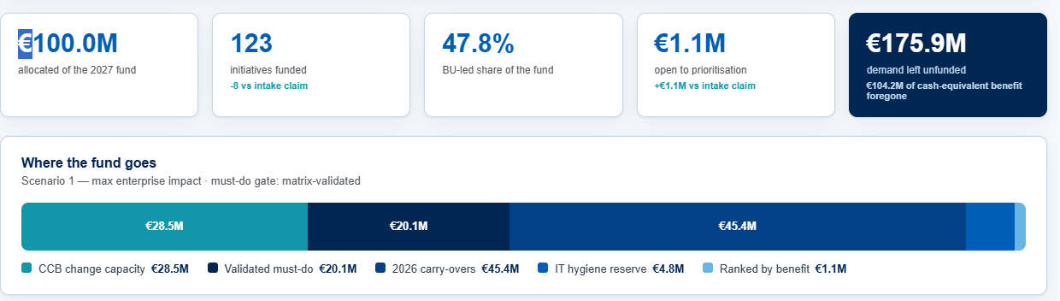
Image 1. Scenario KPI cards and the allocation bar. Replace legacy stages and values with the five approved stages and current final scenario results.
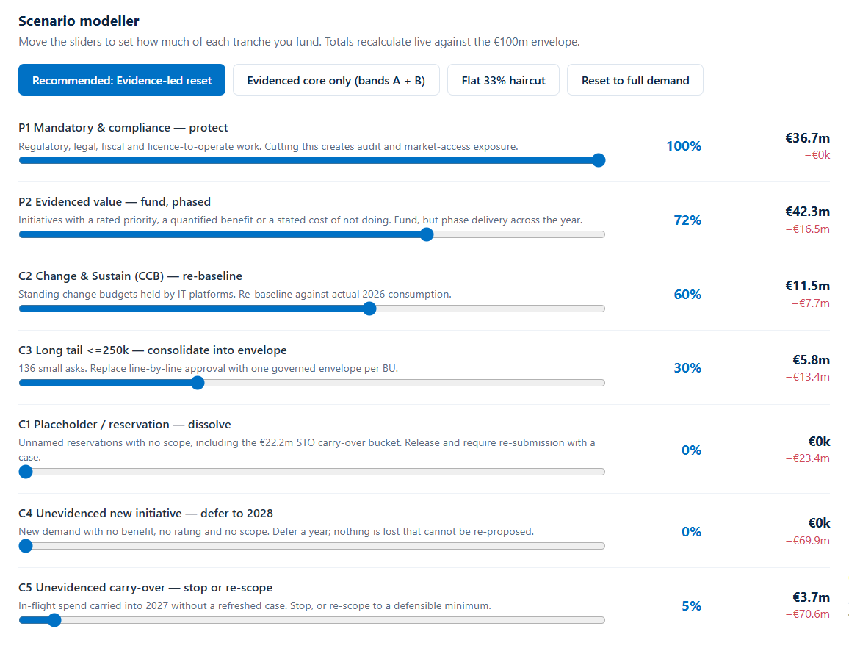
Image 2. Slider and input hierarchy. Rebuild with the five approved levers in a horizontal desktop section; retain numeric entry, visible basis and target amounts. Old tranche percentages are not defaults.

Image references for gates and demand
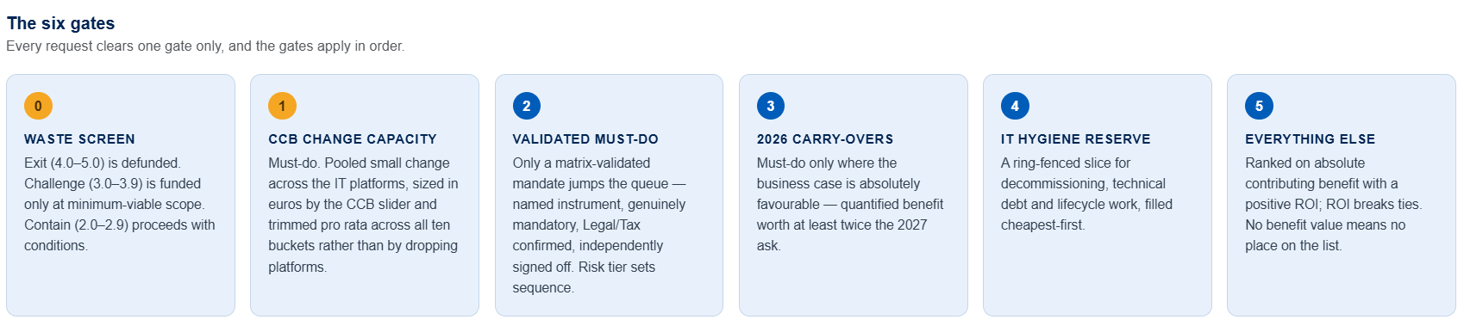
Image 3. Six gate cards. Gate 0 becomes Evidence and decision check; the next five cards follow the approved funding sequence. Remove legacy waste and CCB rules.
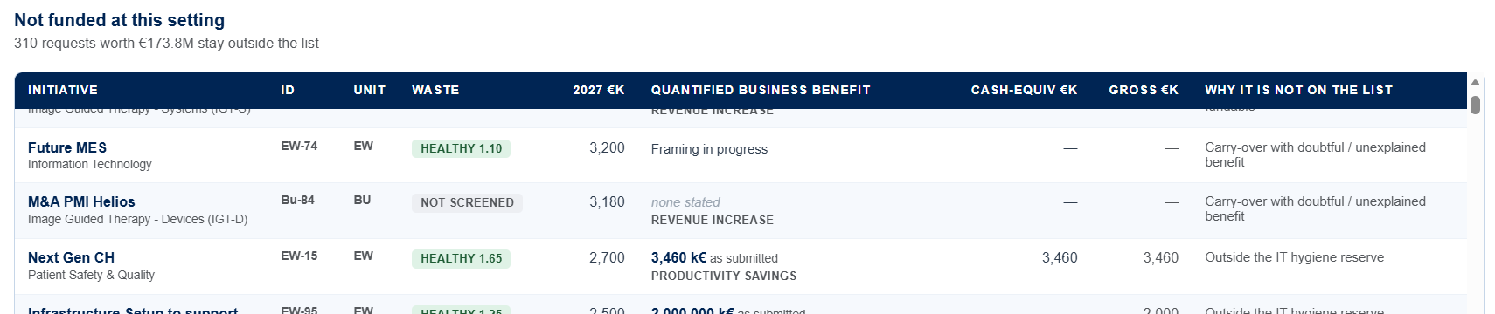
Image 4. Unfunded demand table. Use BURF, program, demand type, requested amount, merit, benefit details and outcome reason, plus residual demand for partial scopes.
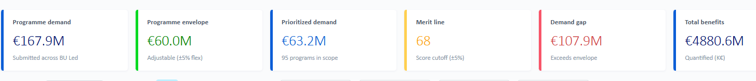
Image 5. Stream KPI cards. Populate from the active scenario, make cards fill the row and distinguish the demand gap from budget variance.

Reference file locations
Controlling design: C:\Users\320126040\Documents\Codex\2026-09-15\create-an-image-of-2\outputs\AOP2027-IT-Portfolio-Scenario-Modelling.html
Supporting component example: C:\Users\320126040\OneDrive - Philips\Download\IT Portfolio Prioritisation 2027 — Philips.html
Latest approach: C:\Users\320126040\Documents\Codex\AOP2027\Approach\AOP2027-Detailed-Prioritisation-Approach.docx
Calculation source: C:\Users\320126040\Documents\Codex\AOP2027\AOP 2027 Demand\15926_IT AOP2027 Demand.xlsx
Source workbook SHA-256: 4ca3c6d4295996c1ff3062d22679ef272ee88a38a6050e112014e5ce25e2ba89
Design HTML SHA-256: efabddd204187f62ccb077b94639344452ff9b38e0d3b3282b887553930a68c2

Image references for filters and details
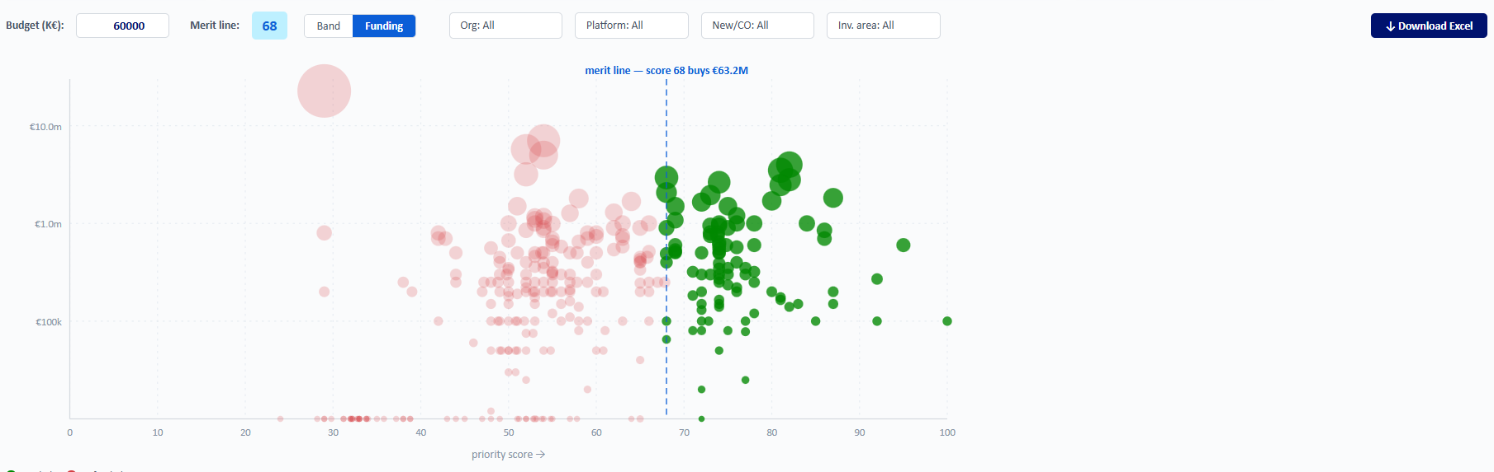
Image 6. Filter row and bubble chart. Filters combine left to right and use checkboxes. Expand the plot to fill its panel and export matching rows as Excel.
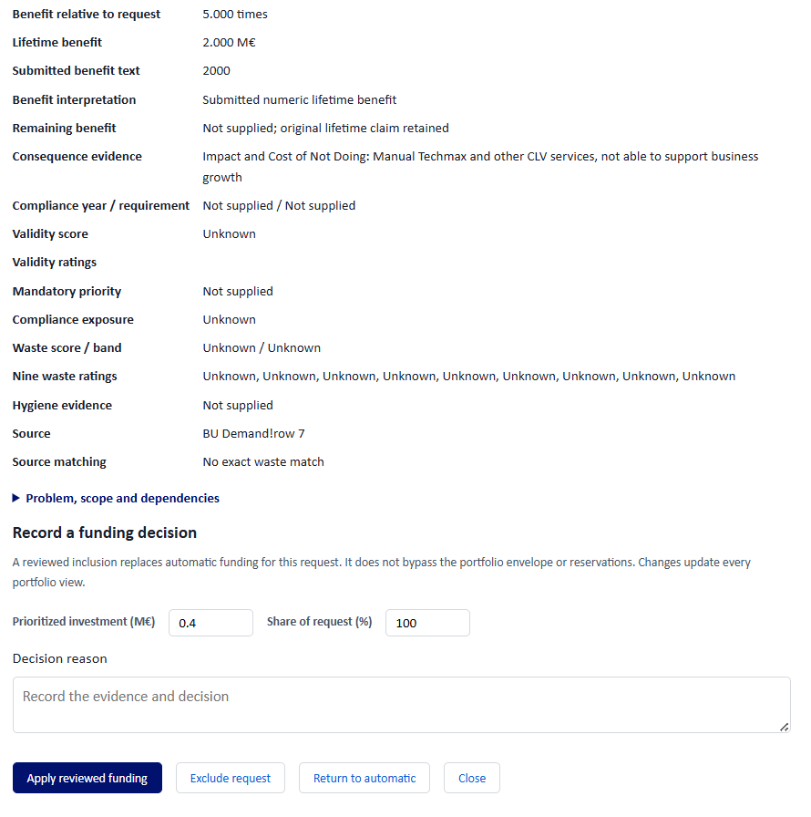
Image 7. Program evidence reference. Show nonblank fields in a compact read-only popup opened from Program Name. Remove Record a funding decision and every funding input or action shown here.
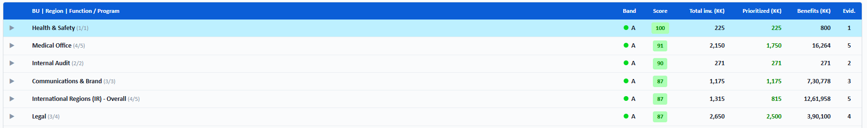
Image 8. Collapsed BURF table reference. Show aggregate child and funded counts, representative band, average merit, summed financial values and evidence count. Open a row to work with its programs.

