Cairo University  
Faculty of Computers and Information



**CS251**

**Software Engineering I**

Online Educational Games

Software Requirements Specifications

Team Names

Eslam Hassan Ali

Ahmed Mohamed El-Sayed

Mohamed Sayed El-Naggar

Amr Kamal El-Deen

2016-2017

Contents

Team 3

Document Purpose and Audience 3

Introduction 3

Software Purpose 3

Software Scope 3

Definitions, acronyms, and abbreviations 3

Requirements 4

Functional Requirements 4

Non Functional Requirements 4

System Models 5

Use Case Model 5

Use Case Tables 6-16

Ownership Report 17

# 

# Team

|  |  |  |  |
| --- | --- | --- | --- |
| **ID** | **Name** | **Email** | **Mobile** |
| 20120055 | Ahmed Mohamed El-Sayed | negro.mido74@gmail.com | 01113582953 |
| 20120086 | Eslam Hassan Alii | Eslam.hassan7472@gmail.com | 01119791819 |
| 20120314 | Mohamed Sayed El-Naggar | [mohamedsayedfci@gmail.com](mailto:mohamedsayedfci@gmail.com) | 01112110371 |
| 20120267 | Amr Kamal El-Deen | [Amrkamal.k7@gmail.com](mailto:Amrkamal.k7@gmail.com) | 01112070653 |

# Document Purpose and Audience

* **Educational document to learn concepts of many categories .**
* **Students and teachers will read this document.**

# Introduction

## Software Purpose

* **The project will be a gaming educational platform. This platform will help students to understand basic educational concepts while they will be playing simple games. These concepts will be related to categories like science, technology and math.**

## Software Scope

* **This project will be a web application .**
* **It will be categories for education only like (science , math , programming and technology) .**
* **Teachers and students will be able to use this application and they should have an account to login .**
* **Student can play , rate and comment on the game .**
* **Teacher can play , create a game and respond .**

## Definitions, acronyms, and abbreviations

# No abbreviations in this project description .

# Requirements

## Functional Requirements

* **This website allows the user (student or teacher) to sign up and has an account by entering username and password.**
* **If the user already has an account the website allows the user to login by his username and password .**
* **The user will be able to show his information like (name , age and score)**
* **After logging in the user will be able to select the category that he wants to play like (science , math , programming , technology ) .**
* **The user will start the game .**
* **The user will able to pause the game and he also will be able to end the game after finishing playing .**
* **If the user is a student he will be able to rate the game and write a comment .**
* **If the user is a teacher he will able to create a game and edit or remove this game and he also will be able to respond on student comment .**

## Non Functional Requirements

|  |  |
| --- | --- |
|  | **Details** |
| **Performance** | * **The system will take 5 mili seconds to login .** * **The system will take 7 mili seconds to check username and password .** |
| **Scalability** | * **The System should be able to support up to 500 game players.** |
| **Usability** | * **The system should has clear information to facilitate the user operations .** |
| **Reliability** | * **The system should check the age of user then it will show the concept of the course according to this age .** |
| **Security** | * **The system is a closed source .** * **The system will close the account automatically when the user doesn't make any actions withdraw 20 minutes .** |
| **Maintainability** | * **The system will be updated every month and new versions will be available** * **The system will be able to fix any debugs during this month .** |

# 

# System Models

## Use Case Model

## 

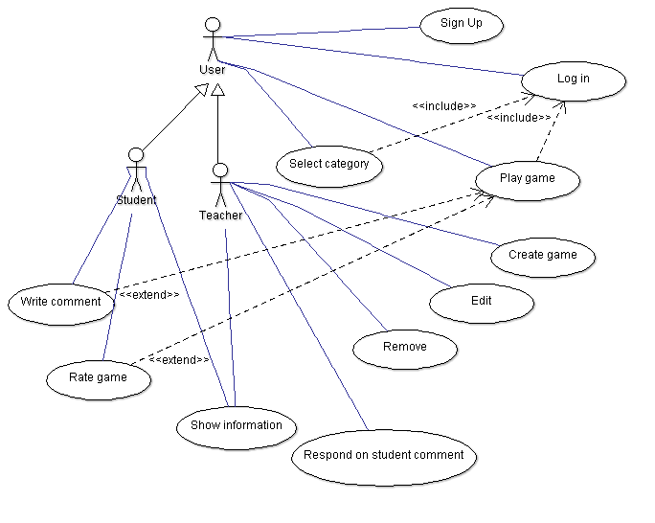

## Use Case Tables

|  |  |  |
| --- | --- | --- |
| Use Case ID: | 1 | |
| Use Case Name: | Sign Up | |
| Actors: | User(Teacher,Student) | |
| Pre-conditions: | Open the website | |
| Post-conditions: | Account created and Logged in to the website | |
| Flow of events: | **User Action** | **System Action** |
| 1- Enter information details (Name , Age , E-mail and Gender) |  |
|  | 2- System check this information . |
|  | 3- Save this info. Into the database . |
| Exceptions: | **User Action** | **System Action** |
| 1- User Enter information details |  |
|  | 2- system went down.  3- System rejects informations. |
| Includes: | - User must have an internet connection | |
| Notes and Issues: | --- | |

# 

|  |  |  |
| --- | --- | --- |
| Use Case ID: | 2 | |
| Use Case Name: | Login | |
| Actors: | User(Teacher,Student) | |
| Pre-conditions: | Signed Up | |
| Post-conditions: | View the home page.  Make actions on the website. | |
| Flow of events: | **User Action** | **System Action** |
| 1- Enter Username and Password. |  |
|  | 2- System check this Username and Password . |
| Exceptions: | **User Action** | **System Action** |
| 1- User Enter Username or password incorrectly. |  |
|  | 2- system went down. |
| Includes: | - User already have an account | |
| Notes and Issues: | --- | |

|  |  |  |
| --- | --- | --- |
| Use Case ID: | 3 | |
| Use Case Name: | Select category | |
| Actors: | User(Teacher,Student) | |
| Pre-conditions: | Logged in to the site | |
| Post-conditions: | Start the game | |
| Flow of events: | **User Action** | **System Action** |
| 1- User selects the category. |  |
|  | 2- System enter user to category he selected. |
| Exceptions: | **User Action** | **System Action** |
| 1- User choose wrong category. |  |
|  | 2- system went down. |
| Includes: | - User already have an account  -User shoud logged in website | |
| Notes and Issues: | --- | |

|  |  |  |
| --- | --- | --- |
| Use Case ID: | 4 | |
| Use Case Name: | Play game | |
| Actors: | User(Teacher,Student) | |
| Pre-conditions: | Select category | |
| Post-conditions: | Playing the game | |
| Flow of events: | **User Action** | **System Action** |
| 1- Click to start game |  |
|  | 2- System open the game to the user |
|  | 3-User playing the game |  |
| Exceptions: | **User Action** | **System Action** |
| 1- User leave the game along time |  |
|  | 2- system logged user out |
| Includes: | -User should choose the category | |
| Notes and Issues: | --- | |

|  |  |  |
| --- | --- | --- |
| Use Case ID: | 5 | |
| Use Case Name: | Write comment | |
| Actors: | User(Student) | |
| Pre-conditions: | End game | |
| Post-conditions: | Comment will be written | |
| Flow of events: | **User Action** | **System Action** |
| 1- write the comment |  |
|  | 2- System save the comment |
|  |  | 3- system will show the comment to all users |
| Exceptions: | **User Action** | **System Action** |
| 1- write comment incorrectly |  |
|  | 2- system went down. |
|  |  | 3- system will not save the comment |
| Includes: | -User should ended the game | |
| Notes and Issues: | --- | |

|  |  |  |
| --- | --- | --- |
| Use Case ID: | 6 | |
| Use Case Name: | Rate the game | |
| Actors: | User(Student) | |
| Pre-conditions: | End game | |
| Post-conditions: | The game will be rated | |
| Flow of events: | **User Action** | **System Action** |
| 1- user will rate the game |  |
|  | 2- System saves this rate |
|  |  | 3- system will show this rate to all users |
| Exceptions: | **User Action** | **System Action** |
| 1- User enter wrong rate |  |
|  | 2- system went down. |
|  |  | 3- system don’t save the rate. |
| Includes: | -User should end the game | |
| Notes and Issues: | --- | |

|  |  |  |
| --- | --- | --- |
| Use Case ID: | 7 | |
| Use Case Name: | Respond on student comment | |
| Actors: | User(teacher) | |
| Pre-conditions: | Write comment | |
| Post-conditions: | Respond of teacher will be submited | |
| Flow of events: | **User Action** | **System Action** |
| 1- user will reply on student`s comment |  |
|  | 2- System saves this respond |
|  |  | 3- system will show this respond to all users |
|  | 4- So on |  |
| Exceptions: | **User Action** | **System Action** |
| 1- User reply on another comment |  |
|  | 2- system went down. |
|  |  | 3- system don’t save the respond. |
| Includes: | - Student should leave a comment | |
| Notes and Issues: | --- | |

|  |  |  |
| --- | --- | --- |
| Use Case ID: | 8 | |
| Use Case Name: | Show information | |
| Actors: | User(Student,Teacher) | |
| Pre-conditions: | Log in | |
| Post-conditions: | The information will be shown to the user | |
| Flow of events: | **User Action** | **System Action** |
| 1- user click to show information |  |
|  | 2- System display the information |
|  | 3- user edit his information |  |
|  |  | 4- system saves the new informations |
| Exceptions: | **User Action** | **System Action** |
| No exception |  |
|  | 2- system went down. |
|  |  | 3- system don’t save the new information |
| Includes: | - User should logged in | |
| Notes and Issues: | --- | |

|  |  |  |
| --- | --- | --- |
| Use Case ID: | 9 | |
| Use Case Name: | Craete game | |
| Actors: | User(teacher) | |
| Pre-conditions: | Log in | |
| Post-conditions: | The game will be created | |
| Flow of events: | **User Action** | **System Action** |
| 1- user will create the game |  |
|  | 2- System creates the game |
|  |  | 3- system will show this game to all users |
| Exceptions: | **User Action** | **System Action** |
| 1- User create the game and not select the category |  |
|  | 2- system went down. |
|  |  | 3- system don’t save the game. |
| Includes: | - The user should be logged in | |
| Notes and Issues: | --- | |

|  |  |  |
| --- | --- | --- |
| Use Case ID: | 10 | |
| Use Case Name: | Edit | |
| Actors: | User(Teacher) | |
| Pre-conditions: | Create game | |
| Post-conditions: | The game will be edited | |
| Flow of events: | **User Action** | **System Action** |
| 1- user will edit the game |  |
|  | 2- System saves this edit |
|  |  | 3- system will display the edited game to all users |
| Exceptions: | **User Action** | **System Action** |
| 1- No Exeptions |  |
|  | 2- system went down. |
| Includes: | -The user should logged in  -The Teacher should create the game | |
| Notes and Issues: | --- | |

|  |  |  |
| --- | --- | --- |
| Use Case ID: | 11 | |
| Use Case Name: | Remove | |
| Actors: | User(Teacher) | |
| Pre-conditions: | Create game | |
| Post-conditions: | The game will be removed | |
| Flow of events: | **User Action** | **System Action** |
| 1- user click to remove the game |  |
|  | 2- System will remove the game |
|  |  | 3- system will send a message to all users that this game was removed |
| Exceptions: | **User Action** | **System Action** |
| 1- No exeptions |  |
|  | 2- system went down. |
| Includes: | -The user should logged in  -The Teacher should create the game | |
| Notes and Issues: | --- | |

# Ownership Report

|  |  |
| --- | --- |
| **Item** | **Owners** |
| Ahmed Mohamed El-Sayed | *Purpose , scope and use case tables* |
| Eslam Hassan Ali | *Use case models and use case tables* |
| Mohamed Sayed El-Naggar | *Functional requirements and use case tables* |
| Amr Kamal El-Deen | *Non functional requirements and use case tables* |