Cairo University  
Faculty of Computers and Information



**CS251**

**Software Engineering I**

Online Educational game

Software Design

Team Names

Month & Year

Contents

Instructions [To be removed] 3

Team 3

Document Purpose and Audience 3

System Models 3

I. Class diagrams 4

Important Algorithm 5

II. Sequence diagrams 6-8

Class - Sequence Usage Table 9

# Team

|  |  |  |  |
| --- | --- | --- | --- |
| **ID** | **Name** | **Email** | **Mobile** |
| 20120055 | Ahmed Mohamed el-naggar | Negro.mido74@gmail.com |  |
| 20120314 | Mohamed sayed el-naggar | Mohamedsayedfci8@gmail.com |  |
| 20120086 | Eslam hassan ali | Eslamhassan7472@gmail.com |  |
| 20120267 | Amr kamal el-diin | Amr kamal Eldeen hassan |  |

# Document Purpose and Audience

* This document illustrates the design of the project
* This design used in the implementation
* This design facilitates the implementation of the project

# System Models

## I. Class diagrams

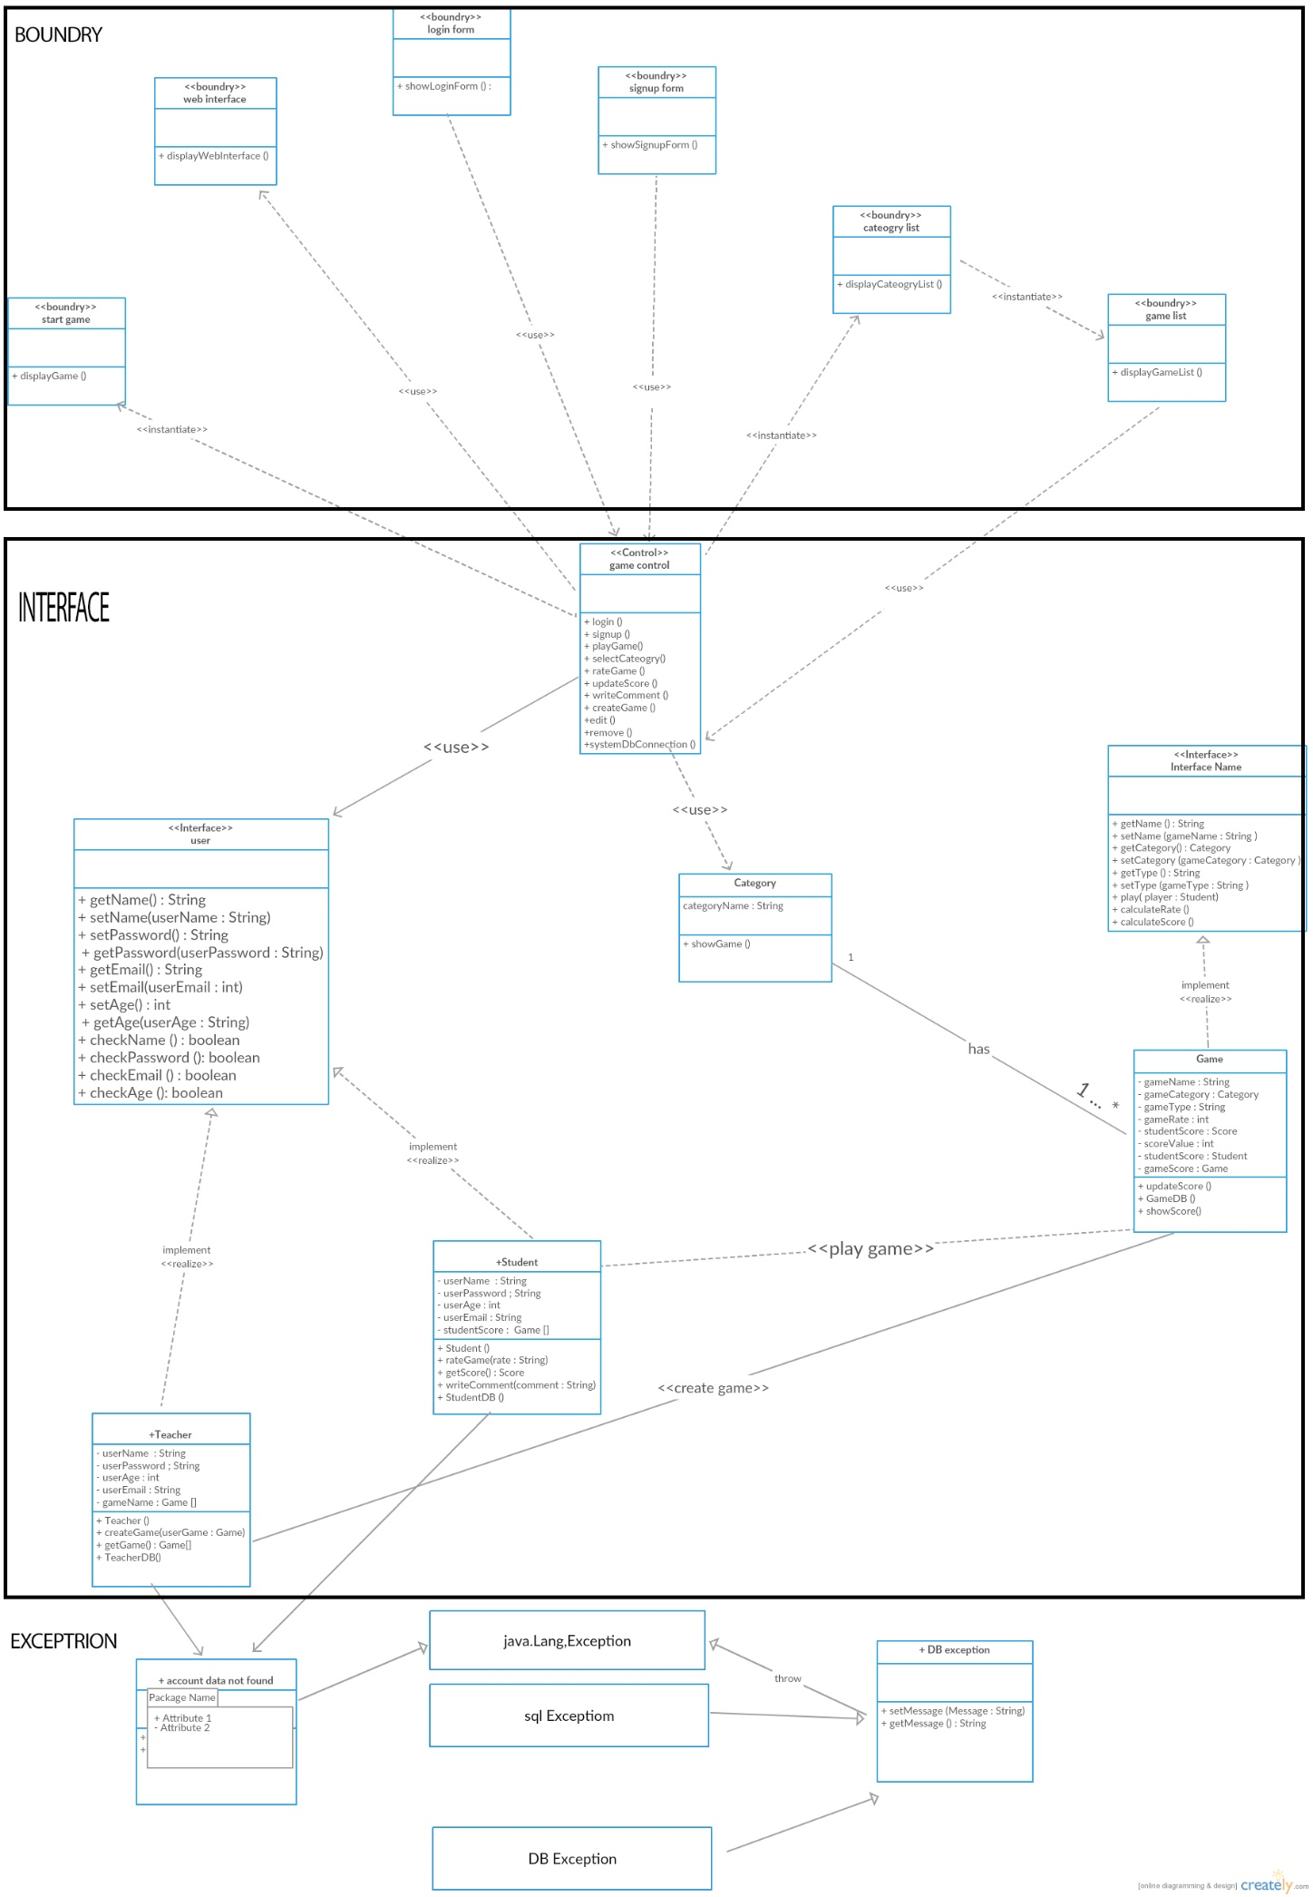

| **Class ID** | **Class Name** | **Description & Responsibility** |
| --- | --- | --- |
| 1 | Web Interface | Display the site services to the user |
| 2 | Login Form | Allows the user to use the site by entering username and password |
| 3 | SignUp Form | Allows the user to create an account to login to the site |
| 4 | Category list | Allows the user to choose the category of the game |
| 5 | Game list | Display the list of the games |
| 6 | Start game | Allows the user to play the game |
| 7 | Game control | Connect classes to each other |
| 8 | Category | Retrieve the category list to the controller game to view it to the user |
| 9 | Game | Implement the game rules |
| 10 | User(student and Teacher) | Save data about student and teacher |
| 11 | Account data not found | Check the exception if the data of the user not correctly |
| 12 | DB Exception | Check if there is no connection with the DB or if the DB retrieve wrong results |

## II. Sequence diagrams

**1)**

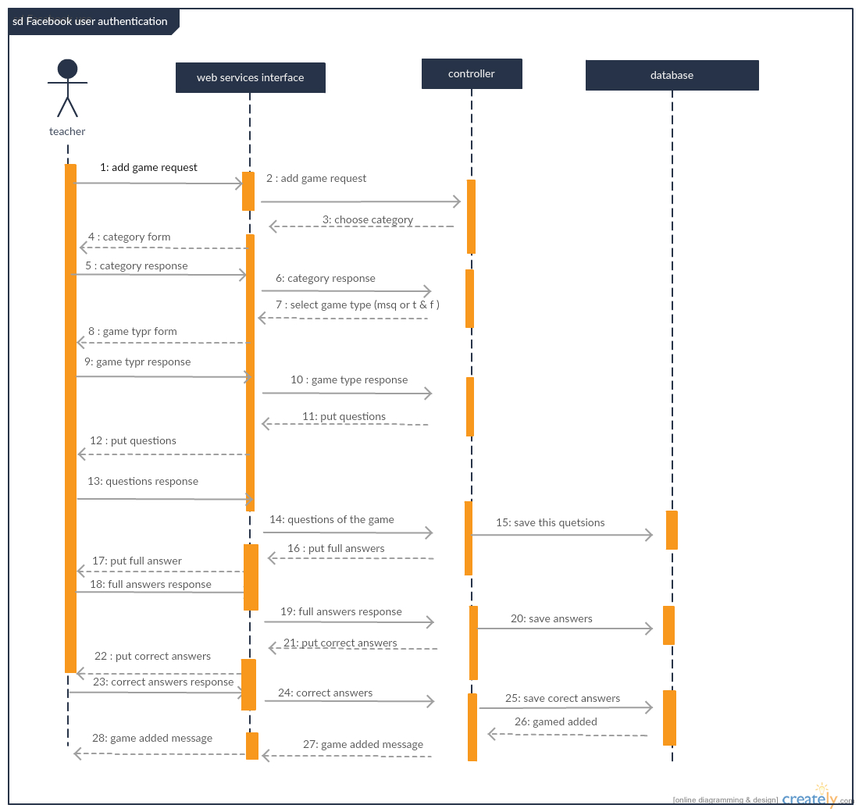

**2)**

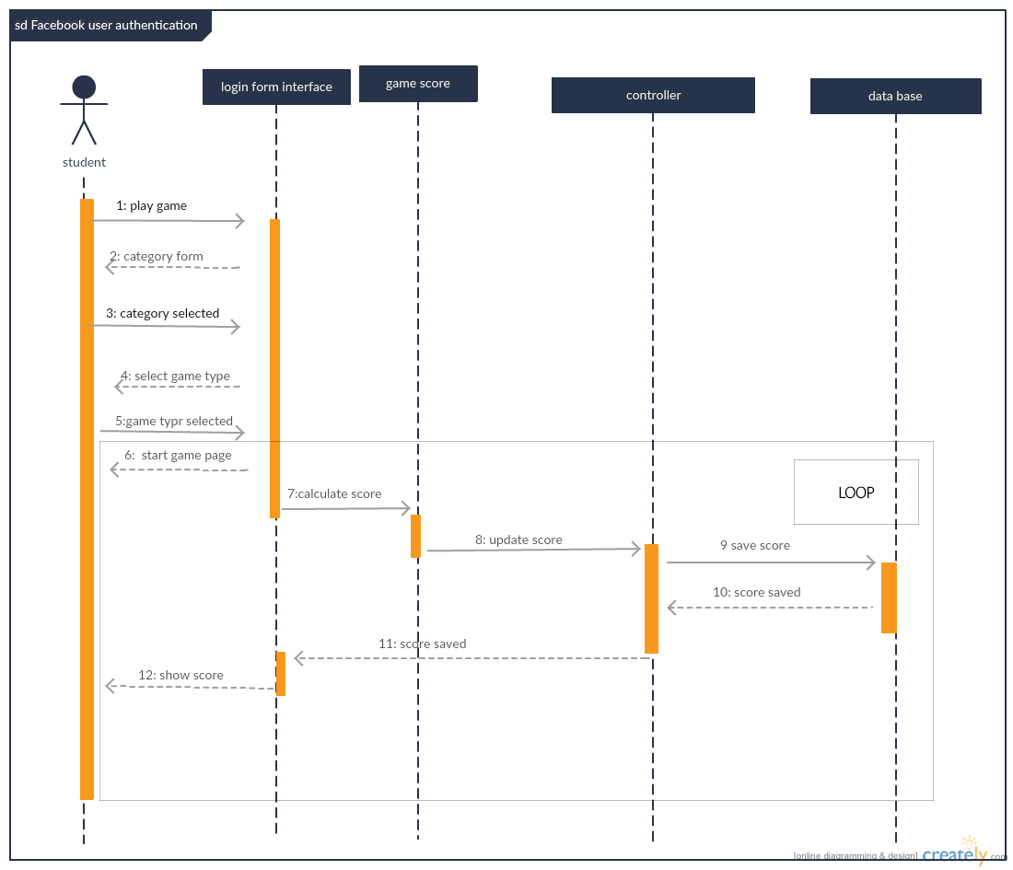

**3)**

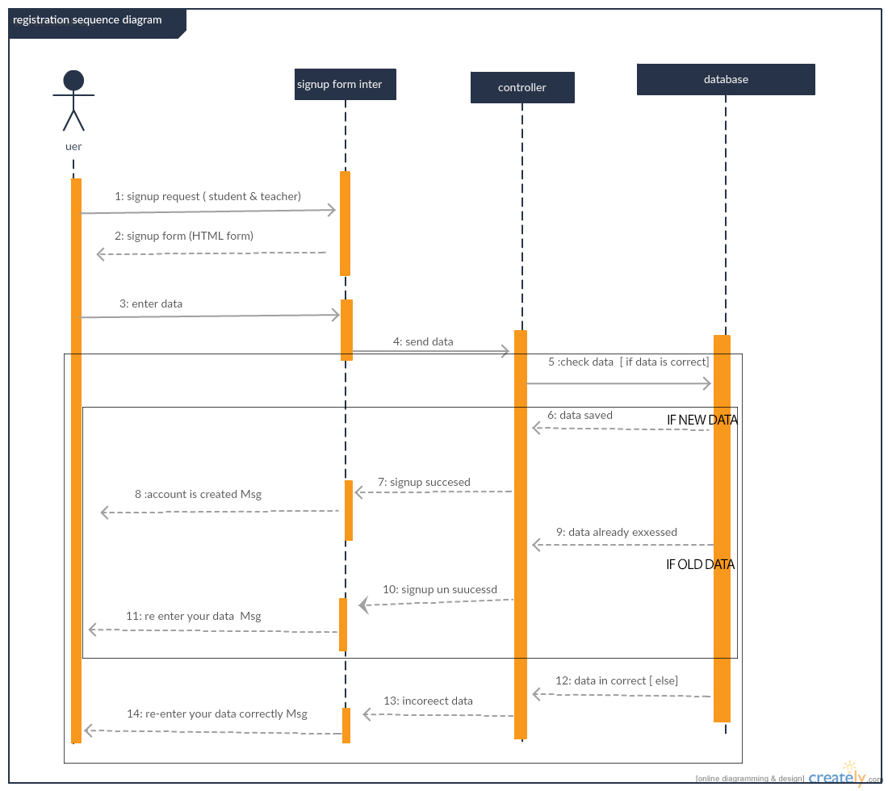

### 

### Class - Sequence Usage Table

| **Class Name** | **Sequence Diagrams** | **Overall used methods** |
| --- | --- | --- |
| Web Interface | 1 | Add game |
| Login form | 2 | Login |
| Sign up form | 3 | Sign up |
| Category list |  |  |
| Game list |  |  |
| Start game |  |  |
| Game control | 1,2,3 | Save data , get data and check data |
| Category |  |  |
| Game | 2 | Update score , calculate score |
| User | 3 | Login , sign up |
| teacher | 1 | Add game |
| student | 2 | Play game |

# Git-hup link

[https://github.com/amrkamal123/SW_project](%20https:/github.com/amrkamal123/SW_project)