**Online CV Builder**

**Online Resume Builder Data Base Project.**

**Faculty of Engineering , Al-Azher University .**

**Department of Systems and Computer Science.**

**Third Division , Second Term.**

**Subject : Data Base.**

**Project name : Online CV Builder.**

**Under the Supervision of Dr. Gamal Tharwat.**

**Team Members:**

**1-Amr Rabea Mabrok Ibrahem…78**

**2-Eslam Esam Eldin Mohamed…26**

**3-Mohamed Maghawry Ismail…119**

**4-Mahmoud Abdel-Rahman Badr…126**

**5-Khaled Mohamed Elsaid Ahmed…150**

**Introduction**

**This project is to make it easier for Users to design their own CV where we ask them for their data that we want and then store it in the Database in an organized and correct way and display it in the final image in the form of a CV file.**

**We require the entry of certain data and on special conditions so that there are no errors, so we ask that the names be entered in the form of letters, for example.**

**The process of selecting Entities and Attributes, as well as the relationships between the Entities, must be consistent with the goal of the project and fulfill the requirements.**

**We have tried to achieve this with our small experience and our current information, and we hope that God will grant us success in that.**

**Entities With Attributes**

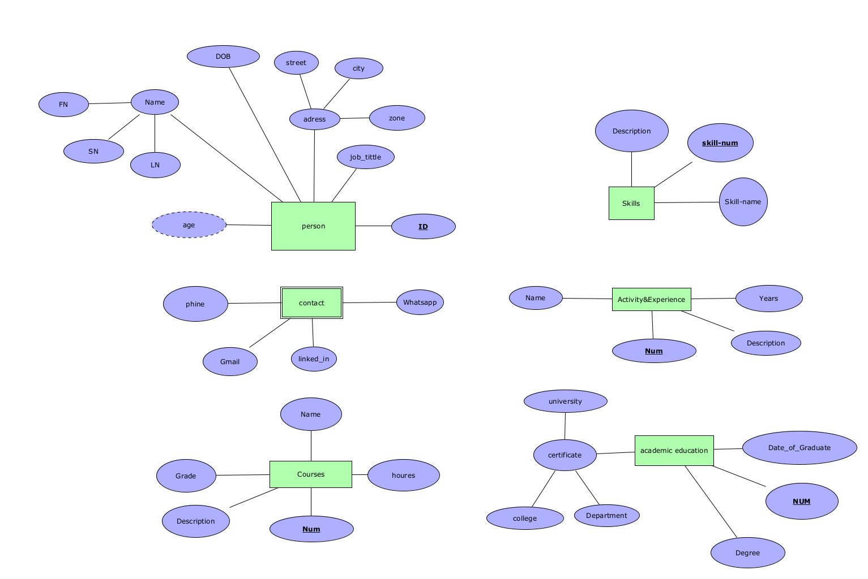

**Entities Relationships**

**z**

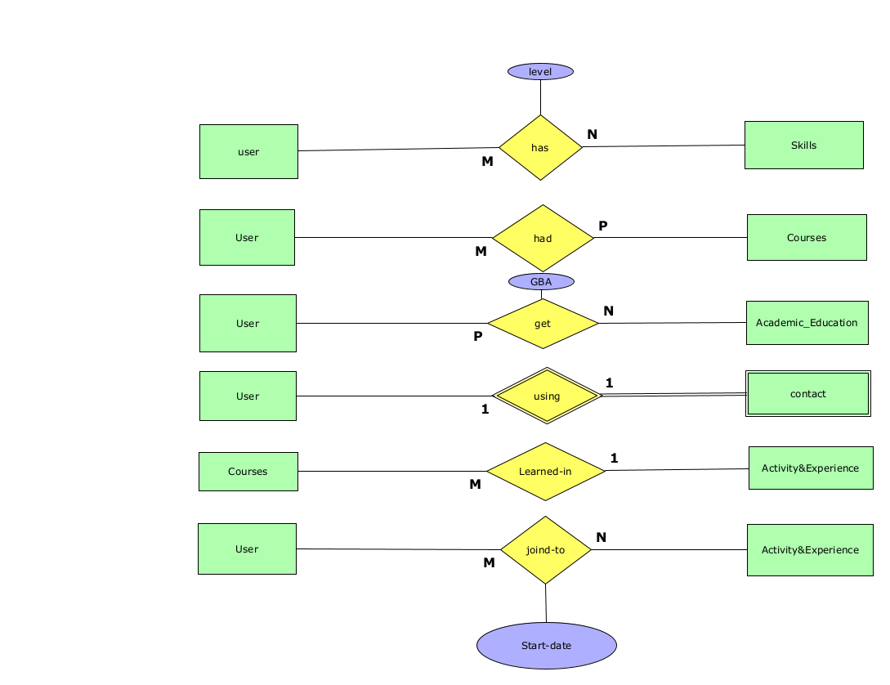

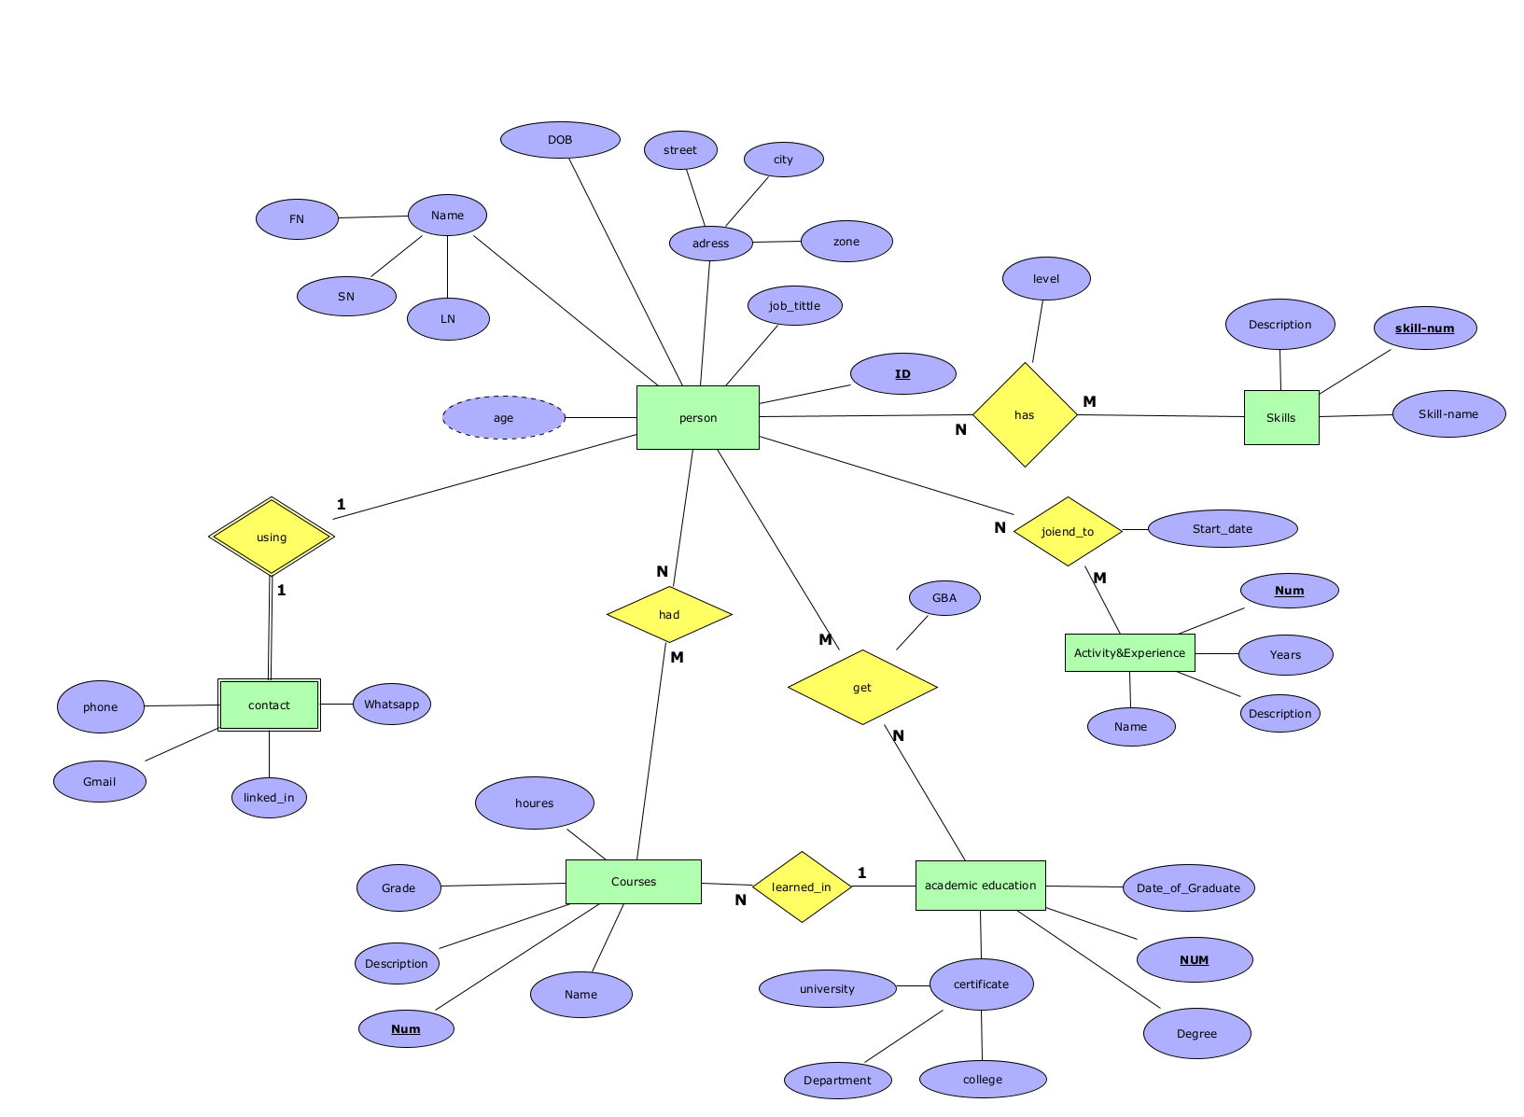**Full ERD Diagram**

**Relationships Mapping** 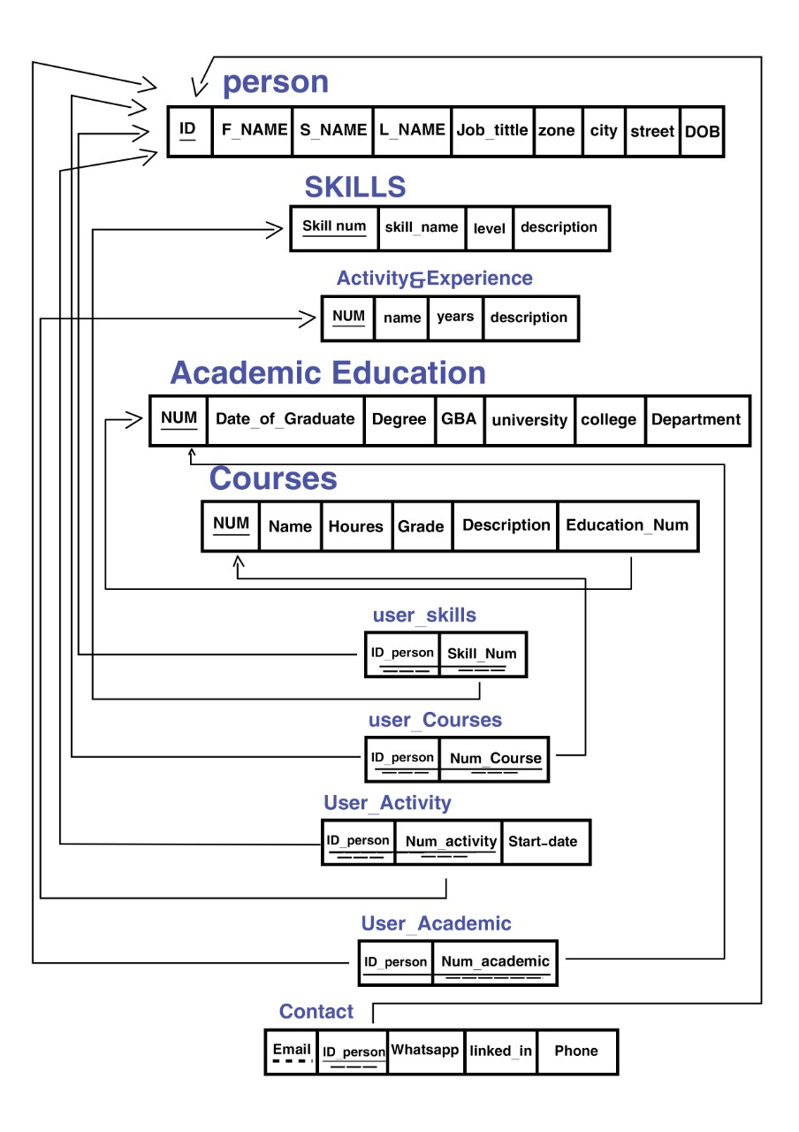

**Data Dictionary**

|  |  |  |  |  |  |  |
| --- | --- | --- | --- | --- | --- | --- |
| **No**  **person** | **Attribute Name** | **Data Type** | **Description** | **PK** | **FK** | **Reference** |
| 1 | ID | Varchar(6) | ID_Person | Yes |  |  |
| 2 | F_Name | Varchar(15) | First_Name_Of_Person  Not-Null |  |  |  |
| 3 | S_Name | Varchar(15) | Seound_Name_Of_Person |  |  |  |
| 4 | L_name | Varchar(15) | last_Name_Of_Person  Not-Null |  |  |  |
| 5 | Job_Title | Varchar(15) | Job_Title  Not-Null |  |  |  |
| 6 | Zone | Varchar(6) | Person_Zone |  |  |  |
| 7 | City | Varchar(6) | Person_City |  |  |  |
| 8 | Street | Varchar(6) | Person_Street |  |  |  |
| 9 | DOB | Date(10) | Date of birth |  |  |  |

|  |  |  |  |  |  |  |
| --- | --- | --- | --- | --- | --- | --- |
| **No**  **CONTACT** | **User Email** | **Data Type** | **Description** | **PK** | **FK** | **Reference** |
| 1 | ID_person | Varchar(6) | ID | Yes | Yes | User |
| 2 | Email | Varchar(30) | name |  |  |
| 3 | Whatsapp | Varchar(50) | Link |  |  |  |
| 4 | Linkedin | Varchar(50) | Link |  |  |  |

|  |  |  |  |  |  |  |
| --- | --- | --- | --- | --- | --- | --- |
| **No**  **SKILLS** | Attribute name | **Data Type** | **Description** | **PK** | **FK** | **Reference** |
| 1 | Skill_Num | Number(5) | Primary_key | Yes |  |  |
| 2 | Skill_Name | Varchar(15) | Not_Null |  |  |  |
| 3 | Level | Number(3) | Percentage |  |  |  |
| 4 | Description | Varchar(100) | Description-of-skill |  |  |  |

|  |  |  |  |  |  |  |
| --- | --- | --- | --- | --- | --- | --- |
| **No**  **person_SKILL** | **Attribute Name** | **Data Type** | **Description** | **PK** | **FK** | **Reference** |
| 1 | ID_person | Varchar(6) | Id-of-person | Yes | Yes | User |
| 2 | Skill_Num | Varchar(5) | Number-of-skill | Skills |

|  |  |  |  |  |  |  |
| --- | --- | --- | --- | --- | --- | --- |
| **No**  **Person_academic** | Attribute Name | **Data Type** | **Description** | **PK** | **FK** | **Reference** |
| 1 | ID_person | Varchar(6) | Id-of-person | Yes | Yes | User |
| 2 | Academic_Num | Number(5) | Number-of-Academic | Academic Education |

|  |  |  |  |  |  |  |
| --- | --- | --- | --- | --- | --- | --- |
| **No**  **Activity&Experience** | **Attribute Name** | **Data Type** | **Description** | **PK** | **FK** | **Reference** |
| 1 | Num | Number(2) | Number-of-activity | Yes |  |  |
| 2 | Name | Varchar(20) | Name-of-activity |  |  |  |
| 3 | Years | Number(2) | Number-of-years-of-experience |  |  |  |
| 4 | Description | Varchar(100) | Description-of-Activity |  |  |  |

|  |  |  |  |  |  |  |
| --- | --- | --- | --- | --- | --- | --- |
| **No**  **CPURSES** | **Attribute Name** | **Data Type** | **Description** | **PK** | **FK** | **Reference** |
| 1 | Course_Num | Number(6) | Number-of-course | Yes |  |  |
| 2 | Course_Name | Varchar(20) | Name-of-course |  |  |  |
| 3 | Hours | Number(2) | Hours-of-course |  |  |  |
| 4 | Grade | Number(3) | In Percentage |  |  |  |
| 5 | Description | Varchar(100) | Description-of-course |  |  |  |
| 6 | Education_Num | Number(4) | Number-of-education |  | Yes | Academic Education |

|  |  |  |  |  |  |  |
| --- | --- | --- | --- | --- | --- | --- |
| **No**  **Person_Activity** | **Attribure Name** | **Data Type** | **Description** | **PK** | **FK** | **Reference** |
| 1 | ID_Person | Varchar(6) | Id-of-person | Yes | Yes | User |
| 2 | Num_Activity | Number(6) | Number-of-Activity | Activity |
| 3 | Start_Date | Date | Date |  |  |  |

|  |  |  |  |  |  |  |
| --- | --- | --- | --- | --- | --- | --- |
| **No**  **Academic_Education** | **Attribute Name** | **Data Type** | **Description** | **PK** | **FK** | **Reference** |
| 1 | Num | Number(2) | Number-of-Academic-Education | Yes |  |  |
| 2 | Date of Graduate | Date(10) | DOG |  |  |  |
| 3 | Degree | Number(4) | Percentage |  |  |  |
| 4 | GBA | Varchar(4) | GBA-of-Person |  |  |  |
| 5 | University | Varchar(20) | University-of-Person |  |  |  |
| 6 | College | Varchar(20) | College-of-Person |  |  |  |
| 7 | Department | Varchar(20) | Department-of-Person |  |  |  |

|  |  |  |  |  |  |  |
| --- | --- | --- | --- | --- | --- | --- |
| **No**  **Person_Course** | **Attribute Name** | **Data Type** | **Description** | **PK** | **FK** | **Reference** |
| 1 | ID_person | Varchar(6) | Id_of_person | Yes | Yes | User |
| 2 | Course_Num | Number(6) | Number-of-course | Courses |