

تحت اشراف
أ. د \ خالد فتحي
عمرو خالد منصور حسن – نظم معلومات (IS)
شيماء عيد موسى – نظم معلومات (IS)
حسام حسين عبد الستار – هندسة برمجيات (SE)
سهام سيد شعيب – نظم معلومات (IS)
-----
كلية الحاسبات والمعلومات - جامعة اسيوط الاهليه
An AI-Powered Student Performance Monitoring & Early-Warning Web System 2
1. Project Overview 2
1.1 Problem Statement 2
1.2 Why Student Performance Prediction Matters 3
2. System Architecture 3
2.1 Architectural Overview 3
2.2 High-Level Architecture Diagram 4
2.3 Component Description 4
User 4
Web Application (Frontend) 4
Backend API 5
Machine Learning Module 5
Supabase 5
2.4 Data Flow Diagram (DFD) 6
3. Database Design 6
3.1 Overview 6
3.2 Entity Relationship Diagram (ERD) 7
4. Machine Learning Module 7
4.1 Models Used 7
4.2 Why Linear Regression Was Chosen 8
4.3 Risk Classification Logic 8
4.4 SHAP Explainability 8
4.5 ML Integration Workflow 9
5. Web Application Features 11
Dashboard 11
Profile 11
To-Study (Kanban) 11
Grades 11
Percentages 11
Comparisons 12
Logout 12
6. Security & Privacy Considerations 12
7. Technology Stack 12
8. Future Enhancements 12
9. Conclusion 13

An AI-Powered Student Performance Monitoring & Early-Warning Web System
Turning student data into early insights, actionable guidance, and academic success.

1. Project Overview

1.1 Problem Statement
Academic underperformance remains a persistent challenge across educational institutions. Students often struggle due to a combination of academic, behavioral, lifestyle, and socioeconomic factors such as low attendance, limited study hours, lack of motivation, inadequate learning resources, poor sleep patterns, or insufficient parental involvement.

In most cases, these issues are only discovered after final exam results, when it becomes difficult to provide meaningful intervention. Traditional evaluation methods depend mainly on final grades and manual observation, which are reactive, time-consuming, and unable to uncover hidden patterns within student data.

There is a clear need for an intelligent, proactive, and data-driven system that can:
- Predict student performance in advance
- Detect academic risk early
- Provide explainable insights and personalized recommendations

Studistic addresses this gap by combining machine learning with a web-based platform to support early academic intervention.

1.2 Why Student Performance Prediction Matters
Predicting student performance enables institutions and students to shift from reaction to prevention.

By analyzing factors such as study habits, attendance, previous grades, lifestyle balance, and learning environment, machine learning models can identify patterns that are not easily observable through traditional analysis.

Early prediction enables:

- Early identification of at-risk students before failure occurs
- Personalized recommendations based on individual weaknesses
- Data-driven decisions for educators and institutions
- Improved student engagement through transparent feedback
- Efficient resource allocation for tutoring and academic support

Integrating these predictions into a web application transforms raw data into a practical decision-support system accessible anytime, anywhere.

2. System Architecture

2.1 Architectural Overview
Studistic follows a modular, scalable architecture that cleanly separates:

- Presentation layer
- Business logic
- Machine learning processing
- Data storage and authentication

This improves security, maintainability, and extensibility.

Core Components:
1. User
2. Web Application (Frontend)
3. Backend API
4. Machine Learning Module
5. Supabase (Database, Auth, Storage)

2.2 High-Level Architecture Diagram
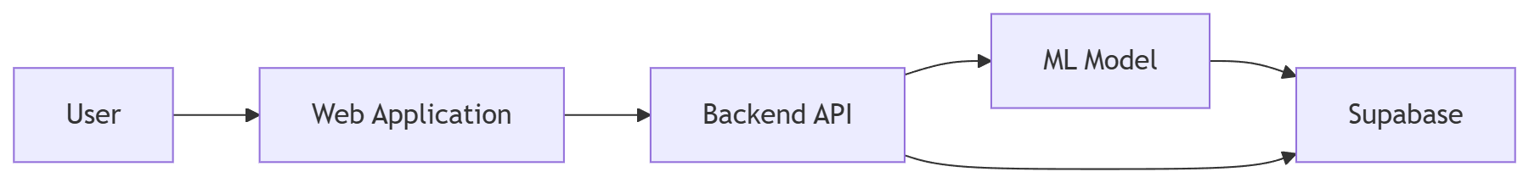

2.3 Component Description

User
The student who interacts with the system to:

- View academic performance
- Receive predictions and risk levels
- Track progress and recommendations

Web Application (Frontend)
Responsibilities:

- Sign up / Sign in
- Dashboard and visualizations
- Predictions and recommendations
- Sidebar navigation (Profile, Grades, Tasks, Comparisons)

The frontend communicates only with the backend API, ensuring security and abstraction.

Backend API
Acts as the system’s control layer:

- Handles authenticated requests
- Retrieves and updates student data
- Sends features to the ML model
- Stores predictions and insights

Machine Learning Module
Responsible for:

- Predicting exam scores
- Classifying academic risk
- Generating explainable insights

The model is server-side only, protecting integrity and preventing misuse.

Supabase
Provides:

- Authentication (secure login & sessions)
- Database (students, features, grades, predictions)
- Storage (profile images)

Supabase enables rapid development with production-ready scalability.

2.4 Data Flow Diagram (DFD)
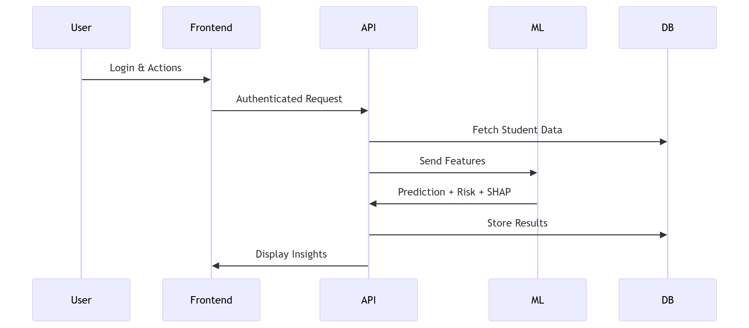

3. Database Design

3.1 Overview
The database is designed to:

- Support secure authentication
- Store ML inputs and outputs
- Enable performance tracking over time

Main Tables:

- users
- student_features
- predictions
- grades

3.2 Entity Relationship Diagram (ERD)
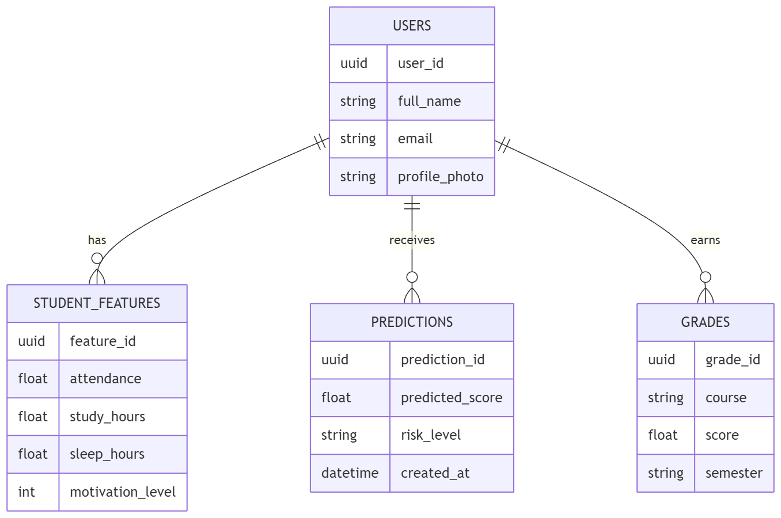

4. Machine Learning Module

4.1 Models Used
- Linear Regression
- Random Forest Regressor
- Artificial Neural Network (ANN)

Models were evaluated using:

- R²
- RMSE
- MAE

4.2 Why Linear Regression Was Chosen
Linear Regression was selected because it offers:

- Strong predictive performance
- Low overfitting risk
- High interpretability
- Seamless SHAP integration

In an educational system, explainability is as important as accuracy.

4.3 Risk Classification Logic
Risk Level | Predicted Score
High Performer | ≥ 75
Medium Risk | 60 – 74
At Risk | < 60
This transforms raw predictions into actionable insights.

4.4 SHAP Explainability
SHAP enables:

- Global explanations (most important features overall)
- Local explanations (why a student got this score)

This builds trust, transparency, and actionable guidance.

4.5 ML Integration Workflow
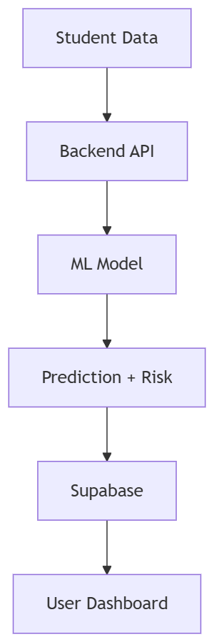

5. Web Application Features

Dashboard
Shows: prediction, risk level, recommendations
Why: instant academic awareness

Profile
Shows: name, photo, basic info
Why: personalization & identity

To-Study (Kanban)
Shows: tasks in To-Do / In-Progress / Done
Why: improves study discipline

Grades
Shows: all course grades
Why: track academic history

Percentages
Shows: feature contributions
Why: understand performance drivers

Comparisons
Shows: performance vs peers (anonymized)
Why: context and motivation

Logout
Why: security and session control

6. Security & Privacy Considerations
- JWT-based authentication (Supabase)
- Role-based access control
- No direct ML access from frontend
- Aggregated peer comparisons only
- Encrypted data storage

7. Technology Stack
Layer | Technology
Frontend | React / Next.js
Backend | Node.js / Python API
ML | Scikit-learn, SHAP
Database | Supabase (PostgreSQL)
Auth | Supabase Auth

8. Future Enhancements
- Educator dashboard
- Real-time alerts
- Mobile app version
- More advanced ML models
- Adaptive recommendations

9. Conclusion
Studistic transforms student data into early warnings, insights, and guidance.
By combining machine learning, explainability, and a modern web application, the system empowers students to take control of their academic journey before failure occurs.

Studistic — Predict Early. Act Smarter. Succeed Faster.

