Cloud

Why cloud?
Physical servers are more expensive, hard to maintain and not flexible when it comes to traffic.

What is cloud?
- Storing data/applications on remote servers.
- Processing data.
- Accessing data.

Service Models

SaaS: Software as a Service

PaaS: Platform as a Service

IaaS: Infrastructure as a Service

Deployment Models
Publc/Private/Hybrid Cloud.

Azure Datafactory
Source: Azure Data Factory Tutorial @ https://www.youtube.com/watch?v=EpDkxTHAhOs

Steps:
- Create Data Factory.
- Create SQL Database.
- Create Storage Account.
- When the Storage Account is deployed >> go to resource >> blobs >> new container >> upload the file (CSV).
- Prepare the database to receive the file from storage by going to the resource group >> SQL Database >> Query Editor >> run SQL Query to create new table(s)
- Go to Data Factory >> Author & Monitor >> “Author” tab on the left (the pen icon)
Analogy: moving cabinet from a shop to home
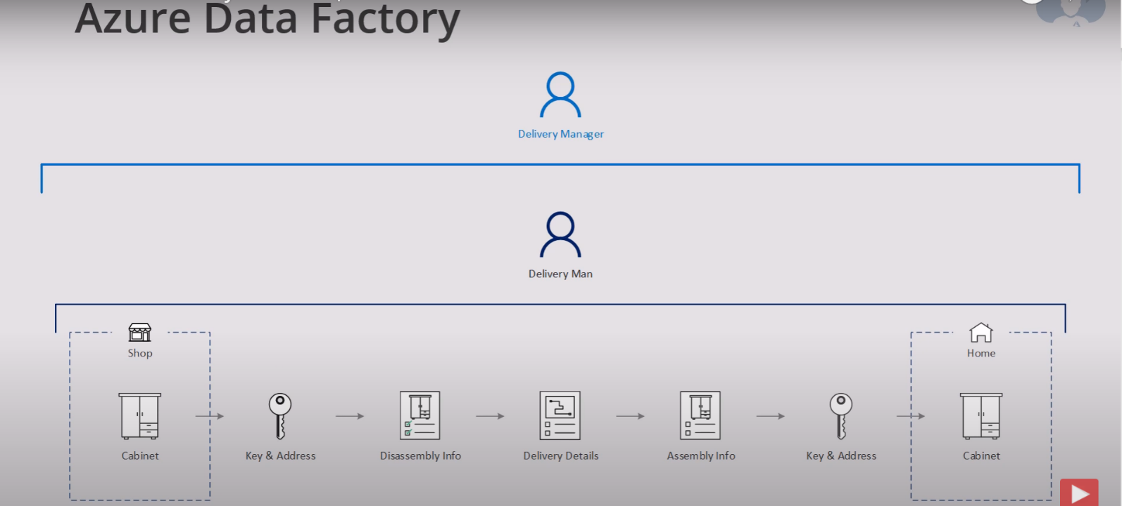
Moving data (CSV file) from Blob storage to customer (SQL Server).
