Additional Information:
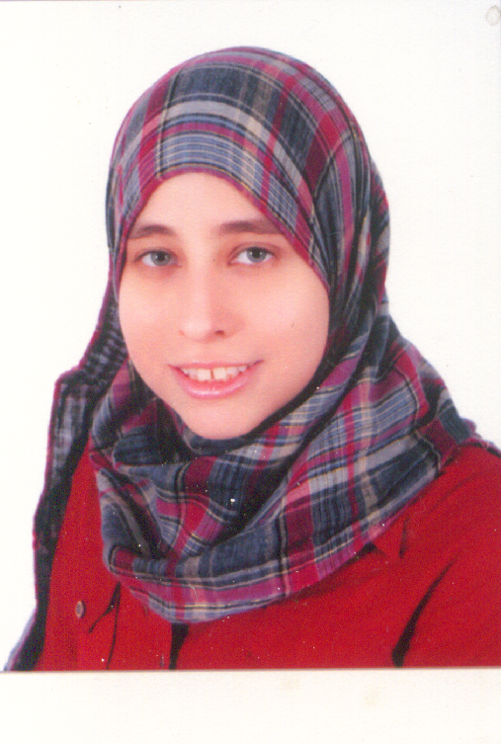

Address : 4 Gamaiet Elnessr Street
Madinet Eldobat
City : Mouhandseen, Giza , dokki
Gender: Female
Nationality: Egyptian
Birth Day: 6/8/1987
Marital Status: Single
Languages: English (good)
Tel : +202 37603379
Mobile : +2 01224826552

E-mail : ayat_eldeek@hotmail.com

Ayat Adel Ahmed El-Deek
_____________________________________________________________________________________________________________________________________________________________________________________________________________________________________________________________________________________________________________________________________________________________________________________________________________________________________________________________________________________________________________________________________________________________________________________________________________________________________________________________________________________________________________________________________________________________________________________

Objective:

I hope this will fully utilize and apply my academic background, and further develop my technical skills and apply.

Education:

B.sc in Commerce, Faculty of Commerce,
Cairo University, May 2008 with good degree.

Soft Skills:

- Ability to work in Teams.
- Work under pressure.
- Self Motivated.
- Good communications with people.

Computer Skills:

Course : Professional Diploma Accounting

- YAT EDUCATION CENTER.

- Windows Vista
- Discovering the Internet
- Excel 2007 for Accountants
- Access 2007 Core
- Accounting Macro
- Office Accounting 2008 Core
- Accounting with Computer
- Banking with Computer
- YPDA Final Project
- CV & Interview Skills

- Course ICDL Diploma.

    - I T
    - Windows XP
    - Internet
    - Word 2003
    - Excel 2003
    - Access 2003
    - Power Point 2003Courses accounting by excel .

- Training Program in the EgyptianAcademy of Legal Accountants

    - Accounting
    - Taxes
    - Establishment
    - Insurance
    - Accounting Excel
    - Peach Tree Program

Experience:

- Summer Training in the field of Banking. Year 2005, year 2007 ( Bank Miser –Mohamed Hafez )
- Candidate From Faculty of Commerce to attend training.
- Mobinil:
- Callcenter ( jun 2010-till now )
- Rotation credit department ( june 2014 till October 2014)

