PSY 308d DA3 Binary Logistic Regression

Daniel Pinedo

April 16, 2019

## Warning: package 'knitr' was built under R version 3.5.3

You have been hired as an Organizational Psychologist for a local restaurant. The Head of HR is concerned about high turnover amongst their servers. Specifically, she is interested in figuring out what predicts whether a server will stay at the restaurant for another year or not. Although a survey of her staff included responses of uncertainty of staying or not, HR *only* cares about those who are planning to stay or leave.

**Analyses:** After speaking with the managers, you think that the two best predictors will be number of overtime hours worked per week and amount earned in tips each week. You decide to survey the wait staff to see whether (a) tips, (b) overtime hours, or (c) both tips AND overtime hours should be used by the HR manager in predicting someone’s retention status.

**Additional Discussion Question:** Additionally, the HR manager is particularly worried that she is going to lose her star waitress Trudy. Given that, on average, Trudy works 7 hours of overtime a week and makes $100 in tips, what would you tell the HR manager about the probability of Trudy staying for another year? *Please address this concern in your discussion section.*

*Variables:* 1. Hours - continuous, average overtime hours worked per week (in hours) 2. Tips - continuous, average amount of tips earned each week (in dollars) 3. Re (Retention) a. “Yes” (plans on staying at the restaurant for another year) b. “No” (does not plan on staying at the restaurant for another year) c. “border” (is unsure whether or not they will stay for another year)

*TIP:* Please center your predictor variables for your main analyses and when using it to calculate the likelihood of Trudy staying!

library(psych)  
library(jmv)

## Warning: package 'jmv' was built under R version 3.5.3

##   
## Attaching package: 'jmv'

## The following object is masked from 'package:psych':  
##   
## pca

## The following object is masked from 'package:stats':  
##   
## anova

library(aod)

## Warning: package 'aod' was built under R version 3.5.3

library(QuantPsyc)

## Warning: package 'QuantPsyc' was built under R version 3.5.3

## Loading required package: boot

##   
## Attaching package: 'boot'

## The following object is masked from 'package:psych':  
##   
## logit

## Loading required package: MASS

##   
## Attaching package: 'QuantPsyc'

## The following object is masked from 'package:base':  
##   
## norm

library(popbio)  
  
dat <- read.csv("https://www.dropbox.com/s/jej8t73qnelvijp/PSY.308d.DA3-4.csv?dl=1")  
head(dat)

## Hours Tips Re  
## 1 2.10 467 border  
## 2 2.22 591 border  
## 3 2.35 541 border  
## 4 2.41 444 border  
## 5 2.57 572 border  
## 6 2.63 483 border

dim(dat)

## [1] 100 3

Subset dataset and check for missing parameters

#remove observations that are not "yes" or "no" for Retention variable  
dat.subset <- dat[which(dat$Re!='border'), ] # N=100 changes to N=69  
dat.subset <- droplevels(dat.subset) # change levels for Retention variable by dropping "border"  
  
#see what is missing  
#run descriptives  
desc <- descriptives(data = dat.subset,   
 vars = c('Re', 'Hours', 'Tips'),  
 sd = TRUE,   
 skew = TRUE,   
 kurt = TRUE,  
 freq = TRUE,  
 hist = TRUE)  
desc

##   
## DESCRIPTIVES  
##   
## Descriptives   
## -------------------------------------------------   
## Re Hours Tips   
## -------------------------------------------------   
## N 69 69 69   
## Missing 0 0 0   
## Mean 2.97 509   
## Median 3.03 521   
## Standard deviation 0.518 84.2   
## Minimum 2.13 321   
## Maximum 3.80 693   
## Skewness 0.0184 0.0913   
## Std. error skewness 0.289 0.289   
## Kurtosis -1.51 -0.374   
## Std. error kurtosis 0.570 0.570   
## -------------------------------------------------   
##   
##   
## FREQUENCIES  
##   
## Frequencies of Re   
## --------------------------------------------------   
## Levels Counts % of Total Cumulative %   
## --------------------------------------------------   
## No 33 47.8 47.8   
## Yes 36 52.2 100.0   
## --------------------------------------------------

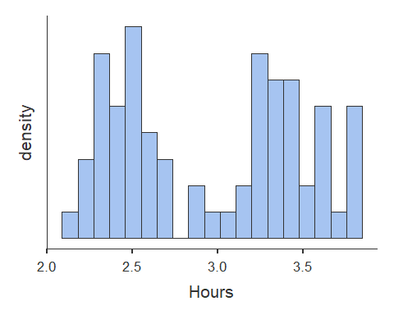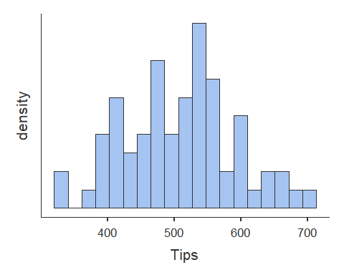

# baseline classification success is equal to the reference frequency for Retention (No = 48%)  
# it also looks like Hours is bimodal - likely non-normal distribution

Assumptions 1. Independence of Observations 2. Predictor Variables Normally Distributed *(Hours is bimodal)* 3. Multicollinearity

**Correlations**

# Correlations of continuous variables  
cortable <- corrMatrix(data = dat.subset,   
 vars = c('Hours', 'Tips'),   
 flag = TRUE)  
cortable

##   
## CORRELATION MATRIX  
##   
## Correlation Matrix   
## -------------------------------------------   
## Hours Tips   
## -------------------------------------------   
## Hours Pearson's r — 0.436   
## p-value — < .001   
##   
## Tips Pearson's r —   
## p-value —   
## -------------------------------------------   
## Note. * p < .05, ** p < .01, *** p <  
## .001

**Logistic Plots**

#Transform binary outcome to integer for the plot to work  
dat.subset$Re.int[dat.subset$Re == "No"] <- 0  
dat.subset$Re.int[dat.subset$Re == "Yes"] <- 1  
  
#Center Predictors  
dat.subset$HoursC <- dat.subset$Hours - round(mean(dat.subset$Hours), digits = 2)  
dat.subset$TipsC <- dat.subset$Tips - round(mean(dat.subset$Tips), digits = 2)  
  
#Show Plots for centered predictors  
logi.hist.plot(dat.subset$TipsC, dat.subset$Re.int, boxp=FALSE, type="hist", col="gray", xlabel = "Tips Centered")

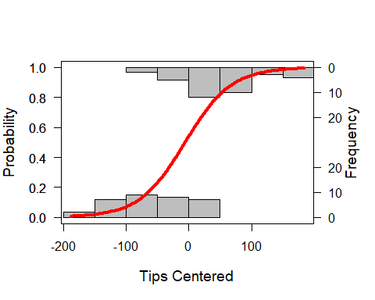

# when tips are above average, people tend to stay vs. below average they go  
logi.hist.plot(dat.subset$HoursC, dat.subset$Re.int, boxp=FALSE, type="hist", col="gray", xlabel = "Hours Centered")

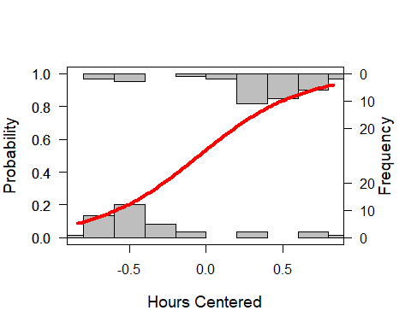

# when OT hours are above average, people tend to stay vs. below they go (caveat: bimodal dsitribution so it is inconclusive)

**BiLoRe Models** Null model

# Null deviance = Chi squared for the model  
# df = N - (# of parameters) - 1  
model0 <- glm(dat.subset$Re ~ 1, family = binomial)  
summary(model0)

##   
## Call:  
## glm(formula = dat.subset$Re ~ 1, family = binomial)  
##   
## Deviance Residuals:   
## Min 1Q Median 3Q Max   
## -1.215 -1.215 1.141 1.141 1.141   
##   
## Coefficients:  
## Estimate Std. Error z value Pr(>|z|)  
## (Intercept) 0.08701 0.24100 0.361 0.718  
##   
## (Dispersion parameter for binomial family taken to be 1)  
##   
## Null deviance: 95.524 on 68 degrees of freedom  
## Residual deviance: 95.524 on 68 degrees of freedom  
## AIC: 97.524  
##   
## Number of Fisher Scoring iterations: 3

print("Logit")

## [1] "Logit"

coef(model0)

## (Intercept)   
## 0.08701138

model0.odds <- exp(coef(model0)) #converts coefficient to odds [P(outcome)/(1-P(outcome))]  
print("Odds")

## [1] "Odds"

model0.odds

## (Intercept)   
## 1.090909

model0.probs <- model0.odds / (1 + model0.odds) #  
print("Probabilities")

## [1] "Probabilities"

model0.probs

## (Intercept)   
## 0.5217391

print("Columns = Observed, Rows = Predicted")

## [1] "Columns = Observed, Rows = Predicted"

print("Null model")

## [1] "Null model"

ClassLog(model0, dat.subset$Re) # classification success under the null model (baseline)

## $rawtab  
## resp  
## No Yes  
## TRUE 33 36  
##   
## $classtab  
## resp  
## No Yes  
## TRUE 1 1  
##   
## $overall  
## [1] 0.4782609  
##   
## $mcFadden  
## [1] 0

Model 1 - Hours predicting Retention

#Multicollinearity  
 #Tolerance = 1 - R squared --> for our purpose < .4 is bad  
 #VIF = 1/Tolerance   
 #Small VIF values indicates low correlation among variables under ideal conditions  
 #Multicollinearity occurs when two or more predictors in the model are correlated and provide redundant information about the response. Multicollinearity was measured by variance inflation factors (VIF) and tolerance. If VIF value exceeding 4.0, or by tol- erance less than 0.2 then there is a problem with multicollinearity (Hair et al., 2010).  
  
# when odds ratio < 1 just flip (invert) the result(in relation to "no" instead of in relation to "yes")  
  
# Deviance score is the chi-squared for this model  
# AIC is used to compare non-nested models for fit (lower means better fit)  
# top chi-squared indicates the change of chi-squared vs the null model (Deviance + chi squared)  
# top df score indicates the change of df vs the null model  
# df = N - (# of predictors) - 1  
  
model1.jmv <- jmv::logRegBin( # Multicollinearity is not relevant for this answer  
 data = dat.subset,  
 dep = Re,  
 covs = vars(HoursC),  
 blocks = list(  
 list(  
 'HoursC')),  
 refLevels = list(  
 list(  
 var = 'Re',  
 ref = 'No')),  
 modelTest = TRUE,  
 OR = TRUE,  
 class = TRUE,  
 acc = TRUE,  
 collin = TRUE)  
  
model1.jmv

##   
## BINOMIAL LOGISTIC REGRESSION  
##   
## Model Fit Measures   
## ---------------------------------------------------------------   
## Model Deviance AIC R²-McF <U+03C7>² df p   
## ---------------------------------------------------------------   
## 1 67.4 71.4 0.295 28.1 1 < .001   
## ---------------------------------------------------------------   
##   
##   
## MODEL SPECIFIC RESULTS  
##   
## MODEL 1  
##   
## Model Coefficients   
## -------------------------------------------------------------------   
## Predictor Estimate SE Z p Odds ratio   
## -------------------------------------------------------------------   
## Intercept 0.139 0.304 0.457 0.648 1.15   
## HoursC 2.973 0.667 4.458 < .001 19.54   
## -------------------------------------------------------------------   
## Note. Estimates represent the log odds of "Re = Yes" vs. "Re  
## = No"  
##   
##   
## ASSUMPTION CHECKS  
##   
## Collinearity Statistics   
## -------------------------------   
## VIF Tolerance   
## -------------------------------   
## HoursC 1.00 1.00   
## -------------------------------   
##   
##   
## PREDICTION  
##   
## Classification Table – Re   
## --------------------------------------   
## Observed No Yes % Correct   
## --------------------------------------   
## No 28 5 84.8   
## Yes 5 31 86.1   
## --------------------------------------   
## Note. The cut-off value is set  
## to 0.5  
##   
##   
## Predictive Measures   
## -------------------   
## Accuracy   
## -------------------   
## 0.855   
## -------------------   
## Note. The  
## cut-off value  
## is set to 0.5

Model 2 - Tips predicting Retention

#Multicollinearity  
 #Tolerance = 1 - R squared --> for our purpose < .4 is bad  
 #VIF = 1/Tolerance   
 #Small VIF values indicates low correlation among variables under ideal conditions  
 #Multicollinearity occurs when two or more predictors in the model are correlated and provide redundant information about the response. Multicollinearity was measured by variance inflation factors (VIF) and tolerance. If VIF value exceeding 4.0, or by tol- erance less than 0.2 then there is a problem with multicollinearity (Hair et al., 2010).  
  
# when odds ratio < 1 just flip (invert) the result(in relation to "no" instead of in relation to "yes")  
  
# Deviance score is the chi-squared for this model  
# AIC is used to compare non-nested models for fit (lower means better fit)  
# top chi-squared indicates the change of chi-squared vs the null model (Deviance + chi squared)  
# top df score indicates the change of df vs the null model  
# df = N - (# of predictors) - 1  
  
model2.jmv <- jmv::logRegBin( # Multicollinearity is not relevant for this answer  
 data = dat.subset,  
 dep = Re,  
 covs = vars(TipsC),  
 blocks = list(  
 list(  
 'TipsC')),  
 refLevels = list(  
 list(  
 var = 'Re',  
 ref = 'No')),  
 modelTest = TRUE,  
 OR = TRUE,  
 class = TRUE,  
 acc = TRUE,  
 collin = TRUE)  
  
model2.jmv

##   
## BINOMIAL LOGISTIC REGRESSION  
##   
## Model Fit Measures   
## ---------------------------------------------------------------   
## Model Deviance AIC R²-McF <U+03C7>² df p   
## ---------------------------------------------------------------   
## 1 58.3 62.3 0.389 37.2 1 < .001   
## ---------------------------------------------------------------   
##   
##   
## MODEL SPECIFIC RESULTS  
##   
## MODEL 1  
##   
## Model Coefficients   
## ---------------------------------------------------------------------   
## Predictor Estimate SE Z p Odds ratio   
## ---------------------------------------------------------------------   
## Intercept 0.1660 0.32620 0.509 0.611 1.18   
## TipsC 0.0271 0.00646 4.199 < .001 1.03   
## ---------------------------------------------------------------------   
## Note. Estimates represent the log odds of "Re = Yes" vs. "Re =  
## No"  
##   
##   
## ASSUMPTION CHECKS  
##   
## Collinearity Statistics   
## ------------------------------   
## VIF Tolerance   
## ------------------------------   
## TipsC 1.00 1.00   
## ------------------------------   
##   
##   
## PREDICTION  
##   
## Classification Table – Re   
## --------------------------------------   
## Observed No Yes % Correct   
## --------------------------------------   
## No 23 10 69.7   
## Yes 6 30 83.3   
## --------------------------------------   
## Note. The cut-off value is set  
## to 0.5  
##   
##   
## Predictive Measures   
## -------------------   
## Accuracy   
## -------------------   
## 0.768   
## -------------------   
## Note. The  
## cut-off value  
## is set to 0.5

Model 3 - Comparing Hours Model to Full Model

#Multicollinearity  
 #Tolerance = 1 - R squared --> for our purpose < .4 is bad  
 #VIF = 1/Tolerance   
 #Small VIF values indicates low correlation among variables under ideal conditions  
 #Multicollinearity occurs when two or more predictors in the model are correlated and provide redundant information about the response. Multicollinearity was measured by variance inflation factors (VIF) and tolerance. If VIF value exceeding 4.0, or by tol- erance less than 0.2 then there is a problem with multicollinearity (Hair et al., 2010).  
  
# when odds ratio < 1 just flip (invert) the result(in relation to "no" instead of in relation to "yes")  
  
# Deviance score is the chi-squared for this model  
# AIC is used to compare non-nested models for fit (lower means better fit)  
# top chi-squared indicates the change of chi-squared vs the null model (Deviance + chi squared)  
# top df score indicates the change of df vs the null model  
# df = N - (# of predictors) - 1  
  
model2.jmv <- jmv::logRegBin( # Multicollinearity is relevant for this answer  
 data = dat.subset,  
 dep = Re,  
 covs = vars(HoursC, TipsC),  
 blocks = list(  
 list(  
 'HoursC'),  
 list(  
 'TipsC')),  
 refLevels = list(  
 list(  
 var = 'Re',  
 ref = 'No')),  
 modelTest = TRUE,  
 OR = TRUE,  
 class = TRUE,  
 acc = TRUE,  
 collin = TRUE)  
  
model2.jmv

##   
## BINOMIAL LOGISTIC REGRESSION  
##   
## Model Fit Measures   
## ---------------------------------------------------------------   
## Model Deviance AIC R²-McF <U+03C7>² df p   
## ---------------------------------------------------------------   
## 1 67.4 71.4 0.295 28.1 1 < .001   
## 2 45.3 51.3 0.526 50.3 2 < .001   
## ---------------------------------------------------------------   
##   
##   
## Model Comparisons   
## -----------------------------------------------   
## Model Model <U+03C7>² df p   
## -----------------------------------------------   
## 1 - 2 22.1 1 < .001   
## -----------------------------------------------   
##   
##   
## MODEL SPECIFIC RESULTS  
##   
## MODEL 1  
##   
## Model Coefficients   
## -------------------------------------------------------------------   
## Predictor Estimate SE Z p Odds ratio   
## -------------------------------------------------------------------   
## Intercept 0.139 0.304 0.457 0.648 1.15   
## HoursC 2.973 0.667 4.458 < .001 19.54   
## -------------------------------------------------------------------   
## Note. Estimates represent the log odds of "Re = Yes" vs. "Re  
## = No"  
##   
##   
## ASSUMPTION CHECKS  
##   
## Collinearity Statistics   
## -------------------------------   
## VIF Tolerance   
## -------------------------------   
## HoursC 1.00 1.00   
## -------------------------------   
##   
##   
## PREDICTION  
##   
## Classification Table – Re   
## --------------------------------------   
## Observed No Yes % Correct   
## --------------------------------------   
## No 28 5 84.8   
## Yes 5 31 86.1   
## --------------------------------------   
## Note. The cut-off value is set  
## to 0.5  
##   
##   
## Predictive Measures   
## -------------------   
## Accuracy   
## -------------------   
## 0.855   
## -------------------   
## Note. The  
## cut-off value  
## is set to 0.5  
##   
##   
## MODEL 2  
##   
## Model Coefficients   
## ---------------------------------------------------------------------   
## Predictor Estimate SE Z p Odds ratio   
## ---------------------------------------------------------------------   
## Intercept 0.1737 0.37858 0.459 0.646 1.19   
## HoursC 2.5360 0.78704 3.222 0.001 12.63   
## TipsC 0.0256 0.00735 3.490 < .001 1.03   
## ---------------------------------------------------------------------   
## Note. Estimates represent the log odds of "Re = Yes" vs. "Re =  
## No"  
##   
##   
## ASSUMPTION CHECKS  
##   
## Collinearity Statistics   
## -------------------------------   
## VIF Tolerance   
## -------------------------------   
## HoursC 1.03 0.968   
## TipsC 1.03 0.968   
## -------------------------------   
##   
##   
## PREDICTION  
##   
## Classification Table – Re   
## --------------------------------------   
## Observed No Yes % Correct   
## --------------------------------------   
## No 29 4 87.9   
## Yes 5 31 86.1   
## --------------------------------------   
## Note. The cut-off value is set  
## to 0.5  
##   
##   
## Predictive Measures   
## -------------------   
## Accuracy   
## -------------------   
## 0.870   
## -------------------   
## Note. The  
## cut-off value  
## is set to 0.5

Use regression equation to calculate predicted logit, odds, and probability

#Discussion: star performer Trudy  
print("Given that Trudy works 7 hours of ovetime and makes $100 in tips, the odds she will remain for another year:")

## [1] "Given that Trudy works 7 hours of ovetime and makes $100 in tips, the odds she will remain for another year:"

# Let OT = Overtime Hours, T = tips  
OT = 7  
T = 100  
  
print("Model - Full model")

## [1] "Model - Full model"

predlogit <- .17 + (2.54*OT) + (.03*T)  
predodds <- exp(predlogit)  
predprob <- predodds / (1 + predodds)  
  
print("Predicted Logit")

## [1] "Predicted Logit"

predlogit

## [1] 20.95

print("Predicted Odds")

## [1] "Predicted Odds"

predodds

## [1] 1254496332

print("Predicted Probability")

## [1] "Predicted Probability"

predprob

## [1] 1