PSY.308d.DA4

Daniel Pinedo

** IMPORTANT NOTES: PLEASE READ BEFORE STARTING ** The structure of your write-up should be: - *Study 1 Results & Discussion:* typical results section + one paragraph discussion interpreting the results of your analyses - *Study 2 Results & Discussion:* typical results section + one paragraph discussion interpreting the results of your analyses - *Conclusion:* an INTEGRATED discussion of the two studies findings (do not simply repeat what has already been reported), implications, limitations, and future directions.

**Additionally, all write-ups should be in APA format and your write-up should NOT exceed 4 pages.**

**Study 1: Pilot Study**

dat <- read.csv("https://www.dropbox.com/s/qhx6mb45e1njvk4/PSY.308d.DA4_1.csv?dl=1")  
  
#load libraries used  
library(pacman)  
p_load(jmv, psych, car, effsize)  
  
#make dataset more readable  
dat$GroupNum <- factor(dat$GroupNum,  
 levels = c(1,2),  
 labels = c("Not Hungry", "Very Hungry"))

McCormick & Co. is proposing a new chartiable foundation, FeedForward, which hopes to set-up meal program interventions in small towns to fight hunger amongst under-resourced citizens. While McCormick is a large company and rather successful, they want evidence before investing more money into the programs and other ideas. They recently hired you as an (sadly unpaid) intern to generate some data and give them the scoop and you have to do it on a budget (A.K.A. no funding for participants - just for supplies). You decide to put up some flyers in a couple nearby apartment buildings to recruit volunteers to join your pilot study for a meal program - luckily you got 9 people to participate!

*Research Question(s):* 1. Does the meal program significantly decrease the hunger compared to those on the waitlist? 2. Does participants’ weight significantly increase from baseline to the end of the program?

*Variables:* Score: self-reported hunger at the end of the program (1 = Not hungry, 100 = very hungry). Group: program assignment (GroupNum; 1 = Program, 2 = Waitlist). Pre: weight in pounds prior at baseline. Post: weight in pounds at the end of two weeks.

Question #1 Assumptions: 1. Independence of observations 2. Normal distribution of dependent variable by condition 3. Homogeneity of variance

# Descriptives by Condition  
descriptives(data = dat,  
 vars = 'Score',  
 splitBy = 'GroupNum',  
 sd = TRUE,   
 min = TRUE,  
 max = TRUE,  
 skew = TRUE,  
 kurt = TRUE,   
 hist = TRUE)

##   
## DESCRIPTIVES  
##   
## Descriptives   
## -----------------------------------------------   
## GroupNum Score   
## -----------------------------------------------   
## N Not Hungry 4   
## Very Hungry 5   
## Missing Not Hungry 0   
## Very Hungry 0   
## Mean Not Hungry 2.75   
## Very Hungry 29.6   
## Median Not Hungry 2.50   
## Very Hungry 15   
## Standard deviation Not Hungry 1.71   
## Very Hungry 36.5   
## Minimum Not Hungry 1   
## Very Hungry 4   
## Maximum Not Hungry 5   
## Very Hungry 92   
## Skewness Not Hungry 0.753   
## Very Hungry 1.80   
## Std. error skewness Not Hungry 1.01   
## Very Hungry 0.913   
## Kurtosis Not Hungry 0.343   
## Very Hungry 3.26   
## Std. error kurtosis Not Hungry 2.62   
## Very Hungry 2.00   
## -----------------------------------------------

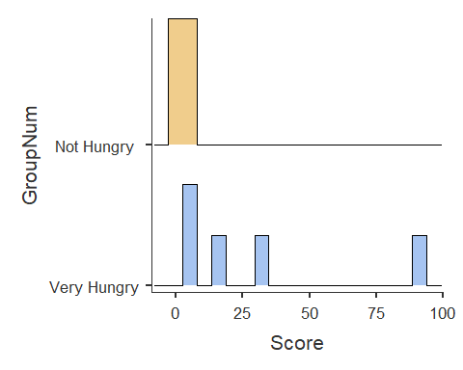

hist(dat$Score [dat$GroupNum== 'Not Hungry'])

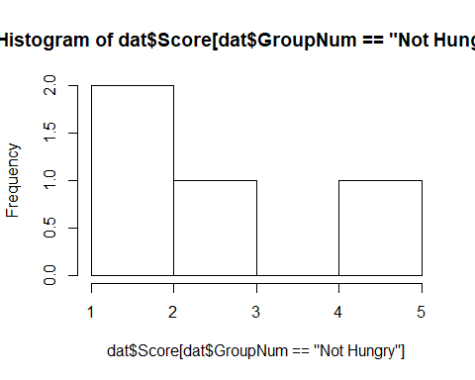

hist(dat$Score [dat$GroupNum== 'Very Hungry'])

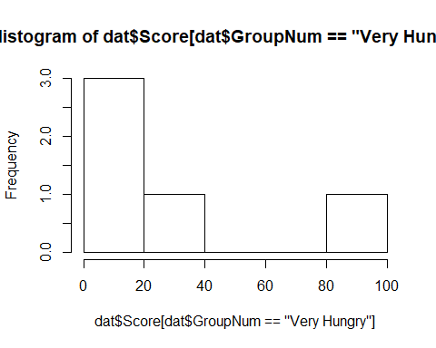

# Mann-Whitney test (with Levene's)  
ttestIS(data = dat,   
 vars = 'Score', # DV  
 group = 'GroupNum', # IV  
 desc = TRUE,  
 mann = TRUE, # Mann-Whitney U  
 eqv = TRUE, # Levene's test  
 meanDiff = FALSE,   
 ci = FALSE,  
 effectSize = FALSE) # Cohen's d

##   
## INDEPENDENT SAMPLES T-TEST  
##   
## Independent Samples T-Test   
## ---------------------------------------------------------   
## statistic df p   
## ---------------------------------------------------------   
## Score Student's t -1.45 7.00 0.190   
## Mann-Whitney U 1.00 0.032   
## ---------------------------------------------------------   
##   
##   
## ASSUMPTIONS  
##   
## Test of Equality of Variances (Levene's)   
## ----------------------------------------   
## F df p   
## ----------------------------------------   
## Score 4.43 1 0.073   
## ----------------------------------------   
## Note. A low p-value suggests a  
## violation of the assumption of  
## equal variances  
##   
##   
## Group Descriptives   
## ----------------------------------------------------------------   
## Group N Mean Median SD SE   
## ----------------------------------------------------------------   
## Score Not Hungry 4 2.75 2.50 1.71 0.854   
## Very Hungry 5 29.6 15.0 36.5 16.3   
## ----------------------------------------------------------------

Effect Size

# Cliff's Delta (non-parametric effect size) - a more robust version of Cohen's d which considers the ordinal nature, as opposed to interval, of most behavioral science and psych data (e.g., Likert scale). It is more powerful under conditions such as skewed distributions, etc. Essentially, it computes the dominance (overlap between two distributions) based on the probability that a selected score in Group 1 being greater than Group 2 minus the probability of a selected score in Group 1 being less than Group 2 divided by the product of the n of Group 1 and Group 2. The value range is between -1.0 and +1.0, where anything closer to the absolute value of 1 is no overlap (good) and closer to 0 is complete overlap (not so good).  
  
cliff.delta(Score ~ GroupNum, data = dat, conf.level = .95, magnitude = TRUE, method = "Cliff's Delta")

##   
## Cliff's Delta  
##   
## delta estimate: -0.9 (large)  
## 95 percent confidence interval:  
## lower upper   
## -0.9870433 -0.4036840

# Because this package is nice - it gives you the Delta estimate and an interpretation.

Question #2 Assumptions: 1. Independence of observations 2. Normal distribution of dependent variable by time 3. Normal distribution of difference scores (Shapiro-Wilk)

# Compute difference scores  
dat$diff <- (dat$Post - dat$Pre)  
  
# Descriptives  
descriptives(data = dat,   
 vars = c('Pre', 'Post', 'diff'),   
 sd = TRUE,   
 range = TRUE,   
 min = TRUE,   
 max = TRUE,   
 skew = TRUE,   
 kurt = TRUE,  
 hist = TRUE)

##   
## DESCRIPTIVES  
##   
## Descriptives   
## ----------------------------------------------------   
## Pre Post diff   
## ----------------------------------------------------   
## N 9 9 9   
## Missing 0 0 0   
## Mean 140 144 4.12   
## Median 141 148 2.00   
## Standard deviation 21.9 21.5 5.66   
## Range 62 65.5 17.0   
## Minimum 113 114 -1.00   
## Maximum 175 179 16.0   
## Skewness 0.131 -0.0414 1.53   
## Std. error skewness 0.717 0.717 0.717   
## Kurtosis -1.14 -0.552 1.50   
## Std. error kurtosis 1.40 1.40 1.40   
## ----------------------------------------------------

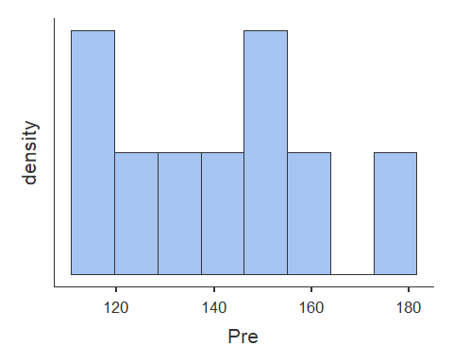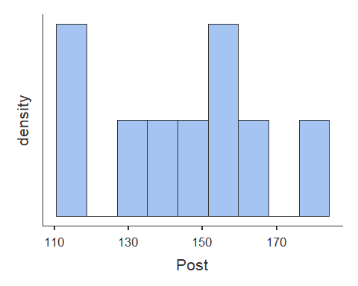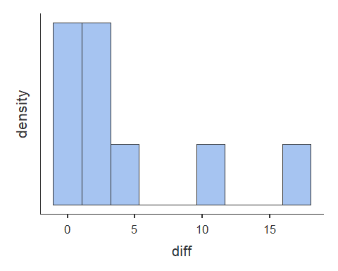

# Wilcoxan Signed Rank Test (with Shapiro-Wilk)  
  
#Pre/Post  
ttestPS(dat,   
 pairs = list(  
 list(i1 = 'Pre', i2 = 'Post')),   
 wilcoxon = TRUE,   
 norm = TRUE,   
 meanDiff = FALSE)

##   
## PAIRED SAMPLES T-TEST  
##   
## Paired Samples T-Test   
## ------------------------------------------------------------   
## statistic df p   
## ------------------------------------------------------------   
## Pre Post Student's t -2.18 8.00 0.061   
## Wilcoxon W 3.00 0.020   
## ------------------------------------------------------------   
##   
##   
## Test of Normality (Shapiro-Wilk)   
## --------------------------------------   
## W p   
## --------------------------------------   
## Pre - Post 0.806 0.024   
## --------------------------------------   
## Note. A low p-value suggests a  
## violation of the assumption of  
## normality

#Post/Pre  
ttestPS(dat,   
 pairs = list(  
 list(i1 = 'Post', i2 = 'Pre')),   
 wilcoxon = TRUE,   
 norm = FALSE,   
 meanDiff = FALSE)

##   
## PAIRED SAMPLES T-TEST  
##   
## Paired Samples T-Test   
## ------------------------------------------------------------   
## statistic df p   
## ------------------------------------------------------------   
## Post Pre Student's t 2.18 8.00 0.061   
## Wilcoxon W 42.0 0.020   
## ------------------------------------------------------------

Effect Size

# Effect size for non-parametric related-samples t-test  
# http://yatani.jp/teaching/doku.php?id=hcistats:wilcoxonsigned  
# r = z/sqrt(N) where n is the total number of observations (cases x 2)  
  
# To get number of cases(n):  
n <- dim(dat)[1] # number of cases/rows  
print(paste("Number of cases/rows(n):", n))

## [1] "Number of cases/rows(n): 9"

# To get sum of ranks(W)  
W <- n*(n+1) / 2 # you can verify this by running Wilcoxon W in both directions and summing both scores  
print(paste("Sum of ranks(W):", W))

## [1] "Sum of ranks(W): 45"

# z = (W - mW + .5)/o  
# https://www.statisticssolutions.com/how-to-conduct-the-wilcox-sign-test/  
mW <- 0 #the null that there is no difference between T1 and T2  
  
 #first we need to find sd   
 cat("\n")

sd = sqrt((n*(n+1)*((2*n)+1))/6)  
 print("sd = sqrt((n*(n+1)*((2*n)+1))/6)")

## [1] "sd = sqrt((n*(n+1)*((2*n)+1))/6)"

print(paste("sd = sqrt((", n, "*(", n, "+1)*((2*", n, ")+1))/6)", sep = ""))

## [1] "sd = sqrt((9*(9+1)*((2*9)+1))/6)"

print(paste("sd =", round(sd,2)))

## [1] "sd = 16.88"

# now to find z:  
 cat("\n")

z = (W - mW + .5)/sd # technically this should be +- .5 dependening on directionality of W-score.  
 print("z = (W - mW + .5)/sd")

## [1] "z = (W - mW + .5)/sd"

print("mW = the null that there is no difference between time 1 and time 2")

## [1] "mW = the null that there is no difference between time 1 and time 2"

print(paste( "z = (", round(W,2), " - ", mW, " + .5)/", round(sd,2), sep = ""))

## [1] "z = (45 - 0 + .5)/16.88"

print(paste("z =", round(z,2)))

## [1] "z = 2.7"

#r is the Pearson value reported for the non-parametric paired-sample t-test  
cat("\n")

N = n*2 #total number of scores (2 x number of cases)  
print(paste("Total number of scores(N):", N))

## [1] "Total number of scores(N): 18"

r = z/sqrt(N)  
print("r = z/sqrt(n) = Effect size = the probability of a time 2 score being greater than a time 1 score")

## [1] "r = z/sqrt(n) = Effect size = the probability of a time 2 score being greater than a time 1 score"

print(paste("r = ", round(z,2), "/sqrt(", N, ")", sep = ""))

## [1] "r = 2.7/sqrt(18)"

print(paste("r =", round(r,2)))

## [1] "r = 0.64"

# Based on Cohen's criteria of evaluating effect size: .10 = small, .30 = medium, and .50 = large  
  
# This z score above is iffy but was provided in full. R also calculates z scores for this test automagically, but I am not sure what is under the hood. See below  
  
 # Wilcoxon signed rank test with z-score  
 wilcoxon <- stats::wilcox.test(dat$Post, dat$Pre, paired = TRUE, exact = TRUE)  
 wilcoxon.z <- stats::qnorm(wilcoxon$p.value) # z score estimate  
 cat("\n")

print("Wilcoxon test run from library(stats):")

## [1] "Wilcoxon test run from library(stats):"

wilcoxon

##   
## Wilcoxon signed rank test  
##   
## data: dat$Post and dat$Pre  
## V = 42, p-value = 0.01953  
## alternative hypothesis: true location shift is not equal to 0

print(paste("Wilcoxon z-score run from library(stats):", round(wilcoxon.z, 2)))

## [1] "Wilcoxon z-score run from library(stats): -2.06"

wilcoxon.r <- abs(wilcoxon.z/sqrt(N))  
 print(paste("library(stats) effect size calculated as abs(", round(wilcoxon.z, 2), "/sqrt(", N, ")): ", round(wilcoxon.r, 2), sep = ""))

## [1] "library(stats) effect size calculated as abs(-2.06/sqrt(18)): 0.49"

# This runs what is called Exact Wilcoxon-Pratt Signed-Rank Test with a z-score  
 library(coin)

## Loading required package: survival

cat("\n")

wilcoxon.coin <- coin::wilcoxsign_test(dat$Post ~ dat$Pre, distribution = "exact")  
 wilcoxon.coin.z = as.numeric(statistic(wilcoxon.coin, type="standardized"))  
 names(wilcoxon.coin.z) = "Z"  
 print("Wilcoxon test run from library(coin):")

## [1] "Wilcoxon test run from library(coin):"

wilcoxon.coin

##   
## Exact Wilcoxon-Pratt Signed-Rank Test  
##   
## data: y by x (pos, neg)   
## stratified by block  
## Z = 2.3102, p-value = 0.01953  
## alternative hypothesis: true mu is not equal to 0

print(paste("Wilcoxon z-score run from library(coin):", round(wilcoxon.coin.z, 2)))

## [1] "Wilcoxon z-score run from library(coin): 2.31"

wilcoxon.coin.r <- abs(wilcoxon.coin.z/sqrt(N))  
 print(paste("library(coin) effect size calculated as abs(", round(wilcoxon.coin.z, 2), "/sqrt(", N, ")): ", round(wilcoxon.coin.r, 2), sep = ""))

## [1] "library(coin) effect size calculated as abs(2.31/sqrt(18)): 0.54"

**Study 2: Intervention**

dat2 <- read.csv("https://www.dropbox.com/s/78onrh7icd92cs4/PSY.308d.DA4_2.csv?dl=1")  
  
library(pacman)  
p_load(jmv, psych, car)

McCormick & Co. was impressed with your pilot study - meal programs seem to be worthwhile. They have invested $10,000 in your research account to do a bigger study where you can recruit and pay participants, gain more supplies, and extend your findings. You decide to set-up three different meal plan programs: Full Day (3 meals per day), Two-A-Day (2 meals per day), and One-A-Day (1 meal per day), and measure the average calorie intake above the noted minimum of 1,200 calories per day for each participant at the end of a two-week period. Given that these are under-resourced participants, they are encouraged to consume above the minimum calorie intake recommended by the health board.

*Research Question(s):* 1. Is there a difference in the number of calories above the minimum consumed between the meal program conditions?

Assumptions: 1. Independence of observations - pass 2. Normal distribution of dependent variable by condition - fail 3. Homogeneity of variance - pass

# Descriptives by Team  
descriptives(data = dat2,  
 vars = 'Calories',  
 splitBy = 'Program',  
 sd = TRUE,   
 min = TRUE,  
 max = TRUE,  
 skew = TRUE,  
 kurt = TRUE,   
 hist = TRUE)

##   
## DESCRIPTIVES  
##   
## Descriptives   
## ----------------------------------------------   
## Program Calories   
## ----------------------------------------------   
## N Full 60   
## One 60   
## Two 60   
## Missing Full 0   
## One 0   
## Two 0   
## Mean Full 25.7   
## One 12.0   
## Two 20.9   
## Median Full 17.0   
## One 6.00   
## Two 10.0   
## Standard deviation Full 38.9   
## One 31.9   
## Two 42.9   
## Minimum Full 12   
## One 1   
## Two 5   
## Maximum Full 251   
## One 219   
## Two 229   
## Skewness Full 4.70   
## One 5.54   
## Two 4.16   
## Std. error skewness Full 0.309   
## One 0.309   
## Two 0.309   
## Kurtosis Full 22.8   
## One 32.9   
## Two 17.3   
## Std. error kurtosis Full 0.608   
## One 0.608   
## Two 0.608   
## ----------------------------------------------

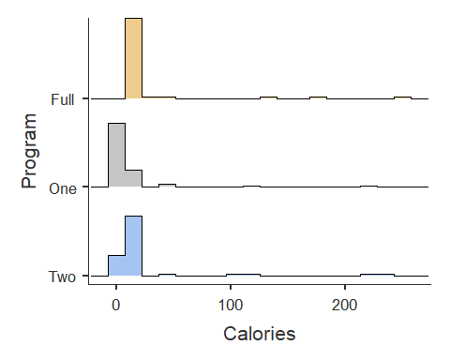

hist(dat2$Calories [dat2$Program== 'One'])

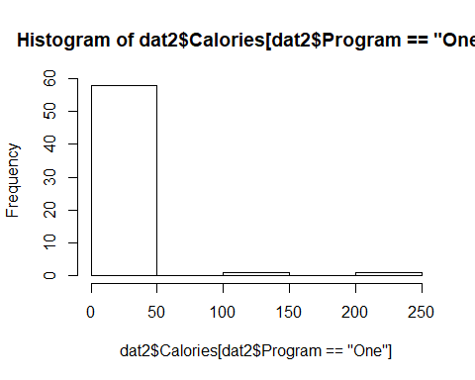

hist(dat2$Calories [dat2$Program== 'Two'])

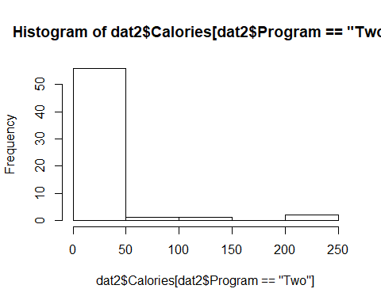

hist(dat2$Calories [dat2$Program== 'Full'])

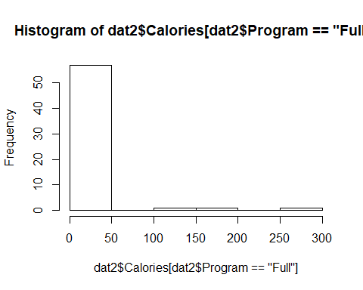

# ANOVA with each Program on Calories (with Levene's Test)   
INTaov <- jmv::ANOVA(data = dat2,   
 dep = 'Calories',   
 factors = c('Program'),   
 effectSize = 'partEta',   
 postHoc = c('Program'),   
 postHocCorr = 'tukey',   
 homo = TRUE)  
INTaov

##   
## ANOVA  
##   
## ANOVA   
## -------------------------------------------------------------------------------   
## Sum of Squares df Mean Square F p <U+03B7>²p   
## -------------------------------------------------------------------------------   
## Program 5796 2 2898 1.99 0.140 0.022   
## Residuals 258073 177 1458   
## -------------------------------------------------------------------------------   
##   
##   
## ASSUMPTION CHECKS  
##   
## Test for Homogeneity of Variances (Levene's)   
## --------------------------------------------   
## F df1 df2 p   
## --------------------------------------------   
## 0.774 2 177 0.463   
## --------------------------------------------   
##   
##   
## POST HOC TESTS  
##   
## Post Hoc Comparisons - Program   
## ----------------------------------------------------------------------------------   
## Program Program Mean Difference SE df t p-tukey   
## ----------------------------------------------------------------------------------   
## Full - One 13.70 6.97 177 1.965 0.124   
## - Two 4.82 6.97 177 0.691 0.769   
## One - Two -8.88 6.97 177 -1.274 0.412   
## ----------------------------------------------------------------------------------

# Kruskal-Wallis including pairwise comparisons (Dwass-Steel-Critchlow-Fligner)  
KW_INT_aov <- anovaNP(data = dat2,   
 dep = 'Calories',   
 group = c('Program'),   
 pairs = TRUE)  
KW_INT_aov

##   
## ONE-WAY ANOVA (NON-PARAMETRIC)  
##   
## Kruskal-Wallis   
## ------------------------------------   
## <U+03C7>² df p   
## ------------------------------------   
## Calories 98.7 2 < .001   
## ------------------------------------   
##   
##   
## DWASS-STEEL-CRITCHLOW-FLIGNER PAIRWISE COMPARISONS  
##   
## Pairwise comparisons - Calories   
## -----------------------------------   
## W p   
## -----------------------------------   
## Full One -11.68 < .001   
## Full Two -10.07 < .001   
## One Two 8.61 < .001   
## -----------------------------------

# Epsilon-squared estimate of effect size  
# .1 .3 .5 --- .2 .4 .6 are good estimates for small/med/large  
  
# EpiSq = (H)/((n^2-1)/(n+1))  
  
H <- KW_INT_aov$table$asDF[ , "chiSq"]  
print(paste("H =", round(H, 2)))

## [1] "H = 98.7"

N2 <- dim(dat2)[1]  
print(paste("N =", N2))

## [1] "N = 180"

EpiSq = (H)/((N2^2-1)/(N2+1))  
print(paste("EpiSq = ", round(H, 2), "/((", N2, "^2-1)/(", N2, "+1)) = ", round(EpiSq, 2), sep = ""))

## [1] "EpiSq = 98.7/((180^2-1)/(180+1)) = 0.55"