**Results**

First, to explore the data and relationships among the variables, descriptive statistics and correlational analysis were conducted for all nine variables (V1-V3 Fluid Intelligence, V4-V6 Verbal Ability, V7-V9 Visuospatial Ability). See Table 1 for means and standard deviations and see Table 2 for correlations between variables. Prior to conducting any analysis, assumption tests specific to factor analysis (FA) were conducted. First, a Bartlett’s Test was conducted confirming that the sample is not from an identity matrix which would mean there are no correlations among variables; the significant results indicate that there are significant relationships among variables ($χ^{2}$ (36) = 859.50, *p* < .001) . Next, a Kaiser-Meyer- Olkin analysis was conducted to ensure that each variable had been adequately sampled.

Table 1

*Descriptive Statistics of Factor Analyzed Variables*

|  |  |  |  |  |  |  |  |
| --- | --- | --- | --- | --- | --- | --- | --- |
|  | *M* | *SD* | *Min* | *Max* | *Skewness* | *Kurtosis* | *SE* |
| V1 | 99.91 | 18.6 | 39.86 | 165.46 | -0.29 | 0.45 | 1.18 |
| V2 | 100.21 | 19.89 | 44.66 | 159.19 | 0.06 | 0.09 | 1.26 |
| V3 | 99.21 | 19.36 | 47.98 | 158.36 | 0.01 | -0.23 | 1.22 |
| V4 | 100.51 | 21.55 | 45.82 | 157.00 | 0.2 | -0.35 | 1.36 |
| V5 | 99.99 | 21.19 | 48.95 | 153.97 | -0.09 | -0.57 | 1.34 |
| V6 | 101.84 | 19.95 | 38.42 | 150.38 | -0.1 | 0.02 | 1.26 |
| V7 | 101.16 | 20.58 | 44.60 | 167.07 | 0.19 | 0.26 | 1.30 |
| V8 | 102.37 | 20.81 | 46.30 | 145.86 | -0.19 | -0.51 | 1.32 |
| V9 | 101.34 | 19.63 | 48.84 | 158.29 | -0.03 | -0.26 | 1.24 |

*Note.* For all variables, *N* = 250

Table 2

*Correlation Matrix of Factor Analyzed Variables*

|  |  |  |  |  |  |  |  |  |  |
| --- | --- | --- | --- | --- | --- | --- | --- | --- | --- |
|  | V1 | V2 | V3 | V4 | V5 | V6 | V7 | V8 | V9 |
| V1 | **.67** |  |  |  |  |  |  |  |  |
| V2 | .66 | **.68** |  |  |  |  |  |  |  |
| V3 | .69 | .71 | **.74** |  |  |  |  |  |  |
| V4 | .42 | .36 | .33 | **.64** |  |  |  |  |  |
| V5 | .35 | .35 | .32 | .52 | **.44** |  |  |  |  |
| V6 | .39 | .33 | .33 | .53 | .47 | **.45** |  |  |  |
| V7 | .40 | .34 | .40 | .25 | .26 | .18 | **.51** |  |  |
| V8 | .39 | .28 | .35 | .10 | .14 | .16 | .49 | **.50** |  |
| V9 | .35 | .30 | .33 | .10 | .16 | .24 | .50 | .48 | **.48** |

*Note*. Bolded diagonal values are Communality values.

Measures of sampling adequacy (MSA) for all variables, except one verbal ability measure, exceeded the .80 benchmark indicating meritorious sampling. The one verbal measure that did not meet that benchmark (V4, MSA = .79), still exceeded the .60 limit and the total MSA was .83 indicating this assumption has been met. Finally, the determinant was calculated to ensure that there was no instance of singularity, meaning that a variable within the data is entirely explained by other variables in the dataset. The determinant for this sample is .03, meaning there were no issues of multicollinearity or singularity.

In order to determine the appropriate number of factors a parallel analysis was conducted, see Figure 1. The analysis indicated that for a principle components analysis (PCA) a two-component model would be most appropriate. However, for an exploratory factor analysis (EFA)

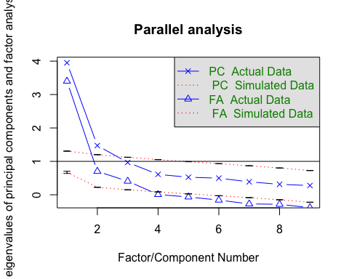

Components/Factor Numbers

Eigenvalues

*Figure 1.* Graphical Display of Parallel Analysis of Principal Component and Exploratory Factor Analyses.

the analysis indicated that either a two or three-factor model may be the best option. This likely indicates that comparisons should be made between the two types of models to determine which is best suited for the data.

The first step was to conduct a two-factor PCA, with either no rotation, varimax rotation, or oblimin rotation. The two-factor model accounted for 60% of the variance in the data and had an RMSR of .10. Although this model accounted for a good portion of the data, there were 3 to 4 instances of variables double-loading onto multiple factors. This was true regardless of the rotation, so it became clear that a three-factor model may be more appropriate. However, because the parallel analysis, indicated the a three-factor model may only be appropriate with an EFA and not the PCA, the decision was made to move onto the alternative analysis.

For the EFAs, both a two-factor and three-factor model were conducted. Additionally, multiple iterations of each model were conducted using either no rotation, a varimax rotation, and an oblimin rotation. Both the two-factor and three-factor EFAs explained less variance than the 60% explainied by the initial PCA (.48 and .57, respectively). However, this was more of an issue for the two-factor model. In addition to explaining more variance, the three-factor EFA also had better fit to the data compared to the two-factor model per RMSR (two-factor = .08, three-factor = .02). For these reasons, the three-factor EFA was chosen to move forward with. The next step was to compare different rotations to find the most appropriate factor pattern. When comparing different rotations, both the no rotation and varimax rotation models still contained instances of double-loadings. However, the oblimin rotation model did not contain double-loadings and maintained factor loadings above 3, and thus this model seemed to best suit the data.

Following an Oblimin (oblique) rotation, the factor pattern matrix for the three-factor solution is displayed in Table 3: factor loadings less than ± .3 have been omitted for ease of interpretation. Using this criterion, items V1-V3 loaded on factor A; items V4-V6 loaded on factor B; and items V7-V9 loaded on factor C. Total this model accounted for 57% of the variance in the data. Specifically, factor A accounted for 23% of the variance, factor B accounted for 17% of the variance in scores, and factor C accounted for 17% of the variance. Inter-factor correlations between factor A and factor C were the highest (*r* = .57), followed by factor A and factor B (*r* = .56), and finally between factor B and factor C (*r* = .31). For a visualization of this factor structure see Figure 2.

**Discussion**

The current project examined the underlying factor structure for cognitive ability measures assessing fluid intelligence, verbal ability, and visuospatial ability. In order to determine the appropriate factor pattern two separate exploratory techniques were used, including PCA and EFA. Although the initial parallel analysis indicated that a two-factor model may be appropriate, the PCA demonstrated that this model generated several instances of the

Table 3

*Three Factor Oblique Rotation Pattern Matrix with Communality Values*

|  |  |  |  |
| --- | --- | --- | --- |
|  | FA | FB | FC |
| V1 | .68 |  |  |
| V2 | .85 |  |  |
| V3 | .88 |  |  |
| V4 |  | .81 |  |
| V5 |  | .64 |  |
| V6 |  | .64 |  |
| V7 |  |  | .67 |
| V8 |  |  | .70 |
| V9 |  |  | .70 |

*Note*. FA = Factor A (*Fluid Intelligence*); FB = Factor B (*Verbal Ability*); FC = Factor C (*Spatial Ability*).

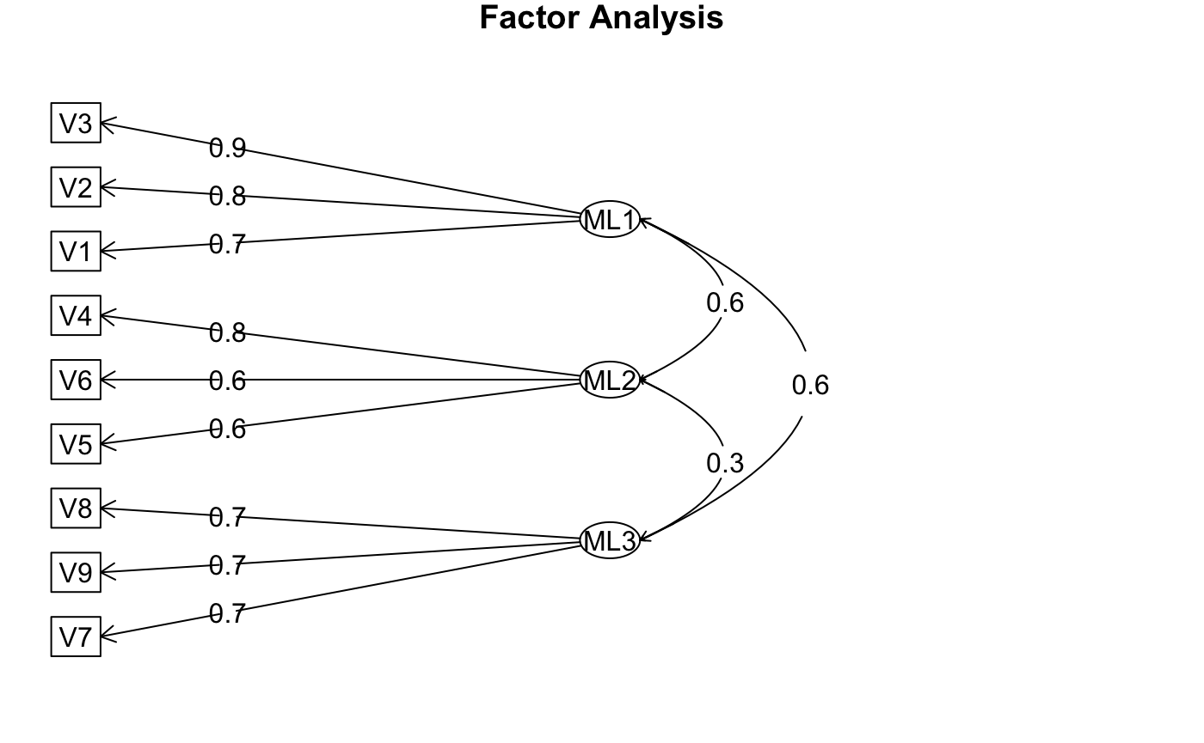

*Figure 2.* Visualization of the Correlated Latent Factor Structure of the Assessed Cognitive Ability Measures. ML1 = Factor A; ML2 = Factor B; ML3 = Factor C.

variables loading on more than one factor and this was true regardless of rotation. Additionally, although the PCA explained slightly more variance than either EFA, the fit to the data for the EFAs was better. Another line of reasoning is that an assumption of PCA is that the latent components explain all the variance in the manifest variables. However, when considering cognitive abilities, it is more realistic to assume some variance in the data would not be completely explained by the latent components, this makes EFA the more accurate option for this line of analysis. Next, both a two-factor and three-factor model EFA were conducted and compared across different types of rotation. Overall the three-factor EFAs explained more variance and had better model fit. Specifically, the three-factor model with an oblimin rotation was the only model that did not contain any double-loadings; thus, the three-factor model with the oblique rotation was chosen.

Conceptually these results are consistent with expectations for measures of cognitive ability. Specifically, using an oblique rotation makes the most sense, not only because it did not generate double loadings, but one would also anticipate cognitive abilities would be correlated. Forcing orthogonality on factors that may share variance occludes information that one could otherwise obtain. Overall these analyses demonstrate that there are separate cognitive abilities that likely share underlying general processes. Future research should use confirmatory techniques to further confirm this factor pattern.