PSY.308b.DA1

Instructions: You are teaching your first Intro to Psychology course! After the first midterm you are disappointed with your students’ overall test scores. You decide to implement two different required study techniques. There are 100 students in the class; 50 of them will be required to meet in groups to study right before the next midterm (Group A) and the other 50 will be required to create flashcards to aid in memorization (Group B). You are interested to know whether or not test scores improved significantly for each group, and you are also interested in which technique proved to be more beneficial.

Hint: Use the PSYC308 Interpretation guide as a resource throughout your completion of the DA.

#prep  
  
library(psych)  
library(jmv)

##   
## Attaching package: 'jmv'

## The following object is masked from 'package:psych':  
##   
## pca

## The following object is masked from 'package:stats':  
##   
## anova

dat <- read.csv("https://www.dropbox.com/s/ouu2gswjn80leyt/PSY.308b.DA1.csv?dl=1")  
#View(dat)

#Q2  
#Assumptions for dependent t-tests  
#1. Split data into groups  
dat.A <- subset(dat, dat$Group == 'A')  
dat.B <- subset(dat, dat$Group == 'B')  
#View(dat.A)  
#View(dat.B)  
#dim(dat)  
#dim(dat.A)  
#dim(dat.B)  
desc.A<- descriptives(dat.A, vars = c('Before', 'After'), hist = TRUE, sd = TRUE, se = TRUE, skew = TRUE, kurt = TRUE)  
desc.A

##   
## DESCRIPTIVES  
##   
## Descriptives   
## -------------------------------------------   
## Before After   
## -------------------------------------------   
## N 50 50   
## Missing 0 0   
## Mean 73.0 81.1   
## Std. error mean 1.48 0.818   
## Median 72.4 80.9   
## Standard deviation 10.4 5.78   
## Minimum 47.1 63.8   
## Maximum 94.9 93.5   
## Skewness 0.0205 -0.234   
## Std. error skewness 0.337 0.337   
## Kurtosis 0.139 0.466   
## Std. error kurtosis 0.662 0.662   
## -------------------------------------------

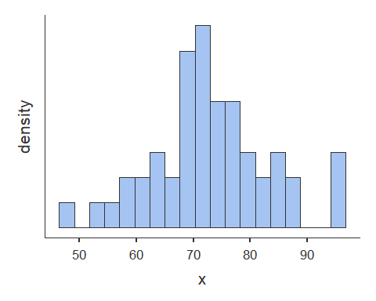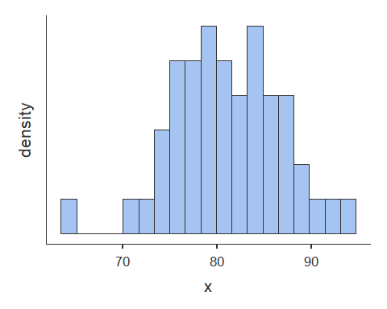

desc.B<- descriptives(dat.B, vars = c('Before', 'After'), hist = TRUE, sd = TRUE, se = TRUE, skew = TRUE, kurt = TRUE)  
desc.B

##   
## DESCRIPTIVES  
##   
## Descriptives   
## -------------------------------------------   
## Before After   
## -------------------------------------------   
## N 50 50   
## Missing 0 0   
## Mean 71.8 79.8   
## Std. error mean 1.48 0.382   
## Median 71.5 79.7   
## Standard deviation 10.5 2.70   
## Minimum 41.1 73.7   
## Maximum 92.4 85.8   
## Skewness -0.557 0.125   
## Std. error skewness 0.337 0.337   
## Kurtosis 0.761 -0.292   
## Std. error kurtosis 0.662 0.662   
## -------------------------------------------

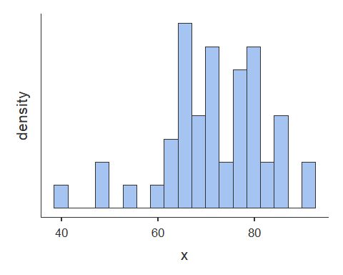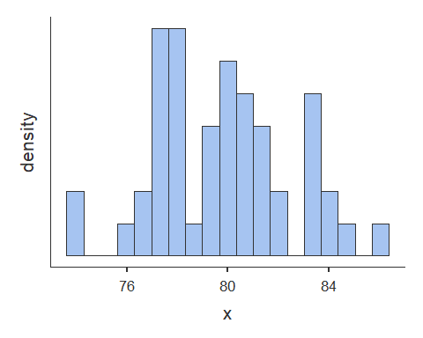

#Q3   
#Assumptions for independent t-test  
#Descriptive statistics split by group  
groupdesc <- descriptives(dat, vars = c('After'), splitBy = 'Group', hist = TRUE, sd = TRUE, se = TRUE, skew = TRUE, kurt = TRUE)  
groupdesc

##   
## DESCRIPTIVES  
##   
## Descriptives   
## ------------------------------------------   
## Group After   
## ------------------------------------------   
## N A 50   
## B 50   
## Missing A 0   
## B 0   
## Mean A 81.1   
## B 79.8   
## Std. error mean A 0.818   
## B 0.382   
## Median A 80.9   
## B 79.7   
## Standard deviation A 5.78   
## B 2.70   
## Minimum A 63.8   
## B 73.7   
## Maximum A 93.5   
## B 85.8   
## Skewness A -0.234   
## B 0.125   
## Std. error skewness A 0.337   
## B 0.337   
## Kurtosis A 0.466   
## B -0.292   
## Std. error kurtosis A 0.662   
## B 0.662   
## ------------------------------------------

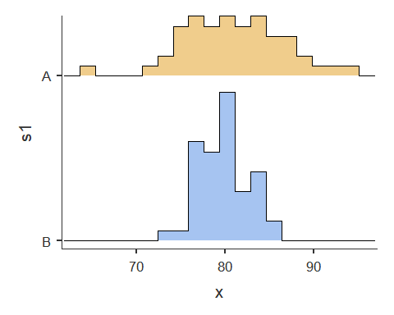

dat$Group <- as.factor(dat$Group)  
#t-test  
ttestIS(data = dat, vars = 'After', group = 'Group', eqv = TRUE, effectSize = TRUE, ci = TRUE, desc = TRUE)

##   
## INDEPENDENT SAMPLES T-TEST  
##   
## Independent Samples T-Test   
## --------------------------------------------------------------------------------------   
## statistic df p Lower Upper Cohen's d   
## --------------------------------------------------------------------------------------   
## After Student's t 1.51 <U+1D43> 98.0 0.135 -0.429 3.15 0.302   
## --------------------------------------------------------------------------------------   
## <U+1D43> Levene's test is significant (p < .05), suggesting a violation of the  
## assumption of equal variances  
##   
##   
## ASSUMPTIONS  
##   
## Test of Equality of Variances (Levene's)   
## ----------------------------------------   
## F df p   
## ----------------------------------------   
## After 21.3 1 < .001   
## ----------------------------------------   
## Note. A low p-value suggests a  
## violation of the assumption of  
## equal variances  
##   
##   
## Group Descriptives   
## -----------------------------------------------------------   
## Group N Mean Median SD SE   
## -----------------------------------------------------------   
## After A 50 81.1 80.9 5.78 0.818   
## B 50 79.8 79.7 2.70 0.382   
## -----------------------------------------------------------

#Q4A   
ttestPS(data = dat.A, pairs = list(list(i1='Before', i2='After')), effectSize = TRUE, ci = TRUE, desc = TRUE)

##   
## PAIRED SAMPLES T-TEST  
##   
## Paired Samples T-Test   
## ------------------------------------------------------------------------------------------------   
## statistic df p Lower Upper Cohen's d   
## ------------------------------------------------------------------------------------------------   
## Before After Student's t -6.03 49.0 < .001 -10.8 -5.39 -0.852   
## ------------------------------------------------------------------------------------------------   
##   
##   
## Descriptives   
## ----------------------------------------------------   
## N Mean Median SD SE   
## ----------------------------------------------------   
## Before 50 73.0 72.4 10.45 1.478   
## After 50 81.1 80.9 5.78 0.818   
## ----------------------------------------------------

#Q4B  
ttestPS(data = dat.B, pairs = list(list(i1='Before', i2='After')), effectSize = TRUE, ci = TRUE, desc = TRUE)

##   
## PAIRED SAMPLES T-TEST  
##   
## Paired Samples T-Test   
## ------------------------------------------------------------------------------------------------   
## statistic df p Lower Upper Cohen's d   
## ------------------------------------------------------------------------------------------------   
## Before After Student's t -5.12 49.0 < .001 -11.1 -4.82 -0.723   
## ------------------------------------------------------------------------------------------------   
##   
##   
## Descriptives   
## ----------------------------------------------------   
## N Mean Median SD SE   
## ----------------------------------------------------   
## Before 50 71.8 71.5 10.49 1.483   
## After 50 79.8 79.7 2.70 0.382   
## ----------------------------------------------------

#Q7  
#t-test with Welchs correction  
ttestIS(data = dat, vars = 'After', group = 'Group', welchs = TRUE, effectSize = TRUE, ci = TRUE, desc = TRUE)

##   
## INDEPENDENT SAMPLES T-TEST  
##   
## Independent Samples T-Test   
## --------------------------------------------------------------------------------------   
## statistic df p Lower Upper Cohen's d   
## --------------------------------------------------------------------------------------   
## After Student's t 1.51 98.0 0.135 -0.429 3.15 0.302   
## Welch's t 1.51 69.4 0.136 -0.438 3.16 0.302   
## --------------------------------------------------------------------------------------   
##   
##   
## Group Descriptives   
## -----------------------------------------------------------   
## Group N Mean Median SD SE   
## -----------------------------------------------------------   
## After A 50 81.1 80.9 5.78 0.818   
## B 50 79.8 79.7 2.70 0.382   
## -----------------------------------------------------------

Questions

1.What are the two types of analyses you would need to use to answer your inquiries?

One dependent t-test for each group (2 tests total) to test if scores increased after each respective intervention, and an independent t-test to test if there was a significant difference between each treatment intervention post-test.

1. Please check the assumptions for the first type of analyses. Report whether each is violated or not and provide evidence to support your conclusions.

Assumptions, dependent t-test: 1. dependent variable (difference scores) is normally distributed in the two conditions 2. independent variable is dichotomous and its levels are paired.

Assumption 1: visual inspection of both conditions across both dependent tests indicated that both conditions are approximately normally distributed for both tests.

Assumption 2: all data are paired as evidenced by dat, dat.A, and dat.B

1. Please check the assumptions for the second type of analyses. Report whether each is violated or not and provide evidence to support your conclusions.

Assumptions, independent t-test: 1. assumption of independence of observations 2. assumption of normality within each of the samples as defined by grouping variable 3. Assumption of homogeneity of variance

Assumption 1: each group member’s scores in group A and B are assumed to be independent of each other Assumption 2: visual inspection of historgram of both groups A and B indicate each is approximately normally distributed

Assumption 3: This assumption fails as evidenced by Levene’s test of homogeneity of variances (p < .001). Welch’s correction or alternate statistical method needed.

1. You are interested in looking at the study techniques individually:
2. Did individuals in Group A obtain significantly higher exam scores after they engaged in the required study technique?

The mean difference (*M* = 8.1) between Before and After for Group A was significant, *t*(49) = 5.12, *p* < .001, *d* = .85.

1. Did individuals in Group B obtain significantly higher exam scores after they engaged in the required study technique?

The mean difference (*M* = 8.0) between Before and After for Group B was significant, *t*(49) = 6.03, *p* < .001, *d* = .72.

Report only the relevant statistics according to APA format for both (a) and (b). Hint: do not forget about the size of the effects

1. The statistics professor in your psychology department heard about your little study you were conducting and was wondering what was going on with it. Interpret your findings from questions 4 (a) and (b) for the statistics professor. Hint: Use the PSYC308 Interpretation guide as a resource.

A dependent t-test was used to compare Before and After exam scores following two different study interventions. There was a statistically significant increase in tests after study group intervention (*M* = 8.1), *t*(49) = 5.12, *p* < .001, *d* = .85; and study skills intervention (*M* = 8.0), *t*(49) = 6.03, *p* < .001, *d* = .72. For group A there was a large effect size (*d* = .85), and for group B there was a medium effect size (*d* = .72) of the interventions on exam scores.

1. The Dean was also interested in your results as this may help to raise scores in other areas of the school too but unfortunately they do not understand statistical language. Please interpret your findings from questions 4 (a) and (b) for the Dean. Hint: Use the PSYC308 Interpretation guide as a resource.

Based on our tests, exam scores increased as a result of both interventions. It was determined that a study group intevention assisted with increasing exam scores, and the study skills intervention also helped increase exam scores. It seems as though both of these methods worked, and we can either use both of the interventions to increase test scores in the future, or run another test to determine if the study group or study skills intervention worked better than the other.

1. Now test whether one of the study techniques was more effective than the other (Be sure to look at the test scores *after* they have engaged in their assigned study technique). Report all relevant statistics according to APA format. (Hint: don’t forget about the size of the effect)

The mean of Group A for test scores (*M* = 81.1) was no significantly higher than the mean of Group B for test scores (*M* = 79.8), Welch’s *t*(69.4) = 1.51, *p* = .136, *d* = .30.

1. You call up Andrew since you know he would be so excited that you’re using statistics to help make decisions at work. Please explain what you found from question 7 to Andrew (who would also be stoked about the fun statistical jargon). Hint: Use the PSYC308 Interpretation guide as a resource.

An independent t-test was used to compare exam scores after interventions in Group A (study group intervention) and Group B (study skill intervention). There was no statistically significant difference between groups (*M* = 1.2), Welch’s *t*(69.4) = 1.51. *p* =.136, *d* = .30. There was a small effect size (*d* = .30) on the difference in exam scores between Groups A and B.

1. Now that you have final findings from your analyses, please explain what you found to the Dean so that they can decide how to move forward with the other schools (remember - they do not understand statistical language well). Hint: Use the PSYC308 Interpretation guide as a resource.

Based on our tests, exam scores increased as a result of both interventions, with no significant difference in either intervention. It was determined that both interventions helped about equally to increase exam scores. As it seems both interventions were successful, and neither more than the other with a random sample of students, it would be recommended to proceed in the future with either intervention, or perhaps study the effects of both in combination to determine if the combination of interventions may heklp test scores increase further.

1. In your own words, define homogeneity of variance. Why is it important? (Why should we consider it when doing certain analyses?).

Homogeneity of variance means that the variance or standard deviation is/are statistically equivalent between two sets of data. It is an important assumption for independent t-tests because the within groups variance, or Standard error of the difference, is computed based on the assumption of homogeneity of variance. if this assumption is violated without correction, the computation may result in subsequent increase in Type 1 error.