Predictors of Test Scores in an Educational Setting

Daniel Pinedo

Psych 308c: Assignment 2

Predictors of Test Scores in an Educational Setting

Students will likely score better on exams if they are dedicated and well-rested. In addition, stress may impact student ability to perform on exams. A local university initiated a study on incoming students on their test performance. The university wanted to know student test scores as well as the average amount of commitment to studying, stress levels, and hours of sleep during the past week. The purpose of this study was to determine how these three latter qualities predict student test scores in order to develop an intervention to improve the grades of future first-year students.

**Method**

The present study utilized a correlational design. Data collection methods included the use of an in-person survey administered at the end of the first semester of classes.

**Participants**

Participants consisted of all 70 first year students of the university. No demographic data was collected.

**Measures**

Each student was assessed using the below measures.

**Commitment.**Commitment (Comm) assessed the average amount of commitment to studying in the past week using a 1 to 10 scale, with higher scores indicating higher commitment.

**Stress*.*** Stressassessed the average amount of stress reported by students in the past week using a 1 to 10 scale, with higher scores indicating higher reported stress.

**Hours.**Hours assessed the average amount of hours of sleep reported by students in the past week using a 1 to 10 scale, with higher scores indicating higher reported hours of sleep.

**Test Score.**Test Score (Test) assessed the average test scores of each student during the last semester using a 1 to 100 scale, with higher scores indicating higher test scores.

**Planned Analysis**

The present study planned to use correlation, simple regression, and multiple regression to assess the relationships between predictors, as well as predictors and the outcome variable.

**Results**

Data analysis can be found in Appendix A. Descriptive statistics can be found in Table 1. There were no missing data in the dataset and analysis continued with tests of assumptions. Descriptive statistics and inspection of histograms reveal that the data may violate the assumption of univariate normality with predictor variables commitment (appears positively skewed and unimodal), stress (appears negatively skewed and unimodal), hours (appears symmetric and bimodal), and outcome variable (Test Scores) being symmetric and bimodal. Data is verified to be normally distributed across all variables in the model, as evidenced by skew for all variables being below a threshold of  3.00 (Commitment = 0.65, Stress = 0.14, Hours = -0.21, Test = 0.26), and kurtosis below a threshold of  10.00 (Commitment = 0.11, Stress = -0.30, Hours = -0.28 Test = -0.21). Scatterplots with regression lines were created to preliminarily assess the assumption of homoscedasticity and to determine linearity. The homoscedasticity assumption does not appear to be violated by visual inspection and was confirmed using a Non-Constant Variance (NCV) test, χ2 (1) = 3.59, *p* *= .*058. The assumption of linearity appears to be met for all variables as evidenced by viewing scatterplots with regression lines added.

Commitment to studying, stress, and hours of sleep were significantly correlated with test scores (Table 2); therefore, the relationship between the outcome (test scores) and potential predictors was assessed through regression analyses. Stress (β = -.68, *p* < .001) explained 47% of the variance in test scores, *F*(1, 68) = 59.70, *p* < .001, *R2* = .47 (Table 3). Adding commitment to studying (β = .32, *p* < .001) with stress (β = -.57, *p* < .001) to the model explained 56% of the variance in productivity, *F*(2, 67) = 42.0, *p* < .001, *R2* = .56 (Table 4). Adding hours of sleep to the model did not add significant variance to the model, *F*(1, 66), *ΔR2* = .01, *p* = .179. Model comparison of the two prior models indicated that the model with both predictor variables of stress and commitment to studying was significantly better than a model with only the predictor for stress, *F*(1, 67), *ΔR2* = .09, *p* < .001.

**Discussion**

The purpose of the current project was to test predictors of exam scores for first year students. All students (*N* = 70) were assessed for stress, commitment to studying, hours of sleep, and their exam scores. Correlation and regression analyses were used to determine whether these variables predicted exam scores at the end of their first semester.

Correlation analyses demonstrated that all three potential predictor variables (stress, commitment to studying, hours of sleep) were all significantly related with test scores and included for further simple regression analyses. When including stress and commitment to studying in the linear model both were significant predictors of performance (Table 4).

In summary, these results indicate that both stress and commitment to studying were significant predictors of student exam scores at the end of their first semester. However, when comparing the predictors, stress is a better predictor of test scores. In conclusion, if the institution wants to increase test scores for the first year students next year, they should focus an intervention on stress reduction as well as promoting goal commitment related to study habits. However, considering that all the variables appear to be non-normal (e.g. bimodal, skewed), these results should also be reconsidered using alternative methods and analyses to confirm.

Table 1

*Descriptive Statistics of Measures*

Variable Mean SD Median Skew Kurtosis

Enjoy 7.97 0.53 8.00 -0.29 0.88

Desire 7.58 0.73 7.60 -0.33 0.60

Length 38.70 5.49 38.50 -0.07 -0.43

Productivity 78.70 4.60 79.00 -0.15 -0.38

Table 2

*Correlation Matrix for Measures Related to Productivity*

Variable 1 2 3 4

1. Length - -.02 .02 .03

2. Enjoy - .29*** .34***

3. Desire - .32***

4. Productivity -

*Note.* * *p* < .05, ** *p* < .01, *** *p* < .001.

Table 3

*Hierarchical Regression Models Predicting Productivity*

Model Variables *B* β SE *R2*

Model 1 Enjoy 2.91 0.34*** 0.62 .11

Model 2 Enjoy 2.28 0.26*** 0.63 .17

Desire 1.57 0.25*** 0.46

Model 3 Enjoy 2.28 0.26*** 0.63 .17

Desire 1.56 0.10*** 0.46

Length 0.03 -0.10 0.05

*Note.*\* *p* < .05, ** *p* < .01, *** *p* < .001.

Appendix A

**Statistical Analysis in R**

**Hypotheses**

H0: no relationship between variables

Ha: length, enjoy, and desire predict product

**Descriptive Statistics and Assumptions**

# Prerequisitites  
 # 1. Variables are measured on the continuous level  
  
# Assumptions  
 # 1. Normal Distribution for X and Y (Product) [i.e. histogram, skew +-3, kurtosis +-10]  
 # Histogram for Comm appears positively skewed and unimodal  
 # Histogram for Stress appears negatively skewed and unimodal  
 # Histogram for Hours appears symmetric and bimodal  
 # Histogram for Test appears symmetric and bimodal  
 # Skewness - Comm 0.65 Stress 0.14 Hours -0.21 Test 0.26  
 # Kurtosis - 0.11 -0.30 -0.28 -0.21   
   
 # 2. Linear Relationship beween X and Y  
 # Visual inspection of scatterplot and prediction model line indicate ...  
 # 3. Homoscedasticity  
 # a. Visual inspection of scatterplots indicate:   
 # higher variance at the lower end for Comm   
 # assymettric variance at the lower end for Stress  
 # higher variance at the upper end for Hours  
 # b. non-constant variance test - H0 = TRUE (PASS)  
   
 # 4. [Examine residuals (e = Y - Y~predicted~) to understand 2 and 3 mathematically]  
  
# Descriptives [Assumption 1]  
desc <- descriptives(data = dat,   
 vars = c('Comm', 'Stress', 'Hours', 'Test'),   
 hist = TRUE,   
 sd = TRUE,   
 range = TRUE,   
 skew = TRUE,   
 kurt = TRUE)  
desc

##   
## DESCRIPTIVES  
##   
## Descriptives   
## --------------------------------------------------------------   
## Comm Stress Hours Test   
## --------------------------------------------------------------   
## N 70 70 70 70   
## Missing 0 0 0 0   
## Mean 5.36 3.62 6.71 72.0   
## Median 5.25 3.55 6.85 71.2   
## Standard deviation 1.45 0.923 1.39 6.05   
## Range 6.40 4.40 6.40 27.7   
## Minimum 2.80 1.30 3.20 59.9   
## Maximum 9.20 5.70 9.60 87.6   
## Skewness 0.650 0.138 -0.214 0.256   
## Std. error skewness 0.287 0.287 0.287 0.287   
## Kurtosis 0.107 -0.304 -0.277 -0.206   
## Std. error kurtosis 0.566 0.566 0.566 0.566   
## --------------------------------------------------------------

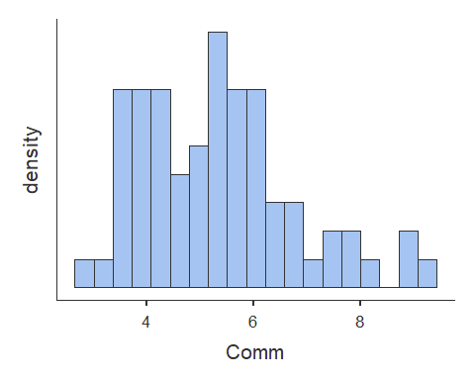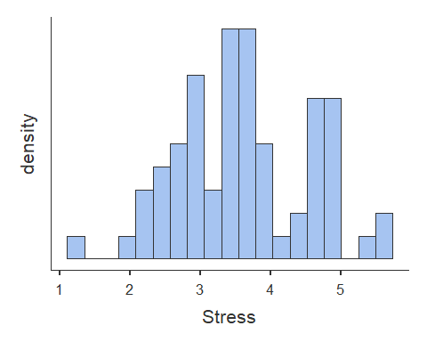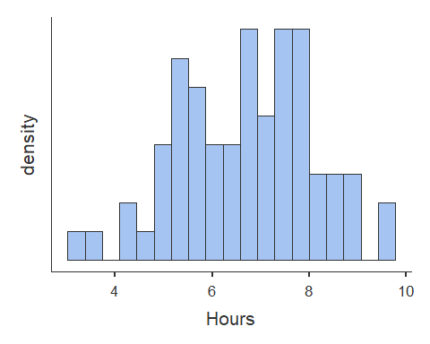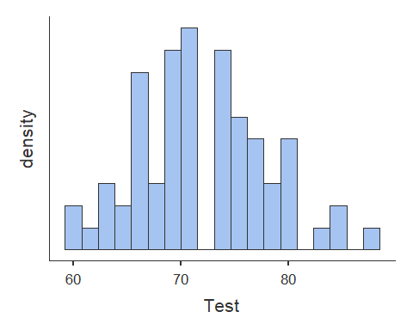

# Scatterplots [Assumption 2 and 3a]  
plot(dat$Comm, dat$Test, abline(lm(dat$Test ~ dat$Comm)))

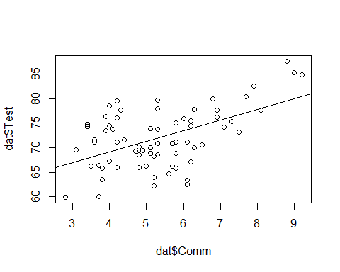

plot(dat$Stress, dat$Test, abline(lm(dat$Test ~ dat$Stress)))

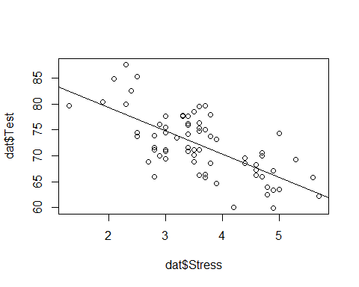

plot(dat$Hours, dat$Test, abline(lm(dat$Test ~ dat$Hours)))

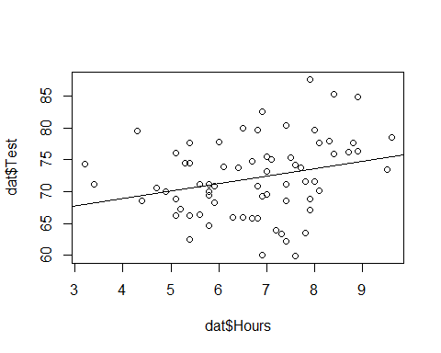

# Homoscedasticity [Assumption 3b]  
  
#non-constant variance Chi-squared test [Chi-squared (df) = ##.##, p = .###]  
#H0 = homoscedastic - TRUE  
#Ha = heteroscedastic  
  
ncvTest(lm(Test ~ Comm + Stress + Hours, data = dat))

## Non-constant Variance Score Test   
## Variance formula: ~ fitted.values   
## Chisquare = 3.590164, Df = 1, p = 0.058123

**Correlations**

# Correlation  
cortable <- corrMatrix(data = dat,   
 vars = c('Comm', 'Stress', 'Hours', 'Test'),   
 flag = TRUE)  
cortable

##   
## CORRELATION MATRIX  
##   
## Correlation Matrix   
## ----------------------------------------------------------------   
## Comm Stress Hours Test   
## ----------------------------------------------------------------   
## Comm Pearson's r  -0.355 0.305 0.522   
## p-value  0.003 0.010 < .001   
##   
## Stress Pearson's r  -0.115 -0.684   
## p-value  0.343 < .001   
##   
## Hours Pearson's r  0.268   
## p-value  0.025   
##   
## Test Pearson's r    
## p-value    
## ----------------------------------------------------------------   
## Note. * p < .05, ** p < .01, *** p < .001

**Simple Regression**

# Simple Regression Model 1  
# Start with the simpler model first - Stress is most correlated with outcome variable (Test)  
model1 <- linReg(data = dat,   
 dep = 'Test', #outcome  
 covs = c('Stress'), #predictors  
 blocks = list(c('Stress')), #order - doesn't matter for simple regression as there is only one variable  
 modelTest = TRUE, #significance test on model [H0: R squared = 0]  
 stdEst = TRUE) #standardized regression coefficient for individual variable [Stand. Estimate or Beta]  
model1 #print to screen

##   
## LINEAR REGRESSION  
##   
## Model Fit Measures   
## -----------------------------------------------------------   
## Model R R² F df1 df2 p   
## -----------------------------------------------------------   
## 1 0.684 0.467 59.7 1 68 < .001   
## -----------------------------------------------------------   
##   
##   
## MODEL SPECIFIC RESULTS  
##   
## MODEL 1  
##   
## Model Coefficients   
## ------------------------------------------------------------------------   
## Predictor Estimate SE t p Stand. Estimate   
## ------------------------------------------------------------------------   
## Intercept 88.26 2.169 40.70 < .001   
## Stress -4.48 0.580 -7.72 < .001 -0.684   
## ------------------------------------------------------------------------

#This model is best fit for simple regression based on R squared and Beta Estimates  
  
# ALTERNATIVE  
model1.1<- lm(Test ~ Stress, data = dat)  
summary(model1.1)

##   
## Call:  
## lm(formula = Test ~ Stress, data = dat)  
##   
## Residuals:  
## Min 1Q Median 3Q Max   
## -9.8125 -2.8887 -0.3681 3.0985 9.6469   
##   
## Coefficients:  
## Estimate Std. Error t value Pr(>|t|)   
## (Intercept) 88.2601 2.1686 40.699 < 2e-16 ***  
## Stress -4.4813 0.5801 -7.725 6.92e-11 ***  
## ---  
## Signif. codes: 0 '***' 0.001 '**' 0.01 '*' 0.05 '.' 0.1 ' ' 1  
##   
## Residual standard error: 4.446 on 68 degrees of freedom  
## Multiple R-squared: 0.4674, Adjusted R-squared: 0.4596   
## F-statistic: 59.68 on 1 and 68 DF, p-value: 6.92e-11

# Simple Regression Model 2  
# Comm is second most correlated with outcome variable (Test)  
model2 <- linReg(data = dat,   
 dep = 'Test', #outcome  
 covs = c('Comm'), #predictors  
 blocks = list(c('Comm')), #order - doesn't matter for simple regression as there is only one variable  
 modelTest = TRUE, #significance test on model [H0: R squared = 0]  
 stdEst = TRUE) #standardized regression coefficient for individual variable  
model2 #print to screen

##   
## LINEAR REGRESSION  
##   
## Model Fit Measures   
## -----------------------------------------------------------   
## Model R R² F df1 df2 p   
## -----------------------------------------------------------   
## 1 0.522 0.272 25.4 1 68 < .001   
## -----------------------------------------------------------   
##   
##   
## MODEL SPECIFIC RESULTS  
##   
## MODEL 1  
##   
## Model Coefficients   
## ------------------------------------------------------------------------   
## Predictor Estimate SE t p Stand. Estimate   
## ------------------------------------------------------------------------   
## Intercept 60.40 2.386 25.31 < .001   
## Comm 2.17 0.430 5.04 < .001 0.522   
## ------------------------------------------------------------------------

# model has predictive significance  
  
# ALTERNATIVE  
model2.1<- lm(Test ~ Comm, data = dat)  
summary(model2.1)

##   
## Call:  
## lm(formula = Test ~ Comm, data = dat)  
##   
## Residuals:  
## Min 1Q Median 3Q Max   
## -11.1331 -3.4520 -0.8247 4.2373 9.9885   
##   
## Coefficients:  
## Estimate Std. Error t value Pr(>|t|)   
## (Intercept) 60.4005 2.3864 25.310 < 2e-16 ***  
## Comm 2.1693 0.4302 5.042 3.64e-06 ***  
## ---  
## Signif. codes: 0 '***' 0.001 '**' 0.01 '*' 0.05 '.' 0.1 ' ' 1  
##   
## Residual standard error: 5.198 on 68 degrees of freedom  
## Multiple R-squared: 0.2721, Adjusted R-squared: 0.2614   
## F-statistic: 25.42 on 1 and 68 DF, p-value: 3.64e-06

# Simple Regression Model 3  
# Hours is third most correlated with outcome variable (Test)  
model3 <- linReg(data = dat,   
 dep = 'Test', #outcome  
 covs = c('Hours'), #predictors  
 blocks = list(c('Hours')), #order - doesn't matter for simple regression as there is only one variable  
 modelTest = TRUE, #significance test on model [H0: R squared = 0]  
 stdEst = TRUE) #standardized regression coefficient for individual variable  
model3 #print to screen

##   
## LINEAR REGRESSION  
##   
## Model Fit Measures   
## -----------------------------------------------------------   
## Model R R² F df1 df2 p   
## -----------------------------------------------------------   
## 1 0.268 0.0716 5.24 1 68 0.025   
## -----------------------------------------------------------   
##   
##   
## MODEL SPECIFIC RESULTS  
##   
## MODEL 1  
##   
## Model Coefficients   
## ------------------------------------------------------------------------   
## Predictor Estimate SE t p Stand. Estimate   
## ------------------------------------------------------------------------   
## Intercept 64.20 3.488 18.41 < .001   
## Hours 1.17 0.509 2.29 0.025 0.268   
## ------------------------------------------------------------------------

# model has predictive significance  
  
# ALTERNATIVE  
model3.1<- lm(Test ~ Hours, data = dat)  
summary(model2.1)

##   
## Call:  
## lm(formula = Test ~ Comm, data = dat)  
##   
## Residuals:  
## Min 1Q Median 3Q Max   
## -11.1331 -3.4520 -0.8247 4.2373 9.9885   
##   
## Coefficients:  
## Estimate Std. Error t value Pr(>|t|)   
## (Intercept) 60.4005 2.3864 25.310 < 2e-16 ***  
## Comm 2.1693 0.4302 5.042 3.64e-06 ***  
## ---  
## Signif. codes: 0 '***' 0.001 '**' 0.01 '*' 0.05 '.' 0.1 ' ' 1  
##   
## Residual standard error: 5.198 on 68 degrees of freedom  
## Multiple R-squared: 0.2721, Adjusted R-squared: 0.2614   
## F-statistic: 25.42 on 1 and 68 DF, p-value: 3.64e-06

**Multiple Regression**

# Multiple regression test #A [Test ~ Stress + Comm] - best fit  
  
modelA <- linReg(data = dat,   
 dep = 'Test', #outcome  
 covs = c('Stress', 'Comm'), #predictors  
 blocks = list(c('Stress', 'Comm')), #order matters here if separate blocks of variables are provided  
 modelTest = TRUE,   
 stdEst = TRUE,   
 ciStdEst = TRUE,   
 r2Adj = TRUE)  
modelA

##   
## LINEAR REGRESSION  
##   
## Model Fit Measures   
## --------------------------------------------------------------------------   
## Model R R² Adjusted R² F df1 df2 p   
## --------------------------------------------------------------------------   
## 1 0.746 0.556 0.543 42.0 2 67 < .001   
## --------------------------------------------------------------------------   
##   
##   
## MODEL SPECIFIC RESULTS  
##   
## MODEL 1  
##   
## Model Coefficients   
## --------------------------------------------------------------------------------------------   
## Predictor Estimate SE t p Stand. Estimate Lower Upper   
## --------------------------------------------------------------------------------------------   
## Intercept 78.46 3.335 23.53 < .001   
## Stress -3.74 0.571 -6.55 < .001 -0.570 -0.744 -0.397   
## Comm 1.33 0.362 3.67 < .001 0.319 0.145 0.493   
## --------------------------------------------------------------------------------------------

# ALTERNATIVE  
modelA.1<- lm(Test ~ Stress + Comm, data = dat)  
summary(modelA.1)

##   
## Call:  
## lm(formula = Test ~ Stress + Comm, data = dat)  
##   
## Residuals:  
## Min 1Q Median 3Q Max   
## -7.6690 -2.5243 -0.3167 2.5740 10.0199   
##   
## Coefficients:  
## Estimate Std. Error t value Pr(>|t|)   
## (Intercept) 78.4604 3.3346 23.529 < 2e-16 ***  
## Stress -3.7385 0.5705 -6.553 9.5e-09 ***  
## Comm 1.3271 0.3620 3.666 0.000488 ***  
## ---  
## Signif. codes: 0 '***' 0.001 '**' 0.01 '*' 0.05 '.' 0.1 ' ' 1  
##   
## Residual standard error: 4.088 on 67 degrees of freedom  
## Multiple R-squared: 0.5564, Adjusted R-squared: 0.5432   
## F-statistic: 42.02 on 2 and 67 DF, p-value: 1.493e-12

# Multiple regression test #A [Test ~ Stress + Comm + Hours]  
  
modelB <- linReg(data = dat,   
 dep = 'Test', #outcome  
 covs = c('Stress', 'Comm', 'Hours'), #predictors  
 blocks = list(c('Stress', 'Comm', 'Hours')), #order matters here if separate blocks of variables are provided  
 modelTest = TRUE,   
 stdEst = TRUE,   
 ciStdEst = TRUE,   
 r2Adj = TRUE)  
modelB

##   
## LINEAR REGRESSION  
##   
## Model Fit Measures   
## --------------------------------------------------------------------------   
## Model R R² Adjusted R² F df1 df2 p   
## --------------------------------------------------------------------------   
## 1 0.754 0.568 0.549 29.0 3 66 < .001   
## --------------------------------------------------------------------------   
##   
##   
## MODEL SPECIFIC RESULTS  
##   
## MODEL 1  
##   
## Model Coefficients   
## ---------------------------------------------------------------------------------------------   
## Predictor Estimate SE t p Stand. Estimate Lower Upper   
## ---------------------------------------------------------------------------------------------   
## Intercept 75.848 3.833 19.79 < .001   
## Stress -3.733 0.567 -6.58 < .001 -0.569 -0.7422 -0.397   
## Comm 1.182 0.375 3.15 0.002 0.284 0.1041 0.464   
## Hours 0.502 0.370 1.36 0.179 0.115 -0.0543 0.285   
## ---------------------------------------------------------------------------------------------

# ALTERNATIVE  
modelB.1<- lm(Test ~ Stress + Comm, data = dat)  
summary(modelB.1)

##   
## Call:  
## lm(formula = Test ~ Stress + Comm, data = dat)  
##   
## Residuals:  
## Min 1Q Median 3Q Max   
## -7.6690 -2.5243 -0.3167 2.5740 10.0199   
##   
## Coefficients:  
## Estimate Std. Error t value Pr(>|t|)   
## (Intercept) 78.4604 3.3346 23.529 < 2e-16 ***  
## Stress -3.7385 0.5705 -6.553 9.5e-09 ***  
## Comm 1.3271 0.3620 3.666 0.000488 ***  
## ---  
## Signif. codes: 0 '***' 0.001 '**' 0.01 '*' 0.05 '.' 0.1 ' ' 1  
##   
## Residual standard error: 4.088 on 67 degrees of freedom  
## Multiple R-squared: 0.5564, Adjusted R-squared: 0.5432   
## F-statistic: 42.02 on 2 and 67 DF, p-value: 1.493e-12

**Model Comparison**

# Hierarchical regression with model comparison (significance of R squared change)  
# 2 models plus comparison of them for final homework should be presented  
  
# Comparison Model 1  
 # Model B: Test ~ Stress + Comm + Hours  
 # Model A: Test ~ Stress + Comm [ best fit ]  
  
compare1 <- linReg(data = dat,   
 dep = 'Test',   
 covs = c('Stress', 'Comm', 'Hours'),  
 blocks = list(  
 list('Stress', 'Comm'), #Model A  
 list('Hours')), #Model B  
 modelTest = TRUE,  
 r2Adj = TRUE,  
 stdEst = TRUE,  
 ciStdEst = TRUE)  
compare1

##   
## LINEAR REGRESSION  
##   
## Model Fit Measures   
## --------------------------------------------------------------------------   
## Model R R² Adjusted R² F df1 df2 p   
## --------------------------------------------------------------------------   
## 1 0.746 0.556 0.543 42.0 2 67 < .001   
## 2 0.754 0.568 0.549 29.0 3 66 < .001   
## --------------------------------------------------------------------------   
##   
##   
## Model Comparisons   
## ----------------------------------------------------------------   
## Model Model <U+0394>R² F df1 df2 p   
## ----------------------------------------------------------------   
## 1 - 2 0.0120 1.84 1 66 0.179   
## ----------------------------------------------------------------   
##   
##   
## MODEL SPECIFIC RESULTS  
##   
## MODEL 1  
##   
## Model Coefficients   
## --------------------------------------------------------------------------------------------   
## Predictor Estimate SE t p Stand. Estimate Lower Upper   
## --------------------------------------------------------------------------------------------   
## Intercept 78.46 3.335 23.53 < .001   
## Stress -3.74 0.571 -6.55 < .001 -0.570 -0.744 -0.397   
## Comm 1.33 0.362 3.67 < .001 0.319 0.145 0.493   
## --------------------------------------------------------------------------------------------   
##   
##   
## MODEL 2  
##   
## Model Coefficients   
## ---------------------------------------------------------------------------------------------   
## Predictor Estimate SE t p Stand. Estimate Lower Upper   
## ---------------------------------------------------------------------------------------------   
## Intercept 75.848 3.833 19.79 < .001   
## Stress -3.733 0.567 -6.58 < .001 -0.569 -0.7422 -0.397   
## Comm 1.182 0.375 3.15 0.002 0.284 0.1041 0.464   
## Hours 0.502 0.370 1.36 0.179 0.115 -0.0543 0.285   
## ---------------------------------------------------------------------------------------------

# ALTERNATIVE  
stats::anova(modelB.1, modelA.1)

## Analysis of Variance Table  
##   
## Model 1: Test ~ Stress + Comm  
## Model 2: Test ~ Stress + Comm  
## Res.Df RSS Df Sum of Sq F Pr(>F)  
## 1 67 1119.7   
## 2 67 1119.7 0 0

# Both statistical tests yield no significant difference between models B and A

# Comparison Model 2  
 # Model A: Test ~ Stress + Comm [ best fit ]  
 # Model 1: Test ~ Stress  
  
compare2 <- linReg(data = dat,   
 dep = 'Test',   
 covs = c('Stress', 'Comm'),  
 blocks = list(  
 list('Stress'), #Model A  
 list('Comm')), #Model B  
 modelTest = TRUE,  
 r2Adj = TRUE,  
 stdEst = TRUE,  
 ciStdEst = TRUE)  
compare2

##   
## LINEAR REGRESSION  
##   
## Model Fit Measures   
## --------------------------------------------------------------------------   
## Model R R² Adjusted R² F df1 df2 p   
## --------------------------------------------------------------------------   
## 1 0.684 0.467 0.460 59.7 1 68 < .001   
## 2 0.746 0.556 0.543 42.0 2 67 < .001   
## --------------------------------------------------------------------------   
##   
##   
## Model Comparisons   
## -----------------------------------------------------------------   
## Model Model <U+0394>R² F df1 df2 p   
## -----------------------------------------------------------------   
## 1 - 2 0.0890 13.4 1 67 < .001   
## -----------------------------------------------------------------   
##   
##   
## MODEL SPECIFIC RESULTS  
##   
## MODEL 1  
##   
## Model Coefficients   
## ------------------------------------------------------------------------------------------   
## Predictor Estimate SE t p Stand. Estimate Lower Upper   
## ------------------------------------------------------------------------------------------   
## Intercept 88.26 2.169 40.70 < .001   
## Stress -4.48 0.580 -7.72 < .001 -0.684   
## ------------------------------------------------------------------------------------------   
##   
##   
## MODEL 2  
##   
## Model Coefficients   
## --------------------------------------------------------------------------------------------   
## Predictor Estimate SE t p Stand. Estimate Lower Upper   
## --------------------------------------------------------------------------------------------   
## Intercept 78.46 3.335 23.53 < .001   
## Stress -3.74 0.571 -6.55 < .001 -0.570 -0.744 -0.397   
## Comm 1.33 0.362 3.67 < .001 0.319 0.145 0.493   
## --------------------------------------------------------------------------------------------

# ALTERNATIVE  
stats::anova(modelA.1, model1.1)

## Analysis of Variance Table  
##   
## Model 1: Test ~ Stress + Comm  
## Model 2: Test ~ Stress  
## Res.Df RSS Df Sum of Sq F Pr(>F)   
## 1 67 1119.7   
## 2 68 1344.4 -1 -224.66 13.443 0.0004878 ***  
## ---  
## Signif. codes: 0 '***' 0.001 '**' 0.01 '*' 0.05 '.' 0.1 ' ' 1

# Both statistical tests yield a significant difference between models A and 1

**Best Model with Centered Data**

#Predicted score on Y when all predictors are averaged vs   
 #{uncentered} predicted score on Y when all predictors are zero.  
  
#Stress  
dat$Stress.C <- dat$Stress - mean(dat$Stress)  
   
#Comm  
dat$Comm.C <- dat$Comm - mean(dat$Comm)  
  
modelA.2<- lm(Test ~ Stress.C + Comm.C, data = dat)  
summary(modelA.2)

##   
## Call:  
## lm(formula = Test ~ Stress.C + Comm.C, data = dat)  
##   
## Residuals:  
## Min 1Q Median 3Q Max   
## -7.6690 -2.5243 -0.3167 2.5740 10.0199   
##   
## Coefficients:  
## Estimate Std. Error t value Pr(>|t|)   
## (Intercept) 72.0186 0.4886 147.393 < 2e-16 ***  
## Stress.C -3.7385 0.5705 -6.553 9.5e-09 ***  
## Comm.C 1.3271 0.3620 3.666 0.000488 ***  
## ---  
## Signif. codes: 0 '***' 0.001 '**' 0.01 '*' 0.05 '.' 0.1 ' ' 1  
##   
## Residual standard error: 4.088 on 67 degrees of freedom  
## Multiple R-squared: 0.5564, Adjusted R-squared: 0.5432   
## F-statistic: 42.02 on 2 and 67 DF, p-value: 1.493e-12

**Visualization with Centered Data**

# plotting a multiple regression model based on:   
 # Model A: Test ~ Stress + Comm (from lm command of model created 'modelA.1')  
  
# create predicted values from predictors and save in object  
model_p <- ggpredict(modelA.2, terms = c('Stress.C', 'Comm.C'), full.data = TRUE, pretty = FALSE)  
  
# plot predicted line  
plot <- ggplot(model_p, aes(x, predicted)) +  
 geom_smooth(method = "lm", se = FALSE, fullrange=TRUE) + xlab("Score") + ggtitle("Plot of Model of Stress and Commitment Predicting Test Score") + ylab("Test Score") +  
 geom_point() + theme_minimal()  
  
plot

