PSY 308c Homework 5

Daniel Pinedo

## *Instructions*

You have been hired by a school-based intervention to figure out what predicts child aggression. The school created a short survey to be administered to students. Two classrooms were randomly chosen to participate. The study was conducted through a pen-and-paper survey at the beginning of first period they measured family adversity and positive peer relationships. They aren’t too savvy on the literature, but some of the staff at the program have been noting (anecdotally) an interesting phenomenon which may be impacting that relationship.

Apparently, even when youth have a lot of familiy adversity, if they also have positive friendships then they don’t act out quite as much. However, this doesn’t seem to be the case for those who also have a lot of adversity in their family but don’t have good peer relationships (they tend to act out a lot).

So, you have been tasked with accessing their data set and analyzing whether **positive peer relationships moderates the relationship between family adversity and child aggression**.

*Three variables for analysis:* FA: Family adversity on a scale of 0-20. AGG: Child aggression on a scale of 0-20. PPR: Positive peer relationships on a scale of 0-20. (outcome)

*Demographics:* Age: self-report; had to be at least 16 to participate. Sex: self-report; male, female. Family Income: $0.00 - $200,000.00. Class Rank: Sophomore, Junior, Senior.

**Initial Data Diagnosis**

# Descriptives to get an overall view of data  
desc <- descriptives(data = dat,   
 vars = c('FA', 'AGG', 'PPR', 'Age', 'Sex', 'FamIncome', 'Rank'),  
 sd = TRUE,   
 range = TRUE,  
 skew = TRUE,   
 kurt = TRUE,  
 freq = TRUE) # for categorical variables  
desc

##   
## DESCRIPTIVES  
##   
## Descriptives   
## -------------------------------------------------------------------------------------------   
## FA AGG PPR Age Sex FamIncome Rank   
## -------------------------------------------------------------------------------------------   
## N 40 40 40 40 40 40 40   
## Missing 0 0 0 0 0 0 0   
## Mean 11.8 9.05 9.50 16.9 58384   
## Median 11.0 8.50 10.0 17.0 57642   
## Standard deviation 3.82 5.27 4.59 0.736 7457   
## Range 16 17 19 2.00 28527   
## Minimum 4 1 1 16.0 43632   
## Maximum 20 18 20 18.0 72159   
## Skewness -0.0533 0.242 0.411 0.246 0.115   
## Std. error skewness 0.374 0.374 0.374 0.374 0.374   
## Kurtosis -0.353 -1.30 -0.0248 -1.07 -0.904   
## Std. error kurtosis 0.733 0.733 0.733 0.733 0.733   
## -------------------------------------------------------------------------------------------   
##   
##   
## FREQUENCIES  
##   
## Frequencies of Age   
## --------------------------------------------------   
## Levels Counts % of Total Cumulative %   
## --------------------------------------------------   
## 16 14 35.0 35.0   
## 17 18 45.0 80.0   
## 18 8 20.0 100.0   
## --------------------------------------------------   
##   
##   
## Frequencies of Sex   
## --------------------------------------------------   
## Levels Counts % of Total Cumulative %   
## --------------------------------------------------   
## Female 22 55.0 55.0   
## Male 18 45.0 100.0   
## --------------------------------------------------   
##   
##   
## Frequencies of Rank   
## ----------------------------------------------------   
## Levels Counts % of Total Cumulative %   
## ----------------------------------------------------   
## Junior 12 30.0 30.0   
## Senior 12 30.0 60.0   
## Sophmore 16 40.0 100.0   
## ----------------------------------------------------

corr.test(dat[2:4]) # Prerequisite: outcome and predictor variables are measured on the continuous level

## Call:corr.test(x = dat[2:4])  
## Correlation matrix   
## FA AGG PPR  
## FA 1.00 0.33 -0.1  
## AGG 0.33 1.00 -0.7  
## PPR -0.10 -0.70 1.0  
## Sample Size   
## [1] 40  
## Probability values (Entries above the diagonal are adjusted for multiple tests.)   
## FA AGG PPR  
## FA 0.00 0.08 0.54  
## AGG 0.04 0.00 0.00  
## PPR 0.54 0.00 0.00  
##   
## To see confidence intervals of the correlations, print with the short=FALSE option

#MISSING DATA --> Different N's and the line that indicates missing items indicates missing cases   
#Running dim(dat) indicates 40 rows/observations  
#Options: (1) delete list-wise (2) impute

*Regression Diagnostics* 1. Missing Data - **NONE** 2. Univariate a. Normality, b. Linearity and c. Outliers 3. Multivariate a. Normality and b.Outliers 4. Heteroscedsticity 5. Multi-collinearity 6. Linearity between outcome and predictor(s)

**2a. Univariate Normality**

#ASSUMPTION: Normal Distribution for continuous variables X and Y (Child Aggression) [i.e. histogram, skew +-3, kurtosis +-10]  
  
desc <- descriptives(data = dat,   
 vars = c('FA', 'AGG', 'PPR'),  
 sd = TRUE,  
 range = TRUE,  
 skew = TRUE,   
 kurt = TRUE,  
 hist = TRUE) # for visual inspection  
desc

##   
## DESCRIPTIVES  
##   
## Descriptives   
## ------------------------------------------------------   
## FA AGG PPR   
## ------------------------------------------------------   
## N 40 40 40   
## Missing 0 0 0   
## Mean 11.8 9.05 9.50   
## Median 11.0 8.50 10.0   
## Standard deviation 3.82 5.27 4.59   
## Range 16 17 19   
## Minimum 4 1 1   
## Maximum 20 18 20   
## Skewness -0.0533 0.242 0.411   
## Std. error skewness 0.374 0.374 0.374   
## Kurtosis -0.353 -1.30 -0.0248   
## Std. error kurtosis 0.733 0.733 0.733   
## ------------------------------------------------------

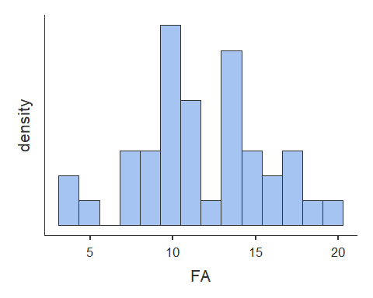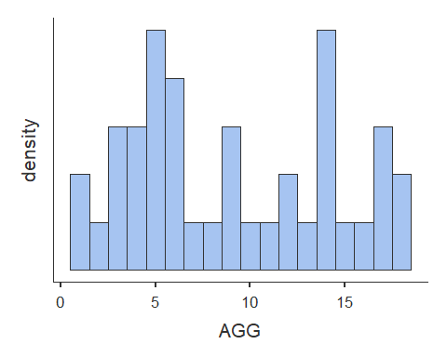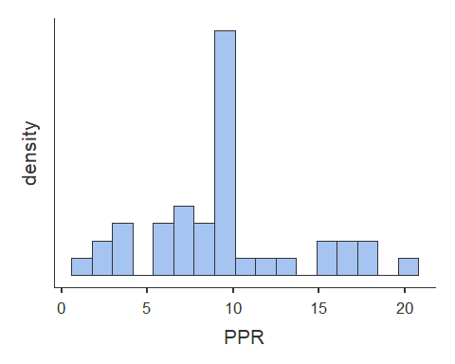

# Histogram for Family Adversity (FA) is normal  
# Histogram for Child Agression (AGG) is bimodal  
# Histogram for Positive Peer Relationships (PPR) is normal  
 # Skewness - ALL PASS  
 # Kurtosis - ALL PASS   
  
#Visual inspection indicates that there are no outliers

**2b. Univariate Linearity**

# Scatterplots [Assumption 2 and 3a]  
plot(dat$FA, dat$AGG, abline(lm(dat$AGG ~ dat$FA)))

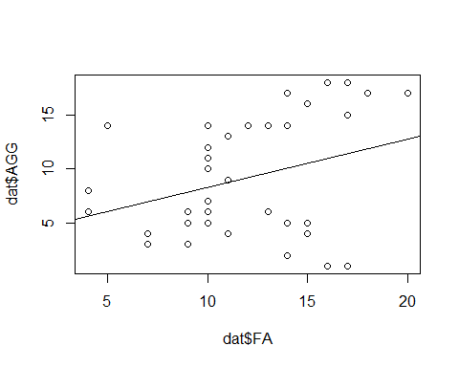

plot(dat$PPR, dat$AGG, abline(lm(dat$AGG ~ dat$PPR)))

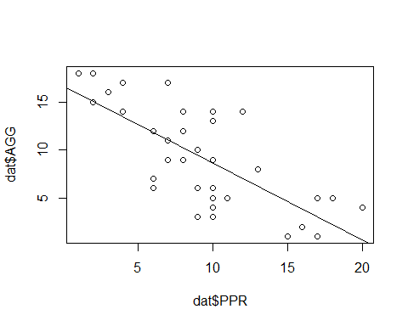

#visual inspection indicates a likely non-linear relationship between Family Adversity and Child Aggression and is consistent with visual inspection of histograms (step 2a) for outliers  
  
#visual inspection indicates a likely linear relationship between Positive Peer Relationship and Child Aggression and is consistent with visual inspection of histograms (step 2a) for outliers

**2c. Univariate Outliers**

#Identify outliers  
#scale() converts to z scores - "3" refers to standard deviations  
dat[abs(scale(dat$AGG)) > 3, ]

## [1] ID FA AGG PPR Age Sex FamIncome  
## [8] Rank   
## <0 rows> (or 0-length row.names)

dat[abs(scale(dat$FA)) > 3, ]

## [1] ID FA AGG PPR Age Sex FamIncome  
## [8] Rank   
## <0 rows> (or 0-length row.names)

dat[abs(scale(dat$PPR)) > 3, ]

## [1] ID FA AGG PPR Age Sex FamIncome  
## [8] Rank   
## <0 rows> (or 0-length row.names)

#Child Aggression (AGG) has 0 univariate outliers  
#Family Adversity (FA) has 0 univariate outliers  
#Positive Peer Relationships (PPR) has 0 univariate outliers  
  
#There are a total of 0 independent observations that contain outliers

**3a. Multivariate Normality**

#look at residuals and the Q-Q plot  
#Observe Leverage (Mahalanobis' Distance) + Discrepancy (= Influence; Cook's Distance)  
  
model.multi_norm <- linReg(data = dat,   
 dep = 'AGG',   
 covs = c('FA', 'PPR'),  
 blocks = list(c('FA', 'PPR')),   
 modelTest = TRUE,   
 r2Adj = TRUE,   
 stdEst = TRUE,   
 ciStdEst = TRUE,  
 qqPlot = TRUE, ##QQ plot  
 resPlots = TRUE) ##residuals plot   
  
model.multi_norm

##   
## LINEAR REGRESSION  
##   
## Model Fit Measures   
## --------------------------------------------------------------------------   
## Model R R² Adjusted R² F df1 df2 p   
## --------------------------------------------------------------------------   
## 1 0.743 0.553 0.529 22.9 2 37 < .001   
## --------------------------------------------------------------------------   
##   
##   
## MODEL SPECIFIC RESULTS  
##   
## MODEL 1  
##   
## Model Coefficients   
## ---------------------------------------------------------------------------------------------   
## Predictor Estimate SE t p Stand. Estimate Lower Upper   
## ---------------------------------------------------------------------------------------------   
## Intercept 12.218 2.330 5.24 < .001   
## FA 0.355 0.152 2.33 0.025 0.257 0.0334 0.481   
## PPR -0.773 0.127 -6.08 < .001 -0.672 -0.8959 -0.448   
## ---------------------------------------------------------------------------------------------   
##   
##   
## ASSUMPTION CHECKS

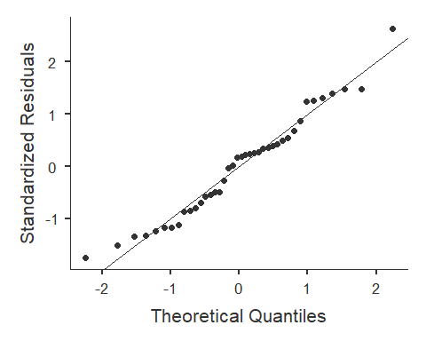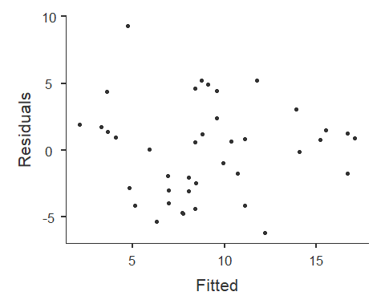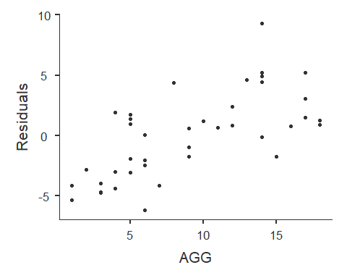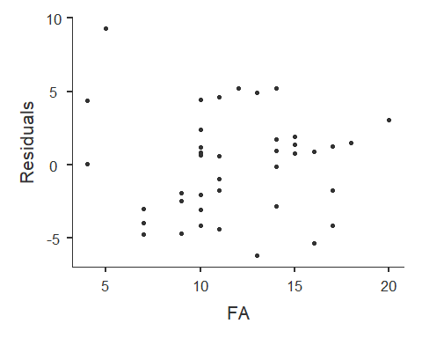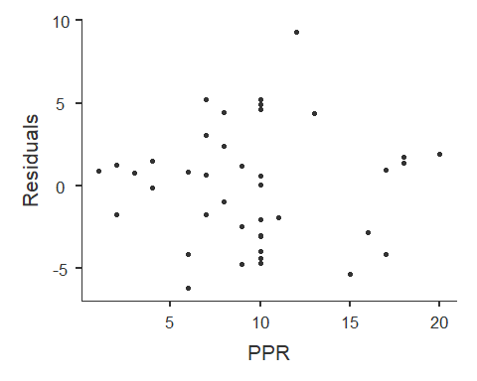

#Alternate not using jvm library  
#model <- lm(Amount ~ Belief + Need, data = dat.no.uni)  
#plot(model)  
  
#inspection of plots of predictors vs residuals indicates possible multivariate normality and possible heteroscadasticity  
#inspection of theoretical quantiles vs standardized residuals indicates a possible problem with multivariate distance and leverage  
#as such, Cook's distance - a measure of influence - will be used to test for multivariate normality  
#for Mahalanobis' Distance (leverage only), see Regression_Diagnostics.Rmd for how-to

**3b. Multivariate Outliers**

#Check and remove multivariate outliers based on Cook's distance (CD)  
#CD = Influence = Leverage + Discrepancy (Discrepancy = how much an observation deviates from the overall pattern of the model)  
  
#create model  
model.cook <- lm(dat$AGG ~ dat$FA + dat$PPR)  
model.cook

##   
## Call:  
## lm(formula = dat$AGG ~ dat$FA + dat$PPR)  
##   
## Coefficients:  
## (Intercept) dat$FA dat$PPR   
## 12.2177 0.3550 -0.7726

summary(model.cook)

##   
## Call:  
## lm(formula = dat$AGG ~ dat$FA + dat$PPR)  
##   
## Residuals:  
## Min 1Q Median 3Q Max   
## -6.1978 -2.8647 0.6212 1.7655 9.2779   
##   
## Coefficients:  
## Estimate Std. Error t value Pr(>|t|)   
## (Intercept) 12.2177 2.3304 5.243 6.65e-06 ***  
## dat$FA 0.3550 0.1525 2.329 0.0255 *   
## dat$PPR -0.7726 0.1271 -6.080 4.89e-07 ***  
## ---  
## Signif. codes: 0 '***' 0.001 '**' 0.01 '*' 0.05 '.' 0.1 ' ' 1  
##   
## Residual standard error: 3.62 on 37 degrees of freedom  
## Multiple R-squared: 0.5527, Adjusted R-squared: 0.5285   
## F-statistic: 22.86 on 2 and 37 DF, p-value: 3.438e-07

#find cook's distance for that model  
dat$cook <- cooks.distance(model.cook)  
  
#create the cutoff [> 4/N]  
cook.cutoff <- 4/nrow(dat)   
cook.cutoff

## [1] 0.1

# 4/40 --> cutoff = .10  
  
#plot it out  
plot(model.cook, which = 4, cook.levels = cook.cutoff)  
  
#Add a cutoff line  
abline(h = cook.cutoff, lty = 2)

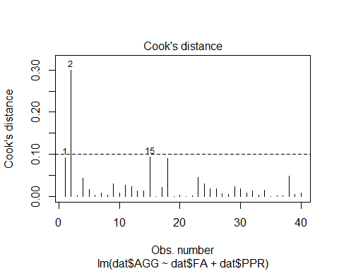

#Show and remove all outliers above your cutoff line  
  
dat[(dat$cook) > cook.cutoff, ]

## ID FA AGG PPR Age Sex FamIncome Rank cook  
## 2 2 5 14 12 17 Male 68026 Junior 0.2988974

dat.final <- dat[!(dat$cook) > cook.cutoff, ]  
  
#N is now 39 after removing 1 multivariate outlier observation(s)  
 #was 40 after removing 0 univariate outlier observation(s)  
 #was 40 after removing 0 observation(s) with missing parameters  
 #was 40 originally (total 1 observation(s) removed from orginal dataset - 3%)

**4. Heteroscedasticity**

#Breusch-Pagan test   
#H0 = no change in variance across residuals.  
model.breusch_pagan <- lm(dat.final$AGG ~ dat.final$FA + dat.final$PPR)  
ncvTest(model.breusch_pagan)

## Non-constant Variance Score Test   
## Variance formula: ~ fitted.values   
## Chisquare = 0.6821571, Df = 1, p = 0.40884

#not significant = homoscedastic  
#If violated use Box-cox transformation [boxcox(model)] in library MASS

**5. Multi-collinearity**

#Tolerance = 1 - R squared --> for our purpose < .4 is bad  
#VIF = 1/Tolerance ---> for our purpose > 2.5 is bad  
#Small VIF values (or higher Tolerance values) indicates low correlation among variables under ideal conditions  
  
#Multicollinearity occurs when two or more predictors in the model are correlated and provide redundant information about the response. Multicollinearity is measured by variance inflation factors (VIF) and tolerance. If VIF value exceeds 4.0, or tolerance less than 0.2 then there is a problem with multicollinearity according to Hair et al. (2010).  
  
model.multicoll <- linReg(data = dat.final,   
 dep = 'AGG',   
 cov = c('FA', 'PPR'),  
 blocks = list(c('FA', 'PPR')),   
 modelTest = TRUE,  
 r2Adj = TRUE,  
 stdEst = TRUE,  
 ciStdEst = TRUE,   
 collin = TRUE) #this line does the thing  
model.multicoll

##   
## LINEAR REGRESSION  
##   
## Model Fit Measures   
## --------------------------------------------------------------------------   
## Model R R² Adjusted R² F df1 df2 p   
## --------------------------------------------------------------------------   
## 1 0.796 0.633 0.613 31.1 2 36 < .001   
## --------------------------------------------------------------------------   
##   
##   
## MODEL SPECIFIC RESULTS  
##   
## MODEL 1  
##   
## Model Coefficients   
## --------------------------------------------------------------------------------------------   
## Predictor Estimate SE t p Stand. Estimate Lower Upper   
## --------------------------------------------------------------------------------------------   
## Intercept 10.744 2.171 4.95 < .001   
## FA 0.476 0.144 3.30 0.002 0.334 0.129 0.540   
## PPR -0.794 0.116 -6.88 < .001 -0.696 -0.901 -0.491   
## --------------------------------------------------------------------------------------------   
##   
##   
## ASSUMPTION CHECKS  
##   
## Collinearity Statistics   
## ----------------------------   
## VIF Tolerance   
## ----------------------------   
## FA 1.01 0.994   
## PPR 1.01 0.994   
## ----------------------------

#Tolerance for all variables indicates low/no multicollinearity

*Data Analysis* 1. Descriptive Statistics 2. Correlations 3. Center Data (if useful) 4. Simple Regression 5. Hierarchical Model Comparison 6. Visualization

**1. Descriptive Statistics**

#Prerequisite: predictors and outcome all measured on continuous level  
#Assumptions:  
 #1. Normal Distribution for X and Y [i.e. histogram, skew +-3, kurtosis +-10]  
 # Histograms observed are normal  
 # Skewness - ALL PASS  
 # Kurtosis - ALL PASS  
 # N/A Observations with missing parameters were removed (see Diagnostics)  
 # N/A univariate outliers were removed (see Diagnostics)  
 # multivariate outliers were removed (see Diagnostics)  
   
 #2. Linear Relationship beween X and Y  
 #visual inspection indicates a non-linear relationship between Family Adversity and Child Aggression  
 #visual inspection indicates a linear relationship between Positive Peer Relationship and Child Aggression  
 #3. Homoscedasticity - OK (see Diagnostics)  
 #4. Multicollearity - OK (see Diagnostics)  
  
#N is now 39 after removing 1 multivariate outlier observation(s)  
 #was 40 after removing 0 univariate outlier observation(s)  
 #was 40 after removing 0 observation(s) with missing parameters  
 #was 40 originally (total 1 observation(s) removed from orginal dataset - 3%)  
  
desc.final <- descriptives(data = dat.final,   
 vars = c('FA', 'AGG', 'PPR', 'Age', 'Sex', 'FamIncome', 'Rank'),   
 sd = TRUE,   
 range = TRUE,   
 skew = TRUE,   
 kurt = TRUE,  
 freq = TRUE)  
desc.final

##   
## DESCRIPTIVES  
##   
## Descriptives   
## -------------------------------------------------------------------------------------------   
## FA AGG PPR Age Sex FamIncome Rank   
## -------------------------------------------------------------------------------------------   
## N 39 39 39 39 39 39 39   
## Missing 0 0 0 0 0 0 0   
## Mean 11.9 8.92 9.44 16.8 58137   
## Median 11 8 10 17.0 57338   
## Standard deviation 3.71 5.28 4.63 0.745 7387   
## Range 16 17 19 2.00 28527   
## Minimum 4 1 1 16.0 43632   
## Maximum 20 18 20 18.0 72159   
## Skewness -0.0404 0.301 0.450 0.260 0.166   
## Std. error skewness 0.378 0.378 0.378 0.378 0.378   
## Kurtosis -0.239 -1.25 -0.0279 -1.11 -0.819   
## Std. error kurtosis 0.741 0.741 0.741 0.741 0.741   
## -------------------------------------------------------------------------------------------   
##   
##   
## FREQUENCIES  
##   
## Frequencies of Age   
## --------------------------------------------------   
## Levels Counts % of Total Cumulative %   
## --------------------------------------------------   
## 16 14 35.9 35.9   
## 17 17 43.6 79.5   
## 18 8 20.5 100.0   
## --------------------------------------------------   
##   
##   
## Frequencies of Sex   
## --------------------------------------------------   
## Levels Counts % of Total Cumulative %   
## --------------------------------------------------   
## Female 22 56.4 56.4   
## Male 17 43.6 100.0   
## --------------------------------------------------   
##   
##   
## Frequencies of Rank   
## ----------------------------------------------------   
## Levels Counts % of Total Cumulative %   
## ----------------------------------------------------   
## Junior 11 28.2 28.2   
## Senior 12 30.8 59.0   
## Sophmore 16 41.0 100.0   
## ----------------------------------------------------

**2. Correlations**

# Correlations of predictor and outcome variables  
cortable <- corrMatrix(data = dat.final,   
 vars = c('AGG', 'FA', 'PPR'),   
 flag = TRUE)  
cortable

##   
## CORRELATION MATRIX  
##   
## Correlation Matrix   
## --------------------------------------------------   
## AGG FA PPR   
## --------------------------------------------------   
## AGG Pearson's r  0.389 -0.723   
## p-value  0.014 < .001   
##   
## FA Pearson's r  -0.079   
## p-value  0.631   
##   
## PPR Pearson's r    
## p-value    
## --------------------------------------------------   
## Note. * p < .05, ** p < .01, *** p < .001

**3. Center data (if useful)**

# Center only predictor variables  
# centered = x - M  
# Centering only changes the intercept for regression equation  
 # Centering means, on average across all predictor variables Y intercept is [coefficient for X units]  
# Center predictors  
dat.final$FA.centered <- dat.final$FA - mean(dat.final$FA)  
dat.final$PPR.centered <- dat.final$PPR - mean(dat.final$PPR)  
  
#USEFUL - We will center data for models of these predictors, as aggression score across average of all predictors is useful

**4. Simple Regression**

# Simple regression  
# R = correlation between observed scores and predicted scores  
# R squared = percentage of variance explained  
# t = Estimate / SE  
# df1 = k = number of predictors  
# df2 = N - k - 1 [k is number of predictors]  
# H0: B0 = 0; H0; R squared = 0  
  
model.wm <- linReg(data = dat.final,  
 dep = 'AGG',   
 covs = c('FA'),  
 blocks = list('FA'),   
 modelTest = TRUE,   
 stdEst = TRUE,   
 ci = TRUE)  
model.wm #1 fit

##   
## LINEAR REGRESSION  
##   
## Model Fit Measures   
## ----------------------------------------------------------   
## Model R R² F df1 df2 p   
## ----------------------------------------------------------   
## 1 0.389 0.152 6.62 1 37 0.014   
## ----------------------------------------------------------   
##   
##   
## MODEL SPECIFIC RESULTS  
##   
## MODEL 1  
##   
## Model Coefficients   
## ------------------------------------------------------------------------------------------   
## Predictor Estimate SE Lower Upper t p Stand. Estimate   
## ------------------------------------------------------------------------------------------   
## Intercept 2.314 2.688 -3.132 7.760 0.861 0.395   
## FA 0.554 0.215 0.118 0.991 2.572 0.014 0.389   
## ------------------------------------------------------------------------------------------

model.process <- linReg(data = dat.final,  
 dep = 'AGG',  
 covs = c('PPR'),  
 blocks = list('PPR'),   
 modelTest = TRUE,   
 stdEst = TRUE,   
 ci = TRUE)  
model.process #2 fit

##   
## LINEAR REGRESSION  
##   
## Model Fit Measures   
## -----------------------------------------------------------   
## Model R R² F df1 df2 p   
## -----------------------------------------------------------   
## 1 0.723 0.522 40.4 1 37 < .001   
## -----------------------------------------------------------   
##   
##   
## MODEL SPECIFIC RESULTS  
##   
## MODEL 1  
##   
## Model Coefficients   
## -------------------------------------------------------------------------------------------   
## Predictor Estimate SE Lower Upper t p Stand. Estimate   
## -------------------------------------------------------------------------------------------   
## Intercept 16.702 1.359 13.95 19.455 12.29 < .001   
## PPR -0.824 0.130 -1.09 -0.562 -6.36 < .001 -0.723   
## -------------------------------------------------------------------------------------------

**5. Hierarchical Model Comparison**

# Model comparison  
# H0 = delta of R squared = 0  
  
# Multiple regression with Moderation  
# REMEMBER: Coefficient estimate for one predictor is slope across average of other predictors.  
#F test tests null hypothesis that null hypothesis is zero (is square of t score of product term)  
#T test test null hypothesis that product term is zero  
  
#create moderator variable  
dat.final$mod.centered <- dat.final$PPR.centered * dat.final$FA.centered  
  
comparison <- linReg(data = dat.final,   
 dep = 'AGG',   
 covs = c('PPR.centered', 'FA.centered', 'mod.centered'),  
 blocks = list(  
 list('PPR.centered'),   
 list('FA.centered'),   
 list('mod.centered') ),   
 modelTest = TRUE,   
 r2Adj = TRUE,  
 stdEst = TRUE,  
 ciStdEst = TRUE)  
comparison

##   
## LINEAR REGRESSION  
##   
## Model Fit Measures   
## --------------------------------------------------------------------------   
## Model R R² Adjusted R² F df1 df2 p   
## --------------------------------------------------------------------------   
## 1 0.723 0.522 0.509 40.4 1 37 < .001   
## 2 0.796 0.633 0.613 31.1 2 36 < .001   
## 3 0.814 0.662 0.633 22.8 3 35 < .001   
## --------------------------------------------------------------------------   
##   
##   
## Model Comparisons   
## -----------------------------------------------------------------   
## Model Model <U+0394>R² F df1 df2 p   
## -----------------------------------------------------------------   
## 1 - 2 0.1111 10.90 1 36 0.002   
## 2 - 3 0.0285 2.95 1 35 0.095   
## -----------------------------------------------------------------   
##   
##   
## MODEL SPECIFIC RESULTS  
##   
## MODEL 1  
##   
## Model Coefficients   
## ---------------------------------------------------------------------------------------------   
## Predictor Estimate SE t p Stand. Estimate Lower Upper   
## ---------------------------------------------------------------------------------------------   
## Intercept 8.923 0.592 15.07 < .001   
## PPR.centered -0.824 0.130 -6.36 < .001 -0.723   
## ---------------------------------------------------------------------------------------------   
##   
##   
## MODEL 2  
##   
## Model Coefficients   
## -----------------------------------------------------------------------------------------------   
## Predictor Estimate SE t p Stand. Estimate Lower Upper   
## -----------------------------------------------------------------------------------------------   
## Intercept 8.923 0.526 16.97 < .001   
## PPR.centered -0.794 0.116 -6.88 < .001 -0.696 -0.901 -0.491   
## FA.centered 0.476 0.144 3.30 0.002 0.334 0.129 0.540   
## -----------------------------------------------------------------------------------------------   
##   
##   
## MODEL 3  
##   
## Model Coefficients   
## -------------------------------------------------------------------------------------------------   
## Predictor Estimate SE t p Stand. Estimate Lower Upper   
## -------------------------------------------------------------------------------------------------   
## Intercept 8.8095 0.5164 17.06 < .001   
## PPR.centered -0.5364 0.1875 -2.86 0.007 -0.470 -0.804 -0.1365   
## FA.centered 0.4736 0.1403 3.37 0.002 0.333 0.133 0.5330   
## mod.centered -0.0857 0.0499 -1.72 0.095 -0.282 -0.616 0.0512   
## -------------------------------------------------------------------------------------------------

#model 1 = AGG ~ PPR  
#model 2 = AGG ~ PPR + FA  
#model 3 = AGG ~ PPR + FA + mod

**Moderation Analysis**

# moderator is represented on the plot line that is in the legend  
# high positive peer relationships does not significantly "exaggerate" the relationship between family adversity and child aggression  
plot <- lm(AGG ~ PPR.centered + FA.centered + (PPR.centered * FA.centered), data = dat.final)  
plotSlopes(plot, plotx = "FA.centered", modx = "PPR.centered", modxVals = "std.dev.", main = "Moderation Analysis", col = c("red", "blue", "black"))

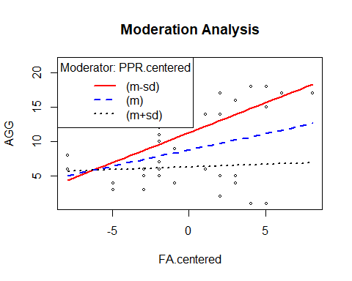

**6. Visualization**

# plotting a regression model based on:   
 # Model 2: AGG ~ PPR.centered + FA.centered  
  
# create linear model  
model.final <- lm(AGG ~ PPR + FA, data = dat.final)  
summary(model.final)

##   
## Call:  
## lm(formula = AGG ~ PPR + FA, data = dat.final)  
##   
## Residuals:  
## Min 1Q Median 3Q Max   
## -6.1640 -2.4019 0.5021 1.7678 5.6769   
##   
## Coefficients:  
## Estimate Std. Error t value Pr(>|t|)   
## (Intercept) 10.7438 2.1709 4.949 1.76e-05 ***  
## PPR -0.7941 0.1155 -6.875 4.78e-08 ***  
## FA 0.4758 0.1441 3.302 0.00218 **   
## ---  
## Signif. codes: 0 '***' 0.001 '**' 0.01 '*' 0.05 '.' 0.1 ' ' 1  
##   
## Residual standard error: 3.284 on 36 degrees of freedom  
## Multiple R-squared: 0.6333, Adjusted R-squared: 0.6129   
## F-statistic: 31.08 on 2 and 36 DF, p-value: 1.44e-08

model_p <- ggpredict(model.final, terms = c('PPR', 'FA'), full.data = TRUE, pretty = TRUE) #for single regression, remove terms = c("v1"", "v2", "vn")  
  
# plot predicted line - for single regression, change to aes(y = VAR, x = VAR)  
plot <- ggplot(model_p, aes(x, predicted)) +  
 geom_smooth(method = "lm", se = TRUE, fullrange=TRUE) + xlab("Score") + ggtitle("Model of Peer Relationships and Family Adversity Predicting Child Aggression") + ylab("Child Aggression") +  
 geom_point() + theme_minimal()  
  
plot

