Parent Overcontrol as Mediator for Parent and Child Anxiety

Daniel Pinedo

Psych 308d: Assignment 5

Parent Overcontrol as Mediator for Parent and Child Anxiety

**Results**

Data analysis is in Appendix A. Observations (*N* = 74) contained no missing parameters in the dataset. Analysis continued with tests of assumptions and inspection of histograms. There were no univariate outliers. Three multivariate outliers were determined and removed (*N*  = 71) based on calculations of Cook’s distance (cutoff = .05), a measure of multivariate influence. Descriptive statistics are in Table 1. Observation of histograms indicated normal distributions. Data was verified to be normally distributed across all variables as evidenced by skew for all variables being within a threshold of  3.00 (Table 1) and kurtosis being within a threshold of  10.00 (Table 1). The homoscedasticity assumption was confirmed using Breusch-Pagan test of non-constant variance, χ2 (1) = 0.00, *p* = .985. When viewing scatterplots with regression lines added and when correlated with child anxiety, the assumption of linearity appears to be met for parent anxiety (*r* = .62, *p* < .001) and parent overcontrol (*r* = .68, *p* < .001). We then completed a mediation analysis for parent overcontrol as mediator for parent anxiety predicting child anxiety.

Parent anxiety and parent overcontrol were both significantly correlated with child anxiety (Table 2). The relationship between parent and child anxiety was mediated by parent overcontrol. The predictive relationship between parent anxiety and parent overcontrol (Table 3, β = 0.74, *p* < .001) was statistically significant, as was parent overcontrol and child anxiety (Table 3, β = 0.47, *p* < .001). The standardized indirect effect was (.74)(.47) = .35, indicating partial mediation (56.6%). We tested the significance of this indirect effect using bootstrapping procedures. Unstandardized indirect effects were computed for each of 1,000 bootstrapped samples (Table 4), and the 95% confidence interval was computed by determining the indirect effects at the 2.5th and 97.5th percentiles. The bootstrapped unstandardized indirect effect was .34, and the 95% confidence interval ranged from 0.19, 0.52. Thus, the indirect effect was statistically significant. The indirect effect (a*b) was calculated additionally using the Sobel test = .34.

**Discussion**

The results of our tests indicate that the conservative Sobel test had similar results to our bootstrapping procedure, indicating that I missed the point of this assignment. It is likely that you wanted me to not remove multivariate outliers so I could see a difference in the results between Sobel test and bootstrapping procedures, due to Sobel test having low power, and being a more conservative test, where sampling distribution of a*b results in a highly skewed distribution. However, I found no conclusive answers on the intertubes as to when (or whether) multivariate outliers are considered assumptions that can be ignored using mediation bootstrapping procedures (i.e., it depends on what our research question is, and whether removing multivariate outliers or keeping them would change the data in some way as to jeopardize the inquiry). In any case, our standard errors for the indirect effect using bootstrapping (Table 3) versus not using bootstrapping (Table 4) were fairly similar, likely due to the fact that our dataset was normal.

The implications of this study indicate that helicopter parents (high anxiety, highly controlling) are likely at least partially responsible for their children having high anxiety. One possible recommendation would be an intervention to reduce parent overcontrol and see if child anxiety is reduced over time. The primary limitation of this study is that, although it suggest a directional relationship, it is cross-sectional and correlation in nature. A longitudinal study could be a future follow-up study to see if the parental overcontrol is a covariate or cause for child anxiety.

Table 1

*Descriptive Statistics of Measures*

Variable Mean SD Median Skew Kurtosis

Parent Anxiety 9.54 4.53 10.00 0.03 -0.20

Child Anxiety 10.80 4.49 10.50 0.25 -0.72

Parent Overcontrol 10.30 4.31 10.50 0.13 -0.54

Table 2

*Correlation Matrix for Measures Related to Child Anxiety*

Variable 1 2 3

1. Parent Anxiety - .62*** .60***

2. Child Anxiety - .68***

4. Parent Overcontrol -

*Note.* * *p* < .05, ** *p* < .01, *** *p* < .001.

Table 3

*Mediation Estimates without bootstrapping*

───────────────────────────────────────────────────────

Effect Label Estimate SE Z p % Mediation

───────────────────────────────────────────────────────

Indirect a × b 0.34 0.08 4.42 <.001 56.6

Direct c 0.26 0.09 2.82 0.005 43.4

Total c + a × b 0.61 0.09 6.66 <.001 100.0

───────────────────────────────────────────────────────

*Path Estimates without bootstrapping*

───────────────────────────────────────────────────────

Label Estimate SE Z p ───────────────────────────────────────────────────────

Parent Anxiety → Parent Overcontrol a 0.58 0.09 6.47 < .001

Parent Overcontrol → Child Anxiety b 0.59 0.10 6.04 < .001

Parent Anxiety → Child Anxiety c 0.26 0.10 2.82 .005

───────────────────────────────────────────────────────

Table 4

*Mediation Estimates with bootstrapping*

───────────────────────────────────────────────────────

Effect Label Estimate SE Z p % Mediation

───────────────────────────────────────────────────────

Indirect a × b 0.34 0.08 4.31 < .001 56.6

Direct c 0.26 0.09 2.90 0.004 43.4

Total c + a × b 0.61 0.08 7.77 < .001 100.0

───────────────────────────────────────────────────────

*Path Estimates with bootstrapping*

───────────────────────────────────────────────────────

Label Estimate SE Z p ───────────────────────────────────────────────────────

Parent Anxiety → Parent Overcontrol a 0.58 0.09 6.42 < .001

Parent Overcontrol → Child Anxiety b 0.59 0.09 6.52 < .001

Parent Anxiety → Child Anxiety c 0.26 0.09 2.90 .004

───────────────────────────────────────────────────────

Appendix A

**Statistical Analysis in R**

Daniel Pinedo

May 9, 2019

**Prompt**

Parents with anxiety disorders tend to have children with anxiety disorders as well (see everything ever written by Bogels, Borelli, Wood, or Rapee). This has led some to hypothesize that anxiety is genetically transmitted. However, you think there might be something else going on. Parental overcontrol, the excess regulation of a child’s emotion, cognition, and behavior is strongly related to child anxiety. You wonder if anxious parents are more overcontrolling, leading to child anxiety. You decided to conduct a study to figure this out.

*Variables:* Parent_Anx: 1-20 (higher scores indicating higher anxiety symptoms) Child_Anx: 1-20 (higher scores indicating higher anxiety symptoms) Parent_OC: 1-20 (higher scores indicating greater use of overcontrol)

**Research Question:** Does parental overcontrol mediate the relationship between parent anxiety and child anxiety?

**(1)** *General assignment:* Conduct the appropriate analysis using bootstrapping techniques. Report the proper assumptions and statistics in the results section. In the discussion section, provide a summary of what you found, discuss the implications, and give at least one limitation and future research direction. Don’t forget to include a table for descriptives, correlations, and regression models.

**(2)** *Conceptual component:* Conduct the same analysis, but use the Sobel test instead of bootstrapping to test the indirect effect. *Report the statistics in your results section.* Provide a summary of what of the findings were for this analysis and compare it to your bootstrapped analysis findings. If the two analyses found different outcomes, determine which results are more appropriate and justify your decision (Hint: What is a known issue with the Sobel test?).

#Prep

library(pacman)  
p_load(psych, jmv, medmod, lavaan, multilevel)

#Read in your data

datboot <- read.csv("https://www.dropbox.com/s/dsplwa2mppfhmu7/Psy.308d.DA5.csv?dl=1")

**Descriptives**

desc <- descriptives(datboot,   
 vars = c('Parent_Anx', 'Child_Anx', 'Parent_OC'),   
 hist = TRUE,   
 sd = TRUE,   
 min = TRUE,   
 max = TRUE,   
 skew = TRUE,   
 kurt = TRUE)  
desc

##   
## DESCRIPTIVES  
##   
## Descriptives   
## ---------------------------------------------------------------   
## Parent_Anx Child_Anx Parent_OC   
## ---------------------------------------------------------------   
## N 74 74 74   
## Missing 0 0 0   
## Mean 9.54 10.8 10.3   
## Median 10.0 10.5 10.5   
## Standard deviation 4.53 4.49 4.31   
## Minimum 1 2 2   
## Maximum 20 20 20   
## Skewness 0.0261 0.254 0.130   
## Std. error skewness 0.279 0.279 0.279   
## Kurtosis -0.195 -0.721 -0.542   
## Std. error kurtosis 0.552 0.552 0.552   
## ---------------------------------------------------------------

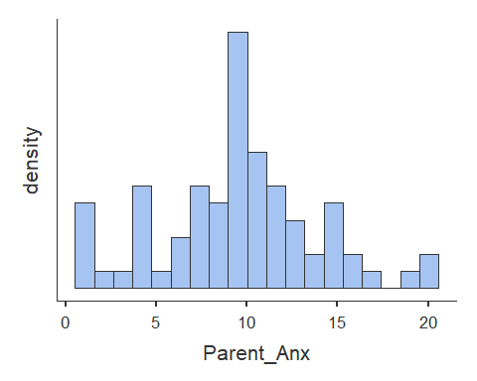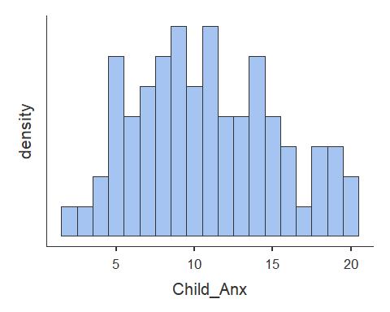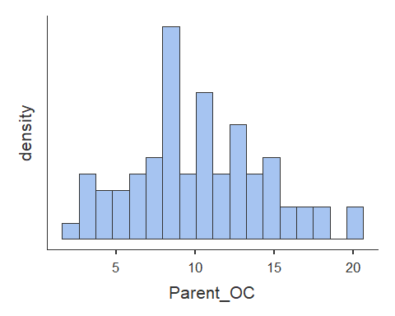

cat("\n")

corr <- corrMatrix(datboot,   
 vars = c('Parent_Anx', 'Child_Anx', 'Parent_OC'),   
 flag = TRUE)  
corr

##   
## CORRELATION MATRIX  
##   
## Correlation Matrix   
## ---------------------------------------------------------------------   
## Parent_Anx Child_Anx Parent_OC   
## ---------------------------------------------------------------------   
## Parent_Anx Pearson's r — 0.618 0.602   
## p-value — < .001 < .001   
##   
## Child_Anx Pearson's r — 0.675   
## p-value — < .001   
##   
## Parent_OC Pearson's r —   
## p-value —   
## ---------------------------------------------------------------------   
## Note. * p < .05, ** p < .01, *** p < .001

Assumptions:

1. Missing Data - **NONE**
2. Univariate a. Normality **PASSED**, b. Linearity and c. Outliers
3. Multivariate a. Normality **PASSED** and b.Outliers **REMOVED**
4. Heteroscedsticity **PASSED**
5. Multi-collinearity **EXPECTED**

**2b. Univariate Linearity**

# Scatterplots [Assumption 2b]  
  
# Y ~ X [path c]  
plot(datboot$Parent_Anx, datboot$Child_Anx, abline(lm(datboot$Child_Anx ~ datboot$Parent_Anx)))

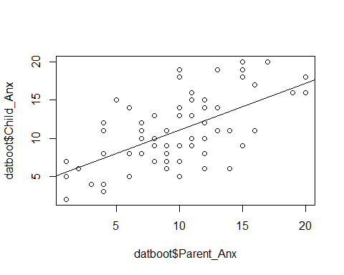

# M ~ X [path a]   
plot(datboot$Parent_Anx, datboot$Parent_OC, abline(lm(datboot$Parent_Anx ~ datboot$Parent_OC)))

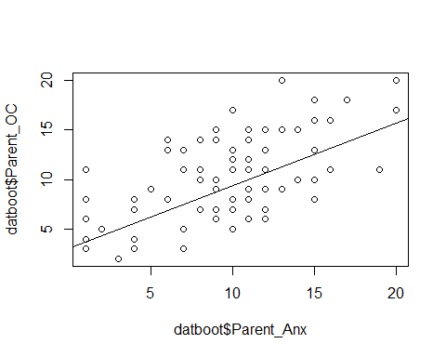

# Y ~ M [path b]   
plot(datboot$Parent_OC, datboot$Child_Anx, abline(lm(datboot$Child_Anx ~ datboot$Parent_OC)))

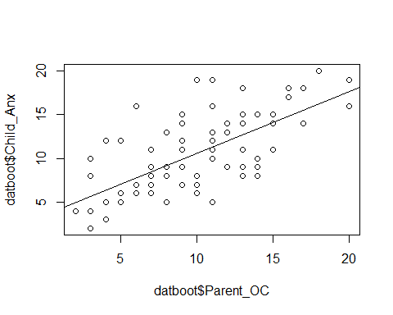

**2c. Univariate Outliers**

#Identify outliers  
#scale() converts to z scores - "3" refers to standard deviations  
datboot[abs(scale(datboot$Parent_Anx)) > 3, ]

## [1] Participant Parent_Anx Parent_OC Child_Anx   
## <0 rows> (or 0-length row.names)

datboot[abs(scale(datboot$Child_Anx)) > 3, ]

## [1] Participant Parent_Anx Parent_OC Child_Anx   
## <0 rows> (or 0-length row.names)

datboot[abs(scale(datboot$Parent_OC)) > 3, ]

## [1] Participant Parent_Anx Parent_OC Child_Anx   
## <0 rows> (or 0-length row.names)

#There are a total of 0 independent observations that contain outliers

**3a. Multivariate Normality**

#look at residuals and the Q-Q plot for independent variables (should be no relationship)  
#Observe Leverage (Mahalanobis' Distance) + Discrepancy (= Influence; Cook's Distance)  
  
# Y ~ X + M  
model.multi_norm <- linReg(data = datboot,   
 dep = 'Child_Anx',   
 covs = c('Parent_Anx', 'Parent_OC'),  
 blocks = list(c('Parent_Anx', 'Parent_OC')),   
 modelTest = TRUE,   
 r2Adj = TRUE,   
 stdEst = TRUE,   
 ciStdEst = TRUE,  
 qqPlot = TRUE, ##QQ plot  
 resPlots = TRUE) ##residuals plot   
  
model.multi_norm

##   
## LINEAR REGRESSION  
##   
## Model Fit Measures   
## --------------------------------------------------------------------------   
## Model R R² Adjusted R² F df1 df2 p   
## --------------------------------------------------------------------------   
## 1 0.725 0.526 0.512 39.4 2 71 < .001   
## --------------------------------------------------------------------------   
##   
##   
## MODEL SPECIFIC RESULTS  
##   
## MODEL 1  
##   
## Model Coefficients   
## ------------------------------------------------------------------------------------------   
## Predictor Estimate SE t p Stand. Estimate Lower Upper   
## ------------------------------------------------------------------------------------------   
## Intercept 2.575 0.998 2.58 0.012   
## Parent_Anx 0.328 0.101 3.24 0.002 0.331 0.127 0.535   
## Parent_OC 0.496 0.107 4.65 < .001 0.476 0.272 0.680   
## ------------------------------------------------------------------------------------------   
##   
##   
## ASSUMPTION CHECKS

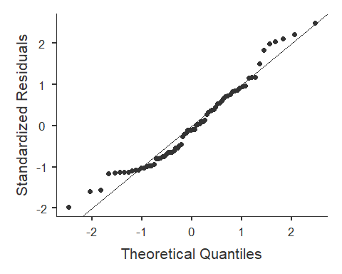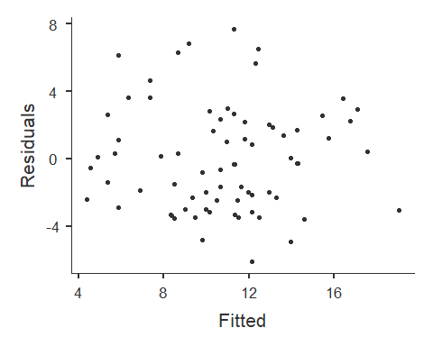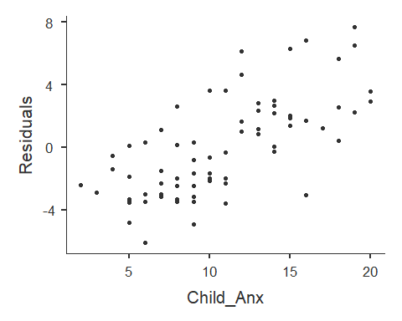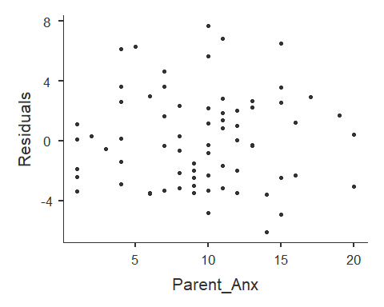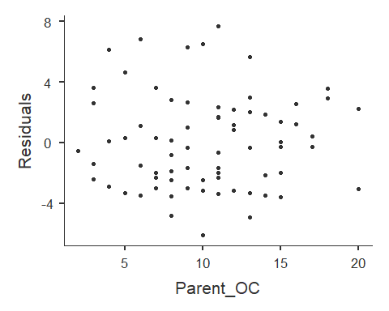

#Alternate not using jvm library  
#model <- lm(model, data)  
#plot(model)

**3b. Multivariate Outliers**

#Check and remove multivariate outliers based on Cook's distance (CD)  
#for Mahalanobis' Distance (leverage only), see /Regression/Regression_Diagnostics.Rmd for how-to  
#CD = Influence = Leverage + Discrepancy (Discrepancy = how much an observation deviates from the overall pattern of the model)  
  
#create model  
model.cook <- lm(datboot$Child_Anx ~ datboot$Parent_Anx + datboot$Parent_OC)  
model.cook

##   
## Call:  
## lm(formula = datboot$Child_Anx ~ datboot$Parent_Anx + datboot$Parent_OC)  
##   
## Coefficients:  
## (Intercept) datboot$Parent_Anx datboot$Parent_OC   
## 2.5754 0.3284 0.4962

summary(model.cook)

##   
## Call:  
## lm(formula = datboot$Child_Anx ~ datboot$Parent_Anx + datboot$Parent_OC)  
##   
## Residuals:  
## Min 1Q Median 3Q Max   
## -6.134 -2.451 -0.302 2.148 7.683   
##   
## Coefficients:  
## Estimate Std. Error t value Pr(>|t|)   
## (Intercept) 2.5754 0.9978 2.581 0.01192 *   
## datboot$Parent_Anx 0.3284 0.1015 3.236 0.00184 **   
## datboot$Parent_OC 0.4962 0.1067 4.650 1.5e-05 ***  
## ---  
## Signif. codes: 0 '***' 0.001 '**' 0.01 '*' 0.05 '.' 0.1 ' ' 1  
##   
## Residual standard error: 3.137 on 71 degrees of freedom  
## Multiple R-squared: 0.5258, Adjusted R-squared: 0.5124   
## F-statistic: 39.36 on 2 and 71 DF, p-value: 3.145e-12

#find cook's distance for that model  
datboot$cook <- cooks.distance(model.cook)  
  
#create the cutoff [> 4/N]  
cook.cutoff <- 4/nrow(datboot)   
print(paste("Our Cook cutoff =", round(cook.cutoff, 3), "- anything above this value will be removed"))

## [1] "Our Cook cutoff = 0.054 - anything above this value will be removed"

#plot it out  
plot(model.cook, which = 4, cook.levels = cook.cutoff)  
  
#Add a cutoff line  
abline(h = cook.cutoff, lty = 2)

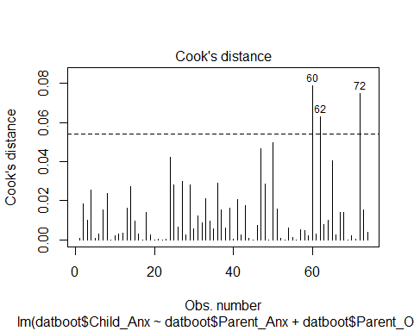

#Show and remove all outliers above your cutoff line  
datboot.no.outliers <- datboot[!(datboot$cook) > cook.cutoff, ]  
  
print(paste("There were", nrow(datboot), "observations before removing multivariate outliers"))

## [1] "There were 74 observations before removing multivariate outliers"

print(paste("We removed outlier observation #:", datboot[(datboot$cook) > cook.cutoff, 1], "with a Cook's distance =", round(datboot[(datboot$cook) > cook.cutoff, 5], 3)))

## [1] "We removed outlier observation #: 60 with a Cook's distance = 0.079"  
## [2] "We removed outlier observation #: 62 with a Cook's distance = 0.063"  
## [3] "We removed outlier observation #: 72 with a Cook's distance = 0.075"

print(paste("We now have", nrow(datboot.no.outliers), "total observations saved in the new dataset after removing", nrow(datboot[(datboot$cook) > cook.cutoff, ]), "outliers"))

## [1] "We now have 71 total observations saved in the new dataset after removing 3 outliers"

#N is now 39 after removing 1 multivariate outlier observation(s)  
 #was 40 after removing 0 univariate outlier observation(s)  
 #was 40 after removing 0 observation(s) with missing parameters  
 #was 40 originally (total 1 observation(s) removed from orginal dataset - 3%)

**4. Heteroscedasticity**

p_load(car)  
#Breusch-Pagan test   
#H0 = no change in variance across residuals.  
model.breusch_pagan <- lm(datboot.no.outliers$Child_Anx ~ datboot.no.outliers$Parent_Anx + datboot.no.outliers$Parent_OC)  
ncvTest(model.breusch_pagan)

## Non-constant Variance Score Test   
## Variance formula: ~ fitted.values   
## Chisquare = 0.0003392379, Df = 1, p = 0.98531

#not significant = homoscedastic  
#If violated use Box-cox transformation [boxcox(model)] in library MASS

**5. Multi-collinearity**

#Multicollinearity is expected in mediation  
  
model.multicoll <- linReg(data = datboot.no.outliers,   
 dep = 'Child_Anx',   
 cov = c('Parent_Anx', 'Parent_OC'),  
 blocks = list(c('Parent_Anx', 'Parent_OC')),   
 modelTest = TRUE,  
 r2Adj = TRUE,  
 stdEst = TRUE,  
 ciStdEst = TRUE,   
 collin = TRUE) #this line does the thing  
model.multicoll

##   
## LINEAR REGRESSION  
##   
## Model Fit Measures   
## --------------------------------------------------------------------------   
## Model R R² Adjusted R² F df1 df2 p   
## --------------------------------------------------------------------------   
## 1 0.771 0.594 0.582 49.7 2 68 < .001   
## --------------------------------------------------------------------------   
##   
##   
## MODEL SPECIFIC RESULTS  
##   
## MODEL 1  
##   
## Model Coefficients   
## --------------------------------------------------------------------------------------------   
## Predictor Estimate SE t p Stand. Estimate Lower Upper   
## --------------------------------------------------------------------------------------------   
## Intercept 1.899 0.9375 2.03 0.047   
## Parent_Anx 0.263 0.0954 2.76 0.007 0.269 0.0747 0.464   
## Parent_OC 0.594 0.1004 5.92 < .001 0.576 0.3820 0.771   
## --------------------------------------------------------------------------------------------   
##   
##   
## ASSUMPTION CHECKS  
##   
## Collinearity Statistics   
## -----------------------------------   
## VIF Tolerance   
## -----------------------------------   
## Parent_Anx 1.59 0.629   
## Parent_OC 1.59 0.629   
## -----------------------------------

#Tolerance for all variables indicates low/no multicollinearity

*Mediation* 1. Regression a. Y ~ X b. M ~ X c. Y ~ X + M

1. No bootstrapping
2. Model
3. Sobel Test
4. Bootstrapping

**1. Regression** a. Y ~ X

model1 <- linReg(data = datboot.no.outliers,   
 dep = 'Child_Anx',   
 covs = 'Parent_Anx',  
 blocks = list(c('Parent_Anx')),   
 modelTest = TRUE,   
 stdEst = TRUE,  
 ci = TRUE,  
 ciWidth = 95)  
model1

##   
## LINEAR REGRESSION  
##   
## Model Fit Measures   
## -----------------------------------------------------------   
## Model R R² F df1 df2 p   
## -----------------------------------------------------------   
## 1 0.620 0.385 43.2 1 69 < .001   
## -----------------------------------------------------------   
##   
##   
## MODEL SPECIFIC RESULTS  
##   
## MODEL 1  
##   
## Model Coefficients   
## -------------------------------------------------------------------------------------------   
## Predictor Estimate SE Lower Upper t p Stand. Estimate   
## -------------------------------------------------------------------------------------------   
## Intercept 4.826 0.9730 2.885 6.767 4.96 < .001   
## Parent_Anx 0.607 0.0924 0.423 0.791 6.57 < .001 0.620   
## -------------------------------------------------------------------------------------------

1. M ~ X

model2 <- linReg(data = datboot.no.outliers,   
 dep = 'Parent_OC',  
 covs = 'Child_Anx',  
 blocks = list(c('Child_Anx')),   
 modelTest = TRUE,   
 stdEst = TRUE,  
 ci = TRUE,  
 ciWidth = 95)  
model2

##   
## LINEAR REGRESSION  
##   
## Model Fit Measures   
## -----------------------------------------------------------   
## Model R R² F df1 df2 p   
## -----------------------------------------------------------   
## 1 0.740 0.548 83.7 1 69 < .001   
## -----------------------------------------------------------   
##   
##   
## MODEL SPECIFIC RESULTS  
##   
## MODEL 1  
##   
## Model Coefficients   
## ------------------------------------------------------------------------------------------   
## Predictor Estimate SE Lower Upper t p Stand. Estimate   
## ------------------------------------------------------------------------------------------   
## Intercept 2.814 0.9018 1.015 4.613 3.12 0.003   
## Child_Anx 0.719 0.0785 0.562 0.875 9.15 < .001 0.740   
## ------------------------------------------------------------------------------------------

1. Y ~ X + M

model3 <- linReg(data = datboot.no.outliers,   
 dep = 'Child_Anx',   
 covs = c('Parent_Anx', 'Parent_OC'),  
 blocks = list(c('Parent_Anx', 'Parent_OC')),   
 modelTest = TRUE,   
 stdEst = TRUE,  
 ci = TRUE,   
 ciWidth = 95)  
model3

##   
## LINEAR REGRESSION  
##   
## Model Fit Measures   
## -----------------------------------------------------------   
## Model R R² F df1 df2 p   
## -----------------------------------------------------------   
## 1 0.771 0.594 49.7 2 68 < .001   
## -----------------------------------------------------------   
##   
##   
## MODEL SPECIFIC RESULTS  
##   
## MODEL 1  
##   
## Model Coefficients   
## --------------------------------------------------------------------------------------------   
## Predictor Estimate SE Lower Upper t p Stand. Estimate   
## --------------------------------------------------------------------------------------------   
## Intercept 1.899 0.9375 0.0287 3.770 2.03 0.047   
## Parent_Anx 0.263 0.0954 0.0731 0.454 2.76 0.007 0.269   
## Parent_OC 0.594 0.1004 0.3936 0.794 5.92 < .001 0.576   
## --------------------------------------------------------------------------------------------

**2. No bootstrapping**

1. Model b. Sobel Test

# (a * b) = (c - c') = Indirect Effect [i.e., amount of mediation]  
# Z = Sobel test  
# a = Path Estimate from X to M  
# b = Path Estimate from M to Y  
# c = Total Estimate (Direct Estimate + Indirect Estimate)  
# c' = Direct Estimate  
  
med <- medmod::med(datboot.no.outliers,   
 dep = 'Child_Anx',   
 pred = 'Parent_Anx',   
 med = 'Parent_OC',   
 pm = TRUE,   
 ci = TRUE,  
 paths = TRUE,  
 label = TRUE,  
 estPlot = TRUE)  
med

##   
## MEDIATION  
##   
## Mediation Estimates   
## ---------------------------------------------------------------------------------------------------   
## Effect Label Estimate SE Lower Upper Z p % Mediation   
## ---------------------------------------------------------------------------------------------------   
## Indirect a × b 0.344 0.0778 0.1912 0.496 4.42 < .001 56.6   
## Direct c 0.263 0.0933 0.0804 0.446 2.82 0.005 43.4   
## Total c + a × b 0.607 0.0911 0.4285 0.786 6.66 < .001 100.0   
## ---------------------------------------------------------------------------------------------------   
##   
##   
## Path Estimates   
## ----------------------------------------------------------------------------------------------------   
## Label Estimate SE Lower Upper Z p   
## ----------------------------------------------------------------------------------------------------   
## Parent_Anx <U+2192> Parent_OC a 0.579 0.0894 0.4035 0.754 6.47 < .001   
## Parent_OC <U+2192> Child_Anx b 0.594 0.0983 0.4013 0.787 6.04 < .001   
## Parent_Anx <U+2192> Child_Anx c 0.263 0.0933 0.0804 0.446 2.82 0.005   
## ----------------------------------------------------------------------------------------------------

## Scale for 'colour' is already present. Adding another scale for  
## 'colour', which will replace the existing scale.

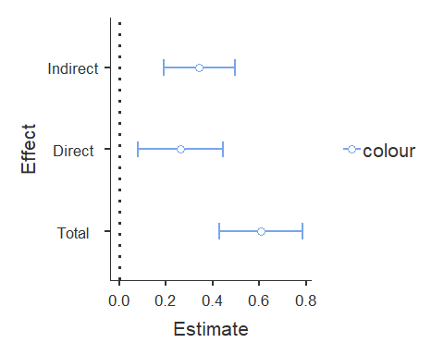

# Look at this in comparison to the indirect mediation estimate.  
# sobel(X, M, Y)  
cat("\n")

sobel(datboot.no.outliers$Parent_Anx, datboot.no.outliers$Parent_OC, datboot.no.outliers$Child_Anx)

## $`Mod1: Y~X`  
## Estimate Std. Error t value Pr(>|t|)  
## (Intercept) 4.825577 0.97296433 4.959665 4.863136e-06  
## pred 0.607077 0.09240246 6.569922 7.931925e-09  
##   
## $`Mod2: Y~X+M`  
## Estimate Std. Error t value Pr(>|t|)  
## (Intercept) 1.8994837 0.93752054 2.026072 4.668296e-02  
## pred 0.2633798 0.09537577 2.761496 7.391486e-03  
## med 0.5939162 0.10040604 5.915144 1.195656e-07  
##   
## $`Mod3: M~X`  
## Estimate Std. Error t value Pr(>|t|)  
## (Intercept) 4.9267776 0.95486459 5.159661 2.264567e-06  
## pred 0.5786964 0.09068353 6.381494 1.723080e-08  
##   
## $Indirect.Effect  
## [1] 0.3436972  
##   
## $SE  
## [1] 0.07922674  
##   
## $z.value  
## [1] 4.338146  
##   
## $N  
## [1] 71

**3. Bootstrapping**

boot <- medmod::med(datboot.no.outliers,   
 dep = 'Child_Anx',   
 pred = 'Parent_Anx',   
 med = 'Parent_OC',   
 estMethod = 'bootstrap',   
 bootstrap = 1000,   
 pm = TRUE,  
 ci = TRUE,  
 paths = TRUE,  
 label = TRUE,  
 estPlot = TRUE)  
  
boot

##   
## MEDIATION  
##   
## Mediation Estimates   
## ---------------------------------------------------------------------------------------------------   
## Effect Label Estimate SE Lower Upper Z p % Mediation   
## ---------------------------------------------------------------------------------------------------   
## Indirect a × b 0.344 0.0785 0.2045 0.502 4.38 < .001 56.6   
## Direct c 0.263 0.0937 0.0574 0.433 2.81 0.005 43.4   
## Total c + a × b 0.607 0.0827 0.4323 0.766 7.34 < .001 100.0   
## ---------------------------------------------------------------------------------------------------   
##   
##   
## Path Estimates   
## ----------------------------------------------------------------------------------------------------   
## Label Estimate SE Lower Upper Z p   
## ----------------------------------------------------------------------------------------------------   
## Parent_Anx <U+2192> Parent_OC a 0.579 0.0874 0.3993 0.748 6.62 < .001   
## Parent_OC <U+2192> Child_Anx b 0.594 0.0915 0.4186 0.780 6.49 < .001   
## Parent_Anx <U+2192> Child_Anx c 0.263 0.0937 0.0574 0.433 2.81 0.005   
## ----------------------------------------------------------------------------------------------------

## Scale for 'colour' is already present. Adding another scale for  
## 'colour', which will replace the existing scale.

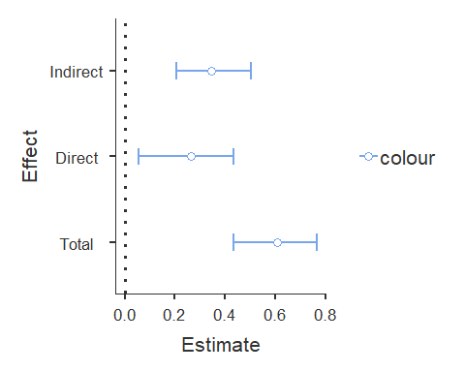

# Check the z-values, SE, and p-values for pathways to see differences (X -> Y for this one).