Predictors of Productivity in a Work Setting

Daniel Pinedo

Psych 308c: Assignment 1

Predictors of Productivity in a Work Setting

Employees will likely be happier if they have autonomy over their time at work. However, it is crucial to determine in which manner this autonomy impacts productivity. A local company initiated a program to allow its employees to take a break from 1-60 minutes at any time during their work day. At the end of 30 days, the company wanted to know how this program worked by measuring productivity as well as the average length of their daily break, how much they enjoyed the break, and their overall desire to come to work. The purpose of this study was to determine how these three latter qualities predict employee productivity.

**Method**

The present study utilized a correlational design. Data collection methods included the use of an in-person survey administered at the end of the first month of the new break program.

**Participants**

Participants consisted of all 175 employees of the company. No demographic data was collected.

**Measures**

Each employee was assessed using the below measures.

***Productivity.*** Productivity (Product) assessed the percentage of time meeting weekly goals using a 100-point scale, with higher scores indicating higher productivity.

***Length.*** Length assessed the length of a break in minutes using a 60-point scale, with higher scores indicating greater amount of time.

***Enjoyment.*** Enjoyment (Enjoy) assessed self-reported level of enjoyment of break using a 10 point scale, with higher scores indicating a greater perceived level of enjoyment.

***Desire.*** Desire assessed self-reported level of desire to come to work using a 10-point scale, with higher scores indicating a greater perceived level of desire.

**Planned Analysis**

The present study planned to use correlation, simple regression, and multiple regression to assess the relationships between predictors, as well as predictors and the outcome variable.

**Results**

Data analysis can be found in Appendix A. Descriptive statistics can be found in Table 1. There were no missing data in the dataset and analysis continued with tests of assumptions. Descriptive statistics and inspection of histograms reveal that the data do not violate the assumption of univariate normality with the possible exception of the outcome variable (Product) being bimodal. Data appear to be normally distributed across all variables in the model, as evidenced by skew for all variables being below a threshold of  3.00 (Length = -0.07, Enjoy = -0.29, Desire = -0.33, Product = -0.15), and kurtosis below a threshold of  10.00 (Length = -0.43, Enjoy = 0.88, Desire = 0.60, Product = -0.39). Scatterplots were run to assess the assumption of homoscedasticity. This assumption does not appear to be violated for the variables of length of break, enjoyment of break, and desire to come to work as the variance across each variable appears to be stable based on visual inspection of the scatterplots. For example, there is less variance in the low end of enjoyment of break, and less variance at the high end of desire to come to work, but these differences do not appear to be significant. In addition, the variable of length of break appears to meet the assumption of homoscedasticity. Finally, the assumption of linearity appears to be met for all variables.

Both enjoyment of break and desire to come to work were significantly correlated with productivity (Table 2), therefore the relationship between the outcome (productivity) and these two predictors were assessed through regression analyses. Enjoyment of break explained 11% of the variance in intent to return, *R2* = .11, *F*(1, 173) = 21.90, *p* < .001 (Table 3). Adding the desire to go to work variable to the model explained 17% of the variance in productivity, *R2* = .17, *F*(2, 172) = 17.4, *p* < .001 (Table 4). Model comparison of the two models indicated that the model with both predictor variables of enjoyment of break and desire to go to work was significantly better than a model with only the predictor for enjoyment of break, *F*(1, 172), *ΔR2* = .06, *p* < .001.

**Discussion**

The purpose of the current project was to test predictors of work productivity. All employees (*N* = 175) were assessed for the length of their breaks, enjoyment of breaks, desire to go to work, and their performance. Correlation and regression analyses were used to determine whether these variables predicted productivity as time meeting weekly goals.

Correlation analyses demonstrated that length of break was not significantly related with performance and not included for further analysis. The remaining two predictor variables of enjoyment of break and desire to go to work were added to simple regression analyses. When including enjoyment and desire in the linear model both were significant predictors of performance (Table 4).

In summary, these results indicate that both enjoyment of break and desire to go to work were significant predictors of employee’s productivity as time meeting weekly goals. However, when comparing the predictors, enjoyment is a better predictor of performance. In conclusion, if the company wants to increase employee time meeting weekly goals, they should continue to focus on promoting autonomy through flexible break times and thereby job satisfaction (e.g, desire to go to work). However, considering that the productivity variable appears to be non-normal (i.e. bimodal), these results should also be reconsidered using alternative methods and analyses to confirm.

Table 1.

*Descriptive Statistics of Predictors of Employee Productivity*

|  |  |  |  |  |
| --- | --- | --- | --- | --- |
|  | Length | Enjoy | Desire | Product |
| Mean | 38.70 | 7.97 | 7.58 | 78.80 |
| Median | 38.5 | 8.00 | 7.60 | 79.00 |
| SD | 5.49 | 0.53 | 0.73 | 4.60 |
| Min | 24.90 | 6.00 | 5.20 | 67.00 |
| Max | 50.80 | 9.30 | 9.60 | 90.00 |
| Skewness | -0.07 | -0.29 | -0.33 | -0.15 |
| Kurtosis | -0.43 | 0.88 | 0.60 | -0.39 |

Table 2.

*Correlation Matrix for Employee Productivity*

|  |  |  |  |  |
| --- | --- | --- | --- | --- |
|  | Length | Enjoy | Desire | Product |
| Length | 1.00 |  |  |  |
| Enjoy | -0.03 | 1.00 |  |  |
| Desire | 0.02 | 0.30* | 1.00 |  |
| Product | 0.03 | 0.34* | 0.33* | 1.00 |

*Note*. * *p* < .001

Table 3.

*Regression of Enjoyment of Break onto Productivity*

|  |  |  |  |  |  |
| --- | --- | --- | --- | --- | --- |
|  | β | | Estimate | SE | *t* |
| Intercept |  | | 55.65 | 4.95 | 11.23* |
| Enjoyment | | .34 | 2.91 | 0.62 | 4.68* |

*Note.* * *p* < .001

Table 4.

*Regression of Enjoyment of Break and Desire to Go to Work onto Productivity*

|  |  |  |  |  |  |
| --- | --- | --- | --- | --- | --- |
|  | β | | Estimate | SE | *t* |
| Intercept |  | | 48.77 | 5.22 | 9.35* |
| Enjoyment | | .26 | 2.28 | 0.63 | 3.62* |
| Desire | .25 | | 1.57 | 0.46 | 3.41* |

*Note.* *\* p* < .001

Appendix A

**Statistical Analysis in R**

**Hypotheses**

H0: no relationship between variables

Ha: length, enjoy, and desire predict product

**Descriptive Statistics and Assumptions**

# Prerequisitites  
 # 1. Variables are measured on the continuous level  
  
# Assumptions  
 # 1. Normal Distribution for X and Y (Product) [i.e. histogram, skew +-3, kurtosis +-10]  
 # Distribition for Y appears to be bimodal, but otherwise normally distributed  
 # Skew for Y is -0.15; Kurtosis for Y is -.38 ---> both pass  
 # 2. Linear Relationship between X and Y  
 # Visual inspection of scatterplot and prediction model line indicate a linear relationship  
 # 3. Homoscedasticity  
 # Visual inspection of scatterplots indicate homoscedasticity is true for all X/Y relationships  
 # 4. [Examine residuals (e = Y - Y~predicted~) to understand 2 and 3]  
  
# Descriptives [Assumption 1]  
desc <- descriptives(data = dat,   
 vars = c('Length', 'Enjoy', 'Desire', 'Product'),   
 hist = TRUE,   
 sd = TRUE,   
 range = TRUE,   
 skew = TRUE,   
 kurt = TRUE)  
desc

##   
## DESCRIPTIVES  
##   
## Descriptives   
## -----------------------------------------------------------------   
## Length Enjoy Desire Product   
## -----------------------------------------------------------------   
## N 175 175 175 175   
## Missing 0 0 0 0   
## Mean 38.7 7.97 7.58 78.8   
## Median 38.5 8.00 7.60 79   
## Standard deviation 5.49 0.531 0.727 4.60   
## Range 25.9 3.30 4.40 23   
## Minimum 24.9 6.00 5.20 67   
## Maximum 50.8 9.30 9.60 90   
## Skewness -0.0738 -0.288 -0.329 -0.150   
## Std. error skewness 0.184 0.184 0.184 0.184   
## Kurtosis -0.428 0.876 0.598 -0.384   
## Std. error kurtosis 0.365 0.365 0.365 0.365   
## -----------------------------------------------------------------

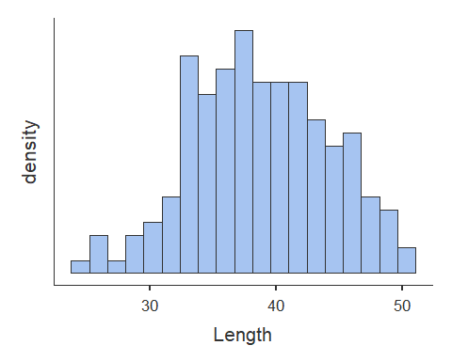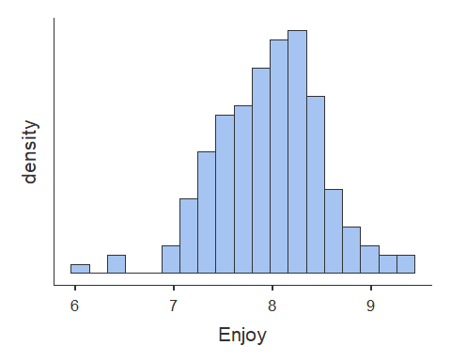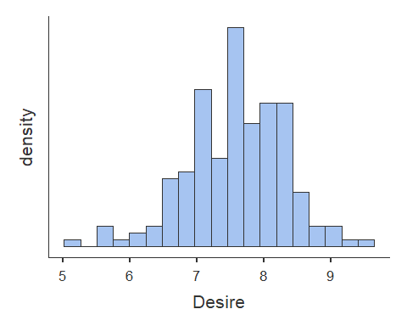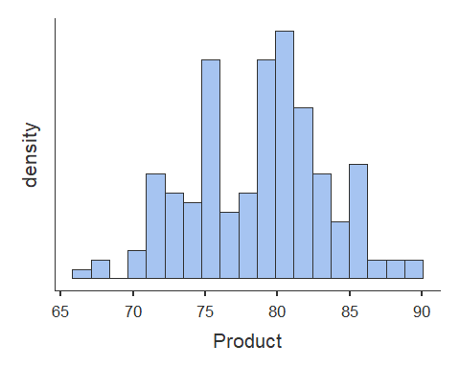

# Scatterplots  
plot(dat$Length, dat$Product, abline(lm(dat$Product ~ dat$Length)))

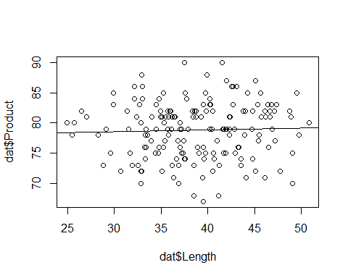

plot(dat$Enjoy, dat$Product, abline(lm(dat$Product ~ dat$Enjoy)))

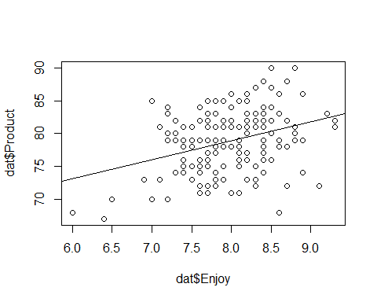

plot(dat$Desire, dat$Product, abline(lm(dat$Product ~ dat$Desire)))

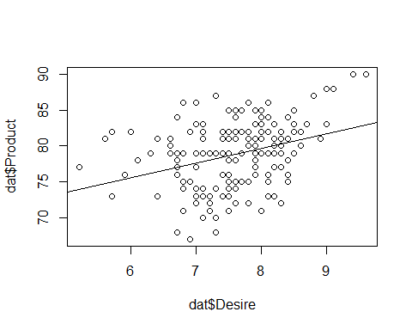

**Correlations**

# Correlation  
cortable <- corrMatrix(data = dat,   
 vars = c('Length', 'Enjoy', 'Desire', 'Product'),   
 flag = TRUE)  
cortable

##   
## CORRELATION MATRIX  
##   
## Correlation Matrix   
## -------------------------------------------------------------------   
## Length Enjoy Desire Product   
## -------------------------------------------------------------------   
## Length Pearson's r - -0.025 0.015 0.034   
## p-value - 0.744 0.843 0.659   
##   
## Enjoy Pearson's r - 0.292 0.336   
## p-value - < .001 < .001   
##   
## Desire Pearson's r - 0.325   
## p-value - < .001   
##   
## Product Pearson's r -   
## p-value -   
## -------------------------------------------------------------------   
## Note. * p < .05, ** p < .01, *** p < .001

**Simple Regression**

# Simple Regression Model 1  
# Start with the simpler model first - Enjoy is most correlated with outcome variable (Product)  
model1 <- linReg(data = dat,   
 dep = 'Product', #outcome  
 covs = c('Enjoy'), #predictors  
 blocks = list(c('Enjoy')), #order - doesn't matter for simple regression as there is only one variable  
 modelTest = TRUE, #significance test on model [H0: R squared = 0]  
 stdEst = TRUE) #standardized regression coefficient for individual variable [Stand. Estimate]  
model1 #print to screen

##   
## LINEAR REGRESSION  
##   
## Model Fit Measures   
## -----------------------------------------------------------   
## Model R R² F df1 df2 p   
## -----------------------------------------------------------   
## 1 0.336 0.113 21.9 1 173 < .001   
## -----------------------------------------------------------   
##   
##   
## MODEL SPECIFIC RESULTS  
##   
## MODEL 1  
##   
## Model Coefficients   
## ------------------------------------------------------------------------   
## Predictor Estimate SE t p Stand. Estimate   
## ------------------------------------------------------------------------   
## Intercept 55.65 4.954 11.23 < .001   
## Enjoy 2.91 0.620 4.68 < .001 0.336   
## ------------------------------------------------------------------------

#This model is best fit for simple regression based on R squared and Beta Estimates  
  
# ALTERNATIVE  
model1.1<- lm(Product ~ Enjoy, data = dat)  
summary(model1.1)

##   
## Call:  
## lm(formula = Product ~ Enjoy, data = dat)  
##   
## Residuals:  
## Min 1Q Median 3Q Max   
## -12.6459 -3.0646 0.3886 3.0980 9.6447   
##   
## Coefficients:  
## Estimate Std. Error t value Pr(>|t|)   
## (Intercept) 55.6501 4.9536 11.234 < 2e-16 ***  
## Enjoy 2.9065 0.6204 4.685 5.65e-06 ***  
## ---  
## Signif. codes: 0 '***' 0.001 '**' 0.01 '*' 0.05 '.' 0.1 ' ' 1  
##   
## Residual standard error: 4.347 on 173 degrees of freedom  
## Multiple R-squared: 0.1126, Adjusted R-squared: 0.1075   
## F-statistic: 21.95 on 1 and 173 DF, p-value: 5.649e-06

# Simple Regression Model 2  
# Desire is second most correlated with outcome variable (Product)  
model2 <- linReg(data = dat,   
 dep = 'Product', #outcome  
 covs = c('Desire'), #predictors  
 blocks = list(c('Desire')), #order - doesn't matter for simple regression as there is only one variable  
 modelTest = TRUE, #significance test on model [H0: R squared = 0]  
 stdEst = TRUE) #standardized regression coefficient for individual variable  
model2 #print to screen

##   
## LINEAR REGRESSION  
##   
## Model Fit Measures   
## -----------------------------------------------------------   
## Model R R² F df1 df2 p   
## -----------------------------------------------------------   
## 1 0.325 0.105 20.4 1 173 < .001   
## -----------------------------------------------------------   
##   
##   
## MODEL SPECIFIC RESULTS  
##   
## MODEL 1  
##   
## Model Coefficients   
## ------------------------------------------------------------------------   
## Predictor Estimate SE t p Stand. Estimate   
## ------------------------------------------------------------------------   
## Intercept 63.24 3.465 18.25 < .001   
## Desire 2.05 0.455 4.51 < .001 0.325   
## ------------------------------------------------------------------------

# ALTERNATIVE  
model2.1<- lm(Product ~ Desire, data = dat)  
summary(model2.1)

##   
## Call:  
## lm(formula = Product ~ Desire, data = dat)  
##   
## Residuals:  
## Min 1Q Median 3Q Max   
## -10.4027 -3.5318 0.5179 3.1867 8.8026   
##   
## Coefficients:  
## Estimate Std. Error t value Pr(>|t|)   
## (Intercept) 63.2376 3.4648 18.251 < 2e-16 ***  
## Desire 2.0529 0.4548 4.514 1.17e-05 ***  
## ---  
## Signif. codes: 0 '***' 0.001 '**' 0.01 '*' 0.05 '.' 0.1 ' ' 1  
##   
## Residual standard error: 4.364 on 173 degrees of freedom  
## Multiple R-squared: 0.1054, Adjusted R-squared: 0.1002   
## F-statistic: 20.37 on 1 and 173 DF, p-value: 1.174e-05

**Multiple Regression**

# Multiple regression test #A  
  
modelA <- linReg(data = dat,   
 dep = 'Product', #outcome  
 covs = c('Enjoy', 'Desire'), #predictors  
 blocks = list(c('Enjoy', 'Desire')), #order matters here if separate blocks of variables are provided  
 modelTest = TRUE,   
 stdEst = TRUE,   
 ciStdEst = TRUE,   
 r2Adj = TRUE)  
modelA

##   
## LINEAR REGRESSION  
##   
## Model Fit Measures   
## --------------------------------------------------------------------------   
## Model R R² Adjusted R² F df1 df2 p   
## --------------------------------------------------------------------------   
## 1 0.411 0.169 0.159 17.4 2 172 < .001   
## --------------------------------------------------------------------------   
##   
##   
## MODEL SPECIFIC RESULTS  
##   
## MODEL 1  
##   
## Model Coefficients   
## -----------------------------------------------------------------------------------------   
## Predictor Estimate SE t p Stand. Estimate Lower Upper   
## -----------------------------------------------------------------------------------------   
## Intercept 48.77 5.215 9.35 < .001   
## Enjoy 2.28 0.630 3.62 < .001 0.263 0.120 0.407   
## Desire 1.57 0.460 3.41 < .001 0.248 0.104 0.391   
## -----------------------------------------------------------------------------------------

# ALTERNATIVE  
modelA.1<- lm(Product ~ Enjoy + Desire, data = dat)  
summary(modelA.1)

##   
## Call:  
## lm(formula = Product ~ Enjoy + Desire, data = dat)  
##   
## Residuals:  
## Min 1Q Median 3Q Max   
## -11.8048 -3.0613 0.4341 3.0130 8.3458   
##   
## Coefficients:  
## Estimate Std. Error t value Pr(>|t|)   
## (Intercept) 48.7712 5.2153 9.351 < 2e-16 ***  
## Enjoy 2.2791 0.6298 3.619 0.000389 ***  
## Desire 1.5662 0.4598 3.406 0.000820 ***  
## ---  
## Signif. codes: 0 '***' 0.001 '**' 0.01 '*' 0.05 '.' 0.1 ' ' 1  
##   
## Residual standard error: 4.219 on 172 degrees of freedom  
## Multiple R-squared: 0.1687, Adjusted R-squared: 0.159   
## F-statistic: 17.45 on 2 and 172 DF, p-value: 1.262e-07

# Multiple regression test #B  
  
modelB <- linReg(data = dat,   
 dep = 'Product', #outcome  
 covs = c('Enjoy', 'Desire', 'Length'), #predictors  
 blocks = list(c('Enjoy', 'Desire', 'Length')), #order matters here if separate blocks of variables are provided  
 modelTest = TRUE,   
 stdEst = TRUE,   
 ciStdEst = TRUE,   
 r2Adj = TRUE)  
modelB

##   
## LINEAR REGRESSION  
##   
## Model Fit Measures   
## --------------------------------------------------------------------------   
## Model R R² Adjusted R² F df1 df2 p   
## --------------------------------------------------------------------------   
## 1 0.412 0.170 0.155 11.7 3 171 < .001   
## --------------------------------------------------------------------------   
##   
##   
## MODEL SPECIFIC RESULTS  
##   
## MODEL 1  
##   
## Model Coefficients   
## --------------------------------------------------------------------------------------------   
## Predictor Estimate SE t p Stand. Estimate Lower Upper   
## --------------------------------------------------------------------------------------------   
## Intercept 47.5536 5.7223 8.310 < .001   
## Enjoy 2.2892 0.6314 3.626 < .001 0.2643 0.120 0.408   
## Desire 1.5606 0.4609 3.386 < .001 0.2467 0.103 0.391   
## Length 0.0305 0.0584 0.523 0.602 0.0364 -0.101 0.174   
## --------------------------------------------------------------------------------------------

# ALTERNATIVE  
modelB.1<- lm(Product ~ Enjoy + Desire + Length, data = dat)  
summary(modelB.1)

##   
## Call:  
## lm(formula = Product ~ Enjoy + Desire + Length, data = dat)  
##   
## Residuals:  
## Min 1Q Median 3Q Max   
## -11.8072 -3.0748 0.3791 2.9392 8.5144   
##   
## Coefficients:  
## Estimate Std. Error t value Pr(>|t|)   
## (Intercept) 47.55359 5.72230 8.310 2.84e-14 ***  
## Enjoy 2.28918 0.63140 3.626 0.00038 ***  
## Desire 1.56058 0.46091 3.386 0.00088 ***  
## Length 0.03050 0.05837 0.523 0.60195   
## ---  
## Signif. codes: 0 '***' 0.001 '**' 0.01 '*' 0.05 '.' 0.1 ' ' 1  
##   
## Residual standard error: 4.228 on 171 degrees of freedom  
## Multiple R-squared: 0.17, Adjusted R-squared: 0.1554   
## F-statistic: 11.67 on 3 and 171 DF, p-value: 5.36e-07

**Model Comparison**

# Hierarchical regression with model comparison (significance of R squared change)  
# 2 models plus comparison of them for final homework should be presented  
  
# Comparison Model 1  
 # Model B: Product ~ Enjoy + Desire + Length  
 # Model A: Product ~ Enjoy + Desire  
  
compare1 <- linReg(data = dat,   
 dep = 'Product',   
 covs = c('Enjoy', 'Desire', 'Length'),  
 blocks = list(  
 list('Enjoy', 'Desire'), #Model A  
 list('Length')), #Model B  
 modelTest = TRUE,  
 r2Adj = TRUE,  
 stdEst = TRUE,  
 ciStdEst = TRUE)  
compare1

##   
## LINEAR REGRESSION  
##   
## Model Fit Measures   
## --------------------------------------------------------------------------   
## Model R R² Adjusted R² F df1 df2 p   
## --------------------------------------------------------------------------   
## 1 0.411 0.169 0.159 17.4 2 172 < .001   
## 2 0.412 0.170 0.155 11.7 3 171 < .001   
## --------------------------------------------------------------------------   
##   
##   
## Model Comparisons   
## ------------------------------------------------------------------   
## Model Model <U+0394>R² F df1 df2 p   
## ------------------------------------------------------------------   
## 1 - 2 0.00133 0.273 1 171 0.602   
## ------------------------------------------------------------------   
##   
##   
## MODEL SPECIFIC RESULTS  
##   
## MODEL 1  
##   
## Model Coefficients   
## -----------------------------------------------------------------------------------------   
## Predictor Estimate SE t p Stand. Estimate Lower Upper   
## -----------------------------------------------------------------------------------------   
## Intercept 48.77 5.215 9.35 < .001   
## Enjoy 2.28 0.630 3.62 < .001 0.263 0.120 0.407   
## Desire 1.57 0.460 3.41 < .001 0.248 0.104 0.391   
## -----------------------------------------------------------------------------------------   
##   
##   
## MODEL 2  
##   
## Model Coefficients   
## --------------------------------------------------------------------------------------------   
## Predictor Estimate SE t p Stand. Estimate Lower Upper   
## --------------------------------------------------------------------------------------------   
## Intercept 47.5536 5.7223 8.310 < .001   
## Enjoy 2.2892 0.6314 3.626 < .001 0.2643 0.120 0.408   
## Desire 1.5606 0.4609 3.386 < .001 0.2467 0.103 0.391   
## Length 0.0305 0.0584 0.523 0.602 0.0364 -0.101 0.174   
## --------------------------------------------------------------------------------------------

# ALTERNATIVE  
stats::anova(modelB.1, modelA.1)

## Analysis of Variance Table  
##   
## Model 1: Product ~ Enjoy + Desire + Length  
## Model 2: Product ~ Enjoy + Desire  
## Res.Df RSS Df Sum of Sq F Pr(>F)  
## 1 171 3057.3   
## 2 172 3062.2 -1 -4.8823 0.2731 0.6019

# Both statistical tests yield no significant difference between models B and A

# Comparison Model 2  
 # Model A: Product ~ Enjoy + Desire  
 # Model 1: Product ~ Enjoy  
  
compare2 <- linReg(data = dat,   
 dep = 'Product',   
 covs = c('Enjoy', 'Desire'),  
 blocks = list(  
 list('Enjoy'), #Model 1  
 list('Desire')), #Model A  
 modelTest = TRUE,  
 r2Adj = TRUE,  
 stdEst = TRUE,  
 ciStdEst = TRUE)  
compare2

##   
## LINEAR REGRESSION  
##   
## Model Fit Measures   
## --------------------------------------------------------------------------   
## Model R R² Adjusted R² F df1 df2 p   
## --------------------------------------------------------------------------   
## 1 0.336 0.113 0.107 21.9 1 173 < .001   
## 2 0.411 0.169 0.159 17.4 2 172 < .001   
## --------------------------------------------------------------------------   
##   
##   
## Model Comparisons   
## -----------------------------------------------------------------   
## Model Model <U+0394>R² F df1 df2 p   
## -----------------------------------------------------------------   
## 1 - 2 0.0561 11.6 1 172 < .001   
## -----------------------------------------------------------------   
##   
##   
## MODEL SPECIFIC RESULTS  
##   
## MODEL 1  
##   
## Model Coefficients   
## ------------------------------------------------------------------------------------------   
## Predictor Estimate SE t p Stand. Estimate Lower Upper   
## ------------------------------------------------------------------------------------------   
## Intercept 55.65 4.954 11.23 < .001   
## Enjoy 2.91 0.620 4.68 < .001 0.336   
## ------------------------------------------------------------------------------------------   
##   
##   
## MODEL 2  
##   
## Model Coefficients   
## -----------------------------------------------------------------------------------------   
## Predictor Estimate SE t p Stand. Estimate Lower Upper   
## -----------------------------------------------------------------------------------------   
## Intercept 48.77 5.215 9.35 < .001   
## Enjoy 2.28 0.630 3.62 < .001 0.263 0.120 0.407   
## Desire 1.57 0.460 3.41 < .001 0.248 0.104 0.391   
## -----------------------------------------------------------------------------------------

# ALTERNATIVE  
stats::anova(modelA.1, model1.1)

## Analysis of Variance Table  
##   
## Model 1: Product ~ Enjoy + Desire  
## Model 2: Product ~ Enjoy  
## Res.Df RSS Df Sum of Sq F Pr(>F)   
## 1 172 3062.2   
## 2 173 3268.7 -1 -206.56 11.602 0.00082 ***  
## ---  
## Signif. codes: 0 '***' 0.001 '**' 0.01 '*' 0.05 '.' 0.1 ' ' 1

# Both statistical tests yield significant difference between models A and 1  
# These model comparisons yield that model A is the best fit for outcome variable Product

**Interpretation**

# Interpret

**Visualization**

# plotting a multiple regression model based on:   
 # Model A: Product ~ Enjoy + Desire (from lm command of model created 'modelA.1')  
  
  
# create predicted values from three predictors and save in object  
model_p <- ggpredict(modelA.1, terms = c('Enjoy', 'Desire'), full.data = TRUE, pretty = FALSE)  
  
# plot predicted line  
plot <- ggplot(model_p, aes(x, predicted)) +  
 geom_smooth(method = "lm", se = FALSE, fullrange=TRUE) + xlab("Score") + ggtitle("Plot of Model Predicting Productivity") + ylab("Weekly Goal Percentage") +  
 geom_point() + theme_minimal()  
  
plot

