PSY.308c.DA1

Daniel Pinedo

**Prompt** A local business has implemented a new program to encourage employees to take more control over their workday. Acccording to the program, employees are allowed to take their break at any point during the day for as long as they want between 1 and 60 minutes. As businesses do, they were wondering how this program may relate to productivity on a 1-100 scale. At the end of the first month, the business conducted a short survey which had all 175 employees report the average length of their break, enjoyment had during the break, and desire to come to work. The business employed you to investigate these factors and how they may relate to productivity.

**Variables:** Length - numeric; length of break in minutes (range 1-60). Enjoy - numeric; self-reported level of enjoyment of break period (scale average; range 1-10). Desire - numeric; self-reported level of desire to come to work (scale average; range 1-10). Product (Productivity) - numeric; percentage of time meeting weekly goals (range 1-100; represented as whole number).

**Hypotheses** H0: no relationship between variables Ha: length, enojoy, and desire predict product N = 175

**Load Libraries**

**Read Data Frame**

dat <- read.csv('https://www.dropbox.com/s/b7vnpku0c1sezb6/PSY.308c.DA1.csv?dl=1')

**Descriptive Statistics and Assumptions**

# Prerequisitites  
 # 1. Variables are measured on the continuous level  
  
# Assumptions  
 # 1. Normal Distribution for X and Y (Product) [i.e. histogram, skew +-3, kurtosis +-10]  
 # Distribition for Y appears to be bimodal, but otherwise normally distributed  
 # Skew for Y is -0.15; Kurtosis for Y is -.38 ---> both pass  
 # 2. Linear Relationship beween X and Y  
 # Visual inspection of scatterplot and prediction model line indicate a linear relationship  
 # 3. Homoscedasticity  
 # Visual inspection of scatterplots indicate homoscedasticity is true for all X/Y relationships  
 # 4. [Examine residuals (e = Y - Y~predicted~) to understand 2 and 3]  
  
# Descriptives [Assumption 1]  
desc <- descriptives(data = dat,   
 vars = c('Length', 'Enjoy', 'Desire', 'Product'),   
 hist = TRUE,   
 sd = TRUE,   
 range = TRUE,   
 skew = TRUE,   
 kurt = TRUE)  
desc

##   
## DESCRIPTIVES  
##   
## Descriptives   
## -----------------------------------------------------------------   
## Length Enjoy Desire Product   
## -----------------------------------------------------------------   
## N 175 175 175 175   
## Missing 0 0 0 0   
## Mean 38.7 7.97 7.58 78.8   
## Median 38.5 8.00 7.60 79   
## Standard deviation 5.49 0.531 0.727 4.60   
## Range 25.9 3.30 4.40 23   
## Minimum 24.9 6.00 5.20 67   
## Maximum 50.8 9.30 9.60 90   
## Skewness -0.0738 -0.288 -0.329 -0.150   
## Std. error skewness 0.184 0.184 0.184 0.184   
## Kurtosis -0.428 0.876 0.598 -0.384   
## Std. error kurtosis 0.365 0.365 0.365 0.365   
## -----------------------------------------------------------------

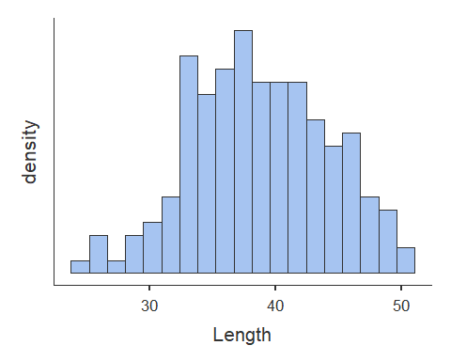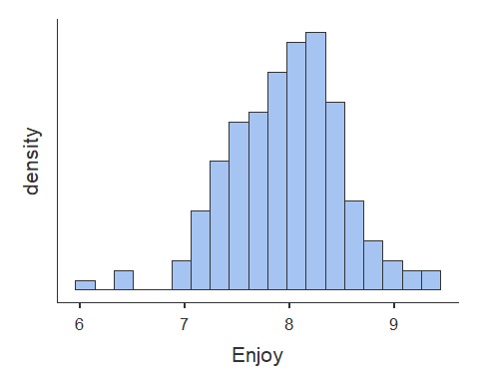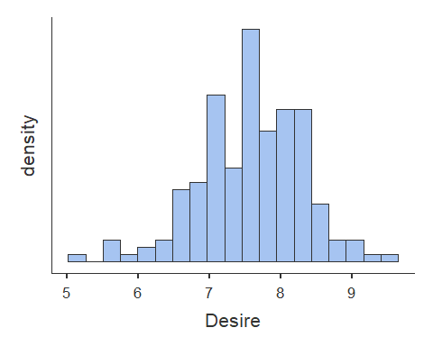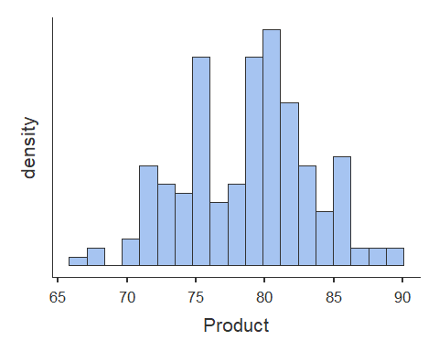

# Scatterplots  
plot(dat$Length, dat$Product, abline(lm(dat$Product ~ dat$Length)))

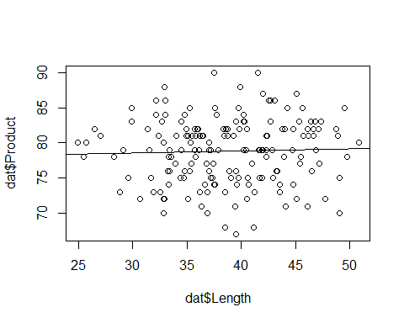

plot(dat$Enjoy, dat$Product, abline(lm(dat$Product ~ dat$Enjoy)))

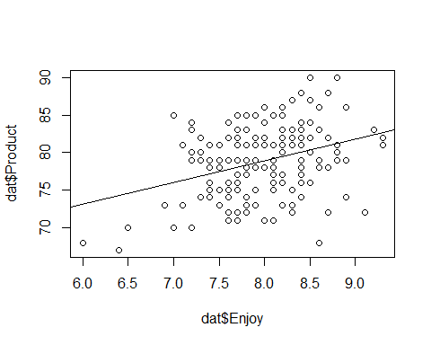

plot(dat$Desire, dat$Product, abline(lm(dat$Product ~ dat$Desire)))

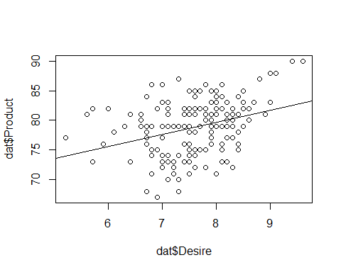

**Correlations**

# Correlation  
cortable <- corrMatrix(data = dat,   
 vars = c('Length', 'Enjoy', 'Desire', 'Product'),   
 flag = TRUE)  
cortable

##   
## CORRELATION MATRIX  
##   
## Correlation Matrix   
## -------------------------------------------------------------------   
## Length Enjoy Desire Product   
## -------------------------------------------------------------------   
## Length Pearson's r  -0.025 0.015 0.034   
## p-value  0.744 0.843 0.659   
##   
## Enjoy Pearson's r  0.292 0.336   
## p-value  < .001 < .001   
##   
## Desire Pearson's r  0.325   
## p-value  < .001   
##   
## Product Pearson's r    
## p-value    
## -------------------------------------------------------------------   
## Note. * p < .05, ** p < .01, *** p < .001

**Simple Regression**

# Simple Regression Model 1  
# Start with the simpler model first - Enjoy is most correlated with outcome variable (Product)  
model1 <- linReg(data = dat,   
 dep = 'Product', #outcome  
 covs = c('Enjoy'), #predictors  
 blocks = list(c('Enjoy')), #order - doesn't matter fore simple regression as there is only one variable  
 modelTest = TRUE, #significance test on model [H0: R squared = 0]  
 stdEst = TRUE) #standardized regression coefficient for individual variable [Stand. Estimate]  
model1 #print to screen

##   
## LINEAR REGRESSION  
##   
## Model Fit Measures   
## -----------------------------------------------------------   
## Model R R² F df1 df2 p   
## -----------------------------------------------------------   
## 1 0.336 0.113 21.9 1 173 < .001   
## -----------------------------------------------------------   
##   
##   
## MODEL SPECIFIC RESULTS  
##   
## MODEL 1  
##   
## Model Coefficients   
## ------------------------------------------------------------------------   
## Predictor Estimate SE t p Stand. Estimate   
## ------------------------------------------------------------------------   
## Intercept 55.65 4.954 11.23 < .001   
## Enjoy 2.91 0.620 4.68 < .001 0.336   
## ------------------------------------------------------------------------

#This model is best fit for simple regression based on R squared and Beta Estimates  
  
# ALTERNATIVE  
model1.1<- lm(Product ~ Enjoy, data = dat)  
summary(model1.1)

##   
## Call:  
## lm(formula = Product ~ Enjoy, data = dat)  
##   
## Residuals:  
## Min 1Q Median 3Q Max   
## -12.6459 -3.0646 0.3886 3.0980 9.6447   
##   
## Coefficients:  
## Estimate Std. Error t value Pr(>|t|)   
## (Intercept) 55.6501 4.9536 11.234 < 2e-16 ***  
## Enjoy 2.9065 0.6204 4.685 5.65e-06 ***  
## ---  
## Signif. codes: 0 '***' 0.001 '**' 0.01 '*' 0.05 '.' 0.1 ' ' 1  
##   
## Residual standard error: 4.347 on 173 degrees of freedom  
## Multiple R-squared: 0.1126, Adjusted R-squared: 0.1075   
## F-statistic: 21.95 on 1 and 173 DF, p-value: 5.649e-06

# Simple Regression Model 2  
# Desire is second most correlated with outcome variable (Product)  
model2 <- linReg(data = dat,   
 dep = 'Product', #outcome  
 covs = c('Desire'), #predictors  
 blocks = list(c('Desire')), #order - doesn't matter fore simple regression as there is only one variable  
 modelTest = TRUE, #significance test on model [H0: R squared = 0]  
 stdEst = TRUE) #standardized regression coefficient for individual variable  
model2 #print to screen

##   
## LINEAR REGRESSION  
##   
## Model Fit Measures   
## -----------------------------------------------------------   
## Model R R² F df1 df2 p   
## -----------------------------------------------------------   
## 1 0.325 0.105 20.4 1 173 < .001   
## -----------------------------------------------------------   
##   
##   
## MODEL SPECIFIC RESULTS  
##   
## MODEL 1  
##   
## Model Coefficients   
## ------------------------------------------------------------------------   
## Predictor Estimate SE t p Stand. Estimate   
## ------------------------------------------------------------------------   
## Intercept 63.24 3.465 18.25 < .001   
## Desire 2.05 0.455 4.51 < .001 0.325   
## ------------------------------------------------------------------------

# ALTERNATIVE  
model2.1<- lm(Product ~ Desire, data = dat)  
summary(model2.1)

##   
## Call:  
## lm(formula = Product ~ Desire, data = dat)  
##   
## Residuals:  
## Min 1Q Median 3Q Max   
## -10.4027 -3.5318 0.5179 3.1867 8.8026   
##   
## Coefficients:  
## Estimate Std. Error t value Pr(>|t|)   
## (Intercept) 63.2376 3.4648 18.251 < 2e-16 ***  
## Desire 2.0529 0.4548 4.514 1.17e-05 ***  
## ---  
## Signif. codes: 0 '***' 0.001 '**' 0.01 '*' 0.05 '.' 0.1 ' ' 1  
##   
## Residual standard error: 4.364 on 173 degrees of freedom  
## Multiple R-squared: 0.1054, Adjusted R-squared: 0.1002   
## F-statistic: 20.37 on 1 and 173 DF, p-value: 1.174e-05

**Multiple Regression**

# Multiple regression test #A  
  
modelA <- linReg(data = dat,   
 dep = 'Product', #outcome  
 covs = c('Enjoy', 'Desire'), #predictors  
 blocks = list(c('Enjoy', 'Desire')), #order matters here if separate blocks of variables are provided  
 modelTest = TRUE,   
 stdEst = TRUE,   
 ciStdEst = TRUE,   
 r2Adj = TRUE)  
modelA

##   
## LINEAR REGRESSION  
##   
## Model Fit Measures   
## --------------------------------------------------------------------------   
## Model R R² Adjusted R² F df1 df2 p   
## --------------------------------------------------------------------------   
## 1 0.411 0.169 0.159 17.4 2 172 < .001   
## --------------------------------------------------------------------------   
##   
##   
## MODEL SPECIFIC RESULTS  
##   
## MODEL 1  
##   
## Model Coefficients   
## -----------------------------------------------------------------------------------------   
## Predictor Estimate SE t p Stand. Estimate Lower Upper   
## -----------------------------------------------------------------------------------------   
## Intercept 48.77 5.215 9.35 < .001   
## Enjoy 2.28 0.630 3.62 < .001 0.263 0.120 0.407   
## Desire 1.57 0.460 3.41 < .001 0.248 0.104 0.391   
## -----------------------------------------------------------------------------------------

# ALTERNATIVE  
modelA.1<- lm(Product ~ Enjoy + Desire, data = dat)  
summary(modelA.1)

##   
## Call:  
## lm(formula = Product ~ Enjoy + Desire, data = dat)  
##   
## Residuals:  
## Min 1Q Median 3Q Max   
## -11.8048 -3.0613 0.4341 3.0130 8.3458   
##   
## Coefficients:  
## Estimate Std. Error t value Pr(>|t|)   
## (Intercept) 48.7712 5.2153 9.351 < 2e-16 ***  
## Enjoy 2.2791 0.6298 3.619 0.000389 ***  
## Desire 1.5662 0.4598 3.406 0.000820 ***  
## ---  
## Signif. codes: 0 '***' 0.001 '**' 0.01 '*' 0.05 '.' 0.1 ' ' 1  
##   
## Residual standard error: 4.219 on 172 degrees of freedom  
## Multiple R-squared: 0.1687, Adjusted R-squared: 0.159   
## F-statistic: 17.45 on 2 and 172 DF, p-value: 1.262e-07

# Multiple regression test #B  
  
modelB <- linReg(data = dat,   
 dep = 'Product', #outcome  
 covs = c('Enjoy', 'Desire', 'Length'), #predictors  
 blocks = list(c('Enjoy', 'Desire', 'Length')), #order matters here if separate blocks of variables are provided  
 modelTest = TRUE,   
 stdEst = TRUE,   
 ciStdEst = TRUE,   
 r2Adj = TRUE)  
modelB

##   
## LINEAR REGRESSION  
##   
## Model Fit Measures   
## --------------------------------------------------------------------------   
## Model R R² Adjusted R² F df1 df2 p   
## --------------------------------------------------------------------------   
## 1 0.412 0.170 0.155 11.7 3 171 < .001   
## --------------------------------------------------------------------------   
##   
##   
## MODEL SPECIFIC RESULTS  
##   
## MODEL 1  
##   
## Model Coefficients   
## --------------------------------------------------------------------------------------------   
## Predictor Estimate SE t p Stand. Estimate Lower Upper   
## --------------------------------------------------------------------------------------------   
## Intercept 47.5536 5.7223 8.310 < .001   
## Enjoy 2.2892 0.6314 3.626 < .001 0.2643 0.120 0.408   
## Desire 1.5606 0.4609 3.386 < .001 0.2467 0.103 0.391   
## Length 0.0305 0.0584 0.523 0.602 0.0364 -0.101 0.174   
## --------------------------------------------------------------------------------------------

# ALTERNATIVE  
modelB.1<- lm(Product ~ Enjoy + Desire + Length, data = dat)  
summary(modelB.1)

##   
## Call:  
## lm(formula = Product ~ Enjoy + Desire + Length, data = dat)  
##   
## Residuals:  
## Min 1Q Median 3Q Max   
## -11.8072 -3.0748 0.3791 2.9392 8.5144   
##   
## Coefficients:  
## Estimate Std. Error t value Pr(>|t|)   
## (Intercept) 47.55359 5.72230 8.310 2.84e-14 ***  
## Enjoy 2.28918 0.63140 3.626 0.00038 ***  
## Desire 1.56058 0.46091 3.386 0.00088 ***  
## Length 0.03050 0.05837 0.523 0.60195   
## ---  
## Signif. codes: 0 '***' 0.001 '**' 0.01 '*' 0.05 '.' 0.1 ' ' 1  
##   
## Residual standard error: 4.228 on 171 degrees of freedom  
## Multiple R-squared: 0.17, Adjusted R-squared: 0.1554   
## F-statistic: 11.67 on 3 and 171 DF, p-value: 5.36e-07

**Model Comparison**

# Hierarchical regression with model comparison (significance of R squared change)  
# 2 models plus comparison of them for final homework should be presented  
  
# Comparison Model 1  
 # Model B: Product ~ Enjoy + Desire + Length  
 # Model A: Product ~ Enjoy + Desire  
  
compare1 <- linReg(data = dat,   
 dep = 'Product',   
 covs = c('Enjoy', 'Desire', 'Length'),  
 blocks = list(  
 list('Enjoy', 'Desire'), #Model A  
 list('Length')), #Model B  
 modelTest = TRUE,  
 r2Adj = TRUE,  
 stdEst = TRUE,  
 ciStdEst = TRUE)  
compare1

##   
## LINEAR REGRESSION  
##   
## Model Fit Measures   
## --------------------------------------------------------------------------   
## Model R R² Adjusted R² F df1 df2 p   
## --------------------------------------------------------------------------   
## 1 0.411 0.169 0.159 17.4 2 172 < .001   
## 2 0.412 0.170 0.155 11.7 3 171 < .001   
## --------------------------------------------------------------------------   
##   
##   
## Model Comparisons   
## ------------------------------------------------------------------   
## Model Model <U+0394>R² F df1 df2 p   
## ------------------------------------------------------------------   
## 1 - 2 0.00133 0.273 1 171 0.602   
## ------------------------------------------------------------------   
##   
##   
## MODEL SPECIFIC RESULTS  
##   
## MODEL 1  
##   
## Model Coefficients   
## -----------------------------------------------------------------------------------------   
## Predictor Estimate SE t p Stand. Estimate Lower Upper   
## -----------------------------------------------------------------------------------------   
## Intercept 48.77 5.215 9.35 < .001   
## Enjoy 2.28 0.630 3.62 < .001 0.263 0.120 0.407   
## Desire 1.57 0.460 3.41 < .001 0.248 0.104 0.391   
## -----------------------------------------------------------------------------------------   
##   
##   
## MODEL 2  
##   
## Model Coefficients   
## --------------------------------------------------------------------------------------------   
## Predictor Estimate SE t p Stand. Estimate Lower Upper   
## --------------------------------------------------------------------------------------------   
## Intercept 47.5536 5.7223 8.310 < .001   
## Enjoy 2.2892 0.6314 3.626 < .001 0.2643 0.120 0.408   
## Desire 1.5606 0.4609 3.386 < .001 0.2467 0.103 0.391   
## Length 0.0305 0.0584 0.523 0.602 0.0364 -0.101 0.174   
## --------------------------------------------------------------------------------------------

# ALTERNATIVE  
stats::anova(modelB.1, modelA.1)

## Analysis of Variance Table  
##   
## Model 1: Product ~ Enjoy + Desire + Length  
## Model 2: Product ~ Enjoy + Desire  
## Res.Df RSS Df Sum of Sq F Pr(>F)  
## 1 171 3057.3   
## 2 172 3062.2 -1 -4.8823 0.2731 0.6019

# Both statistical tests yield no significant difference between models B and A

# Comparison Model 2  
 # Model A: Product ~ Enjoy + Desire  
 # Model 1: Product ~ Enjoy  
  
compare2 <- linReg(data = dat,   
 dep = 'Product',   
 covs = c('Enjoy', 'Desire'),  
 blocks = list(  
 list('Enjoy'), #Model 1  
 list('Desire')), #Model A  
 modelTest = TRUE,  
 r2Adj = TRUE,  
 stdEst = TRUE,  
 ciStdEst = TRUE)  
compare2

##   
## LINEAR REGRESSION  
##   
## Model Fit Measures   
## --------------------------------------------------------------------------   
## Model R R² Adjusted R² F df1 df2 p   
## --------------------------------------------------------------------------   
## 1 0.336 0.113 0.107 21.9 1 173 < .001   
## 2 0.411 0.169 0.159 17.4 2 172 < .001   
## --------------------------------------------------------------------------   
##   
##   
## Model Comparisons   
## -----------------------------------------------------------------   
## Model Model <U+0394>R² F df1 df2 p   
## -----------------------------------------------------------------   
## 1 - 2 0.0561 11.6 1 172 < .001   
## -----------------------------------------------------------------   
##   
##   
## MODEL SPECIFIC RESULTS  
##   
## MODEL 1  
##   
## Model Coefficients   
## ------------------------------------------------------------------------------------------   
## Predictor Estimate SE t p Stand. Estimate Lower Upper   
## ------------------------------------------------------------------------------------------   
## Intercept 55.65 4.954 11.23 < .001   
## Enjoy 2.91 0.620 4.68 < .001 0.336   
## ------------------------------------------------------------------------------------------   
##   
##   
## MODEL 2  
##   
## Model Coefficients   
## -----------------------------------------------------------------------------------------   
## Predictor Estimate SE t p Stand. Estimate Lower Upper   
## -----------------------------------------------------------------------------------------   
## Intercept 48.77 5.215 9.35 < .001   
## Enjoy 2.28 0.630 3.62 < .001 0.263 0.120 0.407   
## Desire 1.57 0.460 3.41 < .001 0.248 0.104 0.391   
## -----------------------------------------------------------------------------------------

# ALTERNATIVE  
stats::anova(modelA.1, model1.1)

## Analysis of Variance Table  
##   
## Model 1: Product ~ Enjoy + Desire  
## Model 2: Product ~ Enjoy  
## Res.Df RSS Df Sum of Sq F Pr(>F)   
## 1 172 3062.2   
## 2 173 3268.7 -1 -206.56 11.602 0.00082 ***  
## ---  
## Signif. codes: 0 '***' 0.001 '**' 0.01 '*' 0.05 '.' 0.1 ' ' 1

# Both statistical tests yield significant difference between models A and 1  
# These model comparisons yield that model A is the best fit for outcome variable Product

**Interpretation**

# Interpret

**Visualization**

# plotting a multiple regression model based on:   
 # Model A: Product ~ Enjoy + Desire (from lm command of model created 'modelA.1')  
  
  
# create predicted values from three predictors and save in object  
model_p <- ggpredict(modelA.1, terms = c('Enjoy', 'Desire'), full.data = TRUE, pretty = FALSE)  
  
# plot predicted line  
plot <- ggplot(model_p, aes(x, predicted)) +  
 geom_smooth(method = "lm", se = FALSE, fullrange=TRUE) + xlab("Score") + ggtitle("Plot of Model Predicting Productivity") + ylab("Weekly Goal Percentage") +  
 geom_point() + theme_minimal()  
  
plot

