Predictors of Success for Youth in a Transitional Housing Program

Daniel Pinedo

Psych 308c: Assignment 3

Predictors of Success for Youth in a Transitional Housing Program

Homeless youth (ages 16 to 25) are among the most at risk members of the population. A local transitional living program provides services to this population to assist with finding a job, literacy, high school graduation, and temporary shelter. The CEO of this program formed a study to test if the predictors of success for this program are consistent with the literature, including high school graduation and levels of safety. In addition, income and illiteracy levels were also collected for this sample and will also be tested. The purpose of this study was to determine how income, illiteracy, safety, and high school graduation status predict success of the youth in successful transition.

**Method**

The present study used a correlational design. Data collection methods included verified income and high school graduation, and a score for illiteracy and success provided by the program.

**Participants**

Participants consisted of 50 youth who completed the program. No demographic data was collected.

**Measures**

Each participant was assessed using the below measures.

**Income.**Income assessed the annual income of each participant, in dollars.

**Illiteracy*.*** Illiteracyassessed the level of illiteracy on 0 to 3 scale, with higher scores indicating higher illiteracy.

**Safety.**Safety assessed safety levels in the area in which participants lived using a 0 to 10 scale, with higher scores indicating higher levels of safety.

**High School Graduation.**High School Graduation (HS.Grad) assessed graduation status using a nominal scale with three categories of *normal graduation date*, *graduated later than normal*, or *did not graduate*.

**Success.**Success assessed successful transition of participants using a 0 to 10 scale based on a variety of compiled factors, with higher scores indicating higher levels of success.

**Planned Analysis**

The present study planned to use correlation, simple regression, and multiple regression to assess the relationships between predictors, as well as predictors and the outcome variable.

**Results**

Data analysis can be found in Appendix A. Descriptive statistics can be found in Table 1. There were no missing data in the dataset and analysis continued with tests of assumptions. Descriptive statistics and inspection of histograms indicated that the data is normally distributed for continuous variables. Data was verified to be normally distributed across all variables in the model, as evidenced by skew for all variables being below a threshold of  3.00 (income = 0.14, illiteracy = 0.87, safety = 0.01, success = 0.10), and kurtosis below a threshold of  10.00 (income = -0.95, illiteracy = -0.28, safety = -0.85 success = -0.80). Scatterplots with regression lines were created to assess the assumption of homoscedasticity and to determine linearity. The homoscedasticity assumption does not appear to be violated by visual inspection and was confirmed using a Non-Constant Variance (NCV) test, χ2 (1) = 3.10, *p* *= .*078. The assumption of linearity appears to be met for income (*r* = .70, *p* < .001), illiteracy (*r* = -.59, *p* = .001), and safety (*r* = .36, *p* = .009) when correlated with success, as further evidenced by viewing scatterplots with regression lines added.

Income, illiteracy, and safety were significantly correlated with success (Table 2); therefore, the relationship between the outcome (success) and potential predictors was assessed through regression analyses. Income (β = .70, *p* < .001) explained 47% of the variance in test scores, *F*(1, 48) = 45.90, *p* < .001, *R2* = .47 for Model 1 (Table 3). Adding illiteracy (β = -.36, *p* < .001) and income (β = .55, *p* < .001) to the model explained 60% of the variance in success, *F*(2, 47) = 34.80, *p* < .001, *R2* = .60 for Model 2. Adding safety to the model did not add significant variance, *F*(1, 46) = 0.01 , *ΔR2* = .00, *p* = .930. Adding graduation status to the model did not add significant variance, *F*(2, 45) = 1.08, *ΔR2* = .02, *p* = .347. Model comparison of Models 1 and 2 indicated that Model 2 was a significantly better fit over Model 1, *F*(1, 47) = 12.60, *ΔR2* = .11, *p* < .001.

**Discussion**

The purpose of the current project was to test predictors of success for youth transitioning from homelessness. Youth (*N* = 50) were measured for income, illiteracy, safety, and graduation status. Correlation and regression analyses were used to determine whether these variables predicted success within the program. When including income and illiteracy in the linear model both were significant predictors of success (Table 3).

These results indicate that both income and illiteracy were significant predictors of success within this program, in contradiction of the claims from the literature of safety and graduation status being the most significant predictors of success. It could be the case that illiteracy captures more information above and beyond graduation rates. In addition, future interventions and studies may also target the relationship between illiteracy and safety (*r* = -.69, *p* < .001), as levels of safety may inversely predict illiteracy, which in turn helps to predict success in youth transitioning from homelessness.

Table 1

*Descriptive Statistics of Measures*

Variable Mean SD Median Skew Kurtosis

Income 19,483.00 6432.00 19938.00 0.14 -0.95

Illiteracy 1.17 0.61 5.00 0.87 -0.28

Safety 5.24 2.54 38.50 0.01 -0.85

Success 5.10 1.47 5.00 0.10 -0.80

Table 2

*Correlation Matrix for Measures Related to Success*

Variable 1 2 3 4

1. Income - -.42** .20 .70***

2. Illiteracy - -.69*** -.59***

3. Safety - .36**

4. Success -

*Note.* * *p* < .05, ** *p* < .01, *** *p* < .001.

Table 3

*Hierarchical Regression Models Predicting Success*

Model Variables *B* β SE *R2*

Model 1 Income 16,000.00 .70*** 2,370.00 .49

Model 2 Income 12,600.00 .55*** 2,330.00 .60

Illiteracy -0.87 -.36*** 0.25

*Note.*\* *p* < .05, ** *p* < .01, *** *p* < .001.

Appendix A

**Statistical Analysis in R**

**Hypotheses**

H0: no relationship between variables

Ha: income + illiteracy + safety + graduation status predict success

N = 50

**Descriptive Statistics and Assumptions**

# Prerequisitites  
 # 1. Variables are measured on the continuous level  
  
# Assumptions  
 # 1. Normal Distribution for X and Y (Product) [i.e. histogram, skew +-3, kurtosis +-10]  
 # Histogram for Income appears normal  
 # Histogram for Illitaracy appears unimodal and skewed positively  
 # Histogram for Safety appears normal  
 # Histogram for Success appears normal  
 # Skewness - ALL PASS  
 # Kurtosis - ALL PASS   
   
 # 2. Linear Relationship beween X and Y  
 # Visual inspection of scatterplot and prediction model line indicate a linear relationship  
 # 3. Homoscedasticity  
 # a. Visual inspection of scatterplots indicate:   
 # possible lower variance at lower end of Income  
 # possible lower variance at upper end of Illiteracy  
 # likely equal variance across Safety  
 # b. non-constant variance test - H0 = TRUE (PASS)  
   
 # 4. [Examine residuals (e = Y - Y~predicted~) to understand 2 and 3 mathematically]  
  
# Descriptives [Assumption 1]  
desc <- descriptives(data = dat,   
 vars = c('Income', 'Illiteracy', 'Safety', 'Success'),   
 hist = TRUE,   
 sd = TRUE,   
 range = TRUE,   
 skew = TRUE,   
 kurt = TRUE)  
desc

##   
## DESCRIPTIVES  
##   
## Descriptives   
## --------------------------------------------------------------------   
## Income Illiteracy Safety Success   
## --------------------------------------------------------------------   
## N 50 50 50 50   
## Missing 0 0 0 0   
## Mean 19483 1.17 5.24 5.10   
## Median 19938 0.950 5.00 5.00   
## Standard deviation 6432 0.610 2.54 1.47   
## Range 21681 2.30 9 6   
## Minimum 8603 0.500 1 2   
## Maximum 30284 2.80 10 8   
## Skewness 0.144 0.870 0.0142 0.0995   
## Std. error skewness 0.337 0.337 0.337 0.337   
## Kurtosis -0.947 -0.276 -0.849 -0.797   
## Std. error kurtosis 0.662 0.662 0.662 0.662   
## --------------------------------------------------------------------

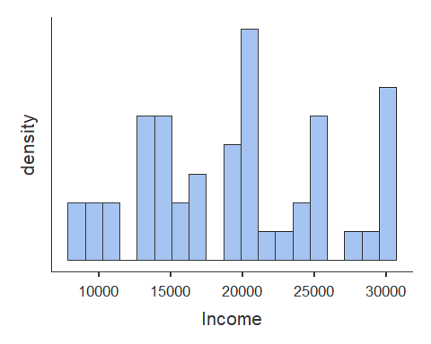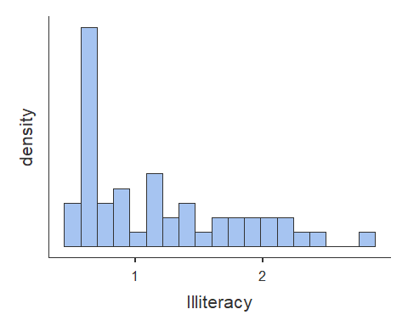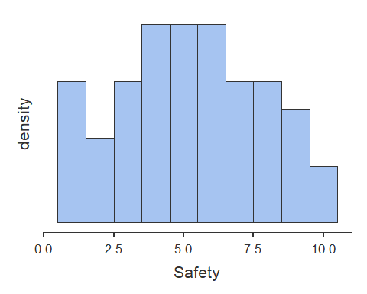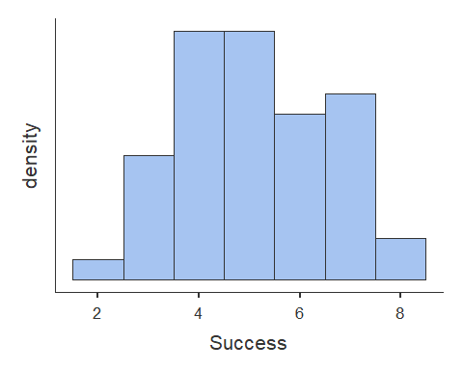

# Scatterplots [Assumption 2 and 3a]  
plot(dat$Income, dat$Success, abline(lm(dat$Success ~ dat$Income)))

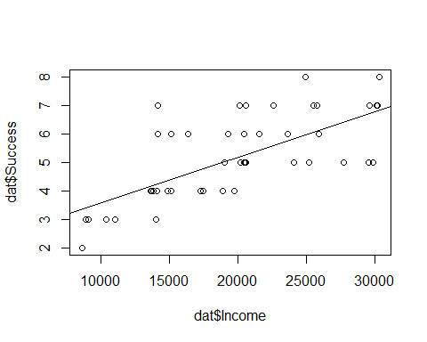

plot(dat$Illiteracy, dat$Success, abline(lm(dat$Success ~ dat$Illiteracy)))

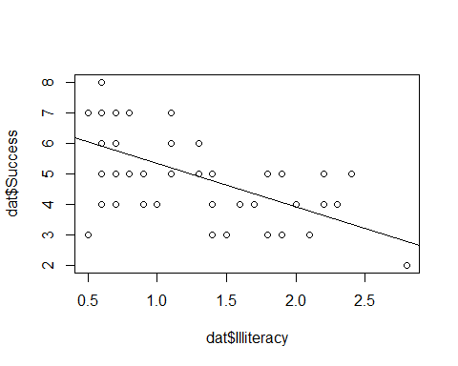

plot(dat$Safety, dat$Success, abline(lm(dat$Success ~ dat$Safety)))

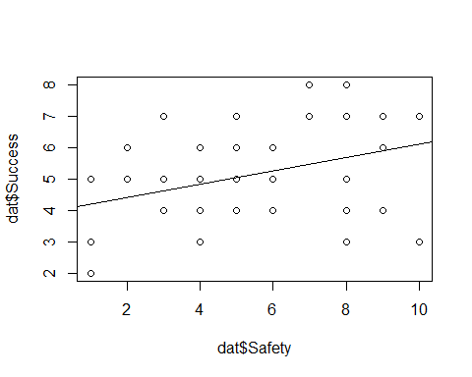

# Homoscedasticity [Assumption 3b]  
  
# non-constant variance Chi-squared test [Chi-squared (df) = ##.##, p = .###]  
# H0 = homoscedastic - TRUE  
# Ha = heteroscedastic  
  
ncvTest(lm(Success ~ Income + Illiteracy + Safety, data = dat))

## Non-constant Variance Score Test   
## Variance formula: ~ fitted.values   
## Chisquare = 3.103699, Df = 1, p = 0.078115

**Correlations**

# Correlation  
cortable <- corrMatrix(data = dat,   
 vars = c('Income', 'Illiteracy', 'Safety', 'Success'),   
 flag = TRUE)  
cortable

##   
## CORRELATION MATRIX  
##   
## Correlation Matrix   
## --------------------------------------------------------------------------   
## Income Illiteracy Safety Success   
## --------------------------------------------------------------------------   
## Income Pearson's r  -0.415 0.196 0.699   
## p-value  0.003 0.172 < .001   
##   
## Illiteracy Pearson's r  -0.691 -0.589   
## p-value  < .001 < .001   
##   
## Safety Pearson's r  0.363   
## p-value  0.009   
##   
## Success Pearson's r    
## p-value    
## --------------------------------------------------------------------------   
## Note. * p < .05, ** p < .01, *** p < .001

**Center the continuous predictor variables**

# c = x - M  
# Centering only quantitatively changes the intercept for regression equation  
# Center Income, Illiteracy, Safety  
dat$Income.c <- dat$Income - mean(dat$Income)  
dat$Illiteracy.c <- dat$Illiteracy - mean(dat$Illiteracy)  
dat$Safety.c <- dat$Safety - mean(dat$Safety)

**Simple Regression of centered continuous predictor variables**

# Simple regression  
# R = correlation between observed scores and predicted scores  
# R squared = percentage of variance explained  
# t = Estimate / SE  
# df = N - k - 1 [k is number of predictors]  
# H0: B0 = 0; H0; R squared = 0  
  
model1 <- linReg(data = dat,   
 dep = 'Success',   
 covs = c('Income.c'),  
 blocks = list('Income.c'),   
 modelTest = TRUE,   
 stdEst = TRUE,   
 ci = TRUE)  
model1

##   
## LINEAR REGRESSION  
##   
## Model Fit Measures   
## -----------------------------------------------------------   
## Model R R² F df1 df2 p   
## -----------------------------------------------------------   
## 1 0.699 0.489 45.9 1 48 < .001   
## -----------------------------------------------------------   
##   
##   
## MODEL SPECIFIC RESULTS  
##   
## MODEL 1  
##   
## Model Coefficients   
## ------------------------------------------------------------------------------------------------   
## Predictor Estimate SE Lower Upper t p Stand. Estimate   
## ------------------------------------------------------------------------------------------------   
## Intercept 5.10 0.151 4.80 5.40 33.87 < .001   
## Income.c 1.60e-4 2.37e-5 1.13e-4 2.08e-4 6.78 < .001 0.699   
## ------------------------------------------------------------------------------------------------

model2 <- linReg(data = dat,   
 dep = 'Success',  
 covs = c('Illiteracy.c'),  
 blocks = list('Illiteracy.c'),   
 modelTest = TRUE,   
 stdEst = TRUE,   
 ci = TRUE)  
model2

##   
## LINEAR REGRESSION  
##   
## Model Fit Measures   
## -----------------------------------------------------------   
## Model R R² F df1 df2 p   
## -----------------------------------------------------------   
## 1 0.589 0.347 25.5 1 48 < .001   
## -----------------------------------------------------------   
##   
##   
## MODEL SPECIFIC RESULTS  
##   
## MODEL 1  
##   
## Model Coefficients   
## ----------------------------------------------------------------------------------------------   
## Predictor Estimate SE Lower Upper t p Stand. Estimate   
## ----------------------------------------------------------------------------------------------   
## Intercept 5.10 0.170 4.76 5.442 29.97 < .001   
## Illiteracy.c -1.43 0.282 -1.99 -0.858 -5.05 < .001 -0.589   
## ----------------------------------------------------------------------------------------------

model3 <- linReg(data = dat,   
 dep = 'Success',  
 covs = c('Safety.c'),  
 blocks = list('Safety.c'),   
 modelTest = TRUE,   
 stdEst = TRUE,   
 ci = TRUE)  
model3

##   
## LINEAR REGRESSION  
##   
## Model Fit Measures   
## ----------------------------------------------------------   
## Model R R² F df1 df2 p   
## ----------------------------------------------------------   
## 1 0.363 0.132 7.31 1 48 0.009   
## ----------------------------------------------------------   
##   
##   
## MODEL SPECIFIC RESULTS  
##   
## MODEL 1  
##   
## Model Coefficients   
## --------------------------------------------------------------------------------------------   
## Predictor Estimate SE Lower Upper t p Stand. Estimate   
## --------------------------------------------------------------------------------------------   
## Intercept 5.100 0.1962 4.7054 5.495 25.99 < .001   
## Safety.c 0.211 0.0779 0.0540 0.367 2.70 0.009 0.363   
## --------------------------------------------------------------------------------------------

**Multiple regression with dummy codes for Categorical Variable (Graduation Status [3 levels])**

# Model comparison  
# D1 is predicted difference between D1 (Graduated later) and reference group (Did not graduate) for a 1 unit change in Y (Success)  
# D2 is predicted difference between D2 (Graduated normal) and reference group (did not graduate) for 1 unit change in Y (Success)  
model4 <- linReg(data = dat,   
 dep = 'Success', #outcome  
 covs = c('D1', 'D2'), #predictors  
 blocks = list(c('D1', 'D2')), #order matters here if separate blocks of variables are provided  
 modelTest = TRUE,   
 stdEst = TRUE,   
 ciStdEst = TRUE,   
 r2Adj = TRUE)  
model4

##   
## LINEAR REGRESSION  
##   
## Model Fit Measures   
## -------------------------------------------------------------------------   
## Model R R² Adjusted R² F df1 df2 p   
## -------------------------------------------------------------------------   
## 1 0.484 0.234 0.201 7.18 2 47 0.002   
## -------------------------------------------------------------------------   
##   
##   
## MODEL SPECIFIC RESULTS  
##   
## MODEL 1  
##   
## Model Coefficients   
## -------------------------------------------------------------------------------------------   
## Predictor Estimate SE t p Stand. Estimate Lower Upper   
## -------------------------------------------------------------------------------------------   
## Intercept 4.07 0.340 11.96 < .001   
## D1 1.23 0.467 2.63 0.012 0.398 0.0937 0.703   
## D2 1.71 0.461 3.72 < .001 0.563 0.2580 0.868   
## -------------------------------------------------------------------------------------------

Model 1 is best fit for simple regression Income predicts 49% of variance for Success

**Model 1 Comparison with Illiteracy added**

# Model comparison  
# H0 = delta of R squared = 0  
compare5 <- linReg(data = dat,   
 dep = 'Success',   
 covs = c('Income.c', 'Illiteracy.c'),  
 blocks = list(  
 list('Income.c'),  
 list('Illiteracy.c')),   
 modelTest = TRUE,   
 stdEst = TRUE,   
 ci = TRUE)  
compare5

##   
## LINEAR REGRESSION  
##   
## Model Fit Measures   
## -----------------------------------------------------------   
## Model R R² F df1 df2 p   
## -----------------------------------------------------------   
## 1 0.699 0.489 45.9 1 48 < .001   
## 2 0.773 0.597 34.8 2 47 < .001   
## -----------------------------------------------------------   
##   
##   
## Model Comparisons   
## ----------------------------------------------------------------   
## Model Model <U+0394>R² F df1 df2 p   
## ----------------------------------------------------------------   
## 1 - 2 0.108 12.6 1 47 < .001   
## ----------------------------------------------------------------   
##   
##   
## MODEL SPECIFIC RESULTS  
##   
## MODEL 1  
##   
## Model Coefficients   
## ------------------------------------------------------------------------------------------------   
## Predictor Estimate SE Lower Upper t p Stand. Estimate   
## ------------------------------------------------------------------------------------------------   
## Intercept 5.10 0.151 4.80 5.40 33.87 < .001   
## Income.c 1.60e-4 2.37e-5 1.13e-4 2.08e-4 6.78 < .001 0.699   
## ------------------------------------------------------------------------------------------------   
##   
##   
## MODEL 2  
##   
## Model Coefficients   
## ---------------------------------------------------------------------------------------------------   
## Predictor Estimate SE Lower Upper t p Stand. Estimate   
## ---------------------------------------------------------------------------------------------------   
## Intercept 5.100 0.135 4.83 5.372 37.74 < .001   
## Income.c 1.26e-4 2.33e-5 7.90e-5 1.73e-4 5.40 < .001 0.549   
## Illiteracy.c -0.874 0.246 -1.37 -0.379 -3.55 < .001 -0.361   
## ---------------------------------------------------------------------------------------------------

Model 5 is a good fit for multiple regression Income and Illiteracy predict 60% of variance for Success

**Model 1 Comparison with Safety added**

# Model comparison  
# H0 = delta of R squared = 0  
compare6 <- linReg(data = dat,   
 dep = 'Success',   
 covs = c('Income.c', 'Safety.c'),  
 blocks = list(  
 list('Income.c'),  
 list('Safety.c')),   
 modelTest = TRUE,   
 stdEst = TRUE,   
 ci = TRUE)  
compare6

##   
## LINEAR REGRESSION  
##   
## Model Fit Measures   
## -----------------------------------------------------------   
## Model R R² F df1 df2 p   
## -----------------------------------------------------------   
## 1 0.699 0.489 45.9 1 48 < .001   
## 2 0.736 0.542 27.8 2 47 < .001   
## -----------------------------------------------------------   
##   
##   
## Model Comparisons   
## ----------------------------------------------------------------   
## Model Model <U+0394>R² F df1 df2 p   
## ----------------------------------------------------------------   
## 1 - 2 0.0533 5.47 1 47 0.024   
## ----------------------------------------------------------------   
##   
##   
## MODEL SPECIFIC RESULTS  
##   
## MODEL 1  
##   
## Model Coefficients   
## ------------------------------------------------------------------------------------------------   
## Predictor Estimate SE Lower Upper t p Stand. Estimate   
## ------------------------------------------------------------------------------------------------   
## Intercept 5.10 0.151 4.80 5.40 33.87 < .001   
## Income.c 1.60e-4 2.37e-5 1.13e-4 2.08e-4 6.78 < .001 0.699   
## ------------------------------------------------------------------------------------------------   
##   
##   
## MODEL 2  
##   
## Model Coefficients   
## ------------------------------------------------------------------------------------------------   
## Predictor Estimate SE Lower Upper t p Stand. Estimate   
## ------------------------------------------------------------------------------------------------   
## Intercept 5.100 0.1440 4.8103 5.390 35.41 < .001   
## Income.c 1.50e-4 2.31e-5 1.03e-4 1.96e-4 6.49 < .001 0.653   
## Safety.c 0.136 0.0583 0.0191 0.254 2.34 0.024 0.235   
## ------------------------------------------------------------------------------------------------

Model 6 is not best fit for multiple regression Income and Safety predict 54% of variance for Success

**Model 1 Comparison with Graduation added**

# Model comparison  
# H0 = delta of R squared = 0  
# D1 is predicted difference between D1 (Graduated later) and reference group (Did not graduate) for a 1 unit change in Y (Success)  
# D2 is predicted difference between D2 (Graduated normal) and reference group (did not graduate) for 1 unit change in Y (Success)  
compare7 <- linReg(data = dat,   
 dep = 'Success',   
 covs = c('Income.c', 'D1', 'D2'),  
 blocks = list(  
 list('Income.c'),  
 list('D1', 'D2')),   
 modelTest = TRUE,   
 stdEst = TRUE,   
 ci = TRUE)  
compare7

##   
## LINEAR REGRESSION  
##   
## Model Fit Measures   
## -----------------------------------------------------------   
## Model R R² F df1 df2 p   
## -----------------------------------------------------------   
## 1 0.699 0.489 45.9 1 48 < .001   
## 2 0.753 0.567 20.0 3 46 < .001   
## -----------------------------------------------------------   
##   
##   
## Model Comparisons   
## ----------------------------------------------------------------   
## Model Model <U+0394>R² F df1 df2 p   
## ----------------------------------------------------------------   
## 1 - 2 0.0775 4.11 2 46 0.023   
## ----------------------------------------------------------------   
##   
##   
## MODEL SPECIFIC RESULTS  
##   
## MODEL 1  
##   
## Model Coefficients   
## ------------------------------------------------------------------------------------------------   
## Predictor Estimate SE Lower Upper t p Stand. Estimate   
## ------------------------------------------------------------------------------------------------   
## Intercept 5.10 0.151 4.80 5.40 33.87 < .001   
## Income.c 1.60e-4 2.37e-5 1.13e-4 2.08e-4 6.78 < .001 0.699   
## ------------------------------------------------------------------------------------------------   
##   
##   
## MODEL 2  
##   
## Model Coefficients   
## ------------------------------------------------------------------------------------------------   
## Predictor Estimate SE Lower Upper t p Stand. Estimate   
## ------------------------------------------------------------------------------------------------   
## Intercept 4.568 0.272 4.020 5.12 16.79 < .001   
## Income.c 1.42e-4 2.39e-5 9.39e-5 1.90e-4 5.94 < .001 0.619   
## D1 0.465 0.377 -0.294 1.22 1.23 0.224 0.151   
## D2 1.038 0.368 0.297 1.78 2.82 0.007 0.341   
## ------------------------------------------------------------------------------------------------

Model 7 is not best fit for multiple regression Income and Graduation predict 57% of variance for Success

Model 5 is most parsimonious fit for multiple regression Income and Illiteracy predict 60% of variance for Success

**Model 5 Comparison with Safety added**

# Model comparison  
# H0 = delta of R squared = 0  
compare8 <- linReg(data = dat,   
 dep = 'Success',   
 covs = c('Income.c', 'Illiteracy.c', 'Safety.c'),  
 blocks = list(  
 list('Income.c', 'Illiteracy.c'),  
 list('Safety.c')),   
 modelTest = TRUE,   
 stdEst = TRUE,   
 ci = TRUE)  
compare8

##   
## LINEAR REGRESSION  
##   
## Model Fit Measures   
## -----------------------------------------------------------   
## Model R R² F df1 df2 p   
## -----------------------------------------------------------   
## 1 0.773 0.597 34.8 2 47 < .001   
## 2 0.773 0.597 22.7 3 46 < .001   
## -----------------------------------------------------------   
##   
##   
## Model Comparisons   
## --------------------------------------------------------------------   
## Model Model <U+0394>R² F df1 df2 p   
## --------------------------------------------------------------------   
## 1 - 2 6.81e-5 0.00778 1 46 0.930   
## --------------------------------------------------------------------   
##   
##   
## MODEL SPECIFIC RESULTS  
##   
## MODEL 1  
##   
## Model Coefficients   
## ---------------------------------------------------------------------------------------------------   
## Predictor Estimate SE Lower Upper t p Stand. Estimate   
## ---------------------------------------------------------------------------------------------------   
## Intercept 5.100 0.135 4.83 5.372 37.74 < .001   
## Income.c 1.26e-4 2.33e-5 7.90e-5 1.73e-4 5.40 < .001 0.549   
## Illiteracy.c -0.874 0.246 -1.37 -0.379 -3.55 < .001 -0.361   
## ---------------------------------------------------------------------------------------------------   
##   
##   
## MODEL 2  
##   
## Model Coefficients   
## -----------------------------------------------------------------------------------------------------   
## Predictor Estimate SE Lower Upper t p Stand. Estimate   
## -----------------------------------------------------------------------------------------------------   
## Intercept 5.10000 0.1366 4.825 5.375 37.3418 < .001   
## Income.c 1.26e-4 2.38e-5 7.83e-5 1.74e-4 5.3014 < .001 0.5506   
## Illiteracy.c -0.85351 0.3410 -1.540 -0.167 -2.5031 0.016 -0.3529   
## Safety.c 0.00669 0.0758 -0.146 0.159 0.0882 0.930 0.0115   
## -----------------------------------------------------------------------------------------------------

Model 8 is not a parsimonious fit for multiple regression Income, Illiteracy, and Safety predict 60% of variance for Success (no added account for variance)

**Model 5 Comparison with Graduation added**

# Model comparison  
# H0 = delta of R squared = 0  
# D1 is predicted difference between D1 (Graduated later) and reference group (Did not graduate) for a 1 unit change in Y (Success)  
# D2 is predicted difference between D2 (Graduated normal) and reference group (did not graduate) for 1 unit change in Y (Success)  
compare9 <- linReg(data = dat,   
 dep = 'Success',   
 covs = c('Income.c', 'Illiteracy.c', 'D1', 'D2'),  
 blocks = list(  
 list('Income.c', 'Illiteracy.c'),  
 list('D1', 'D2')),   
 modelTest = TRUE,   
 stdEst = TRUE,   
 ci = TRUE)  
compare9

##   
## LINEAR REGRESSION  
##   
## Model Fit Measures   
## -----------------------------------------------------------   
## Model R R² F df1 df2 p   
## -----------------------------------------------------------   
## 1 0.773 0.597 34.8 2 47 < .001   
## 2 0.785 0.616 18.0 4 45 < .001   
## -----------------------------------------------------------   
##   
##   
## Model Comparisons   
## ----------------------------------------------------------------   
## Model Model <U+0394>R² F df1 df2 p   
## ----------------------------------------------------------------   
## 1 - 2 0.0185 1.08 2 45 0.347   
## ----------------------------------------------------------------   
##   
##   
## MODEL SPECIFIC RESULTS  
##   
## MODEL 1  
##   
## Model Coefficients   
## ---------------------------------------------------------------------------------------------------   
## Predictor Estimate SE Lower Upper t p Stand. Estimate   
## ---------------------------------------------------------------------------------------------------   
## Intercept 5.100 0.135 4.83 5.372 37.74 < .001   
## Income.c 1.26e-4 2.33e-5 7.90e-5 1.73e-4 5.40 < .001 0.549   
## Illiteracy.c -0.874 0.246 -1.37 -0.379 -3.55 < .001 -0.361   
## ---------------------------------------------------------------------------------------------------   
##   
##   
## MODEL 2  
##   
## Model Coefficients   
## ----------------------------------------------------------------------------------------------------   
## Predictor Estimate SE Lower Upper t p Stand. Estimate   
## ----------------------------------------------------------------------------------------------------   
## Intercept 4.9715 0.309 4.349 5.594 16.095 < .001   
## Income.c 1.27e-4 2.36e-5 8.00e-5 1.75e-4 5.410 < .001 0.5559   
## Illiteracy.c -0.7456 0.311 -1.372 -0.119 -2.398 0.021 -0.3083   
## D1 -0.0557 0.420 -0.901 0.790 -0.133 0.895 -0.0181   
## D2 0.4097 0.438 -0.472 1.291 0.936 0.354 0.1347   
## ----------------------------------------------------------------------------------------------------

Model 9 is not a parsimonious fit for multiple regression Income, Illiteracy, and Graduation predict 62% of variance for Success (no significant added account for prior predicted variance of 60%)

Based on prior literature, Graduation and Safety are best predictors of success. In this case, neither graduation nor safety accounted for a significantly greater amount of variance when added to Income and Illiteracy, Income accounted for highest amount of overall variance by itself, and Income and Illiteracy accounted for the most parsimonious model overall.

Thus, Model 5 is best, most parsimonious fit for multiple regression Income and Illiteracy predict 60% of variance for Success

**Transform Normalized Illiteracy to Literacy on a scale of 0-3 (higher being more literate)**

dat$Literacy.t <- 3 - dat$Illiteracy.c

**Model 5 with normalized Literacy transform**

# Multiple regression [Success ~ Income.c + Literacy.t]  
# Y = B0 + B1*Income + B2*Literacy + residuals [B0 = 2.48, B1 = 12,600, B2 = 0.87]  
# Accounting for error (Sum of Y - Y predicted / N - standard error in gray below):   
 #with average income and literacy, Y is 2.48 {low success}  
  
transform5 <- linReg(data = dat,   
 dep = 'Success', #outcome  
 covs = c('Income.c', 'Literacy.t'), #predictors  
 blocks = list(c('Income.c', 'Literacy.t')), #order matters here if separate blocks of variables are provided  
 modelTest = TRUE,   
 stdEst = TRUE,   
 ciStdEst = TRUE,   
 r2Adj = TRUE)  
transform5

##   
## LINEAR REGRESSION  
##   
## Model Fit Measures   
## --------------------------------------------------------------------------   
## Model R R² Adjusted R² F df1 df2 p   
## --------------------------------------------------------------------------   
## 1 0.773 0.597 0.580 34.8 2 47 < .001   
## --------------------------------------------------------------------------   
##   
##   
## MODEL SPECIFIC RESULTS  
##   
## MODEL 1  
##   
## Model Coefficients   
## --------------------------------------------------------------------------------------------   
## Predictor Estimate SE t p Stand. Estimate Lower Upper   
## --------------------------------------------------------------------------------------------   
## Intercept 2.478 0.751 3.30 0.002   
## Income.c 1.26e-4 2.33e-5 5.40 < .001 0.549 0.345 0.754   
## Literacy.t 0.874 0.246 3.55 < .001 0.361 0.157 0.566   
## --------------------------------------------------------------------------------------------

**Visualization with Centered and Transformed Data**

# plotting a multiple regression model based on:   
 # Model 5 Transform: Success.c ~ Income.c + Literacy.t [centered predictors]  
  
# create predicted values from predictors and save in object  
model5 <- lm(Success ~ Income.c + Literacy.t, data = dat)  
summary(model5)

##   
## Call:  
## lm(formula = Success ~ Income.c + Literacy.t, data = dat)  
##   
## Residuals:  
## Min 1Q Median 3Q Max   
## -1.89881 -0.71826 0.06009 0.66334 1.98364   
##   
## Coefficients:  
## Estimate Std. Error t value Pr(>|t|)   
## (Intercept) 2.478e+00 7.507e-01 3.301 0.001846 **   
## Income.c 1.259e-04 2.333e-05 5.398 2.17e-06 ***  
## Literacy.t 8.741e-01 2.461e-01 3.551 0.000884 ***  
## ---  
## Signif. codes: 0 '***' 0.001 '**' 0.01 '*' 0.05 '.' 0.1 ' ' 1  
##   
## Residual standard error: 0.9555 on 47 degrees of freedom  
## Multiple R-squared: 0.5971, Adjusted R-squared: 0.58   
## F-statistic: 34.83 on 2 and 47 DF, p-value: 5.275e-10

model_p <- ggpredict(model5, terms = c('Income.c', 'Literacy.t'), full.data = TRUE, pretty = FALSE)  
  
# plot predicted line  
plot <- ggplot(model_p, aes(x, predicted)) +  
 geom_smooth(method = "lm", se = TRUE, fullrange=TRUE) + xlab("Score") + ggtitle("Plot of Model of Income and Literacy Predicting Success") + ylab("Success") +  
 geom_point() + theme_minimal()  
  
plot

